# Car Dashboard

Android Auto / Apple Carplay Navigation

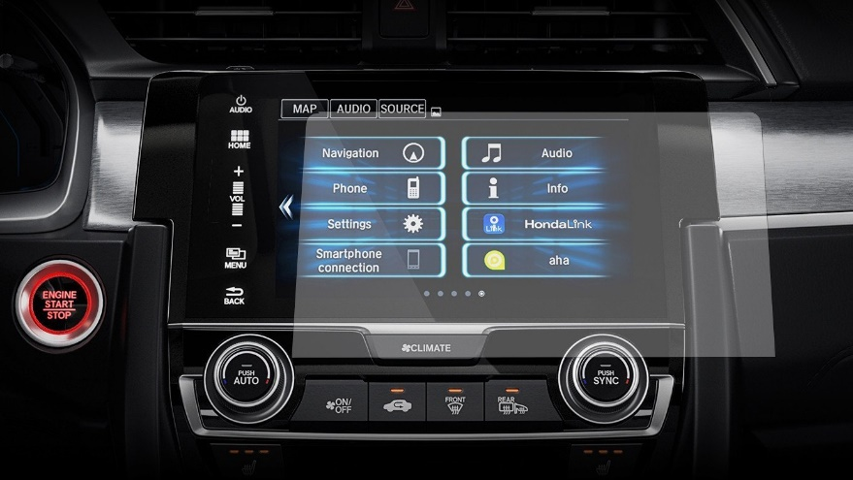

Technology

Software is simple and easy to use

Easy to start and find he navigation application

Really functional and solid

Works pretty well, calculates the route easily, usually have good options, it gives addictive warning, and generally pretty good.

Frustrations

Frustration 1

Frustration 2

Frustration 3

[ … ]

Motivations

Motivation 1

Motivation 2

Motivation 3

[ … ]

About

The task was connecting the phone to the car, accessing android auto on the car dashboard, open a navigation application and navigate to school.

Goals

How accessible this interface is to users.

To see if the interface is easy to use or not.

Also, whether it can be improved or not.