Coffee Shop Sales Analysis with PostgreSQL
Prepared by: RYADUL SEAM | Data Analytics & BI Consultant

The Queries with Outputs are:

-- drop coffee_shop_sales table

drop table if exists coffee_shop_sales ;

-- create coffee_shop_sales table

CREATE TABLE coffee_shop_sales (
transaction_id int PRIMARY KEY,
transaction_date DATE NOT NULL,
transaction_time TIME NOT NULL,
transaction_qty INTEGER CHECK (transaction_qty > 0),
store_id INTEGER NOT NULL,
store_location TEXT,
product_id INTEGER NOT NULL,
unit_price NUMERIC(6,2) CHECK (unit_price >= 0),
product_category TEXT,
product_type TEXT,
product_detail TEXT
);

select * from coffee_shop_sales ;
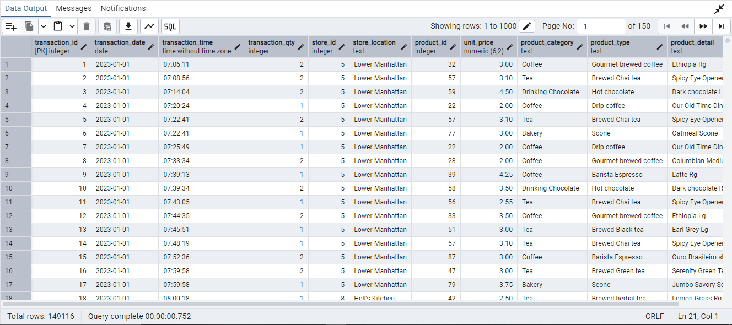

-- check the data type

SELECT column_name, data_type, is_nullable
FROM information_schema.columns
WHERE table_name = 'coffee_shop_sales';
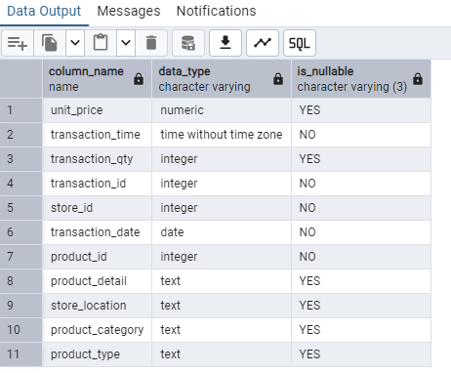

-- total sales for each month

SELECT
TO_CHAR(DATE_TRUNC('month', transaction_date), 'Month YYYY') AS month_name,
SUM(transaction_qty * unit_price) AS total_sales
FROM
coffee_shop_sales
GROUP BY
DATE_TRUNC('month', transaction_date)
ORDER BY
DATE_TRUNC('month', transaction_date);

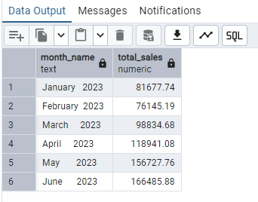

-- calculate MOM on total sales for each month

WITH monthly_sales AS (
SELECT
DATE_TRUNC('month', transaction_date) AS month,
SUM(transaction_qty * unit_price) AS total_sales
FROM
coffee_shop_sales
GROUP BY
DATE_TRUNC('month', transaction_date)
),
sales_with_mom AS (
SELECT
month,
total_sales,
LAG(total_sales) OVER (ORDER BY month) AS previous_month_sales,
ROUND(
(total_sales - LAG(total_sales) OVER (ORDER BY month))
/ NULLIF(LAG(total_sales) OVER (ORDER BY month), 0) * 100, 2
) AS mom_percent
FROM
monthly_sales
)
SELECT
TO_CHAR(month, 'Mon YYYY') AS month_name,
total_sales,
previous_month_sales ,
mom_percent
FROM
sales_with_mom
ORDER BY
month;

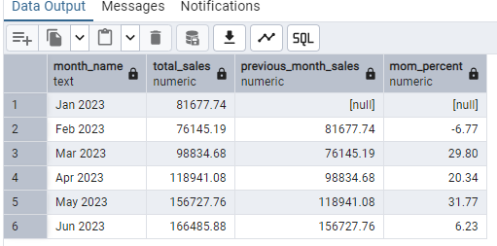

-- total orders for each month

SELECT
TO_CHAR(DATE_TRUNC('month', transaction_date), 'Month YYYY') AS month_name,
count(transaction_id) AS total_orders
FROM
coffee_shop_sales
GROUP BY
DATE_TRUNC('month', transaction_date)
ORDER BY
DATE_TRUNC('month', transaction_date);

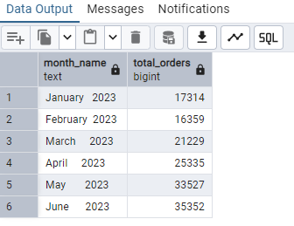

-- calculate MOM on total orders for each month

WITH monthly_orders AS (
SELECT
DATE_TRUNC('month', transaction_date) AS month,
COUNT(*) AS total_orders
FROM
coffee_shop_sales
GROUP BY
DATE_TRUNC('month', transaction_date)
),
orders_with_mom AS (
SELECT
month,
total_orders,
LAG(total_orders) OVER (ORDER BY month) AS previous_month_orders
FROM
monthly_orders
),
final AS (
SELECT
month,
total_orders,
previous_month_orders,
ROUND(
((total_orders - previous_month_orders)::NUMERIC / NULLIF(previous_month_orders, 0)) * 100,
2
) AS mom_percent
FROM
orders_with_mom
)
SELECT
TO_CHAR(month, 'Mon YYYY') AS month_name,
total_orders,
previous_month_orders,
mom_percent
FROM
final
ORDER BY
month;

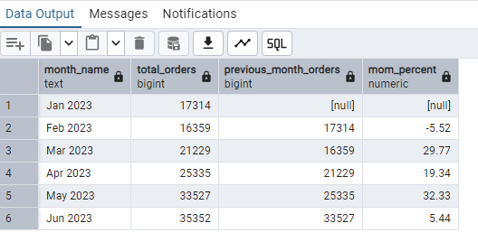

-- total quantity for each month

SELECT
TO_CHAR(DATE_TRUNC('month', transaction_date), 'Month YYYY') AS month_name,
SUM(transaction_qty ) AS total_quantity
FROM
coffee_shop_sales
GROUP BY
DATE_TRUNC('month', transaction_date)
ORDER BY
DATE_TRUNC('month', transaction_date);
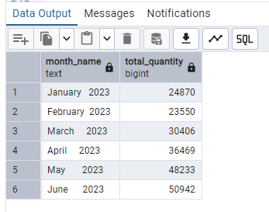

-- calculate MOM on total quantity for each month

WITH monthly_quantity AS (
SELECT
DATE_TRUNC('month', transaction_date) AS month,
SUM(transaction_qty ) AS total_quantity
FROM
coffee_shop_sales
GROUP BY
DATE_TRUNC('month', transaction_date)
),
quantity_with_mom AS (
SELECT
month,
total_quantity,
LAG(total_quantity) OVER (ORDER BY month) AS previous_month_quantity,
ROUND(
(total_quantity - LAG(total_quantity) OVER (ORDER BY month)) ::NUMERIC
/ NULLIF(LAG(total_quantity) OVER (ORDER BY month), 0) * 100, 2
) AS mom_percent
FROM
monthly_quantity
)
SELECT
TO_CHAR(month, 'Mon YYYY') AS month_name,
total_quantity,
previous_month_quantity ,
mom_percent
FROM
quantity_with_mom
ORDER BY
month;

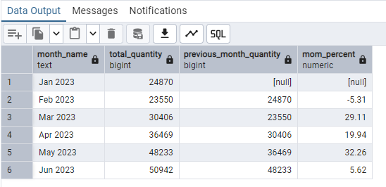

-- daily trend of total sales , total quantity , total orders

select
SUM(transaction_qty * unit_price) AS total_sales ,
SUM(transaction_qty ) AS total_quantity ,
count(transaction_id) AS total_orders
from coffee_shop_sales
where
transaction_date = '2023-05-04';
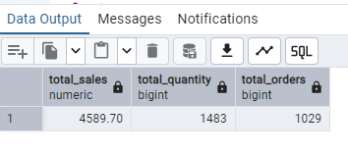

-- SALES TREND OVER PERIOD

select
round (avg (total_sales) , 2 ) as average_sales
from (
select
SUM(transaction_qty * unit_price) AS total_sales
from coffee_shop_sales
where
extract (month from transaction_date ) = 5 -- Filter for "May"
group by
transaction_date

);

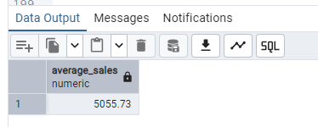

-- DAILY SALES FOR MONTH SELECTED

select
extract (day from transaction_date ) as day ,
SUM(transaction_qty * unit_price) AS total_sales
from coffee_shop_sales
where
extract (month from transaction_date ) = 5 -- Filter for "May"
group by
transaction_date
order by day ;

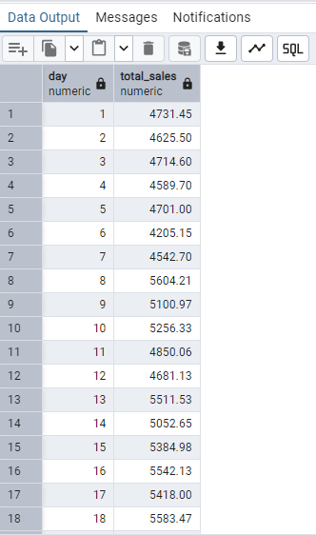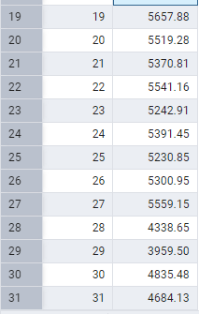

-- COMPARING DAILY SALES WITH AVERAGE SALES – IF GREATER THAN “ABOVE AVERAGE” and LESSER THAN “BELOW AVERAGE”

with daily_sales as (
select
extract (day from transaction_date ) as day_of_month ,
SUM(transaction_qty * unit_price) AS total_sales
from
coffee_shop_sales
where
extract (month from transaction_date ) = 5 -- Filter for "May"
group by
extract (day from transaction_date )
),
sales_with_status as (
select
day_of_month ,
total_sales ,
avg (total_sales) over () as average_sales
from daily_sales
)
select day_of_month ,
total_sales ,
case
when total_sales > average_sales then 'ABOVE AVERAGE'
when total_sales < average_sales then 'BELOW AVERAGE'
else 'AVERAGE'
end as sales_status
from sales_with_status
order by day_of_month ;

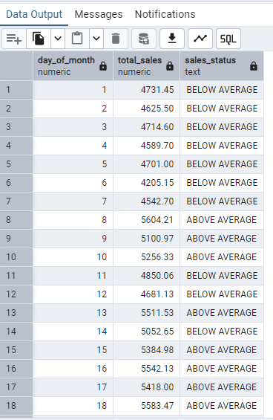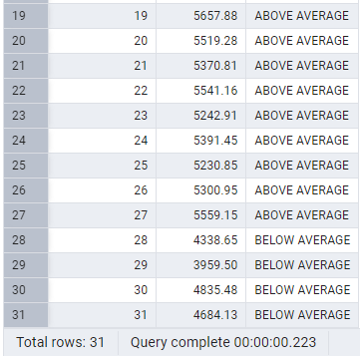

-- SALES BY WEEKDAY / WEEKEND

with daily_sales as (
select
transaction_date ,
unit_price * transaction_qty as sales_amount
from coffee_shop_sales
where
extract (month from transaction_date ) = 5 -- Filter for "May"
)
select
case
when extract ( dow from transaction_date ) in (0,6) then 'Weekends' -- "Sunday = 0" and "Saturday = 7"
else 'Weekdays'
end as day_type ,
round (sum (sales_amount ),2) as total_sales
from daily_sales
group by
case
when extract ( dow from transaction_date ) in (0,6) then 'Weekends' -- "Sunday = 0" and "Saturday = 7"
else 'Weekdays'
end ;

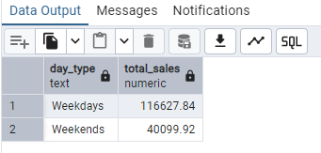

-- SALES BY STORE LOCATION

select
store_location ,
SUM(transaction_qty * unit_price) AS total_sales
from coffee_shop_sales
where extract (month from transaction_date ) = 5 -- Filter for "May"
group by store_location
order by total_sales desc ;

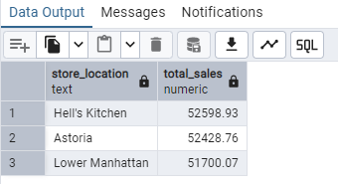

-- SALES BY PRODUCT CATEGORY

select
product_category ,
SUM(transaction_qty * unit_price) AS total_sales
from coffee_shop_sales
where extract (month from transaction_date ) = 5 -- Filter for "May"
group by product_category
order by total_sales desc ;

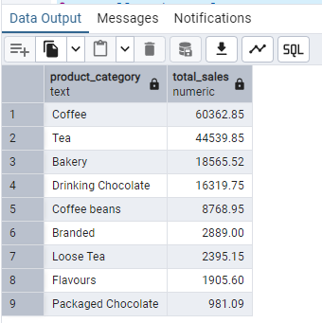

-- SALES BY PRODUCTS (TOP 10)

select
product_type ,
SUM(transaction_qty * unit_price) AS total_sales
from coffee_shop_sales
where extract (month from transaction_date ) = 5 -- Filter for "May"
group by product_type
order by total_sales desc
limit 10 ;

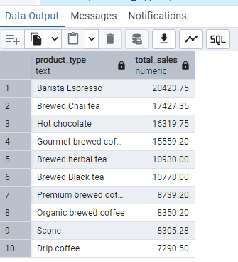

-- SALES BY DAY | HOUR

select
SUM(transaction_qty * unit_price) AS total_sales ,
count (*) as total_orders ,
SUM(transaction_qty ) AS total_quantity
from coffee_shop_sales
where
extract (dow from transaction_date) = 0 and -- "Sunday = 0"
extract (hour from transaction_time ) = 8 -- number of hour = 8
;
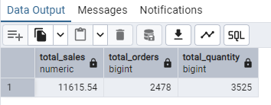

-- TO GET SALES FROM MONDAY TO SUNDAY FOR MONTH OF MAY

WITH sales_by_day AS (
SELECT
CASE
WHEN EXTRACT(DOW FROM transaction_date) = 0 THEN 'Sunday'
WHEN EXTRACT(DOW FROM transaction_date) = 1 THEN 'Monday'
WHEN EXTRACT(DOW FROM transaction_date) = 2 THEN 'Tuesday'
WHEN EXTRACT(DOW FROM transaction_date) = 3 THEN 'Wednesday'
WHEN EXTRACT(DOW FROM transaction_date) = 4 THEN 'Thursday'
WHEN EXTRACT(DOW FROM transaction_date) = 5 THEN 'Friday'
ELSE 'Saturday'
END AS day_of_week,
transaction_qty * unit_price AS sale_amount,
transaction_qty
FROM coffee_shop_sales
WHERE EXTRACT(MONTH FROM transaction_date) = 5
)

SELECT
day_of_week,
ROUND(SUM(sale_amount), 2) AS total_sales,
COUNT(*) AS total_orders,
SUM(transaction_qty) AS total_quantity
FROM sales_by_day
GROUP BY day_of_week
ORDER BY CASE
WHEN day_of_week = 'Sunday' THEN 1
WHEN day_of_week = 'Monday' THEN 2
WHEN day_of_week = 'Tuesday' THEN 3
WHEN day_of_week = 'Wednesday' THEN 4
WHEN day_of_week = 'Thursday' THEN 5
WHEN day_of_week = 'Friday' THEN 6
WHEN day_of_week = 'Saturday' THEN 7
END;

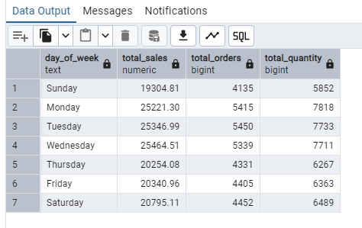

-- TO GET SALES FOR ALL HOURS FOR MONTH OF MAY

select
extract (hour from transaction_time) as hour_of_day ,
SUM(transaction_qty * unit_price) AS total_sales ,
count (*) as total_orders ,
SUM(transaction_qty ) AS total_quantity
from coffee_shop_sales
where
extract (month from transaction_date ) = 5 -- Filter for "May"
group by hour_of_day
order by hour_of_day asc ;

