**Task 1: ITCPA Agile Project Charter**

1. **System Objectives**

* Conestoga College ACSIT requires a new information system to replace the: manual submission and approval process for the capstone project.
* The ITCPA project aims to: resolve any inefficiencies and streamline the end-to-end capstone project approval process.
* The ITCPA application will be built using SAP Fiori design guidelines.
* The new system must continue to support the following major user roles: Clients, ACSIT Program Coordinator, faculty members, and ACSIT Student.
* The new system must provide an extensive set of reports and that can be viewed and printed.

1. **Project Roles/Responsibilities**

**Client Staff**

* **Lea Armstrong**, IT Program Coordinator: Project Sponsor, responsible for approving the project initially and then approving deliverables as the project proceeds;
* **Ted Tanner**, ACSIT Faculty Advisor: Project Contact / Domain Expert, responsible for working with the Technical Staff to manage the project on a day-to-day basis; also responsible for providing information and answering questions.

**Technical Staff**

* Ryan Das, Senior Software Developer: Scrum Master, responsible for facilitating scrum meetings and activities; removes obstacles of the Development team members;
* Jhon Doe, Business Analyst / QA: Product Owner, responsible for prioritizing the product backlog, business analysis and software testing;
* Jane Doe, Senior Software Developer: Development Team Member, responsible for developing the back-end services (API) of the system;
* Janice Doe, Front-end Software Developer: Development Team Member, responsible for developing the UI of the system.

1. **Business Benefits**

* The new **External Client Proposal** Subsystem Will Review student team project applications, reducing manual effort and improving efficiency.
* The new **Capstone Project Matching** Subsystem Will Review and approve student teams, ensuring that projects are assigned in a timely manner and avoiding conflicts or duplicate assignments.
* The new **Student Team Management** Subsystem Will Provide a centralized platform for managing student teams and apply to unassigned client project proposal.

1. **Requirements**

**4A. Preliminary Functional Requirements**

**User Story 1: As a faculty adviser, I want quickly to match and approve the client project proposals and student teams, so that I can concentrate on my main job responsibilities as a teaching professor,**

* **Preliminary Acceptance Criteria: The system should allow Faculty Advisor to match client project proposals to approved student teams at the start of each term.**

**User Story 2: As a Client, I want students to be automatically notified when a project is taken, so that I must spend less time on communication with students regrading projects that have a team already assigned,**

* **Preliminary Acceptance Criteria: project-related information should be communicated to student teams through the system.**

**4B. Non-functional Requirements**

|  |  |
| --- | --- |
| **Usability requirements** | * The system should have a user-friendly interface that is simple to use and does not require any technical knowledge. * The system should be responsive to various devices and screen sizes, giving a consistent user experience across platforms. |
| **Reliability requirements** | * The system should have secure backups and reliable recovery methods for data and system stability * The system should have a low failure rate and reliable operation throughout the process. |
| **Performance requirements** | * The system should respond quickly while the user performs operations. * The system should be able to successfully manage several user interactions at the same time, especially during peak usage periods. |
| **Security requirements** | * The system should have strong access control methods to ensure that only authorized individuals can access the system. * The system should use data encryption techniques to protect sensitive data while transferring between faculty advisor, clients, and students. |

1. **Project Team Critical Success Factors**

* The ITCPA stakeholders are Ted Tanner (project contact person), Conestoga College capstone project clients, ACSIT Program Coordinator, Faculty members and ACSIT students.
* The Product Owner should: develop and communicate the needs of stakeholder.
* The Scrum Master should: facilitate all the communications between the team.
* Team members should: develop new system.

1. **Preliminary Technical Architecture:**

**The proposed technical architecture is cloud**-based technical architecture:

* 1. **Development environment**
* VS Code
* MySQL
  1. **Production Server Environment**
* Azure cloud platform
* Node.js
  1. **Production Client Environment**
* Client should have PCs, laptops or a mobile interface.
* Clients should have a web browser like Brave, Google Chrome etc.

**Task 2: Proposed To-be Workflow**

**Business Process Name: ITCPA Client Capstone Project Matching Process**

**Process Goal: set up a way to track and match the client IT capstone project proposals to students.**

**Process Result: reduce inefficiencies and simplify the entire capstone project approval process.**

**Workflow Diagram:**

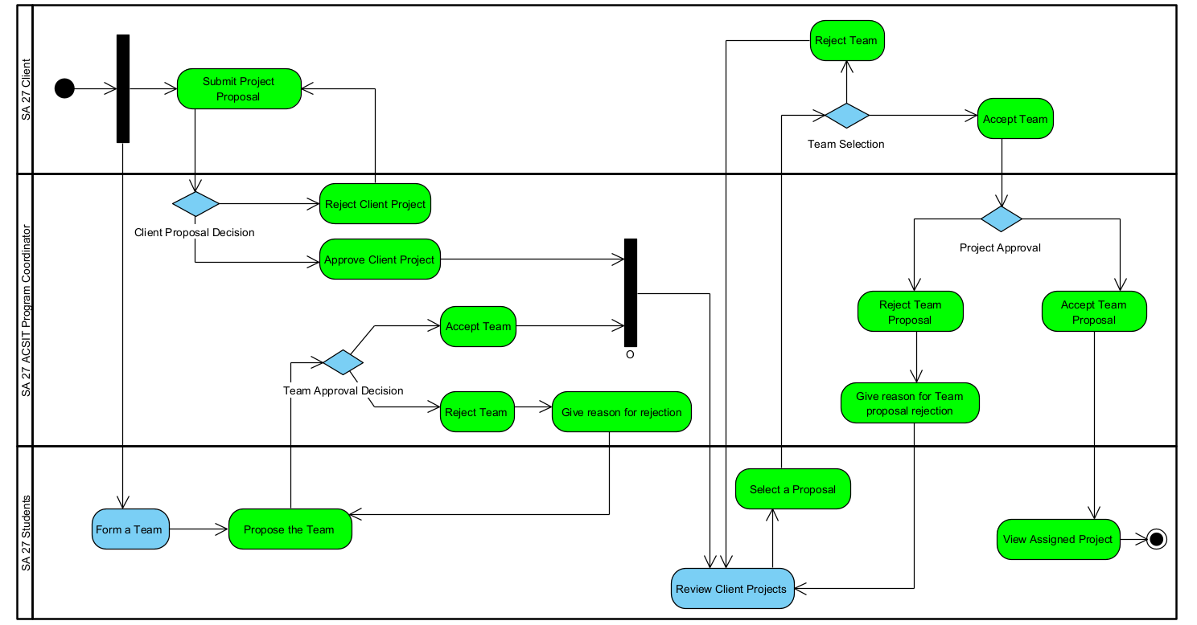

**Appendix A: Interview questions for the stakeholders**

**1. Stakeholder 1 Name / Position: ACSIT Faculty Advisor**

**Questions:**

* **Close-ended question: How many teams do you get assigned to?**
* **Open-ended question: How do you review the client project submitted by the student teams?**

**2. Stakeholder 2 Name / Position: ACSIT Students**

**Questions:**

* **Close-ended question: How long does it take to get assigned to a client project?**
* **Open-ended question: How would an automated capstone project approval process enhance your experience?**