**Task 1A:** Student Team Management Subsystem **(STMS)**

|  |  |  |
| --- | --- | --- |
| **Class** | **Attribute** | **Synonym** (optional) |
| Student |  |  |
|  | studentID {key} | studentNumber |
|  | programCode | courseCode |
|  | teamID | teamCode |
|  | schoolTerm | academicTerm |
|  | fullName | studentName |
|  | phoneNumber | studentPhoneNumber |
|  | emailID | studentEmailAddress |
| StudentTeam |  |  |
|  | teamID {key} | teamCode |
|  | teamName | teamTitle |
|  | teamMembers | teamPersonnel |
|  | facultyAdvisorID{key} |  |
| Faculty Advisor |  |  |
|  | facultyAdvisorID{key} | facultyID |
|  | fullName | FacultyAdvisorName |
|  | emailID | facultyAdvisoremail |
|  | phoneNumber | facultyAdvisorphone |
|  | facultyName |  |
|  | teamAdvised | instructedTeam |

**Task 1B:** Capstone Project Matching Subsystem **(CPMS)**

|  |  |  |
| --- | --- | --- |
| **Class** | **Attribute** | **Synonym**  (optional) |
| Project |  |  |
|  | projectID{key} | projectCode |
|  | projectName | projectTitle |
| StudentTeamProjectApplication |  | ProjectApplication |
|  | applicationID{key} | applicationNumber |
|  | applicationDate | SubmissionDate |
|  | projectID | projectCode |
|  | teamID | teamCode |
| Client |  |  |
|  | clientID{key} | clientNumber |
|  | fullName | clientName |
|  | emailID | clientEmail |
|  | phoneNumber | clientPhoneNumber |
|  | projectProposal | proposedProject |

**Task 2: ITCPA Domain Class Diagram (DCD)**

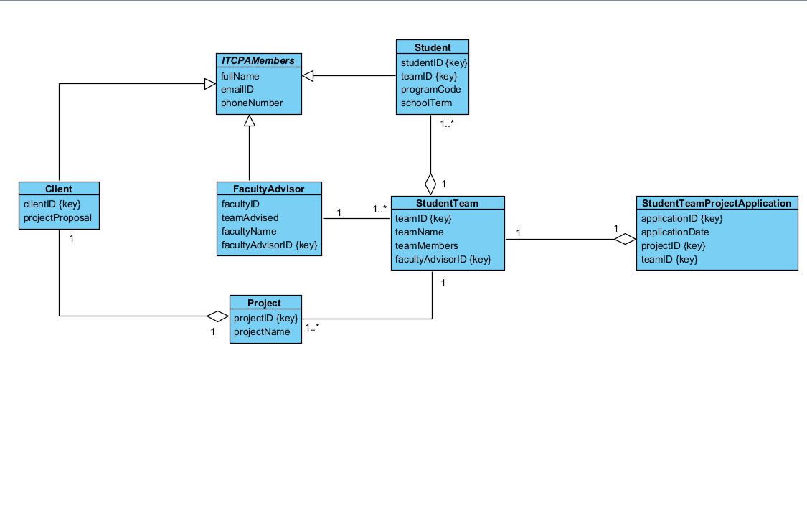

**Task 3A: ITCPA StudentTeamProjectApplication State Table**

|  |  |  |
| --- | --- | --- |
| **State ID** | **State Name** | **Transition Causing Exit** |
| S01 | Draft | Application is submitted, Update application files |
| S02 | Registered | Student team submits a project application |
| S03 | Cancelled | Student team cancels a project application before submission |
| S04 | Declined | Client declines project application |
| S05 | Matched | Application is selected by the client |
| S06 | Expired | Application is in registered state for 14 Days |
| S07 | Confirmed | Program Coordinator approves application in matched state |
| S08 | Rejected | Program Coordinator rejects application in matched state |

**Task 3B: ITCPA StudentTeamProjectApplication State Machine Diagram**

