**Task 1: Use Case Description with Wireframes, SSD and AD**

**1A.** **Fully developed Use Case Description**

|  |  |  |
| --- | --- | --- |
| Use Case # | UC11 | |
| Use Case Name | Look up approved client Proposal | |
| Scenario | Viewing available approved client proposal | |
| Triggering Event | The student team decide to view the list of available approved client proposals | |
| Brief Description | The system facilitates the student team in viewing the list of approved client proposals by accepting filtered conditions entered by the student team. The system then shows the approved client proposals that meet these conditions and are still available. | |
| Primary Actor | ACSIT Students | |
| Included Use Cases (if any) |  | |
| Stakeholders | Student team, faculty advisers | |
| Pre-conditions | Approved client proposals database should not be empty. | |
| Post-conditions | The system displays the list of approved client proposals based on the student team's filtered conditions.  The system is ready to perform another task, like apply to a proposal or log out. | |
| Wireframe(s) |  | |
| Flow of Activities | **Actor** | **System** |
| 1. Student Team enters the filtered condition to find specific client proposals. 2. Student navigates to View Approved Proposals section. | 1.1 System looks up the approved client proposals that meet the conditions and are still available.  1.2 System updates the list based on the filters to student team  2.1 Display approved proposal list |
| Exception  Conditions | 1. If there are no approved client proposals that meet the conditions, the system shows a message saying no proposals are available. | |

**1B.** **System Sequence Diagram (SSD)**

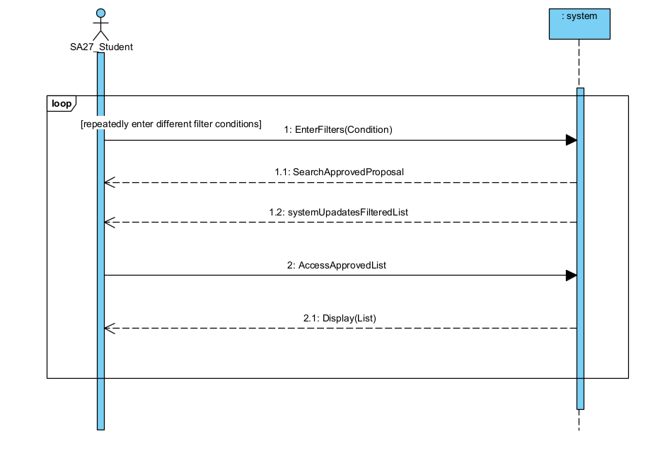

**1C.** **Activity Diagram (AD)**

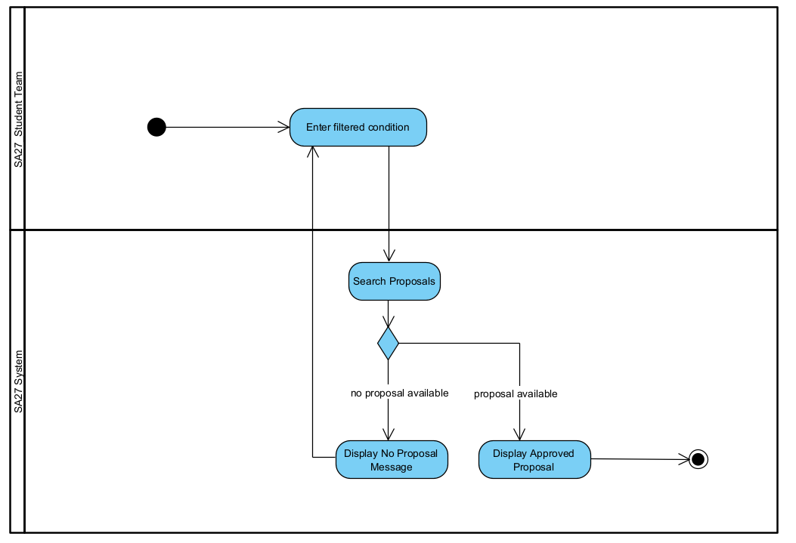

**Task 2: Use Case Description with Wireframes and SSD**

**2A.** **Fully developed Use Case Description**

|  |  |  |
| --- | --- | --- |
| Use Case # | UC12 | |
| Use Case Name | Apply to client proposals | |
| Scenario | Students applies to client proposals | |
| Triggering Event | The student team is approved by the program coordinator | |
| Brief Description | Students look up list of approved client proposals and apply to one or multiple client proposals | |
| Primary Actor | ACSIT Students | |
| Included Use Cases (if any) |  | |
| Stakeholders | Program Coordinator, Client, Students | |
| Pre-conditions | Student Team must be approved.  Client proposals must be approved | |
| Post-conditions | Clients are notified of new application.  Student are sent a conformation email of application. | |
| Wireframe(s) |  | |
| Flow of Activities | **Actor** | **System** |
| 1. Student team requests to look up list of client proposals 2. Student team requests for a project application form. 3. Student team submits application forms. 4. Student team approves the confirmation prompt 5. Student team dismisses confirmation alert box | 1.1 System verifies session ID.  1.2 System updates client proposals list  1.3 System sends updated list to the student team.  2.1 System sends project application form.  3.1 System checks filled information  3.2 System requests conformation from the student team.  4.1 System sends confirmation email to student team.  5.1 System displays the list of submitted applications |
| Exception  Conditions | 1.1 Failed to authenticate.  3.1 Client proposal application form is incorrectly filled | |

**2B.** **System Sequence Diagram (SSD)**

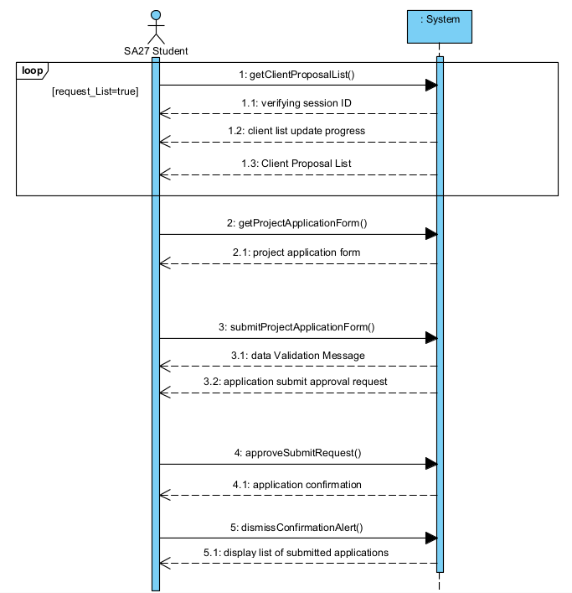

**Task 3: CRUD Matrix**

|  |  |  |  |  |
| --- | --- | --- | --- | --- |
|  | **Use Case** | | | |
| **Domain Class** | <UC #11> Look up approved client Proposal | <UC #12> Apply to client proposals | <UC #14>: Cancel a student team | <UC #41>: Attach document to a client proposal |
| Student | R | R | U | R |
| StudentTeam | R | C | D | U |
| Project | R | R | R | R |
| StudentTeamProjectApplication | R | U | U | U |