**Project theme ideas**

Colour schemes:

We have chosen a white background with green (#2B7A78) text for the welcome message. We picked this colour combination as we felt the green stood out clearly on a white background.

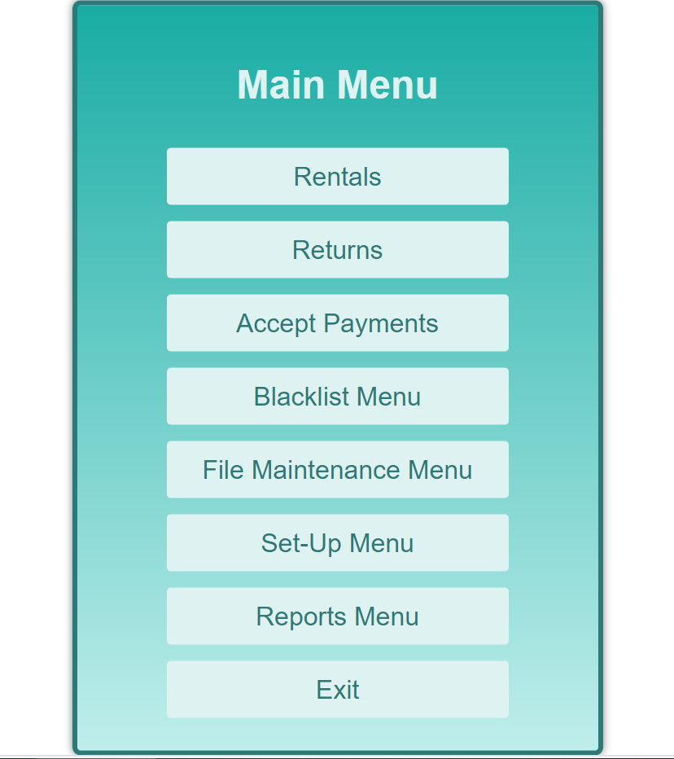

For the menu, we picked the same green (#2B7A78) as the welcome message for the border and for the text contained in link boxes.

For the background colour of the menu we selected a gradient from top to bottom, the top is a teal colour blending into a lighter teal (#bfeeeb, #19aca4).

The colour for the menu heading and the boxes which contain the links is #DEF2F1 which is a whitish teal colour. We picked this colour as we felt it contrasted nicely with the teal backgrounds.

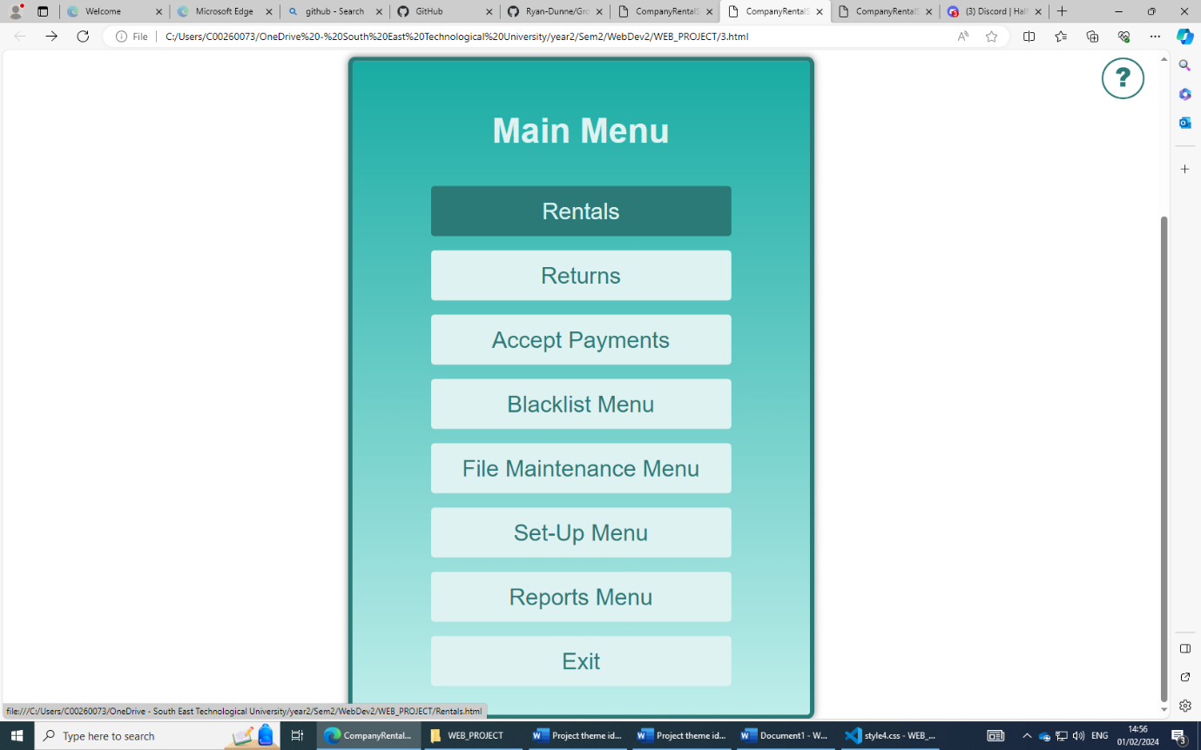

When the link boxes are hovered over the text becomes #DEF2F1 and the background becomes #2B7A78.

Style

Font family: The font-family we decided on was Roboto which is a sans-serif font. After researching we found this text was a good option as it is very easy to read and thought this would be important from an accessibility point of view.

We also decided to do rounded edges on the borders of the links, menu and will also use them for buttons the user has to click on.

Help button

The help button is fixed at the top right-hand corner of pages so the user can easily access help. The colours of the helper logo/button are also white and green(#2B7A78).

The logo will be at the top left-hand side of the screen.