CHAPTER VI

A Brief Case Study Using in Arizona

This section is dedicated to expanding upon the who, when, and where of surface O3 into what potential outcomes can occur in areas exposed to high concentrations. As mentioned in Chapter II.3.4, O3 is an oxidizing agent, participating in redox reactions while simultaneously reducing itself (Marmett et al. 2023; Qiu et al. 2025; Yang et al. 2024). Many of the transformations applied to the models of O3 in the AOI stem from this idea, incorporating air pollutants and high temperatures into thermodynamical equations. Also noted in Chapter II, air pollution and high temperature can be dangerous in their own rights. Features used with TD are included to show that they do not vary with demographic data as much as the estimated surface O3 concentrations. Surface O3 was mentioned to favor high vegetative areas, titrate with its constituents and move towards these sources when exposed to ample heat. Maps XI.3.6-XI.3.11 show clear splits in affected demographics for the randomly selected days to portray concentrations.

VI.1. Trends Over PHOTUC for Five Months

Due to the large nature of this project, depicting 2,125 days would be rather disingenuous to mother nature should a printed copy need exist somewhere. Random months and years were selected to keep the number down to 150. Full applications, processing of the full dataset and project management are further discussed in Chapter VII. It was imperative that all seasons were captured in this section, however due to summer temperatures in the AOI, June 2022 and July 2021 were included as duplicate seasons. January 2019, October 2020, and April 2023 depict the remaining Winter, Fall, and Spring seasons respectively. Given the low variance in terrain except around mountainous areas, many of the urban populations are in basins allowing for cumulation of atmospheric gases. The full daily outputs for each month are depicted starting on Map VIII.MAP.X V.2.2. and on. Only the first of each month was shown in detail. Averages for each county are covered, with the health outcomes of exposures at concentrations greater than the EPA Standard of 70 ppb in mind.

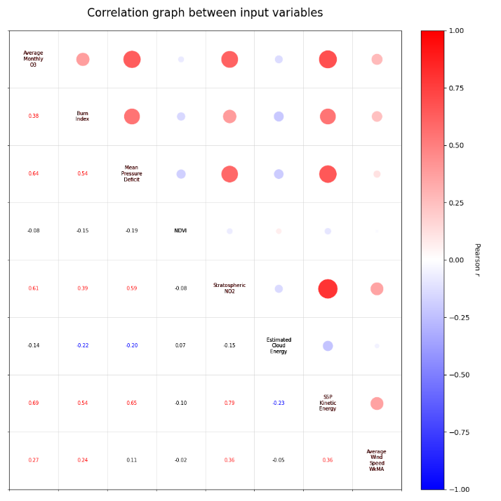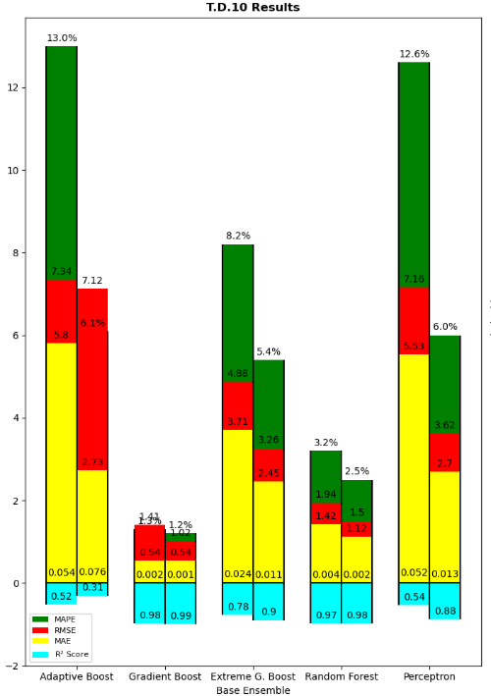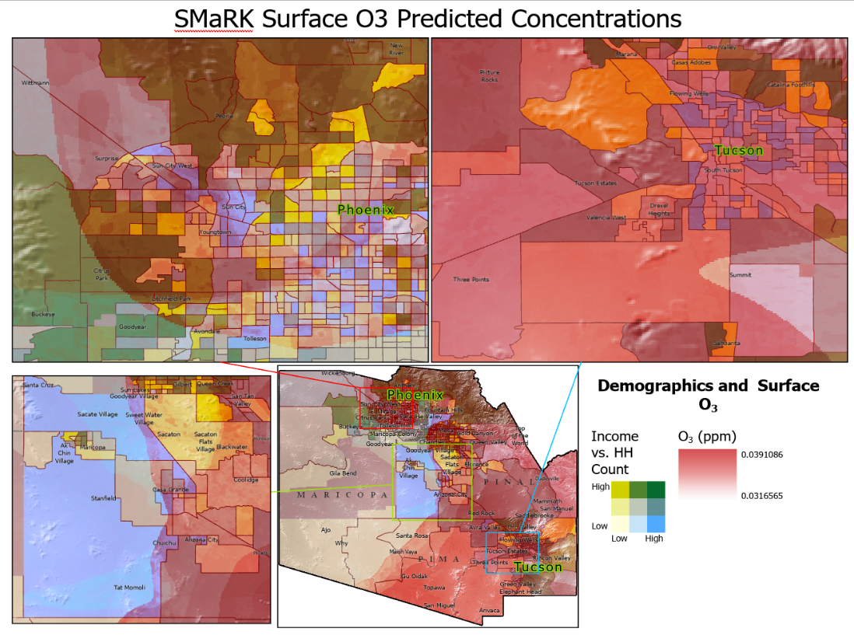

Map 1:

This is a caption for my map!

The overall predicted concentration of O3 for each county was compared to its average monitor value. It’s worth noting that the distribution of monitors per count was even and the distribution of average concentrations was slightly skewed towards Maricopa; in this study, the area saw higher concentrations on average: Studies have shown numerous respiratory and terminal diseases have been exponentially increasing in areas with poor conditions and high exposure to climate change (Abasilim and Friedman 2022; Anbari et al. 2022; Lee, Shin, and Chung 1999; Weschler 2006). In addition, studies find that human expansion tends to also increase exposure as a whole, increasing the amount of populations at risk to air pollution and natural hazards (Di Baldassarre et al. 2018; Abdullah et al. 2019; Iglesias et al. 2021).

In general, exposure to surface O3 has been associated with mortality risk from non-accidental diseases, circulatory disease, respiratory disease, urinary system disease, and nervous system diseases (Chen et al., 2023; Ito et al., 2005; Jerrett et al., 2009; KazemipaRKouhi et al., 2020; Lim et al., 2019; Raza et al., 2018; Reid et al., 2012; Turner et al., 2016). Some of these health outcomes have been related with exposure to mildly toxic environments and harsher living conditions (WHO 2013; Singh, Suresh, and Vellapandian 2023). Health studies which initially implemented ozone exposure as a confounding variable have instead found ozone to be a driver for concerning health outcomes which differ by age, employment, occupation, race/ethnicity, and other socio-economic status (SES) indicators, affecting a wide range of groups (Bell, Zanobetti, and Dominici 2014). Health outcomes due to exacerbated ozone exposure also tend to vary in severity based on duration and frequency of elevated surface O3 reactions (Turner et al. 2016a; Singh, Suresh, and Vellapandian 2023; Y. Wang et al. 2023).

VI.2. Maricopa

Distributions of surface O3 for Maricopa County were the most spread out with values ranging from 8.78 ppm to 107.09 ppm. This county houses Phoenix, the most populous city in Arizona as per census counts and number of households The estimated concentrations ranged from x to y based on gradient boosted fields. The distribution of highly populous areas with smaller amounts of occupied homes can be seen closer to Peoria and Glendale west of Phoenix. The coloring scheme shows many green shaded census tracks near the city center, typically surrounded by counties which have little variations in their mean and median income. Noting the surface O3 maps, the urban setting in Maricopa sees the most diversity in concentration distributions.

When overlaid with corresponding demographic information, many of the census tracts which have a high population, number of occupied households, and low deviation in their overall mean vs. median income are affected by higher concentrations. In addition, during low concentration months such as January, many of the trends show similar tendencies to weather patterns which tend to wrap around certain communities in the area. These same patterns can be seen during the high concentration months like October as well. The effects of both urban heath island effects and high-quality vegetative areas show the trends mentioned in Chapter II.3 where in O3 tends to settle in dry, undermaintained areas where the reaction is not stemming from.

VI.3. Pima

Distributions of surface O3 for Pima county were the most spread out with values ranging from 8.78 ppm to 107.09 ppm. The estimated concentrations ranged from x to y based on gradient boosted fields.

VI.4. Pinal

Distributions of surface O3 for Pima county were the most spread out with values ranging from 8.78 ppm to 107.09 ppm. This county is situated in between the Northeastern part of Pima and Southeastern part of Maricopa. The estimated concentrations ranged from x to y based on gradient boosted fields.

VI.5. O3 Exposure and Potential Impacts

Nearly all public health studies concerning air pollutants utilize statistical modeling techniques in some shape or form (Knowlton et al. 2004; Ito, De Leon, and Lippmann 2005; Javanmardi et al. 2017; De Marco et al. 2022). Such predictions give people the opportunity to avoid elevated exposure and the related health risks associated with short- and long-term exposure (Abdullah et al. 2019; Ghazali et al. 2010; Ballester et al. 2002; Braik et al. 2024; Duncan et al. 2014; Michael MacCracken 2008). Epidemiological studies have found statistically significant relationships between an increased risk of premature death and exposures to air pollutants. This relationship has been observed in relation to no just surface O3 reactions (Manisalidis et al. 2020; Liang et al. 2018; Nawaz 2023), but also in areas where O3 reactions co-funded with NO2 and temperature are occurring at or above national standards (Sun et al. 2024; Weng 2023; Kumar et al. 2015; X. Liu et al. 2022). A lower exposure of O3 typically relates to a high exposure to nitrogen dioxide (NO2), meaning those who are exposed to the risks of NO2 are equally at risk, if not more so, to illnesses and diseases which stem from both pollutants due to frequent movement between toxic environments (Singh, Suresh, and Vellapandian 2023; Akhter et al. 2015; Alexis et al. 2010; Xue et al. 2023; Turner et al. 2016a; T. Zhao et al. 2018).

Urban studies find interactions with redox states and pulmonary toxicity during long-term exposure episodes (L. Chen et al. 2019; Marmett et al. 2022; Ni et al. 2024) during reaction favored metrological events have been found to be related to mortality, respiratory, and increases in immune system response in numerous countries at urban locations similar to PHOTUC (Geels et al. 2015; Jerrett et al. 2009; Malley et al. 2017a; Turner et al. 2016b; C. Wang et al. 2021; Y. Zhang et al. 2024). Spatial-temporal analytics on monitoring systems combined with individual level data show activity spaces attribute greatly to a variety of health outcomes associated with ozone concentrations (US EPA 2015; Anenberg et al. 2018; H. Liu et al. 2018; Nuvolone, Petri, and Voller 2018; T. Zhao et al. 2018; J. Zhang, Wei, and Fang 2019). In addition, this thesis has found that surface ozone reactions typically follow the patterns mentioned in Chapter 2, occurring in middle-class to middle-low class areas in the study area. Combining the known risks and spatial temporal statistics of the SMaRK model, this section depicts the importance of clear representations of high-resolution surface O3 while doing a small systematic review of the effects of short- and long-term exposures to O3 seen in recent public health studies e.g. (Gao et al. 2022; Marmett et al. 2022; Turner et al. 2016b; Xue et al. 2023; T. Zhao et al. 2018).

VI.5. Environmental Impacts

Epidemiological studies have found statistically significant relationships between an increased risk of premature death and exposures to air pollutants which are common constituents for ozone production (Anenberg et al. 2022; Fuller et al. 2022; Nawaz 2023). Studies such as these tend to utilize the active monitoring of surface O3 reactions combined with statistical models and remote sensing images to create detailed exposure charts assigned to populations of interest (Gao et al. 2022; Jerrett et al. 2009; Turner et al. 2016a). While these are incredibly accurate, the models used can be improved beyond this thesis to allow for larger, more detailed trend analyses of urban environments (US EPA 2015; Balamurugan, Balamurugan, and Chen 2022; Y. Wang et al. 2023).

Current O3 exposure models have been used to support analyses which model the effects of other harmful air pollutants as well (Huang et al. 2017; Liang et al. 2018; N. Zhao et al. 2021). Due to the molecule’s unstable and reaction-ready state, ozone models need to be as accurate as possible to highlight possible health burdens associated with it and subsequent air pollution (Anenberg et al. 2018; Heal et al. 2013; Jahn and Hertig 2022). Policymakers at both local- and national-scales have lead large scale projects dedicated to improving air quality for the public and environmental health of their jurisdictions (Schlink et al. 2006; Honrath et al. 2017; IPCC 2022; WHO 2021; Kobayashi et al. 2015). The studies, data, and resulting policies which stem from these findings rely on consistent and accurate distributions of said pollutant gathered over time (Honrath et al. 2017; Tao 2023; Y. Wang et al. 2023; Weng 2023).

While recent years have added a wealth of information to atmospheric chemistry studies (H. Liu et al. 2018; Gaudel et al. 2018; Bourgeois et al. 2020; Johnson et al. 2024); historical analysis are difficult to create, and their importance for those encased in environmental injustice cycles is invaluable. More data is required for the slight correlations that have been found with the lack of early spatial information (Borja-Aburto et al. 1997; Hoek et al. 1997; Schlink et al. 2006; T. Zhao et al. 2018; J. Zhang, Wei, and Fang 2019; Anbari et al. 2022).

VI.6. Health Outcomes and Indicators

Health indicators such as measurements of lung function, respiratory symptoms, records of hospital admissions for specific diagnoses, and mortality have all been reported as outcomes due to elevated surface ozone exposure over long periods of time. The variation of health outcomes due to socio-economic status (SES) has been discussed in literature during the late 1990s (Hoek et al. 1997; Kelsall et al. 1997; Zmirou et al. 1998; Schwartz 2000). This known connection between predisposed and vulnerable people provides arguments that short-term mortality trends my actually be advanced by several days due to ozone pollution (SAMHSA 2017; Hu et al. 2012; Lopez-Bueno et al. 2020; Padilla et al. 2016). Trends like these have then shown elevated levels are typically followed by reduced mortality after the increased ozone production event. In historical modeling, coarse datasets have found very weak effects (Borja-Aburto et al. 1997; Hoek et al. 1997; Knowlton et al. 2004; Lee, Shin, and Chung 1999) only to be more prominent after adding suitable corrections to ozone models (De Marco et al. 2022; Javanmardi et al. 2017; H. Liu et al. 2018; Nuvolone, Petri, and Voller 2018; J. Zhang, Wei, and Fang 2019). Given such conflicting results in modeling outcomes, the assessment of the health risk due to surface ozone is still an intriguing aspect of air pollution monitoring *that can be further progressed with high spatial resolution data.*

VI.7. Final Exposure Concerns and Mean Aoi Trends

Health outcomes related to short- and long-term surface ozone have been investigated to find worrying evidence that supports O3 tends to disproportionally affect vulnerable populations based on surrounding environments. (Bell, Zanobetti, and Dominici 2014; Turner et al. 2016a; Malley et al. 2017b; Tessum et al. 2021; Hsu et al. 2021; Ermagun, Smith, and Janatabadi 2024). Outcomes such as chronic obstructive pulmonary disease (COPD), elderly cognitive impairment, pro-thrombosis, pediatric asthma, and general inflammation are suspected to stem from exacerbated long-term exposure to surface O3 reactions (Balmes 2019; Gao et al. 2022; Niu et al. 2022). In short-term ozone studies, pre-teen and post-retirement age groups are more at risk while young, healthy populations varying results due to interactions with oxidative systems in the body. (Barath et al. 2013; C. Chen et al. 2023, 2023; Díaz et al. 2018; Goodman et al. 2018; Raza et al. 2018; Roth, Hwang, and Li 2008).

Short-term ambient exposure to surface O3 may also impact the risk of multiple sclerosis (MS) by increasing triglycerides, cholesterol, and blood pressure in predisposed populations. Women and older adults (especially those over 75) seem to be more affected by short-term ozone exposures (C. Chen et al. 2023; Fuller et al. 2022). Many of these outcomes occur at or above the EPA standard of 70ppb. Maricopa county, which houses Phoenix, saw high averages of income, population density, and surface O3 concentrations. In addition, areas with better kept greenspace near both Phoenix and Tucson would see the brunt of high concentrations in the area. While January and October showed averages lover than the EPA standard, these areas spiked, with potential exposures above 70ppb according to both in-situ and modelled measurements. Further improvements to the overall code, pre-processing methods, and applications of RK are needed to better depict harmful substances and exposures at high resolutions in urban areas.

Citations

Abasilim, Chibuzor, and Lee S. Friedman. 2022. “Comparison of Health Outcomes from Heat-Related Injuries by National Weather Service Reported Heat Wave Days and Non-Heat Wave Days - Illinois, 2013-2019.” INTERNATIONAL JOURNAL OF BIOMETEOROLOGY 66 (3): 641–45. doi:10.1007/s00484-021-02218-6.

Abdullah, Samsuri, Najihah Husna Ahmad Nasir, Marzuki Ismail, Ali Najah Ahmed, and Mohamad Nor Khasbi Jarkoni. 2019. “Development of Ozone Prediction Model in Urban Area.” International Journal of Innovative Technology and Exploring Engineering 8 (10): 2263–67. doi:10.35940/ijitee.J1127.0881019.

Akhter, Hasina, Carol Ballinger, Nianjun Liu, Thomas van Groen, Edward M. Postlethwait, and Rui-Ming Liu. 2015. “Cyclic Ozone Exposure Induces Gender-Dependent Neuropathology and Memory Decline in an Animal Model of Alzheimer’s Disease.” Toxicological Sciences: An Official Journal of the Society of Toxicology 147 (1): 222–34. doi:10.1093/toxsci/kfv124.

Alexis, Neil E., John C. Lay, Milan Hazucha, Bradford Harris, Michelle L. Hernandez, Philip A. Bromberg, Howard Kehrl, et al. 2010. “Low-Level Ozone Exposure Induces Airways Inflammation and Modifies Cell Surface Phenotypes in Healthy Humans.” INHALATION TOXICOLOGY 22 (7): 593–600. doi:10.3109/08958371003596587.

Anbari, Khatereh, Yusef Omidi Khaniabadi, Pierre Sicard, Hasan Raja Naqvi, and Rajab Rashidi. 2022. “Increased Tropospheric Ozone Levels as a Public Health Issue during COVID-19 Lockdown and Estimation the Related Pulmonary Diseases.” Atmospheric Pollution Research 13 (12): 101600. doi:10.1016/j.apr.2022.101600.

Anenberg, Susan C., Daven K. Henze, Veronica Tinney, Patrick L. Kinney, William Raich, Neal Fann, Chris S. Malley, et al. 2018. “Estimates of the Global Burden of Ambient PM2.5, Ozone, and NO2 on Asthma Incidence and Emergency Room Visits.” Environmental Health Perspectives 126 (10). Environmental Health Perspectives: 107004. doi:10.1289/EHP3766.

Anenberg, Susan C, Arash Mohegh, Daniel L Goldberg, Gaige H Kerr, Michael Brauer, Katrin Burkart, Perry Hystad, Andrew Larkin, Sarah Wozniak, and Lok Lamsal. 2022. “Long-Term Trends in Urban NO2 Concentrations and Associated Paediatric Asthma Incidence: Estimates from Global Datasets.” The Lancet Planetary Health 6 (1): e49–58. doi:10.1016/S2542-5196(21)00255-2.

Balamurugan, Vigneshkumar, Vinothkumar Balamurugan, and Jia Chen. 2022. “Importance of Ozone Precursors Information in Modelling Urban Surface Ozone Variability Using Machine Learning Algorithm.” Scientific Reports 12 (1). Nature Publishing Group: 5646. doi:10.1038/s41598-022-09619-6.

Ballester, EB, GCI Valls, JL Carrasco-Rodriguez, ES Olivas, and S del Valle-Tascon. 2002. “Effective 1-Day Ahead Prediction of Hourly Surface Ozone Concentrations in Eastern Spain Using Linear Models and Neural Networks.” ECOLOGICAL MODELLING 156 (1): 27–41.

Balmes, John R. 2019. “Long-Term Exposure to Ozone and Cardiopulmonary Mortality: Epidemiology Strikes Again.” American Journal of Respiratory and Critical Care Medicine 200 (8). American Thoracic Society - AJRCCM: 958–59. doi:10.1164/rccm.201906-1105ED.

Barath, Stefan, Jeremy P. Langrish, Magnus Lundbäck, Jenny A. Bosson, Colin Goudie, David E. Newby, Thomas Sandström, Nicholas L. Mills, and Anders Blomberg. 2013. “Short-Term Exposure to Ozone Does Not Impair Vascular Function or Affect Heart Rate Variability in Healthy Young Men.” Toxicological Sciences 135 (2): 292–99. doi:10.1093/toxsci/kft157.

Bell, Michelle L., Antonella Zanobetti, and Francesca Dominici. 2014. “Who Is More Affected by Ozone Pollution? A Systematic Review and Meta-Analysis.” American Journal of Epidemiology 180 (1): 15–28. doi:10.1093/aje/kwu115.

Borja-Aburto, V. H., D. P. Loomis, S. I. Bangdiwala, C. M. Shy, and R. A. Rascon-Pacheco. 1997. “Ozone, Suspended Particulates, and Daily Mortality in Mexico City.” American Journal of Epidemiology 145 (3): 258–68. doi:10.1093/oxfordjournals.aje.a009099.

Bourgeois, Ilann, Jeff Peischl, Chelsea R. Thompson, Kenneth C. Aikin, Teresa Campos, Hannah Clark, Róisín Commane, et al. 2020. “Global-Scale Distribution of Ozone in the Remote Troposphere from the ATom and HIPPO Airborne Field Missions.” Atmospheric Chemistry and Physics 20 (17): 10611–35. doi:10.5194/acp-20-10611-2020.

Braik, Malik, Alaa Sheta, Elvira Kovac-Andric, Heba Al-Hiary, Sultan Aljahdali, Walaa H. Elashmawi, Mohammed A. Awadallah, and Mohammed Azmi Al-Betar. 2024. “Predicting Surface Ozone Levels in Eastern Croatia: Leveraging Recurrent Fuzzy Neural Networks with Grasshopper Optimization Algorithm.” WATER AIR AND SOIL POLLUTION 235 (10). doi:10.1007/s11270-024-07378-w.

Chen, Chen, Tiantian Li, Qinghua Sun, Wanying Shi, Mike Z. He, Jiaonan Wang, Jing Liu, et al. 2023. “Short-Term Exposure to Ozone and Cause-Specific Mortality Risks and Thresholds in China: Evidence from Nationally Representative Data, 2013-2018.” Environment International 171 (January): 107666. doi:10.1016/j.envint.2022.107666.

Chen, Lulu, Ruijing Ni, Mengyao Liu, Jingxu Wang, Hongjian Weng, Hao Kong, and Jintai Lin. 2019. “Changes in Global Surface Ozone and Health Implications over the Past Decades.” Geophysical Research Abstracts 21 (January). Copernicus Gesellschaft mbH: 1–1.

De Marco, Alessandra, Hector Garcia-Gomez, Alessio Collalti, Yusef Omidi Khaniabadi, Zhaozhong Feng, Chiara Proietti, Pierre Sicard, Marcello Vitale, Alessandro Anav, and Elena Paoletti. 2022. “Ozone Modelling and Mapping for Risk Assessment: An Overview of Different Approaches for Human and Ecosystems Health.” Environmental Research 211 (August): 113048. doi:10.1016/j.envres.2022.113048.

Di Baldassarre, Giuliano, Daniel Nohrstedt, Johanna Mård, Steffi Burchardt, Cecilia Albin, Sara Bondesson, Korbinian Breinl, et al. 2018. “An Integrative Research Framework to Unravel the Interplay of Natural Hazards and Vulnerabilities.” Earth’s Future 6 (3): 305–10. doi:10.1002/2017EF000764.

Díaz, Julio, Cristina Ortiz, Isabel Falcón, Coral Salvador, and Cristina Linares. 2018. “Short-Term Effect of Tropospheric Ozone on Daily Mortality in Spain.” Atmospheric Environment 187 (August): 107–16. doi:10.1016/j.atmosenv.2018.05.059.

Duncan, Bryan N., Ana I. Prados, Lok N. Lamsal, Yang Liu, David G. Streets, Pawan Gupta, Ernest Hilsenrath, et al. 2014. “Satellite Data of Atmospheric Pollution for U.S. Air Quality Applications: Examples of Applications, Summary of Data End-User Resources, Answers to FAQs, and Common Mistakes to Avoid.” Atmospheric Environment 94 (September): 647–62. doi:10.1016/j.atmosenv.2014.05.061.

Ermagun, Alireza, Virginia Smith, and Fatemeh Janatabadi. 2024. “High Urban Flood Risk and No Shelter Access Disproportionally Impacts Vulnerable Communities in the USA.” COMMUNICATIONS EARTH & ENVIRONMENT 5 (1). doi:10.1038/s43247-023-01165-x.

Fuller, Richard, Philip J Landrigan, Kalpana Balakrishnan, Glynda Bathan, Stephan Bose-O’Reilly, Michael Brauer, Jack Caravanos, et al. 2022. “Pollution and Health: A Progress Update.” The Lancet Planetary Health 6 (6): e535–47. doi:10.1016/S2542-5196(22)00090-0.

Gao, Qi, Emma Zang, Jun Bi, Robert Dubrow, Sarah R. Lowe, Huashuai Chen, Yi Zeng, Liuhua Shi, and Kai Chen. 2022. “Long-Term Ozone Exposure and Cognitive Impairment among Chinese Older Adults: A Cohort Study.” Environment International 160 (February): 107072. doi:10.1016/j.envint.2021.107072.

Gaudel, A., O. R. Cooper, G. Ancellet, B. Barret, A. Boynard, J. P. Burrows, C. Clerbaux, et al. 2018. “Tropospheric Ozone Assessment Report: Present-Day Distribution and Trends of Tropospheric Ozone Relevant to Climate and Global Atmospheric Chemistry Model Evaluation.” Edited by Detlev Helmig and Alastair Lewis. Elementa: Science of the Anthropocene 6 (January): 39. doi:10.1525/elementa.291.

Geels, C, C Andersson, O Hänninen, AS Lanso, PE Schwarze, CA Skjoth, and J Brandt. 2015. “Future Premature Mortality Due to O3, Secondary Inorganic Aerosols and Primary PM in Europe - Sensitivity to Changes in Climate, Anthropogenic Emissions, Population and Building Stock.” INTERNATIONAL JOURNAL OF ENVIRONMENTAL RESEARCH AND PUBLIC HEALTH 12 (3): 2837–69. doi:10.3390/ijerph120302837.

Ghazali, Nurul Adyani, Nor Azam Ramli, Ahmad Shukri Yahaya, Noor Faizah Fitri Md Yusof, Nurulilyana Sansuddin, and Wesam Ahmed Al Madhoun. 2010. “Transformation of Nitrogen Dioxide into Ozone and Prediction of Ozone Concentrations Using Multiple Linear Regression Techniques.” Environmental Monitoring and Assessment 165 (1–4): 475–89. doi:10.1007/s10661-009-0960-3.

Goodman, Julie E., Ke Zu, Christine T. Loftus, Heather N. Lynch, Robyn L. Prueitt, Isaac Mohar, Sara Pacheco Shubin, and Sonja N. Sax. 2018. “Short-Term Ozone Exposure and Asthma Severity: Weight-of-Evidence Analysis.” Environmental Research 160 (January): 391–97. doi:10.1016/j.envres.2017.10.018.

Heal, Mathew R., Clare Heaviside, Ruth M. Doherty, Massimo Vieno, David S. Stevenson, and Sotiris Vardoulakis. 2013. “Health Burdens of Surface Ozone in the UK for a Range of Future Scenarios.” ENVIRONMENT INTERNATIONAL 61 (November): 36–44. doi:10.1016/j.envint.2013.09.010.

Hoek, Gerard, Joel D. Schwartz, Bernard Groot, and Paul Eilers. 1997. “Effects of Ambient Particulate Matter and Ozone on Daily Mortality in Rotterdam, the Netherlands.” Archives of Environmental Health: An International Journal 52 (6): 455–63. doi:10.1080/00039899709602224.

Honrath, Richard E., Yaoxian Huang, Shiliang Wu, Louisa J. Kramer, and Detlev Helmig. 2017. “Surface Ozone and Its Precursors at Summit, Greenland: Comparison between Observations and Model Simulations.” Atmospheric Chemistry and Physics 17 (23): 14661–74. doi:10.5194/acp-17-14661-2017.

Hsu, Angel, Glenn Sheriff, Tirthankar Chakraborty, and Diego Manya. 2021. “Disproportionate Exposure to Urban Heat Island Intensity across Major US Cities.” Nature Communications 12 (1): 2721. doi:10.1038/s41467-021-22799-5.

Hu, Yi, Jinfeng Wang, Xiaohong Li, Dan Ren, Luke Driskell, and Jun Zhu. 2012. “Exploring Geological and Socio-Demographic Factors Associated with under-Five Mortality in the Wenchuan Earthquake Using Neural Network Model.” INTERNATIONAL JOURNAL OF ENVIRONMENTAL HEALTH RESEARCH 22 (2): 184–96. doi:10.1080/09603123.2011.613113.

Huang, Min, Gregory R. Carmichael, R. Bradley Pierce, Duseong S. Jo, Rokjin J. Park, Johannes Flemming, Louisa K. Emmons, et al. 2017. “Impact of Intercontinental Pollution Transport on North American Ozone Air Pollution: An HTAP Phase 2 Multi-Model Study.” Atmospheric Chemistry and Physics 17 (9): 5721–50. doi:10.5194/acp-17-5721-2017.

Iglesias, Virginia, Anna E. Braswell, Matthew W. Rossi, Maxwell B. Joseph, Caitlin McShane, Megan Cattau, Michael J. Koontz, et al. 2021. “Risky Development: Increasing Exposure to Natural Hazards in the United States.” Earth’s Future 9 (7): e2020EF001795. doi:10.1029/2020EF001795.

IPCC. 2022. Global Warming of 1.5°C: IPCC Special Report on Impacts of Global Warming of 1.5°C above Pre-Industrial Levels in Context of Strengthening Response to Climate Change, Sustainable Development, and Efforts to Eradicate Poverty. 1st ed. Cambridge University Press. doi:10.1017/9781009157940.

Ito, Kazuhiko, Samantha F. De Leon, and Morton Lippmann. 2005. “Associations Between Ozone and Daily Mortality: Analysis and Meta-Analysis.” Epidemiology 16 (4): 446–57. doi:10.1097/01.ede.0000165821.90114.7f.

Jahn, Sally, and Elke Hertig. 2022. “Using Clustering, Statistical Modeling, and Climate Change Projections to Analyze Recent and Future Region-Specific Compound Ozone and Temperature Burden Over Europe.” GeoHealth 6 (4): e2021GH000561. doi:10.1029/2021GH000561.

Javanmardi, Parviz, Pouran Morovati, Majid Farhadi, Sahar Geravandi, Yusef Omidi Khaniabadi, Kambiz Ahmadi Angali, Adewale Matthew Taiwo, et al. 2017. “Monitoring The Impact Of Ambient Ozone On Human Health Using Time Series Analysis And Air Quality Model Approaches.” Fresenius Environmental Bulletin 26 (November).

Jerrett, Michael, Richard T. Burnett, C. Arden Pope, Kazuhiko Ito, George Thurston, Daniel Krewski, Yuanli Shi, Eugenia Calle, and Michael Thun. 2009. “Long-Term Ozone Exposure and Mortality.” New England Journal of Medicine 360 (11). Massachusetts Medical Society: 1085–95. doi:10.1056/NEJMoa0803894.

Johnson, Matthew S., Alexei Rozanov, Mark Weber, Nora Mettig, John Sullivan, Michael J. Newchurch, Shi Kuang, et al. 2024. “TOLNet Validation of Satellite Ozone Profiles in the Troposphere: Impact of Retrieval Wavelengths.” Atmospheric Measurement Techniques 17 (8): 2559–82. doi:10.5194/amt-17-2559-2024.

Kazemiparkouhi, Fatemeh, Ki-Do Eum, Bingyu Wang, Justin Manjourides, and Helen H. Suh. 2020. “Long-Term Ozone Exposures and Cause-Specific Mortality in a US Medicare Cohort.” Journal of Exposure Science & Environmental Epidemiology 30 (4): 650–58. doi:10.1038/s41370-019-0135-4.

Kelsall, J. E., J. M. Samet, S. L. Zeger, and J. Xu. 1997. “Air Pollution and Mortality in Philadelphia, 1974-1988.” American Journal of Epidemiology 146 (9): 750–62. doi:10.1093/oxfordjournals.aje.a009351.

Knowlton, Kim, Joyce E. Rosenthal, Christian Hogrefe, Barry Lynn, Stuart Gaffin, Richard Goldberg, Cynthia Rosenzweig, Kevin Civerolo, Jia-Yeong Ku, and Patrick L. Kinney. 2004. “Assessing Ozone-Related Health Impacts under a Changing Climate.” Environmental Health Perspectives 112 (15): 1557–63. doi:10.1289/ehp.7163.

Kobayashi, Shinya, Yukinari Ota, Yayoi Harada, Ayataka Ebita, Masami Moriya, Hirokatsu Onoda, Kazutoshi Onogi, et al. 2015. “The JRA-55 Reanalysis: General Specifications and Basic Characteristics.” 気象集誌. 第2輯 93 (1): 5–48. doi:10.2151/jmsj.2015-001.

Kumar, Amit, Deepak Singh, Bhupendra Pratap Singh, Manoj Singh, Kumar Anandam, Krishan Kumar, and V. K. Jain. 2015. “Spatial and Temporal Variability of Surface Ozone and Nitrogen Oxides in Urban and Rural Ambient Air of Delhi-NCR, India.” AIR QUALITY ATMOSPHERE AND HEALTH 8 (4): 391–99. doi:10.1007/s11869-014-0309-0.

Lee, J T, D Shin, and Y Chung. 1999. “Air Pollution and Daily Mortality in Seoul and Ulsan, Korea.” Environmental Health Perspectives 107 (2): 149–54. doi:10.1289/ehp.99107149.

Liang, Ciao-Kai, J. Jason West, Raquel A. Silva, Huisheng Bian, Mian Chin, Yanko Davila, Frank J. Dentener, et al. 2018. “HTAP2 Multi-Model Estimates of Premature Human Mortality Due to Intercontinental Transport of Air Pollution and Emission Sectors.” Atmospheric Chemistry and Physics 18 (14). Copernicus GmbH: 10497–520. doi:10.5194/acp-18-10497-2018.

Lim, Chris C., Richard B. Hayes, Jiyoung Ahn, Yongzhao Shao, Debra T. Silverman, Rena R. Jones, Cynthia Garcia, Michelle L. Bell, and George D. Thurston. 2019. “Long-Term Exposure to Ozone and Cause-Specific Mortality Risk in the United States.” American Journal of Respiratory and Critical Care Medicine 200 (8): 1022–31. doi:10.1164/rccm.201806-1161OC.

Liu, Huan, Shuai Liu, Boru Xue, Zhaofeng Lv, Zhihang Meng, Xiaofan Yang, Tao Xue, Qiao Yu, and Kebin He. 2018. “Ground-Level Ozone Pollution and Its Health Impacts in China.” Atmospheric Environment 173 (January): 223–30. doi:10.1016/j.atmosenv.2017.11.014.

Liu, Xiaoyong, Jiqiang Niu, Jun Yan, Junhui Yan, Chengmei Zhao, Feng Xu, Yidan Zhang, and Bingbing Zhang. 2022. “Surface Ozone in the Central Plains Urban Agglomeration, China: Spatial-Temporal Variations and Health Impacts.” POLISH JOURNAL OF ENVIRONMENTAL STUDIES 31 (5): 4767–77. doi:10.15244/pjoes/150460.

Lopez-Bueno, J. A., J. Diaz, C. Sanchez-Guevara, G. Sanchez-Martinez, M. Franco, P. Gullon, M. Nunez Peiro, I Valero, and C. Linares. 2020. “The Impact of Heat Waves on Daily Mortality in Districts in Madrid: The Effect of Sociodemographic Factors.” ENVIRONMENTAL RESEARCH 190 (November). doi:10.1016/j.envres.2020.109993.

Malley, Christopher S., Daven K. Henze, Johan C.I. Kuylenstierna, Harry W. Vallack, Yanko Davila, Susan C. Anenberg, Michelle C. Turner, and Mike R. Ashmore. 2017a. “Updated Global Estimates of Respiratory Mortality in Adults ≥30Years of Age Attributable to Long-Term Ozone Exposure.” Environmental Health Perspectives 125 (8): 087021. doi:10.1289/EHP1390.

Manisalidis, Ioannis, Elisavet Stavropoulou, Agathangelos Stavropoulos, and Eugenia Bezirtzoglou. 2020. “Environmental and Health Impacts of Air Pollution: A Review.” Frontiers in Public Health 8 (February): 14. doi:10.3389/fpubh.2020.00014.

Marmett, B, RB Carvalho, RB Nunes, and CR Rhoden. 2022. “Exposure to O3 and NO2 in Physically Active Adults: An Evaluation of Physiological Parameters and Health Risk Assessment.” ENVIRONMENTAL GEOCHEMISTRY AND HEALTH 44 (12): 4269–84. doi:10.1007/s10653-021-01194-5.

Marmett, B, RB Carvalho, GN da Silva, GP Dorneles, PRT Romao, RB Nunes, and CR Rhoden. 2023. “The Role of O3 Exposure and Physical Activity Status on Redox State, Inflammation, and Pulmonary Toxicity of Young Men: A Cross-Sectional Study.” ENVIRONMENTAL RESEARCH 231 (August). doi:10.1016/j.envres.2023.116020.

Michael MacCracken. 2008. Sudden and Disruptive Climate Change : Exploring the Real Risks and How We Can Avoid Them. Earthscan Climate. London: Routledge. https://search.ebscohost.com/login.aspx?direct=true&AuthType=ip,sso&db=nlebk&AN=208918&site=ehost-live&scope=site&authtype=ip,sso&custid=s8860338.

Nawaz, M. Omar. 2023. “An Adjoint Sensitivity Framework for Public Health: The Sources of Air Pollution and Their Current and Future Impacts at Both the Urban and National Scale.” Dissertation, University of Colorado, Boulder. https://scholar.colorado.edu/concern/graduate_thesis_or_dissertations/q237ht48v.

Ni, JM, JM Jin, YW Wang, B Li, Q Wu, YF Chen, SW Du, YL Li, and C He. 2024. “Surface Ozone in Global Cities: A Synthesis of Basic Features, Exposure Risk, and Factors.” GEOGRAPHY AND SUSTAINABILITY 5 (1): 64–76. doi:10.1016/j.geosus.2023.09.008.

Niu, Yue, Huichu Li, Weidong Wang, Cuiping Wang, Cong Liu, Xihao Du, Qingli Zhang, et al. 2022. “Ozone Exposure and Prothrombosis: Mechanistic Insights from a Randomized Controlled Exposure Trial.” Journal of Hazardous Materials 429 (May): 128322. doi:10.1016/j.jhazmat.2022.128322.

Nuvolone, Daniela, Davide Petri, and Fabio Voller. 2018. “The Effects of Ozone on Human Health.” Environmental Science and Pollution Research 25 (9): 8074–88. doi:10.1007/s11356-017-9239-3.

Padilla, Cindy M., Wahida Kihal-Talantikit, Sandra Perez, and Severine Deguen. 2016. “Use of Geographic Indicators of Healthcare, Environment and Socioeconomic Factors to Characterize Environmental Health Disparities.” Environmental Health 15 (1): 79. doi:10.1186/s12940-016-0163-7.

Qiu, YX, QZ Liu, JW Tao, P Yan, GS Tan, FJ Liu, DY Wang, et al. 2025. “Enabling the Synthesis of O3-Type Sodium Anion-Redox Cathodes via Atmosphere Modulation.” NATURE COMMUNICATIONS 16 (1). doi:10.1038/s41467-025-57665-1.

Raza, Auriba, Marcus Dahlquist, Tomas Lind, and Petter L. S. Ljungman. 2018. “Susceptibility to Short-Term Ozone Exposure and Cardiovascular and Respiratory Mortality by Previous Hospitalizations.” Environmental Health 17 (1): 37. doi:10.1186/s12940-018-0384-z.

Reid, Colleen E., Jonathan M. Snowden, Caitlin Kontgis, and Ira B. Tager. 2012. “The Role of Ambient Ozone in Epidemiologic Studies of Heat-Related Mortality.” ENVIRONMENTAL HEALTH PERSPECTIVES 120 (12): 1627–30. doi:10.1289/ehp.1205251.

Roth, H. Daniel, Peggy May T. Hwang, and Yuanzhang Li. 2008. “Assesment of Recent Ozone Short-Term Epidemielogical Studies.” Inhalation Toxicology 13 (1): 1–24. doi:10.1080/089583701459038.

SAMHSA, Substance Abuse and Mental Health Services Administration. 2017. “Greater Impact: How Disasters Affect People of Low Socioeconomic Status.” Supplemental Research Bulletin, July.

Schlink, Uwe, Olf Herbarth, Matthias Richter, Stephen Dorling, Giuseppe Nunnari, Gavin Cawley, and Emil Pelikan. 2006. “Statistical Models to Assess the Health Effects and to Forecast Ground-Level Ozone.” Environmental Modelling & Software 21 (4): 547–58. doi:10.1016/j.envsoft.2004.12.002.

Schwartz, J. 2000. “Harvesting and Long Term Exposure Effects in the Relation between Air Pollution and Mortality.” American Journal of Epidemiology 151 (5): 440–48. doi:10.1093/oxfordjournals.aje.a010228.

Singh, S. Ankul, Swathi Suresh, and Chitra Vellapandian. 2023. “Ozone-Induced Neurotoxicity: In Vitro and in Vivo Evidence.” Ageing Research Reviews 91 (November): 102045. doi:10.1016/j.arr.2023.102045.

Sun, Haitong Zhe, Kim Robin Van Daalen, Lidia Morawska, Serge Guillas, Chiara Giorio, Qian Di, Haidong Kan, et al. 2024. “An Estimate of Global Cardiovascular Mortality Burden Attributable to Ambient Ozone Exposure Reveals Urban-Rural Environmental Injustice.” One Earth 7 (10): 1803–19. doi:10.1016/j.oneear.2024.08.018.

Tao, Chenliang. 2023. “Surface Ozone, NO2, and PM2.5 Concentrations Estimated by the Deep Learning Model (Air Transformer) Based on Satellite Data.” Zenodo. DRCI:DATA2024006028207158. doi:10.5281/ZENODO.10071407.

Tessum, Christopher W., David A. Paolella, Sarah E. Chambliss, Joshua S. Apte, Jason D. Hill, and Julian D. Marshall. 2021. “PM2.5 Polluters Disproportionately and Systemically Affect People of Color in the United States.” Science Advances 7 (18): eabf4491. doi:10.1126/sciadv.abf4491.

Turner, Michelle C., Michael Jerrett, C. Arden Pope, Daniel Krewski, Susan M. Gapstur, W. Ryan Diver, Bernardo S. Beckerman, et al. 2016a. “Long-Term Ozone Exposure and Mortality in a Large Prospective Study.” American Journal of Respiratory and Critical Care Medicine 193 (10). American Thoracic Society - AJRCCM: 1134–42. doi:10.1164/rccm.201508-1633OC.

US EPA, OAR. 2015. “Health Effects of Ozone Pollution.” Overviews and Factsheets. June 5. https://www.epa.gov/ground-level-ozone-pollution/health-effects-ozone-pollution.

Wang, CL, YY Wang, ZH Shi, JJ Sun, KJ Gong, JY Li, MM Qin, et al. 2021. “Effects of Using Different Exposure Data to Estimate Changes in Premature Mortality Attributable to PM2.5 and O3 in China.” ENVIRONMENTAL POLLUTION 285 (September). doi:10.1016/j.envpol.2021.117242.

Wang, Yuting, Guy P. Brasseur, Yong‐Feng Ma, Vincent‐Henri Peuch, and Tao Wang. 2023. “Does Downscaling Improve the Performance of Urban Ozone Modeling?” Geophysical Research Letters 50 (23): e2023GL104761. doi:10.1029/2023GL104761.

Weng, Xiang. 2023. “Surface Hourly Measurement Data of O3, NO2 and PM2.5 for ‘Large Modeling Uncertainty in Projecting Decadal Surface Ozone Changes over Urban and Industrial Regions of China.’” Zenodo. DRCI:DATA2023074026434277. doi:10.5281/ZENODO.7629985.

Weschler, Charles J. 2006. “Ozone’s Impact on Public Health: Contributions from Indoor Exposures to Ozone and Products of Ozone-Initiated Chemistry.” Environmental Health Perspectives 114 (10): 1489–96. doi:10.1289/ehp.9256.

WHO. 2021. World Health Organization (WHO) Global Air Quality Guidelines: Particulate Matter (PM2. 5 and PM10), Ozone, Nitrogen Dioxide, Sulfur Dioxide and Carbon Monoxide. 1st ed. Geneva: World Health Organization.

WHO, Regional Office for Europe. 2013. “Health Effects of Ozone.” In Review of Evidence on Health Aspects of Air Pollution – REVIHAAP Project: Technical Report. WHO Regional Office for Europe. https://www.ncbi.nlm.nih.gov/books/NBK361809/.

Xue, Tao, Ruohan Wang, Mingkun Tong, Frank J. Kelly, Hengyi Liu, Jiajianghui Li, Pengfei Li, et al. 2023. “Estimating the Exposure–Response Function between Long-Term Ozone Exposure and under-5 Mortality in 55 Low-Income and Middle-Income Countries: A Retrospective, Multicentre, Epidemiological Study.” The Lancet Planetary Health 7 (9). Elsevier: e736–46. doi:10.1016/S2542-5196(23)00165-1.

Yang, YH, Q Wang, JR Hou, J Liu, TY Sun, MX Tang, CT Chen, et al. 2024. “Enhancing Reversibility and Kinetics of Anionic Redox in O3-NaLi1/3Mn2/3O2 through Controlled P2 Intergrowth.” ANGEWANDTE CHEMIE-INTERNATIONAL EDITION 63 (43). doi:10.1002/anie.202411059.

Zhang, Junfeng, Yongjie Wei, and Zhangfu Fang. 2019. “Ozone Pollution: A Major Health Hazard Worldwide.” Frontiers in Immunology 10 (October). Frontiers. doi:10.3389/fimmu.2019.02518.

Zhang, Y, LL Fan, SG Wang, and H Luo. 2024. “Short-Term Interaction Effects of PM2.5 and O3 on Daily Mortality: A Time-Series Study of Multiple Cities in China.” TOXICS 12 (8). doi:10.3390/toxics12080578.

Zhao, Na, Xinyi Dong, Kan Huang, Joshua S. Fu, Marianne Tronstad Lund, Kengo Sudo, Daven Henze, et al. 2021. “Responses of Arctic Black Carbon and Surface Temperature to Multi-Region Emission Reductions: A Hemispheric Transport of Air Pollution Phase 2 (HTAP2) Ensemble Modeling Study.” Atmospheric Chemistry and Physics 21 (11). Copernicus GmbH: 8637–54. doi:10.5194/acp-21-8637-2021.

Zhao, Tianyu, Iana Markevych, Marcel Romanos, Dennis Nowak, and Joachim Heinrich. 2018. “Ambient Ozone Exposure and Mental Health: A Systematic Review of Epidemiological Studies.” Environmental Research 165 (August): 459–72. doi:10.1016/j.envres.2018.04.015.

Zmirou, Denis, Joel Schwartz, Marc Saez, Antonella Zanobetti, Bogdan Wojtyniak, Giotta Touloumi, Claudia Spix, et al. 1998. “Time-Series Analysis of Air Pollution and Cause-Specific Mortality.” Epidemiology 9 (5). Lippincott Williams & Wilkins: 495–503.