Ryan Korteway Nick Heady Michael Christensen 1-26-17 CIS 467

**Feasibility study**

* We will be using the Xcode IDE and the Swift language to develop our app. We will also be using the standard SDK for iOS development.
* For our frameworks and API's:
  + We will use Firebase as a backend for user identification and as a database. We will incorporate this using cocoapods and the Firebase API. Using Firebase will enable us to easily allow GVSU students to login in with their already created GVSU gmail account and this will also allow us to verify that they are a legitimate GVSU student.
  + For our payment method we will most likely use braintree which we will also implement using a cocoapod.
  + We will use the google maps API to integrate google maps into our app come sprint 2.
* Our code repository will be organized as a master branch with each of us having a separate branch we are working on. We will carefully upload our storyboard files to git as we know git has a problem merging storyboard files. We will only have one person working on the storyboard at a time to account for this.
* We will be using Firebase's Realtime Database for our database backend of user profiles and related information:
  + Potential Schema: GVB
    - * + Users

Riders

Name : Bill

Phone Number: xxx-xxx-xxxx

Location: Allendale

Destination: Grand Rapids

State : active

………..

* Drivers
  + Driver1
    - (same info as users but also car info and pay rate)

…………...

(An active drivers section, with subheadings for

each of the locations we will be servicing, Allendale, Grand Rapids, and Meijers)

* For our app, we will have a firebase backend/server and our clients will be the IOS apps running on our users iphones.

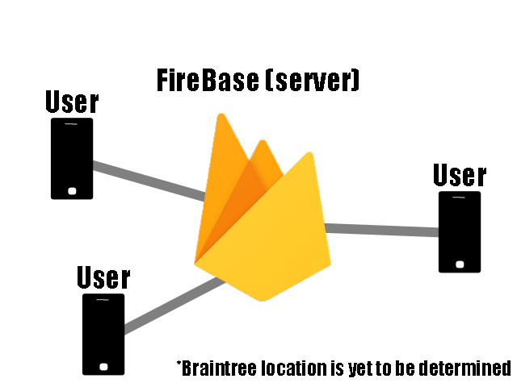

* What protocol(s) will be used between the system components? Are they standard protocols? If not, you should document them.
  + Protocol's will be Swift/IOS standard calls, Firebase API calls, and Braintree API calls.
  + If we use Braintree as our payment method we will be using a Python/Flask server hosted by Heroku that we will connect to view HTTP
* The development will be done in Xcode in its environments and in its simulator as well as a pair of test iphones as well.

**Nontrivial requirements**

For the requirement of account creation, we can implement firebase into our app so that signing up to use the app will be as simple as giving us the users GVSU email address and a password of their choosing.

From there the users can just sign in by providing the same credentials, again, authentication and user management actions such as account resetting being taken care of by firebase itself once we integrate the proper buttons and links into our app's UI.

Searches for rides will be done by querying the active drivers portion of the database for riders who are in the same location as the user is and are planning on heading to the same destination as the user.

Payments to drivers will tentatively be done via braintree integration into our app. Using their system calls within our app to integrate with their back end to be the middleman between the users as they make their payments etc.

Ride tracking will be done by reserving a portion of our database for a collection of "ride" entries which will contain data such as the UUID of both the driver, the rider, the start and stop locations, and the date/time of the ride.

A nontrivial requirement of this project will be how to keep ourselves and our users legally safe and secure. Our solution to this is to have a very solid user agreement to explain what we do and don't do to try and keep our users safe and how much or what kinds of responsibility we do or do not take. This course of action can really only be properly implemented after an advisory meeting with a legal professional.

A nontrivial requirement of the app will also be to get the word out so that we have users to give us feedback on our app between sprints 2 and 3. A potential solution to this will be to make a flier advertising our app and having it approved by the proper authorities on campus so that they can be hung anywhere it is appropriate to do so.

**User Interface**

The interface layout is relatively simple. The user is presented with a login screen and when they sign up they’ll be asked to provide some information. After submitting this info, they’ll be taken to the primary “Rider” screen, which allows them to specify where they are and where they’d like to go. In the first full version of the app, three options will be available: Allendale, Meijer (Standale), and Downtown. They will then be paired with a driver. The drivers interface will be similar, but they will only provide their current location.

The second version of the app will remove the options and use Google Maps to determine current location and pairing options. Provided here is a representation some basic features we want implemented on version one, the “Rider” screen and pop-out menu:

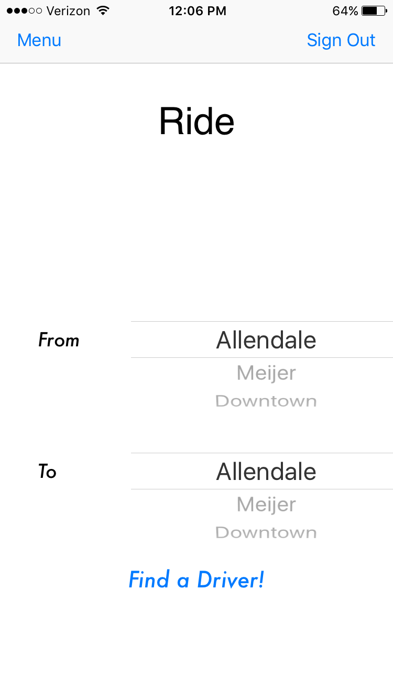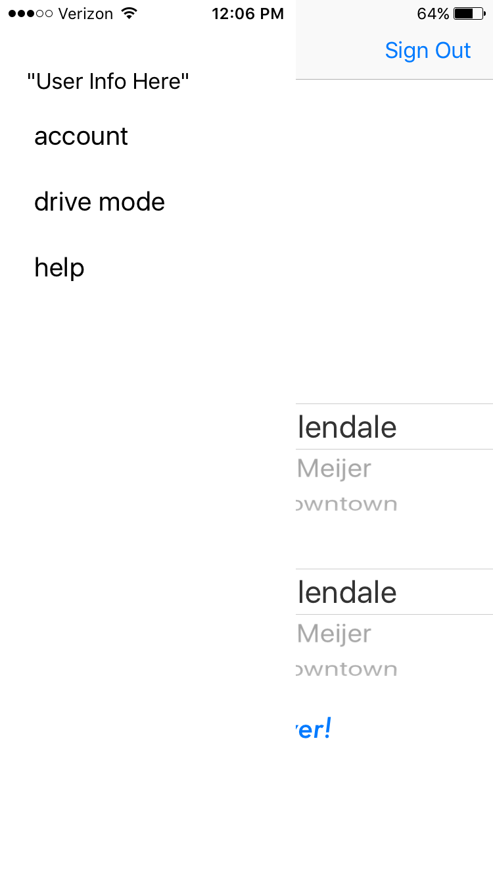

**Labor/Skills Division**

Nick Heady is in charge of our UI because he has more experience and interest in it. He also assists Ryan in firebase research and implementations so that he can learn more about the backend.

Ryan Korteway is more integrated into the firebase backend and implementing the necessary API calls into the view controllers so interactions with the UI of the app result in the proper actions/responses from the backend because he did extensive research into the Firebase tutorials and API calls early on in the project.

Michael Christensen is in charge of researching the last major component of our app which is Payment integrations as this was a remaining key component of the app. He has past experience using venmo whereas Nick and Ryan do not and venmo is one of the possible payment options for our users once braintree is integrated into the app.

Our entire team will research the legal questions we have about our app before we launch it. We expect this to take a fair amount of time because we will be responsible for setting up rides, storing a lot of personal data and collecting and distributing location information about individuals. We also need to research what type of security measures we need to have in order to store this information.

**Work Policies**

The central repository will be used to keep code in sync and individuals will branch when attempting major changes. We will assign one person to handle permanent storyboard changes and testing will be done on physical devices when major changes occur. A large part of this project is problem solving and researching APIs. The team participates in 1-2 meetings each week where we discuss progress on the research, demonstrate any testing we’ve done, and try to solve problems we’ve encountered.