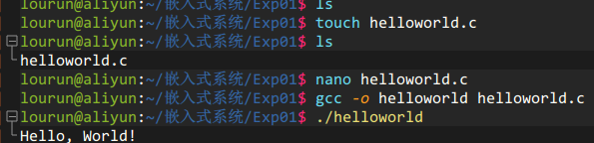
hello world.c
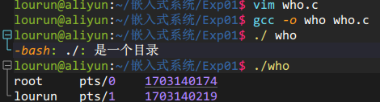
who.c
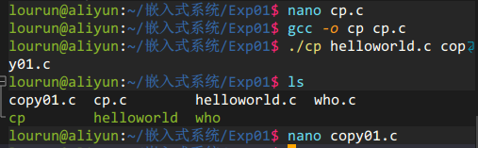
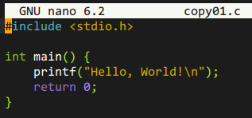
cp.c
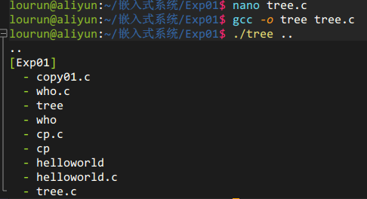
tree.c
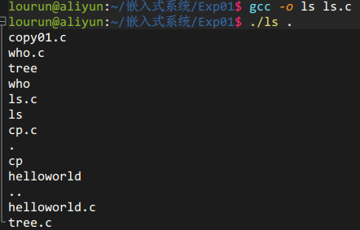
ls.c
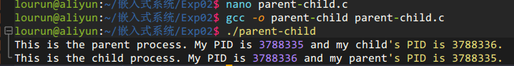
parent-child.c
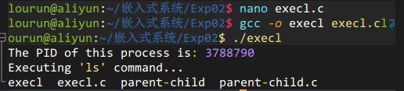
execl.c
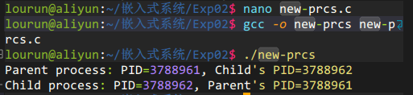
new-prcs.c
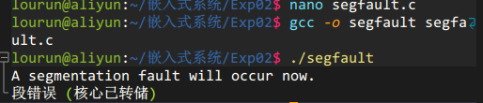
segfault
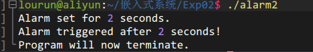
alarm2
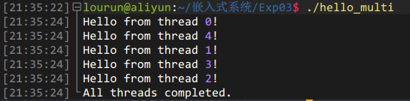
hello_multi
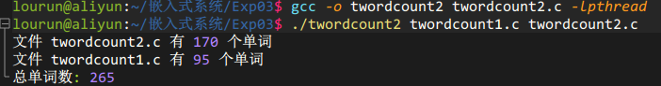
twordcount1,2
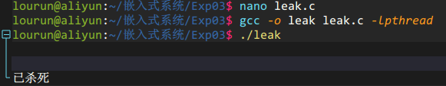
leak
lockdemo
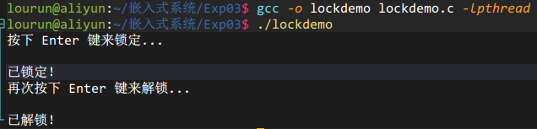
semaphores
gethostbyname
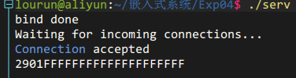
multi-server-2
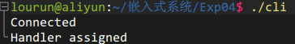
serv,c
cli.c

