Portable VIS-NIR Spectrometer

Design Document

Team SDDEC26-06
Faculty advisor/Client:
Manojit Pramanik (mano@iastate.edu)
Avishek Das (avishek@iastate.edu)

Project Members:

Team email address: sddec26-06@iastate.edu
Team website: https://sddec26-06.sd.ece.iastate.edu

Executive Summary

Provide a brief (300-500 word) summary of your project. This summary should give the reader enough information to understand the purpose, design strategies, and project progress thus far. It should address at least the following questions/items:
- What is the problem and why is it important?
- What are your key design requirements?
- Summarize your design, include approaches and technologies used.
- How much progress have you made thus far?
- How well does your design meet requirements and address user needs? How do you know?
- What are potential next steps to be taken?
The central project that our group is working on is finding a low-cost alternative to professional use spectrometers, especially one in the Near Infrared (NIR). Our motivation for taking on this design challenge is that current spectrometers are expensive, bulky, and not as accessible. We used a high sensitivity linear CCD (TCD1304DG), controlled through a STM32F411CEU6 microcontroller, and we will use a python application to display the data in real-time through USB. Our operating range for this spectrometer is 400nm – 1000nm wavelength. Our current progress includes PCB design verification and fabrication, sourcing optical components, and setting up microcontroller communication. Since our primary focus is on building this for Avishek’s person lab first, our metrics for measuring how well we meet the design requirements are quite clear. We have weekly standup meetings where we go over current design implementations, bugs, errors, and general updates on what phase we are in the project. While Avishek has given us room approach this project however we see fit, he makes sure that we are staying within his needs for the project – the operating wavelength, size, and components to use.

Learning Summary

Development Standards & Practices Used
List all standard circuit, hardware, software practices used in this project. List all the Engineering standards that apply to this project that were considered.

Summary of Requirements
List all requirements as bullet points in brief.

Applicable Courses from Iowa State University Curriculum
List all Iowa State University courses whose contents were applicable to your project.

New Skills/Knowledge acquired that was not taught in courses
List all new skills/knowledge that your team acquired which was not part of your Iowa State curriculum in order to complete this project.
Table of Contents
1. Introduction 5
1.1. Problem Statement 5
1.2. Intended Users 5
2. Requirements, Constraints, And Standards 5
2.1. Requirements & Constraints 5
2.2. Engineering Standards 5
3 Project Plan 6
3.1 Project Management/Tracking Procedures 6
3.2 Task Decomposition 6
3.3 Project Proposed Milestones, Metrics, and Evaluation Criteria 6
3.4 Project Timeline/Schedule 6
3.5 Risks And Risk Management/Mitigation 7
3.6 Personnel Effort Requirements 7
3.7 Other Resource Requirements 7
4 Design 7
4.1 Design Context 7
4.1.1 Broader Context 7
4.1.2 Prior Work/Solutions 8
4.1.3 Technical Complexity 8
4.2 Design Exploration 9
4.2.1 Design Decisions 9
4.2.2 Ideation 9
4.2.3 Decision-Making and Trade-Off 9
4.3 Proposed Design 9
4.3.1 Overview 9
4.3.2 Detailed Design and Visual(s) 9
4.3.3 Functionality 10
4.3.4 Areas of Concern and Development 10
4.4 Technology Considerations 10
4.5 Design Analysis 10
5 Testing 10
5.1 Unit Testing 11
5.2 Interface Testing 11
5.3 Integration Testing 11
5.4 System Testing 11
5.5 Regression Testing 11
5.6 Acceptance Testing 11
5.7 Security Testing (if applicable) 11
5.8 Results 11
6 Implementation 12
7 Professional Responsibility 12
7.1 Areas of Responsibility 12
7.2 Project Specific Professional Responsibility Areas 12
7.3 Most Applicable Professional Responsibility Area 12
8 Closing Material 12
8.1 Discussion 12
8.2 Conclusion 12
8.3 References 13
8.4 Appendices 13
9 Team 13
9.1 Team Members 13
9.2 Required Skill Sets for Your Project 13
(if feasible – tie them to the requirements) 13
9.3 Skill Sets covered by the Team 13
(for each skill, state which team member(s) cover it) 13
9.4 Project Management Style Adopted by the team 13
Typically Waterfall or Agile for project management. 13
9.5 Initial Project Management Roles 13
9.6 Team Contract 13

List of figures/tables/symbols/definitions (This should be the similar to the project plan)

Introduction
  - Problem Statement
Dr. Avishek Das needs a spectrometer that facilitates his routine experiments in the Biomedical Imaging Lab (BILab) at Iowa State University. In the research environment around the BILab, available spectrometers are expensive, bulky, and effectively fixed to a single location, which can introduce scheduling constraints and delays when an experiment requires measurements in a non-standard setup. These delays reduce iteration speed and limit the ability to validate results.
To address these needs, our project is developing a lower-cost, portable spectrometer that operates across the 400 to 1000-nm wavelength range. The device will operate as a complete package, combining three systems into a compact physical design with the core measurement functions needed for reliable use. First, the instrument will incorporate an optical system that separates incoming light into its component wavelengths, next a sensor and readout system will accurately capture the resulting spectrum, and finally a computer interface will display and record measurement data in a consistent, usable format. This structure will enable us to deliver a self-contained, practical tool that fits Dr. Das's workflows, supports use across the BILab, and remains more affordable than commercially available options.

  - Intended Users
This project was outlined and sponsored by Iowa State researchers at the BILab. Specifically, the project was proposed by Dr. Das under Prof. Pramanik. Through our work with Dr. Das, he has made it clear that he is the only one in the ISU faculty who currently plans on using the device in his research. Because of this, our project will only be considering his needs, although it may be useful to other users as well.

Persona 1: Dr. Das
Dr. Das is a Postdoc Research Associate with the Biomedical Imaging Lab at Iowa State University. He is a highly technical user who leads research in bio-sensing and optics. He is explorative and curious, valuing solutions that do not compromise on portability or efficiency. Encouraged to make his workflow more cost-effective, he attempts to do more with less.
The needs for this device pertain to the research that Dr. Das is doing in biomedicine. The research requires the ability to do quick, non-invasive embedded object imaging in multilayered biological tissues. More specifically, he wants to utilize the characteristics of light at near infrared wavelengths for this imaging. The system needs to be able to be integrated into the rest of his laboratory. This means sending collected information to his computer for analysis and visualization and maybe a phone for modularity. Based on these requirements, Dr. Das needs to quickly and accurately measure the wavelengths of light and easily view the results, while not being restricted by the cost or location of a device.
With the proposed spectrometer, Dr. Das can conduct more frequent and flexible testing. The spectrometer will fit in as a simplified, affordable substitute to solutions currently found on the market. It doesn't come with any extra functionality that won't be used in this kind of research, which maximizes its performance for the specific desired frequencies. The device boosts his lab's throughput and data collection speed.
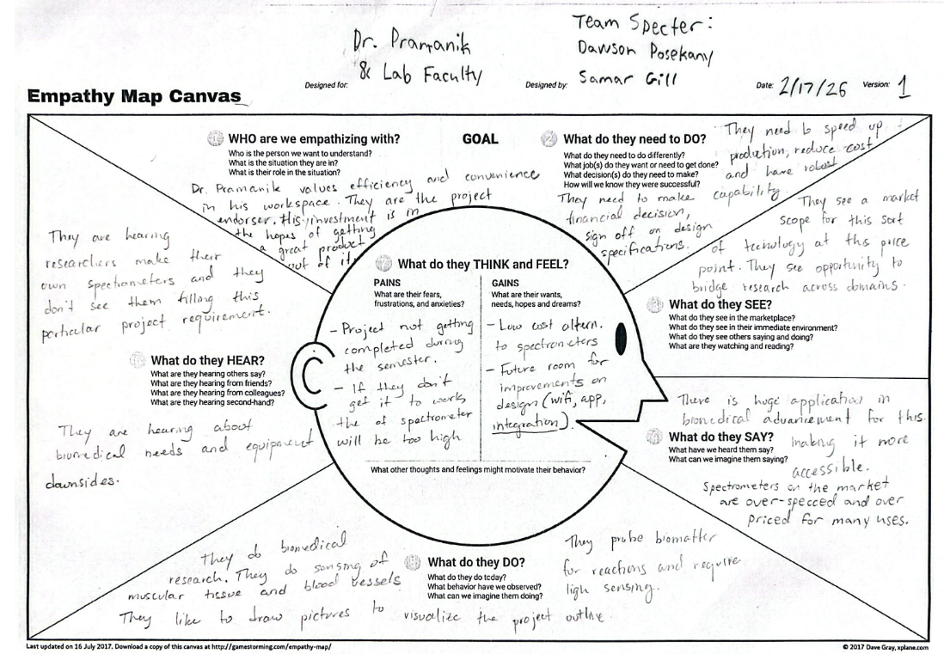
Note: Dr. Das encouraged publishing this device into scientific literature if the team feels the work warrants it. People outside Dr. Das’s lab could then use the device for a variety of purposes. In the way that the team is approaching this project, only the needs of Dr. Avishek and the capabilities of our team are being considered when making design decisions. Due to this, documentation about the needs of external users were placed in the appendix.

Requirements, Constraints, And Standards
  - Requirements & Constraints
Functional Requirements
- The device shall seperate incoming light into its component wavelengths and capture the resulting spectrum using the TCD1304DG linear CCD sensor.
- The device shall operate across a wavelength range of 400 nm to 1000 nm. (constraint)
- The device shall transmit spectral data to a host computer in real time via USB.
- A python application shall display the captured spectrum visually on the host computer.
- The device shall support a configurable integration time to accommodate varying light source intensities.
- The firmware shall drive all required timing signals for the TCD1304DG (master clock, integration clear pulse, shift gate) using the STM32F411CEU6 microcontroller. (constraint)
Resource Requirements
- The device shall use the STM32F411CEU6 as the primary microcontroller. (constraint)
- The optical subsystem shall use the TCD1304DG linear CCD as the detector. (constraint)
- The total bill of material cost shall remain significantly below that of comparable commercial VIS-NIR spectrometers.
Physical Requirements
- The device shall be portable and compact enough to be relocated within a lab environment by a single person without specialized equipment.
- All optical components shall be mountable on a standard optical breadboard using post-mount hardware during the development and testing phase.
- The final device shall include an enclosure that protects internal optics and electronics from ambient light contamination and physical damage.
- The device shall have some protective circuitry to prevent improper use from causing damage.
Performance Requirements
- The device shall achieve sufficient spectral resolution to distinguish features relevant to Dr. Das’s biosensing research across the 400-1000 nm range.
- The signal-to-noise ratio of the captured spectrum shall be adequate for reliable identification of spectral peaks under lab lighting conditions.
- The device shall complete a full spectral acquisition and transmission cycle at a rate sufficient for real-time display on the host computer.
User Experience Requirements
- The Python interface shall display a live spectral plot that updates with each new acquisition.
- The device shall be operable by Dr. Das without requiring hardware reconfiguration or adjustments to the code between routine measurements.
- Setup and teardown time for a standard measurement shall be minimal, supporting the fast iteration speed that motivated this project.
Economic Requirements
- The total project cost shall remain within the allocated senior design budget. (constraint)
- The final device cost shall be lower than commercially available VIS-NIR spectrometers with comparable wavelength coverage.
Environmental Requirements
- The device shall be designed for indoor laboratory use under standard temperature and humidity conditions.
- Component selection shall prefer parts with reasonable availability and lead times to avoid supply chain delays.
- Materials used shall not be hazardous to people or the environment, assuming proper operation and disposal.
  - Engineering Standards

As ethical engineers, our deontological principles dictate that we adhere to IEEE’s engineering standards. This team of engineers trust their panel of experts to put out well researched guidelines that will help us ensure our project is safe and reliable.

1. IEC 61010-1: Safety Requirements for Electrical Equipment
- Standard Type: Safety
- Description & Purpose: This is a foundational safety standard for lab equipment. Its primary goal is to protect the user and environment from hazards like a shock or fire. Crucially, it discusses the single-fault condition which states that even if one component should fail, the device remains safe to touch.
- Relevance to Vis-NIR Project: This spectrometer has a light collecting device and a power supply, so the team must adhere to this guideline to ensure the chassis is properly grounded and that any heat generated is efficiently dissipated.
- Design Modifications:
  - Isolation: Including vias to ground and adequate spacing to reduce danger in the case of a current surge and EMI protection.
  - Containment: Making a metal layer between the outer device and the internal optics and electronics with the aim of protecting the user.

2. IEC 61326-1: Electromagnetic Compatibility (EMC) Requirements
- Standard Type: Compatibility and Immunity
- Description & Purpose: This standard regulates the electromagnetic emissions and immunity of laboratory equipment. It ensures the spectrometer does not interfere with other electronics. On the other hand, it also seeks to ensure that our device can operate accurately in a noisy electromagnetic environment.
- Relevance to Vis-NIR Project: Spectrometers rely on highly sensitive photodetectors. The signals that are then produced are relatively weak. Without EMC compliance, external electrical noise could easily distort spectral data, leading to high signal-to-noise ratios. This would ultimately interfere with the high data resolution that we seek to achieve with this device.
- Design Modifications:
  - Shielding: Including some sort of coating or metal around the analog front-end should protect from outside EM noise.
  - Filtering: Decoupling capacitors added to the power traces level out the incoming power and prevent noise from leaking out to other parts of the circuit or off the device as radiation.

3. ASTM E275: Describing and Measuring Performance of UV-Vis Spectrophotometers
- Standard Type: Performance and Metrology
- Description & Purpose: This standard provides a consistent methodology for verifying the technical performance of a spectrometer. It focuses on characterizing wavelength accuracy, stray light levels, and photometric precision to ensure the data collected is scientifically valid.
- Relevance to Vis-NIR Project: This is the benchmark for our project’s success. It allows us to compare our "Senior Design" instrument against industry-standard benchmarks. It moves the project from being a "sensor" to a "scientific instrument."
- Design Modifications:
  - Calibration Routine: Developing a software module that executes a startup self-test, checking the dark current and the reference signal against a known baseline. A device that generates known, overlapping wavelengths will also be used to ensure precision of the sensor.
  - Opto-mechanical Alignment: Testing the slit and grating mounts to meet resolution requirements serves us with better data and is in line with this standard. The team will accomplish this by using a variable slit in earlier models for flexibility in the testing phase.

4. NIST-Traceable Wavelength Standards (SRM 2034)
- Standard Type: Calibration and Traceability
- Description & Purpose: The National Institute of Standards and Technology uploads data from their own devices with standardized absorption peaks. These standards are what all spectrometers are calibrated against.
- Relevance to Vis-NIR Project: Calibrating our sensor using an NIST-traceable material is necessary to adhere to code. This ensures that a reading of 900nm on our device is the same as 900nm on any other calibrated device.
- Design Modifications:
  - Reference Holder: Designing a standardized "sample slot" in the spectrometer housing that can hold a container for the NIST reference material.
  - Software Correction: Implementing a "Wavelength Shift" algorithm in the software to adjust the pixel-to-wavelength mapping based on the NIST reference peaks.

3 Project Plan

3.1 Project Management/Tracking Procedures
Earlier on in the project design process, the team implemented a waterfall+agile management style. During this time, the team was ordering most of the parts that would be needed for the remainder of the project, and that led to much more careful steps to ensure that the parts were what was needed for the current design and for future iterations of the design. That said, our other weekly work took a more agile approach where each pair of team members would work on a task or two each week.
Later in the projects' lifecycle, the team took on an agile management strategy. At this point, with our first prototype functioning, it was up to the team to work on improvements, additional features, and integrations with the greater Bio-imaging system Dr. Das is responsible for. The work was more focused on “what can we do next” rather than “what is the next step in this process”.
As for how progress is tracked in this management system, weekly roundups are made during the team’s weekly meetings with Dr. Das. These can be referenced at any point to know what tasks and sub-tasks were created and when. For the software side of our project, a GitLab is hosted which allows us to look at previous points in our development. As for the optics and hardware side of the project, the team stores our files on Microsoft Teams, including manuals, datasheets, and other documentation.

3.2 Task Decomposition
The main tasks involved with designing this project are to set up the optics, generate code for the microcontroller, create a user interface, and set up interaction between different sections of the project. Testing and optimization will also be necessary, as well as a way to calibrate the device.
The optics task can be further broken down into splitting the light based on wavelength, reducing effects of second order diffractions and ambient light, and mapping the spectrum onto the CCD. This will mainly involve selecting parts and determining proper positioning.
For the microcontroller code, it will need to generate the PWM timer signals, include ADC to read the data, use DMA for performance, and implement USB communication with the computer. It will also need to respond to inputs from the computer to determine when to start measurements and change any other parameters.
The user interface will need to graphically display the received data and have options for the user to customize the measurement. This will involve code for USB communication and manipulation of the data to reflect the correct wavelengths and intensities.
In order to put all of these sections together, various smaller tasks will need to be completed. These include selecting and incorporating a battery, creating a housing for the device, and including circuitry for driving the CCD.

3.3 Project Proposed Milestones, Metrics, and Evaluation Criteria
What are some key milestones in your proposed project? It may be helpful to develop these milestones for each task and subtask from 3.2. How do you measure progress on a given task? These metrics, preferably quantifiable, should be developed for each task. The milestones should be stated in terms of these metrics: Machine learning algorithm XYZ will classify with 80% accuracy; the pattern recognition logic on FPGA will recognize a pattern every 1 ms (at 1K patterns/sec throughput). ML accuracy target might go up to 90% from 80%.
In an agile development process, these milestones can be refined with successive iterations/sprints (perhaps a subset of your requirements applicable to those sprint).
Our project is divided into three subsystems (optics, microcontroller and driver board, and computer interface), each of which has a specific design requirement and needs. The milestones below are organized by subsystems and mapped to the quantitative performance targets derived from our requirements.
- Subsystem 1: Optical System: The optical subsystem is responsible for physically separating incoming light into its component wavelengths and directing the resulting spectrum onto the CCD detector.
  - Milestone 1.1 - Optical Component Procurement and Bench Assembly All optical components (diffracting grating [transmission grating part number, focusing lens LA1134-AB-ML, slit aperture and mounting hardware) are sourced and assembled on an optical breadboard. Metric: All components are physically mounted and aligned within the breadboard footprint, with no missing parts. Evaluation: Visual inspection and component checklist.
  - Milestone 1.2 - Wavelength Coverage Verification The optical path successfully disperses light and covers the full 400-1000nm operating range. Metric: When illuminated by a broadband light source, the CCD pixel array captures a continuous spectrum spanning at least 600 nm (400 to 1000 nm). Evaluation: Pixel-to wavelength mapping verified using at least two known spectral emission lines (e.g., from a mercury or neon lamp) at opposite ends of the range.
  - Milestone 1.3 - Spectral Resolution The optical system resolves spectral features at a level sufficient for Dr. Das’s biosensing work. Metric: The full-width at half-maximum (FWHM) of narrow emission line is ≤ 5nm across the 400-1000 nm range. Evaluation: A narrow-linewidth source (e.g., laser diode or filtered lamp) is measured and its FWHM is extracted from the acquired spectrum.
- Subsystem 2: Microcontroller and Driver Board The microcontroller and driver board form the electrical backbone of the device. The STM32F411CEU6 must generate precise timing signals to operate the TCD1304DG CCD, perform analog-to-digital conversion of hte pixel data, and transmit results over USB. This subsystem is analogous to the nervous system of the device: everything downstream depends on it firing correctly and on time.
  - Milestone 2.1 - Firmware Timing Signals Verified The STM32 firmware correctly drives the three required TCD1304DG timing signals: master clock (fM), integration clear gate (ICG), and shift gate (SH). Metric: On an oscilloscope, fM runs at 2MHz (±5%), ICG pulse width ≥1 ms at startup, and SH pulse timing meets the TCD1304DG datasheet specifications. Evaluation: Logic analyzer or oscilloscope capture compared against TCD1304DG timing diagram.
  - Milestone 2.2 - ADC Acquisition of CCD Output The STM32 ADC acquires the full 3648-pixel CCD output waveform per integration cycle via DMA transfer. Metric: A complete frame of 3648 samples is read without dropped samples, confirmed by DMA transfer complete flag and buffer inspection. Evaluation: UART or USB debug dump of a single frame; sample count and waveform shape verified.
  - Milestone 2.3 - USB Data transmission The device streams spectral frames to the host computer over USB at a rate sufficient for real-time display. Metric: Complete 3648-sample frames are transmitted at a rate of ≥10 frames per second at minimum integration time. Evaluation: USB packet timing measured on the host; frame rate computed from timestamps.
  - Milestone 2.5 - PCB Fabrication and Bring-Up The custom driver PCB is fabricated, assembled, and passes electrical bring-up. Metric: All power rails are within ±5% of nominal voltage, no short circuits, and STM32 boots successfully from flash. Evaluation: Multimeter checks on power rails, successful firmware flash and firmware flash and execution confirmed via debug UART.
- Subsystem 3: Computer Interface (Python Application): The python application serves as the human-facing layer of the spectrometer: it receives raw pixel data from the STM32, applies the wavelength calibration, and presents a live spectral plot. The goal is for Dr. Das to plug in the device and immediately see a spectrum, with no reconfiguration required between routine measurements.
  - Milestone 3.1 - USB Data Reception and Parsing The Python application successfully receives and parses a full spectral frame from the STM32 over USB. Metric: Application receives 3648-sample frames with no data corruption (validated via checksum or frame header/footer markers). Evaluation: Captured frames compared to known test patterns transmitted by the firmware.
  - Milestone 3.2 - Live Spectral Display The application displays a live, updating spectral plot of intensity vs. wavelength Matric: Plot updates at ≥5 Hz during continuous acquisition and correctly label the x-axis in nanometers using the calibration mapping. Evaluation: Timed observation of display update rate; axis labels verified against calibrated emission line positions.
  - Milestone 3.3 - Dark Current Correction The application applies a dark frame subtraction to reduce baseline noise. Metric: After dark subtractions, the RMS noise floor across a baseline (no-light) acquisition is reduced by at least 50% compared to uncorrected data. Evaluation: Statistical comparison of raw vs. dark-corrected frames under identical conditions.
  - Milestone 3.4 - Data Export The application can save an acquired spectrum to a file for downstream analysis. Metric: A spectrum is exportable as a two-column CSV (wavelength in nm, intensity in ADC counts) with a single button press or command. Evaluation: Exported file opened in a spreadsheet and columns verified.
- System-Level Milestone
  - Milestone S.1 - Full System Integration and Acceptance All three subsystems operate together as a single, functional spectrometer. Metric: The assembled device, driven by the Python application, acquires and displays a correctly calibrated spectrum form a known reference source, with wavelength error ≤2 nm, FWHM ≤5 nm, and SNR sufficient to clearly resolve at least one identifiable spectral feature. Evaluation: Demonstrated live to Dr. Das in a lab session; feedback documented.

3.4 Project Timeline/Schedule
To keep on track and make long term plans, the team made use of a Gantt chart. This allows for the team to manage past progress and evaluate their current status with where they planned to be. The Gantt chart for the first semester can be found below.
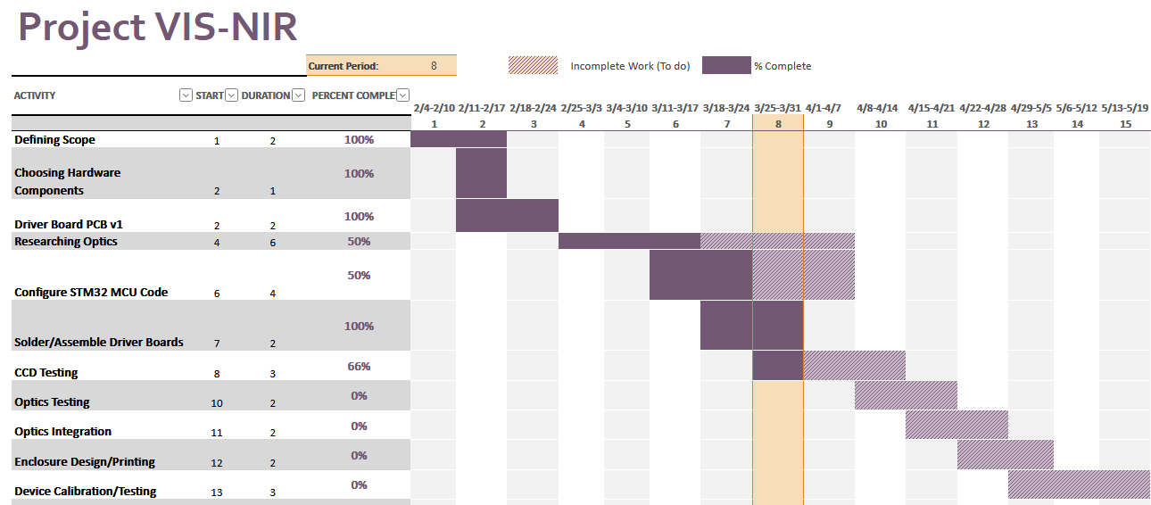
Image 3.4.1: Semester 1 Gantt Chart
The planned schedule had the team ending the first semester with a functioning prototype of the spectrometer, showcasing portability and live spectral analysis. The project fell slightly behind schedule half way through the Spring semester due to the changes that needed to be made to the diffraction grating and filtering.

3.5 Risks and Risk Management/Mitigation

Identified Risk | Probability | Severity | Mitigation strategy
2nd Order Reflections | 1.0 | Very High | Add linear edge pass filter and validate wavelength mapping experimentally across spectral range. Potential software fixes.
Order Delays | 0.5 | Medium | Have multiple tasks queued to allow switching tasks while waiting for the other to progress.
Damaging Delicate Optics Components | 0.3 | High | Wear gloves and handle all optics components according to BILab standards.
Low signal-to-noise ratio at higher wavelengths (800–1000 nm) | 0.8 | High | Adjustable integration time range, optimize analog front-end gain, and select optics with NIR-optimized coatings.
Limited dynamic range during bright measurements | 0.4 | Medium | Support adjustable integration timing and optional neutral density filtering.
Optical alignment sensitivity | 0.7 | High | Use adjustable mounts inside the enclosure.
Enclosure light leakage | 0.3 | Medium | Add sealing features and verify dark-condition performance during system testing.
Calibration drift over time | 0.5 | Low | Perform periodic recalibration using known spectral reference sources and store correction tables.
Thermal variation affecting measurements | 0.4 | Low | Characterize temperature dependence and allow recalibration or compensation in firmware if required.

3.6 Personnel Effort Requirements

Subsystem/Task | Description | Man-hours
Optics
Overall design | Base-level optics selection including slit, grating, lenses, and mirrors. | 10
Second-order light filtering | Evaluating various methods to suppress spectral overlap | 20
Component selection |  | 12
  Selection of grating, mirrors, slit, lenses, and optical filter options
Testing/Positioning | Alignment testing, wavelength spread verification, and focus optimization | 14
Enclosure Design | Designing an enclosure that provides stable mounts between optical components and CCD board | 20
Total |  | 76
Microcontroller
MCU IDE Bringup | Familizaring ourselves with the IDE and building the basic code for the CCD driver timers. | 12
CCD driver timer implementation | Generating SH, ICG, and master clock timing signals for TCD1304 operation | 16
ADC acquisition configuration |  | 10
  Configuring ADC sampling timing synchronization and buffering
Testing Basic Code | Verifying CCD waveform timing and signal capture stability | 4
Code Improvements | Improve the baseline code to enable inputs from the host pc for calibration modes and selectable integration times. | 18
Noise reduction | Implementation of noise reduction processes. | 8
Total |  | 68
User interface
Scoping Data Transmission/Features | Validating waveform timing throughput and transfer reliability | 8
PC visualization interface | Developing plotting pipeline for spectral display and storage | 10
Designing device or selecting filters | Adding selectable integration control, gain selection, and capture triggers | 10
Calibration Procedure for pixel map | Mapping pixel index to wavelength using reference emission source | 12
Spectral correction workflow | Implementing intensity normalization and dark-frame subtraction | 8
Total |  | 48
Assembly and Testing
PCB Design and Assembly | Fabrication of CCD driver PCB and others. | 12
Mechanical enclosure assembly | Integrating optics, electronics, and housing into portable structure. | 8
System-level integration testing | End-to-end spectrum capture validation across wavelength range and tuning of response. | 30
Performance validation | Resolution, SNR, repeatability, and wavelength accuracy testing. | 12
Documentation and handoff preparation | Preparing calibration instructions, wiring diagrams, and usage procedures. | 8
Total |  | 70
Grand Total |  | 262

3.7 Other Resource Requirements
Additional resources needed to complete this project are as follows:
- Thin film deposition machines available at the ASC will be used to fabricate a linear edge pass filter that will be used to filter 2nd order reflections.

4 Design

4.1 Design Context

4.1.1 Broader Context
Area | Description | Examples
Public health, safety, and welfare | How does your project affect the general well-being of various stakeholder groups? These groups may be direct users or may be indirectly affected (e.g., solution is implemented in their communities) | Increasing/reducing exposure to pollutants and other harmful substances, increasing/reducing safety risks, increasing/reducing job opportunities
Global, cultural, and social | How well does your project reflect the values, practices, and aims of the cultural groups it affects? Groups may include but are not limited to specific communities, nations, professions, workplaces, and ethnic cultures. | Development or operation of the solution would violate a profession’s code of ethics, implementation of the solution would require an undesired change in community practices
Environmental | What environmental impact might your project have? This can include indirect effects, such as deforestation or unsustainable practices related to materials manufacture or procurement. | Increasing/decreasing energy usage from nonrenewable sources, increasing/decreasing usage/production of non-recyclable materials
Economic | What economic impact might your project have? This can include the financial viability of your product within your team or company, cost to consumers, or broader economic effects on communities, markets, nations, and other groups. | Product needs to remain affordable for target users, product creates or diminishes opportunities for economic advancement, high development cost creates risk for organization

4.1.2 Prior Work/Solutions
Several commercial spectrometers cover the VIS-NIR range relevant to this project. Ocean Optics has the most similar products to our design, offering instruments such as the STS-VIS and the USB2000+. These devices are well-characterized, compact, and support USB connectivity, but carry a price point that places them out of reach for routine, flexible lab use. The following comparison highlights the differences between our proposed design and representative commercial products.
Feature | This Project | Ocean Optics ST VIS | Ocean Optics SR-2VN500-25
Link | N/A | Edmund Optics | Edmund Optics
Wavelength Range | 400–1000 nm | 350-810 nm | 350–1040nm
Detector | TCD1304DG (3648 px) | Unknown | Proprietary (2098)
Interface | USB | USB/RS-232 | USB/RS-232
Approximate Cost | < $500 | $1820.00 | $3859.00
Portability | High | High | High
Open / Customizable | Yes (open firmware/software) | No | No
The primary advantage of this project over commercial solutions is cost and customizability. The primary disadvantage is that commercial instruments have been thoroughly validated and characterized, while this device requires the team to develop and verify calibration procedures from scratch.
No prior Iowa State senior design project was identified that directly replicates this work, though open-source spectrometer designs such as the "Public Lab Spectrometer" and projects based on the TCD1304 CCD on hobbyist forums informed the team's component selection and firmware strategy.

4.1.3 Technical Complexity
This project satisfies the technical complexity requirement in two major areas:
- Multiple distinct subsystems using different engineering disciplines: the optical subsystem applies geometric optics and diffraction theory; the microcontroller subsystem applies real-time embedded firmware, ADC timing, and DMA transfers; the analog front-end applies precision analog circuit design; and the Python interface applies signal processing and GUI development.
- Multiple challenging requirements that meet or exceed industry norms: achieving FWHM ≤ 5 nm spectral resolution across a 600 nm span with a linear CCD, generating microsecond-accurate CCD timing signals from a custom STM32 firmware, suppressing second-order diffraction artifacts with a custom-fabricated thin-film optical filter, and streaming calibrated spectral frames at ≥10 fps over USB all constitute non-trivial engineering problems.

4.2 Design Exploration
The scope of this project had been very well-defined for the team coming into it. This led to fewer design decisions being necessary early on given that several of the components and architectures were already chosen. That being said, there were many questions still on how the proposed components would integrate into a product that aligned with all the specifications laid out by our client. In addition to that, several additional features can or will be implemented that go beyond the expectations of our client. These inclusions are where a lot of the groups decision-making can be made and their talents and interests can shine even more brightly.

4.2.1 Design Decisions
Three primary areas where specific technical choices were required have been summarized below:
- Optical Grating Type: Selection between transmission and reflective diffraction gratings to disperse incoming light across the CCD.
- Data Processing Language: Selection of a programming language for the host-side spectral acquisition and visualization application.
- Second Order Diffraction Mitigation Strategy: Selection of a method to suppress second-order diffraction artifacts that corrupt the lower portion of the target spectrum.

4.2.2 Ideation
The team explored several options for each design decision based on technical requirements and budget.
Optical Grating Type Options:
- Transmission grating with a linear layout: simple alignment but requires a longer optical path that may not fit within the 10 cm × 10 cm enclosure footprint.
- Reflective (blazed) diffraction grating in a Czerny-Turner configuration: more compact, commonly used in commercial instruments, but introduces alignment complexity.
- Volume phase holographic (VPH) grating: high efficiency and low stray light, but expensive and too narrowband for this project.
Data Processing Language Options:
- Python: open-source, large ecosystem, good USB serial libraries, supports cross-platform deployment and potential mobile integration via frameworks such as Kivy.
- MATLAB: team is highly familiar, excellent for real-time plotting and matrix operations, but requires a paid license and is not well-suited for standalone deployment.
- LabVIEW: strong in instrumentation contexts, but proprietary, expensive, and not maintainable by most future users.
Second-Order Diffraction Mitigation Options:
- Two modes of operation with different filters: Simple and cost effective, however this would degrade user experience and limit testing capabilities.
- Custom thin-film linear variable filter: directly addresses the problem with a graded cutoff matched to the CCD pixel array, no mechanical switching required. The primary trade off is cost at ~$1700.
- Custom thin-film linear variable filter fabricated at the ISU ASC: directly addresses the problem with a graded cutoff matched to the CCD pixel array, no mechanical switching required; fabrication feasibility is the primary uncertainty.
- Software correction only: no physical filter; post-process the spectrum to subtract modeled second-order contributions; simplest mechanically but unreliable for research-grade data.

4.2.3 Decision-Making and Trade-Off
In this section, each of the mentioned design decisions will be expanded upon, giving particular focus to what steps the team took to make the choice and what information was researched or tested to aid in the decision-making process.
Optical Grating Type:
Ray-tracing simulations showed that a transmission grating in a linear layout cannot fit within the 10 cm × 10 cm target enclosure footprint. The reflective grating was therefore selected despite the added alignment complexity. A weighted decision matrix was used, scoring each option against criteria including compactness, alignment complexity, cost, and calibration linearity. The reflective grating scored highest overall. The tradeoff accepted is a more time-intensive optical alignment process, which contributed to schedule delays in the first semester. Adjustable mounts are being used to manage this risk.
Data Processing Language:
The team chose to work with python as a group by organizing the requirements of the language to be used and doing a weighted decision matrix. One of the main additional features that is desired by the final product is mobile integration, and the team knows that python is very good at this using downloadable libraries. The other option was using MATLAB, which is likely the best at handling and plotting the large sets of real time data that the device will be sending. The main tradeoff is that the team has extensive knowledge with working in MATLAB while our python knowledge is limited. Despite this, the open source ecosystem that python provides can’t be beaten for a project that is expected to be expanded upon after this teams conclusion with it.
Optical Noise Mitigation Strategy:
Second order diffractions of the lower wavelengths of our desired spectrum can cause unrecoverable amounts of noise and must be dealt with. The team is heavily considering fabricating their own filter since commercial filters of this type are expensive and out of the budget of the project. The decision will be made by considering the feasibility of fabrication, the verification of a two filter design, and the time that remains to procure a prototype.

Proposed Design

4.3.1 Overview
The proposed design is a self-contained, portable spectrometer that measures the spectrum of light across visible and near-infrared wavelengths (400 to 1000 nm). Light entering the device through a narrow slit is spread out by a diffraction grating into its component colors and focused onto a linear image sensor. A small circuit board reads the sensor and sends the data to a laptop via USB. A Python application on the laptop displays the spectrum in real time as a plot of intensity versus wavelength.
The device is designed to be compact enough to carry between benches in a research lab, affordable enough to build on a senior design budget, and accurate enough to support biosensing experiments in the BILab. It does not require any specialized training to operate: the user plugs it into their computer, opens the Python application, and begins acquiring spectra.

4.3.2 Detailed Design and Visual(s)
System Architecture Overview: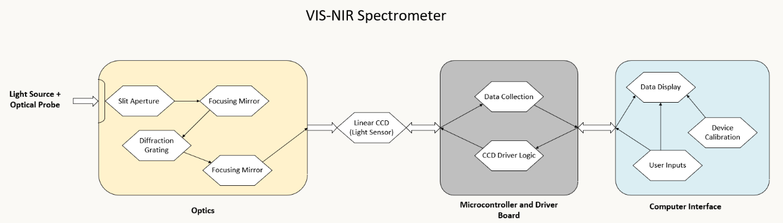
Figure 1 High level overview of the spectrometer.
The proposed portable spectrometer is organized into three tightly integrated subsystems: the optical subsystem, the embedded acquisition subsystem, and the computer interface subsystem. Together, these blocks convert incident light over the 400 to 1000 nm range into calibrated spectral data that can be displayed and stored on a host computer.
Subsystem 1: Optical System
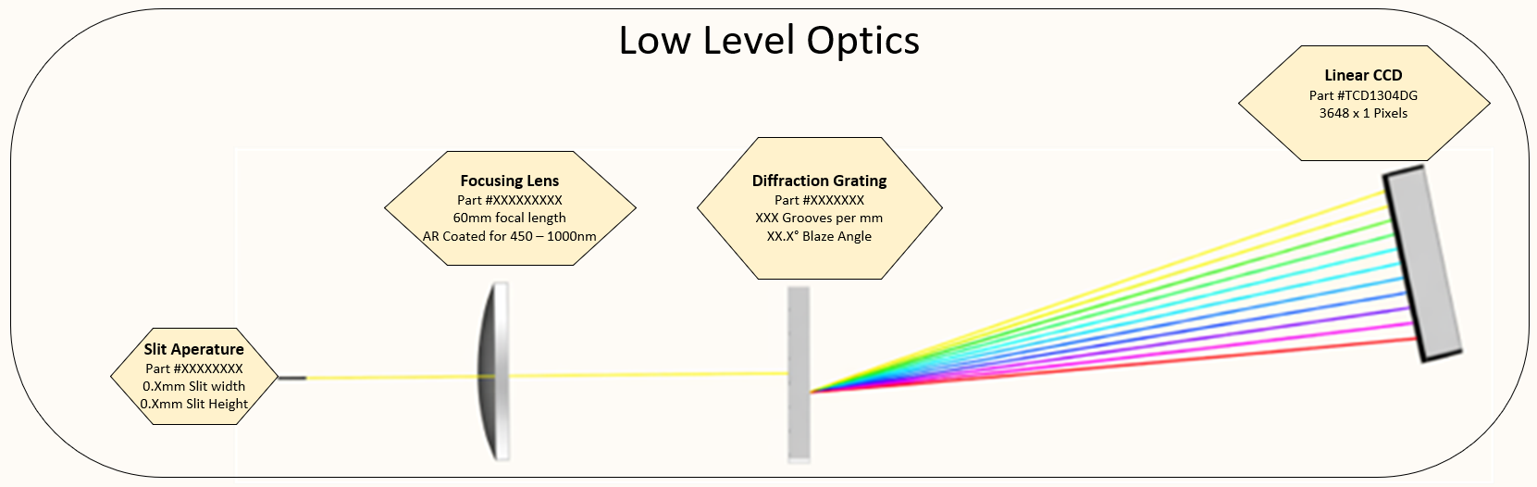
Figure 2 Low Level Optics Diagram (Place Holder...needs to be updated to new type of optics layout)
The optical subsystem separates incoming light by wavelength and images the dispersed spectrum onto the detector. In the updated design, this subsystem uses a Czerny-Turner configuration rather than a focusing lens geometry. Light first enters through the slit aperture, which defines the spatial width of the source presented to the spectrometer. Slit width directly affects the optical tradeoff between spectral resolution and optical throughput. After the slit, the light is directed toward a collimating mirror, which forms a collimated beam and sends it to the reflective diffraction grating. The grating disperses the light angularly as a function of wavelength across the target 400 to 1000 nm operating range. A focusing mirror then images the dispersed spectrum onto the TCD1304DG linear CCD.
This reflective Czerny-Turner layout is better aligned with the project goals because it supports a compact optical path and avoids lens-driven chromatic effects across the wide visible-to-near-infrared range. The grating geometry and mirror placement are selected so that the first-order spectrum spans the useful 3648-pixel active width of the TCD1304DG. A long-pass filter is also included in the optical path to reduce second-order overlap from shorter wavelengths. This is important because short-wavelength light in a higher diffraction order can fall on the same detector location as long-wavelength first-order light and create false spectral content if it is not suppressed.
The TCD1304DG serves as the terminal sensing element in the optical chain. It converts the focused spectrum into a sequential analog signal, where each pixel corresponds to a narrow wavelength band. Its sensitivity from approximately 350 to 1000 nm makes it suitable for the required measurement range.
Subsystem 2: Microcontroller and Driver Board:
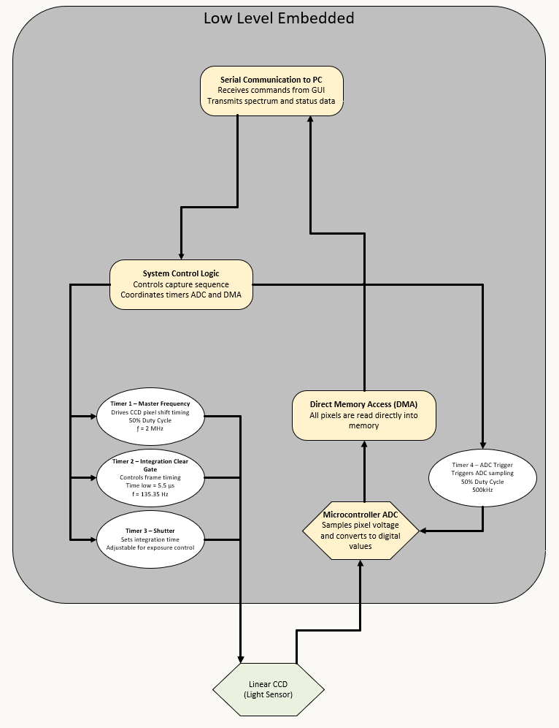
The embedded subsystem controls the CCD, digitizes the sensor output, and transfers spectral frames to the computer. This subsystem is built around the STM32F411CEU6 microcontroller, which acts as the timing and acquisition controller for the TCD1304DG. The microcontroller generates the three required CCD timing signals using hardware timers: the 2 MHz master clock (fM), the shift gate (SH), and the integration clear gate (ICG). These timing signals define pixel shift timing, frame timing, and the effective integration period used for exposure control.
During operation, the system control logic coordinates the capture sequence. It receives commands from the host computer over USB serial, updates integration timing as requested by the user, initiates frame capture, and manages the transfer of each completed spectrum. The CCD analog output is sampled by the STM32 ADC using timer-triggered conversions so that each pixel is captured at a controlled point in the readout cycle. Direct Memory Access (DMA) is used to move the sampled data directly into memory as a full frame buffer with minimal CPU overhead. This preserves timing consistency and reduces the chance of dropped samples or software-induced jitters.
Once a full 3648-sample frame has been acquired, the embedded system packages the raw spectral data and sends it to the host computer over USB CDC. The custom driver PCB supports this process by providing regulated power, local decoupling, and analog filtering for the CCD signal path.
Subsystem 3: Python Host Application: 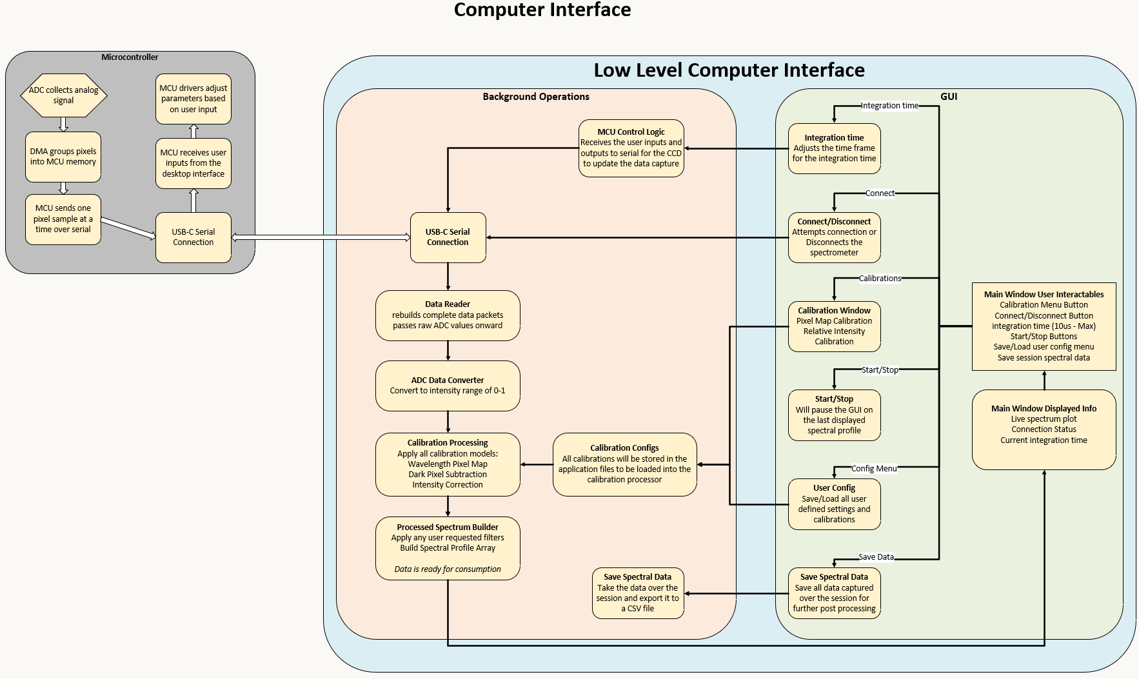
The host application receives raw frame data from the embedded system, applies calibration and correction steps, and presents the spectrum to the user in a usable form. Communication with the hardware is handled over USB CDC using a Python serial interface such as PySerial. Each incoming frame is reconstructed into a complete 3648-sample spectral array before post-processing is applied.
The application then performs the main data-conditioning steps needed for meaningful spectral output. First, it converts the received ADC samples into an intensity array. It then applies dark-frame subtraction to reduce baseline offset and fixed-pattern contributions. A stored pixel-to-wavelength calibration is applied so that detector position is mapped into physical wavelength units. Additional intensity correction or relative-response calibration can also be applied if required by the final calibration procedure. The processed result is then displayed as a live plot of intensity versus wavelength, with continuous updates during acquisition.
The GUI also serves as the main operator interface for the instrument. It manages connection and disconnection from the spectrometer, allows the user to set integration time, provides controls for starting and stopping live acquisition, opens the calibration tools, and supports saving both user settings and acquired spectra. Captured spectra can be exported as CSV data for downstream analysis, typically as wavelength and intensity columns.

4.3.3 Functionality
A typical measurement session proceeds as follows:
- The user connects the optical slit to a SMA fiber optic probe and positions the probe in the desired measurement location.
- The user connects the spectrometer to their laptop via USB. The Python application is launched.
- The application begins streaming spectral frames from the device and displays a live intensity-versus-wavelength plot.
- The user adjusts the integration time via the application interface if the signal is saturated or too weak.
Once a satisfactory spectrum is acquired, the user saves it to a CSV file with a single button press for additional downstream analysis.

4.3.4 Areas of Concern and Development
The current design meets the core functional requirements as specified, with the following primary concerns identified for the remaining development period:
- Second-order diffraction suppression: This is the highest-severity risk in the project. Without adequate filtering, spectral data above approximately 800 nm will be corrupted by second-order artifacts from shorter wavelengths. The team is actively evaluating both commercial longpass filters and a custom thin-film filter fabricated at the ASC.
- Optical alignment: The reflective grating geometry is sensitive to component positioning. Achieving FWHM ≤ 5 nm across the full 600 nm operating range requires careful alignment of the slit, grating, and CCD. Adjustable kinematic mounts are being used to manage this during the development phase before the enclosure is finalized.
- SNR at longer wavelengths: The TCD1304DG has decreasing quantum efficiency above ~850 nm. Achieving adequate SNR in the 850–1000 nm range may require longer integration times and careful management of dark current, which itself increases with integration time. Characterization testing is planned to determine the practical sensitivity limit.
- Enclosure design: The final enclosure must block all ambient light while providing stable, repeatable mounting for the optical components. This remains in early design and will be developed following successful optical alignment on the open breadboard.

4.4 Technology Considerations
The design uses four distinct technology domains, each with specific strengths and tradeoffs:
Optical Components (slit, grating, lenses/mirrors, filter):
- Strengths: Passive, no power consumption, highly reliable, mature commercial availability.
- Weaknesses: Sensitive to physical alignment; performance depends on component quality and coatings. Reflective grating geometry complicates alignment compared to a transmission grating.
- Tradeoff: A reflective grating was selected over a transmission grating to satisfy the enclosure size constraint, accepting increased alignment complexity.
TCD1304DG Linear CCD Sensor:
- Strengths: 3648-pixel resolution, good sensitivity across 350–1000 nm, well-documented timing requirements, low dark current at short integration times.
- Weaknesses: Analog output requires a precise, noise-sensitive analog front-end; quantum efficiency drops significantly above 850 nm; requires three precisely timed control signals.
- Tradeoff: Chosen by the client as a constraint. Its 3648-pixel array provides high spectral sampling density given the 600 nm operating range, and its sensitivity profile covers the target range acceptably.
STM32F411CEU6 Microcontroller:
- Strengths: High clock speed (up to 100 MHz), hardware timers suitable for CCD timing generation, built-in ADC, DMA, and USB full-speed peripheral, large community and documentation base.
- Weaknesses: Limited 12-bit ADC resolution (4096 counts); Too slow for higher speed detectors which is a possible upgrade to be done in semester 2; USB CDC implementation requires careful driver configuration on the host side.
- Tradeoff: Chosen by the client as a constraint. The STM32F411 provides sufficient peripheral capability for all timing, ADC, and USB requirements within the project's scope.

Python Host Application:
- Strengths: Open source, cross-platform, large library ecosystem, no licensing cost, extensible for future features such as mobile integration.
- Weaknesses: Interpreted language introduces some latency; real-time plotting at high frame rates can cause GUI lag if not carefully implemented using background threading or non-blocking update patterns.
- Tradeoff: Selected over MATLAB and LabView for long-term maintainability and accessibility. Performance concerns are manageable.

4.5 Design Analysis
As of the current project state, the microcontroller and driver board subsystem is functional. The STM32F411CEU6 firmware successfully generates the three required CCD timing signals (fM, SH, ICG) and reads out the full 3648-pixel CCD output frame via ADC with DMA. Initial verification on an oscilloscope confirmed that the timing signals match the TCD1304DG datasheet specifications. The custom driver PCB has been fabricated and assembled, with all power rails verified within tolerance and the STM32 booting successfully from flash.
A preliminary functionality test was conducted by illuminating the CCD with a light source and observing the output. The readout correctly showed elevated signal in illuminated pixels and returned to baseline when light was blocked, confirming that the sensor and readout chain are operating as expected.
The optical subsystem is currently in the component selection and alignment phase. Optical components have been sourced and are being evaluated for placement on the optical breadboard. The diffraction grating geometry is being finalized, and first measurements of spectral spread across the CCD are planned as the next milestone.
The Python application framework has been scoped and initial USB communication and frame parsing have been prototyped. Live plotting infrastructure is being set up in parallel with the optical work.
The proposed design is feasible based on progress to date. The primary remaining technical uncertainties are second-order diffraction suppression and achieving the target spectral resolution through optical alignment. Both are being actively addressed. Cost constraints continue to require careful component evaluation before ordering, which is an accepted tradeoff given the project's budget requirements.
Immediate next steps include finalizing the optical layout and grating positioning, acquiring and testing a long pass filter for second-order suppression, completing the pixel-to-wavelength calibration using a known reference source, and integrating all three subsystems for end-to-end spectral acquisition.

5 Testing
Testing is an extremely important component of most projects, whether it involves a circuit, a process, power system, or software.
The testing plan should connect the requirements and the design to the adopted test strategy and instruments. In this overarching introduction, give an overview of the testing strategy and your team’s overall testing philosophy. Emphasize any unique challenges to testing for your system/design.
In the sections below, describe specific methods for testing. You may include additional types of testing, if applicable to your design. If a particular type of testing is not applicable to your project, you must justify why you are not including it.
When writing your testing planning consider a few guidelines:
- Is our testing plan unique to our project? (It should be)
- Are you testing related to all requirements? For requirements you’re not testing (e.g., cost related requirements) can you justify their exclusion?
- Is your testing plan comprehensive?
- When should you be testing? (In most cases, it’s early and often, not at the end of the project)

5.1 Unit Testing
What units are being tested? How? Tools?

5.2 Interface Testing
What are the interfaces in your design? Discuss how the composition of two or more units (interfaces) are being tested. Tools?

Integration Testing
What are the critical integration paths in your design? Justification for criticality may come from your requirements. How will they be tested? Tools?

System Testing
Describe system level testing strategy. What set of unit tests, interface tests, and integration tests suffice for system level testing? This should be closely tied to the requirements. Tools?

Regression Testing
How are you ensuring that any new additions do not break the old functionality? What implemented critical features do you need to ensure do not break? Is it driven by requirements? Tools?

Acceptance Testing
How will you demonstrate that the design requirements, both functional and non-functional are being met? How would you involve your client in the acceptance testing?

Security Testing (if applicable)

User Testing
Describe how the team will include real users to interact with the solution/product. Your user testing plan should evaluate your solution/product’s usability and overall user experience by gathering user feedback through observations, surveys, etc. User feedback allows the team to identify areas for improvement and ensure the product meets user needs.

Results
What are the results of your testing thus far? Include any numerical, graphical, or qualitative testing results here? How do they demonstrate compliance with the requirements or addressing user needs? Use a summary narrative to discuss what you’ve learned and what next steps need to be taken.

6 Implementation
Describe any (preliminary) implementations of your design thus far. Support any general, descriptive text with relevant images. If your project has inseparable activities between design and implementation, you can list them either in the Design section or this section.

7 Ethics and Professional Responsibility
Use this section to describe your considerations of engineering ethics and professional responsibility. Most importantly how are you defining engineering ethics and professional responsibility in the context of your project and what steps are you taken to ensure ethical and responsible conduct. Each section references one type of ethical/professional responsibility considerations. You may also use this introductory section to note any overarching ethical philosophy among your team.

Areas of Professional Responsibility/Codes of Ethics

This discussion is with respect to the paper by J. McCormack and colleagues titled “Contextualizing Professionalism in Capstone Projects Using the IDEALS Professional Responsibility Assessment”, International Journal of Engineering Education Vol. 28, No. 2, pp. 416–424, 2012
Pick one of IEEE, ACM, or SE code of ethics (all linked in class slides). Create a table, like Table 1 in the McCormack et al. (2012, pg. 418)) paper, with the following columns representing: Area of Responsibility (from the paper), Definition (in your own words), Relevant Item from Code of Ethics (from the Code of Ethics you selected, and description of how your team has interacted with that area of professional responsibility or adhered to that code during your project thus far.
In text below the table, describe one area in which your team is performing well. Describe what your team is doing and how that signifies strong performance. Also describe one area in which your team needs to improve. Describe what your team is currently doing and what it should do in the future to improve.

7.2 Four Principles
Create a table with rows for each broader context area (see Section 4.1.1) and columns for each of the four principles (beneficence, nonmalificence, respect for autonomy, and justice; see Beauchamp, 2007). Within the table, identify at least one way each of the four principles applies to each of the broader context areas. Some principle-broader context connections might be more prominent than others, but you should be able to identify something for each table cell. Note: Your design may end up negative or neutral in some cell. For example, your product might perform poorly in environment-nonmaleficence because it utilizes natural resources without a positive/mitigating effect.
Below the table, note one broader context-principle pair that is important to your project. Briefly describe the benefit in that area you are working towards and how you will ensure it. Also note one broader context-principle pair in which your project/end design is or will be lacking. Describe either (a) how this negative is overcome by other positives in other areas of the project/design or (b) what your team must do to improve in this area.

7.3 Virtues
List and define at least three virtues that are important to your team. Describe what you will do or have done as a team to support these virtues among all team members.
Each team member should also answer the following:
- Identify one virtue you have demonstrated in your senior design work thus far? (Individual)
  - Why is it important to you?
  - How have you demonstrated it?
- Identify one virtue that is important to you that you have not demonstrated in your senior design work thus far? (Individual)
  - Why is it important to you?
  - What might you do to demonstrate that virtue?

8 Closing Material

8.1 Conclusion
Summarize the work you have done so far. Briefly re-iterate your goals. Then, re-iterate the best plan of action (or solution) to achieving your goals. What constrained you from achieving these goals (if something did)? What could be done differently in a future design/implementation iteration to achieve these goals?
At this point in time, we have a design that can display the CCD output to a computer. This includes a driver board for the CCD, microcontroller code for driving the CCD and communicating with the computer, and a functional GUI. We have also done research into the optical setup, and have purchased a housing that will be used until the design is finalized. We have also purchased components and begun building a calibration device.
Our main goal for this point was to have a device with basic functionality, which has not fully been achieved. Due to the cost and issues with second order diffractions, we were unable to finalize the optics portion of the design.

8.2 References
List technical references and related work / market survey references. Do professional citation style (ex. IEEE). See link: https://ieee-dataport.org/sites/default/files/analysis/27/IEEE%20Citation%20Guidelines.pdf

8.3 Appendices

Personas we were considering

Any additional information that would be helpful to the evaluation of your design document.
If you have any large graphs, tables, or similar data that does not directly pertain to the problem but helps support it, include it here. This would also be a good area to include hardware/software manuals used. May include CAD files, circuit schematics, layout etc,. PCB testing issues etc., Software bugs etc.

Persona 1: Biomedical/Electrical Engineering Researcher
- Demographic: Adult, Researcher, PhD
- Hobbies: Learning
- Motivation: Money, Scientific advancement
- Personality: Passionate, Curious
- Values: Accuracy, understanding of the world
This user is a professional in their respective field of study. They are driven by a desire for scientific advancement. They are well versed in each of the fields of work used to make this device, including optics, embedded systems, and analog circuitry. They are highly technical and value precision and efficiency. The researcher needs access to an accurate yet affordable spectrometer that can be used in various applications. This tool offers a way to streamline testing, ultimately speeding up the researchers' contribution to the scientific community.

Persona 2: Medical Staff
- Demographic: Specialized Staff in bio-sensing
- Hobbies/Interests: Passionate workers care and keep up to date with new bio-sensing technology.
- Work Motivations: Making testing and data collection intuitive and usable for more people.
- Values: They value efficiency and reliability to draw quick, accurate conclusions.
- Personality/Emotions: They want the best for their clients and fellow faculty
This user is a specialized medical staff member with a focus on bio-sensing technology. Staying current with the latest developments in the field is both a professional priority and a personal interest. This user is deeply motivated by making testing and data collection more intuitive and accessible, not just for specialists but for a wider range of clinical staff.
Efficiency and reliability are central to how this user works. In a medical setting, quick and accurate conclusions are not a luxury; they directly impact the quality of care. This user wants tools that are dependable and easy to interpret and genuinely care about the wellbeing of both clients and colleagues.
A portable, accessible spectrometer aligns well with this user's goals. The ability to perform non-invasive optical measurements quickly and reliably could streamline workflows that currently require more complex or time-consuming methods. For this user, the value lies in a tool that brings meaningful sensing capability into everyday clinical use without demanding deep technical expertise to operate.

Persona 3: Educational Institutions
- Demographic: High school or University Lab Instructor.
- Hobbies/Interests: Science Communication, niche design projects.
- Work Motivations: Bridging theory and hands on learning for students.
- Values: They need cheap and portable devices so that they can supply a classroom. The devices must be durable and “student-proof”. Encapsulation is crucial.
- Personality/Emotions: They are encouraging and patient, wanting to share the natural world with their students.

9 Team
Complete each section as completely and concisely as possible. We strongly recommend using tables or bulleted lists when applicable.

9.1 Team Members

9.2 Required Skill Sets for Your Project

(if feasible – tie them to the requirements)

9.3 Skill Sets covered by the Team

(for each skill, state which team member(s) cover it)

9.4 Project Management Style Adopted by the team

Typically, Waterfall or Agile for project management.

9.5 Initial Project Management Roles
(Enumerate which team member plays what role)

9.6 Team Contract Team Members:

Team Members:
1) Ryan Majstorovic
2) Dawson Posekany
3) Evan Tamer
4) Samar Gill

Team Procedures

- Day, time, and location (face-to-face or virtual) for regular team meetings:
  - Manojit: Our meeting with our advisor will be face to face during our weekly visit to ASC.
  - Avishek: We will be in constant communication through teams. We plan to meet in his ASC lab during our weekly trip to the ASC for hands on work and progress evaluation.
- Team: Monday/Tuesday, Weekends when needed, afternoons, TLA or SIC.
- Preferred method of communication updates, reminders, issues, and scheduling (e.g., e-mail, phone, app, face-to-face):
  - Microsoft Teams for File Sharing and interaction with Project Contact
  - Discord for quick discussions and assistance for the Senior Design team.
- Decision-making policy (e.g., consensus, majority vote):
  - Decisions will be made via consensus. Team members will use best judgement to decide if something needs to be brought up to the group.
- Procedures for record keeping (i.e., who will keep meeting minutes, how will minutes be shared/archived):
  - Minutes will be recorded in an excel spreadsheet along with current and future tasks pertaining to the week. This document will be discussed with the team and recorded at that time.

Participation Expectations

- Expected individual attendance, punctuality, and participation at all team meetings:
  - Try to show up to all meetings on time, but missing some occasionally is fine.
  - If you will not be there on time, let the group know beforehand and review the meeting notes afterwards.
  - Team members have the duty of keeping up to date when they must miss a meeting. This involves giving status reports and staying up to date on their assignments.
  - In meetings all members should participate by giving status updates, adding feedback, and asking questions about the system.
- Expected level of responsibility for fulfilling team assignments, timelines, and deadlines:
  - Everyone should make their best effort to put in a reasonable amount of time, ideally averaging four to seven hours per week.
  - Be honest with expectations for deadlines. If a deadline needs to be pushed bring it up in the weekly standup.
- Expected level of communication with other team members:
  - Should let the group know if there are any issues, such as being unavailable for a meeting or having difficulties with tasks
  - Should be responsive and helpful in group chats
- Expected level of commitment to team decisions and tasks:
  - Work with the team and speak up/ask questions.
  - Impart expertise whenever available.

Leadership

- Leadership roles for each team member (e.g., team organization, client interaction, individual component design, testing, etc.):
  - Dawson Posekany – PCB Design/Simulation/Testing, Progress Documentation
  - Evan Tamer – Breadboard circuit design, Note taking
  - Samar Gill – Embedded design, project presentation
  - Ryan Majstorovic – Embedded design, Team Organization

- Strategies for supporting and guiding the work of all team members:
  - Weekly standups to discuss progress and overall direction of project
  - Breaking into teams as needed to accomplish tasks.
- Strategies for recognizing the contributions of all team members:
  - Members will document their individual accomplishments in Weekly Reports.
  - Insights and Progress will be discussed during Weekly standups and documented in the cooresponding Excel sheet.

Collaboration and Inclusion

- Describe the skills, expertise, and unique perspectives each team member brings to the team.
Dawson Posekany – Experience with Spectroscopy devices, familiarity with PCB design
Evan Tamer – Embedded systems
Ryan Majstorovic – Embedded systems, PCB design
Samar Gill – Embedded system, integrating AI tool use
- Strategies for encouraging and supporting contributions and ideas from all team members:
Keeping open communication on issues that may arise hammering on asking a question if you need more information. Working in teams of two to expand the knowledge base working on a task.
- Procedures for identifying and resolving collaboration or inclusion issues (e.g., how will a team member inform the team that the team environment is obstructing their opportunity or ability to contribute?)
  - Either tell someone in the group or bring it up with faculty if it keeps being an issue

Goal-Setting, Planning, and Execution

- Team goals for this semester:
- Get a functioning and documented branching framework for our project, breaking down the project into actionable tasks.
- Stage 1: Breadboard circuit, Labview integration, basic light sensing.
- Stage 2: Wifi Capability, Optics integration, circuit optimization, and device powering.
- Strategies for planning and assigning individual and team work:
- Work will be assigned during our weekly standup. Depending on the nature and difficulty of tasks, the team will be split amongst two-man teams.
- Strategies for keeping on task:
- Working as groups and having weekly tasks. Kindly holding each other accountable in our designated groups.

Consequences for Not Adhering to Team Contract

- How will you handle infractions of any of the obligations of this team contract?
  - Problems will be first be handled by having team discussions on what might need to change.

- What will your team do if the infractions continue?

If infractions become egregious, issues will be discussed with the Project Faculty (Contact and/or Advisor) or Class Instructors depending on the nature of the issue.

***************************************************************************
a) I participated in formulating the standards, roles, and procedures as stated in this contract.
b) I understand that I am obligated to abide by these terms and conditions.
c) I understand that if I do not abide by these terms and conditions, I will suffer the
consequences as stated in this contract.
1) Ryan Majstorovic DATE 2/8/2026
3) Dawson Posekany DATE 2/8/2026
4) Evan Tamer DATE 2/8/2026
4) Samar Gill DATE 2/8/2026

_________________

