Portable VIS-NIR Spectrometer
Design Document
Review Copy

SDDEC26-06 Team Spectro
Iowa State University Senior Design - EE 4910 / 4920
Advisor: Prof. Manojit Pramanik
Client: Dr. Avishek Das, Biomedical Imaging Lab
Prepared for review: April 30, 2026

Review Change Summary
This review copy preserves the original design document and rebuilds it with a cleaner professional layout. It removes course-template prompts, completes thin testing and implementation sections, updates the data processing pipeline to match the current firmware and Python GUI, normalizes terminology, and adds review-ready tables, captions, and source-backed current/planned validation language.
- Preserved the original document unchanged and generated this new review copy.
- Matched the presentation style with bold headings, navy section dividers, tan accents, and cream table headers.
- Completed testing, implementation, closing, references, appendix, and team sections without inventing unverified measured results.
- Updated pipeline wording to: Microcontroller Readout; Bias and Dark Correction; Wavelength Calibration; Response Correction and Normalization; Display, Spectrogram, and Export.
- Reused technical figures from the original document where they support the report narrative.

Table of Contents
1. Introduction
2. Requirements, Constraints, and Standards
3. Project Plan
4. Design
5. Testing
6. Implementation
7. Ethics and Professional Responsibility
8. Closing Material
9. Team
Appendix A. Pipeline Slide Copy
Appendix B. Additional Personas

1. Introduction
The Portable VIS-NIR Spectrometer is being developed for biomedical imaging research in the Biomedical Imaging Lab at Iowa State University. The client need is a lower-cost, portable spectrometer that can be moved into experimental setups more easily than a commercial bench instrument while still providing useful spectral information across the visible and near-infrared range.
The target instrument operates over the 400-1000 nm range and combines three tightly coupled subsystems: an optical subsystem that disperses incoming light onto a linear CCD, an embedded electronics subsystem that clocks and samples the CCD output, and a Python desktop application that receives, calibrates, displays, and exports spectral data.

Primary User Persona: Dr. Avishek Das
Dr. Das is a technical biomedical imaging researcher who needs fast, repeatable spectral measurements without requiring a fixed commercial spectrometer setup. The instrument must be practical inside a research lab: portable, affordable, understandable, and capable of producing data that can be exported for downstream analysis.
Design Intent
The project does not attempt to duplicate every feature of a commercial spectrometer. It focuses on the core measurement chain needed by the client: VIS-NIR spectral capture, real-time display, calibration, and analysis-ready export in a compact research prototype.

2. Requirements, Constraints, and Standards
Requirement Area | Requirement / Constraint | Verification Approach
Spectral range | Operate across 400-1000 nm VIS-NIR coverage. | Validate with known laser/reference sources spanning the range.
Detector | Use the Toshiba TCD1304DG linear CCD as the sensing element. | Confirm CCD timing, readout, and full-frame acquisition.
Embedded controller | Use the STM32F411CEU6 as the primary controller. | Verify timer outputs, ADC conversion, DMA completion, and USB CDC streaming.
Data transfer | Transmit spectral frames to the host computer in real time over USB. | Measure received frame rate and packet integrity in the Python app.
Desktop interface | Display a live spectrum and save session data for analysis. | Demonstrate live plotting, spectrogram mode, and CSV export.
Calibration | Support wavelength mapping and signal correction suitable for repeatable measurements. | Use reference peaks, bias/dark capture, and response correction workflows.
Portability/cost | Remain compact and significantly lower cost than comparable commercial VIS-NIR systems. | Track BOM, enclosure footprint, and subsystem integration choices.

Standards and Engineering Practices
Standard / Practice | Relevance to Project
IEC 61010-1 | Frames safety considerations for laboratory electrical equipment, including enclosure, grounding, heat, and single-fault thinking.
IEC 61326-1 | Guides electromagnetic compatibility concerns for sensitive analog measurement equipment.
ASTM E275 | Provides spectrophotometer performance concepts such as wavelength accuracy, stray light, and photometric precision.
NIST-traceable wavelength references | Motivates wavelength calibration against known spectral references rather than arbitrary pixel labels.
IEEE/ACM-style software practice | Supports version control, documented interfaces, repeatable tests, and reviewable design decisions.

3. Project Plan

Project Management and Tracking
The team uses a hybrid waterfall-plus-agile workflow. Early optical, PCB, and component-ordering work required careful sequencing because procurement and fabrication delays could block later work. Software, firmware, calibration, and integration tasks are managed iteratively through weekly check-ins, issue tracking, source control history, and task handoffs within the team.

Task Decomposition
Subsystem | Primary Work
Optics | Select grating, slit, lenses, filter strategy, mechanical spacing, enclosure layout, and alignment procedure.
Detector/electronics | Drive TCD1304DG timing, condition output signal, sample through STM32 ADC, and protect/route the PCB.
Firmware | Generate CCD control timing, trigger ADC + DMA, package frames, and stream CCD1 USB CDC binary packets.
Desktop GUI | Parse USB frames, process spectra, show live plots/spectrograms, support calibration, and export CSV data.
Validation | Measure wavelength range, resolution, packet integrity, calibration behavior, usability, and integrated system performance.

Milestones, Metrics, and Evaluation Criteria
Subsystem | Milestone | Metric / Acceptance Evidence
Optics | Bench optical path assembled | Slit, grating, focusing optics, and CCD target are mounted and aligned on the breadboard or prototype structure.
Optics | Wavelength coverage verified | Known sources produce detectable responses across the target 400-1000 nm range after alignment and calibration.
Optics | Spectral resolution characterized | Line-source FWHM is measured and compared against the target resolution requirement.
Firmware | CCD timing verified | PHI/M, SH, and ICG timing are measured on oscilloscope or logic analyzer and compared with the TCD1304DG timing needs.
Firmware | Full frame captured | STM32 ADC + DMA captures the 3694-sample frame layout without sample-count mismatch.
Firmware/GUI | USB frame stream parsed | Python receives and parses CCD1 binary packets with frame counter, sample count, effective region, flags, and ADC payload.
GUI | Live display and export | The Kivy app displays processed line spectra or rolling spectrograms and exports CSV with raw and derived columns.
System | End-to-end acceptance | Known reference source is captured, calibrated, displayed, and exported with documented wavelength and signal behavior.

Schedule and Resource Planning
The original project schedule is maintained as a planning artifact and should continue to be updated as integration work matures. The most important near-term work is end-to-end validation: optical alignment, reference-source calibration, verified data export, and integrated demonstration with the current desktop GUI.
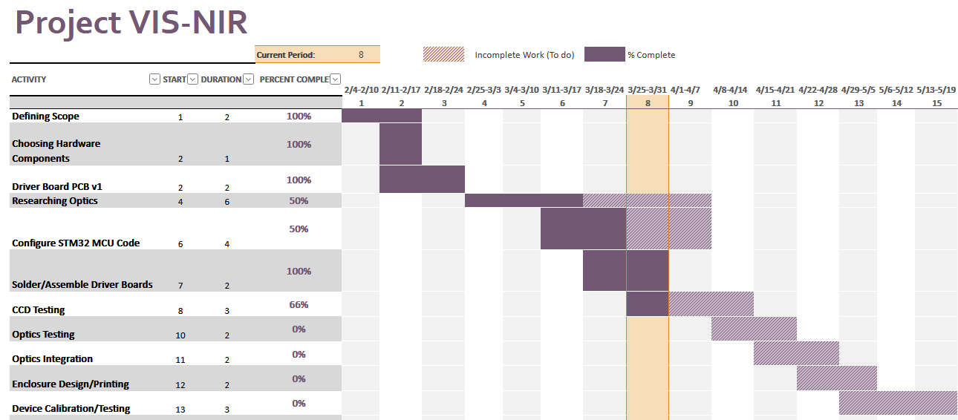
Figure 1. Original project schedule / Gantt chart retained as the planning baseline.

Risk Management
Risk | Impact | Mitigation
Second-order diffraction overlap | Can corrupt wavelength interpretation at longer wavelengths. | Use optical filtering, careful grating geometry, and reference-source validation across the full range.
Low NIR signal-to-noise ratio | May reduce usefulness near 800-1000 nm. | Optimize integration timing, analog conditioning, optical throughput, and dark/bias correction.
Optical alignment sensitivity | Can shift wavelength map or degrade resolution. | Use stable mounts, documented alignment procedure, and repeatable calibration checks.
USB throughput or packet loss | Can make live display lag or miss frames. | Use binary frames, background parsing, frame counters, performance diagnostics, and buffer tracking.
Calibration drift | Can make wavelength or intensity output inconsistent over time. | Store calibration settings and repeat reference-source validation periodically.
Schedule pressure | Integration depends on optics, firmware, hardware, and GUI readiness. | Keep independent subsystem tests active so progress continues while one subsystem blocks.

4. Design

Design Context
Commercial VIS-NIR spectrometers provide strong performance but are costly and less adaptable for a custom biomedical imaging workflow. This project prioritizes a lower-cost, open, portable instrument that can be modified by the research team and integrated with lab-specific measurement setups.
The design is technically complex because optical dispersion, CCD timing, analog sampling, USB transport, calibration, plotting, and file export all influence the final data quality. A weakness in any subsystem can appear as a bad spectrum, so the design treats the spectrometer as one measurement chain rather than unrelated parts.

System Architecture
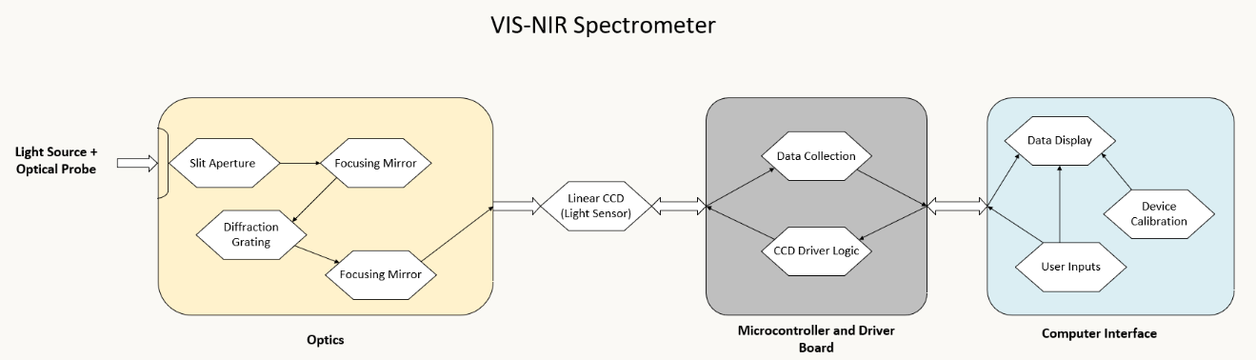
Figure 2. System architecture overview from the original design document.
The spectrometer converts incident light into a digital spectrum through five major stages: optical dispersion, CCD readout, embedded sampling, desktop processing, and calibrated display/export. The optical subsystem maps wavelength to CCD position, the STM32 subsystem captures that pixel array, and the Python host turns raw frames into usable visual and tabular data.

Subsystem Design
Subsystem | Current Design Role | Important Interfaces
Optics | Disperse 400-1000 nm light onto the TCD1304DG linear CCD and suppress unwanted optical artifacts. | Input slit, grating/lens alignment, CCD focal plane, enclosure.
Detector and electronics | Clock the CCD, condition output signal, sample through STM32 ADC, and provide stable power/control. | CCD timing pins, ADC input, PCB power rails, USB connection.
Firmware | Generate CCD timing, capture frames with ADC + DMA, and stream CCD1 binary frames over USB CDC. | TCD1304DG timing, USB CDC endpoint, host parser packet format.
Desktop application | Receive frames, process calibration, render line/spectrogram views, log diagnostics, and export sessions. | Serial COM port, JSON configs, CSV exports, Kivy UI.
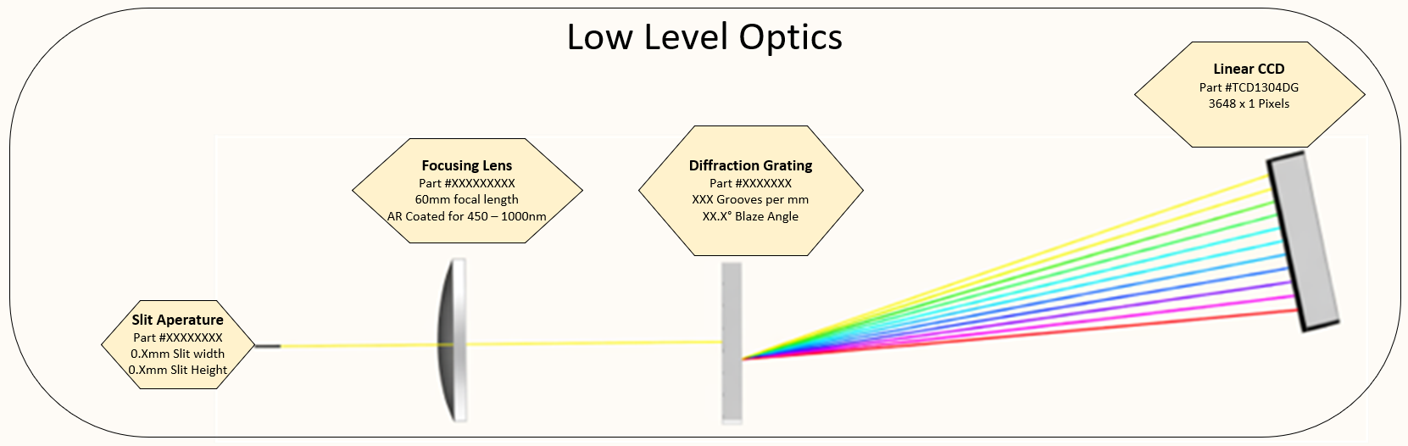
Figure 3. Optical subsystem concept retained from the original design document.
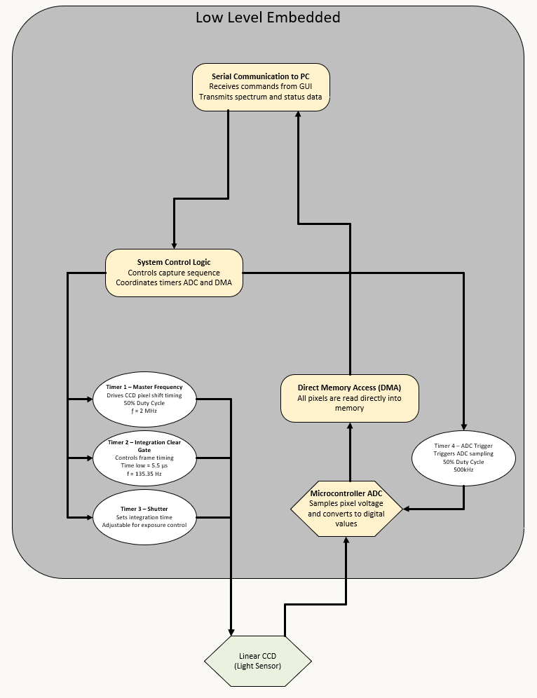
Figure 4. Embedded detector/electronics subsystem concept retained from the original design document.
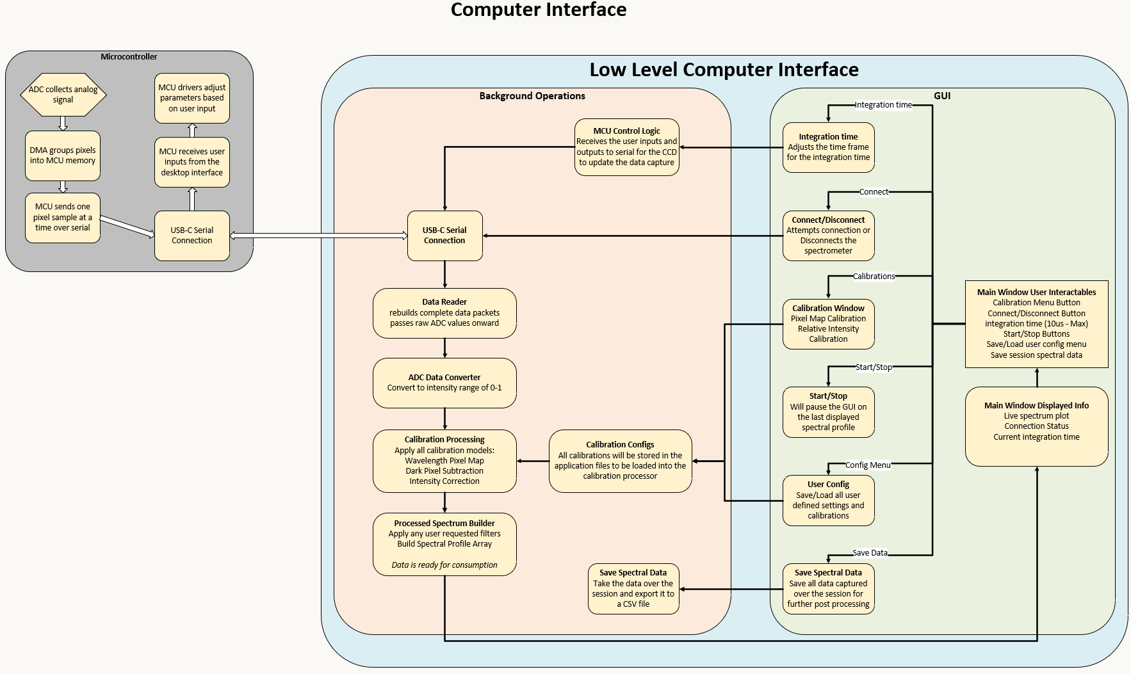
Figure 5. Python host application concept retained from the original design document.

Data Processing Pipeline
The data pipeline has been updated to match the current firmware and PythonGUI implementation. The STM32 streams CCD1 binary frames containing 3694 ADC samples. The desktop app preserves raw ADC counts, applies the current calibration pipeline for live display, creates compact spectrogram rows, and exports raw plus derived columns.
Phase | Name | Definition
1 | Microcontroller Readout | STM32 clocks the CCD, captures a 3694-sample ADC line with DMA, and streams the CCD1 binary USB CDC frame.
2 | Bias and Dark Correction | Stored bias, shielded-pixel frame dark reference, and optional master-dark offsets remove additive baselines.
3 | Wavelength Calibration | Known reference peaks map pixel index to wavelength through fitted polynomial coefficients.
4 | Response Correction and Normalization | Flat-field/PRNU and QE response terms compensate instrument response, then the signal is scaled for display.
5 | Display, Spectrogram, and Export | The GUI renders a line spectrum or rolling spectrogram and saves CSV files with raw and processed data columns.

Functionality
- Acquire CCD output through STM32 ADC + DMA with fixed frame geometry and frame counters.
- Stream frames to the host through USB CDC using a binary packet format instead of plain-text sample dumps.
- Display processed live spectra from effective pixels and optionally show a rolling spectrogram built from recent frames.
- Support calibration workflows for bias capture, dark correction, wavelength mapping, flat-field correction, and QE/response correction.
- Export session data to CSV with raw ADC counts, processed counts, dark reference, wavelengths, volts, and processed intensity.

Technology Considerations
Technology | Strengths | Tradeoff / Watch Item
TCD1304DG linear CCD | 3648 effective pixels provide dense spectral sampling across the target range. | Requires precise timing and its NIR sensitivity decreases toward the upper end of the range.
STM32F411CEU6 | Hardware timers, ADC, DMA, and USB full-speed peripheral fit the embedded role. | 12-bit ADC and USB CDC throughput require careful validation.
Python + Kivy desktop app | Open, maintainable, and fast enough with background parsing and bounded buffers. | UI refresh must avoid blocking the serial reader or packet processor.
JSON calibration/config files | Easy to inspect, version, and edit during prototype development. | Requires disciplined handling so saved calibration matches the physical setup.

Design Analysis
The firmware and desktop software have matured beyond the early prototype description. The current embedded stream is structured around CCD1 binary frames, and the Python GUI includes connection management, packet parsing, processed live display, rolling spectrogram mode, calibration manager, display/layout controls, diagnostics, performance monitoring, and CSV export.
The optical subsystem remains the main validation driver. The next high-value work is confirming wavelength coverage, suppressing second-order diffraction, measuring spectral resolution, and tying those measurements to the wavelength calibration workflow in the desktop app.

5. Testing
Testing must verify the entire measurement chain: optical input, CCD timing, ADC sampling, USB frame transport, processing, calibration, display, and export. The strategy is to validate each subsystem independently, then validate the interfaces where measurement errors are most likely to be introduced.
Test Type | Planned / Current Tests | Acceptance Evidence
Unit testing | Firmware timer configuration, ADC/DMA callbacks, packet parser behavior, processing helpers, config loading, calibration math, and CSV export. | Oscilloscope/logic capture for timing; parser fixtures; Python compile/import checks; known vector tests for processing helpers.
Interface testing | CCD-to-ADC signal chain, STM32 USB CDC packet stream, Python serial transport, GUI-to-command-service actions, and config-to-processing updates. | Correct frame counts, no sample-count mismatch, stable connection state, and correct GUI response to calibration changes.
Integration testing | End-to-end stream from STM32 through Python state/session manager into line plot, spectrogram, and CSV export. | Live graph updates from real frames; exported file opens with expected raw and derived columns.
System testing | Known reference sources used to validate wavelength mapping, range, resolution, and repeatability under lab conditions. | Documented wavelength error, FWHM, signal-to-noise behavior, and repeat acquisition consistency.
Regression testing | Repeat parser, processing, GUI startup, and export checks after firmware or GUI changes. | No reintroduction of frame parsing failures, frozen UI behavior, broken calibration preview, or malformed CSV output.
Acceptance testing | Client-observed demonstration of setup, acquisition, calibration, display, and export for a known source. | Client confirms workflow meets research prototype needs and identifies remaining improvements.
Security and safety testing | USB command handling, file export paths, electrical safety checks, enclosure light leakage, and standard lab handling practices. | No unsafe exposed power condition, no unintended file overwrite workflow, and no command path that disrupts normal acquisition without user action.
User testing | Dr. Das or lab representative uses the app to connect, view data, switch views, calibrate, and export. | Observed usability issues are logged and converted into design improvements.

Current Results and Planned Validation
Current confirmed status includes a testable STM32F411 firmware path, PCB design/fabrication progress, a Python desktop interface with the implemented live processing pipeline, received calibration laser diodes, and an initial diffraction demonstration showing visible dispersion across multiple orders. These are current-state results, not final performance claims.
Planned validation will quantify wavelength coverage, spectral resolution, wavelength mapping error, signal-to-noise ratio, frame throughput, export correctness, and user workflow reliability. Final claims should be made only after those measurements are recorded with source, setup, and analysis notes.

6. Implementation
Area | Current Implementation State | Next Implementation Work
Firmware | STM32F411 firmware drives CCD timing, starts ADC + DMA capture, maintains frame slots, and transmits CCD1 binary frames over USB CDC. | Add/verify command handling for integration control and record throughput under real acquisition conditions.
Desktop GUI | Kivy app connects to serial ports, rebuilds packets, displays processed line spectra or rolling spectrograms, logs diagnostics, and exports CSV. | Run sustained acquisition tests and refine usability based on client walkthrough feedback.
Processing pipeline | Bias/dark correction, wavelength mapping, flat-field correction, QE/response correction, normalization, and spectrogram row generation exist in the Python backend. | Populate calibration data from measured references and document calibration procedures.
Optics | Optical components and diffraction behavior are under active alignment and evaluation. | Finalize grating/filter/enclosure positioning and quantify wavelength coverage/resolution.
Electronics/PCB | Driver board work and STM32 bring-up are in testable state. | Complete electrical validation, enclosure integration, and any needed analog front-end tuning.
The implementation is intentionally modular: firmware owns timing and frame formation, the Python backend owns parsing/state/calibration/export, and the frontend owns user interaction and visualization. This separation allows each subsystem to be tested independently while keeping the full measurement chain understandable.

7. Ethics and Professional Responsibility
The ethical responsibility of this project is to produce a research instrument that is honest about its limits, safe for laboratory use, and useful to the client without overstating calibration or measurement quality. The team should treat the spectrometer as a scientific measurement device, not just a working electronics demo.
Responsibility Area | Application to Project
Public health, safety, and welfare | Use safe electrical practices, protect users from exposed circuitry, avoid overheating, and clearly document operating limitations.
Honesty and integrity | Report measured wavelength accuracy, resolution, and SNR only after validation; clearly label planned tests and provisional results.
Environmental responsibility | Prefer reusable optical/electronic hardware and avoid unnecessary replacement of components during prototyping.
Economic responsibility | Keep the design affordable and open enough that the client can maintain or improve it after the course.
Professional competence | Document firmware, GUI, calibration, and test procedures so future users understand how the instrument produces data.
Key virtues for the team are accuracy, transparency, and accountability. Accuracy is necessary because calibration determines the scientific value of the spectrum. Transparency is necessary because prototype limitations must be visible to the client. Accountability is necessary because hardware, firmware, optics, and software decisions all affect the final measurement.

8. Closing Material

Conclusion
The project has progressed from a concept for a portable VIS-NIR spectrometer into a working multi-subsystem prototype path. The embedded and desktop software now support a structured frame stream and a modernized processing pipeline. The remaining project risk is concentrated in optical validation and final end-to-end performance measurement.
The recommended next steps are to finalize optical alignment, validate wavelength mapping using known sources, measure spectral resolution and signal-to-noise ratio, complete client usability testing, and record all acceptance evidence in a repeatable test report.

References
[1] Toshiba, "TCD1304DG Linear Image Sensor Datasheet," Toshiba Electronic Devices & Storage Corporation.
[2] STMicroelectronics, "STM32F411xC/E Arm Cortex-M4 MCU Datasheet and Reference Manual," STMicroelectronics.
[3] International Electrotechnical Commission, "IEC 61010-1 Safety Requirements for Electrical Equipment for Measurement, Control, and Laboratory Use."
[4] International Electrotechnical Commission, "IEC 61326-1 Electrical Equipment for Measurement, Control and Laboratory Use - EMC Requirements."
[5] ASTM International, "ASTM E275 Standard Practice for Describing and Measuring Performance of Ultraviolet and Visible Spectrophotometers."
[6] National Institute of Standards and Technology, "NIST Standard Reference Materials for Wavelength Calibration."
[7] Kivy Organization, "Kivy Documentation," used for the Python desktop interface framework.
[8] Python Software Foundation and package maintainers, "Python, NumPy, Pydantic, and pyserial documentation," used for desktop processing and serial communication.

Appendices
Appendices preserve supporting personas and presentation-ready pipeline copy that help reviewers understand the design context without leaving the document.

9. Team
Team Member | Primary Contribution Areas
Ryan Majstorovic | Embedded systems, PCB design, team organization, firmware/GUI integration support.
Dawson Posekany | PCB design, simulation/testing, spectroscopy background, progress documentation.
Samar Gill | Embedded systems, project presentation, AI-assisted workflow integration.
Evan Tamer | Breadboard circuit design, lab note-taking, electronics support.

Team Workflow
The team uses weekly standups and advisor/client check-ins to assign work, review progress, and identify blockers. Communication is split between formal project channels for files and client interaction and faster team messaging for implementation questions. Decisions are made by consensus when they affect subsystem interfaces or project direction.

Appendix A. Pipeline Slide Copy
Phase | Slide Title | Slide-Ready Statement
1 | Microcontroller Readout | CCD signal captured by STM32 ADC + DMA and sent as a binary USB frame.
2 | Bias and Dark Correction | Bias and dark baselines are removed from each pixel signal.
3 | Wavelength Calibration | Reference peaks convert pixel position into wavelength.
4 | Response Correction and Normalization | Flat-field and QE corrections are applied before scaling.
5 | Display, Spectrogram, and Export | Python displays live spectra and saves raw plus processed data.
Recommended slide notation: lambda = wavelength; a.u. = arbitrary units. Use pixel index on uncalibrated plots and lambda (nm) after wavelength mapping is saved.

Appendix B. Additional Personas
Persona | Motivation | Design Relevance
Biomedical / electrical engineering researcher | Affordable, accurate, modifiable spectroscopic measurement. | Supports the primary client use case and future publication or lab reuse.
Medical staff | Efficient optical sensing workflows with reliable output. | Reinforces the need for usability, repeatability, and clear output interpretation.
Educational institutions | Low-cost classroom-friendly instrument for hands-on optics and sensing. | Reinforces portability, durability, documentation, and affordability.

Appendix C. Source Materials Used For This Review Copy
- Original design document: SDDEC26-06_Team_Spectro_Design_Document.docx
- Data processing pipeline review document: Data_Processing_Pipeline_Review.docx
- Faculty panel presentation: VIS-NIR-Spectrometer-Faculty Panel Presentation.pptx
- Current repository documentation and source code for firmware stream geometry, PythonGUI processing, and CSV export behavior.

