6 March 2024

Ryan Millard

ST10383326

Millard

ST10383326

## Website development

## Website development

## Website development

## Website development

## Website development

## Website development

## Website development

## Website development

WEDE5020

WEDE5020

WEDE5020

WEDE5020

WEDE5020

WEDE5020

WEDE5020

WEDE5020

WEDE5020

WEDE5020

WEDE5020

WEDE5020

WEDE5020

WEDE5020

WEDE5020

WEDE5020

ICE Task 2

ICE Task 1

ICE Task 1

ICE Task 1

ICE Task 1

ICE Task 1

ICE Task 1

ICE Task 1

Contents

Website Choice 4

List of Resources 9

Website Assets 10

Website Pages and Content 16

Bibliography 19

List of Figures

Figure 1 - Homepage view from the Samsung Internet Browser on a Samsung Galaxy A34 using dark mode (04/03/2024). 5

Figure 2 - Homepage view from the Microsoft Edge Browser on a Lenovo 80JA (04/03/2024). 7

Figure 3 - The background of 42nd Precinct Security’s business card, given by a secretary at the company (2024). 9

Figure 4 - Two Security Officers Standing at Boundary Gate 9

Figure 5 – Old Logo 10

Figure 6 – Improved Logo 10

Figure 7 – Security Officer Behind Desk 10

Figure 8 – Security Officer Standing By 11

Figure 9 – Armed Response Officer at the Side of His Vehicle 11

Figure 10 – Alarm Keypad 11

Figure 11 – High-Security Keypad 12

Figure 12 – Outdoor CCTV Camera 12

Figure 13 – Armed Response Officer in Bulletproof Vest (on-premises) 12

Figure 14 – Single Security Officer Standing at Boundary Gate 13

Figure 15 – Armed Response Officer in Front of His Car 13

Figure 16 – Car Guard in Parking Lot 13

Figure 17 – Two Armed Response Officers Standing in Front of Armed Response Vehicle 14

Figure 18 - Armed Response Officer (Nighttime) 14

Figure 19 - Sitemap 17

# Website Choice

**Company chosen:** [42nd Precinct Security](http://42ndprecinct.co.za/)

42nd Precinct Security's website needs a few minor tweaks, which will improve the overall experience of every user that enters the site. Their existing website suffers from broken gateways, preventing the proper rendering of pages beyond the homepage, underutilized images, and a lack of responsiveness regarding the device’s viewport size across various devices, specifically those with smaller viewports. 42nd Precinct Security plays a vital role in safeguarding our community, and, by improving their online presence, I will contribute to their mission of ensuring safety and security.

The key success indicators for a successful website for a company in the security sector include the following:

1. **User Engagement:** Includes metrics like average time on site, page views per visit, and bounce rate. High engagement indicates that users find the site valuable and are spending time exploring its content, increasing the likelihood of them becoming a client.
2. **Content Quality:** Regularly publishing high-quality, relevant content can help attract and retain users, as well as improve search engine rankings.
3. **Social Media Engagement:** If the company is active on social media, metrics like shares, likes, and comments can indicate how well the content is resonating with the audience.
4. **Customer Satisfaction:** Feedback from users can provide valuable insights into how well the site is meeting their needs. This could be measured through surveys, reviews, or direct feedback.
5. **Mobile Responsiveness:** With more and more users accessing websites from their mobile devices, it’s important for the site to be mobile-friendly.
6. **Traffic:** The number of visitors to the site can be a good indicator of its success. This can be broken down into new visitors (reach) and returning visitors (retention).
7. **Search Engine Ranking:** For users to find the website, it needs to rank well in search engine results for relevant keywords. This can drive organic traffic to the site.
8. **Conversion Rate:** This is the percentage of visitors who take a desired action on the site, such as requesting a quote, booking a consultation, or making a purchase.
9. **Page Load Speed:** Users have little patience for slow-loading websites, so ensuring the site loads quickly can improve the user experience and impact other metrics like engagement and conversion rate.

To achieve the user engagement goal, the company will need a website that is visually pleasing and contains information that visitors find interesting or helpful. This can be accomplished by using a colour palette that is tailored to 42nd Precinct Security and represents their identity, this colour palette will mainly use shades of yellow-orange (#FAA61A), an off-white colour (#ECF0F1) and an off-black colour (#010101), as these colours not only look good together but they protect the viewer’s eyes from strain due to the contrast between them not being as immense as pure white on pure black or vice versa. This will be more likely to retain visitors as they won’t feel physically tired after 5 minutes of using the company’s website. In addition to this, the components on the website must catch the interest of users to lengthen their stay.

To improve the quality of the content on the website, those who are tasked with managing the website will be required to consistently post and upload interesting, high-quality content to social media and the website to keep it relevant and spark interest in viewers.

Within the “Contact Us” page, there will be a Google Form which prompts users to rate their experience on the website. This will prove to be extremely valuable as it will provide the admins with feedback and allow for changes to be made to the website when an issue arises. In addition, this will lead to the website being more cohesive.

In addition to the Google Form that prompts users for feedback, there will also be one on another page for candidates to apply for available jobs, which will be listed on the website.

One of the largest problems that the company’s website currently faces is its lack of support for devices with smaller screens, as can be seen in **Figure 1**. Users who visit the website in its current state will most likely be repelled by the layout of the website as it either doesn’t entirely fit their screen and they struggle to read what is on the screen, or they have to zoom in to be able to read what is on the screen and then have to scroll from left to right and then back each time they read a line, which some users find intolerable. This issue will be easily solved using media queries and will thus save the business from losing clients on mobile devices to their competitors, who have responsive websites.

Using meta tags, the website will be able to draw I more traffic as browsers will discover the website far more easily when topics related to the business are searched. This will draw in more organic traffic and cause the website’s ranking to improve over time if the website is constantly updated to include modern and relevant content.

Figure 1 - Homepage view from the Samsung Internet Browser on a Samsung Galaxy A34 using dark mode (04/03/2024).

Since the website will be using pure HTML and CSS as well as Vanilla JavaScript, there are not many options when it comes to speeding up loading times for users as unpredictable circumstances, such as a heavy load on the network infrastructure in an area, may cause the website’s loading time to increase. To improve normal loading times, cross origin resource sharing will be avoided to save the users from potentially long loading times, which may cause them to lose interest in the site and move on to another website. To do this, the website will not import anything unless it is a necessary import.

**Figure 2** shows the website from the Microsoft Edge browser, which is better than its mobile counterpart but still not great as the main content of the website has been put inside a div that does not occupy the full width of the screen. This was evidently a stylistic choice; however, it made the website look like a flyer rather than a company’s website, which would look good if it were on a piece of paper rather than a website. As a result of this, users may feel initially overwhelmed by information, and that parts of the website are missing or empty due to too much negative space on the edges of the screen and the content seemingly being crammed into the centre.

As can be seen in **Figure 1**, many of the pictures are not well-suited for use on a website. For example, the logo’s background should be removed as it is not visually appealing on browsers that are set to be in dark mode, and it has poor resolution. The images on the website will either be enhanced and used or discarded when the rework to the website is being done.

The objectives of the reworking of this website are as follows:

1. Improve UI/UX
   1. Modern & suitable colour palette (#FAA61A, #ECF0F1, #010101, #333333, #131313).
   2. Improve image quality.
   3. Improve responsiveness (for all screen sizes).
   4. Maintain user’s interest.
2. Improve loading times.
3. Provide information in a congruent manner.
4. Better logical segregation of the website.

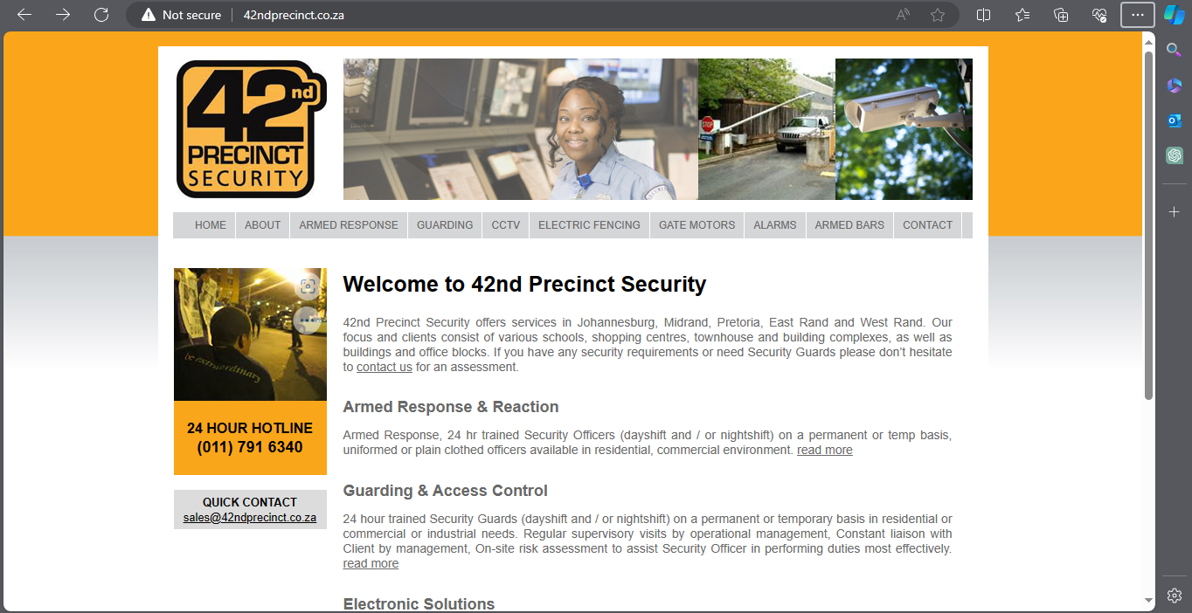

Figure 2 - Homepage view from the Microsoft Edge Browser on a Lenovo 80JA (04/03/2024).

# List of Resources

Images:

1. Logo
2. Products
3. Security Officers

Sourced from:

* [42nd Precinct Security | Instagram](https://www.instagram.com/42ndprecinctsecurity/?igsh=eHd0bDVoaXJueGxl) (42nd Precinct Security, 2024)
* [42nd Precinct Security | Facebook](https://www.facebook.com/42ndprecinct?mibextid=qi2Omg) (42nd Precinct Security, 2024)
* USB Flash Drive loaded with professional images.

Text:

1. Mission Statement.
2. Vision Statement.
3. Spectrum of Clients.
4. Main services offered.
5. Main products offered.
6. Business Ideologies & Objectives
7. Value Statement.
8. Location of Premises.
9. Security Industry Regulatory Authority information.
10. Employment Equity and BBBEE information.
11. Registrations and Affiliations.
12. History of the Company.
13. Contact Information.
14. Hotlines.
15. Domain Name (42ndprecinct.co.za).

* Sourced from:
* [42nd Precinct Security | Website](http://42ndprecinct.co.za/) (access to source code, which is mainly PHP, via FTP, which was granted to me by the website’s admin) (42nd Precinct Security, 2024).
* (42nd Precinct Security, n.d.)

# Website Assets

Figure 3 - The background of 42nd Precinct Security’s business card, given by a secretary at the company (2024).

Figure 4 - Two Security Officers Standing at Boundary Gate

A small image of two security officers at Rand Park High School, which was sourced from 42nd Precinct’s website (2024).

Figure 5 – Old Logo

The old logo that was used on the website, which is dull, noisy, low resolution, and is not 100% the same as the actual company’s logo.



Figure 6 – Improved Logo

The preferred logo, which has is the visually enhanced version of **Figure 5**, which uses the correct colours, is larger, has a higher resolution, and accurately reflects the company’s logo.

The following figures (7-19) all came from 42nd Precinct Security’s website:

Figure 7 – Security Officer Behind Desk

Figure 8 – Security Officer Standing By

Figure 9 – Armed Response Officer at the Side of His Vehicle

Figure 10 – Alarm Keypad

Figure 11 – High-Security Keypad

Figure 12 – Outdoor CCTV Camera

Figure 13 – Armed Response Officer in Bulletproof Vest (on-premises)

Figure 14 – Single Security Officer Standing at Boundary Gate

Figure 15 – Armed Response Officer in Front of His Car

Figure 16 – Car Guard in Parking Lot

Figure 17 – Two Armed Response Officers Standing in Front of Armed Response Vehicle

Figure 18 - Armed Response Officer (Nighttime)

# Website Pages and Content

**Pages**

|  |  |
| --- | --- |
| **Name** | **Content** |
| Home | Logo  Links to other pages  Slogan  Digital Business Card  Hotlines (42nd, police, ambulance, fire brigade, etc.)  Image of Armed Response officer  Mission Statement  Brief Description of Company  Affiliations and Recognitions  Summary of Products and Services offered.  History  Links to Social Media  Logo  Links to other pages |
| About | Logo  Links to other pages  Slogan  Digital Business Card  Mission Statement  Business History  Contributions to the community  Affiliations and Recognitions  Links to Social Media  Logo  Links to other pages |
| Products and Services | Logo  Links to other pages  Slogan  Short Summary of Business History  Summary of Main Products and Services Provided  Detailed List of Products and Services Provided  Affiliations and Recognitions  Links to Social Media  Logo  Links to other pages |

|  |  |
| --- | --- |
| **Name** | **Content** |
| Employment opportunities | Logo  Links to other pages  Slogan  Mission Statement  Why choose us?  List of vacancies and description of each  Google Form (Accepts a CV in PDF form)  Links to Social Media  Logo  Links to other pages |
| Contact Us | Logo  Links to other pages  Slogan  Hotlines (42nd, police, ambulance, fire brigade, etc.)  Digital Business Card  Cell/Landline numbers  Email  Image of the Premises  Embedded Google Map  Embedded Google Form for Feedback on Website  Links to Social Media  Logo  Links to other pages |

**Sitemap**

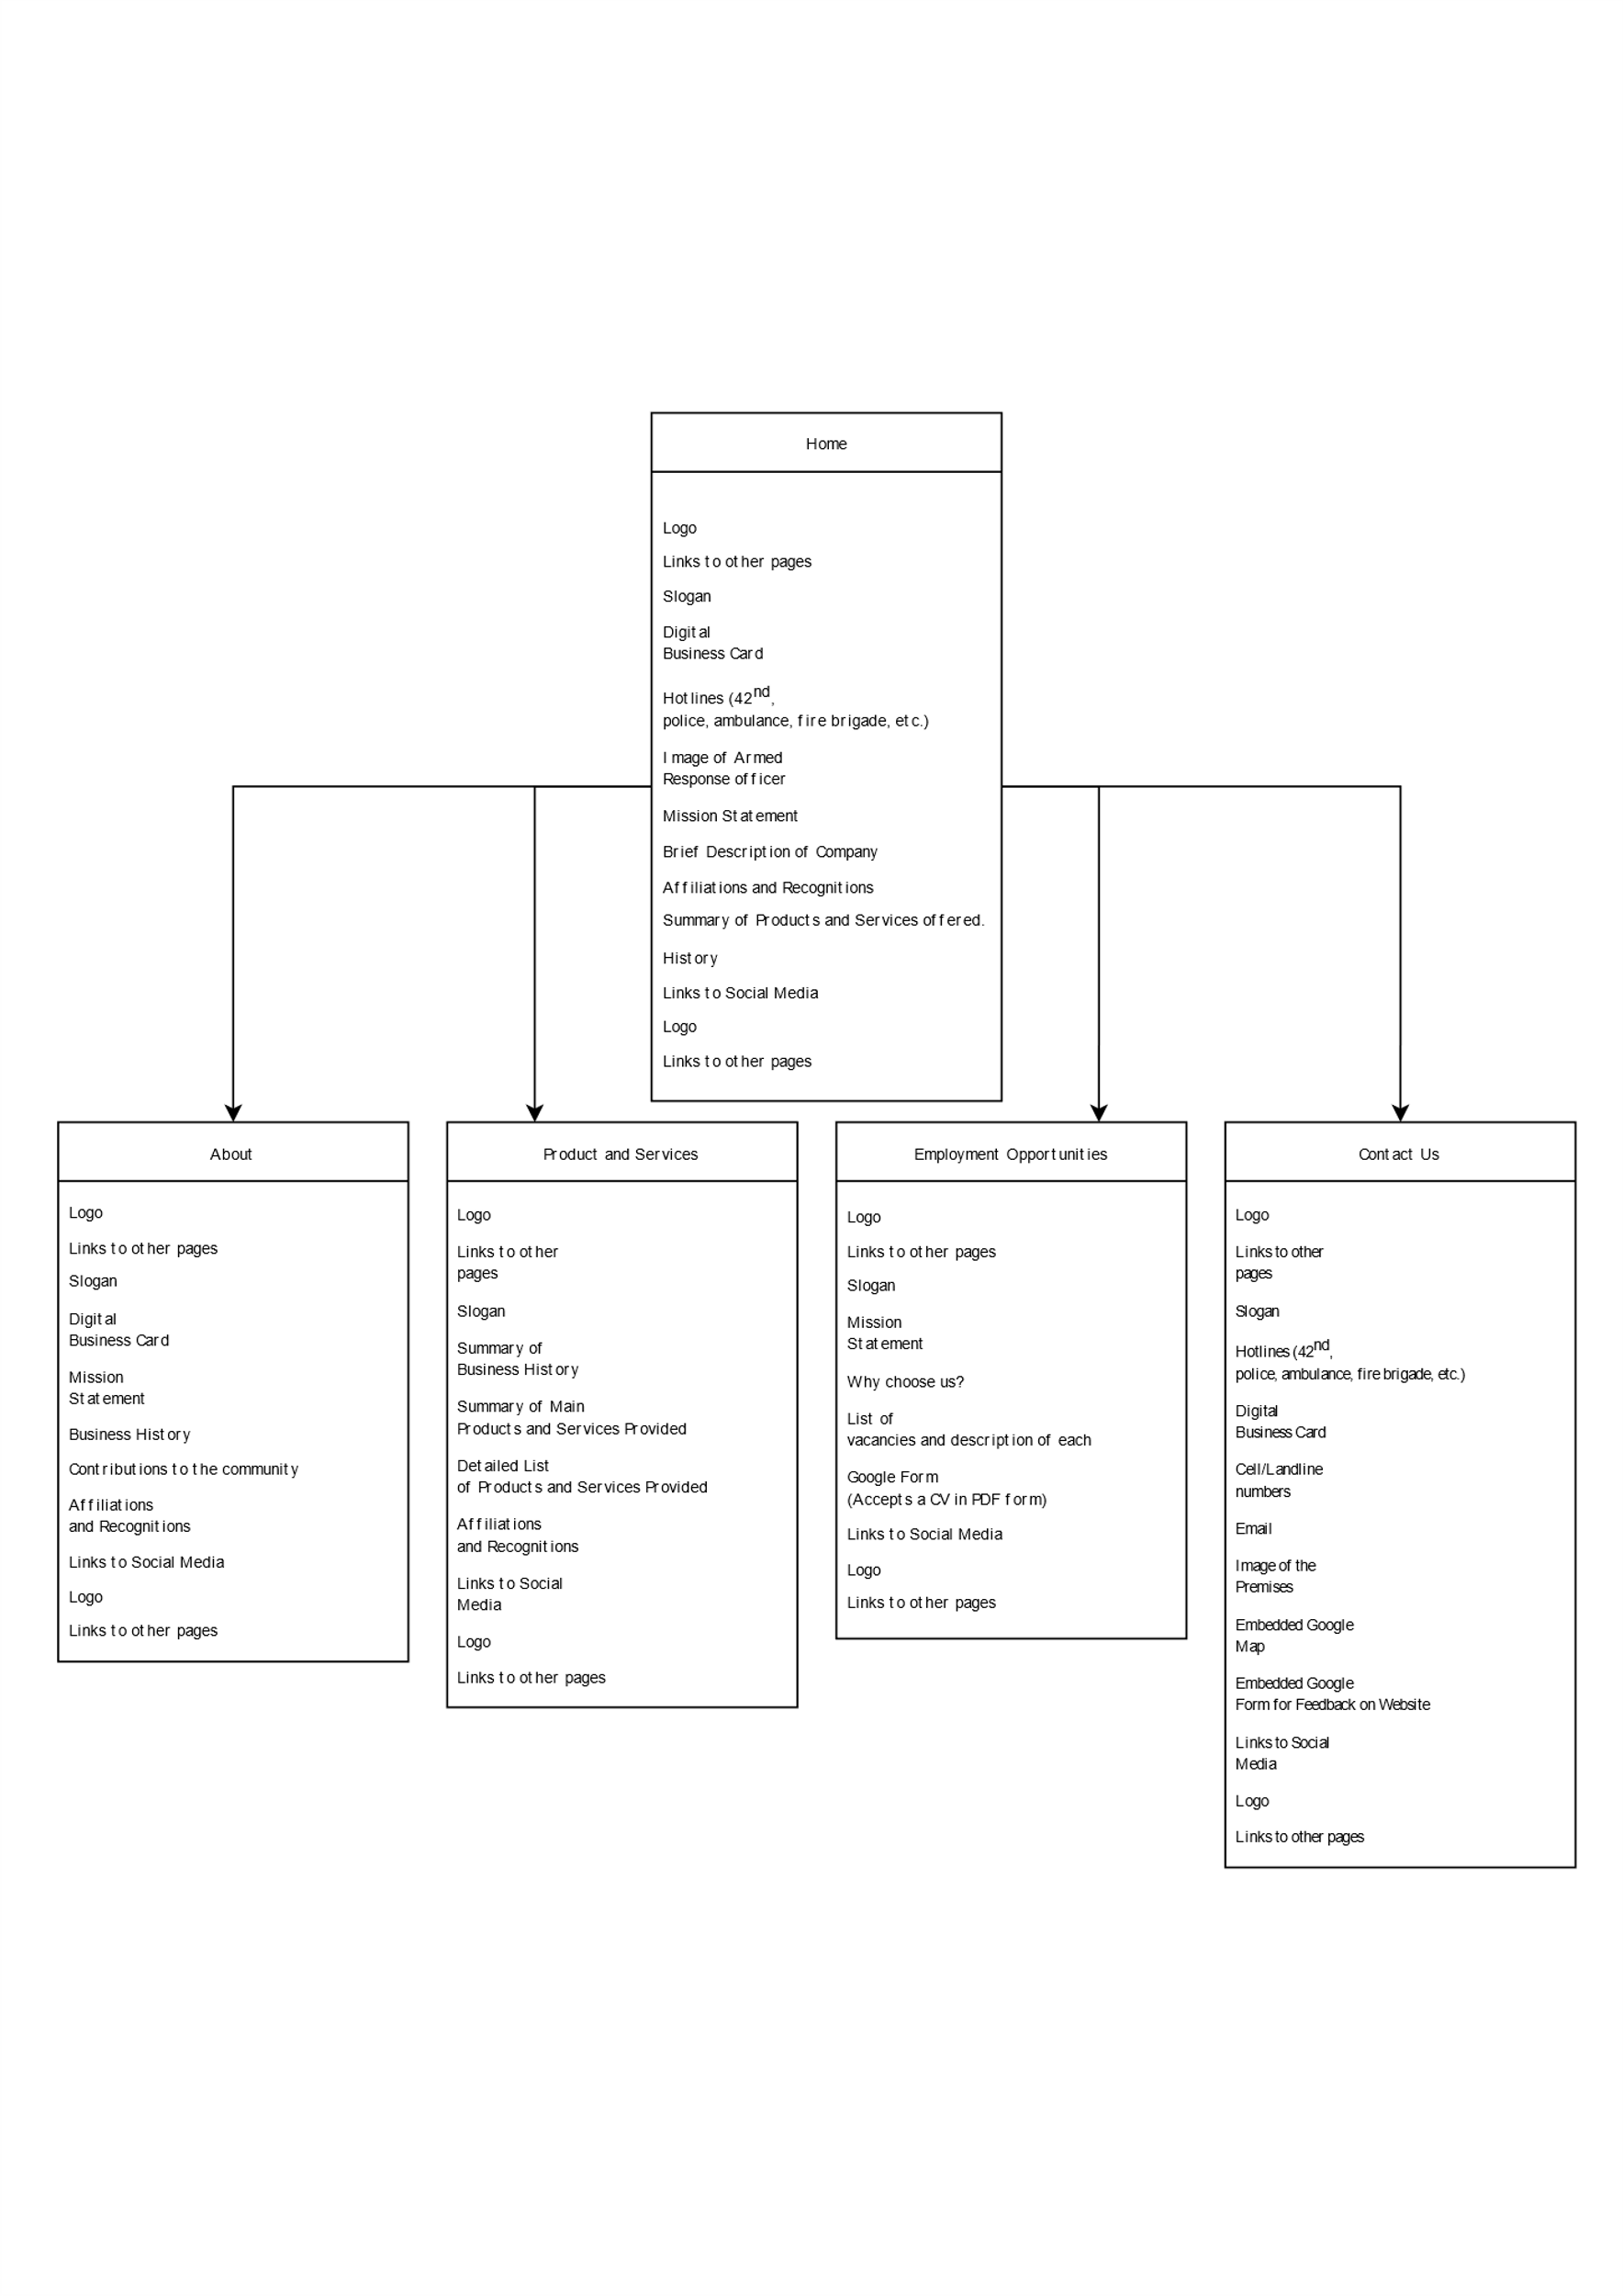

Figure 19 - Sitemap

# Bibliography

42nd Precinct Security, 2024. *42nd Precinct Security.* [Online]   
Available at: http://42ndprecinct.co.za/  
[Accessed 6 March 2024].

42nd Precinct Security, 2024. *Facebook.* [Online]   
Available at: https://www.instagram.com/42ndprecinctsecurity/?igsh=eHd0bDVoaXJueGxl  
[Accessed 6 March 2024].

42nd Precinct Security, 2024. *Instagram.* [Online]   
Available at: https://www.facebook.com/42ndprecinct?mibextid=qi2Omg  
[Accessed 6 March 2024].

42nd Precinct Security, n.d. *Company Profile.* Johannesburg: s.n.