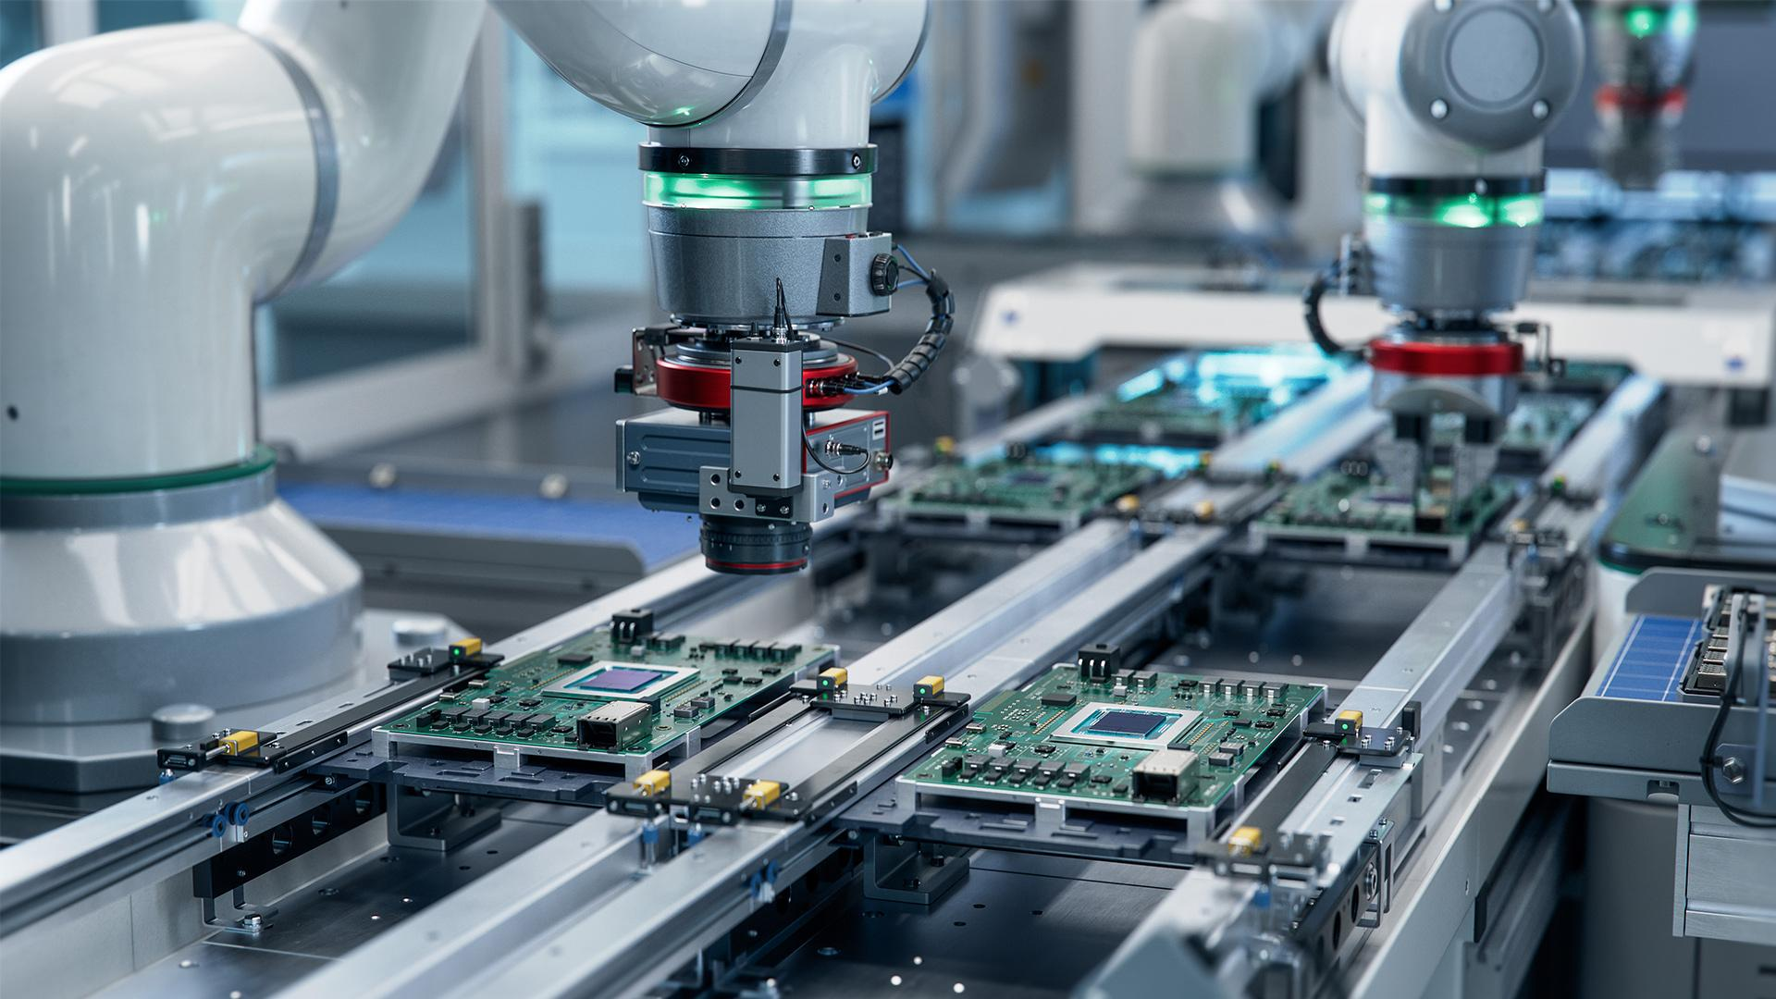

“Many jobs in the factory are being replaced by machines. I like working here but am worried that I will be replaced. What should I do?”

26/Sep/2023 Ryan R. Mohammed

With advances in technology by the day, there are a considerable amount of people who acknowledge that technology is coming fast, too fast. Most jobs will take a long time before technology and AI get to a point where it will take decades, possibly centuries before this replacement occurs meaning that some people will not have to worry. Unfortunately , that is not the case for everybody, labour Jobs such as the jobs in factories with repetitive motion are being replaced by technology due to their efficiency.

Working in a factory which is a labour job is not going to last long, as a factory worker you should be worried about your occupation. What I will suggest is that you prepare yourself for the worse and start familiarising yourself with other professions. Because if technology comes to take your job, you have to be ready to adapt moving on to a different profession. So if you’re worried, prepare yourself for the worst.

Don’t think just because you got a new job that you think everything will be fine, because it’s not. Because there’s a high chance that with the speed at which technology is improving at, technology will come for your new job. My final advice is to just keep moving up fast, or atleast fast enough to keep the worry of technology taking over your job out of your way.