

|  |
| --- |
|  |
| E-Business  Debenhams Ireland |
| |  |  |  | | --- | --- | --- | | By David Cantwell, Adam Cotter and Ryan Monaghan | 11/24/15 | IT2 | |

IT2-A

Adam Cotter- R00128198

David Cantwell- R00127358

Ryan Monaghan- R00115129

Contents

**Section 1** 4

**Section 2 - Introduction to our group** 4

**Purpose behind the project we have chosen?** 4

**What will the reader learn after reading our report?** 4

**Section 3 - Company information** 5

**Categorise the website (clicks, B2C)** 6

**Section 4 - Websites usability** 7

**Checking the website in browsers (Edge, Firefox, IE 11 and Chrome)** 7

**Are breadcrumbs used throughout?** 7

**Meaningful URL** 7

**Amazon de facto layout?** 8

**Is the search facility provided? Is it easy to use?** 10

**Consistent Layout from page to page?** 11

**Consistent branding from page to page?** 11

**Products webpage** 13

**Is the Url appropriate in accordance to the Debenhams websites?** 13

**Is it a compelling product copy?** 13

**Is it a useful product copy?** 13

**Quality of images** 13

**Do they suggest related products?** 14

**Are reviews included in the website?** 14

**Is warranty information provided by the company?** 14

**Are social links included on their website?** 14

**Does the website provide clear calls to action?** 14

**Purchasing** 15

**Process Flow:** 15

**Additional Purchasing Information** 16

**Are stock levels clear?** 17

**Customer Service** 17

**Overview** 17

**Track and Trace** 17

**Returns and Refunds** 17

**Delivery Information** 18

**My Order** 18

**FAQs** 18

**Contact Us** 18

**Additional Customer Service Information** 18

**Is their privacy policy easy to understand?** 19

**Section 5 - Improvements to website** 23

**Section 6 - The Marketplace –depends on the number of images used** 23

**Describe the marketplace in which the business operates.** 23

**Identify and describe one major competitor within the marketplace.** 24

**Briefly compare and contrast your business’ website, products and services with the competitor.** 24

**Compare and contrast the traffic to each using online tools. Comment on your findings.** 25

**Finding on website traffic** 26

**Daily page views per visitor** 27

**Daily Time spent on site** 27

**Where did the traffic come from before landing on our page?** 29

**Total number of sites linking to Debenhams vs Littlewoods.** 30

**Sites with similar names?** 31

**Marketing – Newsletters** 32

**Compare & contrast newsletters – Comment on findings, recommend changes.** 32

**Debenhams Newsletter** 32

**Littlewoods Newsletter** 32

**Marketing on images used** 32

**Search Engine Optimization** 33

**Overview** 33

**Keywords & Phrases** 33

**Keyword Observations** 33

**Marketing – Web 2.0** 34

# **Section 1**

This is going to be our project for E-Business, our lecturer has asked us to use an Irish website and go through what type of a business the online website is.

In this project there are going to be three of us, which are Adam Cotter, David Cantwell and Ryan Monaghan.

The company that we are going to choose for our project will be based on the Irish website, Debenhams.ie

# **Section 2 - Introduction to our group**

Hello, my name is Adam Cotter and I have been using online shopping for past number of years. Along with shopping online I have previously made websites in my first year of college. So I have covered a lot on website design and website layout. I also have done six years of Business studies when I was back in secondary school.

My name is David Cantwell and I am the second member of the group. I’m currently studying IT in CIT. I have completed a HTML and CSS fundamentals module. During this course, we built our own website and made our own CSS. This gave me working knowledge of good website design. In addition, I studied Business at Leaving Cert level, which afforded me basic knowledge of how ecommerce and marketing via the internet has an effect on company business.

My name is Ryan, I’m a frequent online shopper, be it for items of clothing or digital purchases. During my first year in CIT, I studied Web development and Web Publishing as part of my modules. I hope to use what I have learned from those modules throughout the report of this assignment, in tandem with the knowledge I have gained so far in my eBusiness module.

## **Purpose behind the project we have chosen?**

We have chosen this website because we have all shopped online before and we all thought that the best online Irish website to use would be Debenhams.

We have chosen this company because it is a well-known Irish company and a lot of people use this website to buy items such as clothes.

The Debenhams website was created in March 2009.

They sell items of clothing for men, women, and children. Also they sell products such as electronics and toys.

## **What will the reader learn after reading our report?**

After reading our report on the website Debenhams.ie, the reader will learn the following:

* They will learn why the site is successful.
* Also learn about how the company advertise.
* Will learn about their selling techniques which catches the eyes of the consumer.
* They will also learn why it is a good thing to use this website.
* They will find out more information on the company.
* Learn if its clicks only.
* They will learn if it is B2C or B2B.
* If they use cookies to track your activity.
* If they let customers give reviews on products.
* If the web page easy to use such as navigation.
* The most important thing they will learn is if the website is secure to use.
* Finally they will learn about SEO.

# **Section 3 - Company information**

Debenhams has a well laid out “about us” page, giving the customer a lot of important information without the introduction of waffle. They show how much of a broad influence they have being an “International” company that “trades out of 240 stores across 28 countries”. It is evident that quality and branding is high on the list of priorities to the company, as they provide the customer a unique “differentiated and exclusive mix of own brands” along with “international brands and concessions”.

They inform the reader that they are a successful diverse company. For example, in the UK and they have a “top four market share in womenswear and menswear, it also has a top 10 share in children’s-wear. It leads the market in premium health and beauty”

The Debenhams also tells us of their large online presence as they are operational online in “70 countries” which helped them win the awarded Multichannel Retailer of the Year at the Oracle Retail Week Awards.

They also show the reader their support for the clothing industry itself by listing the names of brands. Just a few of these brands being Ted Baker, John Rocha and Jasper Conrad.

The Debenhams website also provides useful links to other sections of their website, for example their social media, Company information, History of Debenhams etc.

Through Google search, the latest news is from the mirror report on a new [Debenhams discount voucher](http://www.mirror.co.uk/money/debenhams-discount-voucher-codes-free-5427751) this appears to be a Christmas promotion as it ends December 24th. This would act as a boost to end of year sales and is also a good PR advertisement.

I gathered the WhoIS information off of the [Irish Domain Registry](https://www.iedr.ie/)

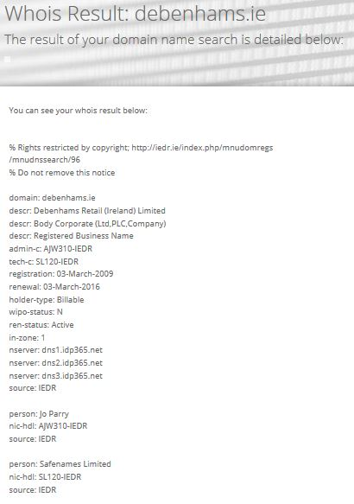

From this we can see when the site was registered in 2009. The domain named registered.

When the domain is up for renewal in 2016 and we can see the name of the person who registered it (Joe Parry)

I also searched for the company on the CRO.ie from which I got the results in the hypertext link [here](https://www.cro.ie/Home/Search-Results?sb-search=debenhams&sb-inst=1296&sb-logid=389282-8z9pu04c0qfblh9f).

## **Categorise the website (clicks, B2C)**

Debenhams acts as a click and bricks site with 240 stores in 28 countries and they are also available online in 70 countries. This gives the company a great advantage with a high street presence as it creates revenue from the older generation or the non tech savvy shopper. The online presence is a must to survive in such an aggressive market it is also a great way to market the company as well as create revenue. The Debenhams site allows you to have an option of “Click & Collect” which is a nice option and may produce footfall and create revenue from impulse spending, it also creates an advantage of less shipping costs or you can get it delivered straight to your door.

# **Section 4 - Websites usability**

In the first 5 seconds of landing on the page, the highly branded and well know name- Debenhams is clearly distinguishable. Many people would recognise the brand as a department store with a strong branded clothing/beauty background. Instantly, from the navigation bar you can clearly see the different categories of products that they sell.

Also on entering the home page, one of the first images is that of a large rolling advertisement which shows their best clothes offers of the week. This allows the customer see at a glance, a brief indication of what’s on offer, enticing them to delve further.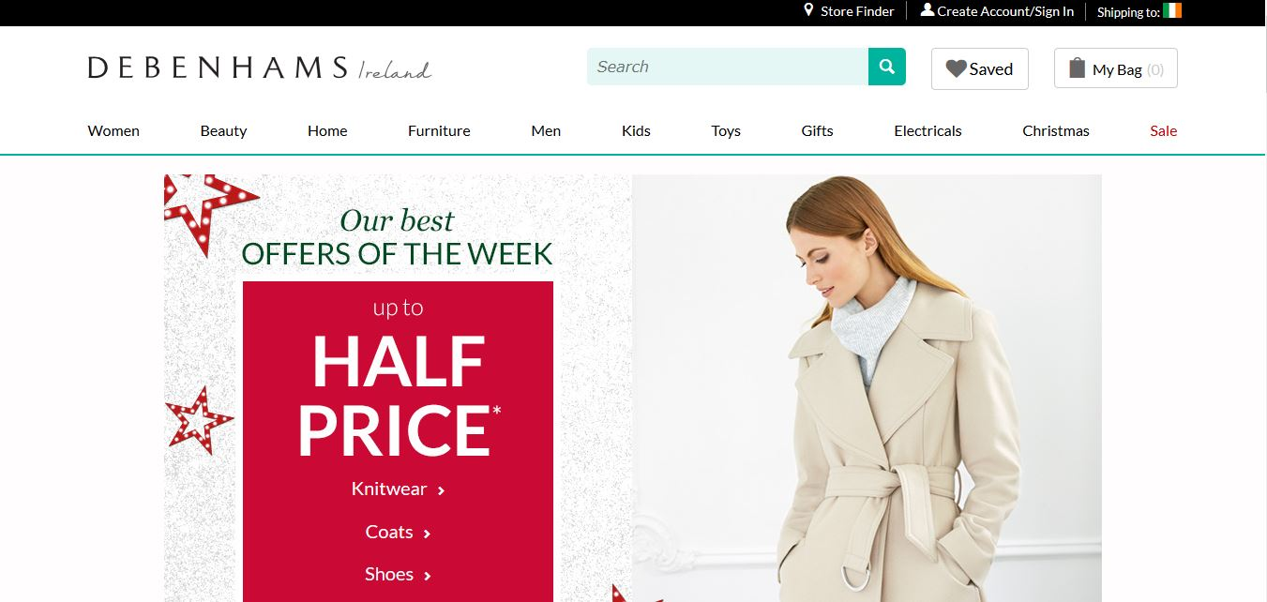

## **Checking the website in browsers (Edge, Firefox, IE 11 and Chrome)**

There is an excellent flow between the different browsers with the same layout throughout. The graphics are clear and undistorted. As layout is the consistently the same between all the browsers, each user has the same similar experience regardless of which browser is used.

## **Are breadcrumbs used throughout?**

Breadcrumbs are used throughout the website. The format of these can be seen in the screenshots below. The breadcrumbs are consistent and helpful for moving around the site from section to section.



## **Meaningful URL**

Debenhams uses useful and meaningful URLs for the navigating to the correct department and the subsection within the department. However, if you are viewing a specific item the URL is far from meaningful as shown in point 3 below .

1)

2)

3)

### **Amazon de facto layout?**

Debenhams has many elements of the Amazon de facto standard with the search bar at the top of the page with the logo/Brand name on the left. The account access, shopping basket/cart and a wish-list/saved

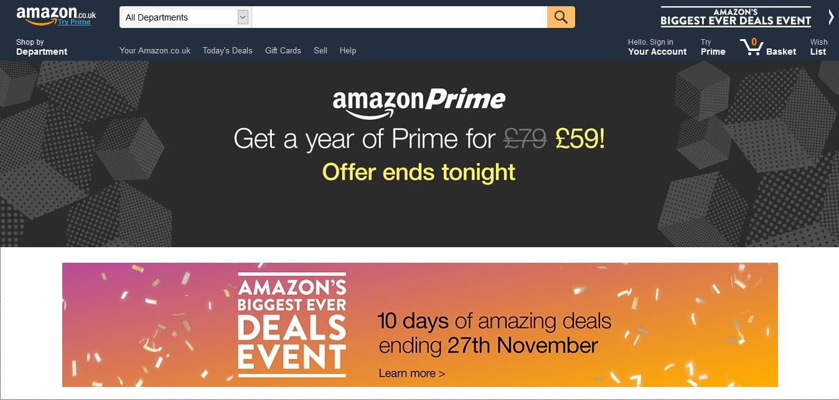



Both of the websites have a similar layout above the fold. The have the navigation bar where it’s expected. Both use a drop down box system. They both have the search bar, shopping cart, wish list, account login and logo in the same location. The advantage of all websites using this de facto layout enables users to feel a familiarity with the basics of a website without having previously shopped. Debenhams also follows suit to that of Amazon, in regards, to their main eye catching advertisement being that of their best offers.

Amazon webpage footer

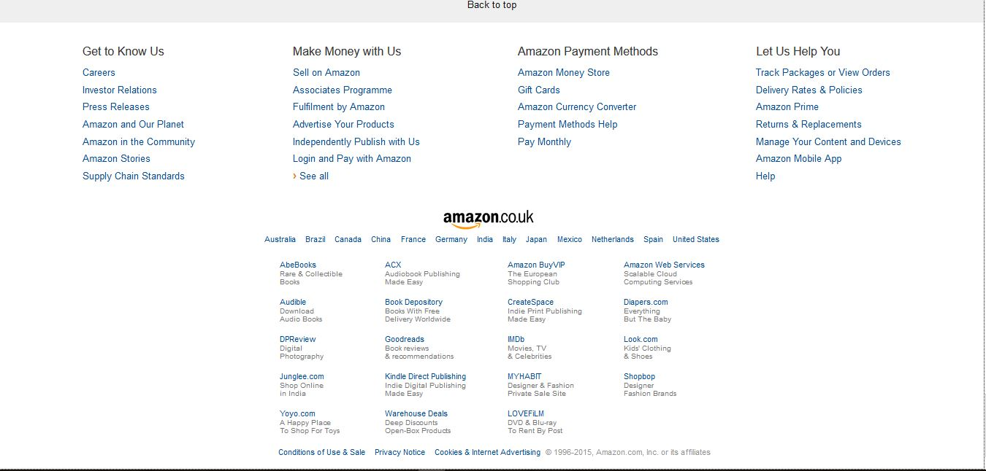

Debenhams webpage footer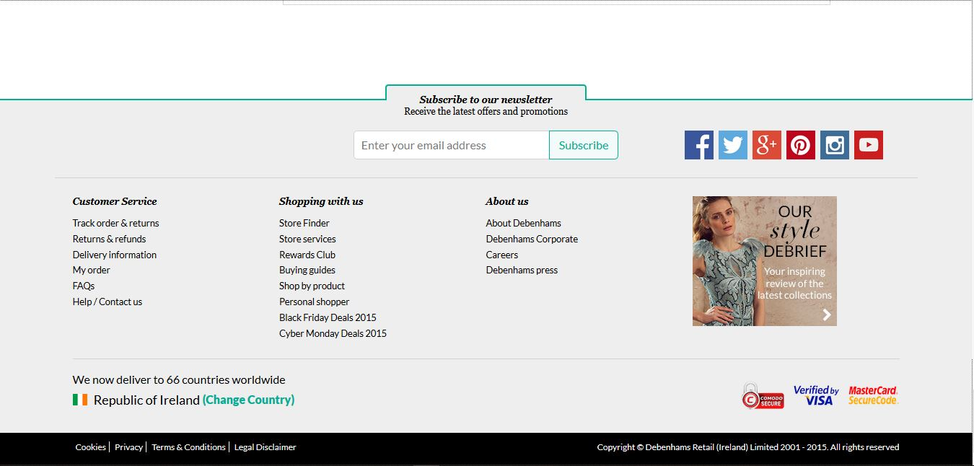

As you can see from the above screenshots of the webpages they both have a standardised layout. This as a result makes the users experience easy and feel familiar, allowing them to comfortably browser further.

This standard layout allows the customer to make certain assumptions in regards to the location of certain services for example About us, Country selection, Help/Customer Service, housekeeping can also be located here along with copyright, (cookies privacy, T&C legal Disclaimer).

### **Is the search facility provided? Is it easy to use?**

Yes, Debenhams has a search bar provided at the top of its website and this is always located and visible in the same place no matter what section one is browsing. Whether one is exploring the menswear, gift section or simply looking a certain product this feature allows you to jump from one product to another with ease. In the screenshot below I searched Jeans and the website came back with a successful result.

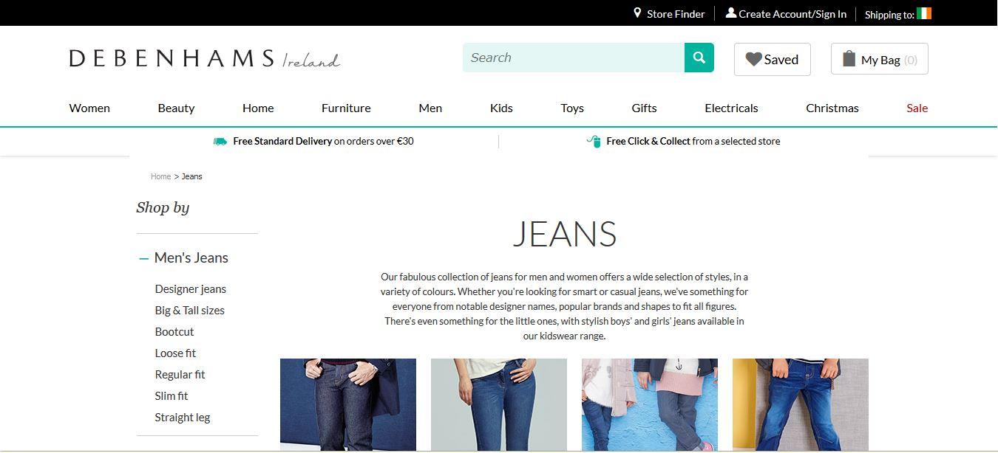

### **Consistent Layout from page to page?**

All the pages on the site have an inviting clean white background with a consistent font in black.

An easy to access navigation bar so you can browse easily in a free flowing style.

Titles and footers are consistent throughout the website allowing for ease of use and access. There is a consistent format on every product page showing three items across. These have a high white background to enhance presentation and visibility. Under the photo of each item there is a short description its brand name and its item price. Each item has a save to wish list icon in order to add items to your wish list. Under each section e.g. toys, Kids, shoes etc. is an eye catching advertisement banner for the section you are in.

### **Consistent branding from page to page?**

Yes, there is consistent branding from page to page, however it is quite limited. In my opinion, this is because Debenhams has such a strong advertisement campaign of their brand using other media platforms such as television, social media sites such as Facebook, Twitter and Instagram but to mention just a few.

Debenhams don’t flaunt their brand all over the pages. They expect you to know their brand and what it stands for as it is such a well-established company.

They have the main logo/company name located in the top left of the title bar which is consistent on every page. The same font and colour scheme is used throughout with the D E B E N H A M S name clearly identifiable.



Even though Debenhams doesn’t push their own brand they do push the other named brands they sell and support.

Under each section they have a large advertisement banner that advertises many of the brands they are selling in this section and there offers.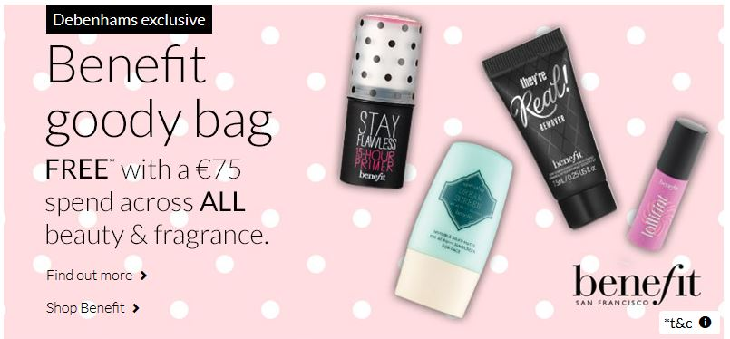

They also advertise the brand of the product under each item throughout all the pages. This shows how brand orientated Debenhams is when selling their products.

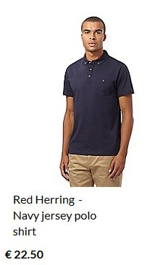

## **Products webpage**

### **Is the Url appropriate in accordance to the Debenhams websites?**

Yes, the URL they use is a good one to use because it has the company name and for an Irish website it is has the .ie at the end of it. This makes the url appropriate to the Debenhams home page.

H:\Pictures for eb\Deb.PNG

**Is it a compelling product copy?**  
I guess it is a compelling product copy because it is well detailed and they really try and sell the product to the customers.

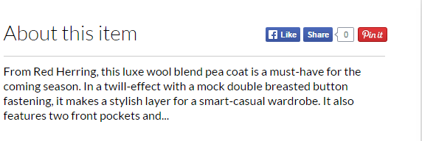

### **Is it a useful product copy?**

It is a useful product copy, we know this because the way they have everything laid out on pages with items, not only this but they also a picture of the product too.

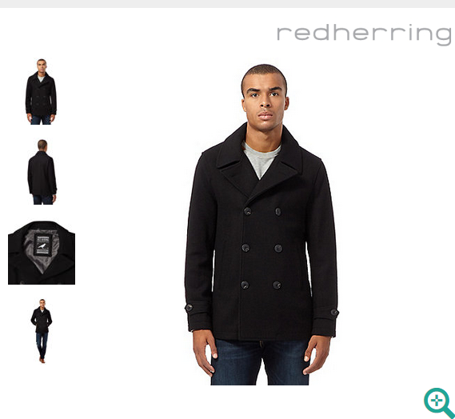

### **Quality of images**

The quality of the images are of a high standard. We know this because of the fact that the page has a good spacing and there is a good use of colours. Along with this the pictures are very clear, and this means the resolution being used is of high resolution.

The images on display on the website does include a zoom in feature, in the zoom feature you have two types of options you can hover over the picture to get a closer view or you can also click on the image you want to view and it will open a new window where you can zoom in and out.

### **Do they suggest related products?**

On the Debenhams website they do show you other related products, they have it down as other items in that range, some of the items are cheaper while others are more expensive. They also have another section which is similar to related products called why not try, this is where they single out a particular product and try to sell it.

**Are reviews included in the website?**On the website they do include a review section where you can leave both positive and negative remarks towards an item and on the website there are some good reviews and some bad product reviews. The review section is surprisingly very well detailed, for example it has a section where you recommend it to a friend or not and there are also sections which include your email to verify that you are a person and not some type of bot.

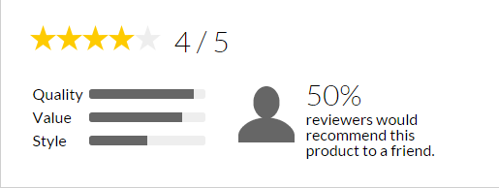

### **Is warranty information provided by the company?**

Yes the website we have chosen have a section with information regarding warranty information, in the warranty information section they have made it very clear to the user about their warranty. The section is in clear text and the wording they have used in very basic. Here is what is issued on their website with regards to warranty/returns (1) “ Debenhams is happy to exchange your item if it is within 28 days, but there can be exceptions as to what can be returned.” (Source: <http://www.debenhams.ie/wcsstore/DebenhamsIESite/faq/our_online_services/returns.html> )

### **Are social links included on their website?**

On their website they have included a section where it shows all of their social links, the social links section can be found at the bottom of the main page, the social links associated with them are the following; Facebook, Twitter. Google Plus, Pinterest, Instagram and also YouTube. All of these links on the website are clickable links, which will direct you to whichever social media page you want to go onto.

H:\Pictures for eb\social media picture.PNG

### **Does the website provide clear calls to action?**

Yes the website does display these features such as add to bag, my bag, saved, and they also have go to checkout. All of these features are very easy to find on the website as they are very clear to distinguish from the rest of the page.

## **Purchasing**

### **Process Flow:**

For this section, I will be running through the process of completing a purchase from Debenhams’ online store, outlining each step along the way, from search, to checkout.

It is important an online based retailer makes the process as simple, and as user friendly as possible. Having a responsive and easy to use system in place ensures the customer is able to complete their purchase with ease. On the other hand, if a system is too complex, or lacks functionality, it may turn the user off, and lose the company potential customers. Below, I have outlined the steps, and process involved in making a purchase from [Debenhams.ie](http://www.debenhams.ie/)

#### **The Home Page.**

* The home page acts as a landing page for a website, from here the customer should be able to search for a specific item, or freely browse items by department. Debenhams is no different in this case. The customer is immediately greeted by an aesthetically pleasing home page, key items such as branding, search, departments and sales are all displayed above the fold, improving the user’s ease of access.
* Purchase process flow – For this example, I will be running through the methods, and steps involved in purchasing a sweater. From the home page, I have used the search bar, and entered the item of clothing I am looking for “Men’s Sweater”, I have not specified a brand, style or colour in this case. From here, the search returned the “Men’s Jumpers”, and also applied filters to help tailor my search.

#### **Product View.**

* Once a product has been selected, the customer is taken to a product view page. The product view page gives the user more detailed information on the product they have selected. Brief item descriptions,

#### **Shopping Bag.**

* Once the customer is happy with their selection, they are taken to the shopping bag. From here, the customer can review any items in their basket, or “Shopping Bag”. An overview of their basket, including item description, size, colour, and quantity are displayed. Customers can also apply any coupons, promotional codes and also claim reward points if they happen to possess a “Debenhams Reward Card”.

#### **Checkout.**

* Once the customer is happy with their product selection, they are taken to the checkout. The customer is not required to create an account to complete a purchase, however an e-mail address is required in order to confirm an order. Once the e-mail is supplied, the customer may choose to have their order delivered to their door, or alternatively, collect their order from their nearest Debenhams retailer. In the case of this process flow, I will be opting to have it delivered.
* After order delivery preference has been decided, the user is asked to enter a number of fields, including name, contact details, and delivery address. Upon completion, the user is presented with a final screen, giving the user one last overview of their items, as well as a number of payment methods. The user can choose to pay using three different payment options:
  + **Debenhams Reward Club Card –** Reward club cards can be obtained online, or in any local Debenhams retailer. Reward points act as a form of currency, and can be used to complete transactions on Debenhams.com, or in brick and mortar stores. Cards can be topped up, however credit can also be earned through purchasing products from Debenhams.
  + **Gift Card –** Gift cards can be purchased online, or in any Debenhams retail store. They come in the form of pre-paid cards, usually ranging from €25 to upwards of €100. Gift cards contain a unique number and PIN, which must be entered to complete a transaction.
  + **Credit or Credit Card –** The final method of payment on Debenhams online store is a credit, or debit card. Users are required to enter the number associated with the card, as well as its start, and end dates, security number, and issue number.
* The checkout also comes with a number of security features. Debenhams’ checkout incorporates HTTPS, which ensures a secure connection to the site. Certificates are verified, and encryption is applied. The page is also verified by Comodo secure, VISA, and MasterCard SecureCode.

### **Additional Purchasing Information**

#### **The Shopping Cart.**

Once a customer is happy with a product, they can choose to add it to their “Bag” or shopping cart. The cart is designed in such a way that the user can roam freely around the site without having to worry about cart contents disappearing, or being involuntarily removed. Additional products can be added, or removed from the bag at the users will. The shopping cart remains visible at all times regardless of directory, and is located above the fold, to the upper-right of the webpage. The cart is further highlighted through the use of colour, the cart is a bright orange colour, which is extremely eye catching when compared to the colour palette of the web page.

#### **Is registration needed to buy an item?**

No, registration is not required to purchase an item. You do however have to supply an e-mail address, to which your order information is sent. A purchase cannot be made without supplying Debenhams an e-mail address.

#### **Payment Method information.**

The customer is supplied with three methods of payment options, a Debenhams Reward Card, a Gift Card, or a Credit/Debit card, information on the aforementioned payment methods can be found above. The checkout lacks the ability to complete a payment via cheque, Google Checkout and PayPal.

#### **Is security of the communication emphasized?**

Simply put, yes. Debenhams constantly emphasizes that any payment, or credentials entered while at the checkout are completely protected, and your connection is secure. The checkout makes use of HTTPS, which verifies the page has a secure connection, and its certificates are valid, and is also encrypted using a modern cipher suite. The footer states the checkout I also VISA verified, and secured by both Comodo, and MasterCard.

#### **Do they provide tracking of the orders?**

Yes, Debenhams supply tracking information to the user. Once a purchase has been made, an order confirmation form is sent to the e-mail linked to the purchase. Within the order form is a tracking number which can be pasted into an external postage service’s website, be it Royal Mail, An Post, DHL or UPS.

### **Are stock levels clear?**

Stock levels are clear in the sense Debenhams will tell you if the item is in stock or not. Exact stock numbers of specific items are not disclosed, compared to the likes of Amazon.

#### **Is gift wrapping available?**

No, gift wrapping does not appear to be available. No option appears at the checkout, and searching the FAQ archived wields no results.

## **Customer Service**

### **Overview**

Customer service is an integral aspect of successful business, lack thereof could result in a potential loss of sales and customers. It is important to have a system in place to handle customer queries on the fly. Having a good system in place can in-turn act as a form of marketing in itself, courteous and professional customer-representative interactions will only reflect positives back to the business.

Customer service can come in many formats, below I have outlined the forms offered by Debenhams:

### **Track and Trace**

Track and Trace is a quick and easy method of tracking orders, customers are not required to sign-in, and must only enter two prerequisite fields. Customers are prompted to enter their order number, followed by their postcode. Once the aforementioned fields have been entered, the customer is presented with the location of their order.

### **Returns and Refunds**

Debenhams do offer both returns and refunds to customers, however the returned item must be sealed in the case of physical goods, and tags must be present and intact on items of clothing. Items can be returned via the mail, or instore. Once a refund payment has been sanctioned, the funds will return to the original form of payment, be it Credit/Debit card, a Rewards card, or gift Card. There are a number of items excluded from Debenhams refund/return policy, these include undergarments for hygiene purposes as well as food and alcohol.

Debenhams provides an extensive Returns and Refund information section available [here](http://www.debenhams.ie/wcsstore/DebenhamsIESite/faq/our_online_services/returns.html), which goes into depth on topics ranging from refund policy to travel insurance and consumer rights.

### **Delivery Information**

The delivery section of Debenhams customer service outlines delivery methods. Customers can view delivery options, the cost of delivery, cut-off points and delivery times.

### **My Order**

From this section, customers can read about Debenhams order policy. There is also a frequently asked questions section, specifically tailored to order related questions. Customers can reference help articles on late deliveries, and delivery terms such as “*tracking status*”.

There is also a link which redirects customers to the Track and Trace section of the site, which allows users to track the status and location of their order.

### **FAQs**

The frequently asked questions section provides the customer with a breadth of answers to popular question. The questions are sectioned into the following categories: **“Where is my order?” “Returns”** & **“Damaged/Faulty goods”.**

### **Contact Us**

The final section in Debenhams customer service set of links is the *“Contact Us”* segment. From here a customer can contact Debenhams directly. A number of contact options is provided, including a dedicated hotline directory. The hotline directory is split into departments, helping refine the customer’s needs.

Alternatively, customers have the option of emailing Debenhams. It is stated “*it may take up to 48 hours for us to respond to your email.*”

The final form of contact provided by Debenhams is written mail. A PO Box address is provided which customers can use to mail physical queries directly to Debenhams customer services.

### **Additional Customer Service Information**

#### **Is the contact information easy to find?**

The contact information is relatively easy to find, it is located in the footer of the page, which is a common location used by various market leaders such as Amazon. From here the customer can find a plethora of customer service related links, including contact information.

#### **What means of communication are provided?**

Debenhams provides a wide range of communication. Customers can choose to phone Debenhams directly, contact numbers are split into departments, allowing the customer to reach their target department easily. Alternatively, customers may choose to e-mail Debenhams using a provided customer support e-mail. The final means of customer-representative communication is written format. A postage address is provided which customers can use to post physical mail directly to Debenhams.

#### **Are FAQ’s easy to understand?**

A link to the FAQ section can be found at the footer of Debenhams home page. From here the customer is directed to the FAQ section in which they can freely browse popular questions. By default, Debenhams have questions related to orders, returns and Damages/Faulty goods displayed.

However, if these default questions do not resolve the customers query, there is also a search feature integrated. This allows the user to enter topics, keywords or phrases related to their question or query. If a customer’s question is not answered by the FAQ section, the customer is prompted to contact support for further help.

#### **Are delivery and VAT charges easy to find and understand?**

Delivery charges are very easy to find, they are displayed at the checkout before payment. Customers can also use the customer service section to check delivery and shipping fees before making a purchase if needs be. Debenhams have a dedicated section for delivery options in their “How can we help you?” section. From here the customer can check delivery rates, cut-off and delivery times.

VAT is not disclosed when making a purchase, is simply stated VAT is included in the price. In the customer service section however, the customer can find details related to VAT. Debenhams have a dedicated section titled “Payments” which informs the customer on details related to VAT refunds, and VAT receipts. However, the percentage of VAT applied to purchases and orders is not disclosed.

#### **Are T&C easy to find and understand?**

Terms and conditions can also be found at the footer of the page. Once clicked, the customer is redirected toward the “How can we help you page?” The help menu has a dedicated section for terms & conditions. The terms & conditions section is further split into subsections, which allows the user to tailor their search. Subcategories include:

* General Terms & conditions
* Privacy Policy
* Email marketing policy
* Security policy
* Payment security
* Cookies
* Access to information
* Customer ratings and reviews
* Orders and delivery
* Furniture
* Travel insurance
* Gift cards and vouchers
* Current promotions
* Contact us

### **Is their privacy policy easy to understand?**

Debenhams privacy policy is located in the “How can we help you” page, which can be accessed through the footer of the home. Here a customer can find information related to the overall policy, as well as exact details on the information Debenhams will hold about them.

#### **Do they provide a newsletter?**

Yes Debenhams provide newsletters. The newsletter is available on a subscription basis, which users can freely sign up to. New registrants are automatically signed up to receive the newsletter, although they can opt-out there and then, or further down the line. The newsletter is sent out on a monthly basis, and contains the latest special offers, insider information as well as the inside scoop on latest fashion trends.

**25‐point Website Usability Checklist**

|  |  |  |
| --- | --- | --- |
| **Accessibility** | **Rating** | **Comments** |
| 1. Site load‐time is reasonable | ✔ | Debenhams main home page loads in under a second according to Pingdoms benchmarking tool, faster than 90% of other websites. |
| 2. Adequate text‐to‐background contrast | ✔ | Debenhams white background and black text allows the text to remain very readable. Text is not placed over top images, both are given designated positions. |
| 3. Font size/spacing is easy to read | ✔ | The font size is easily readable and remains persistent throughout the website. |
| 4. Flash & add‐ons are used sparingly | ✔ | Debenhams is written entirely in HTML5 which standard across modern websites. Add-ons are not required to navigate the site. |
| 5. Images have appropriate ALT tags | ✔ | The vast majority of images contained on the website do not have alt tags, the only we could find were located on their social media links. |
| 6. Site has custom not‐found/404 page | ✔ | Yes, there is an integrated custom 404 error page which keeps the styling and format of other pages. |
| **Identity** |  |  |
| 7. Company logo is prominently placed | ✔ | The company logo is placed at the header of the page, clearly viewable to those visiting the website. |
| 8. Tagline makes company’s purpose clear | ✔ |  |
| 9. Home‐page is digestible in 5 seconds | ✔ | It is very easy to decipher what the webpage is about at a glance. Every major factor is located above the fold. |
| 10. Clear path to company information | ✔ | Company information can be found in an “About Us” section located at the footer of the webpage, this seems to be standard across multiple webpages including marked giants Amazon. |
| 11. Clear path to contact information | ✔ | Similar to company information, contact information is also found at the footer of the page, matching that of other websites. |

|  |  |  |
| --- | --- | --- |
| **Navigation** |  |  |
| 12. Main navigation is easily identifiable | ✔ | Navigation around the page is intuitive, navigation links are divided into departments making the customers browsing experience less cumbersome. |
| 13. Navigation labels are clear & concise | ✔ |  |
| 14. Number of buttons/links is reasonable | ✔ | The number of links is reasonable considering the market Debenhams is based in. |
| 15. Company logo is linked to home‐page | ✔ | The Debenhams logo acts as a link, once clicked, the user is returned to the home page. |
| 16. Links are consistent & easy to identify | ✔ | Links are sectioned into dedicated departments, which makes them very identifiable, formatting is also consistent throughout. |
| 17. Site search is easy to access | ✔ | The search bar is located in the header of the homepage above the fold. It is also persistent across webpages. |
| **Content** |  |  |
| 18. Major headings are clear & descriptive | ✔ |  |
| 19. Critical content is above the “fold” | ✔ | Key components are all located above the fold, the search bar, department links, and sales can all be found above the fold. |
| 20. Styles & colours are consistent | ✔ | Debenhams’ home page features as consistent colour scheme that remains persistent across the website. |
| 21. Emphasis (bold, etc.) is used sparingly | ✔ | Emphasis is only used on titles, and discounted items. They are used sparingly, and act as a means of catching the user’s attention. |
| 22. Ads & pop‐ups are unobtrusive | ✔ | The only pop-up we had while conducting our assignment was an initial region setting. However, this pop-up only appears once, and is helpful as opposed to tedious. The website contains no adverts other than links to discounted items located on the page, there are no third party adverts. |
| 23. Main copy is concise & explanatory | ✔ |  |
| 24. URLs are meaningful & user‐friendly | ✔ | The URL’s are extremely user friendly. As you navigate the website, the URL will change to match your department, and brand as opposed to scrambles strings of text. (eg. www.debenhams.ie/beauty/estee-lauder) |

25. HTML page titles are explanatory ✔  Similar to the URL’s, the HTML titles list the department and brand you’re currently browsing

**© 2 0 0 9 U s e r E f f e c t • w w w . u s e r e f f e c t . c o m • ( 8 4 7 ) 7 0 8 ‐ 6 0 0 7**

# **Section 5 - Improvements to website**

After doing this project we would like to add the following improvements to the website as we believe this might help the website even more.

First of all Adam would like to change the change the background, Adam believes that for a website to be a good website the background needs to have an interesting background something with a bit of colour instead of having a plain white background. The colour Adam had in mind was possibly a grey background with possibly and a Debenhams logo imprinted in to the background of it.

Another adjustment that we would like to make to the website is David’s opinion on what needs to be issued. He thinks that a new a block should be created to make a popular section, in this section it would show users what is the most popular products to buy for the week.

The final adjustment that we would like to make to website we are doing is from Ryan. Ryan would like for the website to be more consumer friendly due to the fact that websites such as Amazon immediately tell you if a product you are looking for is out of stock or not and on the Debenhams website you can only find out after adding it to your bag and going to the checkout section.

# **Section 6 - The Marketplace –depends on the number of images used**

## **Describe the marketplace in which the business operates.**

Debenhams is a leading international retail store operating under a department store structure. This is a very aggressive market with many competitors e.g. SHAWS, Littlewoods and Brown Thomas to name a few. Debenhams specialise in high quality brands. They strongly promote named brands and designers and from this the Debenhams name is now equated with quality products. Their website is a valuable source of revenue operating online throughout 70 countries. This is especially important in the countries where they only have an online presence. Their e business model has a wide scope covering a wide demographic from young to old with the products to match. Debenhams have also created profiles on many social media platforms, from blogs providing tips, offers and competitions to YouTube videos featuring interviews, how-to videos and not to forget their customer surveys with their design team so they can stay in touch directing with their customers. This allows them to find out first hand their customers likes and dislikes. Knowing what your customer wants and likes is essentially in staying current in such an aggressive market. These social media platforms also enables them to market their brand to a new customer base.

**Identify and describe one major competitor within the marketplace.**

One major competitor with the same image for quality is Littlewoods, they are a click only company. They have created a successful online based operation. Both Debenhams and Littlewoods operate a department store structure. Littlewoods have been a strong competitor for Debenhams for quite some time now.

## **Briefly compare and contrast your business’ website, products and services with the competitor.**

Broadly speaking, their websites are quite similar as both have a white background and clear black font. All products on both sites are displayed on a white background with the brand name, description and the price.

Both Debenhams and Littlewoods follow the Amazon de facto website structure.

The Littlewoods navigation follows a different title structure with women, men, child / baby being first on their tool bar giving the impression they are more family orientated. The Debenhams navigation bar from right to left has been laid out more for the female customer as that is their main demographic and the men’s and kids sections are over to the right. As you can see, the Littlewoods navigation bar layout is cluttered when compared to Debenhams. This makes Littlewoods navigation bar hard to read clearly.

Another section of the website that is worth a comparison is the review section. Littlewoods make their reviews easier to find and read. Debenhams on the other hand are harder to find and while it has a section for reviews and often states there are reviews to read, on looking at these they are often empty. This is an important section as people will often rely on other people’s experiences before the purchase their items.

Littlewoods navigation bar



Debenhams navigation bar



One service that gives Littlewoods an advantage over Debenhams is the flexi account payments where the customer can pay in instalments, while with Debenhams the customer has to pay in full on checkout. Littlewoods also offers a “refer a friend” scheme, giving the customer a €20 discount. Another service, both companies provide is delivery this can play a major factor when making a purchase. Littlewoods offer free delivery on all items while Debenhams only offer free standard delivery over €30. Littlewoods also provide the free use of delivering your items to Parcel motel for ease of collection for the customer while Debenhams allows for free pick up from their stores.

## **Compare and contrast the traffic to each using online tools. Comment on your findings.**

Below is a contrast of Debenhams online traffic against its competitor Littlewoods.

The set of screenshots shown below are from [www.Alexa.com](http://www.alexa.com/) which is a web analysis toolkit.

As we can see from the screenshots Debenhams has a global rank of 45,125 which is up 2,081 compared to Littlewoods which has a global rank of 36,138 Littlewoods has dropped 7,010.

This shows that Littlewoods global ranking is ahead of its competitor Debenhams by 8,987. However, it is important to note that while their global rank is ahead Debenhams is gaining ground with an increase of 2,081. Littlewoods is steadily declining and it may be the case that Debenhams has picked up some of Littlewoods customers.

Littlewoods popularity ranking In Ireland is very close to that of its competitor. Debenhams is ranked 115 vs Littlewoods rank of 112.

The vast majority of the websites visitors to Debenhams (87.1%) are Irish of course as they use .ie domains.

The second most popular viewers are from the United Kingdom (4.8%)

The bounce rate for Debenhams is quite large at 35% this means that 35% of all visitors only view a single page, therefore each person that enters the site leaves without interacting with the webpage. Littlewoods has a bounce rate of 31.40% showing that their customers are more likely to stay on their website that that of Debenhams. Therefore the bounce rate is a very important ratio.

Currently Debenhams daily page view per customer ratio stands at 7.30% vs Littlewoods rate of 10.30%. This stat means that people appear to prefer using Littlewoods website more, as they have more customers returning to it each day. Changes in layout could have an effect on the bounce rate for example if customers do not like a new layout the bounce rate may increase as customers decide to shop elsewhere.

The daily time spent on site is very important as the longer the person spends on the page the more likely they are to delve deeper into the site. The more they look at items the more they are likely to buy, therefore, generating revenue for the company.

## **Finding on website traffic**

Littlewoods (31.40%) is better than Debenhams (35%) meaning that Littlewoods retains more viewers of their website. Along with Littlewoods higher daily page view per customer, its popularity rating and their customer daily time on site percentage of 5.59 v's Debenhams 4.24 it is evident that Littlewoods website is more effective. Visitors currently use it more, stay on it longer and view more pages. However, it is important to note that Debenhams global ranking is on the increase and Littlewoods has decreased. Therefore Littlewoods need to keep on top of changing trends the layout of their website and how easy it is to navigate.

Below are the graphs to these points on Debenhams vs Littlewoods.

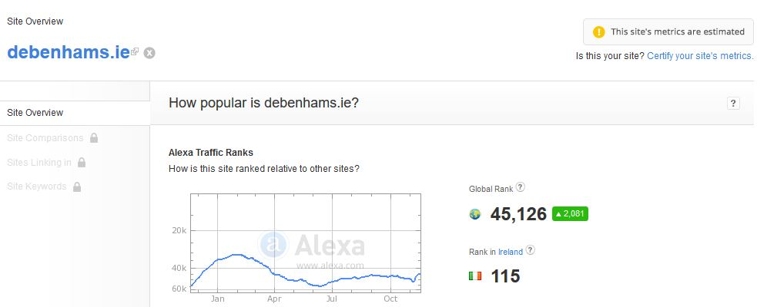

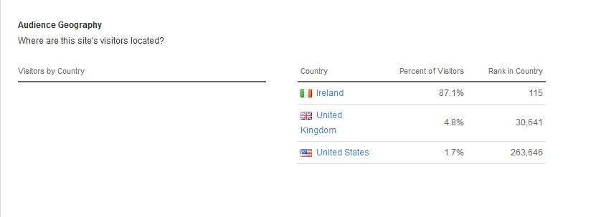

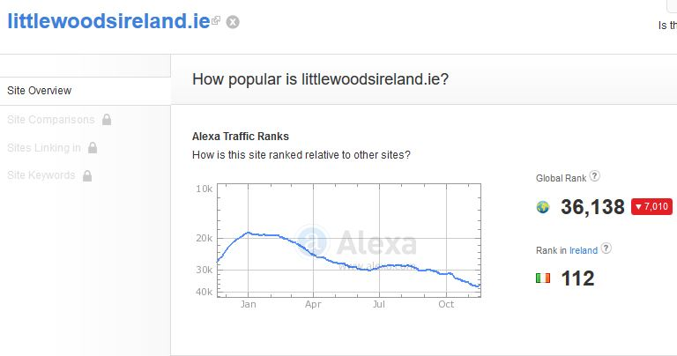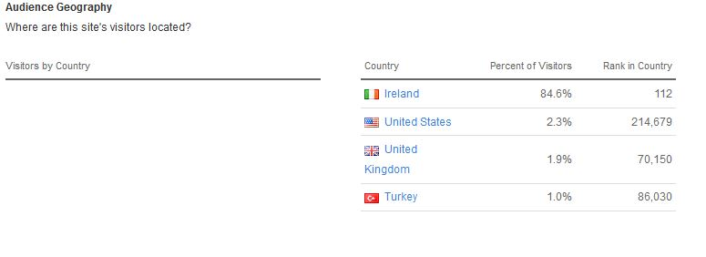

## **Daily page views per visitor**

Debenhams 7.30%

Littlewoods 10.30%

## **Daily Time spent on site**

Debenhams 4:24

Littlewoods 5:59

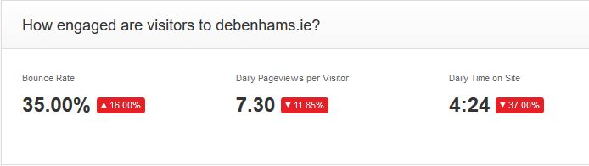

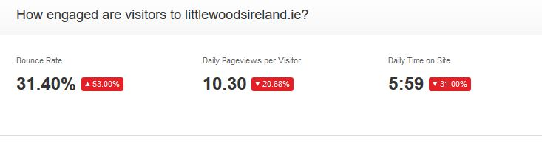**Which search keywords send traffic to each site?**

The screenshots below show, which keywords visitors searched to land on Debenhams website showing which brands in particular are popular with the company. For example Debenhams has faith shoes and Estée Lauder. Popular search terms with Littlewoods are Lipsy, Superdry and mamas and papas. These keywords can create extra web page landing and maybe even revenue or they could also lead to a higher bounce rate.

Debenhams

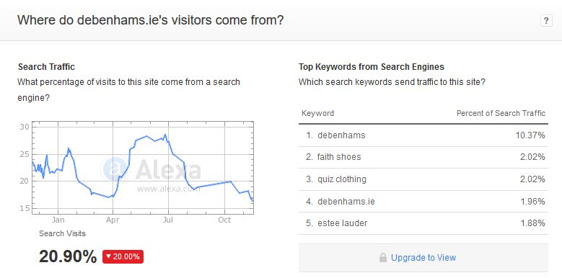

Littlewoods:

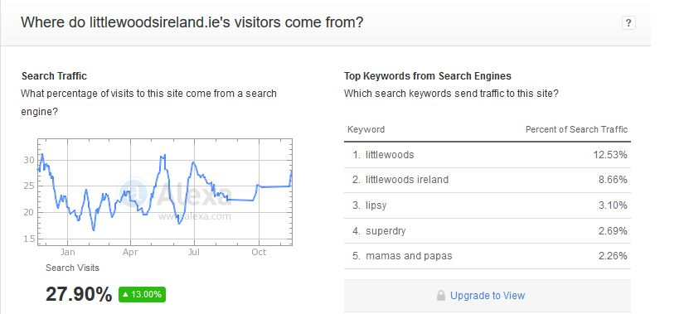

## **Where did the traffic come from before landing on our page?**

This can be a useful tool as if a lot of the company’s website traffic comes from a specific page. It may be of value to advertise there as it can pull more of the demographic to the company’s (Debenhams) website. But Debenhams and Littlewoods are so well known and branded that most of their traffic comes straight from google searches and there social media outlets. Amazon Debenhams and Littlewoods all sell clothes online and some of their customers may be comparing items and prices. This could account for the (3.1%) of Debenhams and the (2%) of Littlewoods traffic coming from Amazon.co.uk.

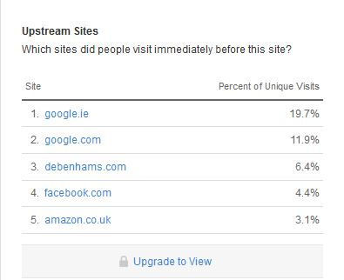

Littlewoods

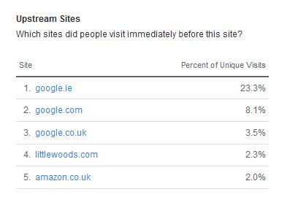

## **Total number of sites linking to Debenhams vs Littlewoods.**

Debenhams has 55 more site links than Littlewoods this could be from bloggers linking from there blog to the Debenhams home page or to a product these can be valuable to creating website traffic. I believe Debenhams may have more site links as fashion bloggers (Blogspot.de) will use it as a good point of reference. While Littlewoods is more family orientated and deals less with branding from this less bloggers would use this site for linking.

Debenhams:

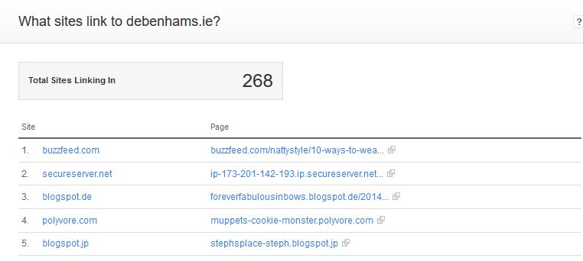

Littlewoods:

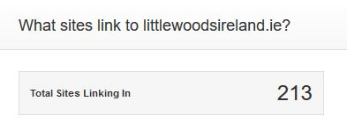

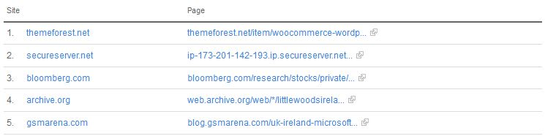

## **Sites with similar names?**

These results show other websites that these company’s provide (1,2,4) as they have a relation from there domain name. Some of the websites were bought by people, the domains (3,5). These people also known as domain squatters.

Debenhams:

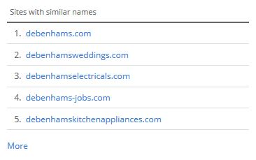

The Littlewoods results have the same issue, as the first site is there legitimate website. But the second result [www.littlewoodsbingo.com](http://www.littlewoodsbingo.com) is a registered domain name owned by domain squatters in the hope to make money. [www.littlewoodsbingo.com](http://www.littlewoodsbingo.com) also redirects you to www.littlewoodsgaming.com.

Littlewoods:

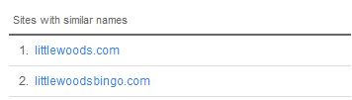

# **Marketing – Newsletters**

## **Compare & contrast newsletters – Comment on findings, recommend changes.**

### **Debenhams Newsletter**

The Debenhams newsletter is available on a subscription basis, meaning the user has to sign up for it manually, this can be done via the home page of the website. When registering an account for Debenhams, you are also automatically signed up to receive the newsletter, you can also choose to opt-out if needs be.

Throughout the course of this assignment, I have been signed up to the newsletter for three or so weeks. During this period of time I have received five newsletters in total, three of which came in the past week, this could be a rare case however, as each newsletter has been Black Friday themed.

The Debenhams newsletter details a wide variety of information related to the retailer, from special offers, sales and deals to insider scoops on fashion trends.

### **Littlewoods Newsletter**

Similar to the Debenhams newsletter, Littlewoods also has a subscription based newsletter. Users can once again freely choose whether they want to sign up for it, and choose to opt-out at any point. Littlewoods also have a blog which regularly posts information regarding fashion trends, deals and tips for items to wear on certain occasions. The Littlewoods newsletter is far more in depth compared to Debenhams, relaying far more information related to fashion to its user base.

# **Marketing on images used**

**Does the business use affiliate programmes on their website?**

The Debenhams website does have an affiliate program in place for people who are living in Ireland, Debenhams will accept Irish owned websites or websites that can also attract traffic from the United Kingdom. The affiliate program offers people with a company a lot of things. For example if a person who had their own website was capable of pushing a Debenhams sale from their own website they would receive commission on the products that they helped them sell.

Here are the following benefits of joining the affiliate program according to the Debenhams website.

(2) “What are the benefits?

Competitive commission rates, 30 day window cookie, an Irish website in euro, free delivery from Ireland for spending 30 euro, free returns, there is also free promotions and affiliate updates, and last but not least an up to date optimised product feed.” (Source: <http://www.debenhams.ie/webapp/wcs/stores/servlet/contentView?filepath=/DebenhamsIESite/Static/affilliate_ROI.xml&storeId=10052&langId=-1> )

They also have an affiliate section for bloggers in the affiliate section for bloggers they offer bloggers Skim links which helps the blogger to monetize you blog more efficiently.

**Does the company advertise on any other websites?**Yes the company advertise on many other websites across the internet, examples of websites where they advertise are Google and Facebook.

From advertising on more websites they are going to receive more traffic due to the fact that people may see an item of interest and click on the website link.

**Does Debenhams use search engine marketing?**

Yes the company do use search engine marketing to increase their chances of being top of the list in a particular region of the world such as Ireland we know they use search engine marketing is because if you were to type for example menswear into google search one of the very first page links to come up would be the Debenhams website meaning that they have been using this marketing strategy in order to bring it further up the list than other websites that do men’s clothes.

# **Search Engine Optimization**

## **Overview**

SEO, or Search Engine Optimization is an important part of web design in general, but is far more important to those like Debenhams that market or sell products online. Search engines provide millions of users with the ability to search the wen for specific things using search terms or keywords. Typically users will select a search result from the top 5 links displayed, so it’s imperative you comply, and take advantage of SEO. Not adapting your websites content and structure could place you lower down in a search engines results, and as a result, redirects potential traffic and customers to competitor’s websites.

## **Keywords & Phrases**

Since Debenhams is a retailer in multiple departments ranging from Clothing to perfume, furniture to gifts and toys, there are many keywords and phrases a user could enter to land on the website. Using Alexa’s ranking website I was able to identify the most commonly used phrases and keywords. My findings are as follows:

1. Debenhams 10.37%
2. Faith Shoes 2.02%
3. Quiz Clothing 2.02%
4. Debenhams.ie 1.96%
5. Estee Lauder 1.88%

## **Keyword Observations**

1. As expected, the most commonly used keyword to reach the website is the name itself. Typing Debenhams into Google Chrome returns an advert as the first search result, titles “Huge offerings at Debenhams”. This advert link directs the customer to the home page, as opposed to a section dedicated to sales.
2. The second most common search term is “Faith Shoes”. When entered into Chrome, Faith Shoes once again returns an advert, this time however the advert is related to asos.com a competitor of Debenhams. The first non-advert based link however is a Debenhams web page. Specifically a link to the female department of the site which deals with Faith branded shoes.
3. The third most popular term is “Quiz clothing”. Quiz clothing is a popular brand of women’s clothing, based in the United Kingdom. As expected, Quiz clothing’s official home page is returned as the first result. Irish customers are less likely to use this website however, as the website will display in Pound Sterling as opposed to Euro, and there could also be hefty delivery fees. The second link however is Debenhams’ quiz clothing link, Irish customers are far more likely to shop from this link.
4. The fifth most common search term is Estee Lauder, a popular female orientated fashion line. Upon entering the “Estee Lauder” keyword, three adverts are returned followed by Estee Lauders’ official Twitter and home pages. There are however two Debenhams related links on the first page, one in the form of an advert linking to Debenhams homepage, and the other in the form of a link directing to Debenhams beauty department.

Focusing on the Debenhams home page, the three most popular search terms are not present apart from the most popular “Debenhams”. The Debenhams branding and images are contained in the heading of the main page. As for “Faith Shoes” and “Quiz Clothing” search terms however, they are not contained or, and completely lack a presence on the main page. As both the aforementioned terms are clothing brands, they are hidden deeper in the department directory, and are not viewable, even from the department drop down lists.

Focusing on individual product pages, the search terms are far more present. Once again, the Debenhams branding and logos are contained within the heading of the pages, in clear sight of the user. On the individual product pages branding and images related to the products and search terms have far more of a presence. Images and branding related to the search terms are positioned on the product page, along with brief descriptions of the items.

# **Marketing – Web 2.0**

**What is web 2.0?**

(3) “Web 2.0 is how the World Wide Web is being used and it is being described as a second generation of the web that is focusing on the capability of people to collaborate and share with others information online”. According to the website that I gathered this information off of “Web 2.0 basically refers to the transition from static HTML Web pages to a more dynamic web page that is more organized and it primary focus is to serve web applications to its users.” (Source: http://www.webopedia.com/TERM/W/Web_2_point_0.html)

**Who are the users of Web 2.0?**

The users of Web 2.0 are people such as the publishers, direct contributors and indirect contributors all of these people are users of Web 2.0

Examples of Web 2.0 are Google, Facebook, Amazon, EBay, and LinkedIn and there are also many more examples of websites that use Web 2.0.

**Why is Web 2.0 used?**

The big companies use Web 2.0 because a lot of these companies have seen a growth in the amount of income that has come in within the past three years, according to reports it is reported that (4) “69% of people who responded to the report admitted that their companies have gained measurable business benefits.” (Source: <http://www.mckinsey.com/insights/business_technology/how_companies_are_benefiting_from_web_20_mckinsey_global_survey_results> )

**How do companies such as Google make money from this?**

Large companies such as Google make money from the Web 2.0 factor by use of advertising on their websites the more clicks an advertisement gets from Google adverts, the more revenue the company shall receive. This is only one of many ways a company such as Google can make money.

**How is Web 2.0 implemented into social marketing?**

Web 2.0 is implemented into social marketing by the fact that social websites fuel loyalty.

The whole web 2.0 concept would not work if the company was not fully committed to the web 2.0 service.

**Conclusion**

To conclude our website which is Debenhams, I think that overall Debenhams is an excellent website, this is because I believe they have done almost everything possible to make the website great. I was quite surprised that an Irish website was so well advertised and laid out, I believe that is what made the Debenhams website so popular to the market. As a group, we would invest in Debenhams as opposed to their competitor Littlewoods. Debenhams has a strong presence both online and on the high street, as well boasting a vast international presence. As a whole, the company also has a well-established brand, and is well recognised in the fashion industry.

# **Bibliography**

# [Debenhams discount voucher](http://www.mirror.co.uk/money/debenhams-discount-voucher-codes-free-5427751)

# <https://www.iedr.ie/>

# <https://www.cro.ie/Home/Search-Results?sb-search=debenhams&sb-inst=1296&sb-logid=389282-8z9pu04c0qfblh9f>

# <http://www.amazon.com/>

# <http://www.debenhams.ie/wcsstore/DebenhamsIESite/faq/our_online_services/returns.html>

# <http://www.debenhams.ie/>

# <http://www.debenhams.ie/wcsstore/DebenhamsIESite/faq/home.html>

# <http://www.alexa.com/>

# <http://www.littlewoodsgaming.com/>

# <http://www.debenhams.ie/webapp/wcs/stores/servlet/contentView?filepath=/DebenhamsIESite/Static/affilliate_ROI.xml&storeId=10052&langId=-1>

# http://www.mckinsey.com/insights/business_technology/how_companies_are_benefiting_from_web_20_mckinsey_global_survey_results