Theorical Questions Answer

Q1.

In this question, we have to calculate the interpolation of the desired point.

When applying an inverse linear transformation and encountering pixels that are not exactly aligned with the grid of the source image, a good strategy is to use Bilinear Interpolation. Bilinear Interpolation takes the values of the four closest pixels in the source space and calculates a weighted average based on the distances. By doing this, the final pixel value is affected by the surrounding pixels, ensuring a smoother and more approximate transition. This method helps to minimize artifacts and maintain visual coherence in the converted image.

According to the location of the desired point, we use the Bilinear Interpolation method. According to the following formula, we can find the location of the desired point:

*f*(*x*,*y*)=(1−*x*)(1−*y*)*f*00​+*x*(1−*y*)*f*10​+(1−*x*)*yf*01​+*xyf*11​

In this formula, the value of f(x,y) is the same as the interpolation value and the values of $f_{i,j}$ are the values of the pixels around the desired pixel, where i and j are correct values.

$$f\left(x,y\right)=\left(1-\left(x-a\right)\right)\left(1-\left(y+b\right)\right)f\left(x+1,y\right)$$

$$+x\left(1-\left(y+b\right)\right)f\left(x+1,y+1\right)$$

$$+y\left(1-\left(x-a\right)\right)f\left(x,y\right)$$

$$+xyf(x,y+1)$$

Q2.

Here, according to the location of the pixel that does not have a value, we obtain its value by one of the following methods:

* Linear: If only 2 pixels around the desired pixel have the correct value, we put the average of the sum of the values of the 2 neighboring pixels as the pixel value.
* Bilinear: If 4 pixels around the desired pixel have the correct value, we put the average sum of the values of the 4 adjacent pixels as the pixel value.

|  |  |  |
| --- | --- | --- |
| 107 | 110 | 106 |
| 106 | 105 | 104 |
| 138 | 142 | 140 |

|  |  |  |  |  |
| --- | --- | --- | --- | --- |
| 107 | **A** | 110 | **B** | 106 |
| **C** | **D** | **E** | **F** | **G** |
| 106 | **H** | 105 | **I** | 104 |
| **J** | **K** | **L** | **M** | **N** |
| 138 | **O** | 142 | **P** | 140 |

A = (107 + 110) / 2 = 109

B = (106 + 110) / 2 = 108

C = (107 + 106) / 2 = 107

D = (109 + 107 + 108 + 106) / 4 = 108

E = (105 + 110) / 2 = 108

F = (108 + 108 + 105 + 105) / 4 = 107

G = (106 + 104) / 2 = 105

H = (106 + 105) / 2 = 106

I = (105 + 104) / 2 = 105

J = (138 + 106) / 2 = 122

K = (106 + 122 + 124 + 140) / 4 = 123

L = (105 + 142) / 2 = 124

M = (105 + 124 + 122 + 141) / 4 = 123

N = (104 + 140) / 2 = 122

O = (142 + 138) / 2 = 140

P = (142 + 140) / 2 = 141

|  |  |  |  |  |
| --- | --- | --- | --- | --- |
| 107 | **109** | 110 | **108** | 106 |
| **107** | **108** | **108** | **107** | **105** |
| 106 | **106** | 105 | **105** | 104 |
| **122** | **123** | **124** | **123** | **122** |
| 138 | **140** | 142 | **141** | 140 |

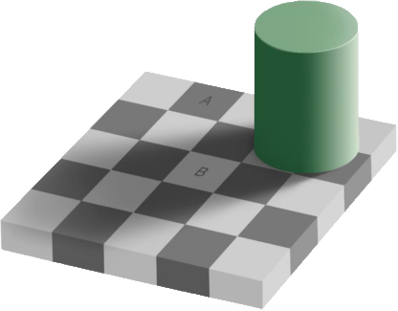Q3.



When we see these two items in the main image, it seems that they are different in color. While if we separate these two houses from the original image and show them next to each other, we will see that to our disbelief and surprise, these two images have no color difference.

This is due to Brightness Adaptation and Brightness Discrimination in the human eye.