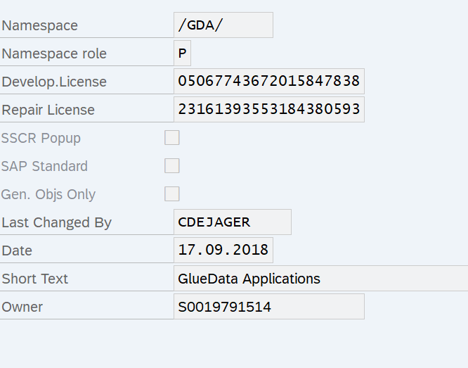

05067743672015847838

23161393553184380593