RDHO-Based Capacity-Feasible Joint Task Offloading and Computing Resource Allocation in Mobile Edge Computing: A Controlled Evaluation
Haoru Su*, Jie Bai, and Jiangyi Zhou
College of Computer Science, Beijing University of Technology, Beijing 100124, China
*Corresponding author: Haoru Su (suhaoru@bjut.edu.cn).
E-mail addresses: suhaoru@bjut.edu.cn (H. Su), baijie0219@gmail.com (J. Bai), zhoujiangyi@bjut.edu.cn (J. Zhou).
Abstract
Mobile edge computing (MEC) complements resource-limited devices with nearby edge and remote cloud resources, but heterogeneous tasks couple discrete execution-node choice with continuous processor allocation. This paper develops an RDHO-based capacity-feasible framework for joint task offloading and computing resource allocation: legal-node encoding and physical CPU decoding are coupled with deterministic capacity repair, RDHO population search, fixed-objective incumbent tracking and optional coordinate refinement. Under the configured end-to-end procedures, RDHO-full achieves the lowest mean reporting fitness. However, strictly controlled experiments with common initialisation, a shared decoder and repair path, equal total evaluation budgets and, where applicable, common refinement show that RDHO significantly outperforms RIME but is significantly outperformed by DBO. The evidence therefore supports the RDHO-based integrated framework rather than universal superiority of the hybrid population operator. Conclusions are limited to the stated simulated model and implemented baselines.
Keywords: mobile edge computing; RDHO; joint task offloading; computing resource allocation; capacity feasibility; controlled evaluation.

1 Introduction
Latency-sensitive sensing, Internet of Things (IoT), fifth-generation (5G) and emerging sixth-generation services generate heterogeneous workloads close to users. Mobile edge computing (MEC) reduces service distance by supplementing devices with edge and cloud resources [1,2].
A practical offloading decision must select a legal execution node and allocate finite processor capacity. The resulting categorical-continuous decisions interact through transmission paths, per-node CPU budgets, device-side energy and task-specific service thresholds.
Existing studies primarily optimise energy and latency, while freshness-aware work adds Age of Information (AoI) and user-oriented work considers Quality of Experience (QoE) or fairness [3-7]. These criteria are related rather than statistically independent: in the present model AoI contains service delay and QoE transforms delay, energy and freshness into bounded utility.
To address this problem, this study develops an RDHO-based optimisation framework that adapts RIME- and DBO-inspired population movements to legal-node selection, physical CPU allocation and deterministic capacity repair. The framework treats the benefit of the hybrid population mechanism as an empirical question rather than an assumption.
The contributions are threefold. First, the paper formulates a capacity-feasible three-tier MEC model with legal local, edge and cloud execution, physical CPU-cycle-rate allocation, per-node aggregate capacity, device-side energy, delay, periodic AoI, priority-weighted aggregate QoE and priority-neutral active-user fairness. Second, it develops an RDHO-based integrated framework with legal-node population encoding, physical-resource decoding, deterministic reassignment and capacity projection, RIME-DBO-inspired population updates, dynamic search guidance, fixed reporting incumbents and optional coordinate refinement. Third, it reports paired controlled experiments with equal NFE, common initialisation, common repair, common refinement, Wilcoxon tests, Holm correction, rank-biserial effect sizes and wins/ties/losses. These experiments distinguish complete-pipeline evidence from isolated population-update evidence and show RDHO better than RIME but not DBO under the stated controls.
Under the configured end-to-end procedures, RDHO-full obtains mean reporting fitness 0.947. This configured comparison has unequal NFE and evaluates complete solvers, not an isolated RIME-DBO population operator. The strictly controlled results reported in Section 6 show the narrower population-stage and common-pipeline conclusions.
Section 2 reviews related work. Sections 3 and 4 define the physical system and P1. Section 5 presents the RDHO-based capacity-feasible optimisation framework. Section 6 separates configured end-to-end and controlled population-update evidence, and Section 7 concludes.

2 Related Work
Following MEC surveys, related work is organised by solution methodology: model-based optimisation, learning-based methods and metaheuristic search [8-10]. Objective dimensions are discussed within these classes.
Model-based studies jointly allocate communication and computation resources or coordinate edge-cloud execution under explicit system constraints [3,11-14]. Legal collaboration topology and resource budgets must be represented before optimising task placement.
Learning-based methods adapt policies to changing states and have been applied to online offloading, vehicular cooperation and blockchain-enabled edge-cloud systems [15-17]. Their training and data requirements motivate complementary transparent offline optimisation for a fixed decision epoch.
Freshness-aware MEC incorporates AoI alongside service time [18-20]. The earlier TLBO-HHO method is included as an AoI-aware metaheuristic baseline [21]. QoE and fairness studies represent service acceptability and user balance [5-7,22-26].
Metaheuristic methods search nonlinear mixed spaces without a learned policy. Relevant mechanisms include HHO, GA, TLBO, RIME, DBO and enhanced sparrow search [27-36]. A hybrid label alone does not establish benefit; initialisation, evaluation budget, population updates and refinement require controlled comparisons.
Representative studies on parking-edge cooperation, blockchain-enabled edge-cloud offloading, cooperative deep reinforcement learning and potential-game strategies show how collaboration topology, resource coupling and service requirements alter offloading decisions [37-40]. A remaining methodological gap is a reproducible framework that combines capacity-feasible physical resource allocation with priority-weighted system QoE and priority-neutral active-user fairness, while experimentally separating the effects of initialisation, evaluation budget, population updates and refinement.
The present work addresses that combined methodological and evaluation gap for a simulated cloud-edge-device epoch; it does not claim that physical CPU modelling alone is novel, nor does it claim communication-resource optimisation, online queue scheduling or deployment validation.

3 System Model

3.1 MEC Network, Assumptions, and Task Model
Consider devices $D$, edge servers $E$, cloud servers $C$ and tasks $T$ in a three-tier architecture. Their union $N=D∪E∪C$ uses global node IDs. We assume fixed topology and link rates during one decision epoch so that the optimisation focuses on execution-node choice and computing-resource allocation. Figure 1 illustrates the three-tier architecture, legal execution-node choices and shared physical CPU-capacity pools considered in one decision epoch.

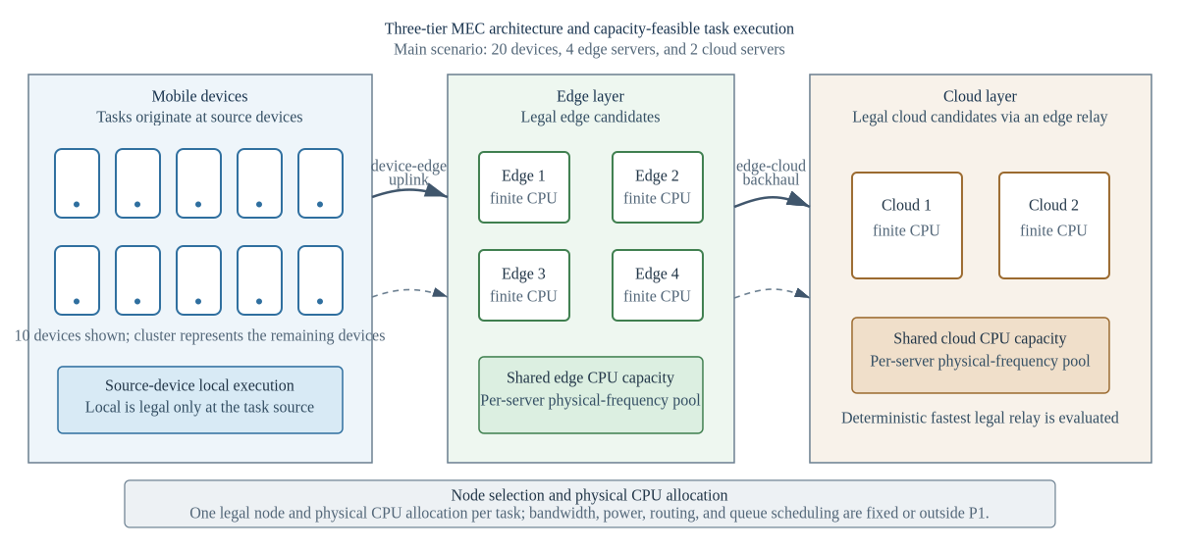
Fig. 1. Three-tier cloud-edge-device architecture with legal execution-node choices and shared physical CPU-capacity pools.
Task $i$ is generated by source device $d(i)$. Local execution is legal only at $d(i)$; reachable edge nodes have positive device-edge rates; a cloud node is legal only through at least one reachable edge with a positive backhaul rate. For a selected cloud, evaluation uses the legal relay with minimum task-specific transmission delay. This is deterministic path evaluation, not route or bandwidth optimisation. Task $i$ is represented by the following tuple, which records input bits, CPU cycles, period, service thresholds, battery ratio, priority and source device.
$$τ_{i}=(b_{i},c_{i},Δ_{i},T_{i}^{max},E_{i}^{bud},A_{i}^{max},β_{i},π_{i},d(i))$$
Binary $x_{ij}=1$ selects exactly one node $j$. The derived layer $z_{i}$ is local, edge or cloud and $s_{i}$ denotes the selected remote server. The physical allocation $f_{i}$ is measured in Hz.
Each search individual stores two normalised coordinates per task. The node coordinate indexes the sorted legal-node set, while $r_{i}∈[0,1$] decodes to a tentative physical frequency. The normalised coordinate is internal algorithm encoding, not a system-level abstract control variable.

3.2 Delay, Energy, and AoI Models
For node $j$ with minimum allocatable frequency $f_{j}^{min}$ and capacity $F_{j}$, the tentative request is
$f_{i}^{req}=f_{j}^{min}+r_{i}\left(F_{j}−f_{j}^{min}\right), 0≤r_{i}≤1, x_{ij}=1$ (1)
When reassignment is required, tasks are processed in a deterministic identifier order used solely for reproducibility. Identifiers are assigned independently of task type, source device and priority; the corresponding neutrality audit is provided in the reproducibility repository.
$T_{j}=\{i∈T:x_{ij}=1\}, n_{j}=card(T_{j}), R_{j}=F_{j}−n_{j}f_{j}^{min}$ (2)
Reassignment repeats for at most $|T||N|$ passes and either reaches non-negative $R_{j}$ for every node or fails explicitly. For a feasible assignment, the projection below applies only to $i∈T_{j}$. A zero excess denominator necessarily selects the first branch, so no division is performed; feasible requests are retained and only overloaded excess is scaled.
qi=max{fireq−fjmin,0}, i∈Tj,fi=fjmin+qi,k∈Tj​qk≤Rj,Rjqi/k∈Tj​qk,k∈Tj​qk>Rj. (3)
Using fixed positive rates $R_{d,e}$ and $R_{e,c}$, end-to-end delay is defined separately for each execution layer.
$T_{i}=\left\{\begin{matrix}c_{i}/f_{i}, & z_{i}=local, \\ b_{i}/R_{d(i),s_{i}}+c_{i}/f_{i}+δ_{E}, & z_{i}=edge, \\ b_{i}/R_{d(i),e_{i}^{⋆}}+b_{i}/R_{e_{i}^{⋆},s_{i}}+c_{i}/f_{i}+δ_{C}, & z_{i}=cloud,\end{matrix}\right.$ (4)
No heuristic congestion attenuation or M/M/1 queue is added, because finite CPU capacity and repaired physical allocations already represent processor scarcity. Fixed edge/cloud overheads are stated simulation parameters.
For local execution, device-side dynamic-voltage-and-frequency-scaling energy is
$E_{i}=κ_{d(i)}c_{i}f_{i}^{2}, z_{i}=local$ (5)
For edge or cloud offloading, let $e_{i}^{⋆}$ denote the selected edge or the fixed legal cloud relay. The reported device-side energy includes uplink transmission only:
$E_{i}=P_{d(i)}\frac{b_{i}}{R_{d(i),e_{i}^{⋆}}}, z_{i}∈\{edge,cloud\}$ (6)
Infrastructure computation and backhaul energy are outside the boundary; the manuscript therefore never labels this metric total system energy.
We assume periodic update generation and no explicit queue backlog. The area of a delay-shifted sawtooth over one period gives the average approximation
$A_{i}=\frac{Δ_{i}}{2}+T_{i}$ (7)
AoI is consequently delay-coupled, not independent. The model is not a queue-aware or peak-AoI formulation.
Table 1 lists one core variable per row. Secondary symbols are defined at first use in the surrounding text to avoid an oversized notation table.
The generated ranges ensure a feasible minimum-frequency assignment; all returned solutions are checked for unique assignment, legal nodes, finite frequencies, bounds and aggregate capacity.
Table 1. Main Notation
Symbol | Definition
$T$ | Task set
$N$ | Unified device, edge and cloud execution-node set
$N_{i}$ | Legal execution-node set of task i
$d(i)$ | Source device of task i
$x_{ij}$ | Binary assignment of task i to node j
$r_{i}$ | Internal normalised CPU coordinate
$f_{i}^{req}$ | Tentative physical CPU request of task i (Hz)
$f_{i}$ | Repaired physical CPU allocation of task i (Hz)
$f_{j}^{min}$ | Minimum allocatable CPU frequency of node j (Hz)
$F_{j}$ | Total CPU capacity of node j (Hz)
$T_{j}$ | Tasks assigned to node j after reassignment
$n_{j}$ | Number of tasks assigned to node j
$R_{j}$ | CPU capacity remaining after minimum allocations
$N_{T}$ | Number of tasks in the decision epoch
$N_{act}$ | Number of active source devices
$U_{m}$ | Mean base utility of active source device m
$Q$ | Priority-weighted aggregate QoE
$J$ | Jain fairness over active-user mean utilities
$B(X)$ | Fixed weighted base objective
$CSR(X)$ | Soft threshold constraint-satisfaction ratio
$F_{report}(X)$ | Fixed problem objective and cross-algorithm scale
$F_{search}(X,t)$ | Iteration-specific internal search fitness
$λ(t)$ | Dynamic search penalty coefficient
$NFE$ | Number of function evaluations

3.3 QoE and Fairness Metrics
The study uses a model-based base utility $u_{i}$ rather than a human-subject mean-opinion score. Delay, energy and freshness satisfaction are bounded exponential functions.
Delay satisfaction is
$S_{i}^{T}=exp\left(−\frac{T_{i}}{T_{i}^{max}}\right)$ (8)
Energy satisfaction is
$S_{i}^{E}=exp\left(−\frac{E_{i}}{E_{i}^{bud}}\right)$ (9)
Freshness satisfaction is
$S_{i}^{A}=exp\left(−\frac{A_{i}}{A_{i}^{max}}\right)$ (10)
The priority-neutral base task utility is
$u_{i}=0.45S_{i}^{T}+0.30S_{i}^{E}+0.25S_{i}^{A}, 0<u_{i}≤1$ (11)
Task priority is used only for system QoE aggregation:
Q=i∈T​πiuii∈T​πi (12)
For each active source device $m$, let $U_{m}$ denote the mean base utility over tasks generated by $m$.
This ordering prevents task priority and the number of generated tasks from being counted again inside fairness.
Let $D_{act}$ contain only source devices that generate at least one task in the epoch, and let $N_{act}$ be their count.
J=m∈Dact​Um2Nactm∈Dact​Um2 (13)
$J=1$ indicates equal active-user mean base utility. It is QoE-outcome fairness, not equality of physical CPU allocations.
The utility coefficients are engineering parameters applied identically to all algorithms; they are not claimed as subjective calibration and are varied in sensitivity analysis.

4 Problem Formulation
P1 combines threshold-normalised device-side energy, delay and AoI with QoE and fairness deficits. These five terms are coupled, because QoE is derived from the first three and AoI contains delay.
The components $E^{norm}$, $D^{norm}$ and $A^{norm}$ are respectively the task means of device-side energy divided by its budget, delay divided by its maximum and AoI divided by its threshold.
The fixed base objective is
$B(X)=0.15E^{norm}+0.15D^{norm}+0.20A^{norm}+0.25(1−Q)+0.25(1−J)$ (14)
Let $N_{T}$ be the number of tasks. Soft delay, battery-adjusted energy and AoI checks are summarised by CSR; they do not replace the hard assignment and CPU constraints.
CSR(X)=13NTi∈T​1(Ti≤Timax)+1(Ei≤max{βi,0.1}Eibud)+1(Ai≤Aimax) (15)
The fixed optimisation problem is therefore defined directly on reporting fitness. The selected-node CPU bound is written as an assignment-weighted bound, so each $f_{i}$ is constrained only by its chosen node.
P1: minXFreport(X)=B(X)+λref[1−CSR(X)]s.t. j∈N​xij=1, xij∈{0,1}, i∈T,xij=0, j∉Ni,j∈N​xijfjmin≤fi≤j∈N​xijFj, i∈T,i∈T​xijfi≤Fj, j∈N, λref=1. (16)
The soft-violation rate is $v=1−CSR$.
The internal normalised coordinates satisfy $0≤r_{i}≤1$ and select only the legal list; they are not additional physical constraints.
The dynamic search fitness used by RDHO is
$F_{search}(X,t)=B(X)+λ(t)\left[1−CSR(X)\right]$ (17)
$λ(t)=λ_{0}{\left(1+\frac{2t}{T_{max}}\right)}^{α}$ (18)
Parents and candidates in one greedy selection are evaluated with the same $λ(t)$. This prevents comparison under incompatible penalty coefficients.
The search process separately tracks the best fixed-objective candidate seen, denoted by $C_{seen}$:
$X_{report}^{⋆}=arg\min_{X∈C_{seen}}F_{report}(X)$ (19)
Search fitness guides optimisation; reporting fitness is the only cross-algorithm scale in tables and statistics.
Thus P1 is one fixed constrained problem, $F_{search}$ is only a penalty-continuation mechanism for solving it, and $F_{report}$ is the sole ranking scale in tables and statistics.

Problem complexity.
Even without continuous allocation, legal node assignments grow combinatorially. Capacity coupling, exponential utility and indicator-based soft violations make P1 a nonlinear mixed discrete-continuous problem.
The study does not claim a new proof of NP-hardness; it motivates a population search and evaluates empirical solution quality and cost.
A returned incumbent consists of one repaired legal node and one physical CPU allocation per task.
These characteristics motivate population search over legal categorical assignments and bounded physical CPU allocations; no deployment claim is made.

5 RDHO-Based Capacity-Feasible Optimisation Framework
RIME-DBO hybrid optimisation (RDHO) is the focal solver in this study. It adapts RIME-inspired perturbation and DBO-inspired role-conditioned movements to the capacity-feasible MEC encoding, decoder and repair path. RDHO-full additionally uses configured seeding and deterministic coordinate refinement; the framework is evaluated both as a complete solver and under controls that isolate its population-update stage.
RIME-inspired and DBO-inspired movements are described as algorithmic components, not as mechanisms presumed to be stronger in advance. Their independent contribution is evaluated under common initialisation, common repair, equal total NFE and common refinement in Section 6.3.
All candidates use the same normalised two-coordinate encoding and are decoded through the common physical repair before evaluation.
RDHO is assessed as a configured capacity-feasible search framework. Controlled experiments, rather than the hybrid label alone, determine which population-update claims are supported.

5.1 Solution Encoding and Physical-Resource Decoding
Each individual is a $|T|×2$ matrix (node coordinate, resource coordinate). The first coordinate indexes the sorted legal nodes; the second decodes to $f_{i}^{req}$ in Eq. (1). Both are clipped to [0,1].
Server selection is therefore an implemented decision with heterogeneous legal paths. The deterministic repair in Eqs. (2)-(3) is shared by RDHO and every baseline.
A candidate evaluation returns $B(X)$, $CSR(X)$, dynamic search fitness, fixed reporting fitness, raw metrics, hard-feasibility flags and capacity utilisation.

5.2 RDHO Population-Update Mechanism
The RDHO population contains equal Gaussian and uniform subsets, a greedy coordinate seed and up to three perturbations. Role shares adapt to diversity, while the configured top 10% are retained as elites.
Producer candidates combine RIME- and DBO-inspired updates through a weight decreasing from 0.8 to 0.2; followers use best-guided puncture or bound-aware foraging, and scouts use theft or a decaying Cauchy perturbation.
The fusion weight is
$ω(t)=0.8−0.6\frac{t}{T_{max}}$ (20)
$X_{k}^{new}=ω(t)X_{k}^{RIME}+\left[1−ω(t)\right]X_{k}^{DBO}$ (21)
The continuous update is an algorithmic neighbourhood only; every resulting assignment is interpreted through the task's legal-node list.
Greedy replacement compares parent and candidate under the same current $λ(t)$. A separate incumbent is tracked on $F_{report}$.
RDHO-full applies deterministic coordinate refinement and then reports the common fixed objective. In the controlled experiments, RDHO-specific local refinement is disabled and the same deterministic refinement is either omitted for every method or applied to every method. This separates complete-pipeline evidence from the population-update comparison.
The complete procedure is summarised in Algorithm 1.
Algorithm 1. RDHO-based capacity-feasible joint task-offloading and physical CPU-allocation strategy.

Algorithm 1. RDHO-based capacity-feasible joint offloading and physical CPU allocation
Require: | Scenario, legal-node encoding, physical decoder, deterministic repair, objective weights, population size and iterations
Ensure: | Hard-feasible incumbent on the fixed reporting objective
1 | Generate the configured RDHO population and optional seed candidates
2 | Decode legal nodes; repair capacity; evaluate the base objective and soft CSR
3 | for each configured iteration do
4 | Evaluate parents with the current dynamic penalty and assign RDHO roles
5 | Generate RIME-DBO-inspired producer, follower and scout candidates
6 | Decode and deterministically repair every candidate
7 | Compare parent and candidate under the same current penalty
8 | Update the independent fixed-objective incumbent
9 | end for
10 | If configured, apply deterministic coordinate refinement
11 | Re-evaluate with fixed reporting coefficient 1 and verify hard feasibility
Return | Node assignments, CPU frequencies and all reported metrics
Note | Controlled experiments replace RDHO-specific initialisation/refinement with the common procedure before comparing population updates
Algorithm 1 retains the RDHO population-update sequence while making its common decoder, deterministic capacity repair, fixed-reference incumbent tracking and optional refinement explicit.

6 Performance Evaluation

6.1 Experimental Setup and Reproducibility
The configured V2 end-to-end experiments and the additive strictly controlled experiments use the same fixed synthetic scenarios 20260701-20260730, legal-node encoding, physical CPU decoder, deterministic capacity repair, hard-feasibility checks and fixed reporting objective. The controlled artifacts are generated from immutable raw CSV files and audited separately; they do not regenerate or modify results/v2/.
The configured end-to-end suite compares RDHO-full, RIME, DBO, TLBO-HHO [21], CWTSSA [36] and Greedy-ED under the same model, utility, repair and fixed reporting objective.
The configured end-to-end comparison intentionally retains each solver's configured procedure; NFE is therefore unequal (RDHO-full 10,232, population baselines 7,551 and Greedy-ED 681). It is reported as a complete-solver comparison and cannot isolate the contribution of RDHO's population-update mechanism.
Table 2. Physical system parameters used in the main experiment.
Parameter | Value and interpretation
Devices / edge / cloud | 20 / 4 / 2
Tasks | 40 heterogeneous tasks
Node CPU capacity | Device 2.2-3.0; edge 18-28; cloud 55-75 GHz
Minimum allocatable CPU | Device 0.2; edge 0.8; cloud 1.5 GHz
Transmit power | 0.2-0.8 W
Device-edge rate | 8-30 Mbit/s; 10% sparse links, connectivity repaired
Edge-cloud rate | 60-150 Mbit/s; 5% sparse links, connectivity repaired
Energy coefficient | (0.8-1.4) × 10⁻²⁷ J s² cycle⁻³
Fixed overhead | Edge 0.010 s; cloud 0.055 s
Cloud relay | Fastest legal fixed relay for each selected cloud
Excluded controls | Bandwidth, power, association, routing and queue scheduling

Table 3. Task-generation ranges and sampling probabilities.
Parameter | Compute-intensive | Data-intensive | Real-time | Lightweight
Sampling probability | 0.28 | 0.24 | 0.28 | 0.20
Input data (MB) | 8-35 | 30-90 | 2-15 | 0.5-5
CPU cycles (Gcycles) | 1.8-4.5 | 0.8-2.2 | 0.5-1.8 | 0.1-0.8
Maximum delay (s) | 1.5-3.0 | 2.5-5.0 | 0.35-1.0 | 0.8-2.0
AoI threshold (s) | 2.0-3.0 | 3.0-5.0 | 0.5-1.0 | 1.0-2.0
Energy budget (J) | 2.5-6.0 | 2.0-5.0 | 1.0-3.5 | 0.5-2.0
Battery ratio | 0.45-1.0 | 0.40-0.95 | 0.55-1.0 | 0.50-1.0
Priority / interval (s) | 0.60-0.90 / 0.50-1.00 | 0.50-0.80 / 0.80-1.50 | 0.80-1.00 / 0.10-0.30 | 0.40-0.70 / 0.30-0.60

Table 4. Algorithm and reproducibility parameters for the configured end-to-end comparison and controlled experiments.
Parameter | Value
Configured end-to-end population / iterations | 50 / 150
Objective weights (energy, delay, AoI, QoE, fairness) | 0.15, 0.15, 0.20, 0.25, 0.25
Reporting coefficient | Fixed at 1
Paired scenarios | 30 (seeds 20260701-20260730)
Experiment A control | Common initial population, decoder and repair; no refinement; 3,801 total NFE
Experiment B control | Common initial population, decoder, repair and deterministic refinement; 10,232 total NFE
Controlled statistics | Two-sided paired Wilcoxon, experiment-local Holm correction, rank-biserial effect size, W/T/L
Compared population methods | RDHO, RIME and DBO
No algorithm-specific tuning was performed on the reported scenarios. Configurations and exact baseline implementations are versioned with the raw results.

6.2 Configured End-to-End Solver Comparison
Figure 2 reports fixed-reference incumbents during population search. RDHO's final coordinate refinement is not included in its curve, and Greedy-ED is a fixed reference.
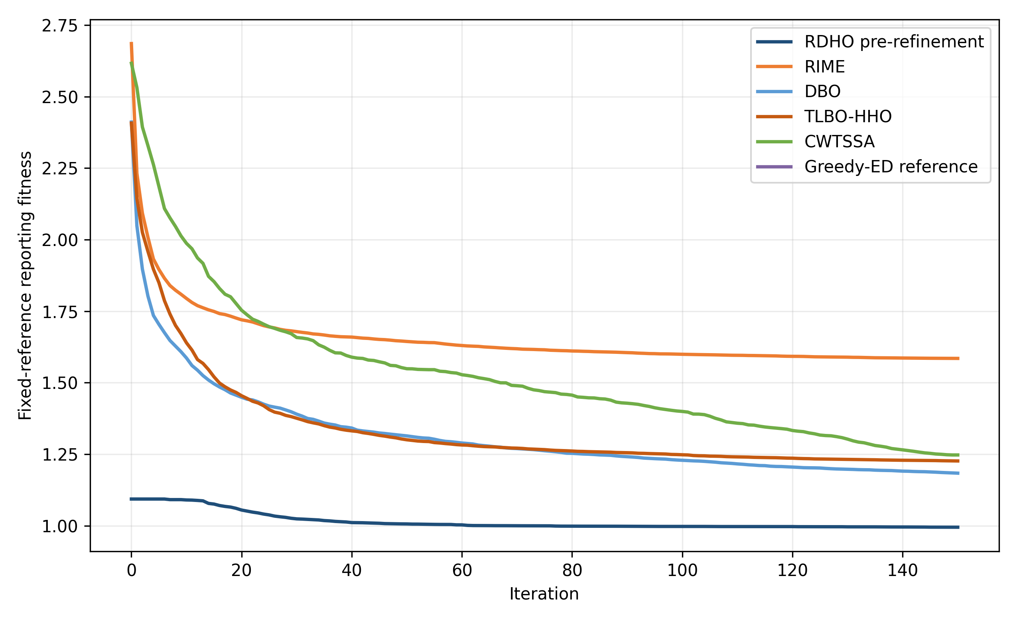
Fig. 2. Fixed-reference reporting-fitness convergence over 150 iterations.
Table 5. Configured end-to-end solver comparison over 30 paired scenarios (mean +/- standard deviation; unequal NFE).
Alg. | Reporting fitness | Device energy (J) | Delay (s) | AoI (s) | QoE | Fairness | Soft CSR | Time (s) | NFE
RDHO-full | 0.947 (0.120) | 94.58 (24.04) | 1.848 (0.218) | 2.171 (0.226) | 0.447 (0.032) | 0.924 (0.020) | 0.721 (0.055) | 7.831 (0.660) | 10232
RIME | 1.585 (0.154) | 126.37 (30.12) | 4.131 (0.795) | 4.454 (0.813) | 0.355 (0.027) | 0.838 (0.040) | 0.513 (0.053) | 5.966 (0.499) | 7551
DBO | 1.184 (0.190) | 93.19 (31.46) | 2.536 (0.479) | 2.859 (0.487) | 0.415 (0.035) | 0.916 (0.026) | 0.629 (0.070) | 5.820 (0.501) | 7551
TLBO-HHO | 1.226 (0.201) | 60.63 (14.07) | 2.766 (0.589) | 3.089 (0.593) | 0.407 (0.040) | 0.910 (0.029) | 0.599 (0.072) | 5.711 (0.495) | 7551
CWTSSA | 1.247 (0.151) | 62.62 (17.65) | 2.775 (0.488) | 3.098 (0.496) | 0.408 (0.031) | 0.914 (0.024) | 0.588 (0.057) | 5.678 (0.486) | 7551
Greedy-ED | 1.093 (0.170) | 99.75 (22.47) | 2.225 (0.538) | 2.548 (0.550) | 0.428 (0.034) | 0.916 (0.032) | 0.648 (0.062) | 0.507 (0.044) | 681
RDHO-full has the lowest configured mean reporting fitness (0.947 +/- 0.120) and every returned solution is hard feasible. Because RDHO-full uses 10,232 NFE while the population baselines use 7,551, this result supports the configured end-to-end solver rather than isolated superiority of its hybrid population update.
Metric-specific leaders differ: TLBO-HHO has the lowest device-side energy, RDHO-full has the lowest delay and AoI and the highest QoE, active-user fairness and CSR, while Greedy-ED is fastest. RDHO-full also consumes more NFE.
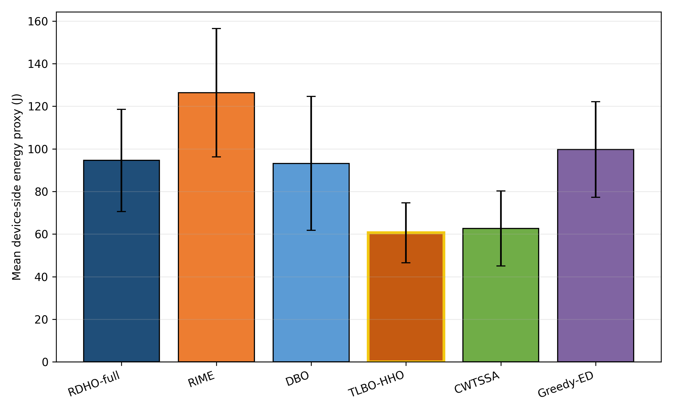
Fig. 3. Mean device-side energy over 30 paired runs.
TLBO-HHO is the energy leader; RDHO optimises energy as one component of the coupled reporting preference.
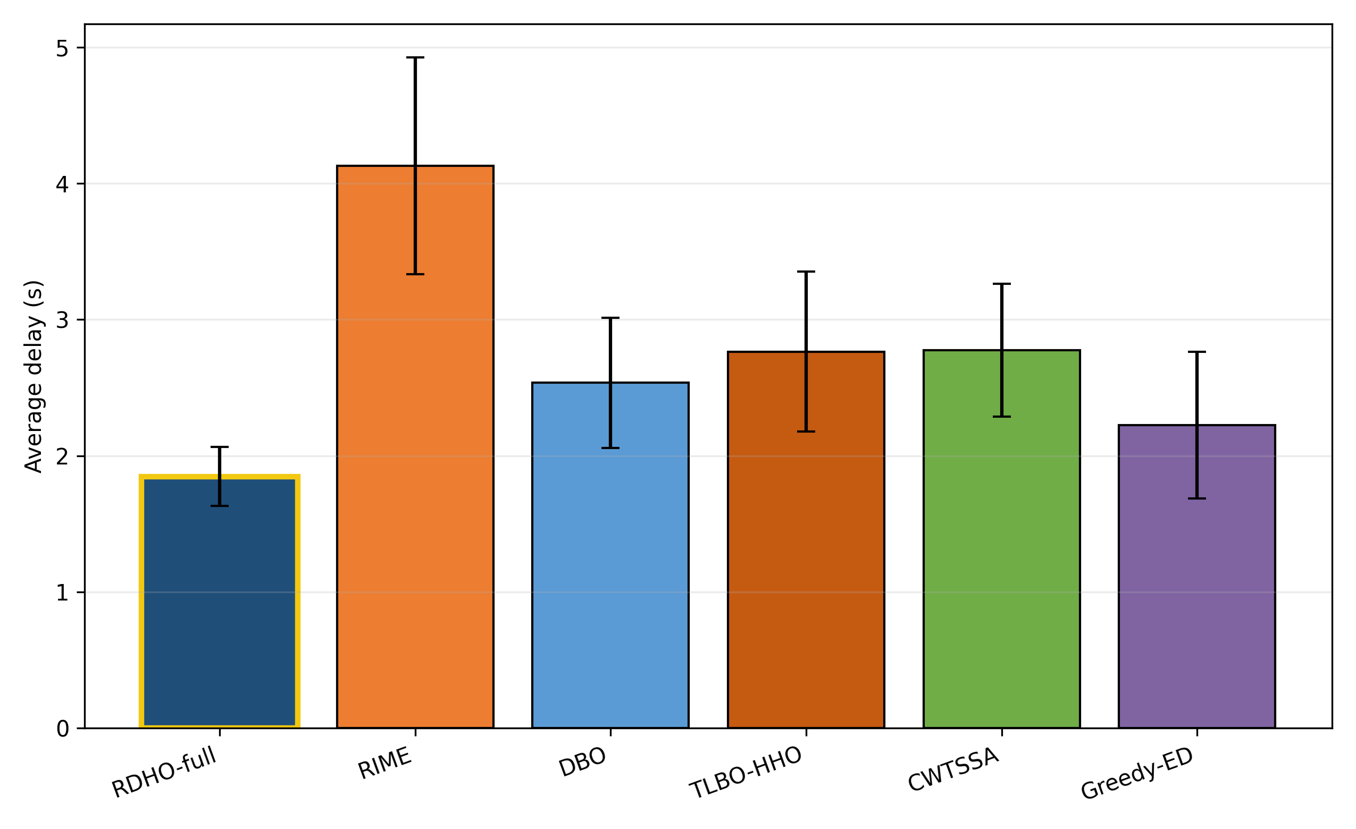
Fig. 4. Mean processing delay over 30 paired runs.
RDHO-full has the lowest mean delay under the configured end-to-end procedures.
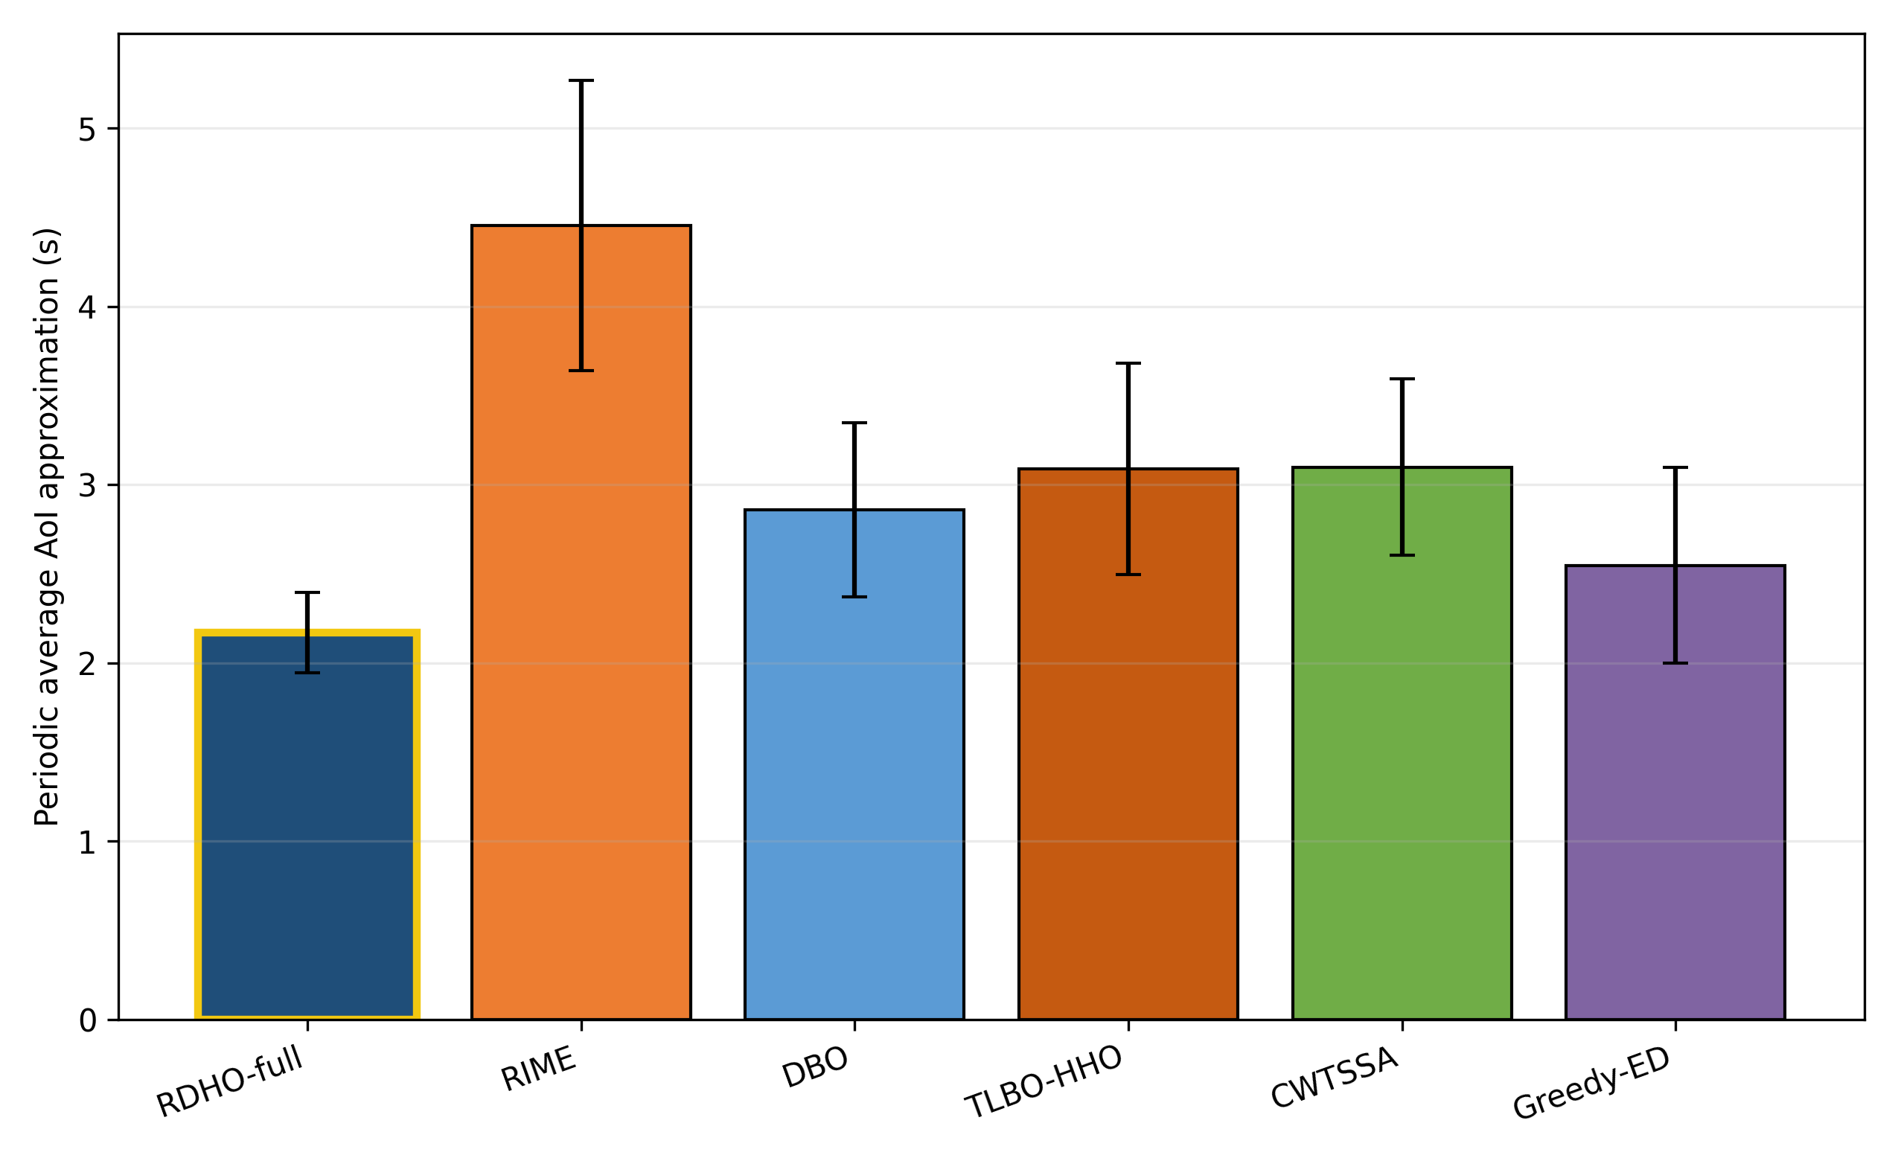
Fig. 5. Periodic no-backlog average-AoI approximation over 30 paired runs.
RDHO-full has the lowest mean AoI approximation; the close ordering with delay follows Eq. (7).
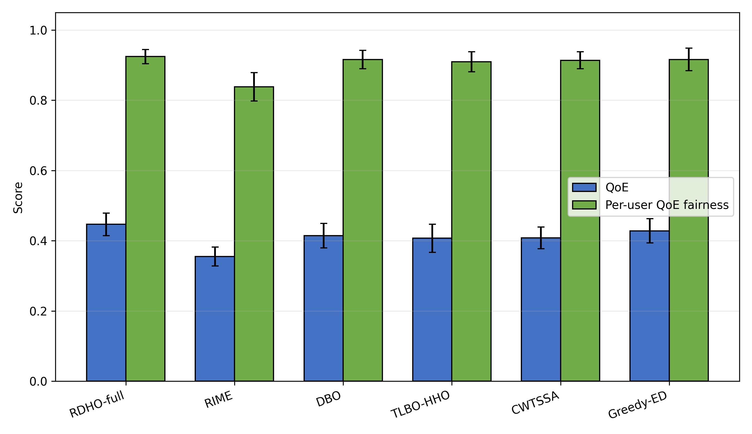
Fig. 6. Priority-weighted aggregate QoE and active-user base-utility fairness.
RDHO-full has the highest mean QoE, whereas fairness differences are small and do not imply equality of CPU allocations.
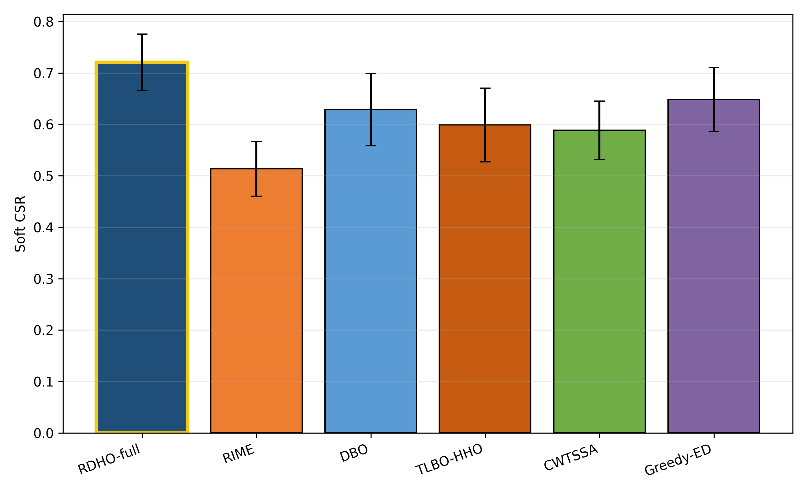
Fig. 7. Soft constraint-satisfaction ratio (CSR).
RDHO-full reaches mean CSR 0.721. CSR remains a binary threshold diagnostic; it does not imply that every task satisfies every soft threshold.
Configured-comparison statistics.
Two-sided paired Wilcoxon tests use the 30 matched reporting-fitness values. Holm adjustment controls the family-wise error rate; median paired difference, signed rank-biserial correlation and wins/ties/losses report magnitude and consistency. In this subsection, they test complete configured procedures with unequal NFE.
Table 6. Paired Wilcoxon tests for configured end-to-end solvers (unequal NFE).
Comparison | $W$ | Two-sided $p$ | Holm $p$ | Median diff. | Signed $r_{rb}$ | W/T/L
RDHO-full vs RIME | 0 | 1.86e-09 | 9.31e-09 | -0.6454 | -1.000 | 30/0/0
RDHO-full vs DBO | 0 | 1.86e-09 | 9.31e-09 | -0.2030 | -1.000 | 30/0/0
RDHO-full vs TLBO-HHO | 0 | 1.86e-09 | 9.31e-09 | -0.2581 | -1.000 | 30/0/0
RDHO-full vs CWTSSA | 0 | 1.86e-09 | 9.31e-09 | -0.2979 | -1.000 | 30/0/0
RDHO-full vs Greedy-ED | 0 | 1.86e-09 | 9.31e-09 | -0.1029 | -1.000 | 30/0/0
RDHO-full is lower in all 30 pairs against each configured main baseline. These tests concern complete procedures with their configured initialisation, population search, incumbent tracking and refinement; they do not prove an isolated hybrid-operator advantage.

6.3 Controlled Evaluation of the RDHO Population Mechanism
Two strictly controlled paired experiments answer the attribution question directly. Every method receives one identical 50-by-40-by-2 initial population per scenario, follows the common legal-node decoder and deterministic repair path, reports the same fixed reporting fitness and is constrained by an exact total NFE budget. All 90 returns in each experiment are hard feasible. The primary endpoint is lower fixed reporting fitness; paired differences are defined as DeltaF = F_RDHO - F_parent, so negative values favour RDHO.
Table 7. Strictly controlled RDHO population-stage and common-pipeline evidence over 30 paired scenarios.
Experiment | Method | Mean +/- SD | Median | NFE | Runtime (s)
A: population stage | RDHO | 1.4188 +/- 0.1612 | 1.3946 | 3801 | 3.149
A: population stage | RIME | 1.6834 +/- 0.1651 | 1.6593 | 3801 | 3.154
A: population stage | DBO | 1.2409 +/- 0.1245 | 1.2208 | 3801 | 3.053
B: common pipeline | RDHO | 0.9732 +/- 0.1244 | 0.9827 | 10232 | 9.054
B: common pipeline | RIME | 0.9836 +/- 0.1205 | 0.9950 | 10232 | 9.169
B: common pipeline | DBO | 0.9664 +/- 0.1234 | 0.9676 | 10232 | 8.930
Paired tests | RDHO comparison | Median DeltaF [95% CI] | Holm p | r_rb | W/T/L
A | RDHO vs RIME | -0.278300 [-0.312822, -0.198123] | 1.304e-08 | -0.983 | 29/0/1
A | RDHO vs DBO | +0.178910 [+0.112584, +0.225303] | 3.725e-09 | +1.000 | 0/0/30
B | RDHO vs RIME | -0.012281 [-0.024215, -0.001839] | 0.019863 | -0.531 | 23/0/7
B | RDHO vs DBO | +0.008226 [+0.000775, +0.014349] | 0.026229 | +0.462 | 10/0/20
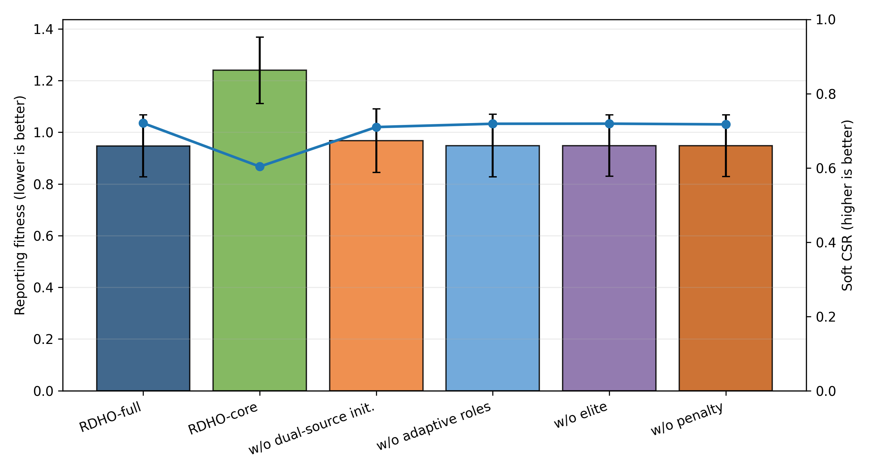
Fig. 8. Reporting fitness and soft CSR for configured RDHO variants.
The configured ablation remains descriptive for the end-to-end RDHO workflow. Coordinate refinement changes configured mean fitness from 1.240 to 0.947, so it is one component of the complete-pipeline result; the controlled experiments below are the evidence for population-update attribution.
6.4 Component, Refinement, Scalability, and Sensitivity Analyses
Equal-NFE population-stage control (Experiment A) uses common initialisation, decoder and repair, disables coordinate refinement, and fixes total NFE at 3,801 for every method. RDHO reports 1.4188 +/- 0.1612, RIME 1.6834 +/- 0.1651 and DBO 1.2409 +/- 0.1245. RDHO versus RIME has median DeltaF -0.278300, Holm p=1.304e-08, rank-biserial -0.983 and W/T/L 29/0/1; RDHO versus DBO has median DeltaF +0.178910, Holm p=3.725e-09, rank-biserial +1.000 and W/T/L 0/0/30. Thus RDHO significantly improves on RIME but is significantly worse than DBO.
Table 8. RDHO scalability under 20-100 tasks.
Tasks | Reporting fitness | Soft CSR | Time (s) | NFE
20 | 0.897 (0.124) | 0.745 (0.059) | 3.430 (0.056) | 8892
40 | 0.977 (0.116) | 0.708 (0.055) | 6.641 (0.119) | 10232
60 | 0.998 (0.106) | 0.698 (0.050) | 10.370 (0.128) | 11572
80 | 1.059 (0.100) | 0.665 (0.041) | 14.833 (0.226) | 12912
100 | 1.135 (0.070) | 0.633 (0.030) | 19.772 (0.220) | 14252
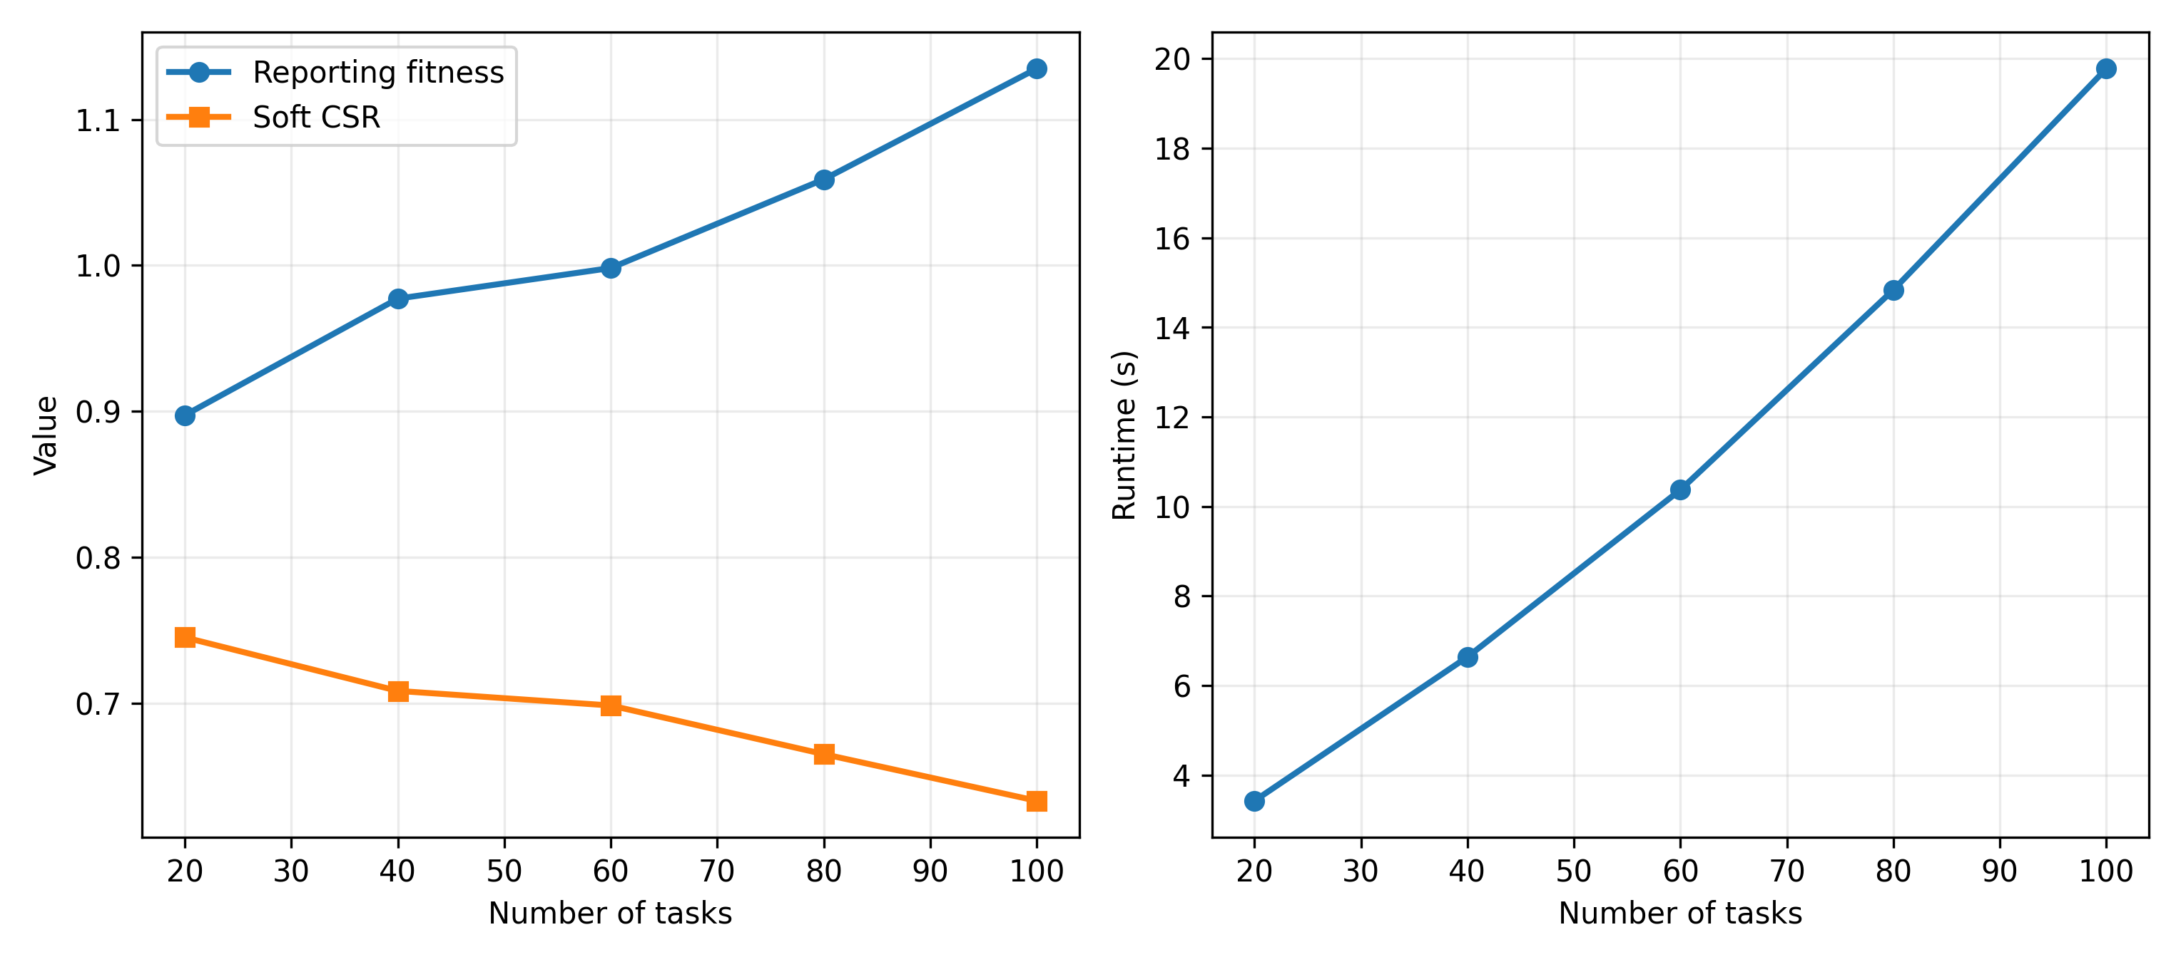
Fig. 9. Reporting fitness, soft CSR and runtime versus task count.
Common-pipeline control (Experiment B) additionally applies the same deterministic coordinate refinement to every method and fixes total NFE at 10,232. RDHO reports 0.9732 +/- 0.1244, RIME 0.9836 +/- 0.1205 and DBO 0.9664 +/- 0.1234. RDHO versus RIME has median DeltaF -0.012281, Holm p=0.019863, rank-biserial -0.531 and W/T/L 23/0/7; RDHO versus DBO has median DeltaF +0.008226, Holm p=0.026229, rank-biserial +0.462 and W/T/L 10/0/20. RDHO again significantly improves on RIME but is significantly worse than DBO.
Component and refinement interpretation.
The controlled results indicate that the implemented RDHO population mechanism improves substantially over RIME but does not improve on DBO in the fixed V2 scenarios. The contribution of RDHO in this study is therefore interpreted at the integrated-framework level, not as evidence of a universally superior hybrid population operator. Common coordinate refinement reduces the absolute gaps, but it does not reverse the controlled RDHO-versus-DBO ordering.
The final sensitivity ranges are generated directly from V2 CSV files; no value is manually entered into a paper table.
Weight changes expose engineering preference rather than a universal optimum. Task-utility coefficient sensitivity checks the internal QoE construction, while CPU-capacity, SLA and server-heterogeneity scaling test load, threshold strictness and heterogeneous legal server choices.
Table 9. Additional configured attribution and sensitivity records (not a substitute for the strict controls in Table 7).
Method | Equal NFE | Common init. | Common refine. | Reporting fitness, mean (SD) | Effect size (reference - row)
RDHO-core | Yes (3,801) | No | No | 1.402 (0.165) | Reference
RIME | Yes (3,801) | No | No | 1.633 (0.161) | -0.978
DBO | Yes (3,801) | No | No | 1.246 (0.145) | 1.000
TLBO-HHO | Yes (3,801) | No | No | 1.240 (0.139) | 0.996
CWTSSA | Yes (3,801) | No | No | 1.330 (0.158) | 0.733
RIME + refine | No | Yes | Yes | 0.982 (0.129) | -1.000
DBO + refine | No | Yes | Yes | 0.967 (0.127) | -0.892
RDHO-full | No (10,232) | RDHO | Yes | 0.947 (0.120) | Reference
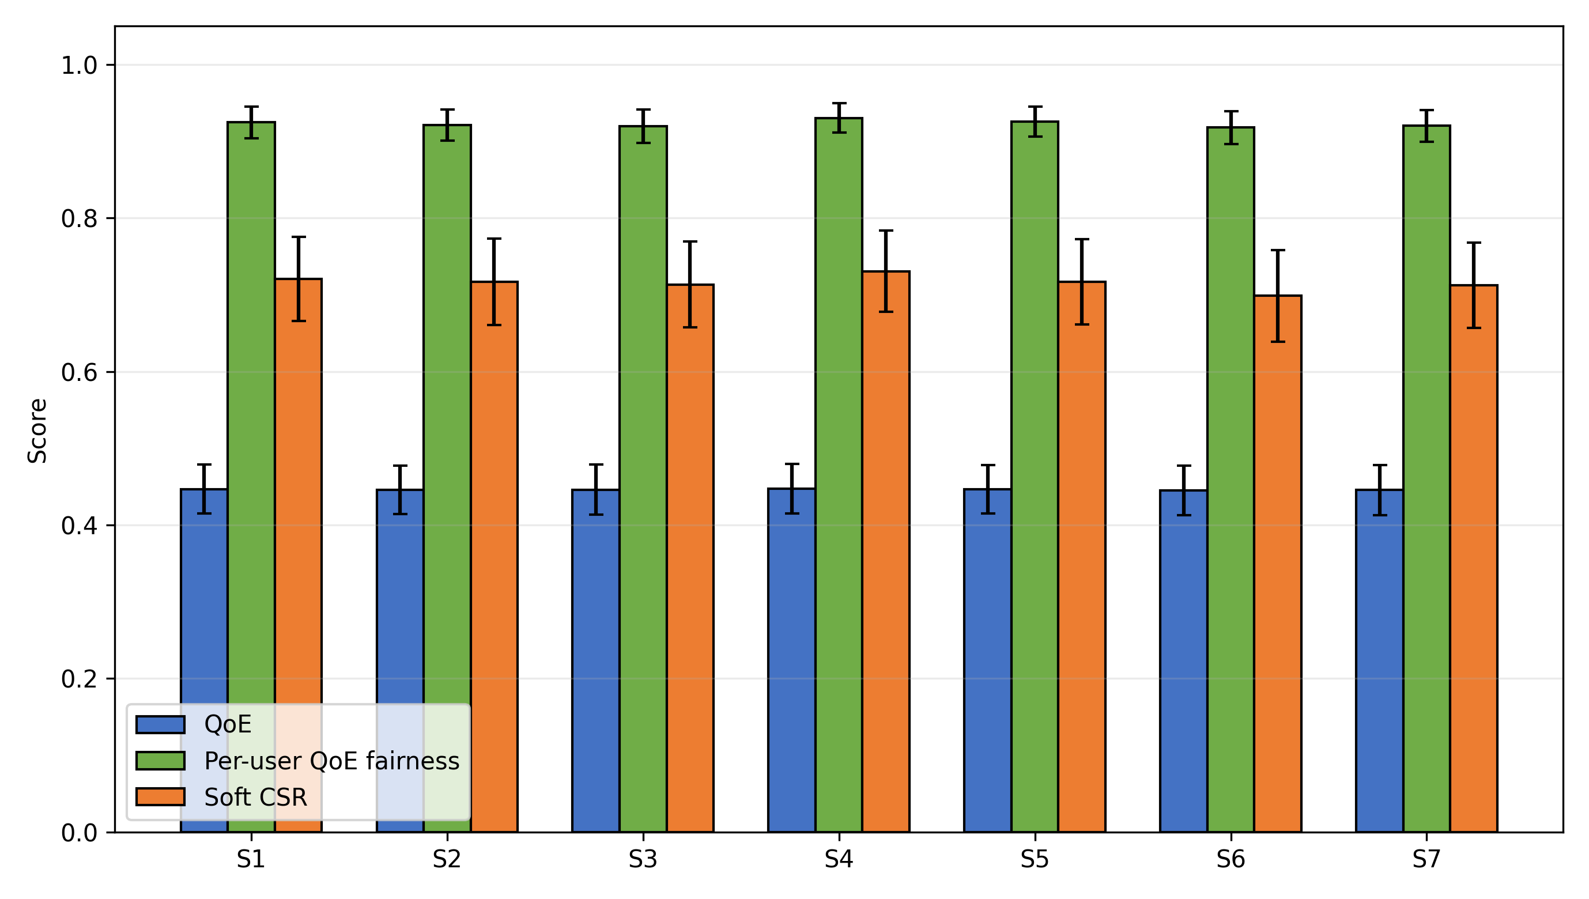
Fig. 10. Objective-weight sensitivity of QoE, active-user fairness and soft CSR.
The penalty heatmaps compare returned solutions under a common $λ_{ref}=1$; they do not alter the reporting definition.
Table 10. Dynamic-penalty sensitivity under fixed reporting fitness.
Initial penalty | Growth exponent | Reporting fitness | QoE | Fairness | Soft CSR | Time (s)
0.5 | 1.0 | 0.947 (0.119) | 0.447 (0.032) | 0.924 (0.020) | 0.719 (0.057) | 6.661 (0.113)
0.5 | 2.0 | 0.948 (0.118) | 0.447 (0.032) | 0.924 (0.020) | 0.719 (0.055) | 6.606 (0.106)
0.5 | 3.0 | 0.948 (0.119) | 0.447 (0.033) | 0.925 (0.020) | 0.720 (0.055) | 6.519 (0.109)
1.0 | 1.0 | 0.949 (0.119) | 0.447 (0.033) | 0.924 (0.020) | 0.719 (0.054) | 6.521 (0.084)
1.0 | 2.0 | 0.947 (0.120) | 0.447 (0.032) | 0.924 (0.020) | 0.721 (0.055) | 6.514 (0.113)
1.0 | 3.0 | 0.948 (0.121) | 0.446 (0.033) | 0.924 (0.020) | 0.721 (0.054) | 6.536 (0.113)
2.0 | 1.0 | 0.948 (0.120) | 0.447 (0.032) | 0.925 (0.020) | 0.721 (0.055) | 6.532 (0.106)
2.0 | 2.0 | 0.948 (0.119) | 0.447 (0.032) | 0.925 (0.020) | 0.721 (0.053) | 6.534 (0.118)
2.0 | 3.0 | 0.950 (0.121) | 0.446 (0.033) | 0.925 (0.020) | 0.722 (0.054) | 6.520 (0.109)

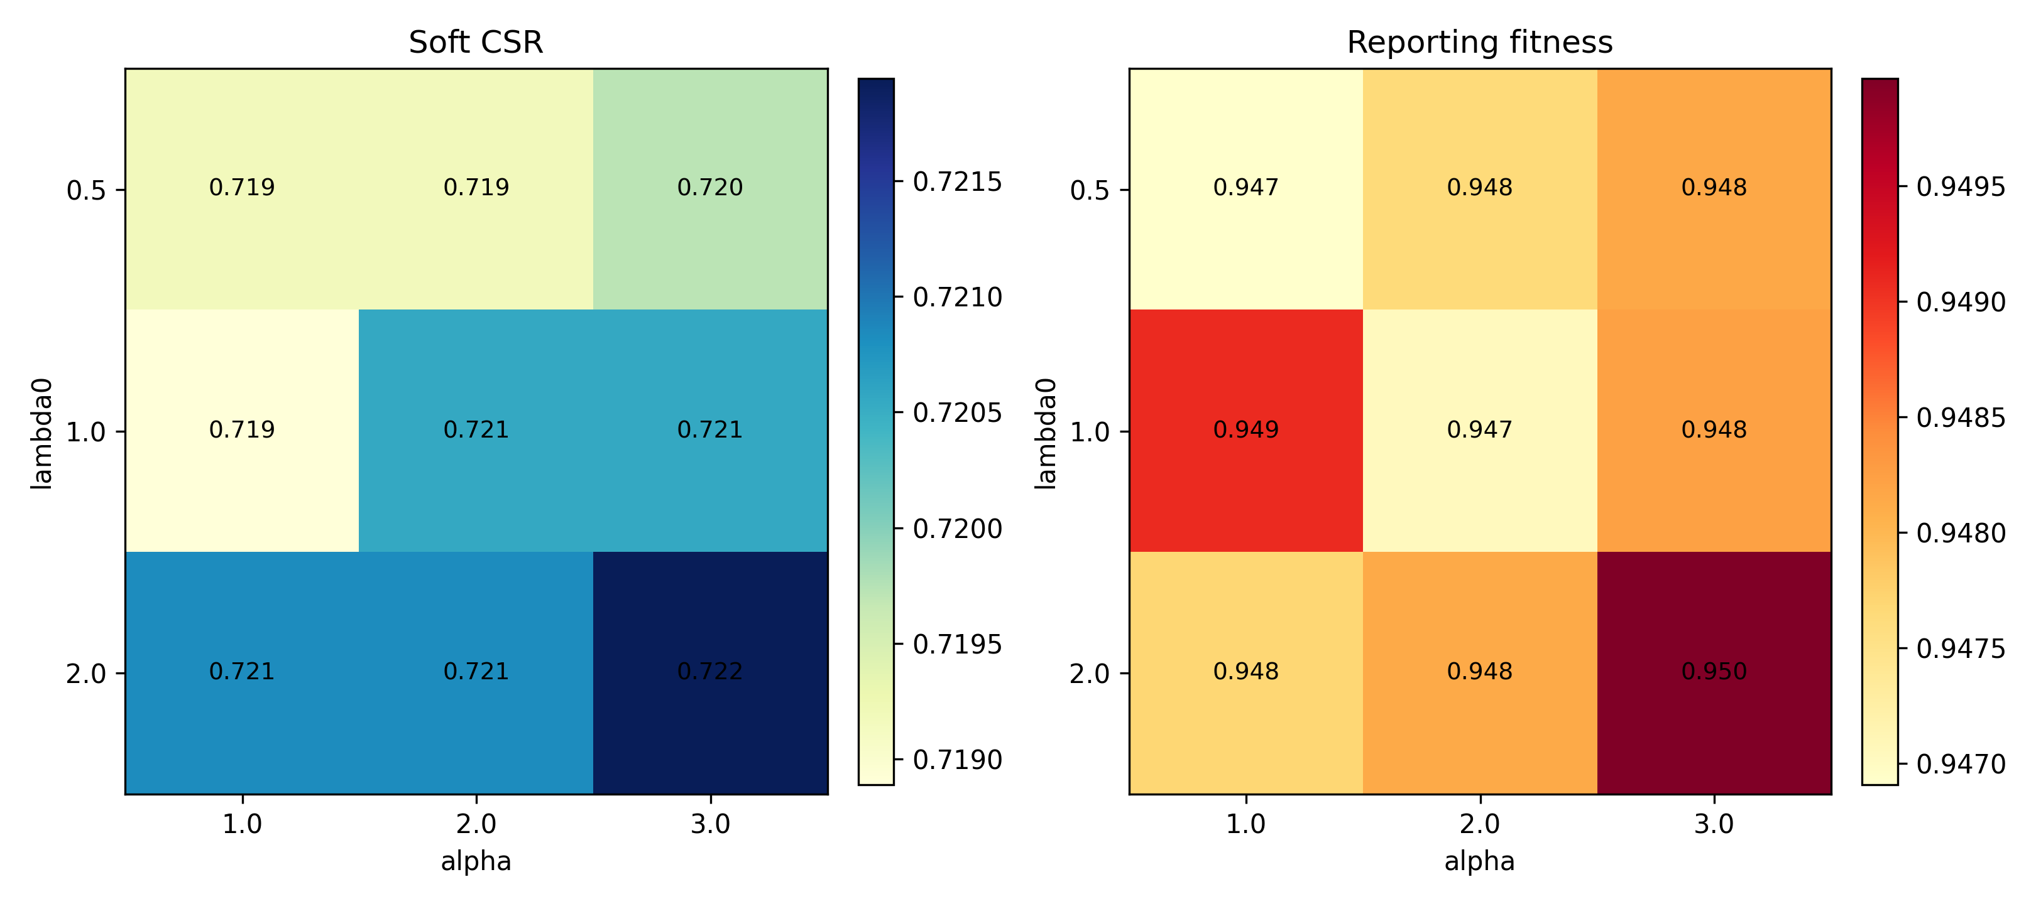
Fig. 11. Dynamic-penalty sensitivity heatmaps for soft CSR and reporting fitness.
The nine penalty schedules are reported without post-hoc selection. Full objective-weight, task-utility, CPU-capacity, SLA and server-heterogeneity tables remain in the repository supplement and extend the sensitivity boundary without post-hoc tuning claims.
Scalability and sensitivity.
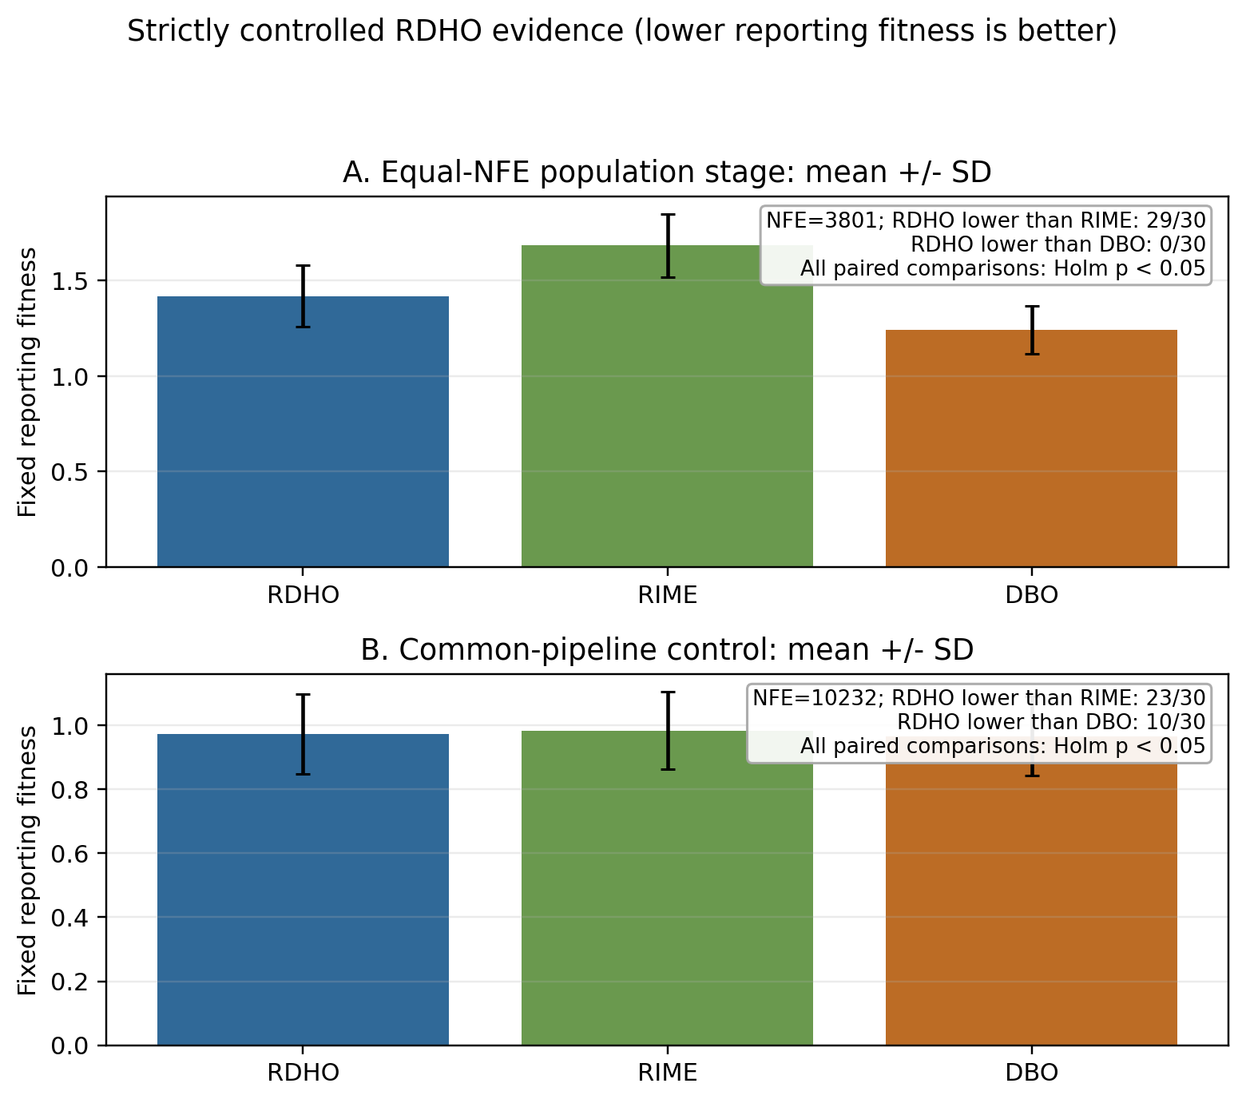
Overall interpretation.
Fig. 12. Strictly controlled paired reporting-fitness evidence. Panels A and B use 3,801 and 10,232 total NFE, respectively; negative RDHO-minus-parent differences favour RDHO.
Figure 12 visualises both controlled experiments rather than hiding the adverse comparison: RDHO is lower than RIME in 29/30 population-stage pairs and 23/30 common-pipeline pairs, but it is lower than DBO in 0/30 and 10/30 pairs, respectively. The Holm-adjusted tests are significant in all four comparisons. The configured RDHO-full result therefore demonstrates the effectiveness of the complete RDHO-based framework under its configured procedure, whereas the isolated population-update evidence does not support superiority over DBO.

7 Conclusion
This work formulated a capacity-feasible MEC joint task-offloading and physical CPU-allocation model and developed RDHO as its focal integrated solver framework. Each task selects one legal source-local, reachable-edge or reachable-cloud node, and deterministic repair enforces physical Hz bounds and per-node capacity.
In the configured end-to-end comparison, RDHO-full has the lowest mean fixed reporting fitness (0.947) with hard feasibility in every returned solution, but this comparison has unequal NFE and evaluates complete solver configurations. The strict controls disclose the narrower result: at 3,801 NFE without refinement, RDHO is significantly lower than RIME but significantly higher than DBO; at 10,232 NFE with common refinement, RDHO is again significantly lower than RIME but significantly higher than DBO. Accordingly, the evidence supports the RDHO-based capacity-feasible framework and its controlled evaluation methodology, not independent or universal superiority of the RIME-DBO population update.
Limitations include synthetic offline tasks, fixed-rate communication, deterministic cloud relay selection, device-side rather than infrastructure energy, a periodic no-backlog AoI approximation, coupled objective terms, engineering utility coefficients and the fixed set of implemented algorithms and 30 scenarios. Future work can investigate adaptive operator selection or DBO-dominant RDHO variants, queue-aware arrivals, communication-resource optimisation, infrastructure energy, calibrated QoE and physical testbeds without claiming that the present hybrid operator has already surpassed DBO.

CRediT authorship contribution statement
Haoru Su: Conceptualization, methodology, supervision, Writing - review and editing. Jie Bai: Methodology, validation, formal analysis, Writing - review and editing. Jiangyi Zhou: Software, data curation, visualization, Writing - original draft, Writing - review and editing. All authors reviewed and approved the final manuscript.

Conflicts of Interest Declaration
All authors declare that they have no conflicts of interest.

Funding
This research received no specific grant from any funding agency in the public, commercial, or not-for-profit sectors.

Declaration of Generative AI and AI-Assisted Technologies in Manuscript Preparation
During the preparation of this work, the authors used ChatGPT for language editing, manuscript polishing, and formatting checks. After using this tool, the authors reviewed and edited the content as needed and take full responsibility for the content of the publication.

Data Availability
Code, configurations, controlled raw results, summaries, paired statistics, NFE and initial-population audits, figures and reproduction commands are archived in the local research repository. The existing V2 result files remain byte-identical; all reported data are synthetic, and no proprietary, confidential or human-subject data were used.

References
[1] Mao, Y., You, C., Zhang, J., Huang, K. and Letaief, K.B. (2017) 'A survey on mobile edge computing: the communication perspective', IEEE Communications Surveys & Tutorials, Vol. 19, No. 4, pp.2322-2358, doi: 10.1109/COMST.2017.2745201.
[2] Taleb, T., Samdanis, K., Mada, B., Flinck, H., Dutta, S. and Sabella, D. (2017) 'On multi-access edge computing: a survey of the emerging 5G network edge cloud architecture and orchestration', IEEE Communications Surveys & Tutorials, Vol. 19, No. 3, pp.1657-1681, doi: 10.1109/COMST.2017.2705720.
[3] Sardellitti, S., Scutari, G. and Barbarossa, S. (2015) 'Joint optimization of radio and computational resources for multicell mobile-edge computing', IEEE Transactions on Signal and Information Processing over Networks, Vol. 1, No. 2, pp.89-103, doi: 10.1109/TSIPN.2015.2448520.
[4] Tang, Z., Sun, Z., Yang, N. and Zhou, X. (2023) 'Age of information of multi-user mobile edge computing systems', IEEE Open Journal of the Communications Society, Vol. 4, pp.1600-1614, doi: 10.1109/OJCOMS.2023.3294942.
[5] Skorin-Kapov, L., Varela, M., Hossfeld, T. and Chen, K.-T. (2018) 'A survey of emerging concepts and challenges for QoE management of multimedia services', ACM Transactions on Multimedia Computing, Communications, and Applications, Vol. 14, No. 2s, pp.1-29, doi: 10.1145/3176648.
[6] Luo, J., Deng, X., Zhang, H. and Qi, H. (2019) 'QoE-driven computation offloading for edge computing', Journal of Systems Architecture, Vol. 97, pp.34-39, doi: 10.1016/j.sysarc.2019.01.019.
[7] Zhou, J. and Zhang, X. (2021) 'Fairness-aware task offloading and resource allocation in cooperative mobile-edge computing', IEEE Internet of Things Journal, Vol. 9, No. 5, pp.3812-3824, doi: 10.1109/JIOT.2021.3100253.
[8] Dong, S., Tang, J., Abbas, K., Hou, R., Kamruzzaman, J., Rutkowski, L. and Buyya, R. (2024) 'Task offloading strategies for mobile edge computing: a survey', Computer Networks, Vol. 254, Article 110791, doi: 10.1016/j.comnet.2024.110791.
[9] Wang, D., Bin Abu Bakar, K., Isyaku, B., Eisa, T.A.E. and Abdelmaboud, A. (2024) 'A comprehensive review on Internet of Things task offloading in multi-access edge computing', Heliyon, Vol. 10, No. 9, Article e29916, doi: 10.1016/j.heliyon.2024.e29916.
[10] Wu, H., Lu, Y., Ma, H., Xing, L., Deng, K. and Lu, X. (2025) 'A survey on task type-based computation offloading in mobile edge networks', Ad Hoc Networks, Vol. 169, Article 103754, doi: 10.1016/j.adhoc.2025.103754.
[11] Zhang, K., Mao, Y., Leng, S., Zhao, Q., Li, L., Peng, X., Pan, L., Maharjan, S. and Zhang, Y. (2016) 'Energy-efficient offloading for mobile edge computing in 5G heterogeneous networks', IEEE Access, Vol. 4, pp.5896-5907, doi: 10.1109/ACCESS.2016.2597169.
[12] Almuseelem, W. (2025) 'Deep reinforcement learning-enabled computation offloading: a novel framework to energy optimization and security-aware in vehicular edge-cloud computing networks', Sensors, Vol. 25, No. 7, Article 2039, doi: 10.3390/s25072039.
[13] An, X., Li, Y., Chen, Y. and Li, T. (2024) 'Joint task offloading and resource allocation for multi-user collaborative mobile edge computing', Computer Networks, Vol. 250, Article 110604, doi: 10.1016/j.comnet.2024.110604.
[14] Chen, T., Tan, F., Ai, J., Xiong, X., Wu, C. and Ren, X. (2024) 'Joint optimization of task offloading and service placement for digital twin empowered mobile edge computing', Proceedings of the 2024 3rd International Conference on Networks, Communications and Information Technology, pp.132-137, doi: 10.1145/3672121.3672145.
[15] Huang, L., Bi, S. and Zhang, Y.-J.A. (2019) 'Deep reinforcement learning for online computation offloading in wireless powered mobile-edge computing networks', IEEE Transactions on Mobile Computing, Vol. 19, No. 11, pp.2581-2593, doi: 10.1109/TMC.2019.2928811.
[16] Liu, L., Feng, J., Mu, X., Pei, Q., Lan, D. and Xiao, M. (2023) 'Asynchronous deep reinforcement learning for collaborative task computing and on-demand resource allocation in vehicular edge computing', IEEE Transactions on Intelligent Transportation Systems, Vol. 24, No. 12, pp.15513-15526, doi: 10.1109/TITS.2023.3249745.
[17] Zang, L., Zhang, X. and Guo, B. (2022) 'Federated deep reinforcement learning for online task offloading and resource allocation in WPC-MEC networks', IEEE Access, Vol. 10, pp.9856-9867, doi: 10.1109/ACCESS.2022.3144415.
[18] Abd-Elmagid, M.A., Pappas, N. and Dhillon, H.S. (2019) 'On the role of age of information in the Internet of Things', IEEE Communications Magazine, Vol. 57, No. 12, pp.72-77, doi: 10.1109/MCOM.001.1900041.
[19] Jin, L., Tang, M., Pan, J., Zhang, M. and Wang, H. (2024) 'Asynchronous fractional multi-agent deep reinforcement learning for age-minimal mobile edge computing', arXiv:2409.16832.
[20] Pei, Y., Zhao, Y. and Hou, F. (2024) 'Minimizing age of information in UAV-assisted edge computing system with multiple transmission modes', Tsinghua Science and Technology, Vol. 30, No. 3, pp.1060-1078, doi: 10.26599/TST.2024.9010046.
[21] Bai, J., Su, H., Bi, J., Zhang, L., Yuan, X. and Liu, X. (2025) 'TLBO-HHO AoI-aware task offloading for mobile edge computing', Proceedings of the 2025 IEEE International Conference on Smart Internet of Things (SmartIoT), pp.88-95, doi: 10.1109/SmartIoT66867.2025.00021.
[22] Fiedler, M., Hossfeld, T. and Tran-Gia, P. (2010) 'A generic quantitative relationship between quality of experience and quality of service', IEEE Network, Vol. 24, No. 2, pp.36-41, doi: 10.1109/MNET.2010.5430142.
[23] Jain, R.K., Chiu, D.M. and Hawe, W.R. (1984) 'A quantitative measure of fairness and discrimination for resource allocation in shared computer systems', Digital Equipment Corporation, Hudson, MA, Technical Report DEC-TR-301.
[24] Kelly, F.P., Maulloo, A.K. and Tan, D.K.H. (1998) 'Rate control for communication networks: shadow prices, proportional fairness and stability', Journal of the Operational Research Society, Vol. 49, No. 3, pp.237-252, doi: 10.1038/sj.jors.2600523.
[25] Le Callet, P., Moller, S. and Perkis, A. (eds) (2013) 'Qualinet white paper on definitions of quality of experience', European Network on Quality of Experience in Multimedia Systems and Services.
[26] Ling, C., Zhang, W., He, H., Yadav, R., Wang, J. and Wang, D. (2024) 'QoS and fairness oriented dynamic computation offloading in the Internet of Vehicles based on estimated time of arrival', IEEE Transactions on Vehicular Technology, Vol. 73, No. 7, pp.10554-10571, doi: 10.1109/TVT.2024.3364669.
[27] Chen, H., Heidari, A.A., Chen, H., Wang, M., Pan, Z. and Gandomi, A.H. (2020) 'Multi-population differential evolution-assisted Harris hawks optimization: framework and case studies', Future Generation Computer Systems, Vol. 111, pp.175-198, doi: 10.1016/j.future.2020.04.008.
[28] Deb, K., Pratap, A., Agarwal, S. and Meyarivan, T. (2002) 'A fast and elitist multiobjective genetic algorithm: NSGA-II', IEEE Transactions on Evolutionary Computation, Vol. 6, No. 2, pp.182-197, doi: 10.1109/4235.996017.
[29] Deb, K., Sindhya, K. and Hakanen, J. (2016) 'Multi-objective optimization', in Decision Sciences: Theory and Practice, CRC Press, Boca Raton, FL, pp.161-200.
[30] Heidari, A.A., Mirjalili, S., Faris, H., Aljarah, I., Mafarja, M. and Chen, H. (2019) 'Harris hawks optimization: algorithm and applications', Future Generation Computer Systems, Vol. 97, pp.849-872, doi: 10.1016/j.future.2019.02.028.
[31] Li, Z. and Zhu, Q. (2020) 'Genetic algorithm-based optimization of offloading and resource allocation in mobile-edge computing', Information, Vol. 11, No. 2, Article 83, doi: 10.3390/info11020083.
[32] Rao, R.V., Savsani, V.J. and Vakharia, D.P. (2011) 'Teaching-learning-based optimization: a novel method for constrained mechanical design optimization problems', Computer-Aided Design, Vol. 43, No. 3, pp.303-315, doi: 10.1016/j.cad.2010.12.015.
[33] Zhang, Q. and Li, H. (2007) 'MOEA/D: a multiobjective evolutionary algorithm based on decomposition', IEEE Transactions on Evolutionary Computation, Vol. 11, No. 6, pp.712-731, doi: 10.1109/TEVC.2007.892759.
[34] Su, H., Zhao, D., Heidari, A.A., Liu, L., Zhang, X., Mafarja, M. and Chen, H. (2023) 'RIME: a physics-based optimization', Neurocomputing, Vol. 532, pp.183-214, doi: 10.1016/j.neucom.2023.02.010.
[35] Xue, J. and Shen, B. (2023) 'Dung beetle optimizer: a new meta-heuristic algorithm for global optimization', The Journal of Supercomputing, Vol. 79, No. 7, pp.7305-7336, doi: 10.1007/s11227-022-04959-6.
[36] Yang, X., Liu, J., Liu, Y., Xu, P., Yu, L., Zhu, L., Chen, H. and Deng, W. (2021) 'A novel adaptive sparrow search algorithm based on chaotic mapping and t-distribution mutation', Applied Sciences, Vol. 11, No. 23, Article 11192, doi: 10.3390/app112311192.
[37] Ma, C., Zhu, J., Liu, M., Zhao, H., Liu, N. and Zou, X. (2021) 'Parking edge computing: parked-vehicle-assisted task offloading for urban VANETs', IEEE Internet of Things Journal, Vol. 8, No. 11, pp.9344-9358, doi: 10.1109/JIOT.2021.3056396.
[38] Wu, H., Wolter, K., Jiao, P., Deng, Y., Zhao, Y. and Xu, M. (2021) 'EEDTO: an energy-efficient dynamic task offloading algorithm for blockchain-enabled IoT-edge-cloud orchestrated computing', IEEE Internet of Things Journal, Vol. 8, No. 4, pp.2163-2176, doi: 10.1109/JIOT.2020.3033521.
[39] Feng, J., Yu, F.R., Pei, Q., Chu, X., Du, J. and Zhu, L. (2020) 'Cooperative computation offloading and resource allocation for blockchain-enabled mobile-edge computing: a deep reinforcement learning approach', IEEE Internet of Things Journal, Vol. 7, No. 7, pp.6214-6228, doi: 10.1109/JIOT.2019.2961707.
[40] Yuan, X., Tian, H., Wang, H., Su, H., Liu, J. and Taherkordi, A. (2020) 'Edge-enabled WBANs for efficient QoS provisioning healthcare monitoring: a two-stage potential game-based computation offloading strategy', IEEE Access, Vol. 8, pp.92718-92730, doi: 10.1109/ACCESS.2020.2992639.

