RDHO-Based Capacity-Feasible Joint Task Offloading and Computing Resource Allocation in Mobile Edge Computing: A Controlled Evaluation
Haoru Su*, Jie Bai, and Jiangyi Zhou
College of Computer Science, Beijing University of Technology, Beijing 100124, China
*Corresponding author: Haoru Su (suhaoru@bjut.edu.cn).
E-mail addresses: suhaoru@bjut.edu.cn (H. Su), baijie0219@gmail.com (J. Bai), zhoujiangyi@bjut.edu.cn (J. Zhou).
Abstract
Mobile edge computing (MEC) complements resource-limited devices with nearby edge and remote cloud resources, but heterogeneous tasks couple discrete execution-node choice with allocated CPU-cycle-rate decisions. This paper develops an RDHO-based capacity-feasible framework: legal-node encoding and allocated CPU-cycle-rate decoding are coupled with deterministic capacity repair, RDHO population search, fixed-objective incumbent tracking and optional coordinate refinement. Under configured end-to-end procedures, RDHO-full achieves the lowest mean reporting fitness. Strict controls with common initialisation, a common decoder/repair path and exact NFE, together with common refinement in Experiment B, show that DBO clearly outperforms RDHO in Experiment A; at the prespecified reporting coefficient lambda_ref=1, DBO retains a smaller but statistically significant advantage in Experiment B. The smaller Experiment-B difference is sensitive to the fixed reporting-penalty coefficient. The evidence supports the integrated RDHO framework rather than universal superiority of its hybrid population update.
Keywords: mobile edge computing; RDHO; joint task offloading; computing resource allocation; capacity feasibility; controlled evaluation.

1 Introduction
Latency-sensitive sensing, Internet of Things (IoT), fifth-generation (5G) and emerging sixth-generation services generate heterogeneous workloads close to users. Mobile edge computing (MEC) reduces service distance by supplementing devices with edge and cloud resources [1,2].
A practical offloading decision must select a legal execution node and allocate finite processor capacity. The resulting categorical-continuous decisions interact through transmission paths, per-node CPU budgets, device-side energy and task-specific service thresholds.
Existing studies primarily optimise energy and latency, while freshness-aware work adds Age of Information (AoI) and user-oriented work considers Quality of Experience (QoE) or fairness [3-7]. These criteria are related rather than statistically independent: in the present model AoI contains service delay and QoE transforms delay, energy and freshness into bounded utility.
To address this problem, this study develops an RDHO-based optimisation framework that adapts RIME- and DBO-inspired population movements to legal-node selection, allocated CPU-cycle-rate decisions and deterministic capacity repair. The framework treats the benefit of the hybrid population mechanism as an empirical question rather than an assumption.
The contributions are threefold. First, the paper formulates a capacity-feasible three-tier MEC model with legal local, edge and cloud execution, allocated CPU-cycle-rate decisions, aggregate node capacity, device-side energy, delay, periodic AoI, priority-weighted aggregate QoE and priority-neutral active-user fairness. Second, it develops an RDHO-based integrated framework with legal-node population encoding, allocated-rate decoding, deterministic reassignment and projection, RIME-DBO-inspired updates, dynamic search guidance, fixed reporting incumbents and optional refinement. Third, it reports paired controls with equal NFE, common initialisation/repair/refinement, Wilcoxon tests, Holm correction, rank-biserial effects and wins/ties/losses.
Under the configured end-to-end procedures, RDHO-full obtains mean reporting fitness 0.947. This configured comparison has unequal NFE and evaluates complete solvers, not an isolated RIME-DBO population operator. The strictly controlled results reported in Section 6 show the narrower population-stage and common-pipeline conclusions.
Section 2 reviews related work. Sections 3 and 4 define the physical system and P1. Section 5 presents the RDHO-based capacity-feasible optimisation framework. Section 6 separates configured end-to-end and controlled population-update evidence, and Section 7 concludes.

2 Related Work
Following MEC surveys, related work is organised by solution methodology: model-based optimisation, learning-based methods and metaheuristic search [8-10]. Objective dimensions are discussed within these classes.
Model-based studies jointly allocate communication and computation resources or coordinate edge-cloud execution under explicit system constraints [3,11,13,14]. Legal collaboration topology and resource budgets must be represented before optimising task placement.
Learning-based methods adapt policies to changing states and have been applied to online offloading, vehicular cooperation and blockchain-enabled edge-cloud systems [12,15-17]. Their training and data requirements motivate complementary transparent offline optimisation for a fixed decision epoch.
Freshness-aware MEC incorporates AoI alongside service time [18-20]. The earlier TLBO-HHO method is included as an AoI-aware metaheuristic baseline [21]. QoE and fairness studies represent service acceptability and user balance [5-7,22-26].
Metaheuristic methods search nonlinear mixed spaces without a learned policy. Relevant mechanisms include HHO, GA, TLBO, RIME, DBO and enhanced sparrow search [27-36]. A hybrid label alone does not establish benefit; initialisation, evaluation budget, population updates and refinement require controlled comparisons.
Representative studies on parking-edge cooperation, blockchain-enabled edge-cloud offloading, cooperative deep reinforcement learning and potential-game strategies show how collaboration topology, resource coupling and service requirements alter offloading decisions [37-40]. A remaining methodological gap is a reproducible framework that combines capacity-feasible allocated CPU-cycle-rate decisions with priority-weighted system QoE and priority-neutral active-user fairness, while experimentally separating initialisation, evaluation budget, population updates and refinement.
The present work addresses that combined methodological and evaluation gap for a simulated cloud-edge-device epoch; it does not claim that allocated CPU-cycle-rate modelling alone is novel, nor does it claim communication-resource optimisation, online queue scheduling or deployment validation.

3 System Model

3.1 MEC Network, Assumptions, and Task Model
Consider devices, edge servers, cloud servers and tasks in a three-tier architecture. Their union uses global node IDs. Fixed topology and link rates are assumed during one decision epoch so that the optimisation focuses on execution-node choice and allocated CPU-cycle-rate decisions. Figure 1 illustrates the legal choices and shared aggregate CPU-cycle-capacity pools.

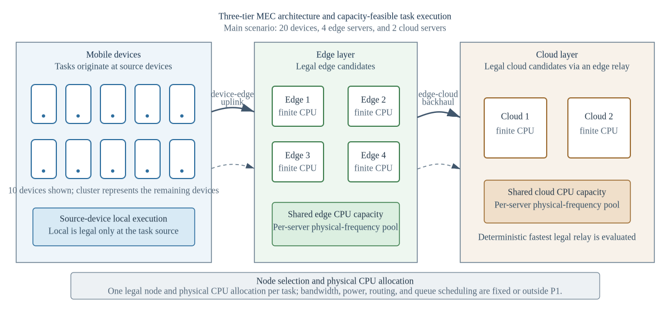
Fig. 1. Three-tier cloud-edge-device architecture with legal execution-node choices and shared aggregate CPU-cycle-capacity pools.
Task i is generated by source device d(i). Local execution is legal only at d(i); reachable edge nodes have positive device-edge rates; a cloud node is legal only through at least one reachable edge with a positive backhaul rate. For a selected cloud, evaluation uses the legal relay with minimum task-specific input-transmission delay. This is deterministic path evaluation, not route or bandwidth optimisation.
$$τ_{i}=(b_{i},c_{i},Δ_{i},T_{i}^{max},E_{i}^{bud},A_{i}^{max},β_{i},π_{i},d(i))$$
Binary x_ij selects exactly one node j. The derived layer is local, edge or cloud, and f_i is the allocated CPU-cycle rate of task i (cycles/s), not an independently additive processor clock. F_j is the aggregate CPU-cycle capacity of node j. For local DVFS f_i is an effective execution frequency; at edge/cloud it is a computation service rate allocated to the task.
Each search individual stores two normalised coordinates per task. The node coordinate indexes the sorted legal-node set, while internal resource coordinate r_i decodes to a tentative allocated CPU-cycle rate. Both coordinates are clipped to [0,1]; r_i is an algorithmic coordinate, not a physical resource unit.

3.2 Delay, Energy, and AoI Models
For node j with minimum allocatable CPU-cycle rate f_j^min and aggregate capacity F_j, the tentative request is f_i^req=f_j^min+r_i(F_j-f_j^min).
$f_{i}^{req}=f_{j}^{min}+r_{i}\left(F_{j}−f_{j}^{min}\right), 0≤r_{i}≤1, x_{ij}=1$ (1)
Algorithm 2 defines complete deterministic repair. At each pass it computes minimum-rate use, visits overloaded nodes in ascending global ID, then visits their assigned task indices in descending order. For each task it considers only legal alternatives other than its current node that can accept that task at the alternative node minimum rate.
$T_{j}=\{i∈T:x_{ij}=1\}, n_{j}=card(T_{j}), R_{j}=F_{j}−n_{j}f_{j}^{min}$ (2)
Among feasible alternatives, Algorithm 2 selects the node with largest post-move residual minimum-rate slack, breaking ties by the smallest global node ID. It recomputes use after the move in the next pass. At most N times the number of nodes passes are allowed. If this deterministic order cannot construct a feasible minimum-rate reassignment for the decoded candidate, evaluation raises ValueError; this does not prove that the entire scenario has no feasible assignment under another move sequence. The exception propagates and aborts the affected optimiser run: the implementation does not assign +infinity, retain the parent, or resample. The controlled evaluator records the repair failure before re-raising; all reported controlled runs have repair_failure_count=0. Targets are already minimum-rate feasible, preventing an overload cycle within a completed repair.
qi=max{fireq−fjmin,0}, i∈Tj,fi=fjmin+qi,k∈Tj​qk≤Rj,Rjqi/k∈Tj​qk,k∈Tj​qk>Rj. (3)
Algorithm 2. Deterministic legal-node reassignment and excess-capacity projection shared by all solvers.
Algorithm 2. Deterministic Legal-Node Reassignment and Capacity Projection
Require: decoded legal node IDs and requested allocated CPU-cycle rates; node minima and aggregate capacities.
1. For at most N times number-of-nodes passes, compute minimum-rate use of each node.
2. Visit overloaded nodes in ascending global ID; visit their currently assigned task indices in descending order.
3. For a task, consider legal nodes other than its current node; retain only targets that remain within capacity after receiving that task at the target minimum rate.
4. Move the task to the feasible target with largest post-move residual slack; break ties by smallest global node ID. Recompute use on the next pass.
5. If the deterministic order cannot construct a feasible minimum-rate reassignment for this decoded candidate, raise ValueError and abort the affected optimiser run; do not infer global scenario infeasibility, assign +infinity, retain the parent or resample.
6. When minima fit, set every task to its node minimum. Retain requested excess if total excess fits residual capacity; otherwise proportionally scale only the excess.
Ensure: legal unique assignments, allocated rates within selected-node bounds and aggregate capacity; repair targets are pre-feasible, so no overload cycle is introduced.
Once every minimum allocation fits, each node retains decoded requests if their total excess over task minima fits its residual capacity; otherwise only that excess is proportionally projected. Thus every allocated CPU-cycle rate remains no lower than the selected node minimum, and no non-overloaded request is silently saturated.
$T_{i}=\left\{\begin{matrix}c_{i}/f_{i}, & z_{i}=local, \\ b_{i}/R_{d(i),s_{i}}+c_{i}/f_{i}+δ_{E}, & z_{i}=edge, \\ b_{i}/R_{d(i),e_{i}^{⋆}}+b_{i}/R_{e_{i}^{⋆},s_{i}}+c_{i}/f_{i}+δ_{C}, & z_{i}=cloud,\end{matrix}\right.$ (4)
No heuristic congestion attenuation or M/M/1 queue is added, because finite CPU capacity and repaired allocated CPU-cycle rates represent processor scarcity. Fixed edge/cloud overheads are synthetic simulation parameters.
For local execution, device-side dynamic-voltage-and-frequency-scaling energy is
$E_{i}=κ_{d(i)}c_{i}f_{i}^{2}, z_{i}=local$ (5)
For edge or cloud offloading, the selected edge or legal cloud relay is fixed by the decoded path. The reported device-side energy includes uplink transmission only; infrastructure computation and backhaul energy are outside the boundary and this metric is never labelled total system energy.
$E_{i}=P_{d(i)}\frac{b_{i}}{R_{d(i),e_{i}^{⋆}}}, z_{i}∈\{edge,cloud\}$ (6)
The task-result size is assumed negligible relative to the input size; result-return delay and downlink energy are omitted. Device-edge rates are independently sampled U(8,30) Mbit/s then independently removed with probability 0.10; edge-cloud rates are independently sampled U(60,150) Mbit/s then independently removed with probability 0.05. If a device has no positive edge link, one uniformly selected edge is resampled from U(8,30); if a cloud has no incoming positive backhaul link, one uniformly selected edge is resampled from U(60,150). Repair changes only the absent link and does not alter existing sampled rates.
We assume periodic update generation and no explicit queue backlog. The area of a delay-shifted sawtooth over one period gives the average approximation
$A_{i}=\frac{Δ_{i}}{2}+T_{i}$ (7)
AoI is consequently delay-coupled, not independent. The model is not a queue-aware or peak-AoI formulation.
Table 1 lists one core variable per row. Secondary symbols are defined at first use in the surrounding text to avoid an oversized notation table.
The generated ranges ensure a feasible minimum-frequency assignment; all returned solutions are checked for unique assignment, legal nodes, finite frequencies, bounds and aggregate capacity.
Table 1. Main Notation
Symbol | Definition
$T$ | Task set
$N$ | Unified device, edge and cloud execution-node set
$N_{i}$ | Legal execution-node set of task i
$d(i)$ | Source device of task i
$x_{ij}$ | Binary assignment of task i to node j
$r_{i}$ | Internal normalised CPU coordinate
$f_{i}^{req}$ | Tentative allocated CPU-cycle-rate request of task i (cycles/s)
$f_{i}$ | Repaired allocated CPU-cycle rate of task i (cycles/s)
$f_{j}^{min}$ | Minimum allocatable CPU-cycle rate of node j (cycles/s)
$F_{j}$ | Aggregate CPU-cycle capacity of node j (cycles/s)
$T_{j}$ | Tasks assigned to node j after reassignment
$n_{j}$ | Number of tasks assigned to node j
$R_{j}$ | CPU-cycle capacity remaining after minimum allocations
$N_{T}$ | Number of tasks in the decision epoch
$N_{act}$ | Number of active source devices
$U_{m}$ | Mean base utility of active source device m
$Q$ | Priority-weighted aggregate QoE
$J$ | Jain fairness over active-user mean utilities
$B(X)$ | Fixed weighted base objective
$CSR(X)$ | Soft threshold constraint-satisfaction ratio
$F_{report}(X)$ | Fixed problem objective and cross-algorithm scale
$F_{search}(X,t)$ | Iteration-specific internal search fitness
$λ(t)$ | Dynamic search penalty coefficient
$NFE$ | Number of function evaluations

3.3 QoE and Fairness Metrics
The study uses a model-based base utility $u_{i}$ rather than a human-subject mean-opinion score. Delay, energy and freshness satisfaction are bounded exponential functions.
Delay satisfaction is
$S_{i}^{T}=exp\left(−\frac{T_{i}}{T_{i}^{max}}\right)$ (8)
Energy satisfaction is
$S_{i}^{E}=exp\left(−\frac{E_{i}}{E_{i}^{bud}}\right)$ (9)
Freshness satisfaction is
$S_{i}^{A}=exp\left(−\frac{A_{i}}{A_{i}^{max}}\right)$ (10)
The priority-neutral base task utility is
$u_{i}=0.45S_{i}^{T}+0.30S_{i}^{E}+0.25S_{i}^{A}, 0<u_{i}≤1$ (11)
Task priority is used only for system QoE aggregation:
Q=i∈T​πiuii∈T​πi (12)
For each active source device $m$, let $U_{m}$ denote the mean base utility over tasks generated by $m$.
This ordering prevents task priority and the number of generated tasks from being counted again inside fairness.
Let $D_{act}$ contain only source devices that generate at least one task in the epoch, and let $N_{act}$ be their count.
J=m∈Dact​Um2Nactm∈Dact​Um2 (13)
$J=1$ indicates equal active-user mean base utility. It is QoE-outcome fairness, not equality of physical CPU allocations.
The parameter ranges are synthetic heterogeneous settings designed to generate capacity-constrained MEC instances; they are not claimed as direct hardware calibration. Their orders of magnitude are consistent with representative MEC system and joint resource-allocation studies [1,3,11,13]. The same versioned ranges are applied to every algorithm and are examined through capacity, SLA and heterogeneity sensitivity analyses.

4 Problem Formulation
P1 combines threshold-normalised device-side energy, delay and AoI with QoE and fairness deficits. These five terms are coupled, because QoE is derived from the first three and AoI contains delay.
The components $E^{norm}$, $D^{norm}$ and $A^{norm}$ are respectively the task means of device-side energy divided by its budget, delay divided by its maximum and AoI divided by its threshold.
The fixed base objective is
$B(X)=0.15E^{norm}+0.15D^{norm}+0.20A^{norm}+0.25(1−Q)+0.25(1−J)$ (14)
Let $N_{T}$ be the number of tasks. Soft delay, battery-adjusted energy and AoI checks are summarised by CSR; they do not replace the hard assignment and CPU constraints.
CSR(X)=13NTi∈T​1(Ti≤Timax)+1(Ei≤max{βi,0.1}Eibud)+1(Ai≤Aimax) (15)
The fixed optimisation problem is therefore defined directly on reporting fitness. The selected-node CPU bound is written as an assignment-weighted bound, so each $f_{i}$ is constrained only by its chosen node.
P1: minXFreport(X)=B(X)+λref[1−CSR(X)]s.t. j∈N​xij=1, xij∈{0,1}, i∈T,xij=0, j∉Ni,j∈N​xijfjmin≤fi≤j∈N​xijFj, i∈T,i∈T​xijfi≤Fj, j∈N, λref=1. (16)
The soft-violation rate is $v=1−CSR$.
The internal normalised coordinates satisfy $0≤r_{i}≤1$ and select only the legal list; they are not additional physical constraints.
The dynamic search fitness used by RDHO is
$F_{search}(X,t)=B(X)+λ(t)\left[1−CSR(X)\right]$ (17)
$λ(t)=λ_{0}{\left(1+\frac{2t}{T_{max}}\right)}^{α}$ (18)
Parents and candidates in one greedy selection are evaluated with the same $λ(t)$. This prevents comparison under incompatible penalty coefficients.
The search process separately tracks the best fixed-objective candidate seen, denoted by $C_{seen}$:
$X_{report}^{⋆}=arg\min_{X∈C_{seen}}F_{report}(X)$ (19)
Search fitness guides optimisation; reporting fitness is the only cross-algorithm scale in tables and statistics.
Thus P1 is one fixed constrained problem, $F_{search}$ is only a penalty-continuation mechanism for solving it, and $F_{report}$ is the sole ranking scale in tables and statistics.

Problem complexity.
Even without continuous allocation, legal node assignments grow combinatorially. Capacity coupling, exponential utility and indicator-based soft violations make P1 a nonlinear mixed discrete-continuous problem.
The study does not claim a new proof of NP-hardness; it motivates a population search and evaluates empirical solution quality and cost.
A returned incumbent consists of one repaired legal node and one allocated CPU-cycle rate per task.
These characteristics motivate population search over legal categorical assignments and bounded allocated CPU-cycle-rate decisions; no deployment claim is made.

5 RDHO-Based Capacity-Feasible Optimisation Framework
RIME-DBO hybrid optimisation (RDHO) is the focal solver in this study. It adapts RIME-inspired perturbation and DBO-inspired role-conditioned movements to the capacity-feasible MEC encoding, decoder and Algorithm-2 repair path. RDHO-full additionally uses configured seeding and local coordinate refinement; the framework is evaluated both as a complete solver and under controls that isolate its population-update stage. The definitions below reproduce the implemented RDHO rather than requiring the reader to infer its operations from source code.
RIME-inspired and DBO-inspired movements are described as algorithmic components, not as mechanisms presumed to be stronger in advance. Their independent contribution is evaluated under common initialisation, common repair, equal total NFE and common refinement in Section 6.3.
All candidates use the same normalised two-coordinate encoding and are decoded through the common physical repair before evaluation.
RDHO is assessed as a configured capacity-feasible search framework. Controlled experiments, rather than the hybrid label alone, determine which population-update claims are supported.

5.1 Solution Encoding, Initialisation, and Capacity Decoding
Individual X has N rows x_i=(u_i,r_i), with u_i and r_i in [0,1]. u_i maps by floor(u_i times the number of sorted legal nodes) to a legal node, and r_i decodes to the tentative allocated CPU-cycle rate above. Every generated coordinate is clipped component-wise to [0,1] before Algorithm 2, metric evaluation and hard-feasibility checks.
With population P=50, the first floor(P/2) members are Gaussian: node coordinates are independent N(0.55,0.25) and resource coordinates independent N(0.60,0.20); the remainder are independent U(0,1). RDHO replaces member 0 with a greedy seed: begin every task at (0.5,0.5), visit task indices in ascending order, test the 16 pairs {0.08,0.35,0.62,0.90} times {0.20,0.50,0.80,1.00}, and retain only a strict fixed-reporting-fitness improvement. Members 1, 2 and 3, when present, are the seed plus independent N(0,0.08) perturbations, then clipped. These are the three perturbations; no additional trigger is used.
A candidate evaluation returns $B(X)$, $CSR(X)$, dynamic search fitness, fixed reporting fitness, raw metrics, hard-feasibility flags and capacity utilisation.

5.2 RDHO Population-Update Mechanism
At iteration t, p=t/T_max and diversity D is the mean over all 2N coordinates of their population standard deviation. Adaptive producer and scout shares are rho_P=clip(0.28-0.10p+0.08D,0.14,0.34) and rho_S=clip(0.08+0.08D+0.04p,0.08,0.20); rho_F=max(0.40,1-rho_P-rho_S). Nominal counts n_P, n_F and n_S are max(1,floor(P rho_role)) and are computed from the full P; they are not renormalised to P-n_E after n_E=max(1,floor(0.10P)) elites are reserved. The ranked loop applies deterministic branch precedence: an elite is copied; otherwise rank<n_P gives producer, else rank<n_P+n_F gives follower, else rank>=P-n_S gives scout, else the member receives N(0,0.04(1-p)) noise. Thus elites truncate nominal roles, and if follower/scout thresholds overlap the earlier follower branch takes precedence; no member is assigned twice. Consequently, rho_P, rho_F and rho_S define nominal role thresholds rather than guaranteed realised population proportions.
For producer current x, search-best x_b and search-worst x_w, draw beta~N(0,1) per coordinate, theta~U(0,2pi) per coordinate, k~U(-1,1) per coordinate and b~U(0,1). Define R=x_b+beta cos(theta)2(1-p)0.28 and D=x+(1-p)k x+b|x-x_w|. The update is x'=wR+(1-w)D with w=0.5+0.3 cos(pi p), decreasing from 0.8 to 0.2.
For a follower, q=min(1,2 exp(-(4p)^2)). With probability q, draw one Bernoulli(0.20) mask per task and replace both coordinates of every masked task by x_b (RIME-inspired puncture). Otherwise draw independent c1,c2~U(0,1) per coordinate and use x'=x_b+c1 x+c2(x-1), then clip to [0,1] (bound-aware DBO-inspired foraging).
For scout rank r, set x_L to the member at ranked index floor(0.35r). If its current search fitness exceeds the current best, draw theta~U(-pi/4,pi/4) per coordinate and use theft x'=x_L+tan(theta)|x-x_L|. Otherwise draw standard Cauchy noise z per coordinate and use x'=x_b+0.035(1-p)z. The Cauchy scale is exactly 0.035(1-p).
All stated random variables are independent unless their shared task mask is stated. The continuous updates define only a neighbourhood: after clipping, u_i is decoded through that task's legal list and Algorithm 2 always precedes evaluation.
Parents and candidates are evaluated under the same iteration search penalty before strict greedy acceptance. Separately, the reporting incumbent is replaced only by a strict improvement in F_report=B+1(1-CSR); dynamic search fitness is not reported as a final cross-algorithm result.
Configured RDHO local refinement uses a seeded random permutation of task indices, up to two sweeps, node grid {0.08,0.28,0.48,0.68,0.88}, resource grid {0.10,0.30,0.55,0.80,1.00}, and strict fixed-reporting improvement; it stops after a sweep with no improvement. Controlled common refinement instead uses ascending task order and exactly one 5-by-5 sweep for every method: 25 evaluations per task, or 1,000 NFE for 40 tasks. Experiment A has 50+3,750+1=3,801 NFE; Experiment B has 50+9,181+1,000+1=10,232 NFE.
For N tasks, M execution nodes, population P, iterations T_max, average legal-node count L and refinement cost R, initialisation is O(PN) plus O(16N) greedy tests, role updates are O(PN), and ordinary decoding/evaluation is approximately O(PNL). A typical repair pass is O(NL); retaining this practical cost gives O(PN+T_max PNL+RNL) time and O(PN+NL) space. In the worst case repair may execute up to NM passes, so one candidate can require O(N^2 M L) repair work and the population-search upper bound includes O(T_max P N^2 M L). This conservative worst case is distinct from the observed zero-failure controlled runs and is not an optimality guarantee.
The complete procedure is summarised in Algorithm 1.
Algorithm 1. Reproducible RDHO-based capacity-feasible joint task-offloading and allocated CPU-cycle-rate strategy.

Algorithm 1. Reproducible RDHO joint offloading and allocated CPU-cycle-rate allocation
Require: | Scenario, legal-node encoding, Algorithm 2 repair, objective weights, P, T_max and a seeded RNG
Ensure: | Hard-feasible fixed-reporting incumbent
1 | Generate Gaussian/uniform subpopulations; insert greedy seed and exactly three N(0,0.08) seed perturbations when positions 1-3 exist
2 | Decode legal nodes, run Algorithm 2, and evaluate B, CSR, current search fitness and fixed reporting fitness
3 | for each configured iteration do
4 | Compute diversity, adaptive role counts and current search ranking; preserve the top 10% elites
5 | Generate the stated producer fusion, follower puncture/foraging, scout theft/Cauchy, or remaining Gaussian candidates; clip to [0,1]
6 | Run the shared decoder and Algorithm 2 for every candidate; an unrepaired candidate raises ValueError and aborts the run (no +infinity, parent retention or resampling)
7 | Strictly compare parent and candidate under the same current search penalty
8 | Strictly update the independent fixed-reporting incumbent
9 | end for
10 | If configured, apply seeded two-sweep RDHO refinement; controls instead use one common ascending 5-by-5 sweep or none
11 | Re-evaluate with lambda_ref=1 and verify unique legal assignment, allocated-rate bounds and aggregate capacity
Return | Node assignments, allocated CPU-cycle rates and all reported metrics
Control | Controlled experiments replace RDHO-specific initialisation/refinement with common procedures before population-update comparison
Algorithm 1 summarises the fully specified update sequence; Algorithm 2 specifies common deterministic legal-node reassignment and excess-capacity projection used by every solver.

6 Performance Evaluation

6.1 Experimental Setup and Reproducibility
The configured V2 end-to-end experiments and additive strictly controlled experiments use the same fixed synthetic scenarios 20260701-20260730, legal-node encoding, allocated-CPU-cycle-rate decoder, deterministic repair, hard-feasibility checks and fixed reporting objective. Controlled artifacts are generated from immutable raw CSV files and audited separately; they do not regenerate or modify results/v2/. The recorded local environment was macOS 26.5.2 on Apple M5 (10 cores, 32 GB memory), Python 3.9.6, NumPy 2.0.2, pandas 2.3.3 and SciPy 1.13.1. Experiment loops use no Python multiprocessing and no explicit thread pinning; all compared methods use the same serial runner configuration. Runtime is a local implementation-cost observation, not a cross-platform benchmark.
The configured end-to-end suite compares RDHO-full, RIME, DBO, TLBO-HHO [21], CWTSSA [36] and Greedy-ED under the same model, utility, repair and fixed reporting objective. RIME, DBO, TLBO-HHO and CWTSSA constants are listed in Table 4 from executable versioned defaults; they remain fixed over every reported scenario, and no algorithm-specific tuning was performed on the reporting scenarios.
The configured end-to-end comparison intentionally retains each solver's configured procedure; NFE is therefore unequal (RDHO-full 10,232, population baselines 7,551 and Greedy-ED 681). It is reported as a complete-solver comparison and cannot isolate the contribution of RDHO's population-update mechanism.
Table 2. Physical system parameters used in the main experiment.
Parameter | Value and interpretation
Devices / edge / cloud | 20 / 4 / 2
Tasks | 40 heterogeneous tasks
Node CPU capacity | Aggregate CPU-cycle capacity: device 2.2-3.0; edge 18-28; cloud 55-75 Gcycles/s
Minimum allocatable CPU | Minimum allocated CPU-cycle rate: device 0.2; edge 0.8; cloud 1.5 Gcycles/s
Transmit power | 0.2-0.8 W
Device-edge rate | 8-30 Mbit/s; 10% sparse links, connectivity repaired
Edge-cloud rate | 60-150 Mbit/s; 5% sparse links, connectivity repaired
Energy coefficient | (0.8-1.4) × 10⁻²⁷ J s² cycle⁻³
Fixed overhead | Edge 0.010 s; cloud 0.055 s
Cloud relay | Fastest legal fixed relay for each selected cloud
Excluded controls | Bandwidth, power, association, routing and queue scheduling

Table 3. Task-generation ranges and sampling probabilities.
Parameter | Compute-intensive | Data-intensive | Real-time | Lightweight
Sampling probability | 0.28 | 0.24 | 0.28 | 0.20
Input data (MB) | 8-35 | 30-90 | 2-15 | 0.5-5
CPU cycles (Gcycles) | 1.8-4.5 | 0.8-2.2 | 0.5-1.8 | 0.1-0.8
Maximum delay (s) | 1.5-3.0 | 2.5-5.0 | 0.35-1.0 | 0.8-2.0
AoI threshold (s) | 2.0-3.0 | 3.0-5.0 | 0.5-1.0 | 1.0-2.0
Energy budget (J) | 2.5-6.0 | 2.0-5.0 | 1.0-3.5 | 0.5-2.0
Battery ratio | 0.45-1.0 | 0.40-0.95 | 0.55-1.0 | 0.50-1.0
Priority / interval (s) | 0.60-0.90 / 0.50-1.00 | 0.50-0.80 / 0.80-1.50 | 0.80-1.00 / 0.10-0.30 | 0.40-0.70 / 0.30-0.60

Table 4. Reproducibility, RDHO, and baseline parameter settings (fixed across reported scenarios).
Parameter | Value
Configured end-to-end population / iterations | 50 / 150
Objective weights (energy, delay, AoI, QoE, fairness) | 0.15, 0.15, 0.20, 0.25, 0.25
Reporting coefficient | Fixed lambda_ref=1; fixed-return post-hoc checks at 0.5, 1, 2 only
Paired scenarios | 30 (seeds 20260701-20260730)
Experiment A control | Common initial population, decoder and repair; no refinement; 3,801 total NFE
Experiment B control | Common initial population, decoder, repair and deterministic refinement; 10,232 total NFE
Controlled statistics | Two-sided paired Wilcoxon, experiment-local Holm correction, rank-biserial effect size, W/T/L
Compared population methods | RDHO, RIME and DBO
RDHO Gaussian source | Node N(0.55,0.25); resource N(0.60,0.20); other half U(0,1)
RDHO greedy seed / perturbations | 16 grid pairs in ascending task order; seed plus N(0,0.08) at positions 1-3
RDHO role / elite constants | producer clip(0.28-0.10p+0.08D,0.14,0.34); scout clip(0.08+0.08D+0.04p,0.08,0.20); elite 10%
RDHO producer / follower | w=0.5+0.3cos(pi p); RIME scale 0.28; puncture q=min(1,2exp(-(4p)^2)), mask 0.20
RDHO scout / remaining | theft angle U(-pi/4,pi/4); Cauchy scale 0.035(1-p); remaining N(0,0.04(1-p))
RIME baseline | normal initialisation; h=2(1-p); exploration scale 0.30; puncture noise 0.035; repository default
DBO baseline | rolling/breeding/foraging/theft 0.20/0.20/0.40/0.20; rolling decay 1-p; repository default
TLBO-HHO baseline | teaching threshold 0.55; learner-HHO threshold 0.80; teaching factors {1,2}; HHO energy 2(1-p); repository default
CWTSSA baseline | producer/scout 0.20/0.10; inertia 0.9-0.5p; t df=3, scale=0.12; Cauchy p=0.20, scale=0.025; repository default
Parameter provenance | Synthetic heterogeneous settings from versioned generator/configuration; not hardware calibrated; no scenario-specific tuning
No algorithm-specific tuning was performed on the reported scenarios. Configurations and exact baseline implementations are versioned with the raw results.

6.2 Configured End-to-End Solver Comparison
Figure 2 reports fixed-reference incumbents during population search. RDHO's final coordinate refinement is not included in its curve, and Greedy-ED is a fixed reference.
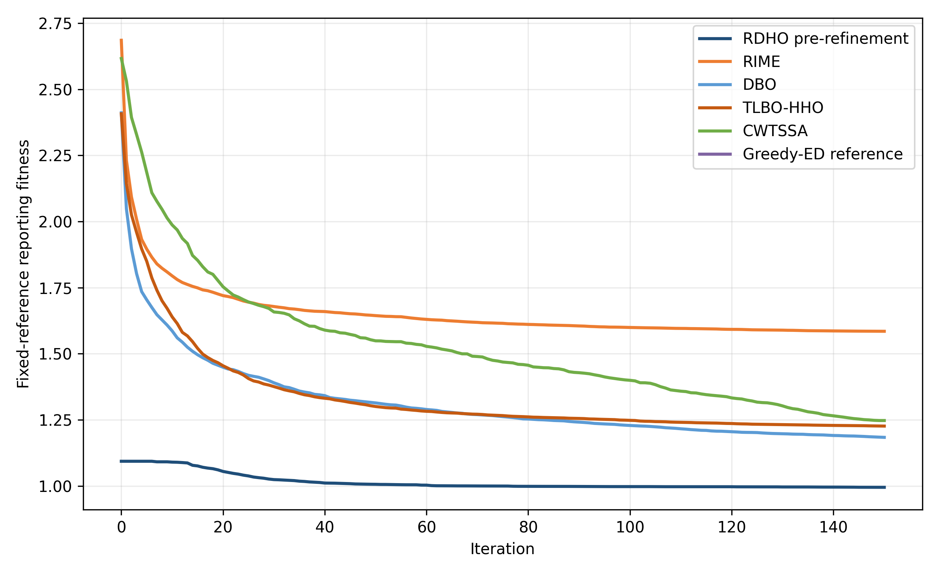
Fig. 2. Fixed-reference reporting-fitness convergence over 150 iterations.
Table 5. Configured end-to-end solver comparison over 30 paired scenarios (mean +/- standard deviation; unequal NFE).
Alg. | Reporting fitness | Device energy (J) | Delay (s) | AoI (s) | QoE | Fairness | Soft CSR | Time (s) | NFE
RDHO-full | 0.947 (0.120) | 94.58 (24.04) | 1.848 (0.218) | 2.171 (0.226) | 0.447 (0.032) | 0.924 (0.020) | 0.721 (0.055) | 7.831 (0.660) | 10232
RIME | 1.585 (0.154) | 126.37 (30.12) | 4.131 (0.795) | 4.454 (0.813) | 0.355 (0.027) | 0.838 (0.040) | 0.513 (0.053) | 5.966 (0.499) | 7551
DBO | 1.184 (0.190) | 93.19 (31.46) | 2.536 (0.479) | 2.859 (0.487) | 0.415 (0.035) | 0.916 (0.026) | 0.629 (0.070) | 5.820 (0.501) | 7551
TLBO-HHO | 1.226 (0.201) | 60.63 (14.07) | 2.766 (0.589) | 3.089 (0.593) | 0.407 (0.040) | 0.910 (0.029) | 0.599 (0.072) | 5.711 (0.495) | 7551
CWTSSA | 1.247 (0.151) | 62.62 (17.65) | 2.775 (0.488) | 3.098 (0.496) | 0.408 (0.031) | 0.914 (0.024) | 0.588 (0.057) | 5.678 (0.486) | 7551
Greedy-ED | 1.093 (0.170) | 99.75 (22.47) | 2.225 (0.538) | 2.548 (0.550) | 0.428 (0.034) | 0.916 (0.032) | 0.648 (0.062) | 0.507 (0.044) | 681
RDHO-full has the lowest configured mean reporting fitness (0.947 +/- 0.120) and every returned solution is hard feasible. Because RDHO-full uses 10,232 NFE while the population baselines use 7,551, this result supports the configured end-to-end solver rather than isolated superiority of its hybrid population update.
Metric-specific leaders differ: TLBO-HHO has the lowest device-side energy, RDHO-full has the lowest delay and AoI and the highest QoE, active-user fairness and CSR, while Greedy-ED is fastest. RDHO-full also consumes more NFE.
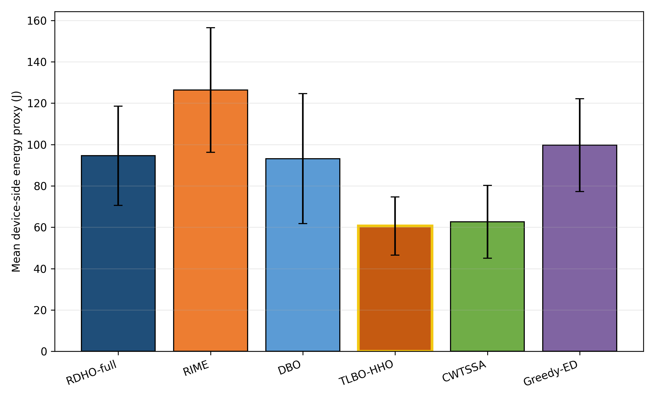
Fig. 3. Mean device-side energy over 30 paired runs.
TLBO-HHO is the energy leader; RDHO optimises energy as one component of the coupled reporting preference.
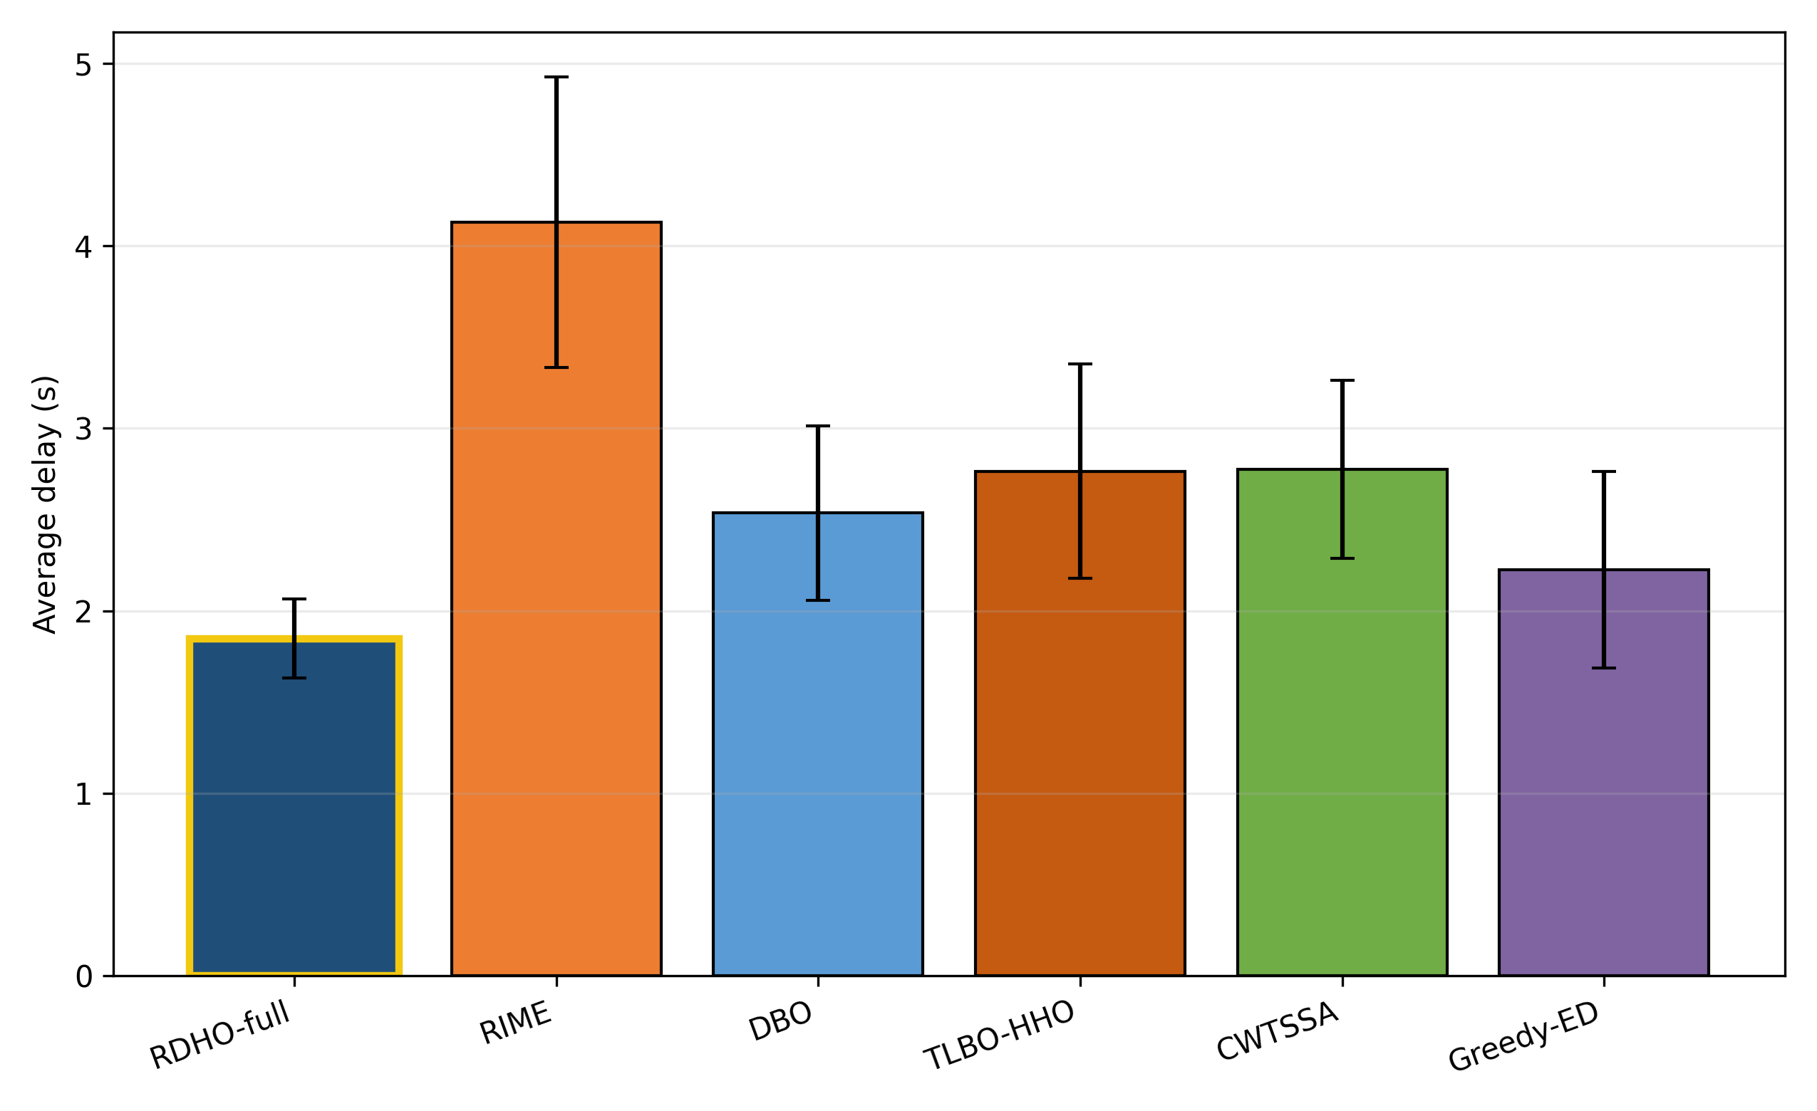
Fig. 4. Mean processing delay over 30 paired runs.
RDHO-full has the lowest mean delay under the configured end-to-end procedures.
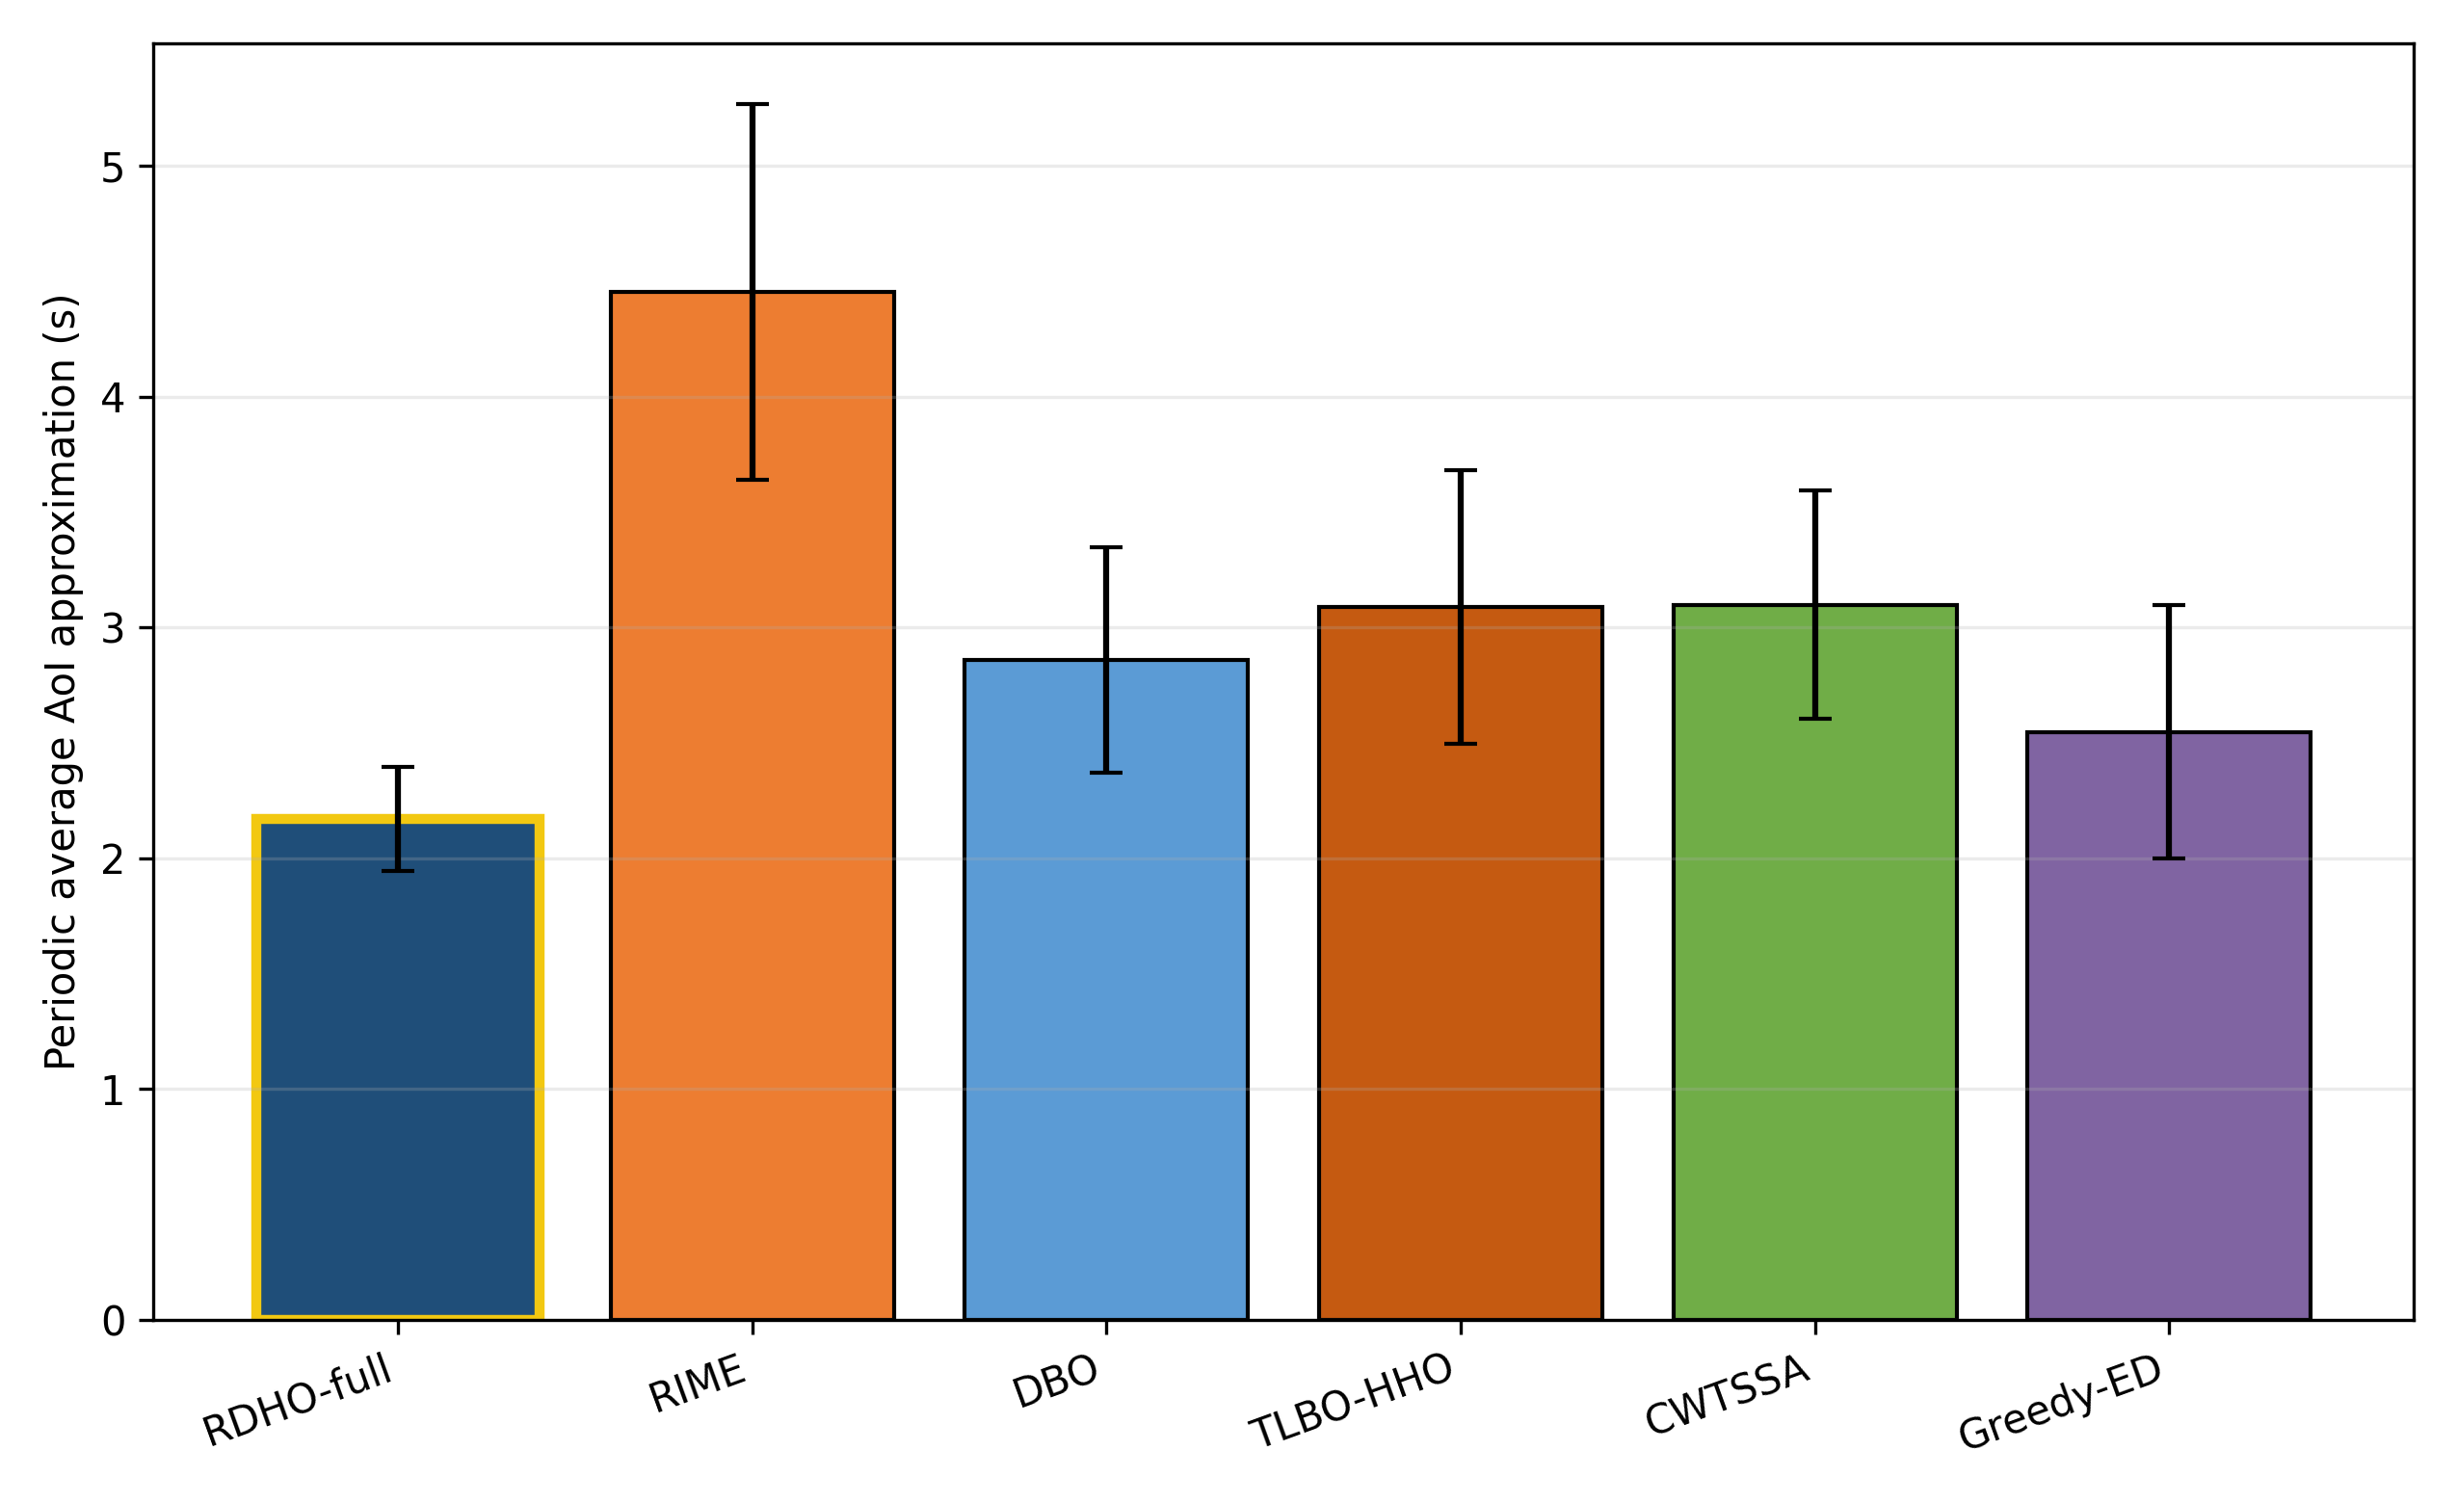
Fig. 5. Periodic no-backlog average-AoI approximation over 30 paired runs.
RDHO-full has the lowest mean AoI approximation; the close ordering with delay follows Eq. (7).
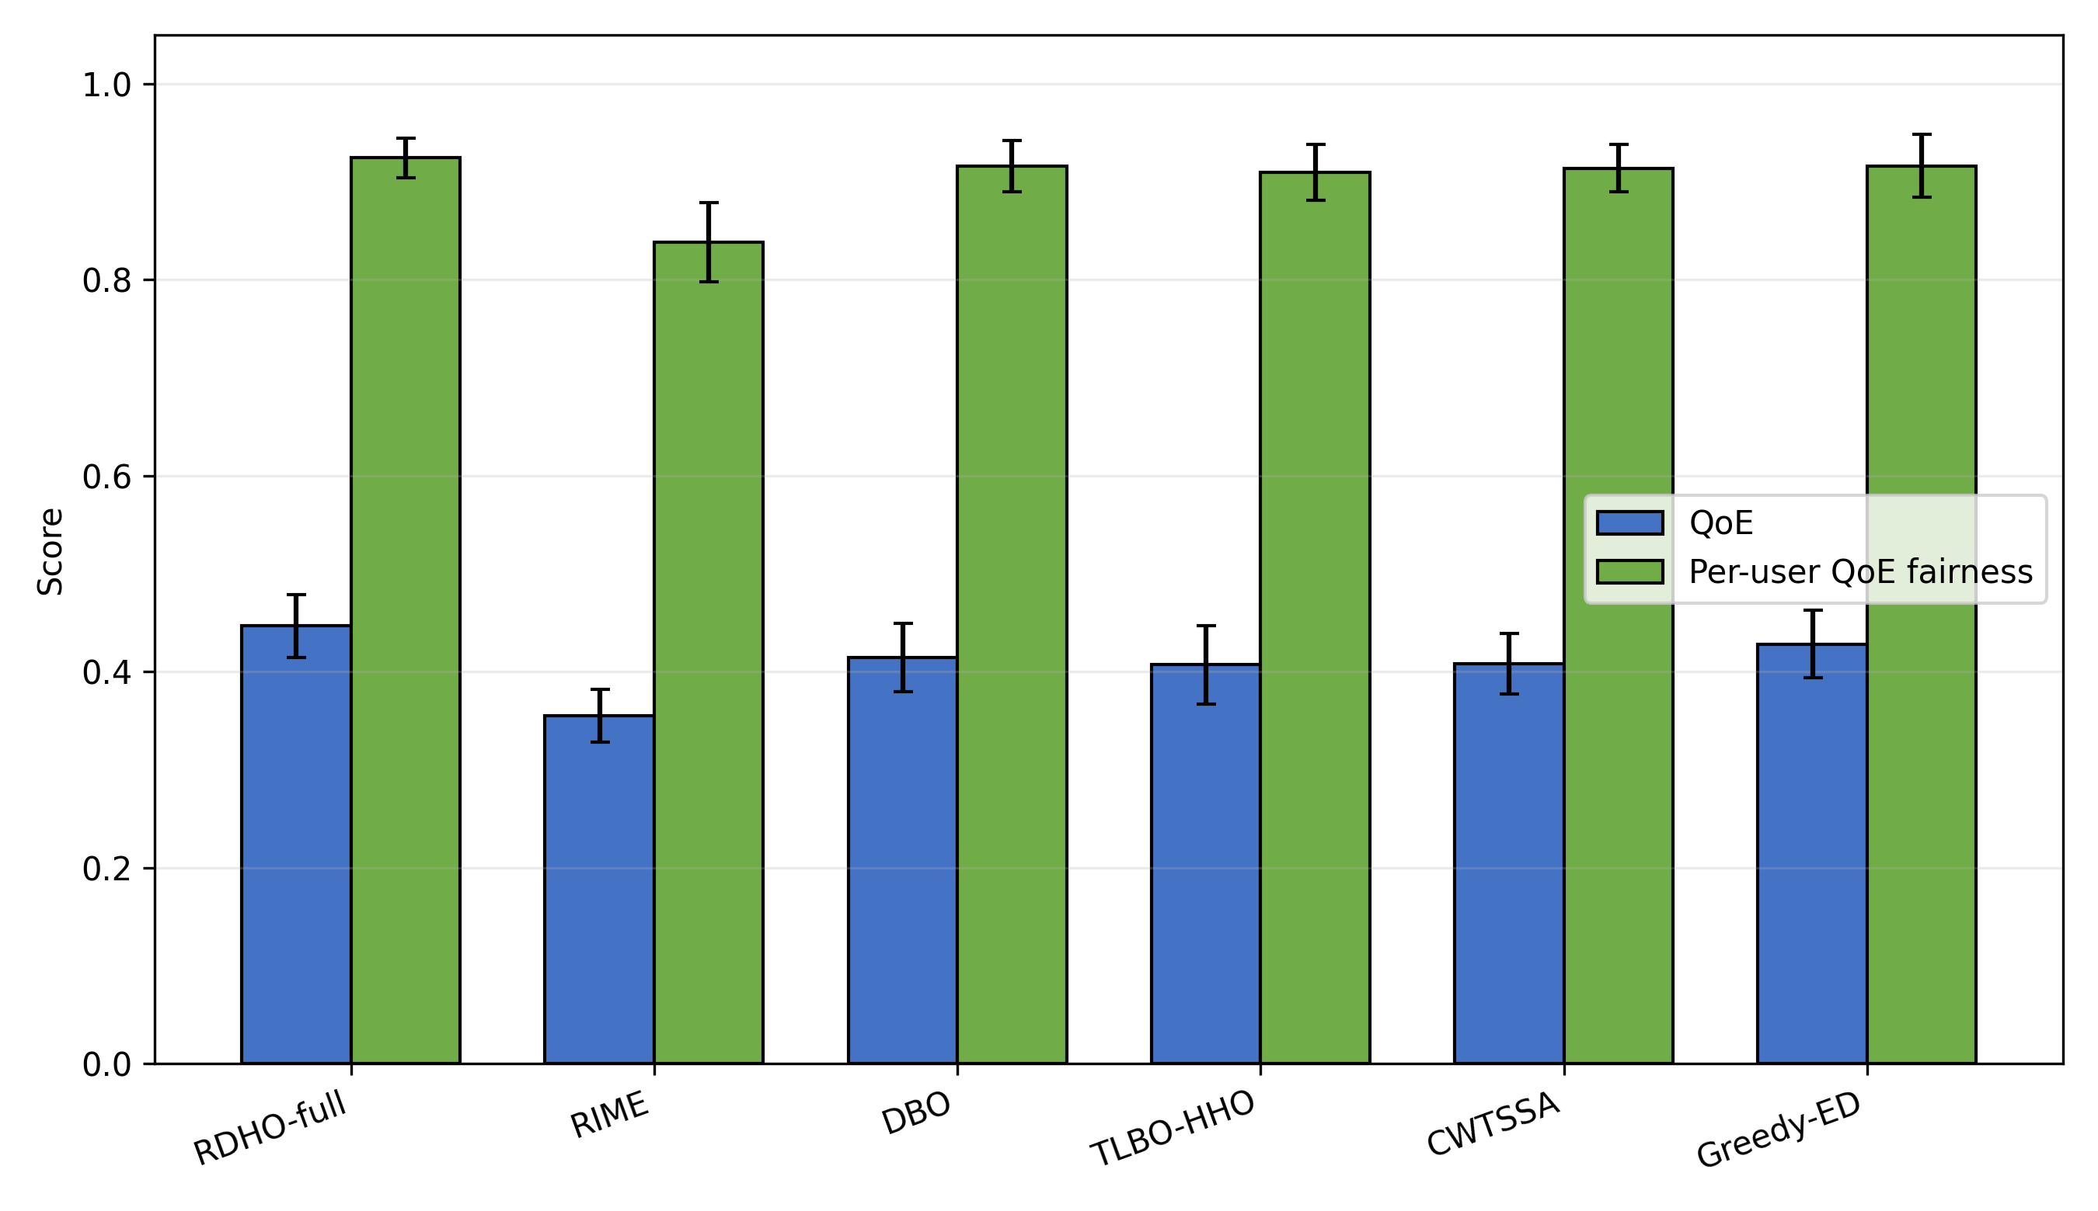
Fig. 6. Priority-weighted aggregate QoE and active-user base-utility fairness.
RDHO-full has the highest mean QoE, whereas fairness differences are small and do not imply equality of CPU allocations.
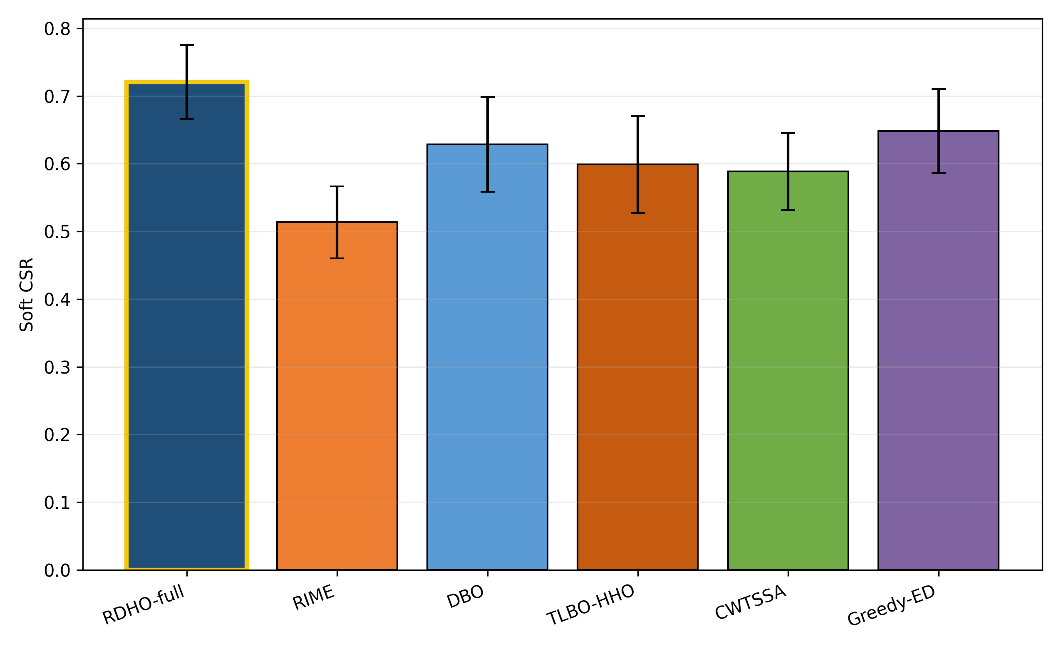
Fig. 7. Soft constraint-satisfaction ratio (CSR).
RDHO-full reaches mean CSR 0.721. CSR remains a binary threshold diagnostic; it does not imply that every task satisfies every soft threshold.
Configured-comparison statistics.
Two-sided paired Wilcoxon tests use the 30 matched reporting-fitness values. Holm adjustment controls the family-wise error rate; median paired difference, signed rank-biserial correlation and wins/ties/losses report magnitude and consistency. In this subsection, they test complete configured procedures with unequal NFE.
Table 6. Paired Wilcoxon tests for configured end-to-end solvers (unequal NFE).
Comparison | $W$ | Two-sided $p$ | Holm $p$ | Median diff. | Signed $r_{rb}$ | W/T/L
RDHO-full vs RIME | 0 | 1.86e-09 | 9.31e-09 | -0.6454 | -1.000 | 30/0/0
RDHO-full vs DBO | 0 | 1.86e-09 | 9.31e-09 | -0.2030 | -1.000 | 30/0/0
RDHO-full vs TLBO-HHO | 0 | 1.86e-09 | 9.31e-09 | -0.2581 | -1.000 | 30/0/0
RDHO-full vs CWTSSA | 0 | 1.86e-09 | 9.31e-09 | -0.2979 | -1.000 | 30/0/0
RDHO-full vs Greedy-ED | 0 | 1.86e-09 | 9.31e-09 | -0.1029 | -1.000 | 30/0/0
RDHO-full is lower in all 30 pairs against each configured main baseline. These tests concern complete procedures with their configured initialisation, population search, incumbent tracking and refinement; they do not prove an isolated hybrid-operator advantage.

6.3 Strictly Controlled RDHO Population Evidence
Two strictly controlled paired experiments answer the attribution question directly. Every method receives one identical 50-by-40-by-2 initial population per scenario, follows the common legal-node decoder and Algorithm-2 repair, reports the same fixed reporting fitness and is constrained by an exact total NFE budget. All 90 returns in each experiment are hard feasible. Table 7 reports reporting fitness, base objective B, soft CSR, QoE, fairness, NFE and runtime. The primary endpoint is lower fixed reporting fitness; paired differences DeltaF=F_RDHO-F_parent are negative when RDHO is lower. Experiment A (no refinement, 3,801 NFE) gives DBO a clear advantage: RDHO versus DBO median DeltaF=+0.178910, Holm p=3.725e-09 and W/T/L=0/0/30. At the prespecified lambda_ref=1, Experiment B (common refinement, 10,232 NFE) gives DBO a smaller but statistically significant advantage: means 0.9732 versus 0.9664, difference 0.006801; median DeltaF=+0.008226, Holm p=0.026229 and W/T/L=10/0/20. RDHO remains lower than RIME in both controls.
Table 7. Strictly controlled fixed-return evidence over 30 paired scenarios: reporting fitness and components, QoE, fairness, NFE and runtime.
Experiment | Method | F_report / B / CSR (mean) | QoE | Fairness | NFE | Runtime (s)
A: population stage | RDHO | 1.4188 / 0.9727 / 0.5539 | 0.3937 | 0.8963 | 3801 | 3.149
A: population stage | RIME | 1.6834 / 1.1701 / 0.4867 | 0.3456 | 0.8476 | 3801 | 3.154
A: population stage | DBO | 1.2409 / 0.8504 / 0.6094 | 0.4096 | 0.9120 | 3801 | 3.053
B: common pipeline | RDHO | 0.9732 / 0.6779 / 0.7047 | 0.4460 | 0.9273 | 10232 | 9.054
B: common pipeline | RIME | 0.9836 / 0.6758 / 0.6922 | 0.4454 | 0.9267 | 10232 | 9.169
B: common pipeline | DBO | 0.9664 / 0.6745 / 0.7081 | 0.4460 | 0.9261 | 10232 | 8.930
Paired tests | RDHO comparison | Median DeltaF [95% CI] | Holm p | r_rb | W/T/L
A | RDHO vs RIME | -0.278300 [-0.312822, -0.198123] | 1.304e-08 | -0.983 | 29/0/1
A | RDHO vs DBO | +0.178910 [+0.112584, +0.225303] | 3.725e-09 | +1.000 | 0/0/30
B | RDHO vs RIME | -0.012281 [-0.024215, -0.001839] | 0.019863 | -0.531 | 23/0/7
B | RDHO vs DBO | +0.008226 [+0.000775, +0.014349] | 0.026229 | +0.462 | 10/0/20
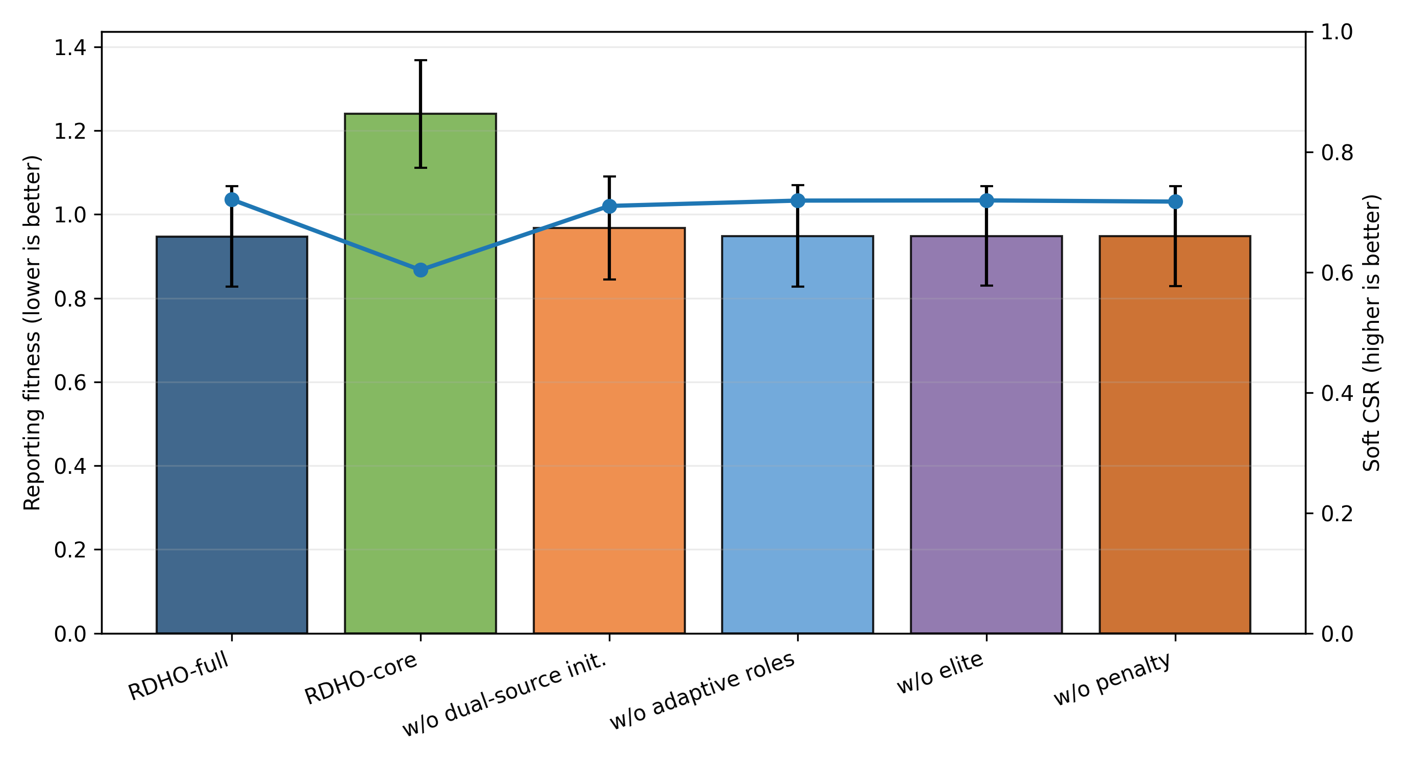
Fig. 8. Reporting fitness and soft CSR for configured RDHO variants.
The configured ablation remains descriptive for the end-to-end RDHO workflow. Coordinate refinement changes configured mean fitness from 1.240 to 0.947, so it is one component of the complete-pipeline result; population-update attribution is reported in Table 7 above, not inferred from this configured ablation.
6.4 Component, Refinement, Scalability, and Sensitivity Analyses
Configured component/refinement analysis begins here. It is descriptive for the complete RDHO workflow, whereas Table 7 provides the formal common-initialisation, common-decoder, common-repair, exact-NFE and common-refinement attribution evidence. The full legacy configured-comparison rows previously presented as Table 9 are moved to the repository supplement to prevent confusion with the strict controls.
Table 8. RDHO scalability under 20-100 tasks.
Tasks | Reporting fitness | Soft CSR | Time (s) | NFE
20 | 0.897 (0.124) | 0.745 (0.059) | 3.430 (0.056) | 8892
40 | 0.977 (0.116) | 0.708 (0.055) | 6.641 (0.119) | 10232
60 | 0.998 (0.106) | 0.698 (0.050) | 10.370 (0.128) | 11572
80 | 1.059 (0.100) | 0.665 (0.041) | 14.833 (0.226) | 12912
100 | 1.135 (0.070) | 0.633 (0.030) | 19.772 (0.220) | 14252
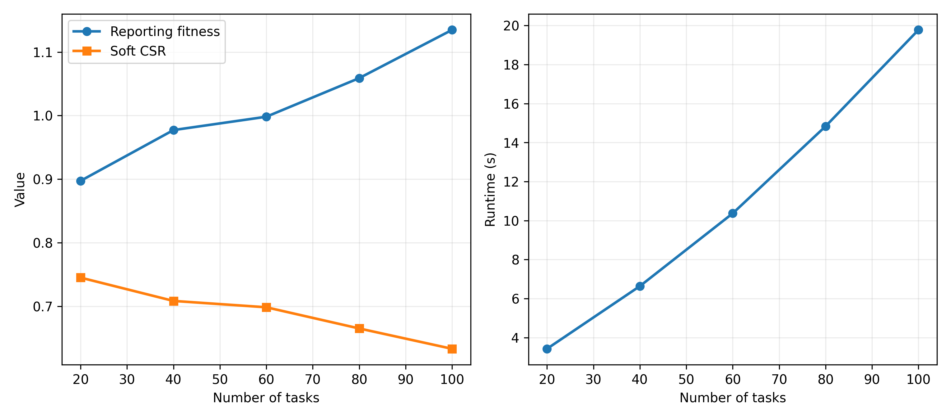
Fig. 9. Reporting fitness, soft CSR and runtime versus task count.
Scalability and configured sensitivity describe the RDHO framework outside the strict attribution controls. They do not override Table 7. Dynamic-search-penalty sensitivity changes only search guidance; fixed reporting fitness remains B+1(1-CSR).
Component and refinement interpretation.
The controlled results indicate that the implemented RDHO population mechanism improves substantially over RIME but not DBO in the fixed V2 scenarios. The contribution is therefore interpreted at the integrated-framework level, not as universal population-update superiority. Common refinement reduces the absolute DBO gap but does not reverse it at lambda_ref=1.
The final sensitivity ranges are generated directly from V2 CSV files; no value is manually entered into a paper table.
Weight changes expose engineering preference rather than a universal optimum. Task-utility coefficient sensitivity checks the internal QoE construction, while CPU-capacity, SLA and server-heterogeneity scaling test load, threshold strictness and heterogeneous legal server choices.
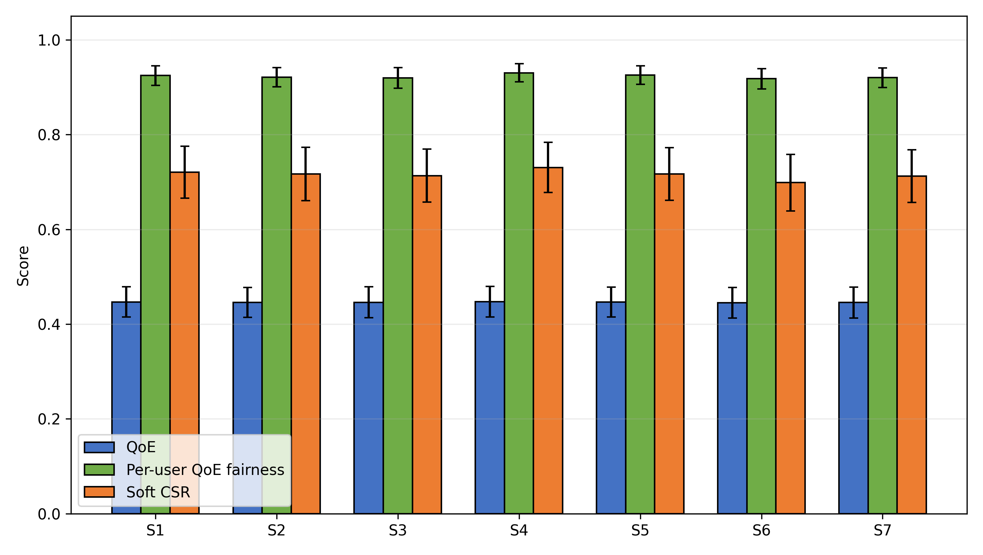
Fig. 10. Objective-weight sensitivity of QoE, active-user fairness and soft CSR.
The penalty heatmaps compare returned solutions under the common fixed reporting coefficient lambda_ref=1; they do not alter the reporting definition.
Table 10. Dynamic-penalty sensitivity under fixed reporting fitness.
Initial penalty | Growth exponent | Reporting fitness | QoE | Fairness | Soft CSR | Time (s)
0.5 | 1.0 | 0.947 (0.119) | 0.447 (0.032) | 0.924 (0.020) | 0.719 (0.057) | 6.661 (0.113)
0.5 | 2.0 | 0.948 (0.118) | 0.447 (0.032) | 0.924 (0.020) | 0.719 (0.055) | 6.606 (0.106)
0.5 | 3.0 | 0.948 (0.119) | 0.447 (0.033) | 0.925 (0.020) | 0.720 (0.055) | 6.519 (0.109)
1.0 | 1.0 | 0.949 (0.119) | 0.447 (0.033) | 0.924 (0.020) | 0.719 (0.054) | 6.521 (0.084)
1.0 | 2.0 | 0.947 (0.120) | 0.447 (0.032) | 0.924 (0.020) | 0.721 (0.055) | 6.514 (0.113)
1.0 | 3.0 | 0.948 (0.121) | 0.446 (0.033) | 0.924 (0.020) | 0.721 (0.054) | 6.536 (0.113)
2.0 | 1.0 | 0.948 (0.120) | 0.447 (0.032) | 0.925 (0.020) | 0.721 (0.055) | 6.532 (0.106)
2.0 | 2.0 | 0.948 (0.119) | 0.447 (0.032) | 0.925 (0.020) | 0.721 (0.053) | 6.534 (0.118)
2.0 | 3.0 | 0.950 (0.121) | 0.446 (0.033) | 0.925 (0.020) | 0.722 (0.054) | 6.520 (0.109)

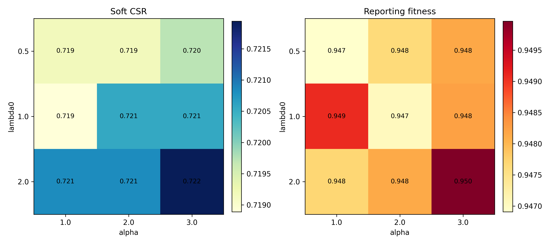
Fig. 11. Dynamic-penalty sensitivity heatmaps for soft CSR and reporting fitness.
The nine penalty schedules are reported without post-hoc selection. Full objective-weight, task-utility, CPU-capacity, SLA and server-heterogeneity tables remain in the repository supplement and extend the sensitivity boundary without post-hoc tuning claims.
Scalability and sensitivity.
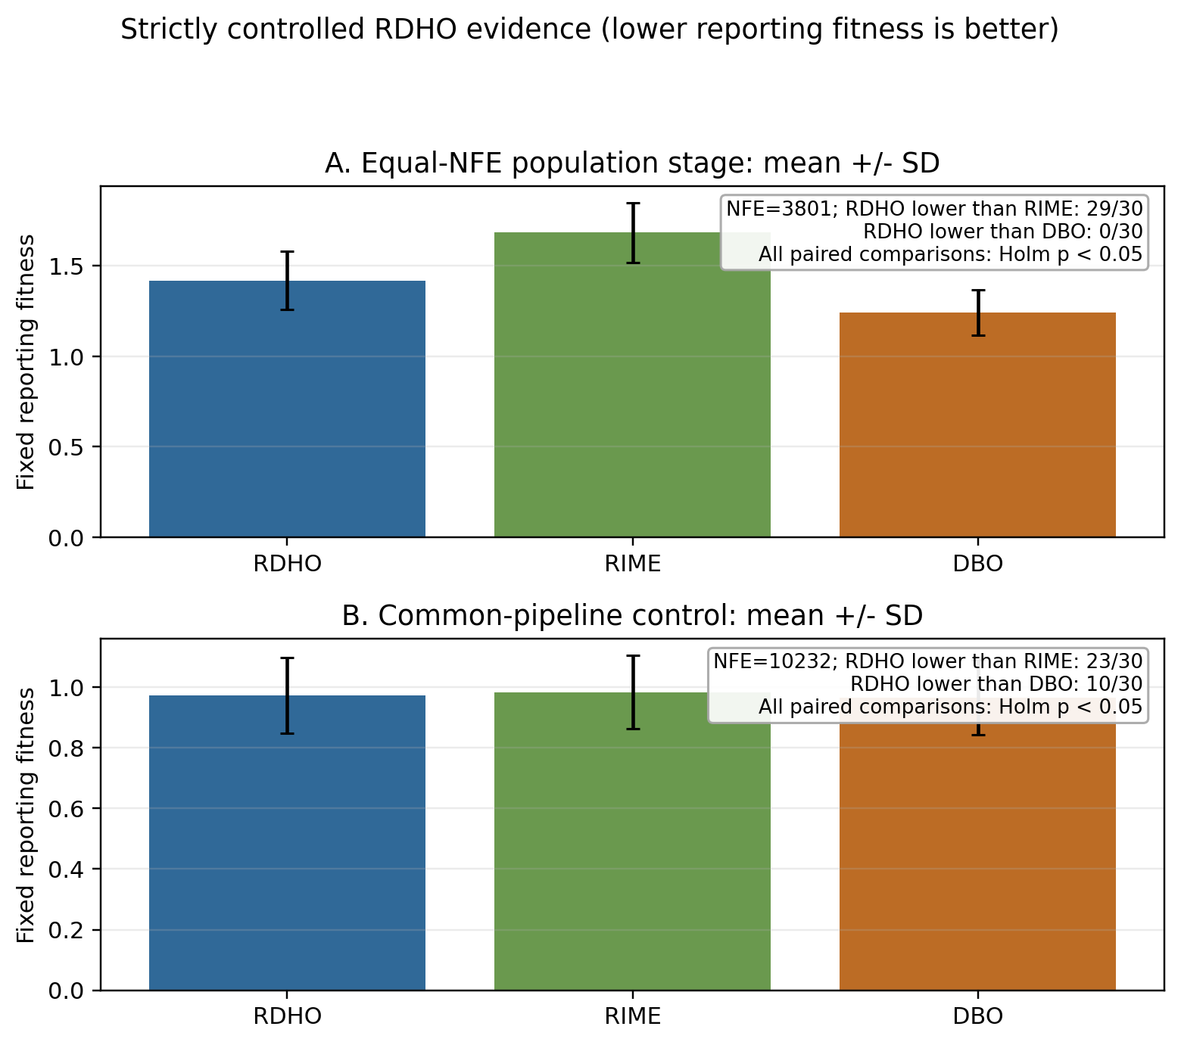
Fixed-return reporting-penalty robustness and overall interpretation.
Fig. 12. Strictly controlled paired reporting-fitness evidence. Panels A and B use 3,801 and 10,232 total NFE, respectively; negative RDHO-minus-parent differences favour RDHO.
Figure 12 visualises both controls rather than hiding the adverse comparison: RDHO is lower than RIME in 29/30 population-stage pairs and 23/30 common-pipeline pairs, but lower than DBO in 0/30 and 10/30 pairs. For fixed returned solutions, post-hoc rescoring F_lambda=B+lambda_ref(1-CSR) at lambda_ref in 0.5, 1 and 2 does not re-optimise or select another incumbent. DBO remains significantly lower than RDHO in Experiment A at all three values (Holm p <= 1.118e-08); in Experiment B it remains significant at 0.5 (Holm p=0.027326) and 1 (Holm p=0.026229), but not at 2 (Holm p=0.104840). Thus the small Experiment-B DBO advantage is penalty-definition-sensitive for fixed returns, while Experiment-A is robust. The configured RDHO-full result demonstrates the complete framework; isolated population-update evidence does not support superiority over DBO.

7 Conclusion
This work formulated a capacity-feasible MEC joint task-offloading and allocated CPU-cycle-rate model and developed RDHO as its focal integrated solver framework. Each task selects one legal source-local, reachable-edge or reachable-cloud node, and deterministic repair enforces allocated-rate bounds and aggregate CPU-cycle capacity.
In the configured end-to-end comparison, RDHO-full has the lowest mean fixed reporting fitness (0.947) with hard feasibility in every returned solution, but this comparison has unequal NFE and evaluates complete solver configurations. The strict controls disclose the narrower result: at 3,801 NFE without refinement, RDHO is significantly lower than RIME but significantly higher than DBO; at 10,232 NFE with common refinement, RDHO is again significantly lower than RIME but significantly higher than DBO. Accordingly, the evidence supports the RDHO-based capacity-feasible framework and its controlled evaluation methodology, not independent or universal superiority of the RIME-DBO population update.
Limitations include synthetic offline tasks, fixed-rate communication, deterministic cloud relay selection, device-side rather than infrastructure energy, a periodic no-backlog AoI approximation, coupled objective terms, engineering utility coefficients and the fixed set of implemented algorithms and 30 scenarios. Energy, delay and AoI also enter QoE, while delay enters AoI and all three reappear in CSR; the current study does not isolate the incremental contribution of each nested objective layer. The current implementation aborts an optimiser run if deterministic candidate repair fails, although no such failure occurred in the reported controlled experiments. Future work can investigate objective-layer ablation, adaptive operator selection or DBO-dominant RDHO variants, queue-aware arrivals, communication-resource optimisation, infrastructure energy, calibrated QoE and physical testbeds without claiming that the present hybrid operator has already surpassed DBO.

CRediT authorship contribution statement
Haoru Su: Conceptualization, methodology, supervision, Writing - review and editing. Jie Bai: Methodology, validation, formal analysis, Writing - review and editing. Jiangyi Zhou: Software, data curation, visualization, Writing - original draft, Writing - review and editing. All authors reviewed and approved the final manuscript.

Conflicts of Interest Declaration
All authors declare that they have no conflicts of interest.

Funding
This research received no specific grant from any funding agency in the public, commercial, or not-for-profit sectors.

Declaration of Generative AI and AI-Assisted Technologies in Manuscript Preparation
During the preparation of this work, the authors used ChatGPT for language editing, manuscript polishing, and formatting checks. After using this tool, the authors reviewed and edited the content as needed and take full responsibility for the content of the publication.

Data Availability
Code and synthetic data are available at https://github.com/Ryan-Yii/mec-rdho-offloading. The controlled fixed-return raw CSVs are results/raw/controlled_population_stage_30_raw_results.csv and results/raw/controlled_common_pipeline_30_raw_results.csv; reproduce the penalty check with python -m tools.analyze_controlled_reporting_penalty_sensitivity. A public immutable GitHub tag/release containing this submission-readiness revision and manuscript artifacts must be created before formal submission; this local revision is not represented as an already-published release. Existing results/v2/ files remain byte-identical, and no proprietary, confidential or human-subject data were used.

References
[1] Mao, Y., You, C., Zhang, J., Huang, K. and Letaief, K.B. (2017) 'A survey on mobile edge computing: the communication perspective', IEEE Communications Surveys & Tutorials, Vol. 19, No. 4, pp.2322-2358, doi: 10.1109/COMST.2017.2745201.
[2] Taleb, T., Samdanis, K., Mada, B., Flinck, H., Dutta, S. and Sabella, D. (2017) 'On multi-access edge computing: a survey of the emerging 5G network edge cloud architecture and orchestration', IEEE Communications Surveys & Tutorials, Vol. 19, No. 3, pp.1657-1681, doi: 10.1109/COMST.2017.2705720.
[3] Sardellitti, S., Scutari, G. and Barbarossa, S. (2015) 'Joint optimization of radio and computational resources for multicell mobile-edge computing', IEEE Transactions on Signal and Information Processing over Networks, Vol. 1, No. 2, pp.89-103, doi: 10.1109/TSIPN.2015.2448520.
[4] Tang, Z., Sun, Z., Yang, N. and Zhou, X. (2023) 'Age of information of multi-user mobile edge computing systems', IEEE Open Journal of the Communications Society, Vol. 4, pp.1600-1614, doi: 10.1109/OJCOMS.2023.3294942.
[5] Skorin-Kapov, L., Varela, M., Hossfeld, T. and Chen, K.-T. (2018) 'A survey of emerging concepts and challenges for QoE management of multimedia services', ACM Transactions on Multimedia Computing, Communications, and Applications, Vol. 14, No. 2s, pp.1-29, doi: 10.1145/3176648.
[6] Luo, J., Deng, X., Zhang, H. and Qi, H. (2019) 'QoE-driven computation offloading for edge computing', Journal of Systems Architecture, Vol. 97, pp.34-39, doi: 10.1016/j.sysarc.2019.01.019.
[7] Zhou, J. and Zhang, X. (2021) 'Fairness-aware task offloading and resource allocation in cooperative mobile-edge computing', IEEE Internet of Things Journal, Vol. 9, No. 5, pp.3812-3824, doi: 10.1109/JIOT.2021.3100253.
[8] Dong, S., Tang, J., Abbas, K., Hou, R., Kamruzzaman, J., Rutkowski, L. and Buyya, R. (2024) 'Task offloading strategies for mobile edge computing: a survey', Computer Networks, Vol. 254, Article 110791, doi: 10.1016/j.comnet.2024.110791.
[9] Wang, D., Bin Abu Bakar, K., Isyaku, B., Eisa, T.A.E. and Abdelmaboud, A. (2024) 'A comprehensive review on Internet of Things task offloading in multi-access edge computing', Heliyon, Vol. 10, No. 9, Article e29916, doi: 10.1016/j.heliyon.2024.e29916.
[10] Wu, H., Lu, Y., Ma, H., Xing, L., Deng, K. and Lu, X. (2025) 'A survey on task type-based computation offloading in mobile edge networks', Ad Hoc Networks, Vol. 169, Article 103754, doi: 10.1016/j.adhoc.2025.103754.
[11] Zhang, K., Mao, Y., Leng, S., Zhao, Q., Li, L., Peng, X., Pan, L., Maharjan, S. and Zhang, Y. (2016) 'Energy-efficient offloading for mobile edge computing in 5G heterogeneous networks', IEEE Access, Vol. 4, pp.5896-5907, doi: 10.1109/ACCESS.2016.2597169.
[12] Almuseelem, W. (2025) 'Deep reinforcement learning-enabled computation offloading: a novel framework to energy optimization and security-aware in vehicular edge-cloud computing networks', Sensors, Vol. 25, No. 7, Article 2039, doi: 10.3390/s25072039.
[13] An, X., Li, Y., Chen, Y. and Li, T. (2024) 'Joint task offloading and resource allocation for multi-user collaborative mobile edge computing', Computer Networks, Vol. 250, Article 110604, doi: 10.1016/j.comnet.2024.110604.
[14] Chen, T., Tan, F., Ai, J., Xiong, X., Wu, C. and Ren, X. (2024) 'Joint optimization of task offloading and service placement for digital twin empowered mobile edge computing', Proceedings of the 2024 3rd International Conference on Networks, Communications and Information Technology, pp.132-137, doi: 10.1145/3672121.3672145.
[15] Huang, L., Bi, S. and Zhang, Y.-J.A. (2019) 'Deep reinforcement learning for online computation offloading in wireless powered mobile-edge computing networks', IEEE Transactions on Mobile Computing, Vol. 19, No. 11, pp.2581-2593, doi: 10.1109/TMC.2019.2928811.
[16] Liu, L., Feng, J., Mu, X., Pei, Q., Lan, D. and Xiao, M. (2023) 'Asynchronous deep reinforcement learning for collaborative task computing and on-demand resource allocation in vehicular edge computing', IEEE Transactions on Intelligent Transportation Systems, Vol. 24, No. 12, pp.15513-15526, doi: 10.1109/TITS.2023.3249745.
[17] Zang, L., Zhang, X. and Guo, B. (2022) 'Federated deep reinforcement learning for online task offloading and resource allocation in WPC-MEC networks', IEEE Access, Vol. 10, pp.9856-9867, doi: 10.1109/ACCESS.2022.3144415.
[18] Abd-Elmagid, M.A., Pappas, N. and Dhillon, H.S. (2019) 'On the role of age of information in the Internet of Things', IEEE Communications Magazine, Vol. 57, No. 12, pp.72-77, doi: 10.1109/MCOM.001.1900041.
[19] Jin, L., Tang, M., Pan, J., Zhang, M. and Wang, H. (2024) 'Asynchronous fractional multi-agent deep reinforcement learning for age-minimal mobile edge computing', arXiv:2409.16832.
[20] Pei, Y., Zhao, Y. and Hou, F. (2024) 'Minimizing age of information in UAV-assisted edge computing system with multiple transmission modes', Tsinghua Science and Technology, Vol. 30, No. 3, pp.1060-1078, doi: 10.26599/TST.2024.9010046.
[21] Bai, J., Su, H., Bi, J., Zhang, L., Yuan, X. and Liu, X. (2025) 'TLBO-HHO AoI-aware task offloading for mobile edge computing', Proceedings of the 2025 IEEE International Conference on Smart Internet of Things (SmartIoT), pp.88-95, doi: 10.1109/SmartIoT66867.2025.00021.
[22] Fiedler, M., Hossfeld, T. and Tran-Gia, P. (2010) 'A generic quantitative relationship between quality of experience and quality of service', IEEE Network, Vol. 24, No. 2, pp.36-41, doi: 10.1109/MNET.2010.5430142.
[23] Jain, R.K., Chiu, D.M. and Hawe, W.R. (1984) 'A quantitative measure of fairness and discrimination for resource allocation in shared computer systems', Digital Equipment Corporation, Hudson, MA, Technical Report DEC-TR-301.
[24] Kelly, F.P., Maulloo, A.K. and Tan, D.K.H. (1998) 'Rate control for communication networks: shadow prices, proportional fairness and stability', Journal of the Operational Research Society, Vol. 49, No. 3, pp.237-252, doi: 10.1038/sj.jors.2600523.
[25] Le Callet, P., Moller, S. and Perkis, A. (eds) (2013) 'Qualinet white paper on definitions of quality of experience', European Network on Quality of Experience in Multimedia Systems and Services.
[26] Ling, C., Zhang, W., He, H., Yadav, R., Wang, J. and Wang, D. (2024) 'QoS and fairness oriented dynamic computation offloading in the Internet of Vehicles based on estimated time of arrival', IEEE Transactions on Vehicular Technology, Vol. 73, No. 7, pp.10554-10571, doi: 10.1109/TVT.2024.3364669.
[27] Chen, H., Heidari, A.A., Chen, H., Wang, M., Pan, Z. and Gandomi, A.H. (2020) 'Multi-population differential evolution-assisted Harris hawks optimization: framework and case studies', Future Generation Computer Systems, Vol. 111, pp.175-198, doi: 10.1016/j.future.2020.04.008.
[28] Deb, K., Pratap, A., Agarwal, S. and Meyarivan, T. (2002) 'A fast and elitist multiobjective genetic algorithm: NSGA-II', IEEE Transactions on Evolutionary Computation, Vol. 6, No. 2, pp.182-197, doi: 10.1109/4235.996017.
[29] Deb, K., Sindhya, K. and Hakanen, J. (2016) 'Multi-objective optimization', in Decision Sciences: Theory and Practice, CRC Press, Boca Raton, FL, pp.161-200.
[30] Heidari, A.A., Mirjalili, S., Faris, H., Aljarah, I., Mafarja, M. and Chen, H. (2019) 'Harris hawks optimization: algorithm and applications', Future Generation Computer Systems, Vol. 97, pp.849-872, doi: 10.1016/j.future.2019.02.028.
[31] Li, Z. and Zhu, Q. (2020) 'Genetic algorithm-based optimization of offloading and resource allocation in mobile-edge computing', Information, Vol. 11, No. 2, Article 83, doi: 10.3390/info11020083.
[32] Rao, R.V., Savsani, V.J. and Vakharia, D.P. (2011) 'Teaching-learning-based optimization: a novel method for constrained mechanical design optimization problems', Computer-Aided Design, Vol. 43, No. 3, pp.303-315, doi: 10.1016/j.cad.2010.12.015.
[33] Zhang, Q. and Li, H. (2007) 'MOEA/D: a multiobjective evolutionary algorithm based on decomposition', IEEE Transactions on Evolutionary Computation, Vol. 11, No. 6, pp.712-731, doi: 10.1109/TEVC.2007.892759.
[34] Su, H., Zhao, D., Heidari, A.A., Liu, L., Zhang, X., Mafarja, M. and Chen, H. (2023) 'RIME: a physics-based optimization', Neurocomputing, Vol. 532, pp.183-214, doi: 10.1016/j.neucom.2023.02.010.
[35] Xue, J. and Shen, B. (2023) 'Dung beetle optimizer: a new meta-heuristic algorithm for global optimization', The Journal of Supercomputing, Vol. 79, No. 7, pp.7305-7336, doi: 10.1007/s11227-022-04959-6.
[36] Yang, X., Liu, J., Liu, Y., Xu, P., Yu, L., Zhu, L., Chen, H. and Deng, W. (2021) 'A novel adaptive sparrow search algorithm based on chaotic mapping and t-distribution mutation', Applied Sciences, Vol. 11, No. 23, Article 11192, doi: 10.3390/app112311192.
[37] Ma, C., Zhu, J., Liu, M., Zhao, H., Liu, N. and Zou, X. (2021) 'Parking edge computing: parked-vehicle-assisted task offloading for urban VANETs', IEEE Internet of Things Journal, Vol. 8, No. 11, pp.9344-9358, doi: 10.1109/JIOT.2021.3056396.
[38] Wu, H., Wolter, K., Jiao, P., Deng, Y., Zhao, Y. and Xu, M. (2021) 'EEDTO: an energy-efficient dynamic task offloading algorithm for blockchain-enabled IoT-edge-cloud orchestrated computing', IEEE Internet of Things Journal, Vol. 8, No. 4, pp.2163-2176, doi: 10.1109/JIOT.2020.3033521.
[39] Feng, J., Yu, F.R., Pei, Q., Chu, X., Du, J. and Zhu, L. (2020) 'Cooperative computation offloading and resource allocation for blockchain-enabled mobile-edge computing: a deep reinforcement learning approach', IEEE Internet of Things Journal, Vol. 7, No. 7, pp.6214-6228, doi: 10.1109/JIOT.2019.2961707.
[40] Yuan, X., Tian, H., Wang, H., Su, H., Liu, J. and Taherkordi, A. (2020) 'Edge-enabled WBANs for efficient QoS provisioning healthcare monitoring: a two-stage potential game-based computation offloading strategy', IEEE Access, Vol. 8, pp.92718-92730, doi: 10.1109/ACCESS.2020.2992639.

