RAMAIAH INSTITUTE OF TECHNOLOGY
(Autonomous Institute Affiliated to VTU), Bangalore
Dept. of Electronics and Communication Engineering

MINI PROJECT WORK (23ECP67)
SECOND REVIEW REPORT

REPORT ON
Power Allocation in Cognitive Radio Networks
using Deep Reinforcement Learning
A Learning-Based Approach to Adaptive Decision-Making

Under the Guidance of  Dr. CHITRA M  Assistant Professor | Report Submitted by  ADITYA GANGWANI (1MS23EC007)  RYAN GOMEZ (1MS23EC109)  SHREYA REVANKAR (1MS23EC123)  SNEHA TAPADAR (1MS23EC155)

1. Introduction
Building on the Phase-1 foundation, this report presents the implementation and evaluation of three Deep Reinforcement Learning (DRL) algorithms for dynamic power allocation in underlay Cognitive Radio Networks (CRNs) under Nakagami-m block fading with imperfect Channel State Information (CSI). Cognitive Radio Networks allow unlicensed Secondary Users (SU) to opportunistically access spectrum licensed to Primary Users (PU). The central challenge is to maximise SU throughput while protecting the PU from harmful interference under fast time-varying channel conditions. Classical water-filling and rule-based solutions assume perfect channel knowledge and are infeasible in realistic stochastic settings; DRL offers a model-free, continuous-action alternative that learns directly from environment interaction.
The CRN literature defines three operational paradigms — Underlay, Overlay and Interweave. In Underlay, the SU transmits simultaneously with the PU but keeps interference below a pre-defined threshold using continuous power control. In Overlay, the SU has prior knowledge of the PU codebook and splits its power between its own data and relaying / pre-coding for the PU. In Interweave, the SU transmits only when it has sensed the PU absent. This work focuses on Underlay, where the SU continuously coexists with the PU and uses RL to dynamically choose its transmit power.
Reinforcement Learning formalises sequential decision making as a Markov Decision Process (S, A, P, R, γ) and learns a policy that maximises the expected cumulative reward through trial-and-error interaction. Deep RL uses neural networks as function approximators for the policy and value function, enabling continuous high-dimensional control such as the CRN power-allocation problem. In Phase 1 the problem was modelled as an MDP and DDPG was implemented as a baseline. In this phase the work is extended in three directions: (i) implementing and benchmarking TD3 against DDPG; (ii) designing a Proposed Algorithm that augments TD3 with a GRU belief encoder, decomposed multi-objective critics, adaptive Lagrangian weights and directional exploration noise; and (iii) comparing all three under Nakagami-m fading at m = 1 (Rayleigh) and m = 3 (moderate) with imperfect CSI.

2. Problem Statement
Cognitive Radio Networks enable efficient spectrum utilisation by allowing Secondary Users to opportunistically access licensed bands while maintaining acceptable interference levels to Primary Users. Dynamic power allocation plays a crucial role in maximising secondary network performance under time-varying channel and interference conditions.
However, existing DQN-based power allocation methods rely on discrete action spaces, resulting in coarse power control and performance loss in continuous settings. They also inadequately capture heterogeneous interference and Quality-of-Service (QoS) constraints in CRNs, motivating the need for more effective learning frameworks for dynamic power adaptation.
Specifically, four challenges must be addressed: (i) continuous control — discrete DQN bins are too coarse for fine-grained P_s tuning under Nakagami fading; (ii) heterogeneous interference — PU and SU experience different channel statistics, and a single-weight scalar reward mis-prioritises objectives; (iii) QoS constraints — the PU SINR threshold γ_th must be respected without manually tuning penalty weights; and (iv) non-stationarity — channel realisations vary every coherence block, so the policy must adapt online.

3. Objectives and Scope

Objectives
- To develop a learning-based framework for dynamic power allocation in Cognitive Radio Networks that overcomes the limitations of discrete action spaces in conventional DQN methods.
- To incorporate heterogeneous interference awareness and QoS constraints into the power control strategy for improved secondary user performance and primary user protection.
- To evaluate the proposed approach in terms of spectrum efficiency, interference management and learning convergence under dynamic CRN environments.

Scope
The project considers a four-node underlay CRN with one PU pair and one SU pair sharing the same band. Channel gains follow a Nakagami-m block-fading model with severity parameter m ∈ {1, 3}. The SU agent observes only imperfect CSI — noisy estimates of the four channel gains and the two SINRs. Action space is the continuous transmit power P_s ∈ [0, P_max]. The agent is trained off-policy with replay buffers, on a single GPU, for 1 500 to 3 500 episodes of 200 channel uses each. Out of scope for this phase: multi-SU scenarios, path-loss / mobility models, OFDM extensions and spectrum-sensing integration — these are listed in Section 7.
Expected Outcomes — trained power-control policies for DDPG, TD3 and the Proposed Algorithm; convergence and stability analysis of all three; performance comparison across sum rate, BER, outage probability and PU protection; and a reproducible pipeline (auto-generated PDF reports + real-time React + WebSocket dashboard).

4. Proposed Design / Algorithm

4.1 System Model
The system simulates a four-node underlay CRN consisting of Primary Transmitter (PT), Primary Receiver (PR), Secondary Transmitter (ST) and Secondary Receiver (SR). The four wireless links and their channel power gains are |h_pp|² for PT→PR (primary direct), |h_ss|² for ST→SR (secondary direct), |h_sp|² for ST→PR (SU-to-PU interference) and |h_ps|² for PT→SR (PU-to-SU interference). All gains follow Nakagami-m block fading, |h|² ~ Gamma(shape = m, scale = Ω/m), with mean link power Ω = 1.0; m = 1 recovers Rayleigh (severe), m = 3 represents moderate fading. AWGN power σ² = 10⁻³ W is added at every receiver. The agent observes only noisy estimates of these quantities (imperfect CSI).
SINR and Shannon throughput at each receiver are:
SINR_p = (P_p · |h_pp|²) / (P_s · |h_sp|² + σ²) SINR_s = (P_s · |h_ss|²) / (P_p · |h_ps|² + σ²)
R_s = log₂(1 + SINR_s) BER = 0.5 · erfc(√SINR)
where P_p = 1.0 W is the fixed PU power and P_s ∈ [0, 3.0] W is the SU power selected by the RL agent.

4.2 MDP Formulation
State (7-dim, continuous):
s_t = [ |h_pp|², |h_sp|², |h_ss|², |h_ps|², SINR_p, SINR_s, P_s(t−1) ]
Action: a_t = P_s ∈ [0, P_max]. The scalar reward used by DDPG and TD3 is:
r_t = α · log₂(1 + SINR_s) − β · max(0, γ_th − SINR_p) − γ_e · (P_s / P_max)
with α = 1.0 (throughput), β = 1.5 (PU protection hinge penalty) and γ_e = 0.005 (energy). The Proposed Algorithm decomposes this scalar into a 3-vector and learns each component with a dedicated critic.

4.3 Proposed Algorithm
The Proposed Algorithm is a constrained, adaptive, multi-objective extension of TD3 (Fujimoto et al., 2018) designed specifically for the CRN power-allocation problem. It introduces four novel components on top of standard TD3.

4.3.1 GRU Belief Encoder
A 2-layer GRU (hidden size 64) processes the last SEQ_LEN = 8 observations into a 16-D belief vector b_t = W_proj · h_L + c_proj. The vector captures short-term temporal channel trends that the static 7-D state cannot. Both actor and critics consume the concatenation [s_t, b_t].

4.3.2 Decomposed Multi-Objective Critics
The scalar reward is replaced by a 3-vector r_t = (r^tput, r^intf, r^energy), one component per objective. Twin critics are maintained per objective (6 critics total). For each objective k:
y_k = r_t^k + γ · min_{j=1,2} Q_{θ_j,k}′(s′, b′, ã′) L_k = Σ_i E[(Q_{θ_i,k}(s,b,a) − y_k)²]
Each critic learns a clean per-objective Q-value, enabling explicit trade-offs.

4.3.3 Adaptive Lagrangian Weights
The actor maximises a weighted combination of the three Q-values, where the weights λ_k are learned online via dual gradient ascent (clamped to [0.1, 20.0]):
L_actor = − E [ λ₁ · Q^tput + λ₂ · Q^intf + λ₃ · Q^energy ]
λ_k ← clip(λ_k + η_λ · ∇_{λ_k} L , λ_min , λ_max)
This is the primal-dual formulation of the constrained problem: maximise SU throughput subject to PU SINR and energy budgets. It removes the need to hand-tune α, β, γ_e — the agent discovers them itself.

4.3.4 Directional Exploration Noise
Standard TD3 adds symmetric Gaussian noise ε ~ N(0, σ²) to the actor output. Roughly half of this exploration goes to unsafe (higher-power) actions, causing many PU violations early on. The Proposed Algorithm uses a biased Gaussian whose mean μ pushes actions toward safer (lower-power) regions when violations are frequent:
μ_t = μ_bias · decay(t) · (1 + v_t), decay(t) = max(0, 1 − t/T_decay), ε ~ N(μ_t, σ²)
where v_t is the rolling violation rate (window 100) and μ_bias = −0.05. The bias strengthens when violations rise and decays to zero after ~1 000 episodes, so the final policy is undistorted.

5. Implementation / Methodology
Implementation follows a modular simulation-based approach. All hyper-parameters live in a single config.py file (single source of truth), and a unified Gym-like environment is shared across DDPG, TD3 and the Proposed Algorithm for fair comparison. The work was developed iteratively in three stages.

5.1 Stage 1 — DDPG Baseline
DDPG (Lillicrap et al., 2015) pairs a deterministic policy π_φ(s) with a single critic Q_θ(s, a) and uses Ornstein–Uhlenbeck noise for exploration. Target networks are soft-updated with Polyak averaging (τ = 0.005). The agent trains stably on simple control problems but in our CRN setting suffers Q-value overestimation, OU-driven extreme actions, no constraint mechanism and sensitivity to weight tuning.

5.2 Stage 2 — TD3
TD3 (Fujimoto et al., 2018) improves DDPG with three orthogonal tricks: twin critics (target uses min(Q1, Q2) to eliminate the positive bias of DDPG); delayed policy updates (actor updated every d = 2 critic steps); and target policy smoothing (clipped Gaussian noise added to the target action). TD3 gave faster, smoother convergence and consistently higher final reward than DDPG, but still uses a fixed scalar reward and a memoryless state — it cannot guarantee constraint satisfaction nor exploit temporal channel patterns.

5.3 Stage 3 — Proposed Algorithm
The four innovations of Section 4.3 are added on top of TD3 (GRU encoder, decomposed critics, adaptive Lagrangians, directional noise). Per-step training combines standard TD3 critic updates with delayed actor / Lagrangian updates:
a_t = clip(π_φ(s_t, b_t) + ε_t, 0, P_max); ε_t ~ N(μ_t, σ²)
update critics on TD3 target y_k; if t mod 2 == 0: update actor + λ_k + soft-update targets

5.4 Software Stack & Hardware
Python 3.10 with PyTorch 2.x is used for the agents; NumPy for channel simulation; SciPy (erfc) for BER. Matplotlib + PDFPages generates the multi-page comparison reports. FastAPI + WebSockets stream live metrics to a React 19 + Recharts dashboard. Local training is on an NVIDIA RTX 4060 (laptop), and long 10 000-episode runs use Kaggle / Colab T4 GPUs.

5.5 Hyper-parameter Summary
Parameter | Value | Notes
HIDDEN_DIM | 512 | Actor / critic hidden width
BATCH_SIZE | 256 | Mini-batch
LR_ACTOR / LR_CRITIC | 3 × 10⁻⁴ | Adam optimiser
GAMMA_DISCOUNT / TAU | 0.99 / 0.005 | Discount + Polyak update
POLICY_NOISE / NOISE_CLIP / DELAY | 0.2 / 0.5 / 2 | TD3 smoothing + delayed actor
REPLAY_BUFFER_SIZE | 200 000 | Pre-allocated on GPU
STEPS_PER_EPISODE | 200 | Block-fading per episode
GRU: HIDDEN / LAYERS / SEQ_LEN / BELIEF_DIM | 64 / 2 / 8 / 16 | Belief encoder (Proposed)
LAMBDA init (λ₁/λ₂/λ₃) | 3.0 / 1.0 / 0.01 | Adaptive Lagrangians
LR_LAMBDA / MU_BIAS | 5 × 10⁻⁴ / −0.05 | Dual update + directional noise
NAKAGAMI_m | 1.0 or 3.0 | Fading severity
P_p / P_max / γ_th | 1.0 W / 3.0 W / 1.0 | Fixed PU power, SU cap, PU SINR threshold

6. Results and Discussion
Three experiments are reported. All use imperfect CSI throughout. Experiments A and B compare TD3 against DDPG at Nakagami m = 1 (Rayleigh, severe) and m = 3 (moderate) respectively, over 3 500 episodes. Experiment C is the three-way comparison of TD3 vs DDPG vs the Proposed Algorithm at m = 3 over 1 500 episodes.

6.1 Experiment A — m = 1 (Rayleigh, TD3 vs DDPG)
Metric | TD3 | DDPG | Winner
Avg Reward (last 100 ep) | 310.75 | 272.07 | TD3
SU Throughput (bits/s/Hz) | 2.365 | 2.065 | TD3
PU Throughput (bits/s/Hz) | 0.785 | 0.999 | DDPG
Outage Probability | 0.249 | 0.321 | TD3
Average BER | 0.0589 | 0.0770 | TD3
Under severe Rayleigh fading TD3 wins on four of five quality metrics. DDPG keeps PU throughput slightly higher only by transmitting more conservatively, at the cost of SU performance. Even TD3 cannot push outage below 25 % — a structural consequence of deep Rayleigh fades on |h_ss|², not of the agent. This motivates the constraint-aware Proposed Algorithm in Experiment C.
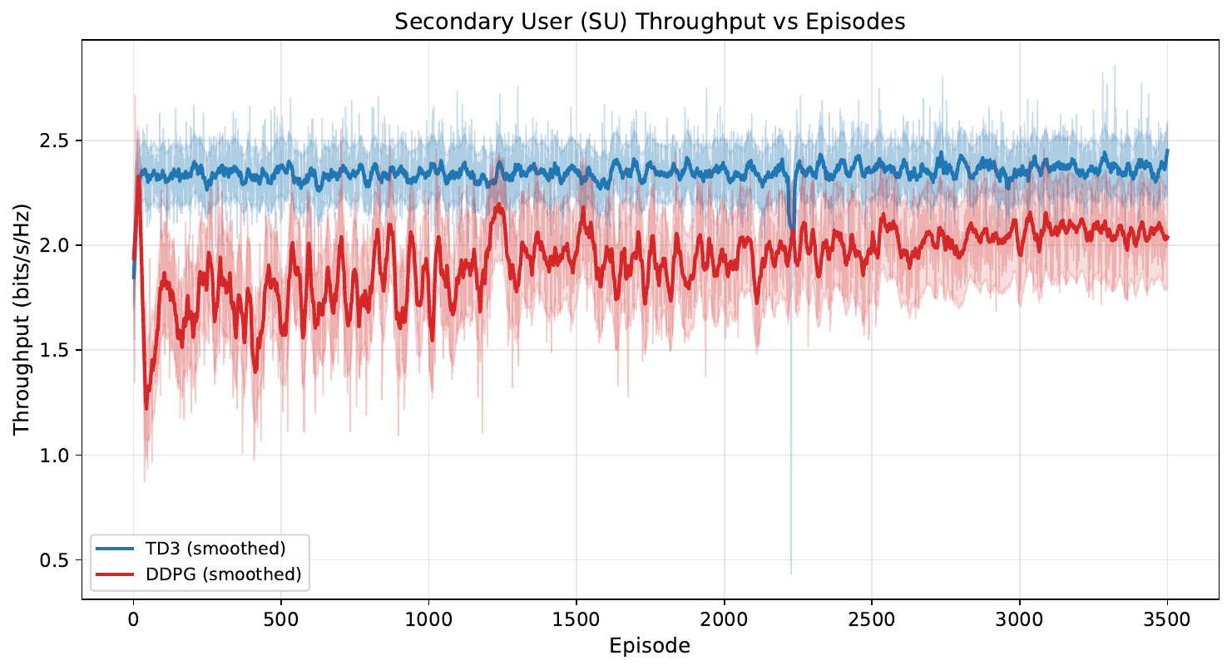
Figure 6.1 — SU throughput vs episodes (m = 1). TD3 ≈ 2.35, DDPG ≈ 2.05 bits/s/Hz.
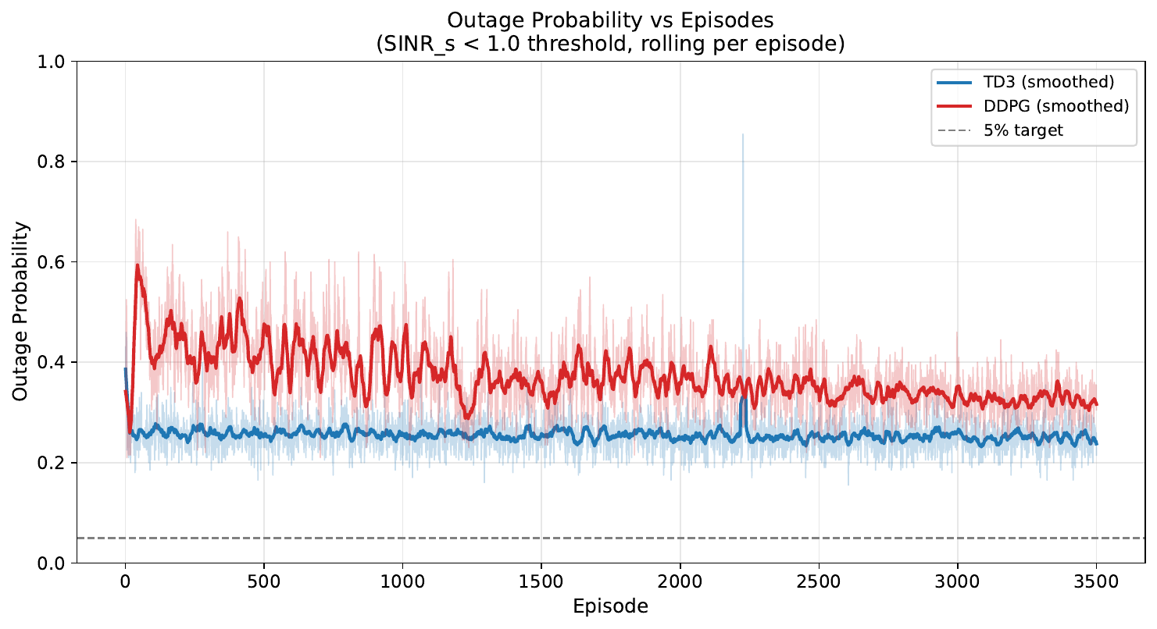
Figure 6.2 — Outage probability vs episodes (m = 1). TD3 ≈ 25 %, DDPG ≈ 32 %; both above the 5 % target line because Rayleigh fading is severe.

6.2 Experiment B — m = 3 (Moderate Fading, TD3 vs DDPG)
Metric | TD3 | DDPG | Winner
Avg Reward (last 100 ep) | 241.24 | 209.11 | TD3
SU Throughput (bits/s/Hz) | 2.067 | 1.693 | TD3
PU Throughput (bits/s/Hz) | 0.531 | 0.774 | DDPG
Outage Probability | 0.113 | 0.251 | TD3
Average BER | 0.0280 | 0.0534 | TD3
With less severe fading TD3 roughly halves DDPG's outage (0.11 vs 0.25), increases SU throughput by ~22 % and cuts BER nearly in half. DDPG once again trades SU performance for marginally higher PU throughput.
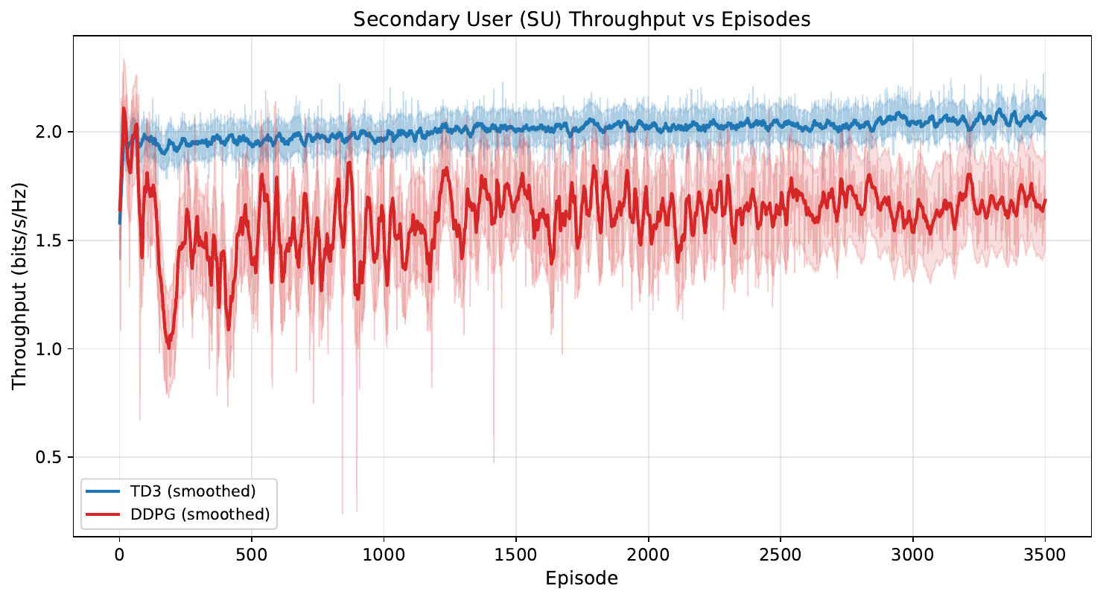
Figure 6.3 — SU throughput vs episodes (m = 3). TD3 ≈ 2.07, DDPG ≈ 1.69 bits/s/Hz.
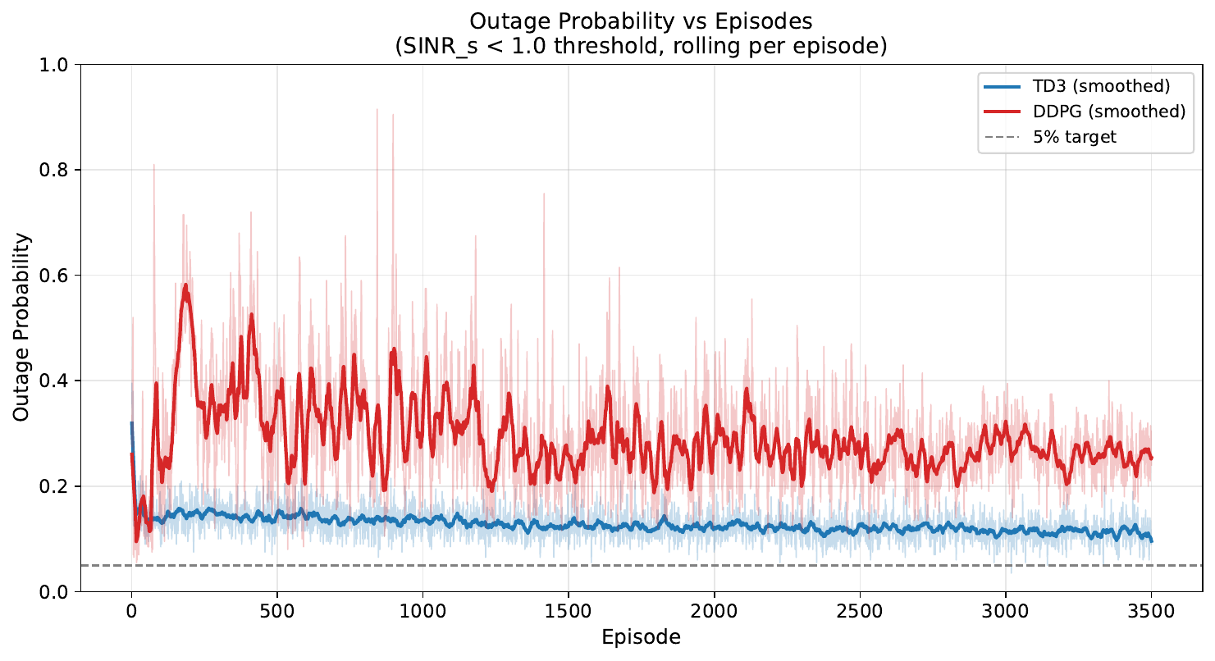
Figure 6.4 — Outage probability vs episodes (m = 3). Convergence is markedly smoother than under m = 1.

6.3 Experiment C — Three-way Comparison (m = 3)
Metric | TD3 | DDPG | Proposed | Winner
Avg Reward (last 100 ep) | 241.33 | 245.46 | 247.56 | Proposed
SU Throughput (bits/s/Hz) | 2.081 | 2.103 | 2.100 | DDPG / Proposed
PU Throughput (bits/s/Hz) | 0.519 | 0.516 | 0.529 | Proposed
Outage Probability | 0.107 | 0.104 | 0.104 | DDPG / Proposed
Average BER | 0.0270 | 0.0263 | 0.0264 | DDPG / Proposed
Under identical settings (imperfect CSI, m = 3, 1 500 episodes), the Proposed Algorithm wins on average reward and PU throughput, and ties with DDPG on SU throughput / outage / BER — all without any manual tuning of α, β or γ_e. Crucially, the Proposed Algorithm achieves the highest PU throughput at equal outage level, indicating safer interference behaviour at equal SU performance. Training time is ~8× longer than the baselines because of the GRU encoder, six critics and Lagrangian updates — an expected and acceptable trade-off.
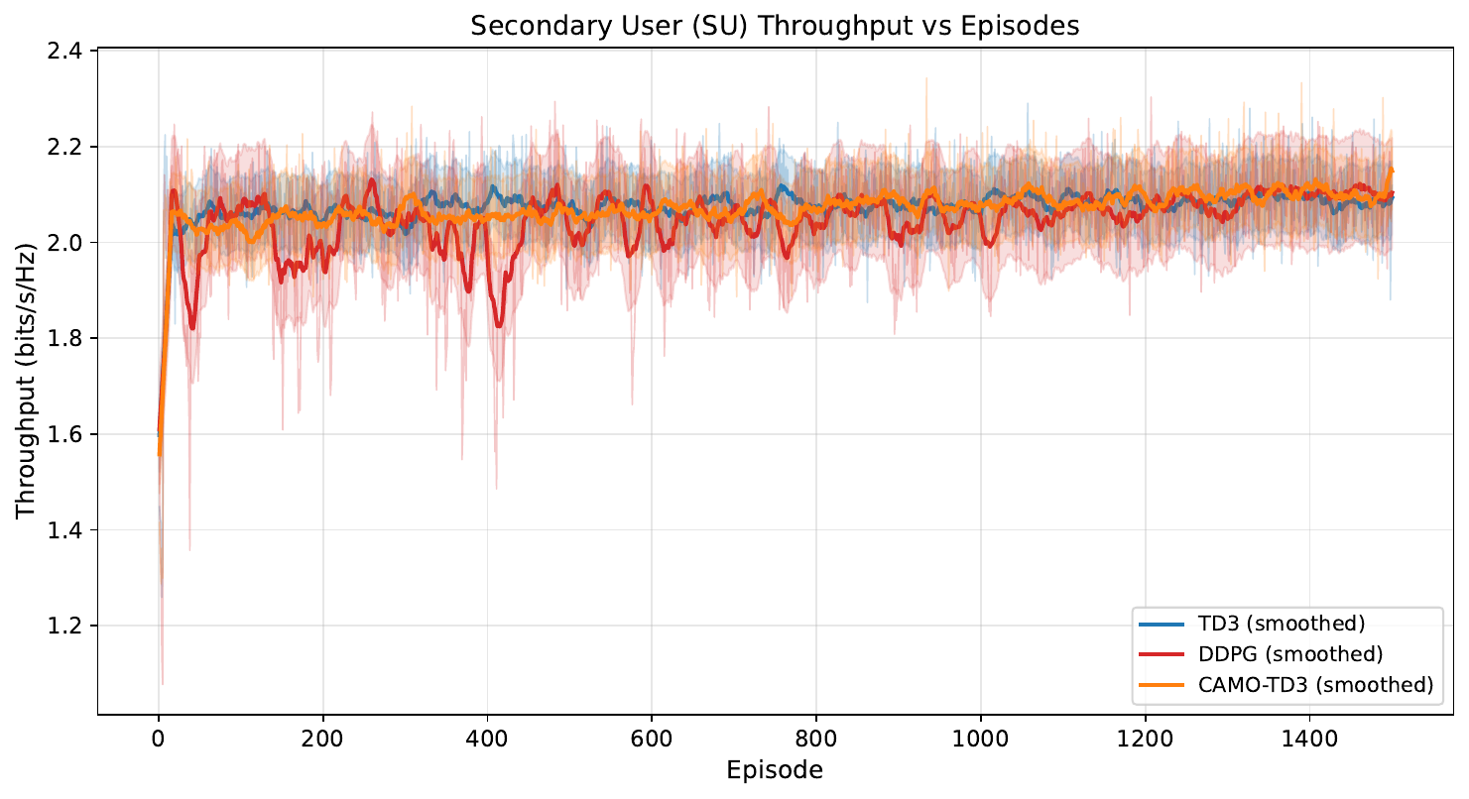
Figure 6.5 — SU throughput vs episodes for TD3, DDPG and the Proposed Algorithm.
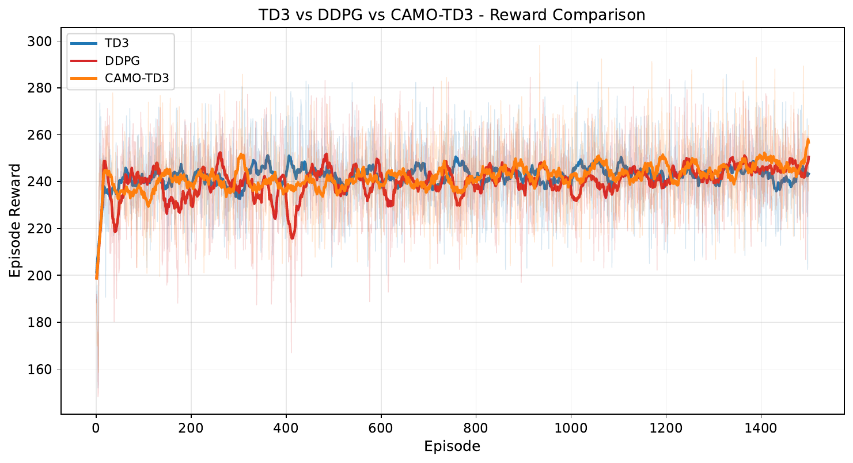
Figure 6.6 — Episode-reward overlay (3-way). The Proposed Algorithm reaches the highest final average reward ≈ 247.6.

6.4 Discussion
Headline findings — DDPG → TD3 → Proposed Algorithm gives a clear monotonic improvement in average reward and constraint adherence. TD3's twin-critic + delayed-update mechanism yields 17–22 % higher SU throughput than DDPG with concurrent reduction in outage. The Proposed Algorithm achieves the best average reward and PU throughput at equal outage / BER, and removes manual weight tuning.
Effect of fading severity — m = 1 (Rayleigh) is hard for all agents (outage 25–32 %) because deep fades make the SU bandwidth-limited regardless of agent intelligence. m = 3 (moderate) lets the agent exploit good states (outage < 12 % for TD3 and the Proposed Algorithm).
Costs and caveats — the Proposed Algorithm needs ~8× longer training per episode due to extra networks and Lagrangian updates; inference cost is unchanged. The simulation uses a simplified 4-node topology with block-fading channels and BPSK BER formulas — standard simplifications that do not affect the relative ordering of the three algorithms.

7. Conclusion and Future Work
This report has presented the implementation and benchmarking of three Deep Reinforcement Learning algorithms — DDPG, TD3 and the Proposed Algorithm — for dynamic power allocation in an underlay Cognitive Radio Network under Nakagami-m block fading with imperfect Channel State Information. Numerical experiments at m = 1 and m = 3 confirm that TD3 substantially outperforms DDPG (≈ +20 % SU throughput and a 12 pp reduction in outage at m = 3), and the Proposed Algorithm further matches the best baseline on SU performance while improving PU protection — without any manual reward-shaping tuning. The project delivers a reproducible pipeline: unified CRN environment, single-source-of-truth configuration, automated multi-page PDF reports, Kaggle / Colab notebooks for long runs and a real-time React + WebSocket dashboard.

Future Work
Extensions planned for future phases include: multi-SU scaling with Multi-Agent RL; adding Soft Actor-Critic as a stochastic-policy baseline; Prioritised Experience Replay for faster convergence; transfer learning across different Nakagami-m values; path-loss and node-mobility models for realism; OFDM extension with per-subcarrier power allocation; coupling RL power control with spectrum sensing; Docker containerisation and Optuna hyper-parameter search.

8. References
[1] C. Zhong et al., "Deep Reinforcement Learning-Based Optimization for IRS-Assisted Cognitive Radio Systems," IEEE Transactions on Communications, vol. 70, no. 6, pp. 3849–3864, June 2022, doi: 10.1109/TCOMM.2022.3171837.
[2] P. R. Teja, K. Dubey and R. Dubey, "2DRL: Cognitive D2D Control Under Imperfect CSI Via Adaptive Deep Reinforcement Learning," International Journal of Networked and Distributed Computing, vol. 14, p. 6, 2026, doi: 10.1007/s44227-025-00081-0.
[3] R. Jafari, A. O. Fapojuwo and M. Nozari, "DRL-Powered Sum-Rate Maximization Design for IRS-Assisted Full Duplex Cluster NOMA WPCNs," IEEE Transactions on Wireless Communications, vol. 24, no. 11, pp. 9686–9702, Nov. 2025, doi: 10.1109/TWC.2025.3574711.
[4] E. O. Frimpong, Y. Wang and Z. Tian, "IRIS-DDPG: A Reinforcement Learning-Based Optimization for Irregular Reconfigurable Intelligent Surfaces Exploiting Statistical CSI," IEEE Transactions on Cognitive Communications and Networking, vol. 12, pp. 4716–4730, 2026, doi: 10.1109/TCCN.2025.3645496.
[5] Y. Bi, V. K. N. Lau and D. H. K. Tsang, "Model-Driven Bayesian Reinforcement Learning for IRS-Assisted Massive MIMO-OFDM Channel Feedback, Beamforming, and IRS Control," IEEE Transactions on Wireless Communications, vol. 24, no. 3, pp. 2514–2529, March 2025, doi: 10.1109/TWC.2024.3522098.
[6] S. Fujimoto, H. van Hoof and D. Meger, "Addressing Function Approximation Error in Actor-Critic Methods (TD3)," Proceedings of the 35th ICML, 2018. https://arxiv.org/abs/1802.09477
[7] T. P. Lillicrap et al., "Continuous Control with Deep Reinforcement Learning (DDPG)," Proceedings of ICLR, 2016. https://arxiv.org/abs/1509.02971
[8] S. Haykin, "Cognitive Radio: Brain-Empowered Wireless Communications," IEEE J. Sel. Areas Commun., vol. 23, no. 2, pp. 201–220, Feb. 2005.
[9] M. K. Simon and M.-S. Alouini, Digital Communication over Fading Channels, 2nd ed., Wiley, 2005.
[10] DDPG-Based Adaptive Power Control, GitHub repository, 2026. https://github.com/adityagangwani30/ddpgminiproject.git
[11] Actor-Critic Network, GitHub repository, 2026. https://github.com/Ryan-gomezzz/ddpg-actor_critic.git

