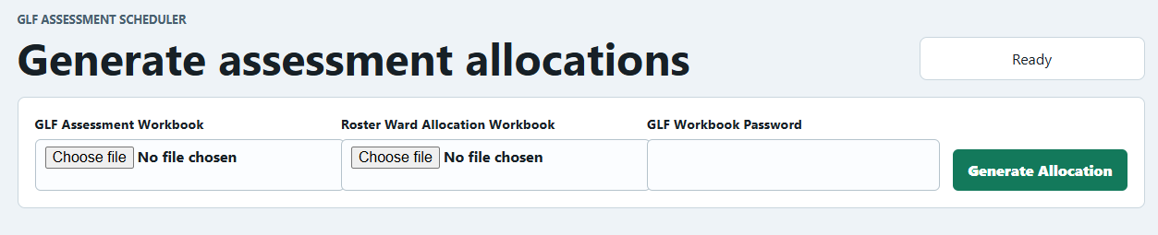
- Click on choose file for GLF assessment workbook, and select the desired GLF xlsx file
- Click on choose file for Roster Ward Allocation workbook, and select the desired roster allocation xlsx file
- Key in the password for GLF workbook (coreassessor)
- Click on generate allocation button to get the new allocation
- This will show the newly allocated assessors to assesses
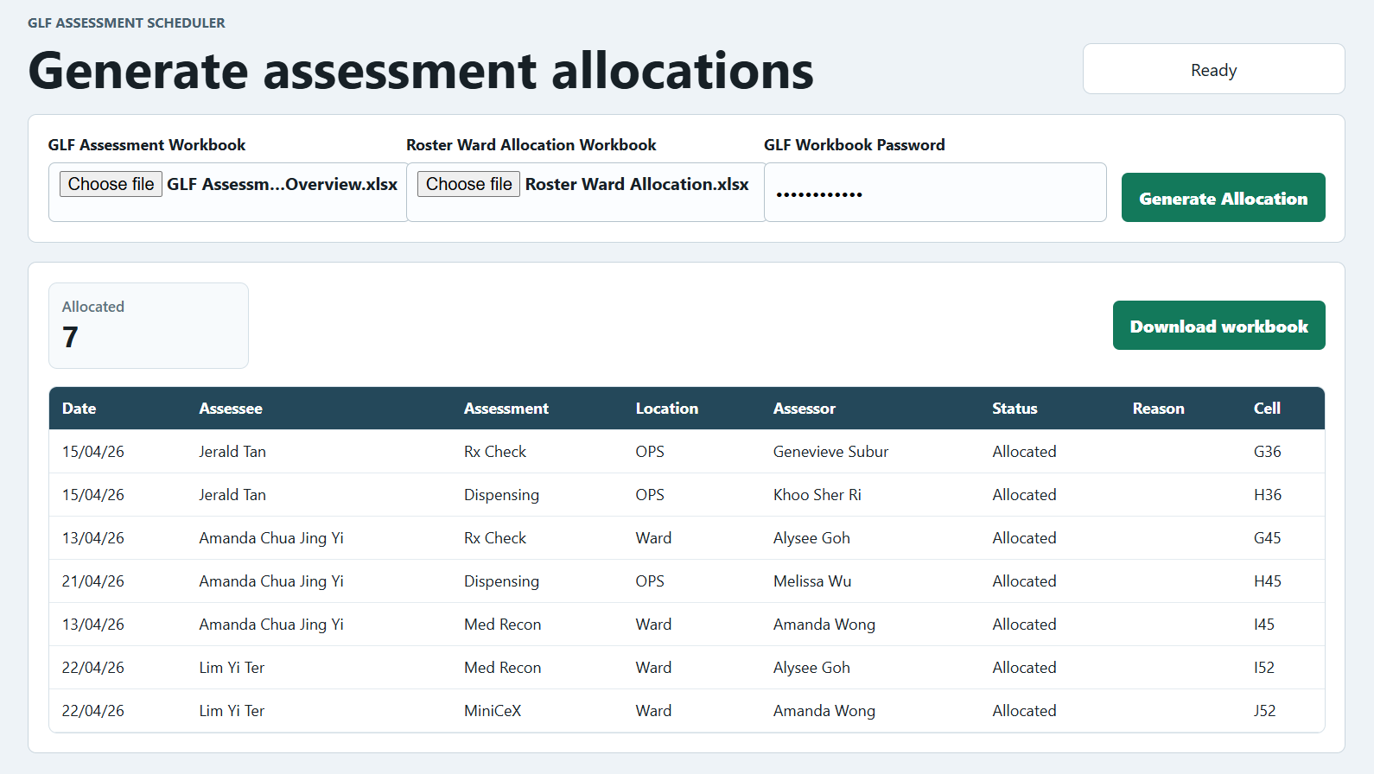
- Clicking on download workbook will download the updated xlsx workbook

