**GroceryCo for Blatant**

This is a lightweight console application of a grocery store. Users can use it to pick a product to add to their grocery list.

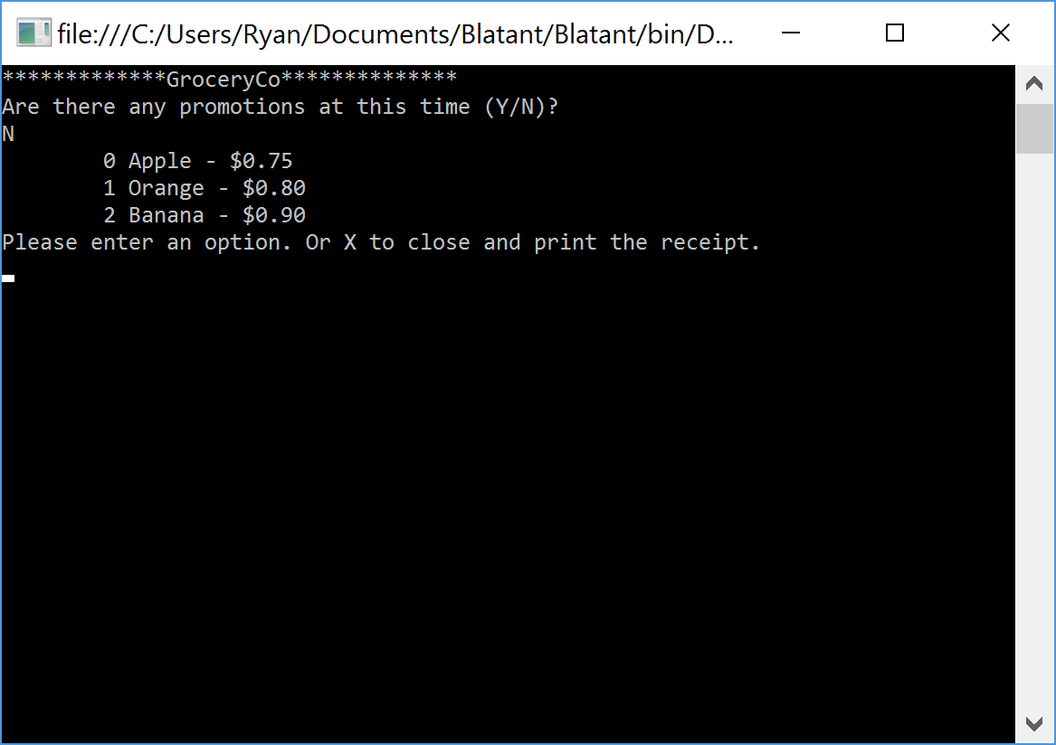

The console application reads in a text file with three products in it along with normal and discounted product prices. The user can select a product and the amount is added to an ongoing total.

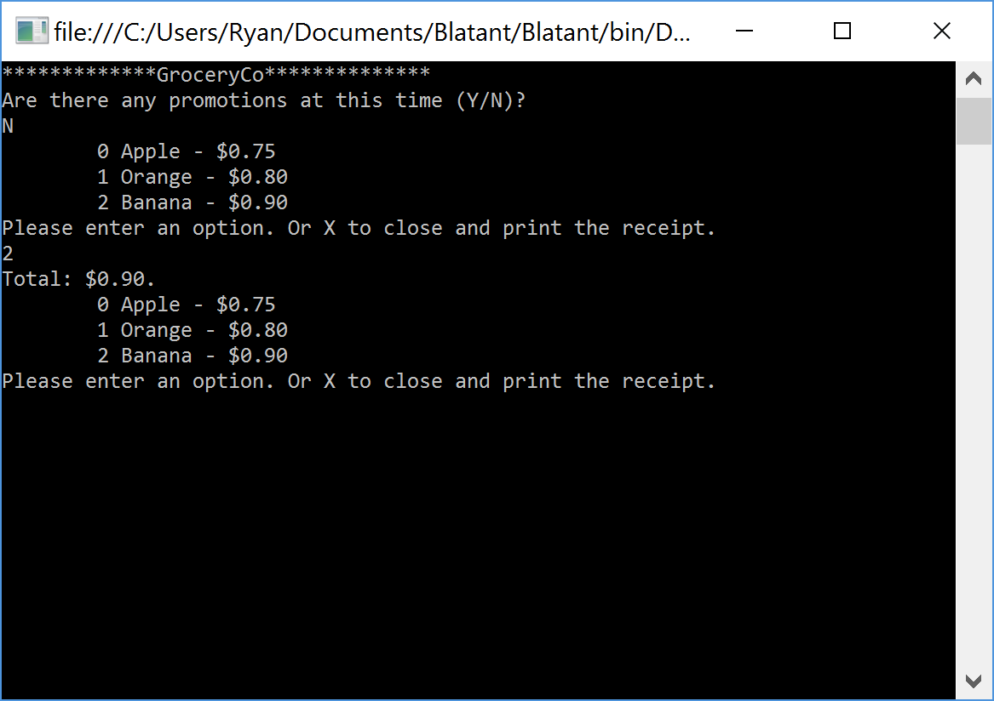

When three items of a specific item type is added. It will cost $2.00.

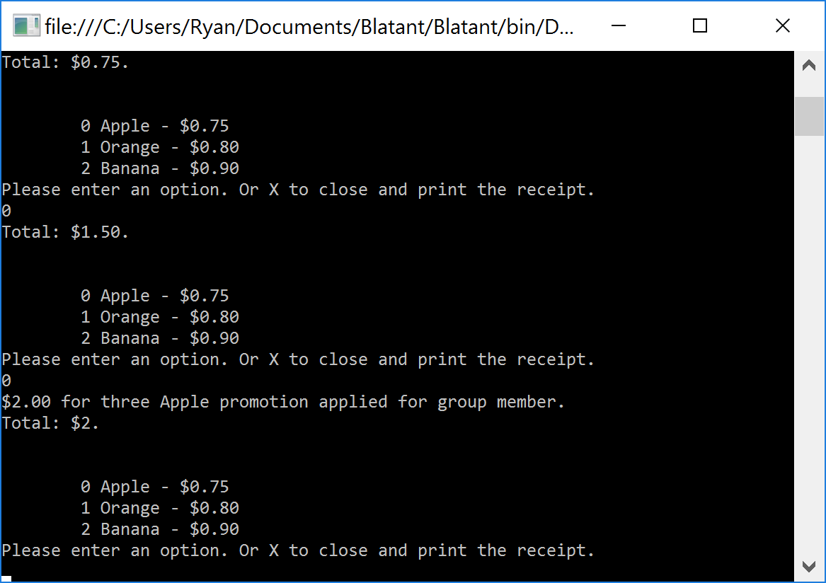

Once the user is complete they can type ‘X’ to leave the application and print. You will have to add your full printer name. The user can open the text file and add products in the same way.

This was a good programming exercise to complete. I found after completing this exercise, I should have done more planning to complete this sooner.