WAR

1. Click File, choose Project Structure

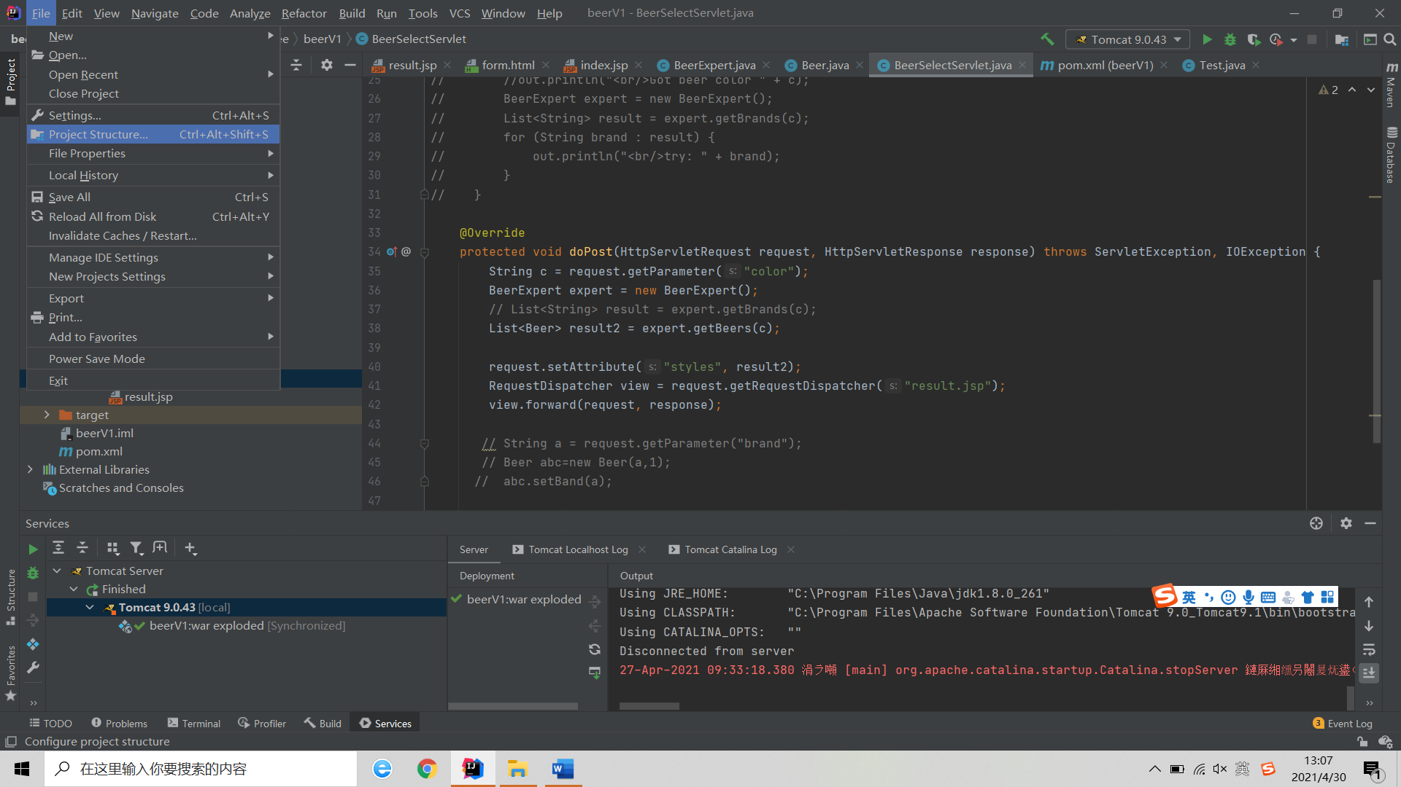

**2**.add the war of project and set the path

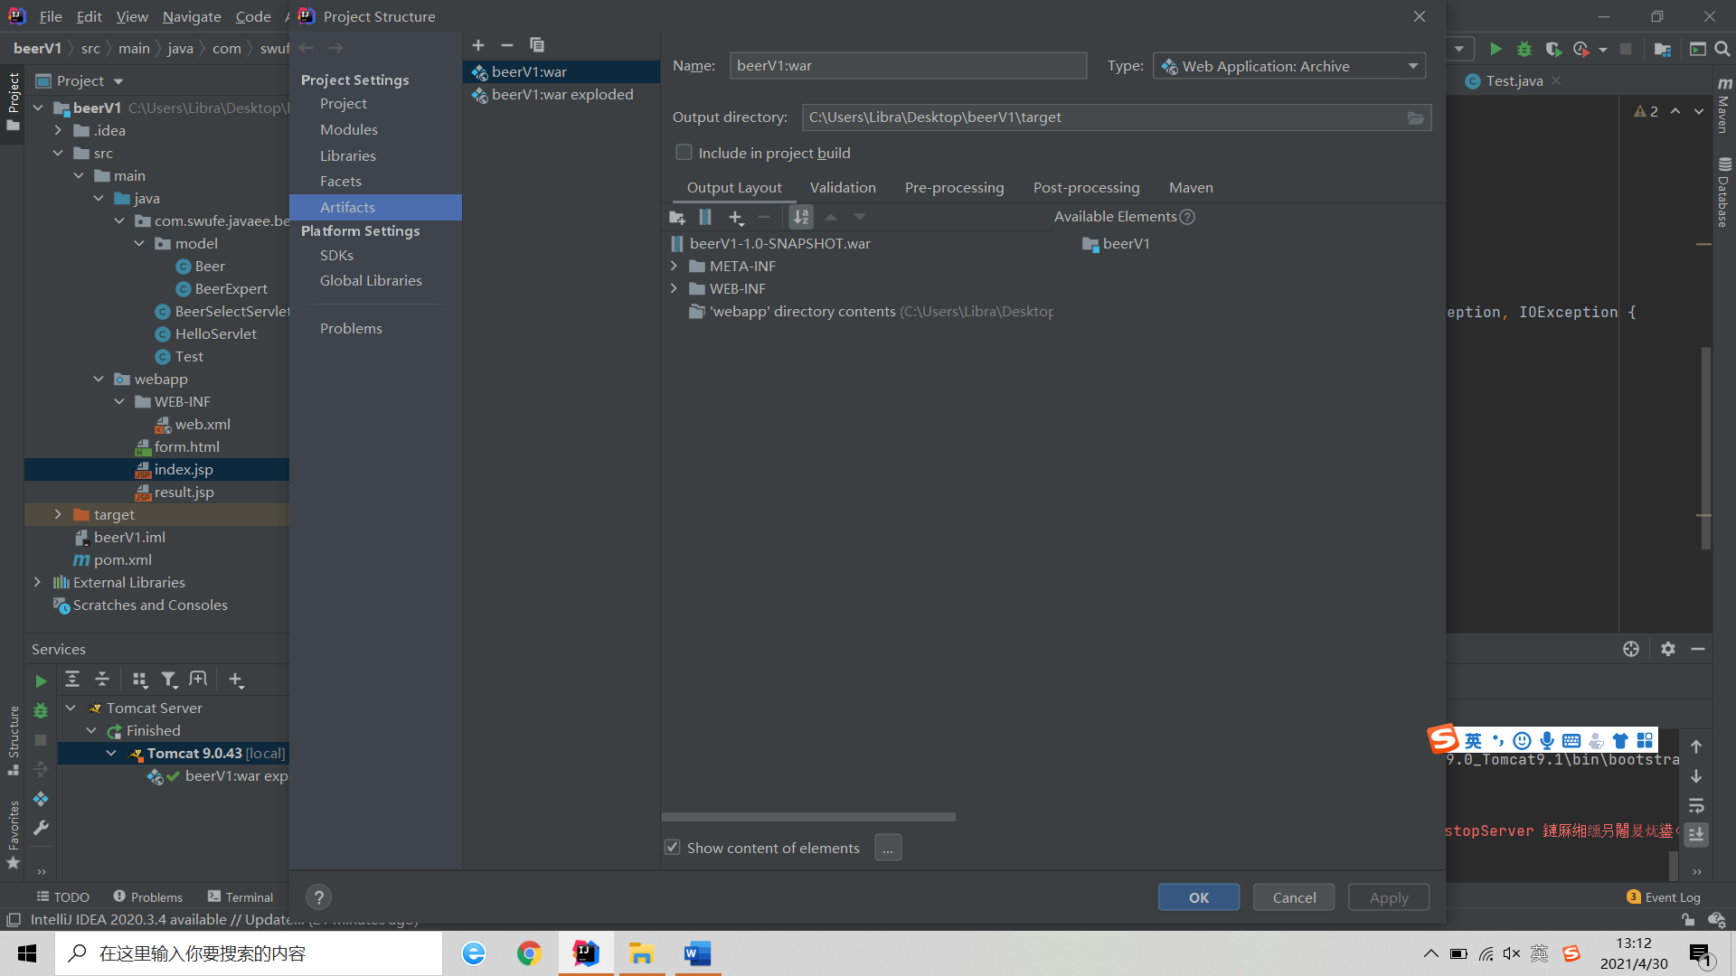

**3**.Build War

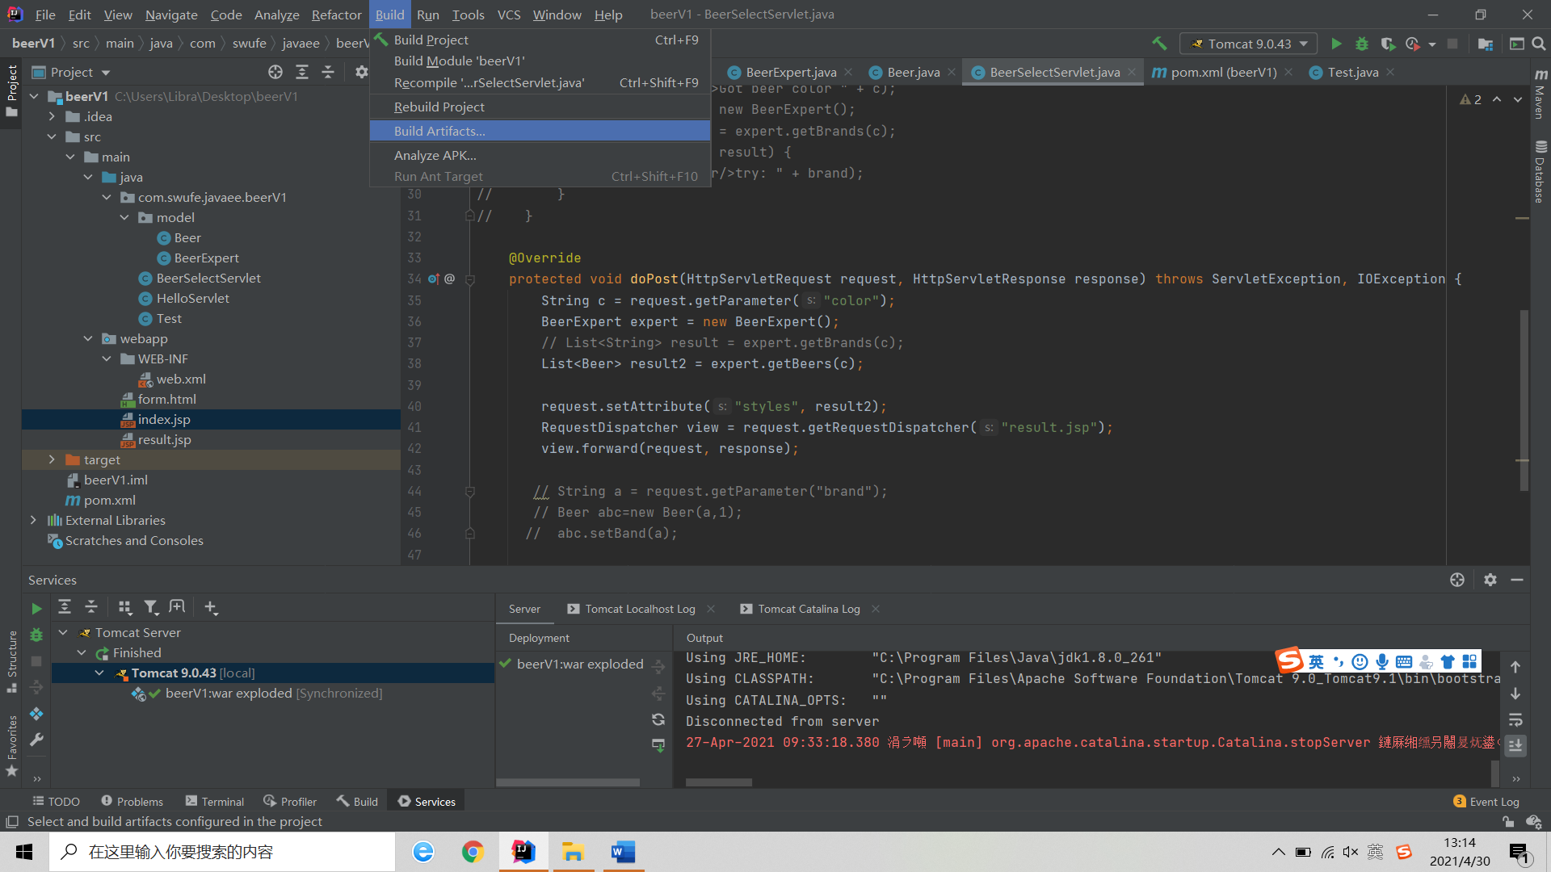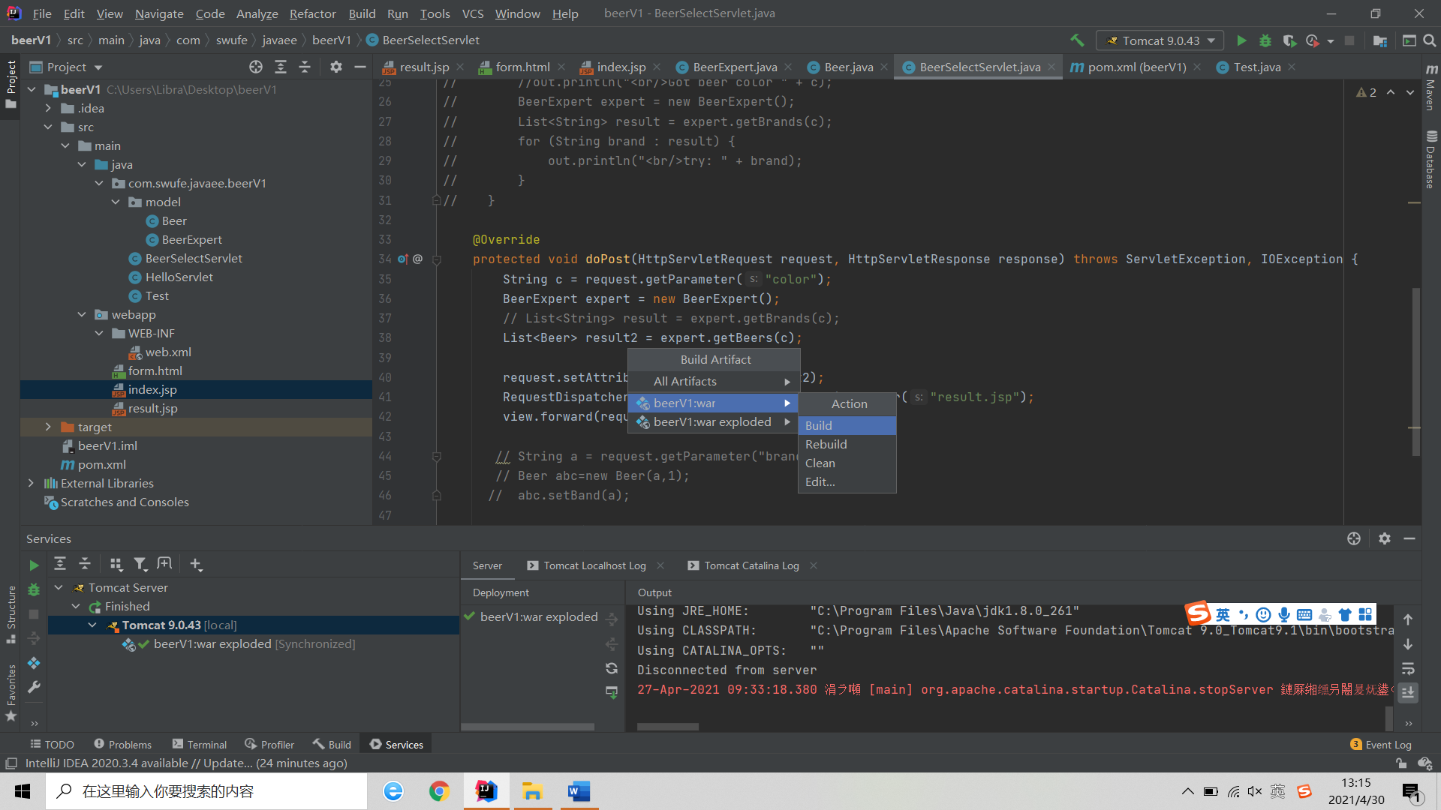

Then the war will be built in directory we set in the second step

1. Deploying the WAR file

First, open Tomcat by host:8080

Then click “选择文件” ,then select the war in directory, then click “部署”

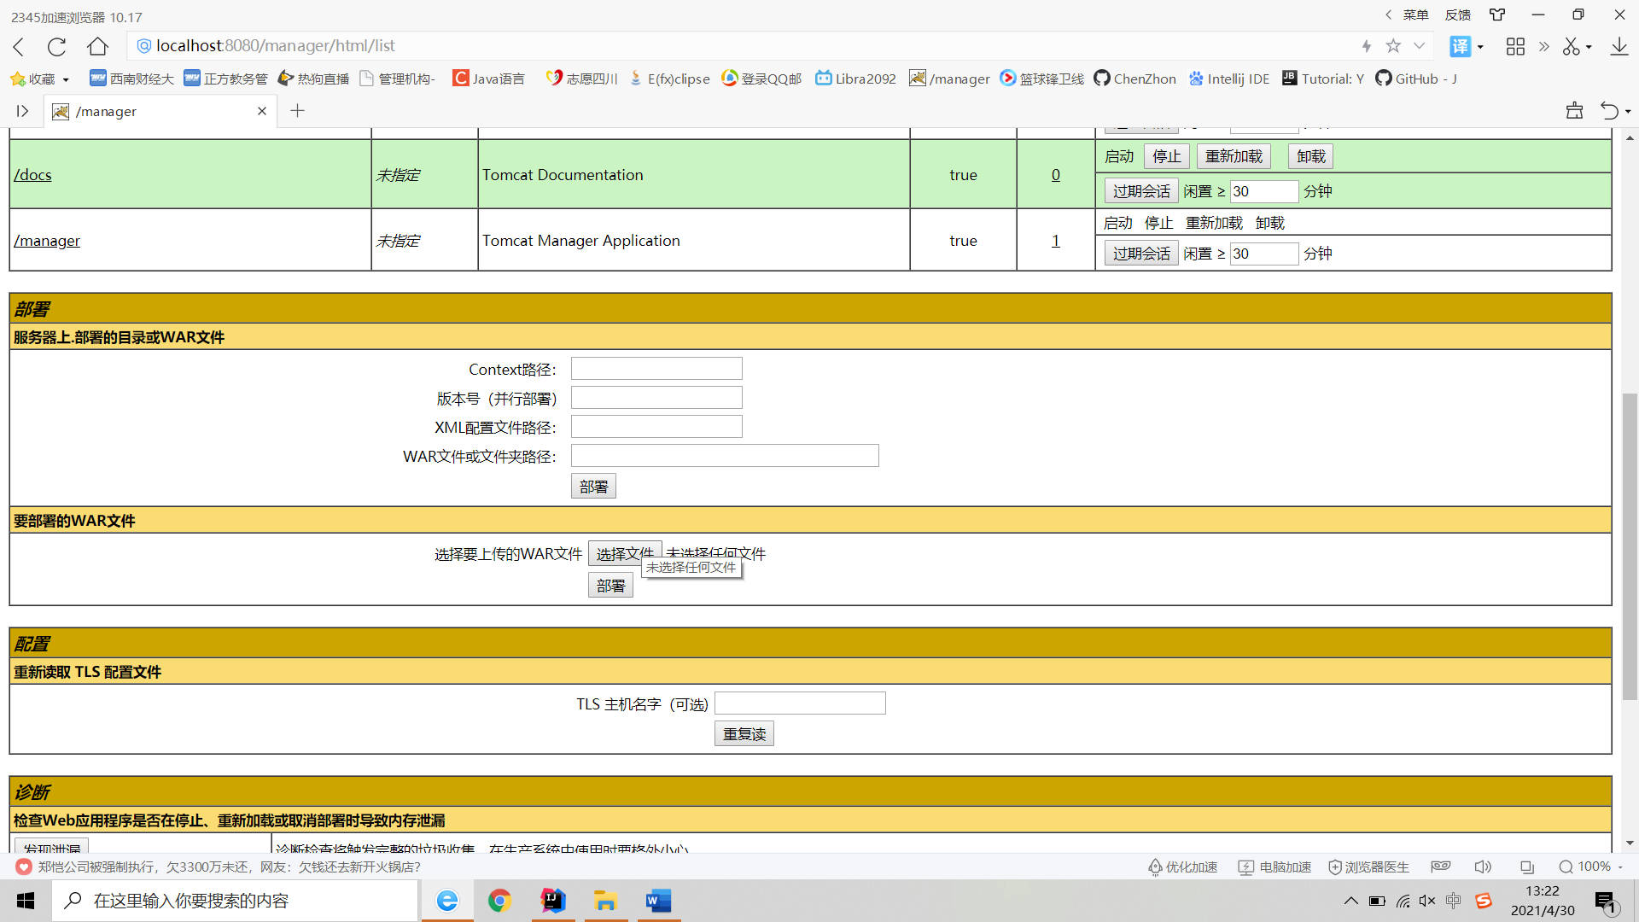

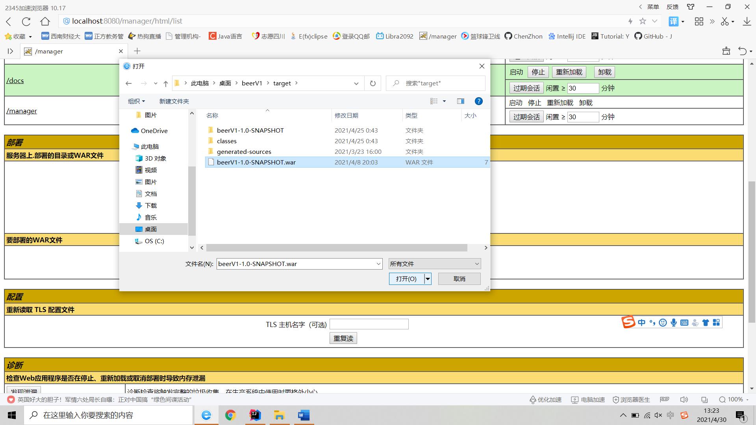

After that , we have done the deploying of war.