BLACK BOX TESTING
Black box testing is a type of testing where an application is tested without the source code being examined. Equivalence Partitioning and Boundary Value Analysis are two black-box testing techniques I'll employ for the Availability feature.
EQUIVALENCE PARTITIONING
Equivalence partitioning groups similar inputs together into classes so that only one representative from each class needs to be tested.
Test Item: Availability
Partition | Test Input | Expected Result
Valid doctor | Select a doctor from the list-box | System displays the selected doctor and enables date selection
Valid date | Select an available date (e.g., 19/04/2026) | System displays available time slots for that doctor
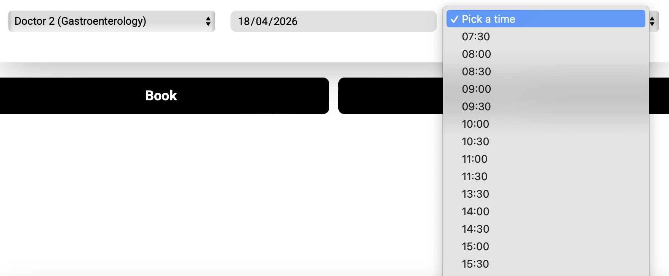
No availability | Select a date where the doctor is fully booked (e.g., 19/04/2026) | System displays "Doctor’s schedule full!" message
Valid time slot | Select a time from the dropdown list | Allow the book button to be pressed.

BOUNDARY VALUE ANALYSIS
This focuses on the limits of date and time selection
Boundary | Test Input | Expected Result
Current date | Select today's date (e.g., 17/04/2026) | System shows remaining slots for today.
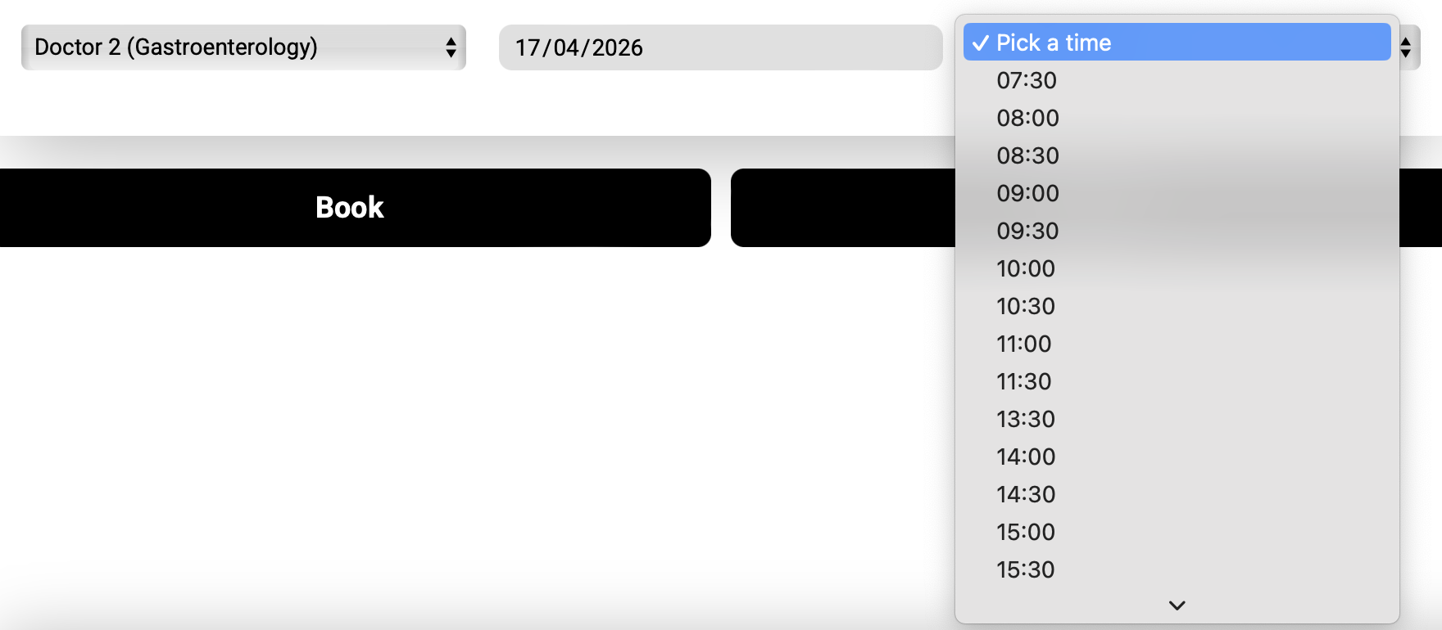
Past date | Select a date before today (e.g., 06/04/2026) | The time slot will not displayed
First slot | Select the first available slot of the day | System successfully accepts the boundary slot selection
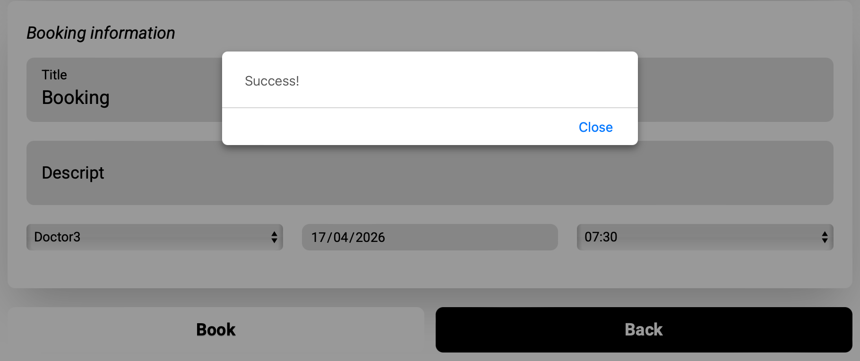
Last Slot | Select the last available slot of the day | System successfully accepts the boundary slot selection
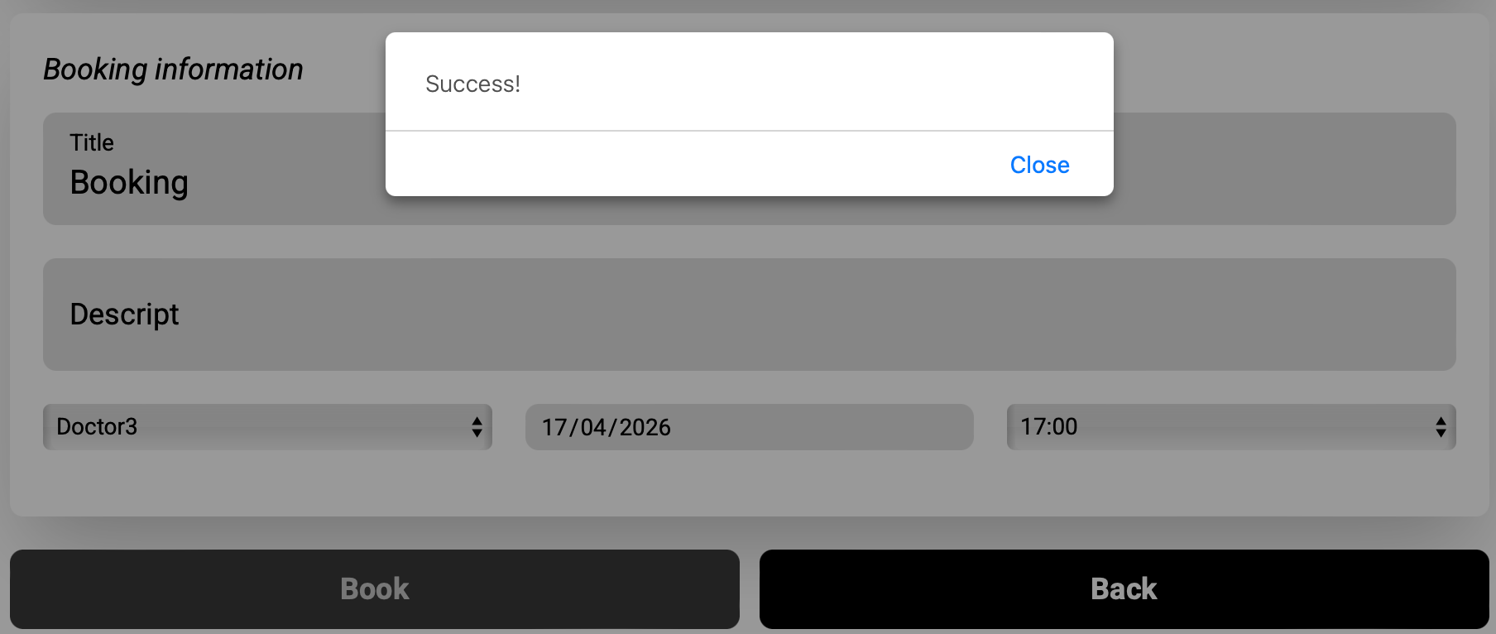

WHITE BOX TESTING
I will use Branch Coverage to ensure every decision path in the code is executed
AVAILABILITY METHOD FLOWCHART
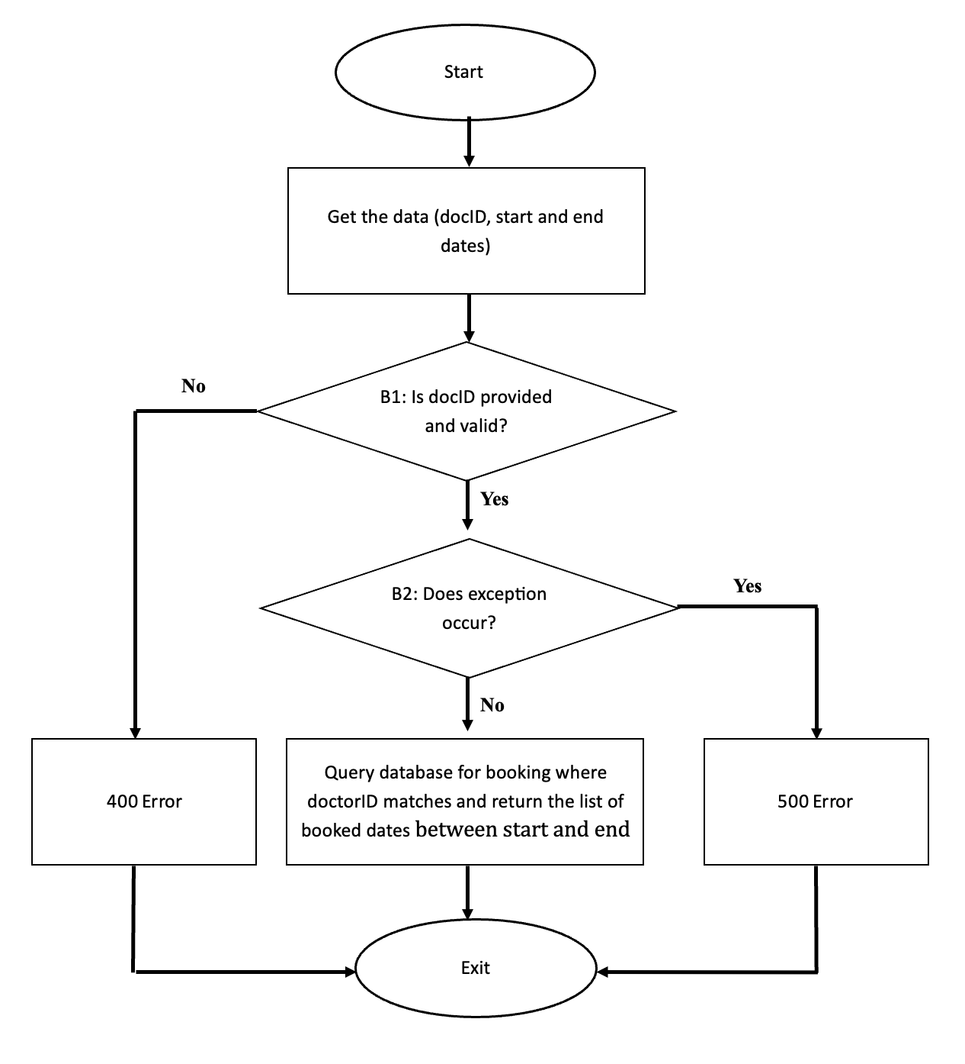

Test case ID | Input | Expected output | Branch Covered
1 | Valid docID, valid date range | Returns array of booked dates | B1= Yes & B2 = No
2 | docID is missing from query | 400 error | B1 = NO
3 | Valid docID,, but no booking exist | Returns empty array | B1 = Yes, B2 = No
4 | Valid docID, but database connect fails | 500 server error | Exception  B1 = yes, B2 = yes

Branch coverage = (number of branches tested /total number of branches) *100
Branches identified: B1 (yes/no), B2 (yes/no) => 4 branches total
Branch | Covered by test case
B1 = No | Test case 2
B1 = Yes | Test case 1,3,4
B2 = No | Test case 1,3
B2 = Yes | Test case 4

4/4 *100% = 100% Branch coverage (4 total test cases)
Since the four indicated test cases have visited every executable line of code in the getdoctor_freetime function, I have achieved 100% Branch Coverage and 100% Statement Coverage.

UNIT TESTING
The main challenge with testing a controller is that it normally depends on a database, and I really don't want my tests messing with real data. What I did was tell Jest to replace the entire booking model with a fake version of itself. Whenever my controller tried to call the model, it would hit the fake one instead, which I could control completely.
For the test structure, I leaned on three things Jest. Grouping related tests under describe() kept things organized, so all my availability tests sat together in one place. Each actual test case lived inside an it() block, where I could spell out exactly what should happen in a given situation. And beforeEach() made sure I was starting fresh every time, wiping out anything the previous test might have left behind.
Since there was no real server running during testing, I had to create fake request and response objects so the controller had something to work with.
Overall, my tests checked that the controller called the right method, handled success correctly, and returned an error message when something went wrong.

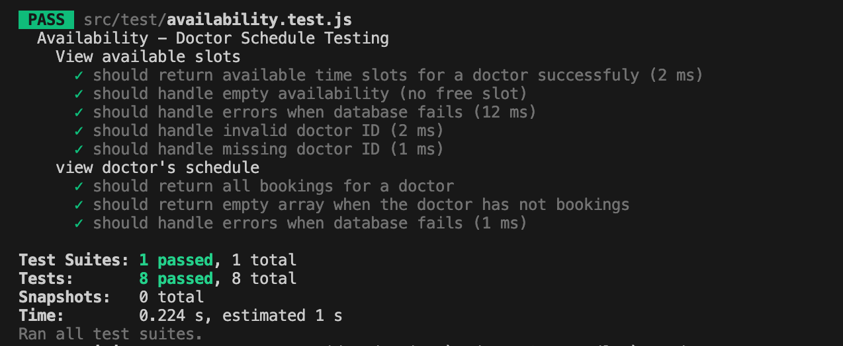
Snapshot of my code for unit testing
