Mapping landscape suitability for forest thinning to reduce evapotranspiration and enhance groundwater recharge in Arizona

Ryan E Lima

Temuulen Tsagaan Sankey

Abraham E Springer

2024-11-22

Abstract

Here, we review the literature on the effects of forest thinning on water yield throughout Arizona and map areas where mechanical treatment has the highest potential for increasing groundwater recharge. This research synthesizes the myriad studies examining the effects of forest treatment on water ield in semi-arid forests and compiles a list of relevant variables. Our approach combines thematic maps of average precipitation, elevation, slope, aspect, forest type, forest density, depth to bedrock, and soil type into a GIS suitability model to highlight areas where forest treatment will most likely enhance recharge statewide.

## 1 Introduction

Since 2000, the Colorado River Basin has been in the midst of a historic drought (Meko, Woodhouse, and Winitsky 2022; Williams, Cook, and Smerdon 2022). Average temperatures increased by 0.9ºC from 2000 - 2014, and streamflow in the Colorado River has declined by 19% below the 1906-1999 average (Hogan and Lundquist 2024; Udall and Overpeck 2017). Extreme hydroclimate events such as droughts, heatwaves, and floods have more than doubled in frequency since 2010 (Bennett, Talsma, and Boero 2021). Simultaneously, Arizona has experienced rapid population growth, increasing the demands on already strained water supplies. Reductions in streamflow have increased reliance on groundwater, while groundwater levels have declined for decades (Tadych et al. 2024). Average annual precipitation in the lower Colorado River Basin is about 330mm, and only about 10mm of that precipitation becomes streamflow while much of the rest is lost to Evapotranspiration (Zou, Ffolliott, and Wine 2010). Sublimation has been shown to remove 10 - 90% of snowfall in the basin; the remaining snowmelt provides over 80% of streamflow to the Colorado River (Lundquist et al. 2024). Therefore, small reductions in evaporative losses could have outsized impacts on available water supplies.

Over 90% of annual precipitation in semi-arid forests can be lost to evapotranspiration (Dore et al. 2012; Ha et al. 2015; Yaseef et al. 2010). Around 65% of surface water in the western states originates from forested lands, which cover just 29% of the land area (Brown, Hobbins, and Ramirez 2005). However, western forests are increasingly at risk from catastrophic wildfires, an emerging driver of runoff change that will increase the impact on the water supply (Williams, Cook, and Smerdon 2022). Forest structure has changed significantly post-Euro-American settlement due to grazing, logging, wildfire exclusion and other factors (Covington and Moore 1994). As a result, many forests in Arizona are overstocked relative to pre-settlement conditions, increasing the risk of catastrophic wildfire (Allen et al. 2002). Increasing temperatures and related droughts have contributed to extensive tree mortality from wildfire, disease, and insect infestation (Berner et al. 2017). Warming temperatures have tripled the frequency and quadrupled the size of wildfires in recent decades (Williams, Cook, and Smerdon 2022). Increasing heat has pushed many low-elevation conifer forests past climate thresholds, creating conditions less suitable for tree regeneration (Davis et al. 2019).

Landscape-scale forest restoration efforts have been planned or implemented across much of Arizona. For example, the Four Forest Restoration Initiative (4FRI) includes plans for restoration across over 2.5 million acres of Arizona’s forests (Schultz, Jedd, and Beam 2012). The primary goal of restoration efforts is to reduce wildfire risk (Allen et al. 2002). However, numerous studies have linked forest treatments to increased water yields in semi-arid forests and have emphasized the role of forest restoration in improving hydrologic services and increasing water availability (Bosch and Hewlett 1982; Baker 1986; Gottfried 1991; Smerdon, Redding, and Beckers 2009; Zou, Ffolliott, and Wine 2010; C. J. W. Wyatt 2013; Moreno et al. 2015; Simonit et al. 2015; C. Wyatt, O’Donnell, and Abraham E. Springer 2015; O’Donnell et al. 2018; Schenk et al. 2020). Forest treatments such as thinning and burning can significantly impact the hydrologic cycle of forests (Del Campo et al. 2022). For example, forest thinning in Arizona has been associated with increased snow cover days (Sankey et al. 2015; Belmonte et al. 2021; Donager et al. 2021), greater soil moisture (Belmonte et al. 2022; Sankey and Tatum 2022), and greater forest canopy moisture (Sankey et al. 2021). However, the response of forests to treatments is complex and non-linear and differs across forest types, with treatment level, and along aspect and elevational gradients (Del Campo et al. 2022; Biederman et al. 2022; Zou, Ffolliott, and Wine 2010; Moore and Wondzell 2005). This research aims to develop criteria for areas suitable for thinning to enhance groundwater recharge. It focuses primarily on regional studies that are likely the best predictor of hydrologic response to treatment (C. J. W. Wyatt 2013).

Source: [Article Notebook](https://Ryan3Lima.github.io/ATUR-ForestThinning/index.ipynb.html)

### 1.1 Regional Hydrologic Responses to Treatment

Several regional studies link forest treatment to changes in stand-level ecohydrology including increased tree growth in Ponderosa Pines (**Rodman et al., 2024**), greater soil moisture and total ecosystem moisture [], increased drought resilience [], Increased snow retention, greater streamflow [], water table rise and increased spring flow []

#### 1.1.1 Water Yield/Runoff

Several regional studies link forest treatment to increased streamflow (Dwivedi et al. 2024; Biederman et al. 2022; Broxton et al. 2023). However, there appears to be a threshold response, with water yield increasing only in treated forests receiving over 500mm of annual precipitation or snow-dominated forests (Biederman et al. 2022; Carroll et al. 2016; Adams et al. 2012; Zou, Ffolliott, and Wine 2010).

#### 1.1.2 Soil Moisture and Drought Resilience

A synthesis of several treatment types across Northern Arizona, including thinning at various levels and prescribed burning, found that treated sites had significantly greater total ecosystem moisture, making forests more resilient to drought(Sankey et al. 2021; Sankey and Tatum 2022). Treatments were shown to increase tree growth, improving resilience to drought in Ponderosa Pine forests (**Rodman et al., 2024**). Thinned Ponderosa Pine forests have higher soil moisture for two to eight years post-thinning, a result also found in semi-arid forests around the Mediterranean (Belmonte et al. 2022; Del Campo et al. 2022, 2019; O’Donnell et al. 2021).

Source: [Article Notebook](https://Ryan3Lima.github.io/ATUR-ForestThinning/index.ipynb.html)

### 1.2 Justification

* regional studies are the best predictor of hydrologic response to thinning in Arizona forests (C. J. W. Wyatt 2013)
* A snythesis of all 4FRI treatments found that thinned and burned forests have signifiantly greater total ecosystem moisture and are thus more resilient to drought and wildfire (Sankey et al. 2021)
* Thinned forests are better buffered against drought impacts in terms of both soil moisture and tree health (Sankey and Tatum 2022).
* Soil moisture and ET may be effected by thining for 3.6 - 8.6 years (Del Campo et al. 2022).
* Prescribed burning or thinning can increase tree growth improving resilience to drought in poderosa pine forests (Rodman et al., 2024)
* Thinned forests (around Flagstaff) have higher soil moisture at 25 and 50cm in the first two years post-thinning (Belmonte et al. 2022).
* Thinning in smei-arid forests around the mediterraniean increased antecedant soil moisture and belowground hydrologic processes and increased deep soil moisture by 50mm/year over the control (Del Campo et al. 2019).
* a review of 35 studies published from 1971 to 2018 found that thinning was more effective than clear-cutting in terms of increasing groundwater recharge due to reduced sublimation and evaporation. Springs can be effective at monitoring groundwater recharge affects in aridlands (Schenk et al. 2020).
* A review of studies on forest mgmt effects on groundwater resources found that a rise in water table can generally be expeted following forest thinning in all forested landscapes (Smerdon, Redding, and Beckers 2009).

#### 1.2.1 Snow retention

* The effects of forest thinning and subsequent snowmelt are highly variable, with responses depending on forest structure and local climate, where thinning in dense and taller vegetation generally increases snow retention, thinning in shorter, less dense forests may decrease retention (Lewis et al. 2023).
* In semi-arid forested watersheds, thinning can influence streamflow variability by modifying snowpack accumulation and melt, particularly in wetter years where thinning can either reduce or increase snow retention based on site-specific conditions.(Broxton et al. 2023).
* Thinning in semi-arid forested watershed can significantly impact streamflow by altering snowmelt timing, with reduce forest cover tending to delay snowmelt at warmer sites while advancing melt at cooler, snowpack-persistent sites (Dwivedi et al. 2024).
* Thinned forests around Flagstaff have greater snow persistance at 25%-35% canopy cover (Belmonte et al. 2021)
* Thinned forests in Northern Arizona have more snow and soil moisture (O’Donnell et al. 2021)
* Found that thinned and burned vs control forests had varying rates of snowmelt and snow persistence. Canopy cover is most predictive of snow persistance (Donager et al. 2021).

#### 1.2.2 Thresholds in literature

* A review of 94 catchment studies showed that significant changes in water yield are correlated to forest growth in forests that recive 600-1200 mm of mean annual precipitation Bosch and Hewlett, 1982 The caveat being there were not many confierous forests studies in that precipitation range (Bosch and Hewlett 1982).
* (Adams et al. 2012) hypotheized that where annual precipitaiton exceeds ~500 mm or water yield is dominated by snowmelt, watershed will experience significantly decreased evapotranspiration and increased flows if canopy cover is reduced by over 20%, however their recent observations suggest that in dry forests water ield may decrease. More research is needed. This paper was focused on tree-die off not thinning.
* (Carroll et al. 2016) found a threshold hydrologic response when evaluating thinning of a snow-dominated semi-arid Pinyon-Juniper community in the Great Basin. They found that a positive water yield in thinned plots was only observed when precipitation exceeded 400mm annually (wet years)
* (Biederman et al. 2022) suggests that distrubance will have positive inpacts on streamflow for a minimum of several years following disturbance in areas where mean annual precipitation exceeds ~500mm. “Presumably because below 500 mm, most precipitation is evaporated regardless of forest condition (Hibbert, 1979)[@]
* (Zhang, Dawes, and Walker 2001) found evaluated 250 world-wide catchment studies and found that the differences in ET between forested and non-forested catchments diminishes in areas with annual rainfall less than 500 mm

### 1.3 thinning decreases ET in some circumstances

* Reductions of canopy cover can increase ET of existing trees, and solar radiation increasing ET [Biederman et al. (2015)](Chen%20et%20al.,%202005;%20Bennett%20et%20al.,%202018)
* Decreases in post-disturbance ET may be offsett by increased soil evaporation increasing net ET (Reed et al., 2016)
* (Goeking and Tarboton 2020) reviewed the hydrologic response of stand-replacing and non-stand replacing disturbances and found that post-distrubance streamflow may increase, not change, or even decrease. Nonstand replacing fires—because of increased evaporation from higher subcanopy radiation and increased transpiration from rapid post-disturbance growth can decrease water availability in some cases.

Source: [Article Notebook](https://Ryan3Lima.github.io/ATUR-ForestThinning/index.ipynb.html)

## 2 Data & Methods

### 2.1 2.2 Weighted Suitability Workflow

#### 2.1.1 2.2.1 Define

“define the goal, supporting criteria, and evaluation metrics for the weighted suitability model”

**The goal is to locate areas on the Mogollon Rim Ranger District in the Coconino National Forest where thinning may increase groundwater recharge based on modeling of criteria found in the literature quantifying the impact of thinning on water yield in Regional studies of Semi-arid forests.**

##### 2.1.1.1 **Criteria**

**Aspect**

Aspect has a large impact on solar radiation.

Closer to 0 or 360 is desired, low suitability scores for closeness

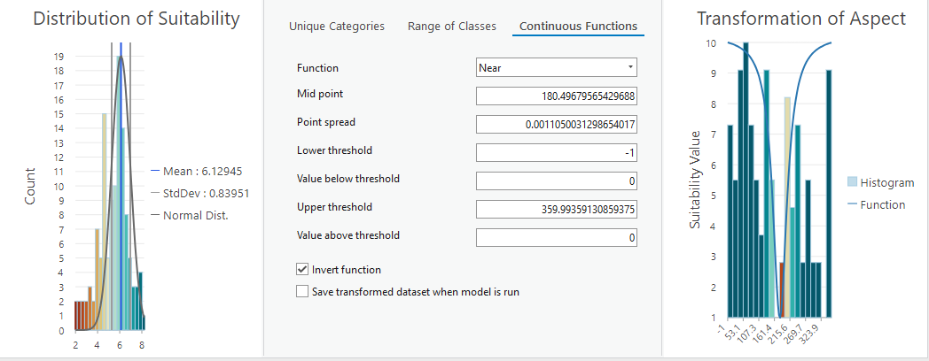 **Slope**

Higher slopes are less suitable because thinning is both more expensive and more precipitation will end up as runoff.

Lower slopes have higher suitability scores

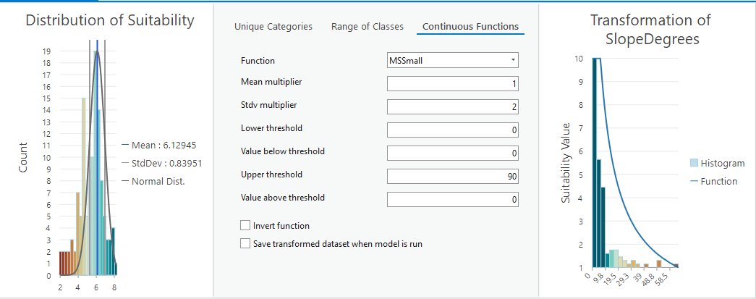 **Precipitation**

Mean annual precipitation must be higher than 500mm 1990 - 2020 Max precipitation must be higher than 500mm annually from 1990 - 2020

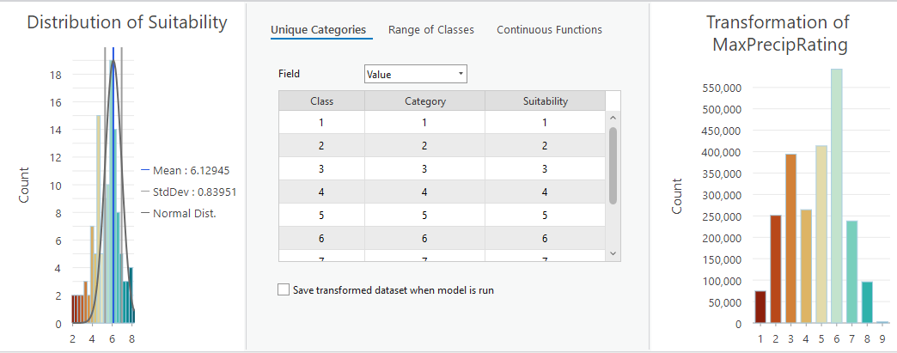

**Vegetation Characteristics**

higher vegetation density, when thinned will yield more water, focus on areas of high vegetation density and high departure from historic conditions.

**NLCD 2021 Total Canopy Cover (% Cover)**

Canopy cover % below 30 were considered low suitability (1) while increases in canopy cover about 30% increase in suitability.

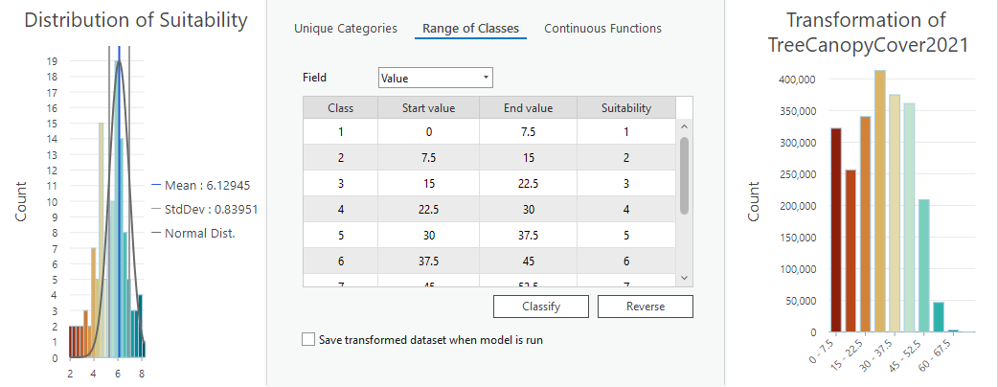

**Landfire 2022 Vegetation Condition Class** 3rd update to the 2016 remap.

Variation from modeled historic conditions. Forests which have deviated significantly from their modeled historic conditions are more suitable for thinning than forests which have not deviated from their historic condition.

Vegetation Condition Class (VCC) represents a simple categorization of the associated Vegetation Departure (VDep) and is a derivative of the VDep layer. It indicates the general level to which current vegetation is different from the estimated modeled vegetation based on past reference conditions. VDep and VCC are based upon methods originally described in the Interagency Fire Regime Condition Class Guidebook, but are not identical to those methods and should not be considered as a replacement data set. Full descriptions of the methods used can be found in the VDep product description. Note that the LANDFIRE (LF) team feels it is very important for users to review the VDep methods before comparing VDep or VCC values across LF versions. [info](https://www.landfire.gov/vegetation/vcc) [PDF](chrome-extension://efaidnbmnnnibpcajpcglclefindmkaj/https://www.landfire.gov/sites/default/files/DataDictionary/LF2022/LF22_VCCADD_230.pdf)

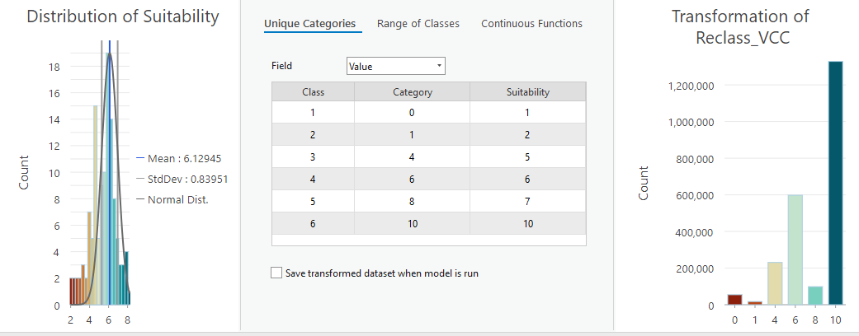

**Soil Hydrologic Conditions**

Soil types A,B,C,D are mapped for the USA, There are no A soil types in the study area, so they were given the following suitability values

B = 10 out of 10 C = 8 out of 10 D = 3 out of 10

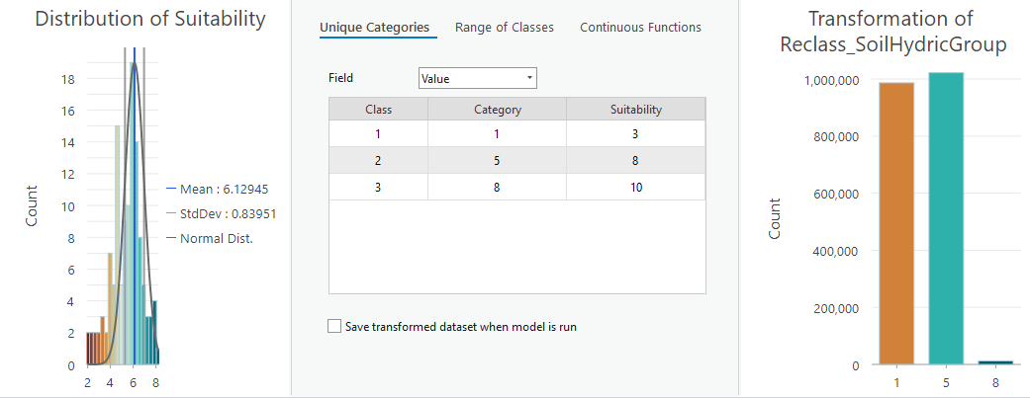

Source: [Article Notebook](https://Ryan3Lima.github.io/ATUR-ForestThinning/index.ipynb.html)

## 3 Preliminary Results

### 3.1 Weighting

Tree Canopy Cover = 20% Vegetation Condition Class = 20% Slope = 20% Aspect = 20% Max Precipitation = 15% Soil Hydrologic Group = 5%

### 3.2 Overall Suitability

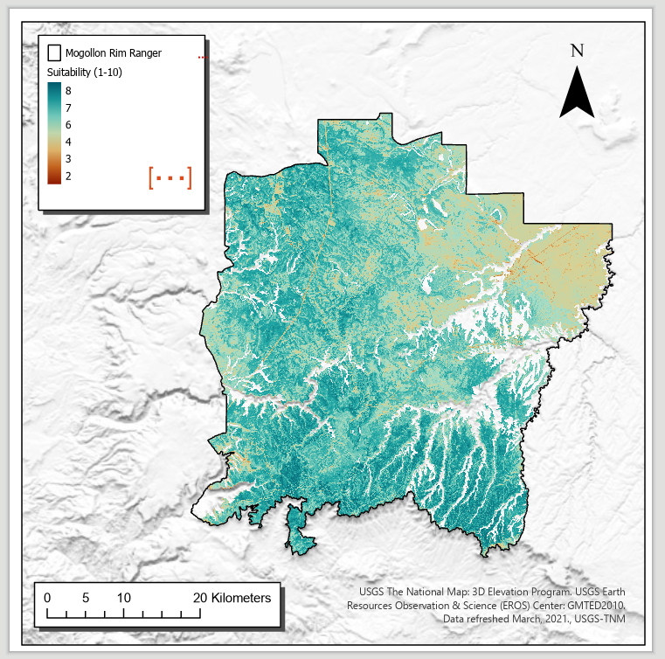

Source: [Article Notebook](https://Ryan3Lima.github.io/ATUR-ForestThinning/index.ipynb.html)

## 4 Questions for the team

### 4.1 1. Can modeling using Snowpalm, the National Water Model, or SWAT either validate this, or be used to improve the suitability transformations and weighting?

#### 4.1.1 1.1 What LULC variables do the various models take in? Is Canopy Cover or VCC represented in those models? If so, could we adjust them to simulate thinning and re-run the models to see what happens?

### 4.2 2. Am I using the right data? Is there better datasets available?

Source: [Article Notebook](https://Ryan3Lima.github.io/ATUR-ForestThinning/index.ipynb.html)

## 5 Conclusion

Source: [Article Notebook](https://Ryan3Lima.github.io/ATUR-ForestThinning/index.ipynb.html)

## References

Source: [Article Notebook](https://Ryan3Lima.github.io/ATUR-ForestThinning/index.ipynb.html)

Adams, Henry D., Charles H. Luce, David D. Breshears, Craig D. Allen, Markus Weiler, V. Cody Hale, Alistair M. S. Smith, and Travis E. Huxman. 2012. “Ecohydrological Consequences of Drought‐ and Infestation‐ Triggered Tree Die‐off: Insights and Hypotheses.” *Ecohydrology* 5 (2): 145–59. <https://doi.org/10.1002/eco.233>.

Allen, Craig D., Melissa Savage, Donald A. Falk, Kieran F. Suckling, Thomas W. Swetnam, Todd Schulke, Peter B. Stacey, Penelope Morgan, Martos Hoffman, and Jon T. Klingel. 2002. “Ecological Restoration of Southwestern Ponderosa Pine Ecosystems: A Broad Perspective.” *Ecological Applications* 12 (5): 1418–33. <https://doi.org/10.1890/1051-0761(2002)012[1418:EROSPP]2.0.CO;2>.

Baker, Malchus B. 1986. “Effects of Ponderosa Pine Treatments on Water Yield in Arizona.” *Water Resources Research* 22 (1): 67–73. <https://doi.org/10.1029/WR022i001p00067>.

Belmonte, Adam, Temuulen Sankey, Joel Biederman, John Bradford, Scott Goetz, and Thomas Kolb. 2021. “UAV-Based Estimate of Snow Cover Dynamics: Optimizing Semi-Arid Forest Structure for Snow Persistence.” *Remote Sensing* 13 (5): 1036. <https://doi.org/10.3390/rs13051036>.

Belmonte, Adam, Temuulen Ts. Sankey, Joel Biederman, John B. Bradford, and Thomas Kolb. 2022. “Soil Moisture Response to Seasonal Drought Conditions and Post‐thinning Forest Structure.” *Ecohydrology* 15 (5): e2406. <https://doi.org/10.1002/eco.2406>.

Bennett, Katrina E., Carl Talsma, and Riccardo Boero. 2021. “Concurrent Changes in Extreme Hydroclimate Events in the Colorado River Basin.” *Water* 13 (7): 978. <https://doi.org/10.3390/w13070978>.

Berner, Logan T, Beverly E Law, Arjan J H Meddens, and Jeffrey A Hicke. 2017. “Tree Mortality from Fires, Bark Beetles, and Timber Harvest During a Hot and Dry Decade in the Western United States (2003–2012).” *Environmental Research Letters* 12 (6): 065005. <https://doi.org/10.1088/1748-9326/aa6f94>.

Biederman, Joel A., Marcos D. Robles, Russell L. Scott, and John F. Knowles. 2022. “Streamflow Response to Wildfire Differs With Season and Elevation in Adjacent Headwaters of the Lower Colorado River Basin.” *Water Resources Research* 58 (3): e2021WR030687. <https://doi.org/10.1029/2021WR030687>.

Biederman, Joel A., Andrew J. Somor, Adrian A. Harpold, Ethan D. Gutmann, David D. Breshears, Peter A. Troch, David J. Gochis, Russell L. Scott, Arjan J. H. Meddens, and Paul D. Brooks. 2015. “Recent Tree Die‐off Has Little Effect on Streamflow in Contrast to Expected Increases from Historical Studies.” *Water Resources Research* 51 (12): 9775–89. <https://doi.org/10.1002/2015WR017401>.

Bosch, J. M., and J. D. Hewlett. 1982. “A Review of Catchment Experiments to Determine the Effect of Vegetation Changes on Water Yield and Evapotranspiration.” *Journal of Hydrology* 55 (1-4): 3–23. <https://doi.org/10.1016/0022-1694(82)90117-2>.

Brown, Thomas C, Michael T Hobbins, and Jorge A Ramirez. 2005. “The Source of Water Supply in the United States.” Discussion {Paper} RMRS-RWU-4851. Fort Collins, CO: U.S. Department of Agriculture, Forest Service, Rocky Mountain Research Station. <https://www.researchgate.net/profile/Jorge-Ramirez-14/publication/266272409_The_source_of_water_supply_in_the_United_States/links/54b5fcb50cf26833efd34687/The-source-of-water-supply-in-the-United-States.pdf>.

Broxton, Patrick D., Willem J. D. Van Leeuwen, Bohumil M. Svoma, James Walter, and Joel A. Biederman. 2023. “Subseasonal to Seasonal Streamflow Forecasting in a Semiarid Watershed.” *JAWRA Journal of the American Water Resources Association* 59 (6): 1493–1510. <https://doi.org/10.1111/1752-1688.13147>.

Carroll, Rosemary W. H., Justin L. Huntington, Keirith A. Snyder, Richard G. Niswonger, Charles Morton, and Tamzen K. Stringham. 2016. “Evaluating Mountain Meadow Groundwater Response to Pinyon‐Juniper and Temperature in a Great Basin Watershed.” *Ecohydrology* 10 (1): e1792. <https://doi.org/10.1002/eco.1792>.

Covington, W. W, and Margaret M Moore. 1994. “Southwestern Ponderosa Pine Forest Structure: Changes Since Euro-American Settlement.” *Journal of Forestry.* 92: 39–47.

Davis, Kimberley T., Solomon Z. Dobrowski, Philip E. Higuera, Zachary A. Holden, Thomas T. Veblen, Monica T. Rother, Sean A. Parks, Anna Sala, and Marco P. Maneta. 2019. “Wildfires and Climate Change Push Low-Elevation Forests Across a Critical Climate Threshold for Tree Regeneration.” *Proceedings of the National Academy of Sciences* 116 (13): 6193–98. <https://doi.org/10.1073/pnas.1815107116>.

Del Campo, Antonio D., María González-Sanchis, Antonio J. Molina, Alberto García-Prats, Carlos J. Ceacero, and Inmaculada Bautista. 2019. “Effectiveness of Water-Oriented Thinning in Two Semiarid Forests: The Redistribution of Increased Net Rainfall into Soil Water, Drainage and Runoff.” *Forest Ecology and Management* 438 (April): 163–75. <https://doi.org/10.1016/j.foreco.2019.02.020>.

Del Campo, Antonio D., Kyoichi Otsuki, Yusuf Serengil, Juan A. Blanco, Rasoul Yousefpour, and Xiaohua Wei. 2022. “A Global Synthesis on the Effects of Thinning on Hydrological Processes: Implications for Forest Management.” *Forest Ecology and Management* 519 (September): 120324. <https://doi.org/10.1016/j.foreco.2022.120324>.

Donager, Jonathon, Temuulen Ts. Sankey, Andrew J. Sánchez Meador, Joel B. Sankey, and Abraham Springer. 2021. “Integrating Airborne and Mobile Lidar Data with UAV Photogrammetry for Rapid Assessment of Changing Forest Snow Depth and Cover.” *Science of Remote Sensing* 4 (December): 100029. <https://doi.org/10.1016/j.srs.2021.100029>.

Dore, Sabina, Mario Montes‐Helu, Stephen C. Hart, Bruce A. Hungate, George W. Koch, John B. Moon, Alex J. Finkral, and Thomas E. Kolb. 2012. “Recovery of Ponderosa Pine Ecosystem Carbon and Water Fluxes from Thinning and Stand‐replacing Fire.” *Global Change Biology* 18 (10): 3171–85. <https://doi.org/10.1111/j.1365-2486.2012.02775.x>.

Dwivedi, Ravindra, Joel A. Biederman, Patrick D. Broxton, Jessie K. Pearl, Kangsan Lee, Bohumil M. Svoma, Willem J. D. Van Leeuwen, and Marcos D. Robles. 2024. “How Three-Dimensional Forest Structure Regulates the Amount and Timing of Snowmelt Across a Climatic Gradient of Snow Persistence.” *Frontiers in Water* 6 (May): 1374961. <https://doi.org/10.3389/frwa.2024.1374961>.

Goeking, Sara A, and David G Tarboton. 2020. “Forests and Water Yield: A Synthesis of Disturbance Effects on Streamflow and Snowpack in Western Coniferous Forests.” *Journal of Forestry* 118 (2): 172–92. <https://doi.org/10.1093/jofore/fvz069>.

Gottfried, Gerald J. 1991. “Moderate Timber Harvesting Increases Water Yields from an Arizona Mixed Conifer Watershed.” *JAWRA Journal of the American Water Resources Association* 27 (3): 537–46. <https://onlinelibrary.wiley.com/doi/abs/10.1111/j.1752-1688.1991.tb01454.x>.

Ha, Wonsook, Thomas E. Kolb, Abraham E. Springer, Sabina Dore, Frances C. O’Donnell, Rodolfo Martinez Morales, Sharon Masek Lopez, and George W. Koch. 2015. “Evapotranspiration Comparisons Between Eddy Covariance Measurements and Meteorological and Remote‐sensing‐based Models in Disturbed Ponderosa Pine Forests.” *Ecohydrology* 8 (7): 1335–50. <https://doi.org/10.1002/eco.1586>.

Hogan, Daniel, and Jessica D. Lundquist. 2024. “Recent Upper Colorado River Streamflow Declines Driven by Loss of Spring Precipitation.” *Geophysical Research Letters* 51 (16): e2024GL109826. <https://doi.org/10.1029/2024GL109826>.

Lewis, Gabriel, Adrian Harpold, Sebastian A. Krogh, Patrick Broxton, and Patricia N. Manley. 2023. “The Prediction of Uneven Snowpack Response to Forest Thinning Informs Forest Restoration in the Central Sierra Nevada.” *Ecohydrology* 16 (7): e2580. <https://doi.org/10.1002/eco.2580>.

Lundquist, Jessica D., Julie Vano, Ethan Gutmann, Daniel Hogan, Eli Schwat, Michael Haugeneder, Emilio Mateo, et al. 2024. “Sublimation of Snow.” *Bulletin of the American Meteorological Society* 105 (6): E975–90. <https://doi.org/10.1175/BAMS-D-23-0191.1>.

Meko, David M., Connie A. Woodhouse, and Anabel G. Winitsky. 2022. “Tree‐Ring Perspectives on the Colorado River: Looking Back and Moving Forward.” *JAWRA Journal of the American Water Resources Association* 58 (5): 604–21. <https://doi.org/10.1111/1752-1688.12989>.

Moore, R., and S. M. Wondzell. 2005. “Physical Hydrology and the Effects of Forest Harvesting in the Pacific Northwest: A Review.” *Journal of the American Water Resources Association* 41 (4): 763–84. <https://doi.org/10.1111/j.1752-1688.2005.tb04463.x>.

Moreno, H. A., H. V. Gupta, D. D. White, and D. A. Sampson. 2015. “Modeling the Distributed Effects of Forest Thinning on the Long-Term Water Balance and Stream Flow Extremes for a Semi-Arid Basin in the Southwestern US.” <https://doi.org/10.5194/hessd-12-10827-2015>.

O’Donnell, Frances C., Jonathon Donager, Temuulen Sankey, Sharon Masek Lopez, and Abraham E. Springer. 2021. “Vegetation Structure Controls on Snow and Soil Moisture in Restored Ponderosa Pine Forests.” *Hydrological Processes* 35 (11): e14432. <https://doi.org/10.1002/hyp.14432>.

O’Donnell, Frances C., William T. Flatley, Abraham E. Springer, and Peter Z. Fulé. 2018. “Forest Restoration as a Strategy to Mitigate Climate Impacts on Wildfire, Vegetation, and Water in Semiarid Forests.” *Ecological Applications* 28 (6): 1459–72. <https://doi.org/10.1002/eap.1746>.

Sankey, Temuulen, Adam Belmonte, Richard Massey, and Jackson Leonard. 2021. “Regional‐scale Forest Restoration Effects on Ecosystem Resiliency to Drought: A Synthesis of Vegetation and Moisture Trends on Google Earth Engine.” Edited by Mat Disney and Dolors Armenteras. *Remote Sensing in Ecology and Conservation* 7 (2): 259–74. <https://doi.org/10.1002/rse2.186>.

Sankey, Temuulen, Jonathon Donald, Jason McVay, Mariah Ashley, Frances O’Donnell, Sharon Masek Lopez, and Abraham Springer. 2015. “Multi-Scale Analysis of Snow Dynamics at the Southern Margin of the North American Continental Snow Distribution.” *Remote Sensing of Environment* 169 (November): 307–19. <https://doi.org/10.1016/j.rse.2015.08.028>.

Sankey, Temuulen, and Julia Tatum. 2022. “Thinning Increases Forest Resiliency During Unprecedented Drought.” *Scientific Reports* 12 (1): 9041. <https://doi.org/10.1038/s41598-022-12982-z>.

Schenk, Edward R., Frances O’Donnell, Abraham E. Springer, and Lawrence E. Stevens. 2020. “The Impacts of Tree Stand Thinning on Groundwater Recharge in Aridland Forests.” *Ecological Engineering* 145 (February): 105701. <https://doi.org/10.1016/j.ecoleng.2019.105701>.

Schultz, Courtney A., Theresa Jedd, and Ryan D. Beam. 2012. “The Collaborative Forest Landscape Restoration Program: A History and Overview of the First Projects.” *Journal of Forestry* 110 (7): 381–91. <https://doi.org/10.5849/jof.11-082>.

Simonit, Silvio, John P. Connors, James Yoo, Ann Kinzig, and Charles Perrings. 2015. “The Impact of Forest Thinning on the Reliability of Water Supply in Central Arizona.” Edited by Lucas C. R. Silva. *PLOS ONE* 10 (4): e0121596. <https://doi.org/10.1371/journal.pone.0121596>.

Smerdon, Brian D., Todd Redding, and Jos Beckers. 2009. “An Overview of the Effects of Forest Management on Groundwater Hydrology.” *Journal of Ecosystems and Management*, March. <https://doi.org/10.22230/jem.2009v10n1a409>.

Tadych, Danielle E., Matthew Ford, Bonnie G. Colby, and Laura E. Condon. 2024. “Historical Patterns of Well Drilling and Groundwater Depth in Arizona Considering Groundwater Regulation and Surface Water Access.” *JAWRA Journal of the American Water Resources Association*, October, 1752–1688.13234. <https://doi.org/10.1111/1752-1688.13234>.

Udall, Bradley, and Jonathan Overpeck. 2017. “The Twenty‐first Century Colorado River Hot Drought and Implications for the Future.” *Water Resources Research* 53 (3): 2404–18. <https://doi.org/10.1002/2016WR019638>.

Williams, A. Park, Benjamin I. Cook, and Jason E. Smerdon. 2022. “Rapid Intensification of the Emerging Southwestern North American Megadrought in 2020–2021.” *Nature Climate Change* 12 (3): 232–34. <https://doi.org/10.1038/s41558-022-01290-z>.

Wyatt, Clint, Francis C. O’Donnell, and Abraham E. Springer. 2015. “Semi‐Arid Aquifer Responses to Forest Restoration Treatments and Climate Change.” *Ground Water*. <https://doi.org/10.1111/gwat.12184>.

Wyatt, Clinton J W. 2013. “Estimating Groundwater Yield Following Forest Restoration Along the Mogollon Rim.” Master’s thesis, Flagstaff, AZ: Northern Arizona University. <https://cdm17192.contentdm.oclc.org/digital/collection/p17192coll1/id/476/rec/3>.

Yaseef, Naama Raz, Dan Yakir, Eyal Rotenberg, Gabriel Schiller, and Shabtai Cohen. 2010. “Ecohydrology of a Semi‐arid Forest: Partitioning Among Water Balance Components and Its Implications for Predicted Precipitation Changes.” *Ecohydrology* 3 (2): 143–54. <https://doi.org/10.1002/eco.65>.

Zhang, L., W. R. Dawes, and G. R. Walker. 2001. “Response of Mean Annual Evapotranspiration to Vegetation Changes at Catchment Scale.” *Water Resources Research* 37 (3): 701–8. <https://doi.org/10.1029/2000WR900325>.

Zou, Chris B., Peter F. Ffolliott, and Michael Wine. 2010. “Streamflow Responses to Vegetation Manipulations Along a Gradient of Precipitation in the Colorado River Basin.” *Forest Ecology and Management* 259 (7): 1268–76. <https://doi.org/10.1016/j.foreco.2009.08.005>.