A+ Computer Science MOUSE BUTTON TEST

Lab Goal : This lab was designed to teach you more about else if statements.
Lab Description : Write a program that will test to see which mouse button was pressed. If the left mouse button is pressed, draw a rectangle at that location. If the right mouse button is pressed, draw a circle at that location. Feel free to change the colors, sizes, and shapes however you want.

Files Needed ::
MouseButtonTester.java
MouseButtonTesterRunner.java

Sample Data :
lots of mouse clicks

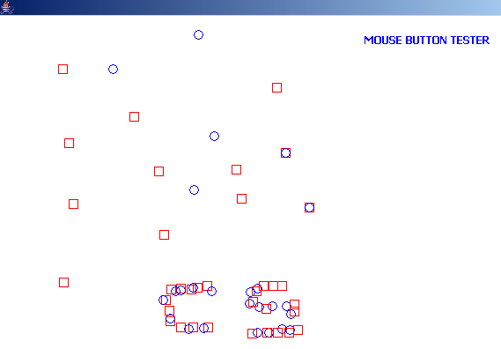
Sample Output :
Google the MouseEvent docs online for additional help.

MouseEvent methods
getX() – gets X position
getY() – gets Y position
getButton() – gets button #

MouseEvent fields
BUTTON1
BUTTON2
BUTTON3

