OKR Report:S3_W2

## 2021-07-08 20:53:45.210857+08:00

# Menu:

Part1: OKR Progress  
Part2:OKRLOG  
Part3:OKR Stats  
Part4:Inventory History  
Part5:Evaluation

# Part1:OKR Progress

~~~~~~~~~~~~~~~~  
|Priority_Task:|  
~~~~~~~~~~~~~~~~  
G3-6-1: DashBoard  
weight:4  
  
 ▏████████████████████████████████████████▕ 100.0%  
  
G3-6-2: WeekFrame  
weight:4  
 K1: Export Reports   
  
 ▏██████████████████████████████ ▕ 75.0%  
  
G3-6-3: OKR Setting  
weight:4  
 K1: Personal Mission Statement Config   
 K2: Seasonal Planning Set Up   
 K3: Goal Section Definition   
  
 ▏ ▕ 0.0%  
  
G3-6-4: OKR Inventory  
weight:4  
 K1: Show Balance   
 K2: Goal Oriented Reward Setting   
 K3: Show Inventory   
 K4: Reward Completion and History   
  
 ▏ ▕ 0.0%  
  
~~~~~~~~~~~~~~~  
|Special_Task:|  
~~~~~~~~~~~~~~~  
G3-6-99: OKR weekly reflection  
weight:2  
 K1: Summarize For this week   
 K2: Plan for Next week   
  
 ▏ ▕ 0.0%  
  
G2-3: Brother for Life  
weight:4  
 K1: Hang out with my Brother   
  
 ▏ ▕ 0.0%  
  
G2-4: Hello Traveller  
weight:6  
  
 ▏████████████████████████████████████████▕ 100.0%  
  
G4-1: Uchicago Ready  
weight:2  
  
 ▏████████████████████████████████████████▕ 100.0%  
  
G4-2: Landing your first job  
weight:6  
 K1: Update the Resume   
 K2: Build Profile on Major Platforms   
 K3: Send 50 companies your resume   
  
 ▏ ▕ 0.0%  
  
~~~~~~~~~~~~~~~~~  
|Recursive_Task:|  
~~~~~~~~~~~~~~~~~  
G1-1: Anti-Purine Diet  
weight:12  
 K1: Take at least 2L of water every day |Counts:1  
 K2: Have P-level below 530 by the end of the week |Counts:1  
  
 ▏█████▋ ▕ 14.3%  
  
G1-2: Have an amazing shape  
weight:10  
 K1: Walk at least 10000 steps every day |Counts:1  
 K2: Complete Keep suggested work out at least 3 out of 7 days |Counts:1  
  
 ▏█████▋ ▕ 14.3%  
  
G1-3: Improve Mental Health  
weight:10  
 K1: Meditate For 2 times (20 min) each day   
 K2: Hit Sleep Score of 80 each day (Sleep by 9.30 p.m) |Counts:1  
  
 ▏██▊ ▕ 7.1%  
  
G2-2: Have Grandma feel non-regrettable and beloved  
weight:6  
 K1: Check all I5 Criterias. |Counts:1  
  
 ▏█████▋ ▕ 14.3%  
  
G3-2: Gain Extracurricular Knowledge on “The fourth Quadrant of cognition”.  
weight:10  
 K1: Letter From Silicon Valley (1+ Every day)   
 K2: WeRead for at least 30 mins.   
  
 ▏ ▕ 0.0%  
  
G3-3: Improve Efficiency  
weight:5  
 K1: Plant 50 Trees this week (Plant 8+ Trees per day) |Counts:1  
  
 ▏█████▋ ▕ 14.3%  
  
G3-4: Pain + Reflection = Progress  
weight:3  
 K1: Review 3 mistakes and comment   
  
 ▏ ▕ 0.0%

# Part2:OKR Log

|  |  |  |  |  |  |
| --- | --- | --- | --- | --- | --- |
| ID | TaskName | Reward | Time | Difficulty | time_stamp |
| P_G3-6-2_K4 | Import from gpk_plan and enable synchronization | 7.0 | 2.5 | 4.0 | 2021-07-07 16:40:47.004642 |
| P_G3-6-1_K1 | Show Week Score Projection | 3.0 | 0.5 | 3.0 | 2021-07-07 17:43:58.491530 |
| S_G2-4_K2 | Update the Travel Plan with Hotel and Travel Details | 7.0 | 2.0 | 3.0 | 2021-07-07 20:10:55.097588 |
| P_G3-6-1_K4 | Show Last Month’s Section Distribution | 4.0 | 0.5 | 3.0 | 2021-07-07 20:14:00.273021 |
| P_G3-6-1_K3 | Show Last 7 Days’ Productivity | 6.0 | 0.5 | 5.0 | 2021-07-07 20:14:09.399205 |
| P_G3-6-1_K2 | Show Recent Tasks (OverDue/Due in N = 3) | 4.0 | 0.7 | 3.0 | 2021-07-07 20:32:48.869820 |
| R_G1-2_K2 | Complete Keep suggested work out at least 3 out of 7 days | 6.0 | 0.1 | 4.0 | 2021-07-07 21:05:46.467613 |
| R_G1-2_K1 | Walk at least 10000 steps every day | 6.0 | 0.6 | 5.0 | 2021-07-07 21:05:56.076102 |
| R_G1-1_K1 | Take at least 2L of water every day | 3.0 | 0.1 | 3.0 | 2021-07-07 21:06:14.872605 |
| P_G3-6-2_K2 | Recurring Tasks Automation | 8.0 | 1.0 | 5.0 | 2021-07-07 21:06:20.787318 |
| R_G1-3_K2 | Hit Sleep Score of 80 each day (Sleep by 9.30 p.m) | 6.0 | 0.0 | 8.0 | 2021-07-07 21:06:51.190823 |
| R_G2-2_K1 | Check all I5 Criterias. | 3.0 | 0.0 | 3.0 | 2021-07-07 21:06:59.928702 |
| R_G3-3_K1 | Plant 50 Trees this week (Plant 8+ Trees per day) | 4.0 | 0.0 | 8.0 | 2021-07-07 21:07:07.625150 |
| S_G2-4_K1 | Order Hotels | 5.0 | 0.3 | 3.0 | 2021-07-07 21:43:59.911967 |
| R_G1-1_K2 | Have P-level below 530 by the end of the week | 4.0 | 0.0 | 5.0 | 2021-07-07 21:44:41.753424 |
| S_G4-1_K1 | Create CNetID | 3.0 | 0.2 | 1.0 | 2021-07-08 08:02:27.911172 |
| S_G4-1_K3 | Register Student ID Card | 6.0 | 0.0 | 3.0 | 2021-07-08 08:23:28.839137 |
| S_G4-1_K2 | Set Official Email | 5.0 | 0.1 | 3.0 | 2021-07-08 08:23:38.202919 |
| P_G3-6-2_K3 | Recurring Task Config | 9.0 | 4.0 | 5.0 | 2021-07-08 12:35:33.120418 |

# Part3:OKR Statistics

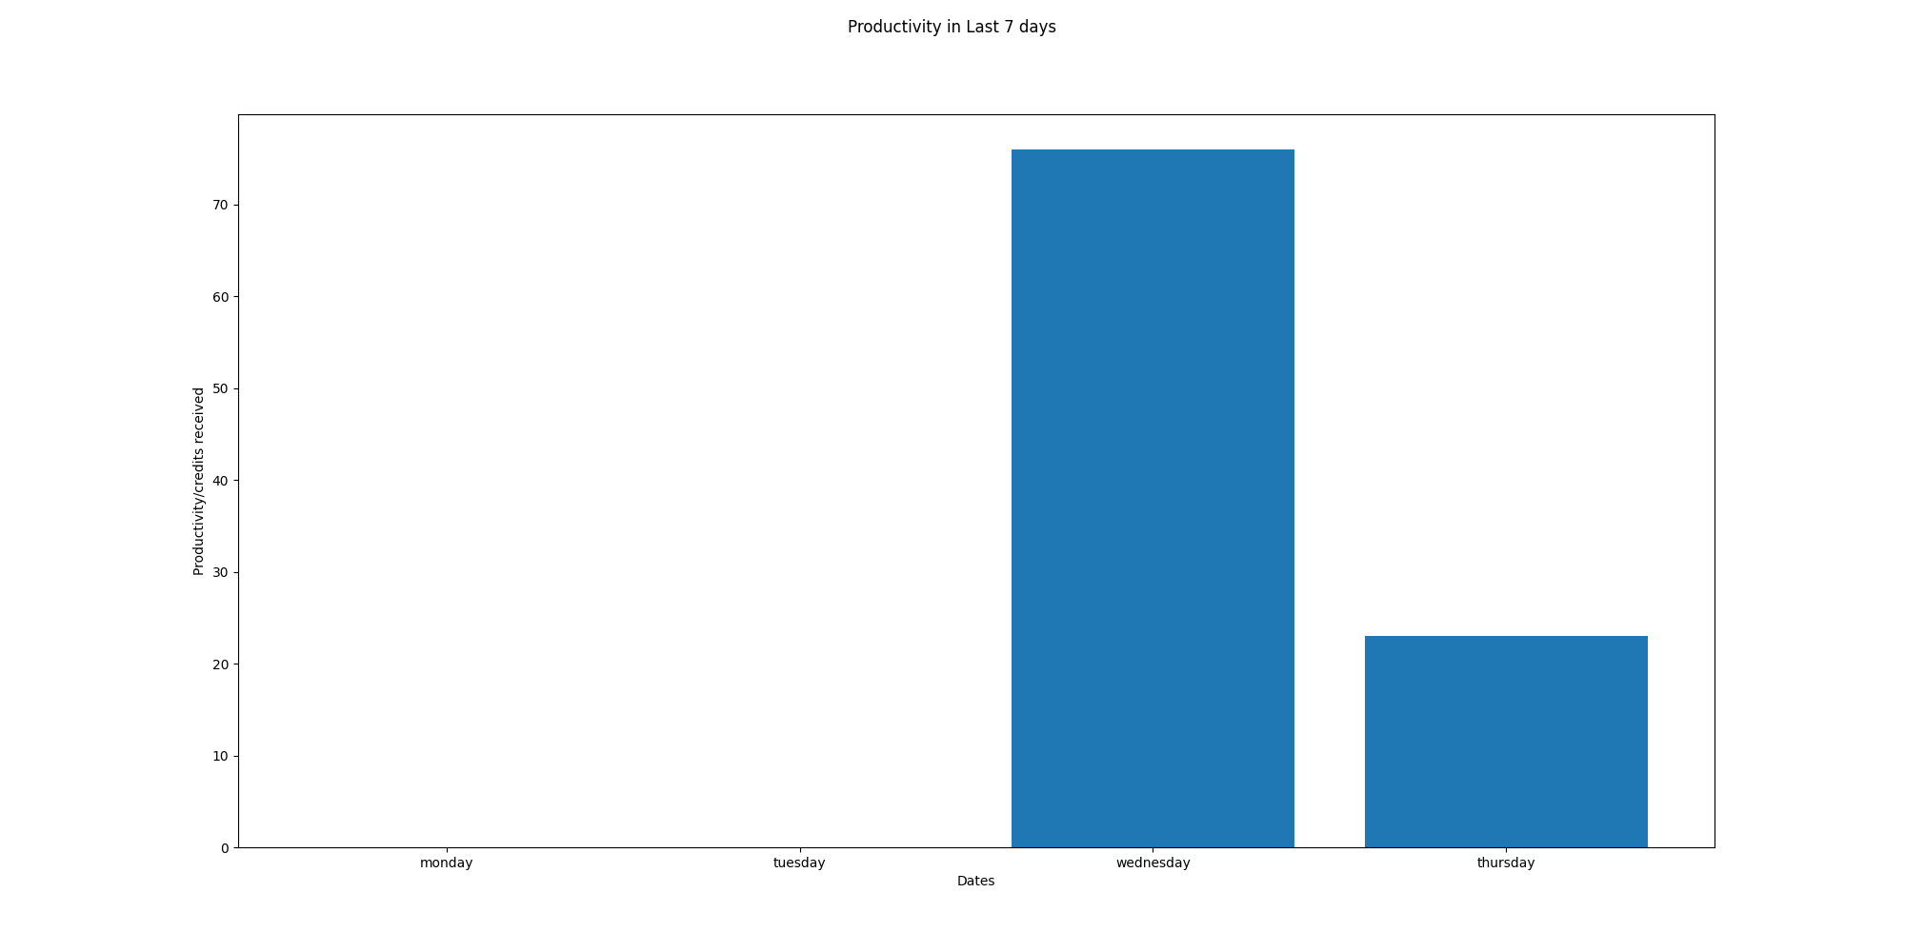

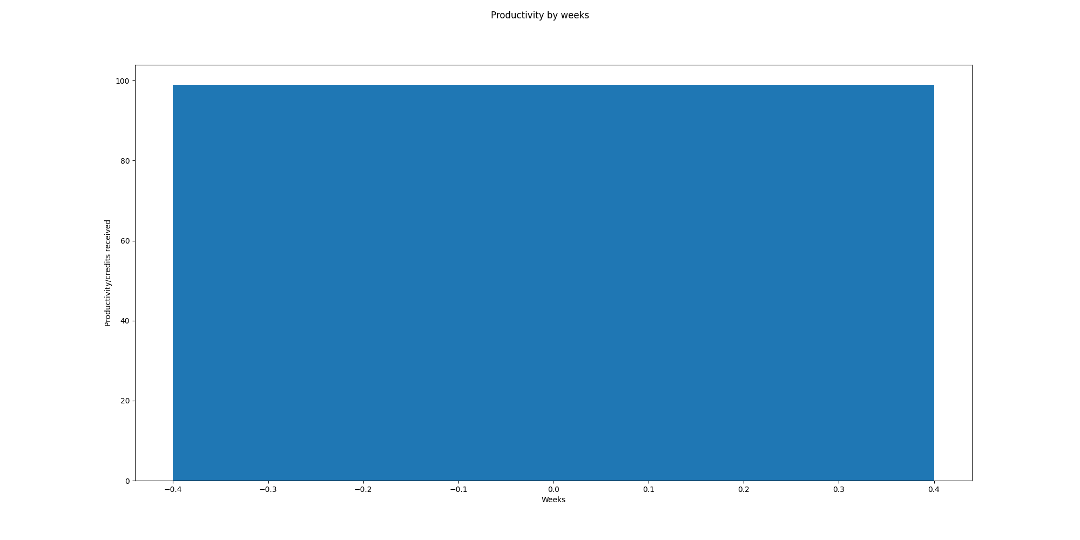

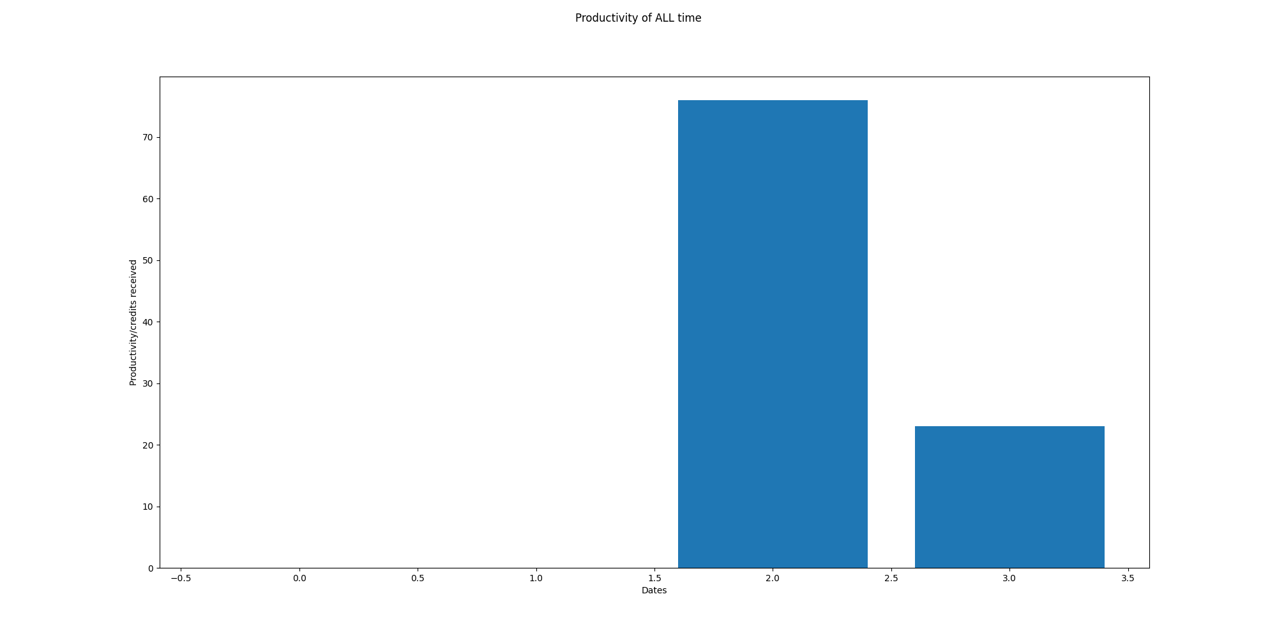

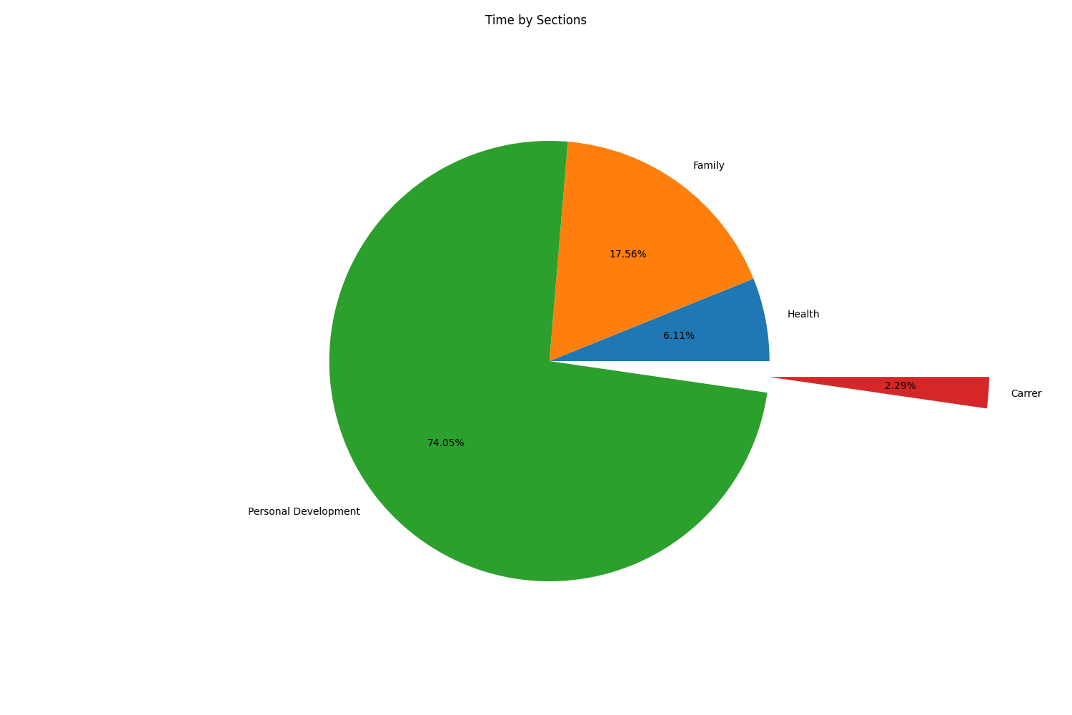

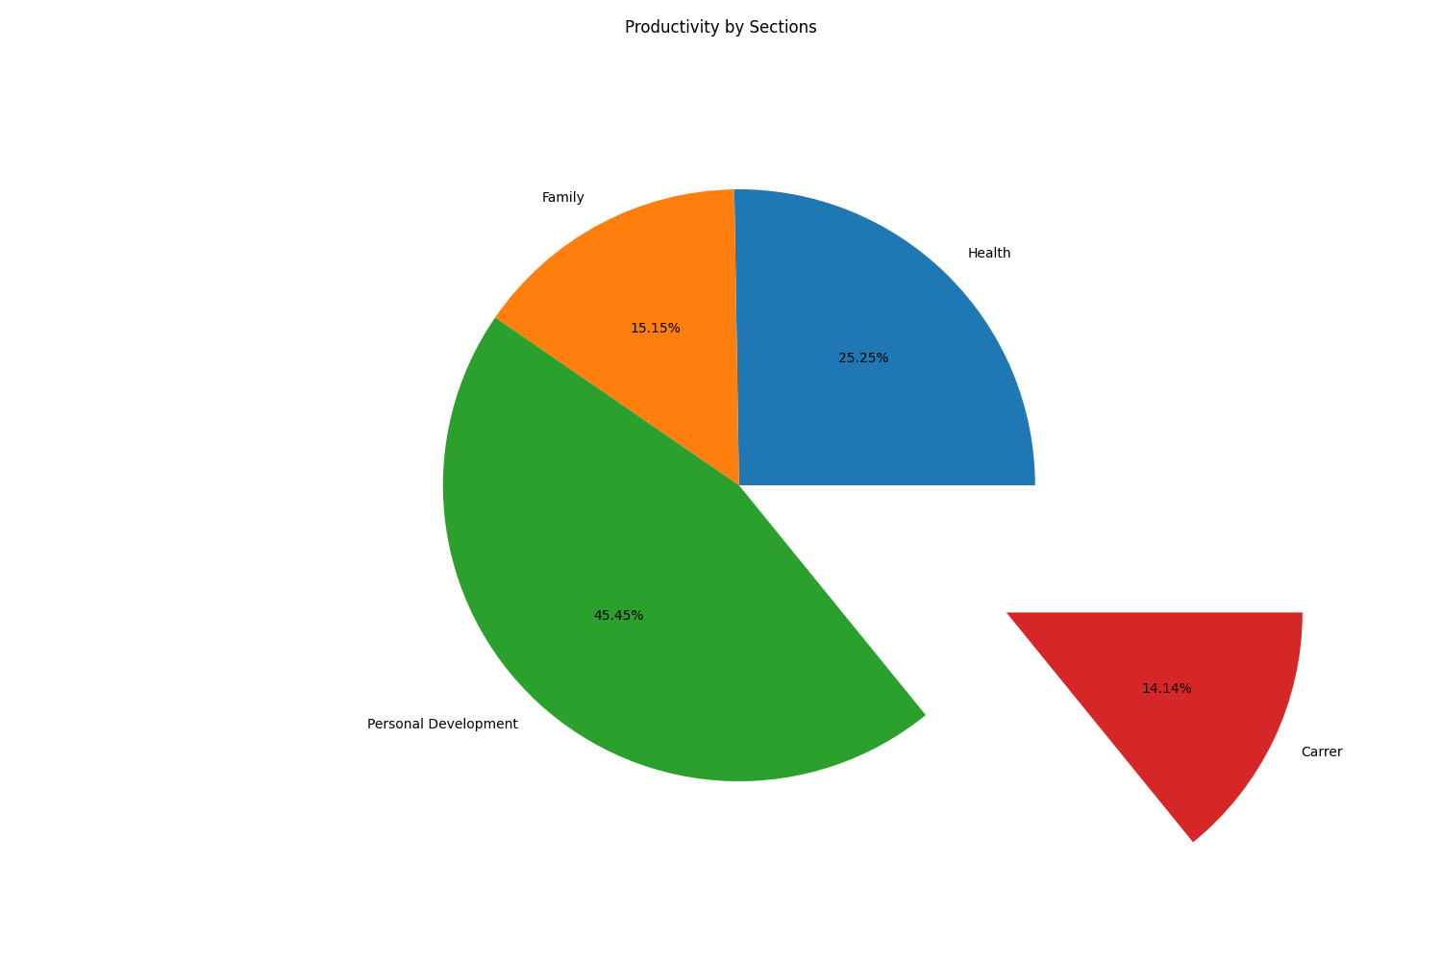

# Part5:OKR Weekly Evaluation

Total Score:22.20496894409938  
Letter Grade:F

