OKR Report:S3_W3

## 2021-07-18 00:19:50.008193+08:00

# Menu:

Part1: OKR Progress  
Part2:OKRLOG  
Part3:OKR Stats  
Part4:Inventory History  
Part5:Evaluation

# Part1:OKR Progress

~~~~~~~~~~~~~~~~  
|Priority_Task:|  
~~~~~~~~~~~~~~~~  
G4-2: Landing your first job  
weight:12  
 K3: Send 50 companies your resume   
  
  
 ▏██████████████████████████▋_____________▕ 66.7%  
  
G4-1: Uchicago Prep  
weight:4  
  
  
 ▏████████████████████████████████████████▕ 100.0%  
  
~~~~~~~~~~~~~~~  
|Special_Task:|  
~~~~~~~~~~~~~~~  
G3-6-6: OKR Daily Reflection  
weight:6  
 K1: Python Implementation   
  
  
 ▏________________________________________▕ 0.0%  
  
G1-1: Anti-Purine Diet  
weight:3  
 K2: Have P-level below 530 by the end of the week   
  
  
 ▏________________________________________▕ 0.0%  
  
G3-6-99: OKR weekly reflection  
weight:2  
  
  
 ▏████████████████████████████████████████▕ 100.0%  
  
G3-6-4: OKR Reflection  
weight:6  
  
  
 ▏████████████████████████████████████████▕ 100.0%  
  
G3-6-5: OKR Notion Integration  
weight:4  
  
  
 ▏████████████████████████████████████████▕ 100.0%  
  
~~~~~~~~~~~~~~~~~  
|Recursive_Task:|  
~~~~~~~~~~~~~~~~~  
G1-1: Anti-Purine Diet  
weight:10  
 K1: Take at least 3L of water every day |Counts:4  
  
  
 ▏██████████████████████▊_________________▕ 57.1%  
  
G1-2: Have an amazing shape  
weight:8  
 K1: Walk at least 10000 steps every day |Counts:5  
 K2: Active time reach 60 mins |Counts:2  
  
  
 ▏███████████████████▉____________________▕ 50.0%  
  
G1-3: Improve Mental Health  
weight:8  
 K1: Meditate For 2 times (20 min) each day  |Counts:3  
 K2:  Construct Buildings (Sleep by 10 |Counts:3  
  
  
 ▏█████████████████▏______________________▕ 42.9%  
  
G3-3: Improve Efficiency  
weight:5  
 K1: Plant 50 Trees this week (Plant 8+ Trees per day)  |Counts:4  
  
  
 ▏██████████████████████▊_________________▕ 57.1%  
  
G2-4: Have she feel secure  
weight:6  
 K1: Spend Quality time w/ JAC  |Counts:4  
  
  
 ▏██████████████████████▊_________________▕ 57.1%

# Part2:OKR Log

|  |  |  |  |  |  |  |
| --- | --- | --- | --- | --- | --- | --- |
| ID | TaskName | Reward | Time | Difficulty | time_stamp | Quadrant |
| R_G1-3_K1 | Meditate For 2 times (20 min) each day | 9.0 | 1.0 | 7.0 | 2021-07-11 08:40:22.317879 | nan |
| R_G1-3_K2 | Hit Sleep Score of 80 each day (Sleep by 9.30 p.m) | 6.0 | 0.0 | 8.0 | 2021-07-11 08:40:29.700643 | nan |
| S_G2-3_K1 | Hang out with my Brother | 8.0 | 3.0 | 1.0 | 2021-07-11 08:41:04.232068 | nan |
| R_G1-2_K1 | Walk at least 10000 steps every day | 7.0 | 0.5 | 5.0 | 2021-07-11 23:36:30.371863 | nan |
| R_G3-2_K1 | Letter From Silicon Valley (1+ Every day) | 4.0 | 0.5 | 2.0 | 2021-07-11 23:36:40.034372 | nan |
| R_G1-1_K1 | Take at least 2L of water every day | 2.0 | 0.5 | 3.0 | 2021-07-11 23:36:50.899371 | nan |
| S_G3-6_K100 | GPK demo meeting w/ ZU | 8.0 | 1.6 | 3.0 | 2021-07-11 23:42:25.068028 | nan |
| S_G2-3_K99 | Family time | 6.0 | 4.0 | 1.0 | 2021-07-11 23:44:09.036729 | nan |
| P_G4-2_K1 | Update the Resume | 8.0 | 1.6 | 4.0 | 2021-07-12 11:29:09.629482 | nan |
| S_G4-1_K99 | Update Transcript Status | 3.0 | 0.1 | 1.0 | 2021-07-12 11:40:29.970755 | nan |
| R_G1-3_K1 | Meditate For 2 times (20 min) each day | 6.0 | 0.5 | 7.0 | 2021-07-12 17:37:44.934550 | nan |
| R_G1-1_K1 | Take at least 3L of water every day | 3.0 | 0.0 | 3.0 | 2021-07-12 21:44:29.686860 | nan |
| S_G3-6-4_K1 | Reflect upon the necessity of Principles | 8.0 | 2.0 | 5.0 | 2021-07-12 22:04:59.822754 | nan |
| R_G3-3_K1 | Plant 50 Trees this week (Plant 8+ Trees per day) | 5.0 | 0.0 | 8.0 | 2021-07-12 22:05:44.074440 | nan |
| S_G3-6-4_K2 | Think of ways to integrate Q4 system | 10.0 | 1.0 | 5.0 | 2021-07-12 22:55:13.456389 | nan |
| R_G1-3_K2 | Construct Buildings (Sleep by 10 | 4.0 | 0.0 | 8.0 | 2021-07-12 22:55:19.692052 | nan |
| P_G4-1_K1 | Complete Math Evaluation Exam | 11.0 | 0.83 | 5.0 | 2021-07-13 07:51:10.086906 | nan |
| S_G4-1_K100 | I20 Sevis Transfer | 9.0 | 1.0 | 4.0 | 2021-07-13 17:07:07.336506 | nan |
| S_G4-2_K4 | Rebuild Resume | 12.0 | 3.0 | 6.0 | 2021-07-13 17:07:12.531656 | nan |
| R_G3-3_K1 | Plant 50 Trees this week (Plant 8+ Trees per day) | 5.0 | 0.0 | 8.0 | 2021-07-13 17:07:17.052284 | nan |
| R_G1-2_K1 | Walk at least 10000 steps every day | 7.0 | 0.5 | 7.0 | 2021-07-13 18:08:33.600367 | nan |
| R_G1-1_K1 | Take at least 3L of water every day | 2.0 | 0.0 | 3.0 | 2021-07-13 19:18:52.061123 | nan |
| P_G4-2_K2 | Build Profile on Major Platforms | 7.0 | 1.5 | 3.0 | 2021-07-13 22:23:42.337598 | nan |
| R_G1-3_K2 | Construct Buildings (Sleep by 10 | 4.0 | 0.0 | 8.0 | 2021-07-13 22:23:50.508356 | nan |
| R_G2-4_K1 | Spend Quality time w/ JAC | 10.0 | 4.0 | 2.0 | 2021-07-14 08:01:26.677671 | nan |
| R_G1-2_K1 | Walk at least 10000 steps every day | 7.0 | 1.0 | 7.0 | 2021-07-14 14:39:48.737432 | nan |
| R_G1-2_K2 | Active time reach 60 mins | 5.0 | 0.0 | 5.0 | 2021-07-14 16:10:32.819515 | nan |
| S_G3-6_K5 | Finish V0.2 Planing | 15.0 | 2.5 | 5.0 | 2021-07-14 17:23:07.184133 | nan |
| R_G1-3_K1 | Meditate For 2 times (20 min) each day | 9.0 | 0.5 | 7.0 | 2021-07-14 22:17:13.456581 | nan |
| R_G3-3_K1 | Plant 50 Trees this week (Plant 8+ Trees per day) | 4.0 | 0.0 | 8.0 | 2021-07-15 16:51:19.755747 | nan |
| R_G1-3_K1 | Meditate For 2 times (20 min) each day | 7.0 | 0.5 | 7.0 | 2021-07-15 16:51:37.736737 | nan |
| S_G3-6-3_K4 | Reconstruct Plan Template | 7.0 | 0.5 | 4.0 | 2021-07-15 16:51:48.144683 | nan |
| S_G3-6-5_K1 | Integrate Template API Importing | 17.0 | 6.0 | 6.0 | 2021-07-16 08:40:29.443343 | nan |
| R_G2-4_K1 | Spend Quality time w/ JAC | 11.0 | 4.0 | 2.0 | 2021-07-16 08:44:10.537654 | nan |
| R_G3-3_K1 | Plant 50 Trees this week (Plant 8+ Trees per day) | 6.0 | 0.0 | 8.0 | 2021-07-16 14:02:53.468489 | nan |
| R_G1-2_K1 | Walk at least 10000 steps every day | 6.0 | 0.0 | 7.0 | 2021-07-16 14:03:06.744040 | nan |
| R_G1-2_K2 | Active time reach 60 mins | 7.0 | 1.0 | 5.0 | 2021-07-16 14:03:11.206065 | nan |
| R_G1-1_K1 | Take at least 3L of water every day | 2.0 | 0.0 | 3.0 | 2021-07-16 14:03:15.646786 | nan |
| R_G1-3_K2 | Construct Buildings (Sleep by 10 | 5.0 | 0.0 | 8.0 | 2021-07-16 14:03:24.351330 | nan |
| S_G2-4_K99 | Travel Packing | 3.0 | 1.5 | 1.0 | 2021-07-16 21:04:48.329509 | 1.0 |
| R_G2-4_K1 | Spend Quality time w/ JAC | 10.0 | 10.0 | 2.0 | 2021-07-17 11:34:21.242669 | 2.0 |
| R_G1-1_K1 | Take at least 3L of water every day | 4.0 | 0.0 | 3.0 | 2021-07-17 23:56:10.194927 | 2.0 |
| R_G1-2_K1 | Walk at least 10000 steps every day | 8.0 | 0.0 | 7.0 | 2021-07-17 23:56:22.677572 | 2.0 |
| S_G1-4_K1 | Brain Storming w/ ZU | 6.0 | 2.0 | 1.0 | 2021-07-17 23:59:11.730844 | 1.0 |
| R_G2-4_K1 | Spend Quality time w/ JAC | 10.0 | 8.0 | 2.0 | 2021-07-18 00:19:07.394806 | 2.0 |
| R_G1-2_K1 | Walk at least 10000 steps every day | 9.0 | 0.5 | 7.0 | 2021-07-18 00:19:15.613818 | 2.0 |
| S_G3-6-99_K2 | Plan for Next week | 6.0 | 1.0 | 3.0 | 2021-07-18 00:19:26.340308 | 2.0 |
| S_G3-6-99_K1 | Summarize For this week | 7.0 | 0.5 | 3.0 | 2021-07-18 00:19:39.177723 | 2.0 |

# Part3:OKR Statistics

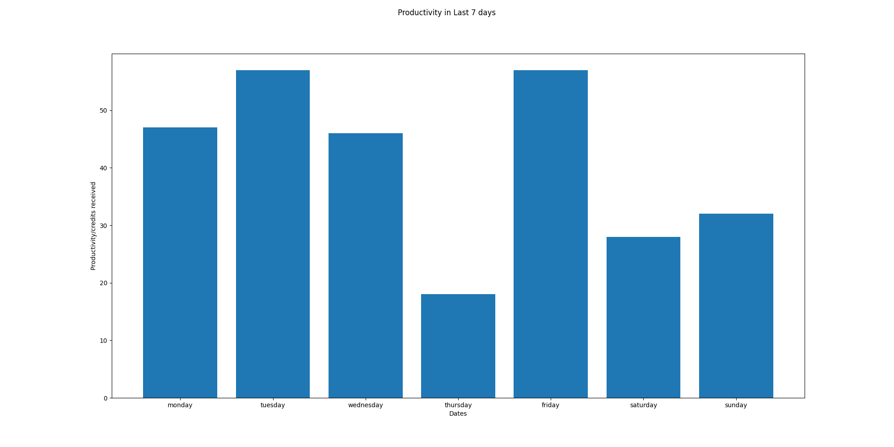

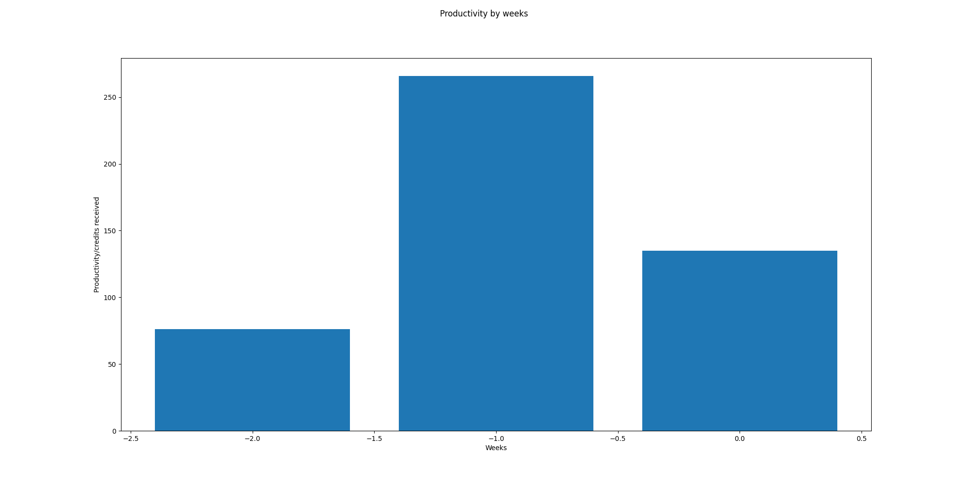

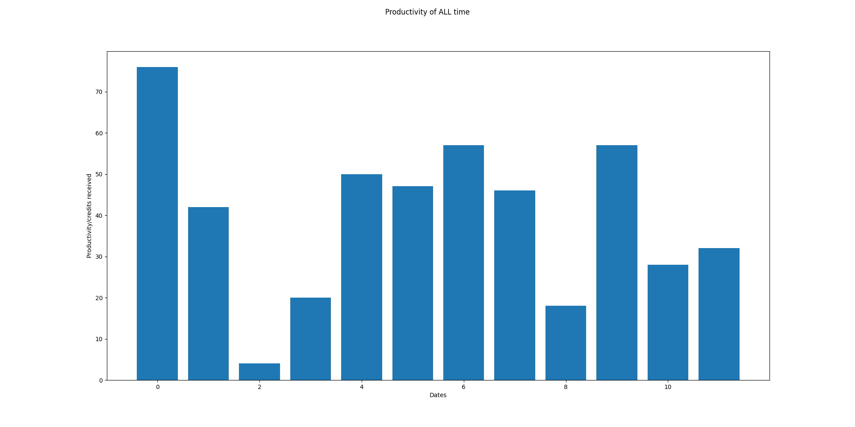

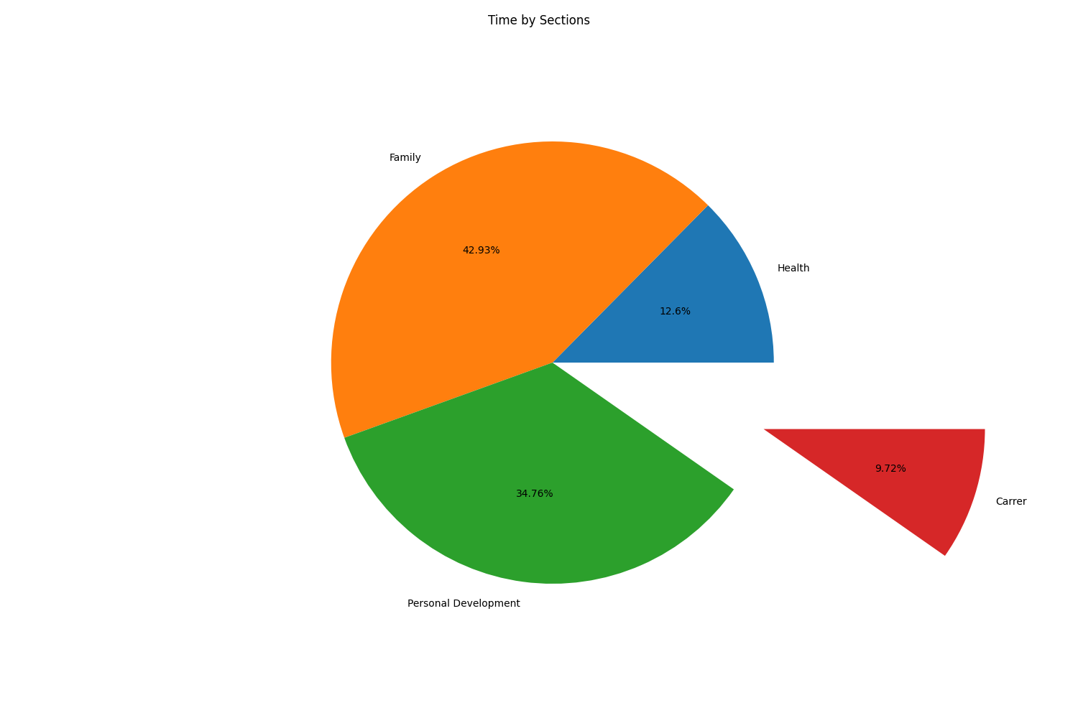

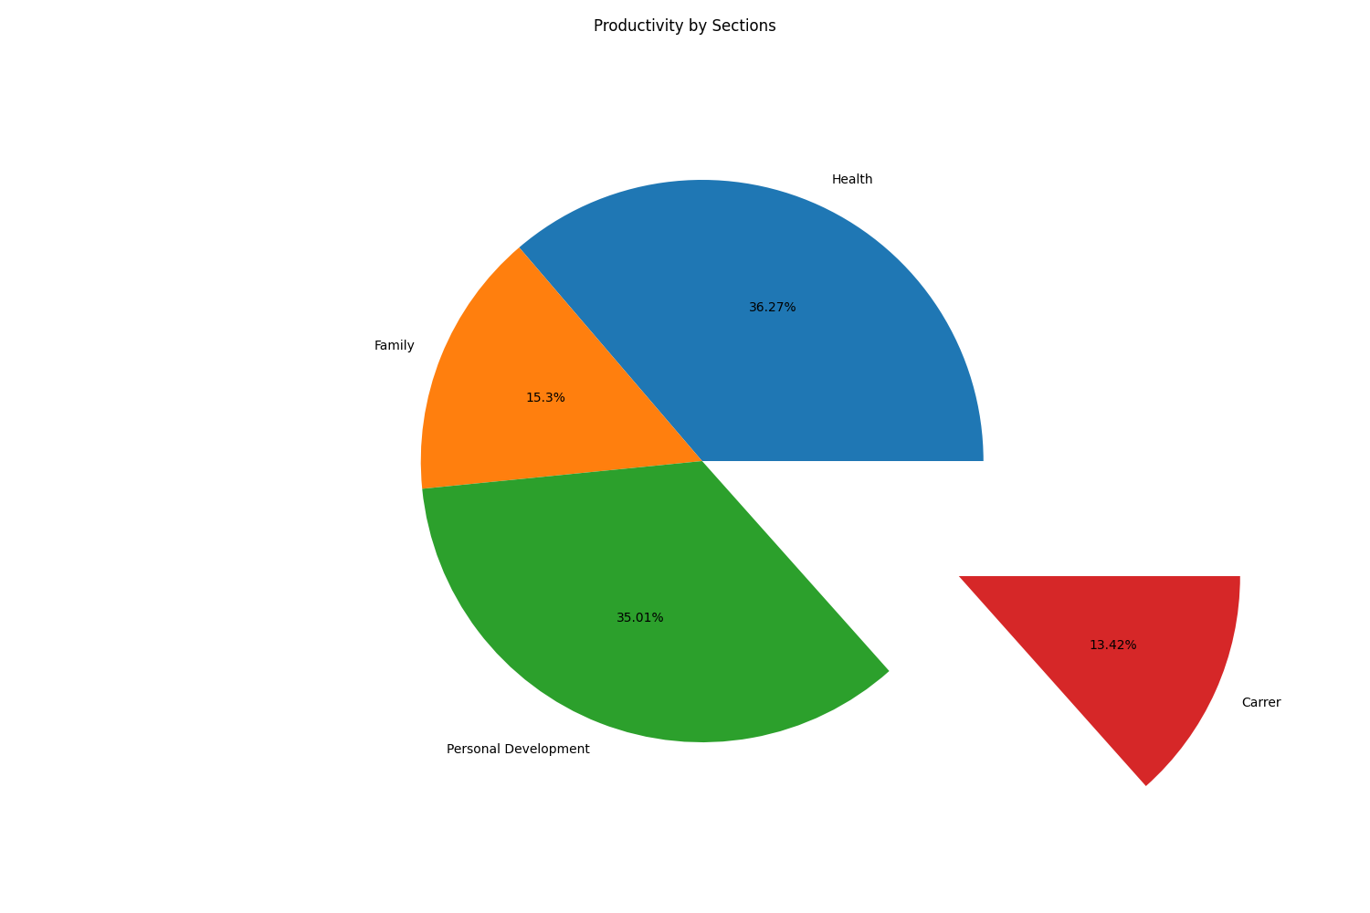

# Part5:OKR Weekly Evaluation

Total Score:58.68725868725869  
Letter Grade:D

