OKR Report:S3_W4

## 2021-07-25 14:05:58.314994+08:00

# Menu:

Part1: OKR Progress  
Part2:OKRLOG  
Part3:OKR Stats  
Part4:Inventory History  
Part5:Evaluation

# Part1:OKR Progress

~~~~~~~~~~~~~~~~  
|Priority_Task:|  
~~~~~~~~~~~~~~~~  
G2-4: Have she felt Secure and Happy on the journey  
weight:12  
  
  
 ▏████████████████████████████████████████▕ 100.0%  
  
~~~~~~~~~~~~~~~  
|Special_Task:|  
~~~~~~~~~~~~~~~  
G3-2: We Read Memoir of Jessie Livermore  
weight:4  
  
  
 ▏████████████████████████████████████████▕ 100.0%  
  
G3-3: Letter from S.V  
weight:4  
  
  
 ▏████████████████████████████████████████▕ 100.0%  
  
G3-6-100: Brain Storm with ZU  
weight:4  
  
  
 ▏████████████████████████████████████████▕ 100.0%  
  
G3-6-6: OKR Daily Reflection  
weight:12  
 K6: Explore and Implement Notion Task List   
  
  
 ▏█████████████████████████████████▎______▕ 83.3%  
  
G1-1: Anti-Purine Diet  
weight:3  
 K2: Have P-level below 530 by the end of the week   
  
  
 ▏________________________________________▕ 0.0%  
  
G3-6-99: OKR weekly reflection  
weight:2  
  
  
 ▏████████████████████████████████████████▕ 100.0%  
  
~~~~~~~~~~~~~~~~~  
|Recursive_Task:|  
~~~~~~~~~~~~~~~~~  
G1-1: Anti-Purine Diet  
weight:10  
 K1: Take at least 3L of water every day |Counts:7  
  
  
 ▏███████████████████████████████████████▉▕ 100.0%  
  
G1-2: Have an amazing shape  
weight:6  
 K1: Walk at least 10000 steps every day |Counts:4  
 K2: Active time reach 60 mins   
  
  
 ▏███████████▍____________________________▕ 28.6%

# Part2:OKR Log

|  |  |  |  |  |  |  |
| --- | --- | --- | --- | --- | --- | --- |
| ID | TaskName | Reward | Time | Difficulty | time_stamp | Quadrant |
| R_G2-4_K1 | Spend Quality time w/ JAC | 10.0 | 8.0 | 2.0 | 2021-07-18 00:19:07.394806 | 2.0 |
| R_G1-2_K1 | Walk at least 10000 steps every day | 9.0 | 0.5 | 7.0 | 2021-07-18 00:19:15.613818 | 2.0 |
| S_G3-6-99_K2 | Plan for Next week | 6.0 | 1.0 | 3.0 | 2021-07-18 00:19:26.340308 | 2.0 |
| S_G3-6-99_K1 | Summarize For this week | 7.0 | 0.5 | 3.0 | 2021-07-18 00:19:39.177723 | 2.0 |
| R_G1-1_K1 | Take at least 3L of water every day | 4.0 | 0.0 | 3.0 | 2021-07-18 23:09:57.672832 | 2.0 |
| R_G1-2_K2 | Active time reach 60 mins | 6.0 | 0.0 | 5.0 | 2021-07-18 23:10:04.916760 | 2.0 |
| P_G2-4_K1 | Let she enjoy the view | 8.0 | 8.0 | 1.0 | 2021-07-19 08:40:07.991666 | 2.0 |
| S_G3-3_K1 | Finish Letter 1-4 | 7.0 | 1.0 | 1.0 | 2021-07-19 08:40:19.699235 | 2.0 |
| R_G1-1_K1 | Take at least 3L of water every day | 2.0 | 0.0 | 3.0 | 2021-07-19 08:40:29.087280 | 2.0 |
| R_G1-2_K1 | Walk at least 10000 steps every day | 7.0 | 0.0 | 7.0 | 2021-07-19 08:40:34.919253 | 2.0 |
| R_G1-2_K1 | Walk at least 10000 steps every day | 9.0 | 1.0 | 7.0 | 2021-07-20 19:32:58.794932 | 2.0 |
| R_G1-1_K1 | Take at least 3L of water every day | 4.0 | 0.0 | 3.0 | 2021-07-20 19:33:03.014715 | 2.0 |
| P_G2-4_K2 | Go anywhere that she please | 8.0 | 8.0 | 1.0 | 2021-07-20 19:33:08.107543 | 2.0 |
| S_G1-99_K99 | Covid Test | 3.0 | 0.2 | 1.0 | 2021-07-21 14:42:48.925446 | 1.0 |
| S_G3-2_K1 | Finish Chapter 2 | 7.0 | 0.5 | 2.0 | 2021-07-21 14:42:57.637202 | 2.0 |
| R_G1-1_K1 | Take at least 3L of water every day | 4.0 | 0.0 | 3.0 | 2021-07-21 23:30:42.248990 | 2.0 |
| R_G1-2_K1 | Walk at least 10000 steps every day | 7.0 | 0.0 | 7.0 | 2021-07-21 23:30:47.305839 | 2.0 |
| P_G2-4_K3 | Pay as much attention to her as you could | 7.0 | 8.0 | 1.0 | 2021-07-21 23:30:53.084806 | 2.0 |
| S_G3-2_K3 | Finish Chapter 4 | 5.0 | 0.5 | 2.0 | 2021-07-22 20:19:46.177884 | 2.0 |
| S_G3-2_K2 | Finish Chapter 3 | 7.0 | 0.5 | 2.0 | 2021-07-22 20:19:54.078602 | 2.0 |
| S_G3-3_K2 | Finish Letter 4-9 | 7.0 | 1.0 | 1.0 | 2021-07-22 20:20:01.563398 | 2.0 |
| P_G2-4_K4 | Take care of everything for her | 8.0 | 8.0 | 1.0 | 2021-07-22 21:52:18.451571 | 2.0 |
| R_G1-1_K1 | Take at least 3L of water every day | 2.0 | 0.0 | 3.0 | 2021-07-22 21:56:31.072813 | 2.0 |
| S_G3-3_K3 | Finish Letter 9-13 | 5.0 | 1.5 | 1.0 | 2021-07-23 10:19:00.270740 | 2.0 |
| S_G4-1_K102 | Insurance Plan | 5.0 | 2.0 | 1.0 | 2021-07-23 15:36:24.856972 | 1.0 |
| S_G3-6-6_K1 | Introduce new features | 10.0 | 3.0 | 3.0 | 2021-07-23 19:00:20.512861 | 2.0 |
| S_G3-6-100_K1 | Discuss on Momento's reflection | 3.0 | 1.0 | 1.0 | 2021-07-23 22:31:20.619304 | 2.0 |
| S_G3-6-100_K2 | Collect User Feedback and advice for improvements | 4.0 | 1.5 | 1.0 | 2021-07-23 22:31:27.347603 | 2.0 |
| R_G1-1_K1 | Take at least 3L of water every day | 2.0 | 0.0 | 3.0 | 2021-07-23 22:31:49.885832 | 2.0 |
| S_G4-1_K101 | Uchicago Transfer In | 6.0 | 2.0 | 3.0 | 2021-07-24 09:17:14.266347 | 1.0 |
| S_G3-6-6_K2 | Design Task List for Q3 | 9.0 | 1.0 | 4.0 | 2021-07-24 10:49:11.529584 | 2.0 |
| S_G3-6-6_K3 | Implement Task List for Q3 | 12.0 | 2.5 | 5.0 | 2021-07-24 13:37:18.790236 | 2.0 |
| S_G3-2_K4 | Finish Chapter 5 | 5.0 | 1.0 | 2.0 | 2021-07-24 17:31:01.889868 | 2.0 |
| R_G1-1_K1 | Take at least 3L of water every day | 2.0 | 0.0 | 3.0 | 2021-07-24 18:23:34.645130 | 2.0 |
| S_G3-6-6_K4 | Blue Print Planning | 8.0 | 1.0 | 3.0 | 2021-07-25 06:04:04.116533 | 2.0 |
| S_G3-6-6_K5 | Integrate all new features | 16.0 | 2.5 | 6.0 | 2021-07-25 11:09:38.909535 | 2.0 |
| R_G1-1_K1 | Take at least 3L of water every day | 2.0 | 0.0 | 3.0 | 2021-07-25 11:10:56.513858 | 2.0 |
| S_G3-6-99_K1 | Summarize For this week | 5.0 | 1.0 | 3.0 | 2021-07-25 13:46:28.134136 | 2.0 |
| S_G3-6-99_K2 | Plan for Next week | 5.0 | 1.5 | 3.0 | 2021-07-25 13:46:34.735179 | 2.0 |
| R_G1-2_K1 | Walk at least 10000 steps every day | 9.0 | 1.0 | 7.0 | 2021-07-25 13:49:05.146650 | 2.0 |

# Part3:OKR Statistics

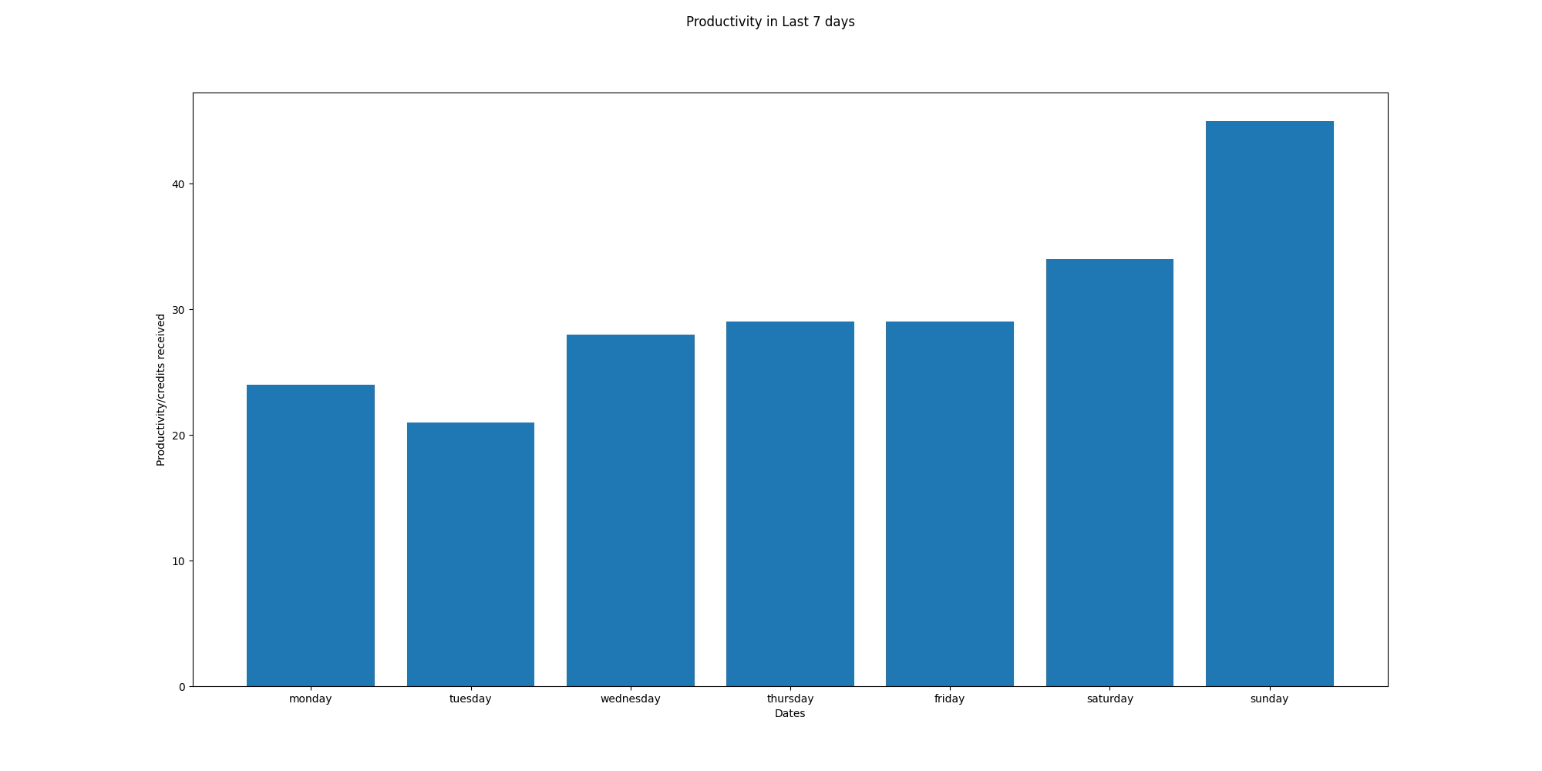

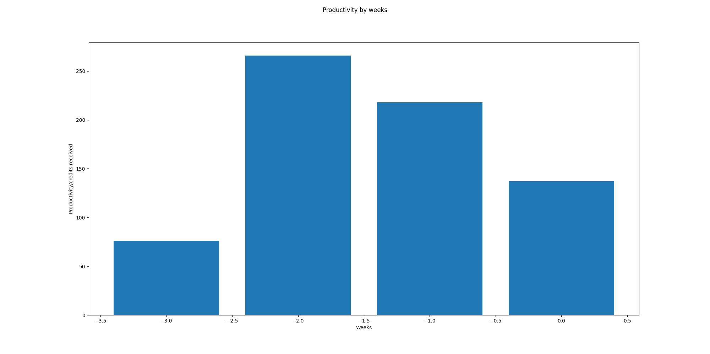

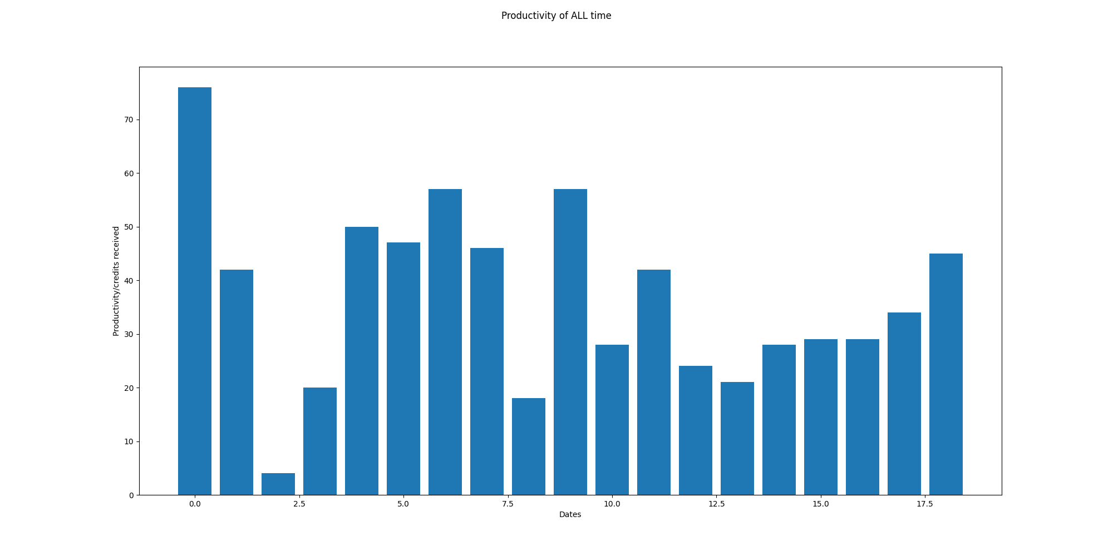

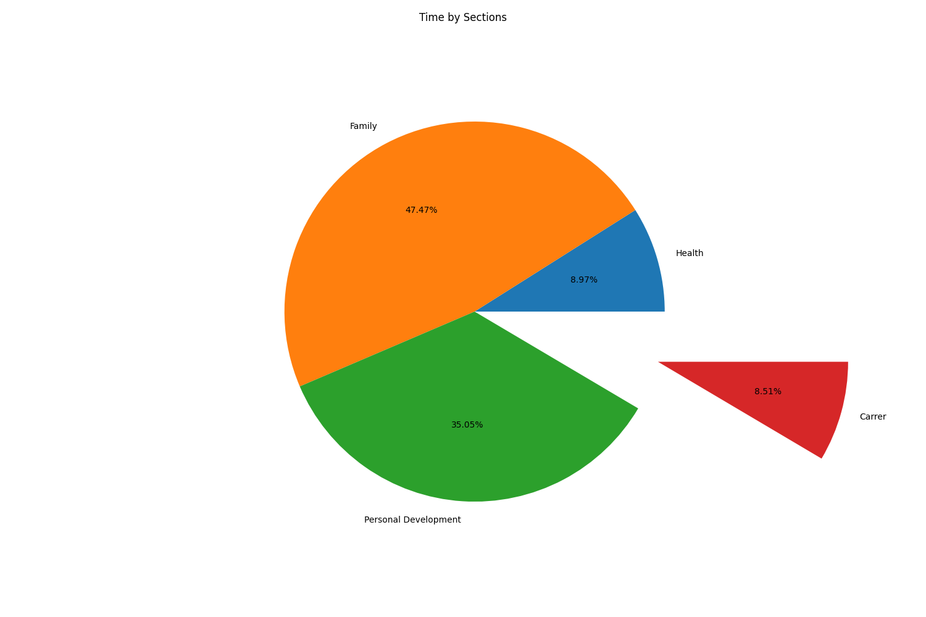

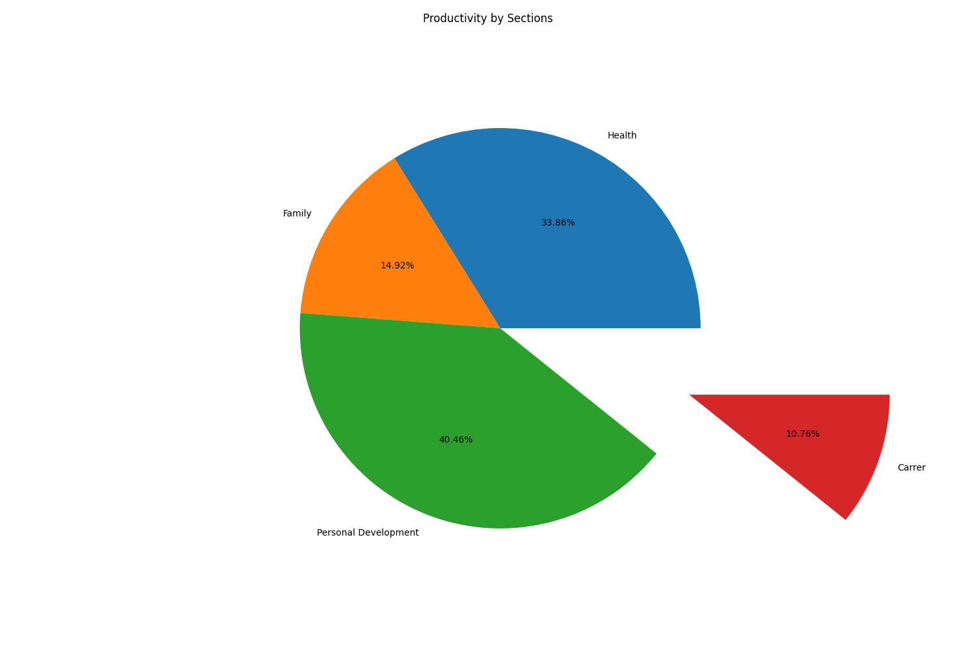

# Part5:OKR Weekly Evaluation

Total Score:83.70927318295739  
Letter Grade:B

