OKR Report:S3_W5

## 2021-08-01 23:05:41.434170+08:00

# Menu:

Part1: OKR Progress  
Part2:OKRLOG  
Part3:OKR Stats  
Part4:Inventory History  
Part5:Evaluation

# Part1:OKR Progress

~~~~~~~~~~~~~~~~  
|Priority_Task:|  
~~~~~~~~~~~~~~~~  
G1-1: Anti-Purine Diet  
weight:9  
  
  
 ▏████████████████████████████████████████▕ 100.0%  
  
G1-2-1: Reboot Life Style  
weight:5  
  
  
 ▏████████████████████████████████████████▕ 100.0%  
  
G4-2-1: Land your first Job  
weight:9  
  
  
 ▏████████████████████████████████████████▕ 100.0%  
  
~~~~~~~~~~~~~~~  
|Special_Task:|  
~~~~~~~~~~~~~~~  
G4-2-2: Know thy Self  
weight:10  
 K5: Set up Road Maps for becoming a Real D.S   
  
  
 ▏████████████████████████████████________▕ 80.0%  
  
G3-2: We Read Memoir of Jessie Livermore  
weight:4  
  
  
 ▏████████████████████████████████████████▕ 100.0%  
  
G3-3: Letter from S.V  
weight:4  
 K1: Finish Letter 13-16   
 K2: Finish Letter 16-20   
 K3: Figure out the 3 lines of C and PD   
  
  
 ▏________________________________________▕ 0.0%  
  
G3-6-100: Brain Storm with ZU  
weight:4  
  
  
 ▏████████████████████████████████████████▕ 100.0%  
  
G3-6-99: OKR weekly reflection  
weight:2  
  
  
 ▏████████████████████████████████████████▕ 100.0%  
  
G3-6-98: OKR Daily Reflection  
weight:1  
  
  
 ▏████████████████████████████████████████▕ 100.0%  
  
G2-1: Keep Grandma Happy  
weight:2  
  
  
 ▏████████████████████████████████████████▕ 100.0%  
  
G2-4-99: Don't Get Mad at her  
weight:2  
  
  
 ▏████████████████████████████████████████▕ 100.0%  
  
G4-5-1-1: Coursera SQL Week 1  
weight:8  
  
  
 ▏████████████████████████████████████████▕ 100.0%  
  
G3-6-6: GPK Today Frame  
weight:4  
 K10: Add Recurs into the Stack Plot too   
  
  
 ▏████████████████████████████████________▕ 80.0%  
  
G3-6-7: GPK Season Frame  
weight:4  
 K1: Allow User to IMPORT Seasonal Plans (doc, Notion)     
 K2: Allow User to Add/Del/Edit Seasonal Plans   
 K3: Allow User to perceive feedback on Seasonal Plans (Assuming Week Plan is derived from Seasonal Plans)   
  
  
 ▏________________________________________▕ 0.0%  
  
G3-7-1: Learn The Basics  
weight:2  
  
  
 ▏████████████████████████████████████████▕ 100.0%  
  
G3-7-2: Construct the PARA System  
weight:2  
  
  
 ▏████████████████████████████████████████▕ 100.0%  
  
~~~~~~~~~~~~~~~~~  
|Recursive_Task:|  
~~~~~~~~~~~~~~~~~  
G2-1: Keep Grandma Happy  
weight:4  
 K2: Check the 5 Criteria each day and Log |Counts:5  
  
  
 ▏████████████████████████████▌___________▕ 71.4%  
  
G1-1: Anti-Purine Diet  
weight:4  
 K1: Take at least 3L of water every day |Counts:6  
  
  
 ▏██████████████████████████████████▎_____▕ 85.7%  
  
G1-2: Have an amazing shape  
weight:6  
 K1: Walk at least 10000 steps every day   
 K2: Active time reach 60 mins   
 K3: Finish KEEP Plan if Applicable |Counts:4  
  
  
 ▏███████▌________________________________▕ 19.0%  
  
G3-6-98: OKR Daily Reflection  
weight:2  
 K2: check out all reflection Qs   |Counts:6  
 K3: Record reports on Notion Archive   |Counts:5  
  
  
 ▏███████████████████████████████▍________▕ 78.6%  
  
G1-3: Improve Mental Health  
weight:4  
 K1: Meditate For 2 times (20 min) each day  |Counts:1  
 K2:  Construct Buildings (Sleep by 10 |Counts:1  
  
  
 ▏█████▋__________________________________▕ 14.3%  
  
G3-3: Improve Efficiency  
weight:3  
 K1: Plant 50 Trees this week (Plant 8+ Trees per day)  |Counts:4  
  
  
 ▏██████████████████████▊_________________▕ 57.1%

# Part2:OKR Log

|  |  |  |  |  |  |  |
| --- | --- | --- | --- | --- | --- | --- |
| ID | TaskName | Reward | Time | Difficulty | time_stamp | Quadrant |
| S_G3-6-6_K4 | Blue Print Planning | 8.0 | 1.0 | 3.0 | 2021-07-25 06:04:04.116533 | 2.0 |
| S_G3-6-6_K5 | Integrate all new features | 16.0 | 2.5 | 6.0 | 2021-07-25 11:09:38.909535 | 2.0 |
| R_G1-1_K1 | Take at least 3L of water every day | 2.0 | 0.0 | 3.0 | 2021-07-25 11:10:56.513858 | 2.0 |
| S_G3-6-99_K1 | Summarize For this week | 5.0 | 1.0 | 3.0 | 2021-07-25 13:46:28.134136 | 2.0 |
| S_G3-6-99_K2 | Plan for Next week | 5.0 | 1.5 | 3.0 | 2021-07-25 13:46:34.735179 | 2.0 |
| R_G1-2_K1 | Walk at least 10000 steps every day | 9.0 | 1.0 | 7.0 | 2021-07-25 13:49:05.146650 | 2.0 |
| S_G3-6-98_K1 | Set up Notion Template for this | 5.0 | 0.5 | 3.0 | 2021-07-26 08:39:10.218808 | 2.0 |
| S_G3-2_K1 | Finish Chapter 7 | 3.0 | 0.2 | 2.0 | 2021-07-26 09:18:54.568831 | 2.0 |
| S_G2-1_K1 | Prepare the 5 Criteria Notion Template for logging | 3.0 | 0.5 | 3.0 | 2021-07-26 10:18:55.198766 | 2.0 |
| P_G1-2-1_K3 | Body Test | 6.0 | 0.5 | 5.0 | 2021-07-26 11:02:56.207054 | 2.0 |
| P_G1-2-1_K2 | Review and redesign your Work out Procedures | 8.0 | 0.1 | 4.0 | 2021-07-26 11:57:52.373772 | 2.0 |
| P_G4-2-1_K1 | Send 10 Companies your resume and record the response | 5.0 | 1.0 | 4.0 | 2021-07-26 13:57:34.244935 | 2.0 |
| S_G4-2-2_K3 | Collect 20 Job Descriptions of a DS Title | 4.0 | 0.6 | 1.0 | 2021-07-26 14:22:13.085646 | 2.0 |
| R_G1-3_K1 | Meditate For 2 times (20 min) each day | 8.0 | 1.0 | 7.0 | 2021-07-26 15:07:04.612612 | 2.0 |
| R_G1-2_K3 | Finish KEEP Plan if Applicable | 7.0 | 0.0 | 5.0 | 2021-07-26 16:24:31.309794 | 2.0 |
| S_G3-7-2_K1 | Learn about PARA in detail | 10.0 | 0.5 | 3.0 | 2021-07-26 17:10:05.871501 | 2.0 |
| S_G3-6_K100 | Study Zu's Notion Template | 8.0 | 0.5 | 3.0 | 2021-07-26 17:28:51.560768 | 1.0 |
| R_G1-1_K1 | Take at least 3L of water every day | 3.0 | 0.0 | 3.0 | 2021-07-26 19:58:22.948704 | 2.0 |
| S_G4-2-2_K0 | Schedule Meeting with specialists | 6.0 | 0.5 | 3.0 | 2021-07-26 19:59:31.598646 | 2.0 |
| S_G4-5-1-1_K1 | Explore coursera SQL course from Duke. | 5.0 | 0.7 | 3.0 | 2021-07-26 21:10:59.747462 | 2.0 |
| R_G3-6-98_K2 | check out all reflection Qs | 3.0 | 0.5 | 3.0 | 2021-07-26 21:38:08.380431 | 2.0 |
| R_G3-6-98_K3 | Record reports on Notion Archive | 2.0 | 0.1 | 3.0 | 2021-07-26 21:38:13.151519 | 2.0 |
| P_G1-1_K99 | Check weather it's okay to take meds | 7.0 | 0.5 | 5.0 | 2021-07-27 09:01:20.496512 | 2.0 |
| S_G4-1_K101 | Dipolma Procedures | 2.0 | 0.7 | 1.0 | 2021-07-27 09:01:27.397866 | 1.0 |
| P_G4-2-1_K2 | Send 20 Companies your resume and record the response | 3.0 | 0.5 | 4.0 | 2021-07-27 09:38:49.650658 | 2.0 |
| S_G2-4-99_K1 | For JAC and Greater good, let it pass | 3.0 | 0.5 | 3.0 | 2021-07-27 12:01:26.553951 | 2.0 |
| S_G4-2-2_K1 | Get Feedback from 1 professionals about your resume | 12.0 | 0.5 | 5.0 | 2021-07-27 12:02:50.186673 | 2.0 |
| S_G4-2-1_K99 | Internship Interview | 5.0 | 0.5 | 3.0 | 2021-07-27 17:00:32.027062 | 1.0 |
| R_G1-2_K3 | Finish KEEP Plan if Applicable | 5.0 | 0.5 | 5.0 | 2021-07-27 17:34:28.766687 | 2.0 |
| R_G1-1_K1 | Take at least 3L of water every day | 3.0 | 0.0 | 3.0 | 2021-07-27 18:18:45.906450 | 2.0 |
| S_G4-5-1-1_K2 | Lesson 1, Problems Database Solve | 5.0 | 1.0 | 3.0 | 2021-07-27 19:59:12.000502 | 2.0 |
| S_G3-7-2_K2 | Build Your OWN P.A.R.A | 12.0 | 3.0 | 3.0 | 2021-07-27 22:20:31.024603 | 2.0 |
| P_G4-2-1_K3 | Send 30 Companies your resume and record the response | 4.0 | 0.5 | 4.0 | 2021-07-28 14:28:21.422650 | 2.0 |
| S_G3-6-6_K6 | Explore Notion todo on JN | 13.0 | 3.0 | 6.0 | 2021-07-28 14:28:31.394938 | 2.0 |
| R_G1-2_K3 | Finish KEEP Plan if Applicable | 5.0 | 0.5 | 5.0 | 2021-07-28 19:27:51.784037 | 2.0 |
| S_G3-6-6_K7 | Design and Implement Fetching | 12.0 | 3.0 | 6.0 | 2021-07-28 22:34:33.984419 | 2.0 |
| S_G3-6-6_K8 | Design and Implement Pushing | 13.0 | 3.0 | 6.0 | 2021-07-28 22:34:40.309783 | 2.0 |
| S_G3-6-100_K1 | Discuss Possibility on long term partnership | 5.0 | 1.0 | 4.0 | 2021-07-28 22:36:10.857014 | 2.0 |
| S_G3-6-100_K2 | Collect User Feedback and advice for improvements | 4.0 | 1.0 | 1.0 | 2021-07-28 22:36:15.534875 | 2.0 |
| R_G2-1_K2 | Check the 5 Criteria each day and Log | 4.0 | 0.1 | 3.0 | 2021-07-28 22:51:47.528673 | 2.0 |
| S_G2-4-99_K2 | For JAC and Greater good, let it pass | 4.0 | 0.1 | 3.0 | 2021-07-29 17:59:30.338993 | 2.0 |
| P_G4-2-1_K5 | Send 50 Companies your resume and record the response | 3.0 | 0.5 | 4.0 | 2021-07-29 17:59:30.344971 | 2.0 |
| P_G4-2-1_K4 | Send 40 Companies your resume and record the response | 5.0 | 0.5 | 4.0 | 2021-07-29 17:59:30.349953 | 2.0 |
| S_G3-6-6_K9 | Design and Implement Syncing | 11.0 | 3.0 | 6.0 | 2021-07-29 17:59:30.354934 | 2.0 |
| P_G1-1_K2 | Have P-level below 580 by the end of the week | 4.0 | 0.0 | 5.0 | 2021-07-29 17:59:30.360913 | 2.0 |
| R_G3-3_K1 | Plant 50 Trees this week (Plant 8+ Trees per day) | 5.0 | 0.0 | 8.0 | 2021-07-29 17:59:30.364898 | 2.0 |
| S_G4-2-2_K2 | Get Feedback from 2 professionals about your resume | 13.0 | 0.1 | 5.0 | 2021-07-29 18:39:39.023500 | 2.0 |
| S_G4-5-1-1_K3 | Lesson 2, Database Design Tools | 5.0 | 0.8 | 3.0 | 2021-07-29 22:10:04.867182 | 2.0 |
| R_G2-1_K2 | Check the 5 Criteria each day and Log | 4.0 | 0.5 | 3.0 | 2021-07-29 22:10:04.873160 | 2.0 |
| S_G2-4-99_K2 | For JAC and Greater good, let it pass | 4.0 | 0.1 | 3.0 | 2021-07-29 22:10:04.880798 | 2.0 |
| S_G4-2-2_K2 | Get Feedback from 2 professionals about your resume | 12.0 | 3.0 | 5.0 | 2021-07-29 22:10:04.887066 | 2.0 |
| P_G4-2-1_K5 | Send 50 Companies your resume and record the response | 3.0 | 0.5 | 4.0 | 2021-07-29 22:10:04.893040 | 2.0 |
| P_G4-2-1_K4 | Send 40 Companies your resume and record the response | 3.0 | 0.5 | 4.0 | 2021-07-29 22:10:04.899019 | 2.0 |
| P_G1-1_K3 | Have P-level below 550 by the end of the week | 4.0 | 0.0 | 5.0 | 2021-07-29 22:10:04.904001 | 2.0 |
| S_G3-6-6_K9 | Design and Implement Syncing | 11.0 | 3.0 | 6.0 | 2021-07-29 22:10:04.909979 | 2.0 |
| R_G1-1_K1 | Take at least 3L of water every day | 3.0 | 0.0 | 3.0 | 2021-07-29 22:10:04.914961 | 2.0 |
| R_G3-6-98_K3 | Record reports on Notion Archive | 2.0 | 0.3 | 3.0 | 2021-07-29 22:10:04.920939 | 2.0 |
| R_G3-6-98_K2 | check out all reflection Qs | 4.0 | 0.2 | 3.0 | 2021-07-29 22:10:04.925920 | 2.0 |
| P_G1-1_K2 | Have P-level below 580 by the end of the week | 4.0 | 0.0 | 5.0 | 2021-07-29 22:10:04.931899 | 2.0 |
| R_G3-3_K1 | Plant 50 Trees this week (Plant 8+ Trees per day) | 5.0 | 0.0 | 8.0 | 2021-07-29 22:10:04.937877 | 2.0 |
| R_G1-3_K2 | Construct Buildings (Sleep by 10 | 3.0 | 0.0 | 8.0 | 2021-07-29 22:10:04.942859 | 2.0 |
| R_G3-3_K1 | Plant 50 Trees this week (Plant 8+ Trees per day) | 3.0 | 0.0 | 8.0 | 2021-07-30 22:00:53.892726 | 2.0 |
| R_G3-6-98_K3 | Record reports on Notion Archive | 2.0 | 0.3 | 3.0 | 2021-07-30 22:00:53.902690 | 2.0 |
| R_G1-1_K1 | Take at least 3L of water every day | 3.0 | 0.0 | 3.0 | 2021-07-30 22:00:53.913650 | 2.0 |
| R_G2-1_K2 | Check the 5 Criteria each day and Log | 4.0 | 0.5 | 3.0 | 2021-07-30 22:00:53.920625 | 2.0 |
| S_G4-5-1-1_K4 | Lesson 3, Building Your Own Entity-Relationship Diagrams | 8.0 | 2.0 | 3.0 | 2021-07-30 22:00:53.930589 | 2.0 |
| S_G3-2_K2 | Finish Chapter 8 | 2.0 | 0.5 | 2.0 | 2021-07-30 22:00:53.938560 | 2.0 |
| S_G4-2-2_K4 | Analyze the Job Descriptions and see where you are | 6.0 | 1.0 | 3.0 | 2021-07-30 22:00:53.945534 | 2.0 |
| R_G1-2_K3 | Finish KEEP Plan if Applicable | 8.0 | 1.0 | 5.0 | 2021-07-30 22:00:53.952509 | 2.0 |
| S_G3-6-6_K11 | GPK Notion-Sync Update | 13.0 | 6.0 | 4.0 | 2021-07-30 22:17:31.249564 | 2.0 |
| S_G3-7-1_K1 | Complete Official Course 7-12 | 5.0 | 2.0 | 2.0 | 2021-07-30 22:26:23.088687 | 2.0 |
| R_G3-6-98_K2 | check out all reflection Qs | 4.0 | 0.2 | 3.0 | 2021-07-30 23:22:03.683035 | 2.0 |
| R_G3-6-98_K3 | Record reports on Notion Archive | 3.0 | 0.3 | 3.0 | 2021-07-31 23:16:06.055295 | 2.0 |
| R_G3-6-98_K2 | check out all reflection Qs | 3.0 | 0.2 | 3.0 | 2021-07-31 23:16:06.063296 | 2.0 |
| R_G1-1_K1 | Take at least 3L of water every day | 4.0 | 0.0 | 3.0 | 2021-07-31 23:16:06.073299 | 2.0 |
| R_G2-1_K2 | Check the 5 Criteria each day and Log | 5.0 | 0.5 | 3.0 | 2021-07-31 23:16:06.080300 | 2.0 |
| S_G4-5-1-1_K5 | Lesson 4, Building Your Own Relational Schemas | 6.0 | 1.2 | 3.0 | 2021-07-31 23:16:06.090302 | 2.0 |
| S_G2-4-99_K3 | For JAC and Greater good, let it pass | 2.0 | 0.1 | 3.0 | 2021-07-31 23:16:06.098304 | 2.0 |
| P_G1-1_K4 | Have P-level below 530 by the end of the week | 5.0 | 0.0 | 5.0 | 2021-07-31 23:16:06.111307 | 2.0 |
| R_G3-6-98_K2 | check out all reflection Qs | 2.0 | 0.2 | 3.0 | 2021-07-31 23:16:06.123310 | 2.0 |
| S_G4-2_K100 | Zoom Meeting | 4.0 | 1.0 | 1.0 | 2021-08-01 10:29:45.036108 | 1.0 |
| S_G4-5-1-1_K6 | Lesson 5, Testing your understanding | 5.0 | 0.5 | 3.0 | 2021-08-01 22:56:04.596625 | 2.0 |
| S_G3-6-99_K2 | Plan for Next week | 7.0 | 1.0 | 3.0 | 2021-08-01 22:56:04.604627 | 2.0 |
| S_G3-6-99_K1 | Summarize For this week | 5.0 | 1.0 | 3.0 | 2021-08-01 22:56:04.611629 | 2.0 |
| R_G3-3_K1 | Plant 50 Trees this week (Plant 8+ Trees per day) | 4.0 | 0.0 | 8.0 | 2021-08-01 22:56:43.502477 | 2.0 |
| S_G3-6-6_K12 | Tk Progress bar set up | 11.0 | 3.0 | 5.0 | 2021-08-01 22:57:08.352552 | 2.0 |
| R_G3-6-98_K3 | Record reports on Notion Archive | 2.0 | 0.3 | 3.0 | 2021-08-01 22:59:32.812475 | 2.0 |
| R_G3-6-98_K2 | check out all reflection Qs | 3.0 | 0.2 | 3.0 | 2021-08-01 22:59:32.819477 | 2.0 |
| R_G1-1_K1 | Take at least 3L of water every day | 4.0 | 0.0 | 3.0 | 2021-08-01 22:59:32.826478 | 2.0 |
| R_G2-1_K2 | Check the 5 Criteria each day and Log | 5.0 | 0.5 | 3.0 | 2021-08-01 22:59:32.833480 | 2.0 |

# Part3:OKR Statistics

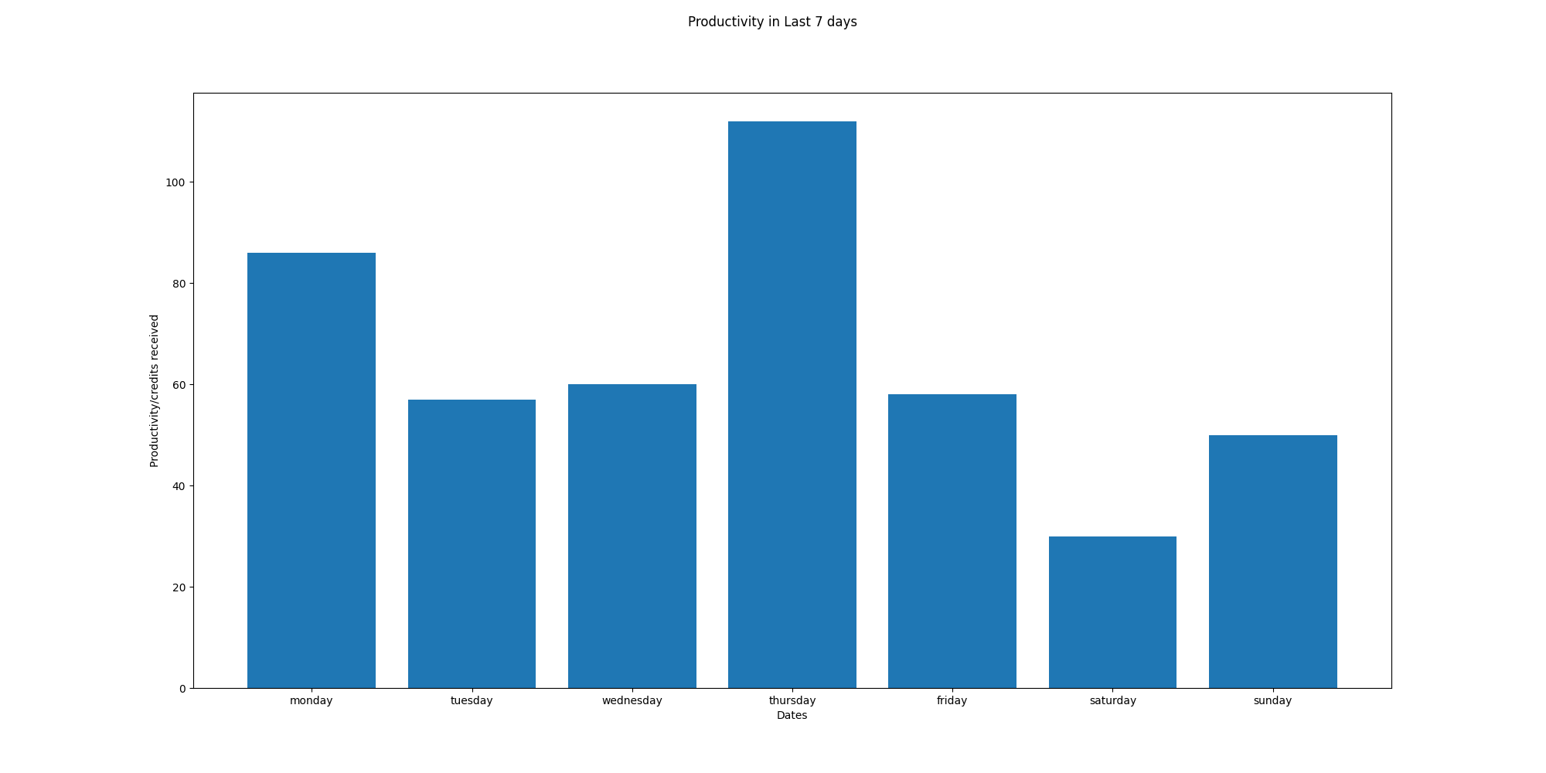

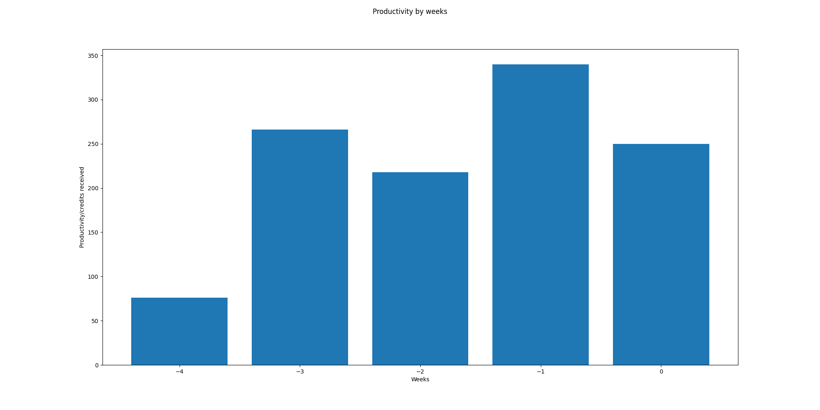

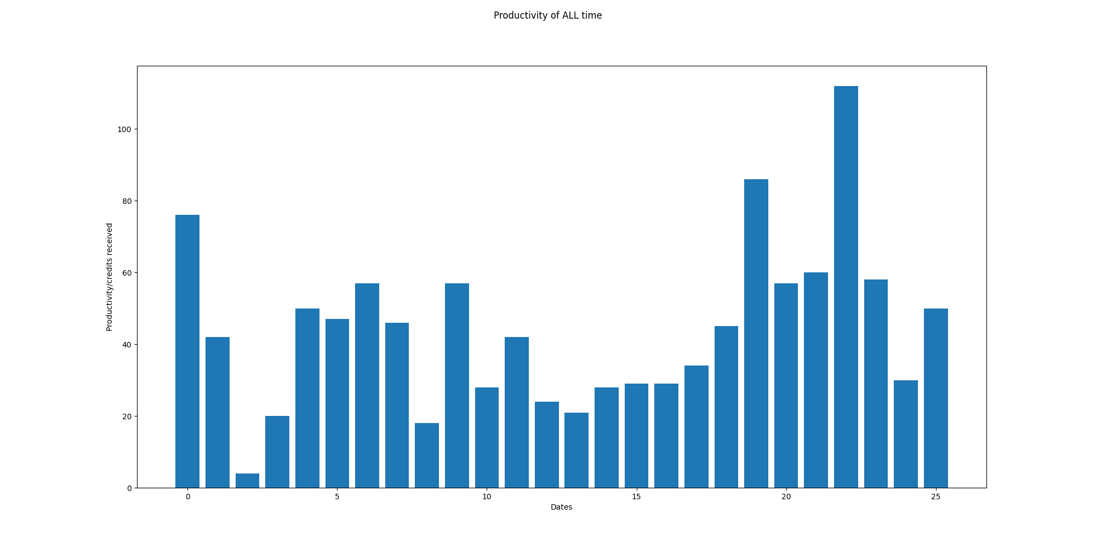

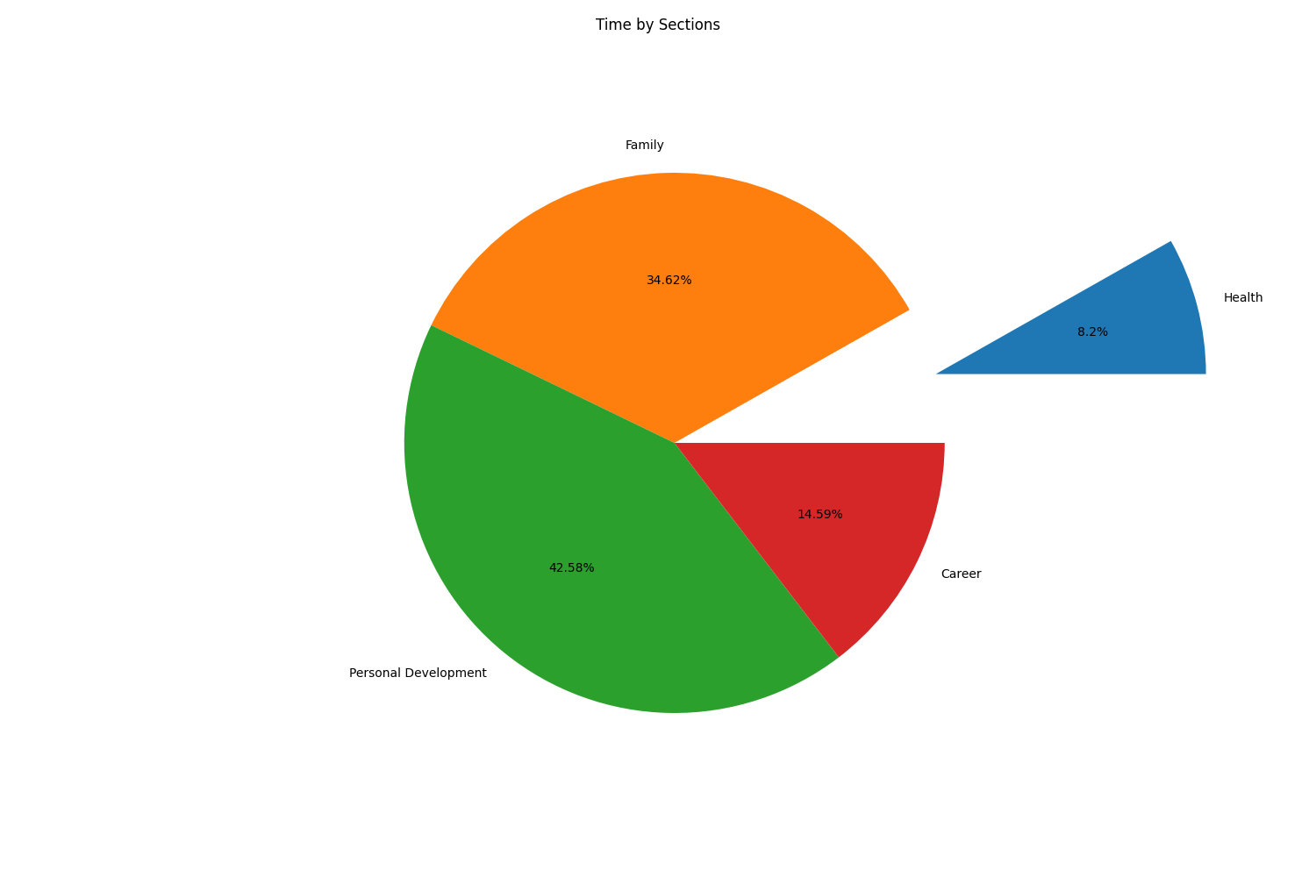

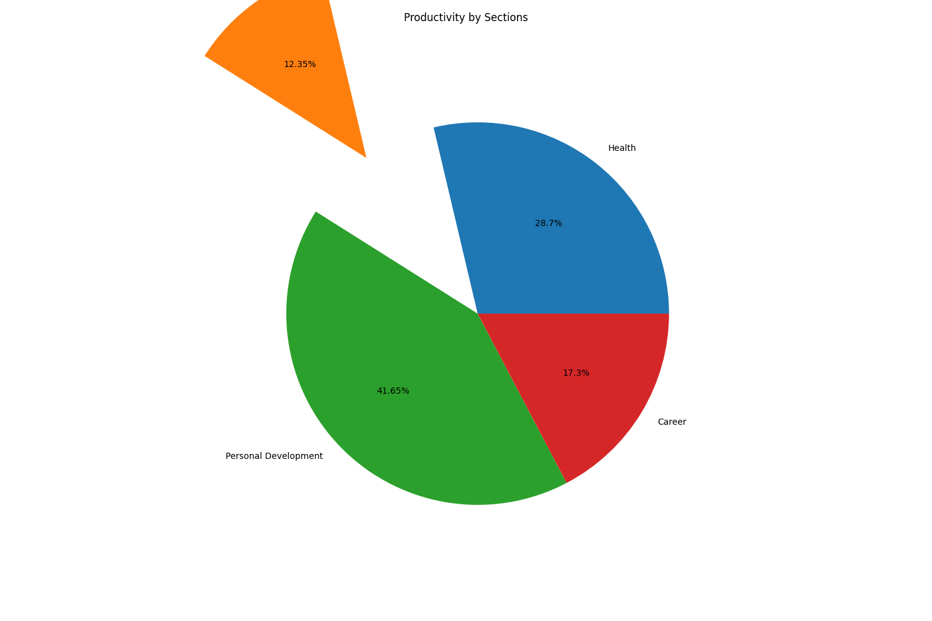

# Part5:OKR Weekly Evaluation

Total Score:76.30075187969925  
Letter Grade:B

