OKR Report:S3_W7

## 2021-08-15 22:26:26.368269+08:00

# Menu:

Part1: OKR Progress  
Part2:OKRLOG  
Part3:OKR Stats  
Part4:Inventory History  
Part5:Evaluation

# Part1:OKR Progress

~~~~~~~~~~~~~~~~  
|Priority_Task:|  
~~~~~~~~~~~~~~~~  
G1-3-1: Life(style) Changer  
weight:6  
 K2: Wake by 8 am   
 K3: Wake by 7 am   
  
  
 ▏█████████████▎__________________________▕ 33.3%  
  
G3-6-3: OKR-Setting Implementation  
weight:8  
 K2: OKR Seasonal Planning   
 K4: Allow user to redefine Orientations   
  
  
 ▏████████████████████____________________▕ 50.0%  
  
G4-2-1: US Intern 2022 further PREP  
weight:8  
 K5: Devise a Actionable plan for job findding   
  
  
 ▏████████████████████████████████________▕ 80.0%  
  
G4-2-2-6: Plan Out the DS Track  
weight:6  
  
  
 ▏████████████████████████████████████████▕ 100.0%  
  
~~~~~~~~~~~~~~~  
|Special_Task:|  
~~~~~~~~~~~~~~~  
G3-6-99: OKR weekly reflection  
weight:2  
  
  
 ▏████████████████████████████████████████▕ 100.0%  
  
G4-5-1-1: Coursera SQL Week 3  
weight:5  
  
  
 ▏████████████████████████████████████████▕ 100.0%  
  
G3-6-100: Brain Storm with ZU  
weight:4  
  
  
 ▏████████████████████████████████████████▕ 100.0%  
  
G4-2-2: US other Preps  
weight:2  
  
  
 ▏████████████████████████████████████████▕ 100.0%  
  
G3-6: GPK Redesigning  
weight:8  
 K1: Fix problem that all recurs are displayed   
 K2: Todo_Section, Add Orientation filter   
 K3: Allow filter and sort in DashBoard   
  
  
 ▏██████████______________________________▕ 25.0%  
  
G4-1-99: Learn to Drive  
weight:6  
 K1: Contact and visit the drive school   
 K2: Start a learning plan for subject1   
 K3: Start learning for subject1   
  
  
 ▏________________________________________▕ 0.0%  
  
G2-2-99: Create OUR-Space on Notion  
weight:6  
 K1: Reaserch for templates   
 K2: Design the structure and content   
 K3: Build the frame work   
  
  
 ▏________________________________________▕ 0.0%  
  
G2-2: Jac's last week  
weight:12  
  
  
 ▏████████████████████████████████████████▕ 100.0%  
  
G1-1: Reboot Weight Projection Project  
weight:6  
 K1: Review what I did   
 K2: Think what do you wish to acomplish   
 K3: Design RoadMap for the Project   
  
  
 ▏________________________________________▕ 0.0%  
  
~~~~~~~~~~~~~~~~~  
|Recursive_Task:|  
~~~~~~~~~~~~~~~~~  
G1-1: Anti-Purine Diet  
weight:4  
 K1: Take at least 3L of water every day |Counts:4  
  
  
 ▏██████████████████████▊_________________▕ 57.1%  
  
G1-2: Have an amazing shape  
weight:6  
 K1: Walk at least 10000 steps every day |Counts:4  
 K2: Active time reach 60 mins |Counts:2  
 K3: Finish KEEP Plan if Applicable   
 K4: Track CAL intake , CAL Output and Log it.   
  
  
 ▏████████▌_______________________________▕ 21.4%  
  
G3-6-98: OKR Daily Reflection  
weight:1  
 K2: check out all reflection Qs   |Counts:5  
 K3: Record reports on Notion Archive   |Counts:5  
  
  
 ▏████████████████████████████▌___________▕ 71.4%  
  
G1-3: Improve Mental Health  
weight:6  
 K1: Meditate For 2 times (20 min) each day    
 K2:  Construct Buildings (Sleep by 10   
  
  
 ▏________________________________________▕ 0.0%  
  
G3-3: Improve Efficiency  
weight:4  
 K1: Plant 50 Trees this week (Plant 8+ Trees per day)    
  
  
 ▏________________________________________▕ 0.0%

# Part2:OKR Log

|  |  |  |  |  |  |  |
| --- | --- | --- | --- | --- | --- | --- |
| ID | TaskName | Reward | Time | Difficulty | time_stamp | Quadrant |
| R_G1-2_K1 | Walk at least 10000 steps every day | 8.0 | 1.0 | 7.0 | 2021-08-08 19:56:41.350156 | 2.0 |
| R_G2-1_K2 | Check the 5 Criteria each day and Log | 3.0 | 0.5 | 3.0 | 2021-08-08 19:56:41.358157 | 2.0 |
| S_G4-5-1-1_K7 | Lesson 7, Testing your understanding | 5.0 | 1.0 | 3.0 | 2021-08-08 19:56:41.374161 | 2.0 |
| S_G3-6-100_K2 | Collect User Feedback and advice for improvements | 5.0 | 1.0 | 1.0 | 2021-08-08 19:56:41.386164 | 2.0 |
| R_G1-2_K2 | Active time reach 60 mins | 5.0 | 0.0 | 5.0 | 2021-08-08 19:56:41.414170 | 2.0 |
| R_G3-6-98_K3 | Record reports on Notion Archive | 3.0 | 0.3 | 3.0 | 2021-08-08 23:29:15.942538 | 2.0 |
| R_G3-6-98_K2 | check out all reflection Qs | 2.0 | 0.2 | 3.0 | 2021-08-08 23:29:15.949423 | 2.0 |
| S_G3-6-99_K1 | Summarize For this week | 5.0 | 1.0 | 3.0 | 2021-08-08 23:29:15.957291 | 2.0 |
| S_G3-6-99_K2 | Plan for Next week | 7.0 | 1.0 | 3.0 | 2021-08-08 23:29:15.964176 | 2.0 |
| S_G3-6-98_K1 | Add <Deadline v.s Completion> Radar as part of the reflection. | 7.0 | 2.0 | 3.0 | 2021-08-08 23:29:15.984830 | 2.0 |
| R_G1-1_K1 | Take at least 3L of water every day | 4.0 | 0.0 | 3.0 | 2021-08-08 23:29:15.992699 | 2.0 |
| S_G4-5-1-1_K1 | Lesson 1, Summarizing Your Data Using Aggregate Functions | 7.0 | 1.0 | 3.0 | 2021-08-09 19:50:19.453208 | 2.0 |
| S_G2-2_K1 | Quality time 1 | 12.0 | 6.0 | 3.0 | 2021-08-09 19:50:19.460209 | 2.0 |
| R_G1-2_K2 | Active time reach 60 mins | 4.0 | 0.0 | 5.0 | 2021-08-09 21:45:18.544478 | 2.0 |
| R_G1-2_K1 | Walk at least 10000 steps every day | 6.0 | 1.0 | 7.0 | 2021-08-09 21:45:18.551479 | 2.0 |
| R_G3-6-98_K3 | Record reports on Notion Archive | 3.0 | 0.3 | 3.0 | 2021-08-09 23:31:45.347860 | 2.0 |
| R_G3-6-98_K2 | check out all reflection Qs | 3.0 | 0.2 | 3.0 | 2021-08-09 23:31:45.355862 | 2.0 |
| R_G1-1_K1 | Take at least 3L of water every day | 4.0 | 0.0 | 3.0 | 2021-08-09 23:31:45.362863 | 2.0 |
| P_G3-6-3_K1 | WeekPlan Section Redesign | 8.0 | 2.5 | 3.0 | 2021-08-09 23:31:45.371865 | 2.0 |
| S_G2-2_K2 | Quality time 2 | 14.0 | 9.0 | 3.0 | 2021-08-10 22:54:55.398078 | 2.0 |
| S_G4-5-1-1_K2 | Lesson 2, Segmenting Your Data Using GROUP BY | 7.0 | 2.0 | 3.0 | 2021-08-10 22:54:55.428086 | 2.0 |
| P_G1-3-1_K1 | Wake by 9 am | 3.0 | 0.0 | 2.0 | 2021-08-10 22:54:55.492100 | 2.0 |
| S_G4-2-2_K2 | Waive non-credit Courses | 6.0 | 2.0 | 1.0 | 2021-08-10 22:54:55.523107 | 2.0 |
| R_G3-6-98_K3 | Record reports on Notion Archive | 4.0 | 0.1 | 3.0 | 2021-08-10 23:15:03.653232 | 2.0 |
| R_G3-6-98_K2 | check out all reflection Qs | 3.0 | 0.1 | 3.0 | 2021-08-10 23:15:09.010095 | 2.0 |
| R_G1-2_K1 | Walk at least 10000 steps every day | 9.0 | 1.0 | 7.0 | 2021-08-10 23:15:14.890622 | 2.0 |
| R_G1-2_K2 | Active time reach 60 mins | 5.0 | 0.0 | 5.0 | 2021-08-10 23:15:22.509653 | 2.0 |
| R_G1-1_K1 | Take at least 3L of water every day | 3.0 | 0.5 | 3.0 | 2021-08-10 23:15:26.644193 | 2.0 |
| P_G4-2-2-6_K1 | Turn Road map into database, assign useful attributes | 5.0 | 1.0 | 5.0 | 2021-08-11 18:07:24.819864 | 2.0 |
| S_G4-5-1-1_K3 | Lesson 3, Joining Tables | 6.0 | 1.0 | 3.0 | 2021-08-11 18:07:24.830866 | 2.0 |
| P_G4-2-2-6_K4 | Sort by Difficulty ASC | 4.0 | 0.1 | 3.0 | 2021-08-11 18:07:24.837868 | 2.0 |
| P_G4-2-2-6_K3 | Sort by usefulness DESC | 3.0 | 0.1 | 3.0 | 2021-08-11 18:07:24.844870 | 2.0 |
| P_G4-2-2-6_K2 | Sort by demand DESC | 3.0 | 0.1 | 3.0 | 2021-08-11 18:07:24.852871 | 2.0 |
| P_G4-2-1_K1 | Talk with BoGu for suggestions | 8.0 | 1.0 | 4.0 | 2021-08-11 19:09:13.266722 | 2.0 |
| R_G1-1_K1 | Take at least 3L of water every day | 3.0 | 0.1 | 3.0 | 2021-08-11 19:46:23.674863 | 2.0 |
| S_G2-2_K3 | Quality time 3 | 12.0 | 6.0 | 3.0 | 2021-08-12 19:26:41.280508 | 2.0 |
| S_G4-5-1-1_K4 | Lesson 4, Practicing Inner Joins | 4.0 | 1.0 | 3.0 | 2021-08-12 19:26:41.297197 | 2.0 |
| R_G1-2_K1 | Walk at least 10000 steps every day | 8.0 | 1.0 | 7.0 | 2021-08-12 23:28:22.796757 | 2.0 |
| R_G1-1_K1 | Take at least 3L of water every day | 3.0 | 0.0 | 3.0 | 2021-08-12 23:28:22.819936 | 2.0 |
| S_G4-1_K102 | MSCA Onboarding | 3.0 | 1.0 | 1.0 | 2021-08-12 23:28:22.847748 | 1.0 |
| R_G3-6-98_K3 | Record reports on Notion Archive | 3.0 | 0.3 | 3.0 | 2021-08-12 23:28:22.857948 | 2.0 |
| R_G3-6-98_K2 | check out all reflection Qs | 4.0 | 0.2 | 3.0 | 2021-08-12 23:28:22.867220 | 2.0 |
| P_G3-6-3_K3 | My Personal Mission Statement | 4.0 | 1.0 | 1.0 | 2021-08-14 00:30:03.689354 | 2.0 |
| S_G4-5-1-1_K5 | Lesson 5, Practicing Outer Joins | 8.0 | 2.0 | 3.0 | 2021-08-14 00:30:03.699553 | 2.0 |
| P_G4-2-1_K4 | Send and Track 30 company your resume | 4.0 | 1.0 | 1.0 | 2021-08-14 11:32:00.924430 | 2.0 |
| P_G4-2-1_K3 | Send and Track 20 company your resume | 5.0 | 1.0 | 1.0 | 2021-08-14 11:32:00.938433 | 2.0 |
| P_G4-2-1_K2 | Send and Track 10 company your resume | 4.0 | 1.0 | 1.0 | 2021-08-14 11:32:00.951436 | 2.0 |
| S_G4-2-2_K1 | Set up a Uchiciago Flight check list | 7.0 | 2.0 | 1.0 | 2021-08-14 22:11:15.471310 | 2.0 |
| S_G4-5-1-1_K6 | Lesson 6, Teradata Week 3 Exercises | 6.0 | 1.0 | 3.0 | 2021-08-14 22:11:15.487087 | 2.0 |
| R_G3-6-98_K2 | check out all reflection Qs | 3.0 | 0.1 | 3.0 | 2021-08-14 23:36:40.889497 | 2.0 |
| R_G3-6-98_K3 | Record reports on Notion Archive | 3.0 | 0.1 | 3.0 | 2021-08-14 23:36:45.836804 | 2.0 |
| R_G3-6-98_K3 | Record reports on Notion Archive | 4.0 | 0.3 | 3.0 | 2021-08-15 22:21:53.147199 | 2.0 |
| R_G3-6-98_K2 | check out all reflection Qs | 3.0 | 0.2 | 3.0 | 2021-08-15 22:21:53.155201 | 2.0 |
| P_G4-2-2-6_K6 | Finalize the RoadMap | 4.0 | 0.5 | 3.0 | 2021-08-15 22:21:53.163203 | 2.0 |
| S_G3-6_K4 | Update the RoadMap | 2.0 | 0.2 | 2.0 | 2021-08-15 22:21:53.170205 | 2.0 |
| S_G4-5-1-1_K7 | Lesson 7, Testing your understanding | 4.0 | 1.0 | 3.0 | 2021-08-15 22:21:53.178207 | 2.0 |
| S_G3-6-99_K2 | Plan for Next week | 4.0 | 1.0 | 3.0 | 2021-08-15 22:21:53.185208 | 2.0 |
| S_G3-6-99_K1 | Summarize For this week | 4.0 | 1.0 | 1.0 | 2021-08-15 22:21:53.192209 | 2.0 |
| P_G4-2-2-6_K5 | Evaluate what Msca can bring you | 3.0 | 0.5 | 3.0 | 2021-08-15 22:21:53.203212 | 2.0 |
| R_G1-2_K1 | Walk at least 10000 steps every day | 8.0 | 1.0 | 7.0 | 2021-08-15 22:21:53.221216 | 2.0 |
| S_G3-6-100_K1 | Discuss His Project and what he learned | 6.0 | 1.0 | 2.0 | 2021-08-15 22:22:41.361340 | 2.0 |
| S_G3-6-100_K2 | Collect User Feedback and advice for improvements | 2.0 | 1.0 | 1.0 | 2021-08-15 22:22:46.104705 | 2.0 |

# Part3:OKR Statistics

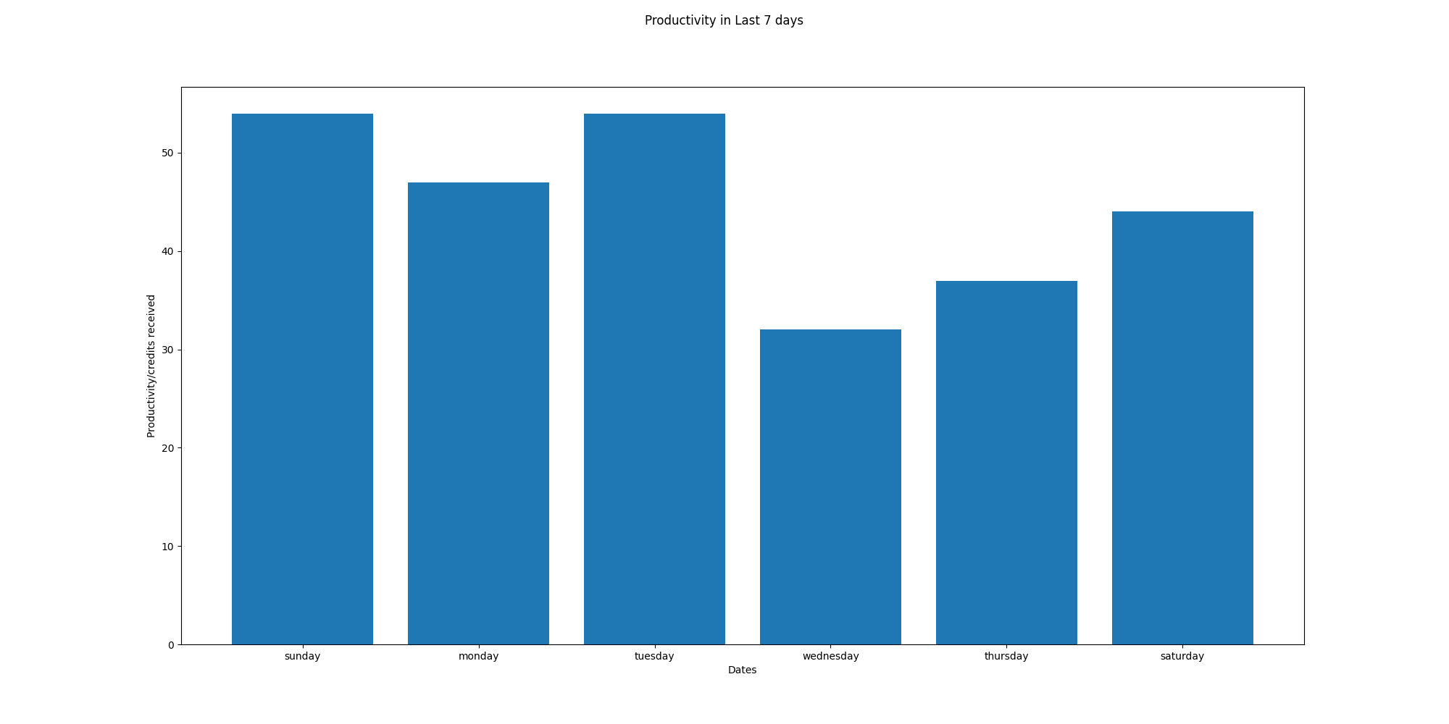

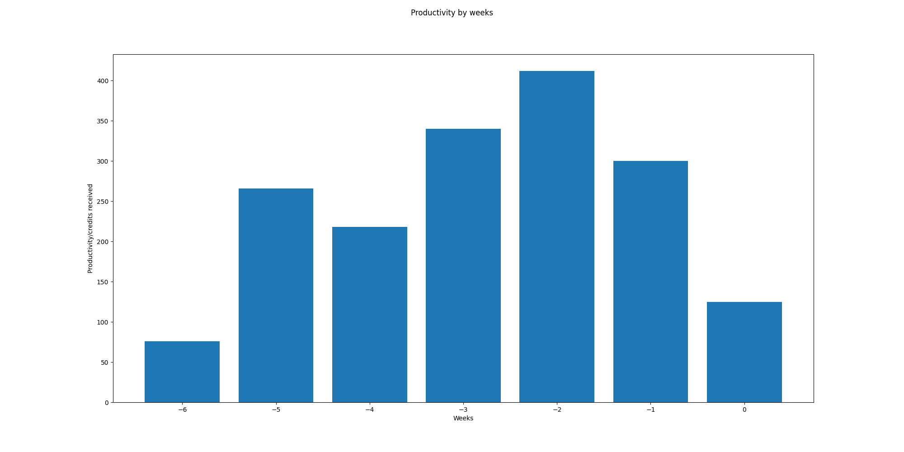

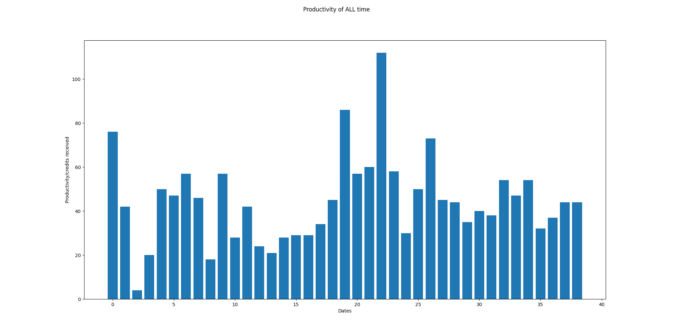

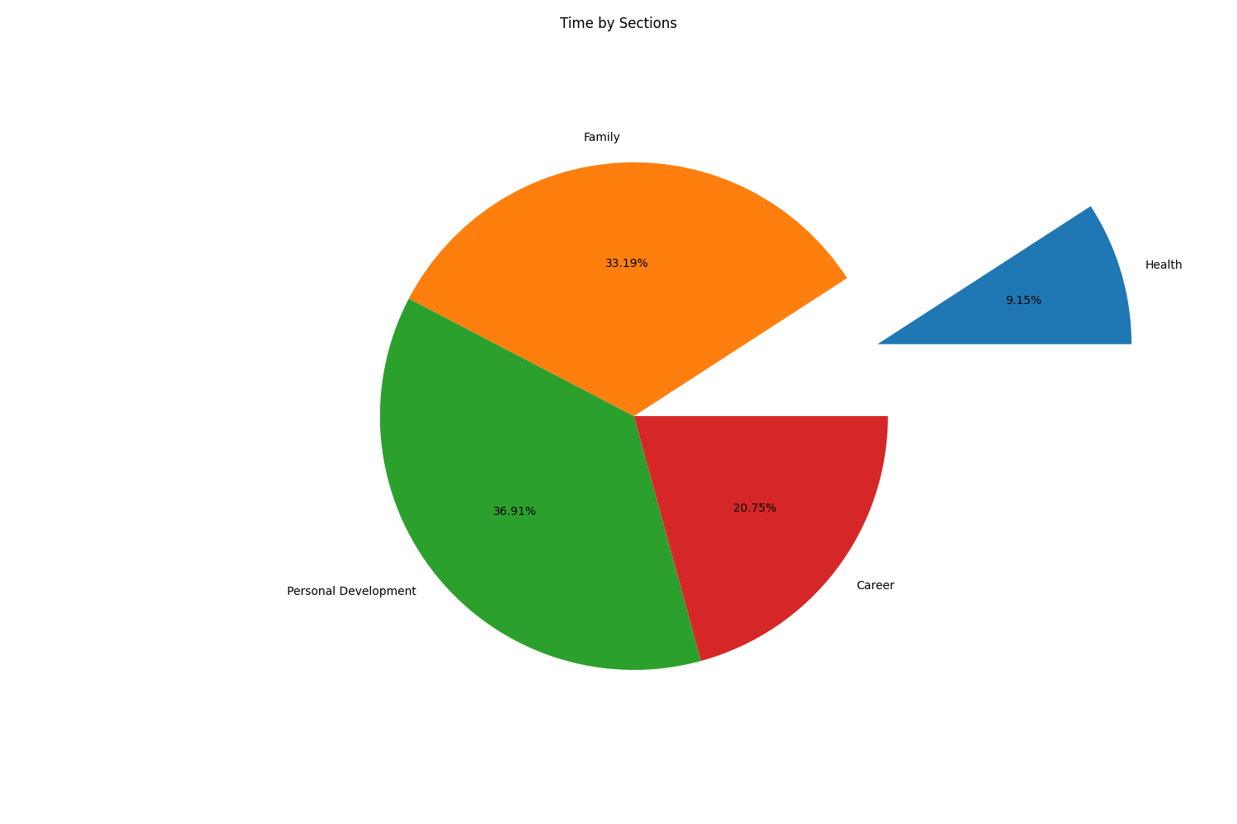

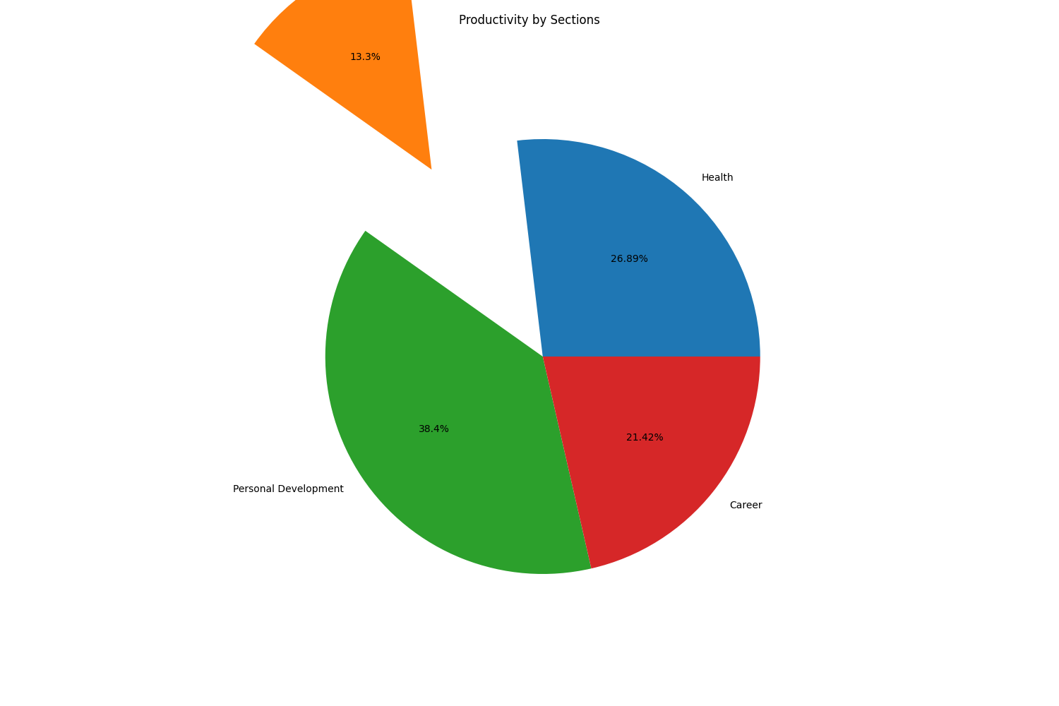

# Part5:OKR Weekly Evaluation

Total Score:49.68571428571428  
Letter Grade:F

