Recursion

Key note:

1. Find the relationship between current function and the next function.
2. Find the end condition.

Q1: If a frog can jump 1 step or 2 steps. How many possible ways the frog can jump X steps?

1. Relationship between each step: Assume we have n steps. Totally, there are f(n) possible ways to jump. Each time there are two possible: 1 step or 2 steps.

Case 1, if jump 1 step first, then we will have n-1 steps remaining which is f(n-1) possible ways.

Case 2, if jump 2 step first, then we will have n-2 steps remaining which is f(n-2) possible ways

Therefore: f(n) = f(n-1) +f(n-2)

1. End condition:

When n < 0. There are 0 possible ways to jump, so f(n) = 0 ***(Not count, since we limit n=1, so do not need to worry here.)

When n == 0. There are 0 possible ways to jump, so f(n) = 1 ***(This count, since it is a way to jump)

When n = 1. There are 1 possible way to jump, so f(n) = 1

public int recusion(int a) {  
 if(a <= 0){  
 return 1;  
 }  
 else if(a == 1){  
 return 1;  
 }  
 else{  
 return recusion(a - 1) + recusion(a-2);  
 }  
}

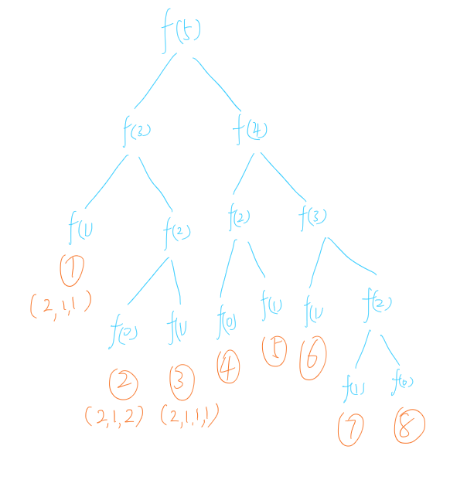

Improvement: The problem here is too many repeated calculations. Expensive!

----------------------------------------------------------------------------------------------------------------------------------------------------------------

Here we can use [**dynamic**](javascript:;) [**programming**](javascript:;)

Key note:

a) Save unique result in a map or other structure. Directly use without calculate again.

In this example, we can save f(4), f(3),f(2) when we first calculate. Therefore we can use anytime without do a repeat calculation.

Map<Integer, Integer> map = new HashMap<>();  
public int dynamic( int a ){  
 if(a <= 0){  
 return 1;  
 }  
 else if(a == 1){  
 return 1;  
 }  
 else{  
 if(map.containsKey(a)){  
 return map.get(a);  
 }  
 else{  
 int val = dynamic(a - 1) + dynamic(a-2);  
 map.put(a,val);  
 return val;  
 }  
 }  
  
}

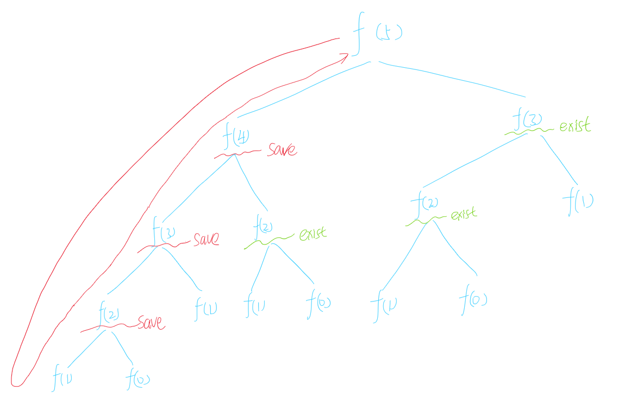

This approach can save lots of time. In another word, when you finish one problem, you need to think about the time and space complexity. Try to reduce them or is there a way to use space complexity to displace time complexity.

Can we improve more?

Yes

Think about this Fibonacci approach (No map, less space complexity):

public int improve( int n){  
 if(n <= 2){  
 return n;  
 }  
 int f1 = 0;  
 int f2 = 1;  
 int sum = 0;  
 for(int i = 1; i<= n; i++){  
 sum = f1 + f2;  
 f1 = f2;  
 f2 = sum;  
 }  
 return sum;  
}

----------------------------------------------------------------------------------------------------------------------------------------------------------------

Q1: If a frog can jump 1 step, 2 steps, 3 steps ····· or X step each times. How many possible ways the frog can jump X steps?

Map<Integer, Integer> map = new HashMap<>();  
public int dynamic( int a ){  
 if(a <= 0){  
 return 1;  
 }  
 else if(a == 1){  
 return 1;  
 }  
 else{  
 if(map.containsKey(a)){  
 return map.get(a);  
 }  
 else{  
 int val = 0;  
 for(int i = 1 ;i<=a; i++){  
 val += dynamic(a - i);  
 }  
 map.put(a,val);  
 return val;  
 }  
 }  
  
}