The State of AI in Winter 2026
yc-ai-pulse memo · generated 2026-05-03 · github.com/RyanAlberts/yc-ai-pulse

Executive summary
This memo analyzes 105 of 196 companies in Winter 2026 (63.3% coverage). 60 build agents — the dominant capability of the batch. 73 companies advertise at least one verifiable traction signal (GitHub stars, named customers, funding rounds, or disclosed user counts). Read against Daron Acemoglu's framing — that AI's productivity claims are likely overstated and the dominant economic story is labor displacement without reabsorption — the implication for capital allocation is that capability density is necessary but not sufficient: the cohort with traction signals is the smaller, more interesting set.

Introduction: three views of this data
What this batch implies for capital allocation depends on whose frame you adopt. Marc Andreessen (a16z) would read the agentic concentration — 60 of 105 cohort companies — as evidence that the dominant industrial transition is accelerating and that capital should concentrate in the winners. Ray Dalio (Bridgewater) would read the same number as one signal among many, weighing it against debt cycles, the monetary regime, and sectoral concentration risk; his prescription is diversification. Daron Acemoglu (MIT, 2024 Nobel laureate in Economics) would push back on the framing itself — that AI productivity gains over the next decade are likely under 0.7% TFP, that the no-ai subset of this batch (6 companies) is more telling than the agents subset, and that the salient investment risk is labor-displacement-without-reabsorption. The memo does not pick a winner; it equips the reader to.

Coverage and methodology
Source: yc-oss/api, last refreshed 2026-02-08. Upstream lists 132 companies for Winter 2026; 120 pass full classification (Tier A), 4 pass with website unreachable (Tier B), 8 are excluded due to missing required fields (Tier C). Excluded companies are named in the dropped register attached to the dashboard. Of the analyzable Tier A+B set, the LLM produced 105 high-confidence + 0 medium-confidence rows. 19 rows fell to low confidence and are excluded from charts.
Anti-hallucination guards: Layer 1 enforces a pydantic schema on every model row, requires at least one source URL drawn from the company website, its YC profile, or a polite depth=1 crawl of the website. Layer 2 (this memo) scans aggregate prose for forbidden hedge phrases and audits every number against the same dataframe the dashboard cites. Per-company taglines and traction details are quoted verbatim from the sources.

The agentic batch
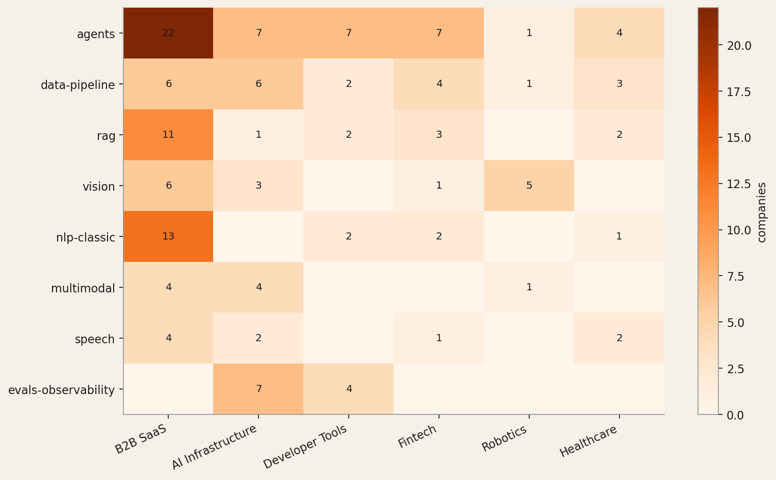
The most concentrated finding: 60 of 105 cohort companies build what they describe as agents (57% of the cohort). The next-most-cited capabilities are data-pipeline and rag. The heatmap above shows where each capability concentrates by industry.

Industry distribution
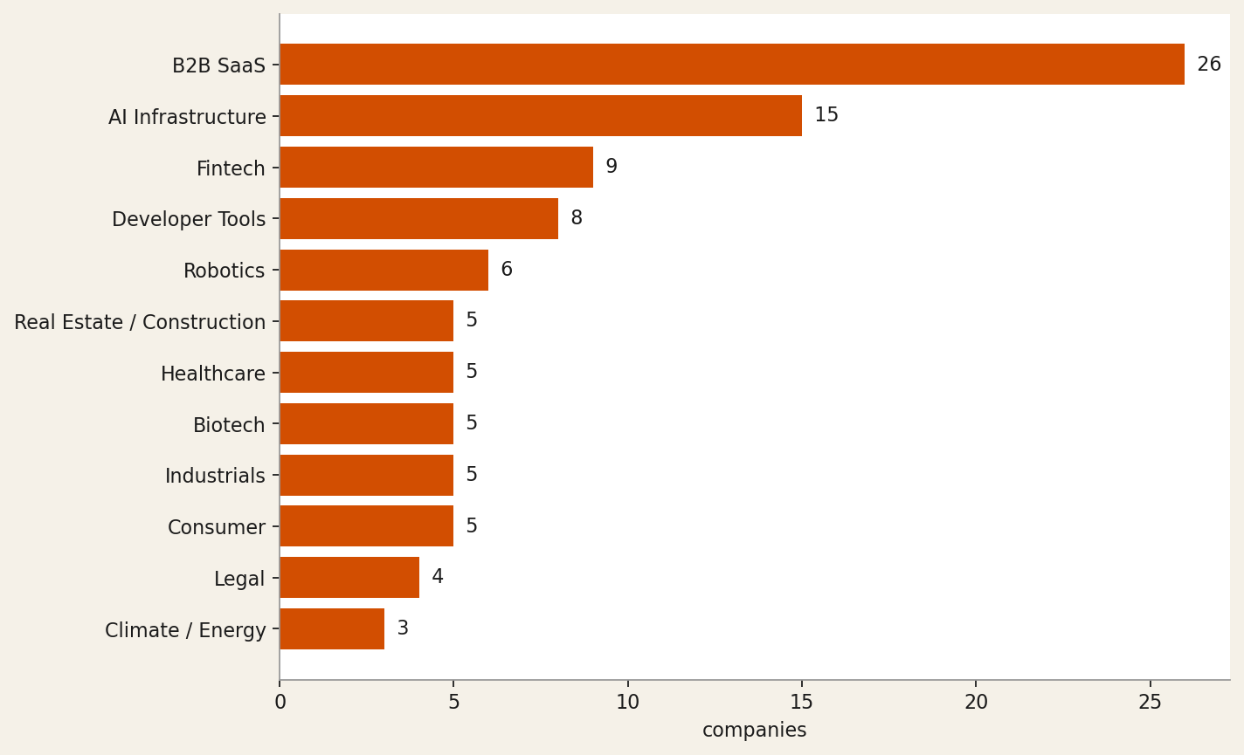
The top three industries account for 50 of 105 companies: B2B SaaS (26), AI Infrastructure (15), Fintech (9). This is consistent with public reporting on the batch composition.

Inside B2B SaaS
B2B SaaS is the largest top-level bucket, but it is also the laziest. Of 26 B2B SaaS companies in the cohort, the YC-supplied sub-industry breakdown is below. (Pure passthrough — not LLM-derived — so the breakdown can't drift from the underlying classifications.)
Sub-industry | Companies
(unspecified) | 13
Engineering, Product and Design | 2
Productivity | 2
Analytics | 2
Retail | 1
Finance and Accounting | 1
Operations | 1
Marketing | 1
Sales | 1
Human Resources | 1
Infrastructure | 1

Tech stack and OSS posture
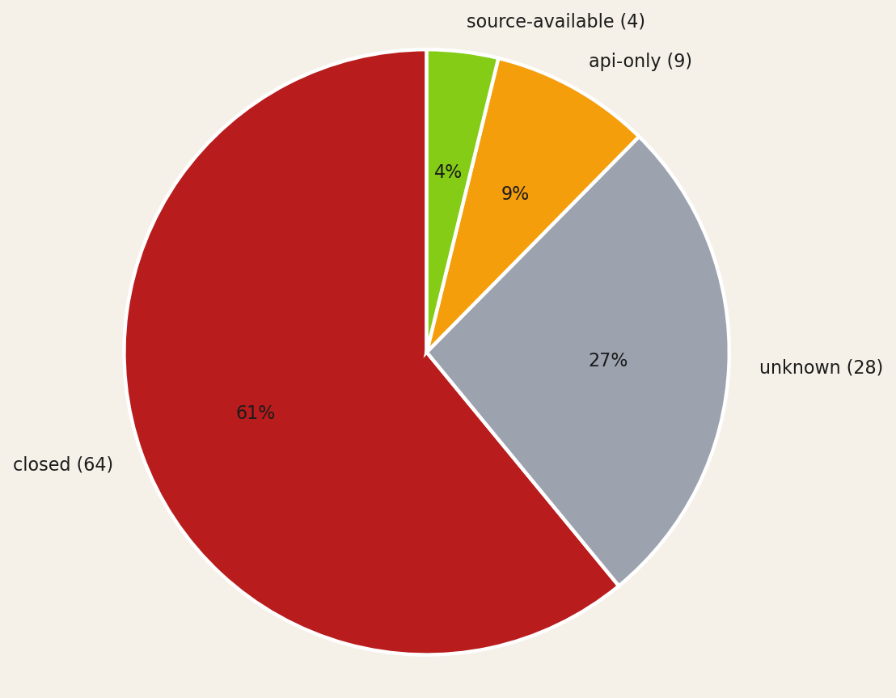
OSS posture: 64 closed, 28 unknown, 9 api-only, 4 source-available, 0 fully-open. The unknown slice represents the cohort the model could not classify even after a depth=1 website crawl.
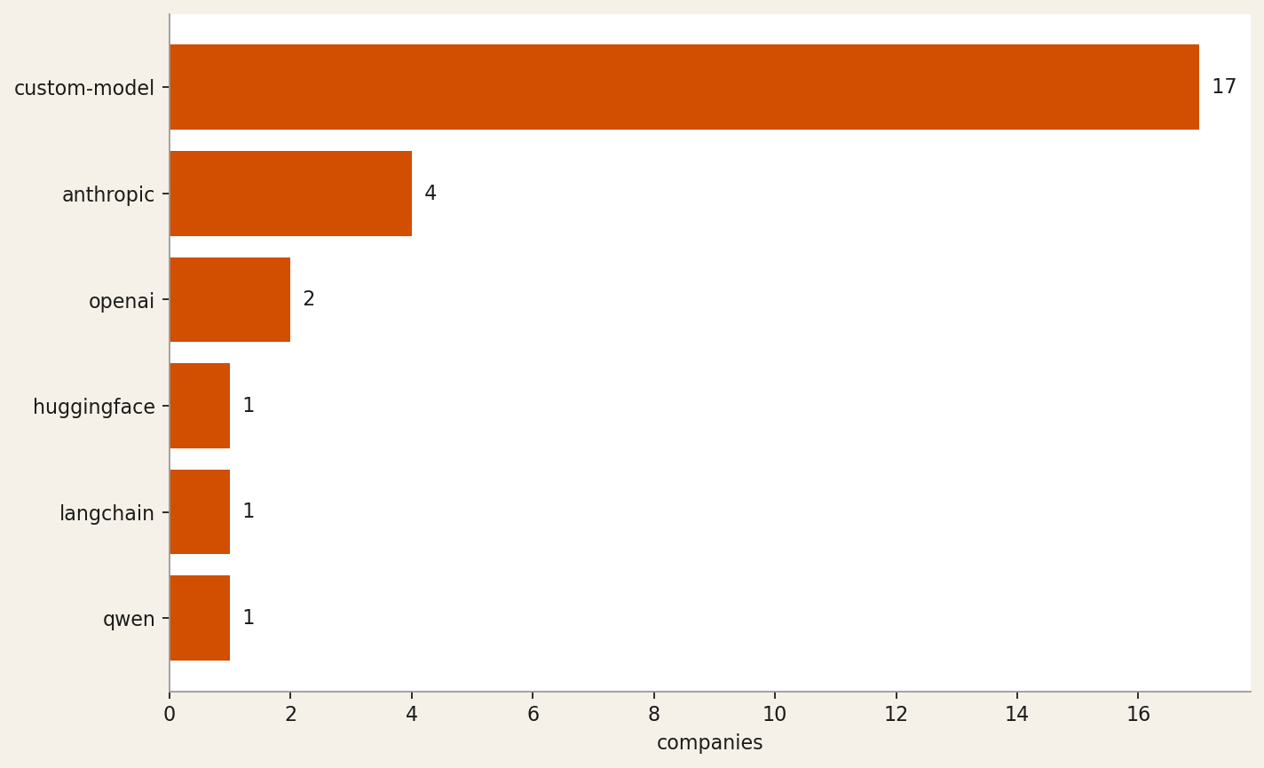
* 84 of 105 companies (80%) had no determinable tech stack on publicly visible surfaces. They are excluded from the chart above and from the Tech-stack lookups in the dashboard. The named entries are the model providers and frameworks the model could verify on the company website or its docs.

Traction signals
73 of 105 cohort companies advertise at least one verifiable traction signal on their public surface. The tables below break down by signal kind. Each row is verbatim from the source page; the URL points to where the evidence lives. Empty buckets mean nothing of that kind was visible.

github-stars (2 companies)
Company | Signal | Source
eigenpal | eigenpal/docx-editor MIT License 634 | https://www.eigenpal.com/projects
runanywhere | 10.4K | https://www.runanywhere.ai/

customer-logo (16 companies)
Company | Signal | Source
lexius | Erewhon (Grocery) — $3,000 monthly savings per store | https://www.lexius.ai/
robby | Trusted by leading home service companies | https://www.tryrobby.com/
corelayer | Moda | https://www.corelayer.com/
arc-prize-foundation | has been used by OpenAI, Anthropic, Google DeepMind, and xAI | https://www.ycombinator.com/companies/arc-prize-foundation
squid | For too long flex data lived in spreadsheets. Not anymore! – Doerte Schneemann, Head of Flexibility Markets | https://www.squid.energy/

funding-round (34 companies)
Company | Signal | Source
patientdeskai | We increased our total investment to $3.8M | https://www.patientdesk.ai/
ditto-biosciences | Backed by Y Combinator | https://www.dittobio.com/
oxus | Backed by Combinator | https://www.oxus-ai.com/
shofo | Backed by Y Combinator | https://www.shofo.ai/
o11 | Announcing o11's backing from Y Combinator | https://o11.ai/

revenue-disclosed (4 companies)
Company | Signal | Source
robby | each uncovering 6 figures in additional revenue opportunities every week | https://www.ycombinator.com/companies/robby
laurence | automating millions in live ad spend | https://www.ycombinator.com/companies/laurence
rhizome-ai | went from launch to six-figures in revenue during 2025 | https://www.ycombinator.com/companies/rhizome-ai
octapulse | signed a 6-figure paid pilot with the largest trout producer in the United States | https://www.ycombinator.com/companies/octapulse

users-disclosed (15 companies)
Company | Signal | Source
arcline | 50+ venture-backed startups across the US and Nordics | https://www.ycombinator.com/companies/arcline
martini | 200+ Films Made | https://www.martini.film/
robby | several paying customers | https://www.ycombinator.com/companies/robby
general-legal | Trusted by over 180+ growth stage companies | https://general.legal/
corvera | 15 design partners | https://www.ycombinator.com/companies/corvera

press-coverage (3 companies)
Company | Signal | Source
inviscid-ai | Excited to be at SEMI-THERM 2026 this week in San Jose (March 9-12) | https://inviscidai.com/stories/semi-therm-2026
strand-ai | Oded joins Kate Kreuger on the Minute 52 podcast to talk about building Strand AI, YC Demo Day, and spatial proteomics | https://strandai.com/blog
ritivel | Featured on Launch YC | https://www.ritivel.com/

partnership (15 companies)
Company | Signal | Source
patientdeskai | Backed by Y Combinator | https://www.patientdesk.ai/media
chamber | We joined Y Combinator (W26 batch) to accelerate our mission | https://www.usechamber.io/about
inviscid-ai | signed a government MOU, partnering with MPSEDC to bring real-time digital twins to the Madhya Pradesh State Data Center | https://inviscidai.com/stories/mpsedc-government-mou
strand-ai | With researchers and advisors from Mount Sinai, Stanford, and Tsinghua | https://strandai.com/about
corvera | Backed by Y Combinator | https://www.corvera.ai/

other (54 companies)
Company | Signal | Source
beyond-reach-labs | Beyond Reach Labs Receives NASA NIAC Phase II Award | https://www.beyondreachlabs.com/news/
servo7 | We're already working with warehouses to automate their fulfillment | https://www.ycombinator.com/companies/servo7
ditto-biosciences | Mapping parasite molecules to treat autoimmune disease March 2, 2026 | https://www.dittobio.com/blog
chamber | SOC 2 Type I — Certified | https://www.usechamber.io/pricing
voltair | validated our core charging tech on a power line | https://www.ycombinator.com/companies/voltair

Six company spotlights

runanywhere
On-device AI inference runtime + SDK that cuts cloud costs to zero — custom kernels, fleet control plane, enterprise observability.
Industry: AI Infrastructure · Capabilities: inference-infra, speech, voice, vision, multimodal · Tech stack: qwen, custom-model · OSS posture: source-available
"RunAnywhere builds 'custom kernels, operator fusion, unified memory optimization' inference engines (MetalRT) and a cross-platform SDK — squarely AI Infrastructure. The 'Open by default' stance, 10.4K GitHub stars, and 'Open Source' YC tag confirm meaningful open posture; multimodal coverage (LLM decode, speech-to-text, speech-to-speech, vision language models) drives the ai_capability set."
Traction signals:
• github-stars: 10.4K (https://www.runanywhere.ai/)
• funding-round: Backed by Y Combinator (https://www.runanywhere.ai/)
• customer-logo: PickleRite — a pickleball performance tracker — runs a specialized LLM entirely on-device using RunAnywhere SDK (https://www.runanywhere.ai/blog)

strand-ai
Foundation models that predict missing biological modalities—proteomics, transcriptomics—from patient data you already have
Industry: Biotech · Capabilities: bio-ai, multimodal, vision, data-pipeline, training-infra · Tech stack: custom-model · OSS posture: api-only
"The site explicitly states 'Predict missing biological modalities from the data you already have' and describes custom foundation models (POSTMAN for spatial proteomics, VariantFormer for gene expression imputation); access is gated via 'Request Access' and 'Request Early Access' with no open-source repository mentioned, confirming api-only posture."
Traction signals:
• funding-round: Backed by Y Combinator (W26) (https://strandai.com/about)
• other: Trained on a dataset of 20,000 slides of paired same-section H&E + mIF data, the largest in the field (https://strandai.com/postman)
• press-coverage: Oded joins Kate Kreuger on the Minute 52 podcast to talk about building Strand AI, YC Demo Day, and spatial proteomics (https://strandai.com/blog)
• other: We ran CZI Biohub's VariantFormer on 538 new 1000 Genomes samples to generate free imputed RNA expression data — 37× faster on cheaper GPUs (https://strandai.com/blog)
• partnership: With researchers and advisors from Mount Sinai, Stanford, and Tsinghua (https://strandai.com/about)

human-archive
Multimodal sensorimotor dataset provider fueling embodied AI and humanoid robotics foundation models
Industry: Robotics · Capabilities: multimodal, vision, robotics, data-pipeline, training-infra · Tech stack: custom-model · OSS posture: unknown
"The description explicitly states they collect and label 'aligned multimodal data' for 'robotics foundation models and general-purpose robotics companies,' and the website confirms they are 'Building the largest sensorimotor human dataset to ever exist' with modalities including tactile, motion, vision, depth, and wrist POV."
Traction signals:
• users-disclosed: 50,000+ Contributor Network (https://www.humanarchive.ai/)
• partnership: 125+ National Partnerships (https://www.humanarchive.ai/)
• other: 1,000+ Custom Rigs (https://www.humanarchive.ai/)

axionorbital-space
SAR-to-optical foundation model enabling cloud-proof, 24/7 Earth observation for defense, commodities, and disaster response
Industry: Industrials · Capabilities: vision, multimodal, training-infra, data-pipeline · Tech stack: custom-model · OSS posture: closed
"The description explicitly states a 'proprietary architecture uses deterministic one-step diffusion to transform complex radar signals into clear, photorealistic images,' confirming a custom vision/multimodal AI model for satellite data processing. Primary industry is Industrials (space/satellite), with Government / Defense and AI Infrastructure as secondary given the stated end markets ('defense…"

pocket
Wearable AI device + app that transcribes conversations in real time and extracts notes, action items, and searchable memory
Industry: Consumer · Capabilities: speech, voice, nlp-classic, rag · Tech stack: unknown · OSS posture: closed
"The description states Pocket is 'a tiny AI device that lives on your phone and turns everything you say and hear into clear notes, action items, and search' built on 'custom hardware, AI, and software' — confirming a Consumer + Hardware classification with speech transcription, voice capture, NLP summarization, and semantic search as the core AI capabilities. No AI provider, open-source reposito…"

corelayer
AI on-call agent that monitors production data and infrastructure to auto-debug issues in minutes for regulated industries
Industry: Developer Tools · Capabilities: agents, rag, evals-observability, data-pipeline · Tech stack: unknown · OSS posture: closed
"The description explicitly states 'AI agents that do on-call support' and 'use AI agents to debug and suggest fixes in minutes,' confirming an agents + RAG posture (production data as context). The product targets engineering teams in regulated industries, placing it squarely in Developer Tools; 'flexible model provider and inference options' on the demo page indicates no committed upstream LLM v…"
Traction signals:
• customer-logo: Moda (https://www.corelayer.com/)
• customer-logo: Hyperspell (https://www.corelayer.com/demo)
• other: Trusted by teams from the growth stage to the enterprise (https://www.corelayer.com/)

What we still cannot answer
Three open questions against the introduction's three POVs:
1. (Andreessen frame) Of the cohort building agents, which subset has the moat — proprietary data, distribution lock-in, or model-tuning expertise? The dashboard cannot tell from public surfaces alone.
2. (Dalio frame) How does cohort exposure correlate with the macro regime? B2B SaaS dominance and a thin OSS slice imply enterprise-buyer dependence; that's fragile against IT-budget cycles.
3. (Acemoglu frame) For the no-ai cohort, is YC's classification noise or signal? If the latter, the batch is more sectorally diverse than the AI label suggests, and the labor-displacement narrative may not apply uniformly.

Reproduce this memo
Install: pipx install yc-ai-pulse · Run: ycai run-coverage --batch winter-2026 --enrich · Then: ycai report runs/<timestamp>
Source: github.com/RyanAlberts/yc-ai-pulse

