The State of AI in Winter 2026
yc-ai-pulse memo · generated 2026-05-02 · github.com/RyanAlberts/yc-ai-pulse

Headline
This memo analyzes 113 of 196 companies in Winter 2026 (63.3% coverage). Of the analyzable cohort, 69 build agents — the dominant capability of the batch. 7 companies are classified as no-ai despite being inside YC's AI batch, a reminder that 'AI' has become marketing taxonomy as much as product taxonomy.

Coverage and methodology
Source: yc-oss/api, last refreshed 2026-02-08. Upstream lists 132 companies for Winter 2026; 120 pass full classification (Tier A), 4 pass with website unreachable (Tier B), 8 are excluded due to missing required fields (Tier C). Excluded companies are named in the dropped register attached to the dashboard. Of the analyzable Tier A+B set, the LLM produced 113 high-confidence + 0 medium-confidence rows (the cohort behind every chart in this memo). 11 rows fell to low confidence and are excluded from charts.
Anti-hallucination guards: Layer 1 enforces a pydantic schema on every model row, requires at least one source URL drawn from the company website or its YC profile, and runs a two-pass cross-check on uncertain rows. Layer 2 (this memo) scans aggregate prose for forbidden hedge phrases and audits every number against the same dataframe the dashboard cites.

The agentic batch
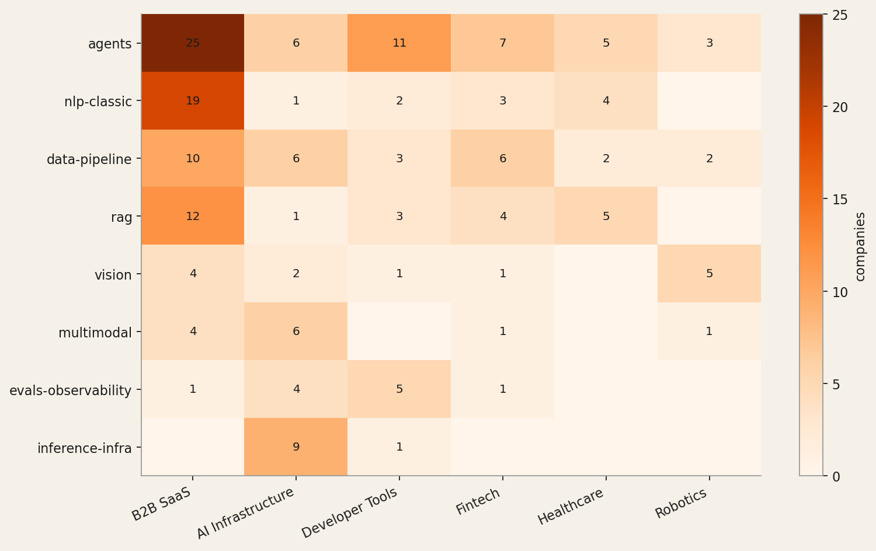
The most concentrated finding: 69 of 113 cohort companies build what they describe as agents (61% of the cohort). The next-most-cited capabilities are nlp-classic and data-pipeline. The heatmap above shows where each capability concentrates by industry. Click-through into the dashboard for row-level evidence on every cell.

Industry distribution
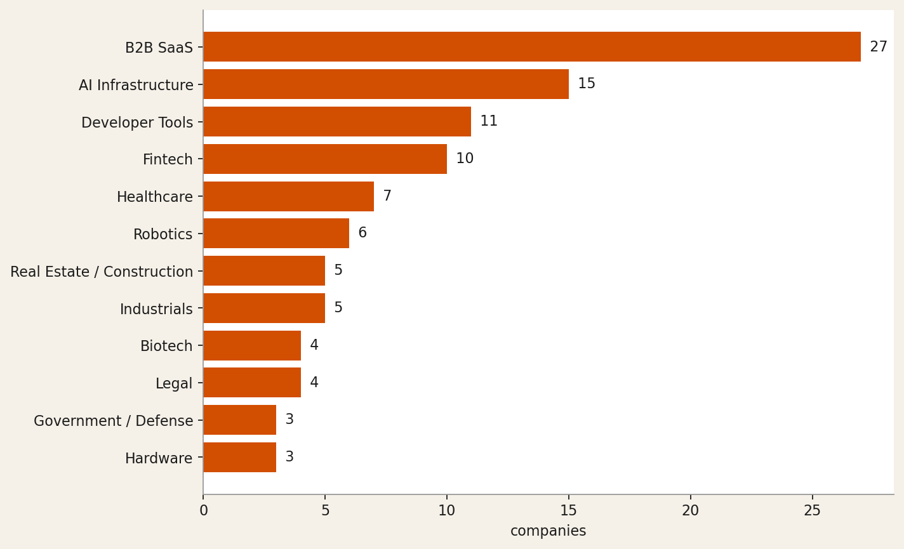
The top three industries account for 53 of 113 companies: B2B SaaS (27), AI Infrastructure (15), Developer Tools (11). This is consistent with public reporting on the batch composition.

Tech stack and open-source posture
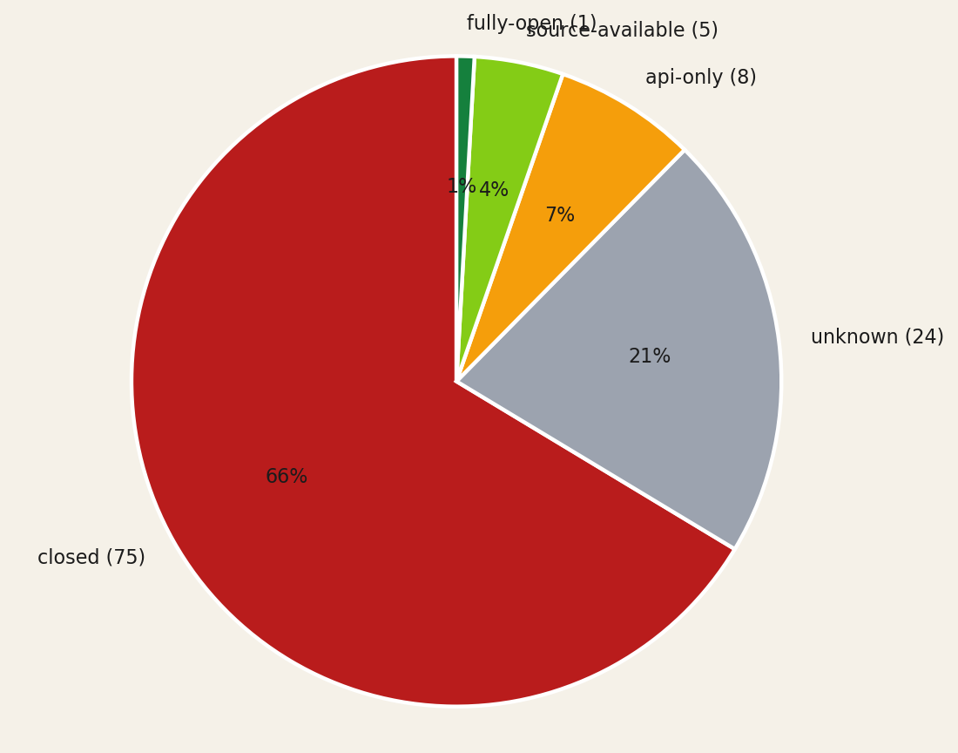
Open-source posture: 75 closed, 24 unknown, 8 api-only, 5 source-available, 1 fully-open. The unknown slice represents the cohort the model could not classify even after a depth=1 website crawl. Tech stack is similarly under-determined: most companies do not advertise their model provider on the marketing surface.
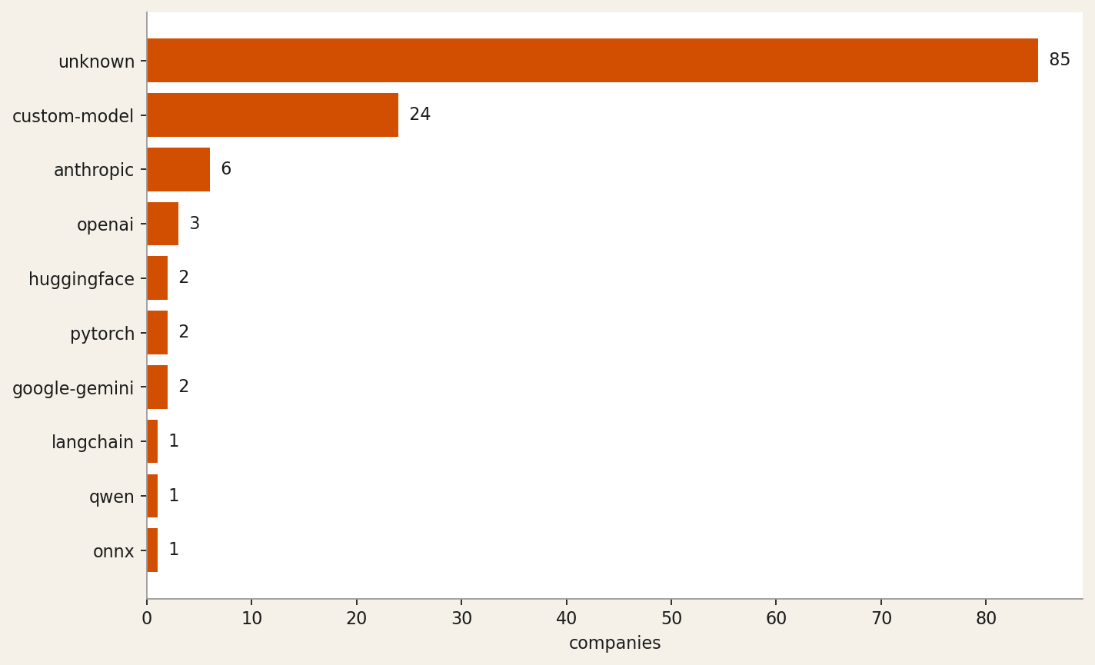

Six company spotlights

runanywhere
On-device AI inference SDK + control plane to deploy, manage, and monitor LLMs across edge devices at scale.
Industry: AI Infrastructure · Capabilities: inference-infra, speech, voice, vision, multimodal · Tech stack: qwen, custom-model, onnx · OSS posture: source-available
"RunAnywhere builds custom inference runtimes (MetalRT) and cross-platform SDKs for on-device AI execution with LLM, speech, vision, and speech-to-speech capabilities; the about page states 'open by default' with published benchmarks and methodology, and the GitHub reference (10.4K stars) confirms source-available posture, while the YC tags 'Infrastructure' and 'Developer Tools' plus the descripti…"

strand-ai
AI platform that predicts missing biological modalities (proteomics, transcriptomics) from existing patient data to accelerate drug discove…
Industry: Biotech · Capabilities: multimodal, vision, bio-ai, data-pipeline · Tech stack: custom-model, pytorch · OSS posture: api-only
"Strand AI builds proprietary foundation models (e.g., POSTMAN, VariantFormer) that predict missing biological modalities from existing patient data — 'One H&E slide becomes 180+ spatial protein maps' — making it a biotech/bio-AI play with a multimodal vision AI core; access is via request/early-access only with no open-source repository mentioned, indicating api-only posture."

shofo
Managed pipeline that continuously indexes, labels, and enriches social-media video at scale for AI pre-training and fine-tuning datasets
Industry: AI Infrastructure · Capabilities: data-pipeline, training-infra, vision, multimodal · Tech stack: huggingface · OSS posture: api-only
"Description explicitly states Shofo 'builds large-scale social media training datasets by collecting, labeling, and enriching public content for pre-training and fine-tuning AI models,' placing it squarely in AI Infrastructure with data-pipeline and training-infra capabilities. The homepage prominently features 'Hugging Face Get Data' for dataset distribution, and the commercial framing ('compani…"

chamber
Autonomous AIOps platform that optimizes GPU cluster utilization so ML teams run ~50% more workloads without manual infra management.
Industry: AI Infrastructure · Capabilities: agents, evals-observability, inference-infra, training-infra · Tech stack: unknown · OSS posture: closed
"Chamber's description explicitly states it 'orchestrates, governs, and optimizes your AI infrastructure' using 'agentic AI' that 'continuously monitoring GPU clusters, forecasting demand, detecting unhealthy nodes, and reallocating resources in real time' — clearly AI Infrastructure with agent-based automation. No open-source repository or model weights are referenced anywhere in the crawled page…"

patientdeskai
AI voice receptionist for dental & healthcare practices — automates scheduling, billing, insurance, and patient comms across any PMS
Industry: Healthcare · Capabilities: voice, agents, speech, nlp-classic · Tech stack: unknown · OSS posture: closed
"The YC description explicitly calls it a 'universal AI front desk' using an 'AI voice agent for patient calls' that automates scheduling, insurance, and reminders — mapping directly to voice, agents, speech, and NLP capabilities. The privacy policy confirms it is 'an AI-powered receptionist and patient communication platform designed exclusively for dental and healthcare practices' handling 'AI-h…"

mousecat
AI-powered fraud investigation platform that auto-generates features, rules, and production decisions for enterprise risk teams.
Industry: Fintech · Capabilities: agents, rag, data-pipeline, evals-observability · Tech stack: unknown · OSS posture: closed
"The website explicitly positions MouseCat as 'AI-Powered Fraud Investigation' for Risk Ops and ML/DS teams, closing the loop from investigation to 'production rules, models and decisions'; YC tags confirm Fintech and Fraud Detection, with AI agents and data-pipeline capabilities evidenced by auto-generating features from data warehouses (Databricks/Snowflake) and backtesting rules end-to-end."

What we still cannot answer
Three open questions surfaced by this analysis:
1. The unknown plurality on tech stack and OSS posture suggests most companies do not advertise model provider or licensing on their marketing surfaces. A deeper crawl into /docs subtrees would close part of this gap.
2. Of the cohort classified no-ai, none claim to use AI but appear in YC's AI batch — this is not a defect in classification but a category question for YC.
3. The dropped register names every excluded company. The pattern of empty long_description fields suggests companies in stealth at the time the upstream feed was last refreshed.

Reproduce this memo
Install: pipx install yc-ai-pulse · Run: ycai run-coverage --batch winter-2026 --enrich · Then: ycai report runs/<timestamp>
Source: github.com/RyanAlberts/yc-ai-pulse

