The State of AI in Winter 2026
yc-ai-pulse memo · generated 2026-05-03 · github.com/RyanAlberts/yc-ai-pulse

Executive summary
This memo analyzes 105 of 196 companies in Winter 2026 (63.3% coverage). 60 build agents — the dominant capability of the batch. 73 companies advertise at least one verifiable traction signal (GitHub stars, named customers, funding rounds, or disclosed user counts). Read against Daron Acemoglu's framing — that AI's productivity claims are likely overstated and the dominant economic story is labor displacement without reabsorption — the implication for capital allocation is that capability density is necessary but not sufficient: the cohort with traction signals is the smaller, more interesting set.

Introduction: three views of this data
What this batch implies for capital allocation depends on whose frame you adopt. The three paragraphs below were generated by reading the entire high-confidence cohort (taglines, capabilities, traction, public discussion on HN and Reddit) from each named figure's published worldview. Each paragraph cites specific companies by slug; the memo does not pick a winner.

Marc Andreessen — a16z
Sixty of these 105 companies ship agents that take autonomous action in the world—this is not a thesis, it is a market. Mendral has had 104 autonomous fixes accepted into production codebases in a single month across 240,000 CI runs per week; that is not a demo, that is a replacement function for an entire class of DevOps labor. Chamber is squeezing 50% more throughput from existing GPU clusters by acting as an autonomous AIOps layer between ML teams and their hardware—compressing the capital cost of the compute buildout that every enterprise is now obligated to fund. Laurence is running a quantitative hedge-fund strategy against Amazon PPC at scale, automating millions in live ad spend and cutting cost-of-sales by 40% for merchants who cannot hire the quant teams that built it. The pattern is identical in each case: a function that previously required a human—or an entire specialized team—is now executed by software at continuous scale with no human in the loop. This is what industrial transitions look like from the inside. The correct allocation response is concentration, not the comfortable diversification across 105 bets that mistakes coverage for strategy—the same instinct would have funded twelve search engines in 1998. Those who argue the data counsels patience or a redistribution of weight toward hard-asset or non-AI plays are reading a different document than this one. The risk absent from every pitch deck here, and unpriced by the traction signals, is regulatory capture: the moment a mandatory compliance layer lands, incumbents freeze and insurgents die. Concentration in the current winners is the only hedge against that asymmetric tail.
Cited: `mendral`, `chamber`, `laurence`

Ray Dalio — Bridgewater
Sixty of these 105 companies build agents — that ratio reads less like an innovation wave and more like a late-cycle crowding signal. When the debt supercycle turns, commoditized software margins compress faster than industrial ones, and most of this cohort is competing for the same enterprise automation budget. Laurence automates millions of dollars in live Amazon ad spend using quantitative techniques borrowed from hedge-fund math that genuinely deliver — a 40% reduction in advertising cost of sales is a real operating number — but its entire value chain runs on Amazon's platform goodwill and on dollar-denominated credit availability; a monetary regime shift or a single antitrust ruling resets that math overnight. Constellation Space, by contrast, was built by people who shipped at SpaceX, Blue Origin, and NASA, and it reroutes satellite traffic autonomously with zero data loss — that is critical infrastructure embedded in the geopolitical realignment toward space dominance, where state procurement budgets and strategic necessity underwrite demand independent of rate cycles. Kyten Technologies ships 5,000-plus aerospace-grade battery packs into orbit and carries no AI classification at all, which is precisely why it belongs in a diversified book: it is a physical-world, defense-adjacent manufacturer whose revenues are determined by allied-capital procurement, not by OpenAI API pricing. An investor who concentrates capital in the 60 agent companies is implicitly betting that this monetary regime holds and that no major power disrupts the cloud layer those agents depend on — both heroic assumptions that the historical record of regime transitions forbids. The correct allocation weights dual-use physical infrastructure heavily, treats the agent cluster as a satellite position sized to its optionality, and diversifies the remainder across biological AI and energy to isolate from any single cycle.
Cited: `laurence`, `constellation-space`, `kyten-technologies`

Daron Acemoglu — MIT, 2024 Nobel laureate in Economics
This cohort is a controlled experiment in labor displacement without a credible reabsorption mechanism, and capital allocators who read it as a productivity windfall are misreading the distributional signal. Consider what these companies actually do: Vela automates the negotiation and booking of thousands of interviews per week, eliminating scheduling coordinators; Mendral accepted 104 CI fixes in a single month with no human in the loop, displacing the junior engineers who historically caught those failures; Panta runs commercial insurance brokerage at software margins by removing the back-office workers who priced and bound those policies. Across 60 agent-focused companies in this cohort of 105, the operating thesis is identical — replace a category of human judgment with a model call. The aggregate productivity gain, if realized at all, will be narrowly captured by the firms deploying these tools and the equity holders of the tools themselves, not by the workers whose tasks are absorbed. My estimate of under 0.7% total-factor productivity growth over the next decade assumes significant friction in worker reabsorption; this cohort accelerates that friction without addressing it. The capital-allocation prescription is therefore not to concentrate into the agent layer — which is where Andreessen-style growth investors and effective-accelerationist readers of this same data would pile in — but to weight redistributive-risk exposure heavily: infrastructure and policy-adjacent positions that benefit from the regulatory and social response to displacement, and to discount agent-company valuations by the probability that political backlash compresses their addressable market before the productivity gains compound.
Cited: `vela`, `mendral`, `panta`

Coverage and methodology
Source: yc-oss/api, last refreshed 2026-02-08. Upstream lists 132 companies for Winter 2026; 120 pass full classification (Tier A), 4 pass with website unreachable (Tier B), 8 are excluded due to missing required fields (Tier C). Excluded companies are named in the dropped register attached to the dashboard. Of the analyzable Tier A+B set, the LLM produced 105 high-confidence + 0 medium-confidence rows. 19 rows fell to low confidence and are excluded from charts.
Anti-hallucination guards: Layer 1 enforces a pydantic schema on every model row, requires at least one source URL drawn from the company website, its YC profile, or a polite depth=1 crawl of the website. Layer 2 (this memo) scans aggregate prose for forbidden hedge phrases and audits every number against the same dataframe the dashboard cites. Per-company taglines and traction details are quoted verbatim from the sources.

The agentic batch
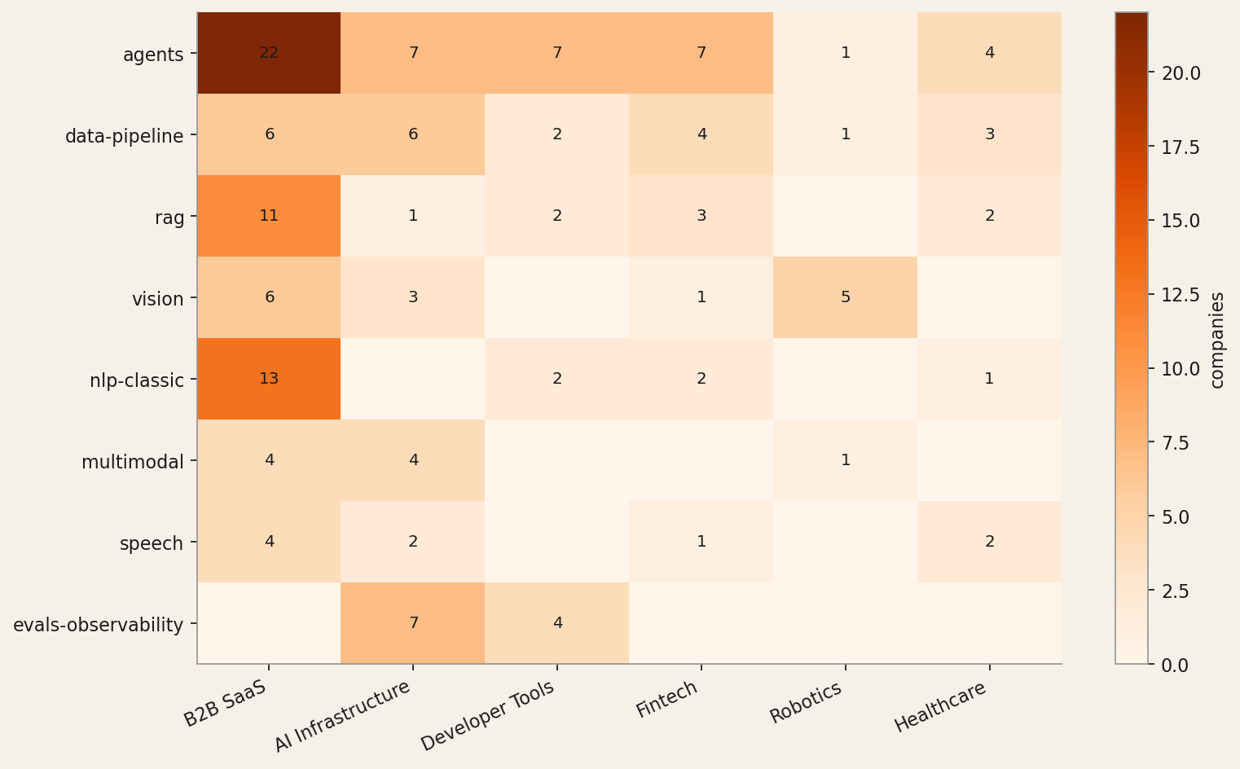
The most concentrated finding: 60 of 105 cohort companies build what they describe as agents (57% of the cohort). The next-most-cited capabilities are data-pipeline and rag. The heatmap above shows where each capability concentrates by industry.

Industry distribution
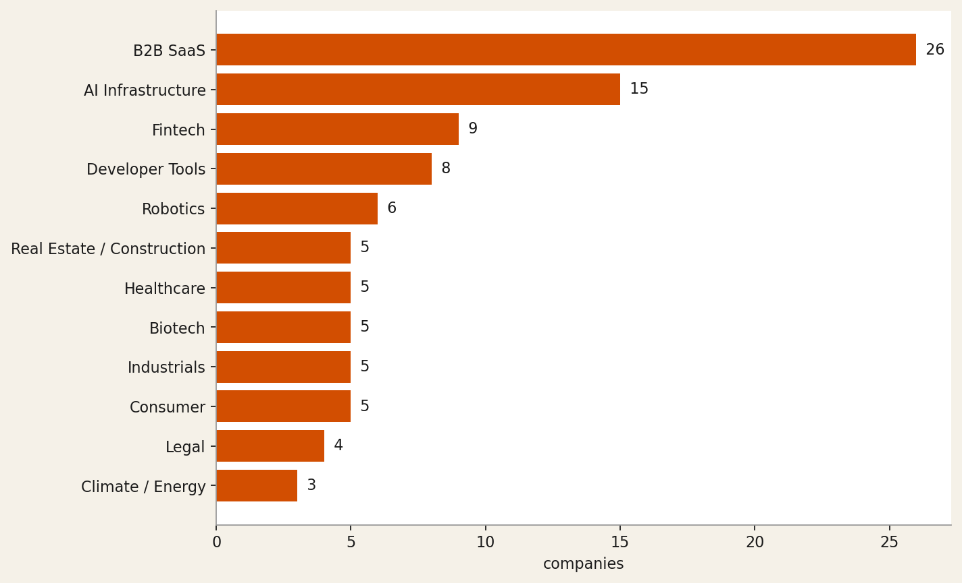
The top three industries account for 50 of 105 companies: B2B SaaS (26), AI Infrastructure (15), Fintech (9). This is consistent with public reporting on the batch composition.

Inside B2B SaaS
B2B SaaS is the largest top-level bucket but the laziest description. Of 26 B2B SaaS companies in the cohort, the topology below was generated bottom-up: a Sonnet pass over every B2B SaaS company's tagline, capabilities, traction, and public discussion (HN/Reddit). The clusters that emerged are not the YC dropdown labels (Sales, Operations, Engineering); they are the patterns the cohort actually exhibits.

AI-native compliance and audit document automation (3 companies)
These companies automate the most labor-intensive document workflows in regulated industries—audit evidence, workpaper generation, and compliance sign-off—by learning from existing processes and producing governance-ready outputs that auditors and legal teams can act on directly.
Members: `oxus`, `eigenpal`, `veriad`

Purpose-built AI for offline-first and non-SaaS-native verticals (5 companies)
These companies build industry-specific AI for operators whose work happens outside conventional SaaS—field technicians, hotel staff, equipment dealers, appointment-based businesses, and library managers—delivering leverage without requiring the buyer to change their stack.
Members: `robby`, `lance`, `chasi`, `booko`, `librar-labs`

Agentic GTM — pipeline intelligence, scheduling, and revenue-cycle automation (5 companies)
These companies deploy autonomous agents across the full GTM motion—surfacing buyer intent, booking meetings, coaching live calls, optimizing ad spend, and arming CS and SE teams with on-demand product knowledge—so revenue teams close more pipeline without adding headcount.
Members: `autumn-ai`, `vela`, `caretta`, `laurence`, `unisson`

Natural-language workflow automation on top of existing enterprise tooling (5 companies)
These companies let non-technical operators build and deploy production automations by describing workflows in plain English or chat, plugging agents into existing SaaS and systems of record without migration or custom engineering.
Members: `bubble-lab`, `jinba`, `crow`, `ressl-ai`, `o11`

Real-time autonomous monitoring with physical or infrastructure intervention (2 companies)
These companies use computer vision or predictive ML to detect failure or loss events in real time—retail theft in physical stores and satellite network degradation—and trigger autonomous responses faster than any human operator could react.
Members: `lexius`, `constellation-space`

Unclustered
6 B2B SaaS companies didn't fit a meaningful cluster: `aurorin-cad`, `sitefire`, `skillsync`, `cardboard`, `samora-ai`, `ishiki-labs`

Tech stack and OSS posture
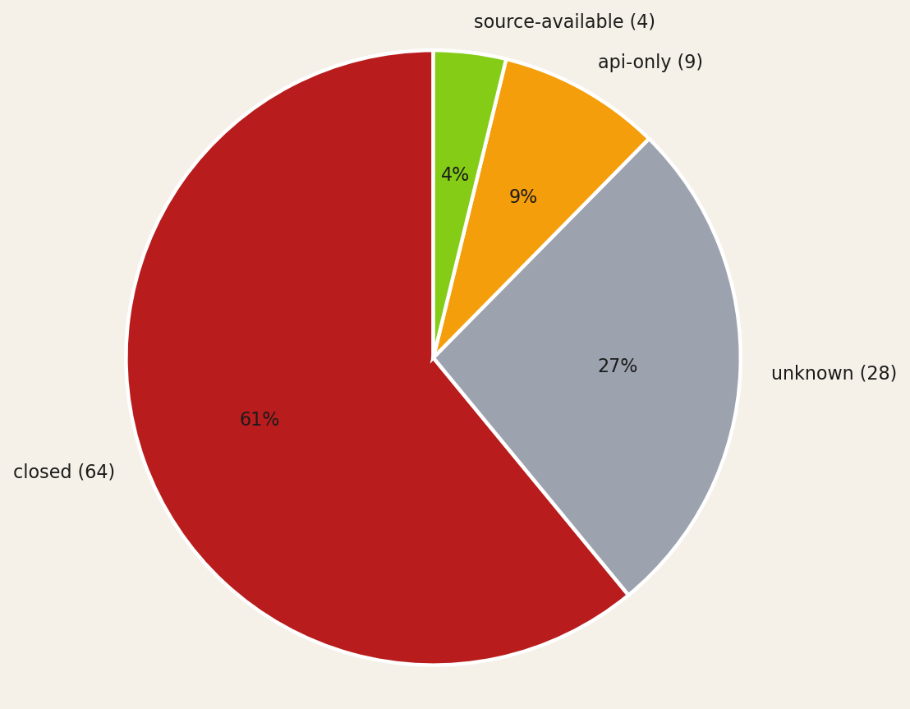
OSS posture: 64 closed, 28 unknown, 9 api-only, 4 source-available, 0 fully-open. The unknown slice represents the cohort the model could not classify even after a depth=1 website crawl.
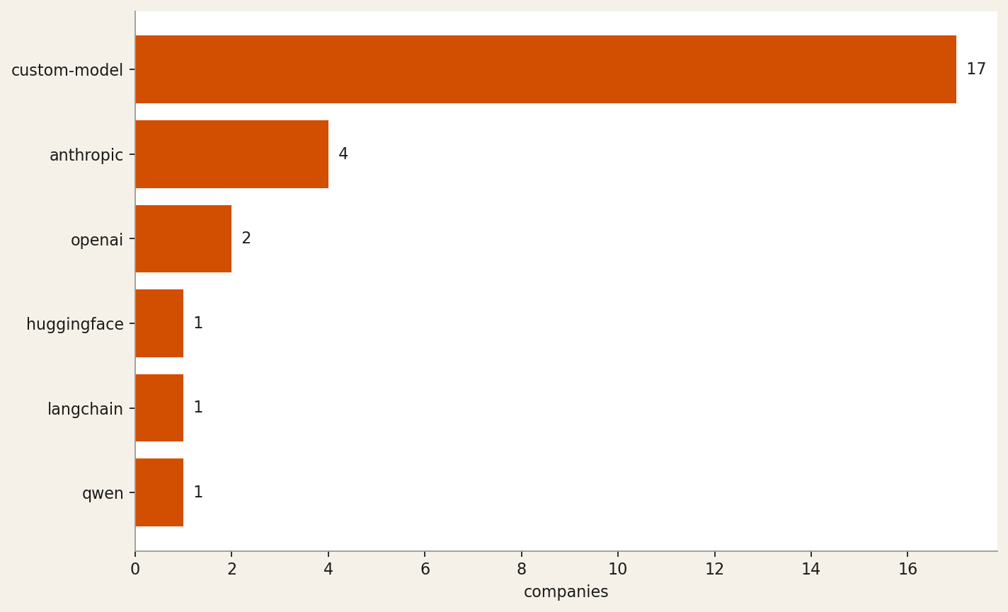
* 84 of 105 companies (80%) had no determinable tech stack on publicly visible surfaces. They are excluded from the chart above and from the Tech-stack lookups in the dashboard. The named entries are the model providers and frameworks the model could verify on the company website or its docs.

Traction signals
73 of 105 cohort companies advertise at least one verifiable traction signal on their public surface. The tables below break down by signal kind. Each row is verbatim from the source page; the URL points to where the evidence lives. Empty buckets mean nothing of that kind was visible.

github-stars (2 companies)
Company | Signal | Source
eigenpal | eigenpal/docx-editor MIT License 634 | https://www.eigenpal.com/projects
runanywhere | 10.4K | https://www.runanywhere.ai/

customer-logo (16 companies)
Company | Signal | Source
lexius | Erewhon (Grocery) — $3,000 monthly savings per store | https://www.lexius.ai/
robby | Trusted by leading home service companies | https://www.tryrobby.com/
corelayer | Moda | https://www.corelayer.com/
arc-prize-foundation | has been used by OpenAI, Anthropic, Google DeepMind, and xAI | https://www.ycombinator.com/companies/arc-prize-foundation
squid | For too long flex data lived in spreadsheets. Not anymore! – Doerte Schneemann, Head of Flexibility Markets | https://www.squid.energy/

funding-round (34 companies)
Company | Signal | Source
patientdeskai | We increased our total investment to $3.8M | https://www.patientdesk.ai/
ditto-biosciences | Backed by Y Combinator | https://www.dittobio.com/
oxus | Backed by Combinator | https://www.oxus-ai.com/
shofo | Backed by Y Combinator | https://www.shofo.ai/
o11 | Announcing o11's backing from Y Combinator | https://o11.ai/

revenue-disclosed (4 companies)
Company | Signal | Source
robby | each uncovering 6 figures in additional revenue opportunities every week | https://www.ycombinator.com/companies/robby
laurence | automating millions in live ad spend | https://www.ycombinator.com/companies/laurence
rhizome-ai | went from launch to six-figures in revenue during 2025 | https://www.ycombinator.com/companies/rhizome-ai
octapulse | signed a 6-figure paid pilot with the largest trout producer in the United States | https://www.ycombinator.com/companies/octapulse

users-disclosed (15 companies)
Company | Signal | Source
arcline | 50+ venture-backed startups across the US and Nordics | https://www.ycombinator.com/companies/arcline
martini | 200+ Films Made | https://www.martini.film/
robby | several paying customers | https://www.ycombinator.com/companies/robby
general-legal | Trusted by over 180+ growth stage companies | https://general.legal/
corvera | 15 design partners | https://www.ycombinator.com/companies/corvera

press-coverage (3 companies)
Company | Signal | Source
inviscid-ai | Excited to be at SEMI-THERM 2026 this week in San Jose (March 9-12) | https://inviscidai.com/stories/semi-therm-2026
strand-ai | Oded joins Kate Kreuger on the Minute 52 podcast to talk about building Strand AI, YC Demo Day, and spatial proteomics | https://strandai.com/blog
ritivel | Featured on Launch YC | https://www.ritivel.com/

partnership (15 companies)
Company | Signal | Source
patientdeskai | Backed by Y Combinator | https://www.patientdesk.ai/media
chamber | We joined Y Combinator (W26 batch) to accelerate our mission | https://www.usechamber.io/about
inviscid-ai | signed a government MOU, partnering with MPSEDC to bring real-time digital twins to the Madhya Pradesh State Data Center | https://inviscidai.com/stories/mpsedc-government-mou
strand-ai | With researchers and advisors from Mount Sinai, Stanford, and Tsinghua | https://strandai.com/about
corvera | Backed by Y Combinator | https://www.corvera.ai/

other (54 companies)
Company | Signal | Source
beyond-reach-labs | Beyond Reach Labs Receives NASA NIAC Phase II Award | https://www.beyondreachlabs.com/news/
servo7 | We're already working with warehouses to automate their fulfillment | https://www.ycombinator.com/companies/servo7
ditto-biosciences | Mapping parasite molecules to treat autoimmune disease March 2, 2026 | https://www.dittobio.com/blog
chamber | SOC 2 Type I — Certified | https://www.usechamber.io/pricing
voltair | validated our core charging tech on a power line | https://www.ycombinator.com/companies/voltair

Six company spotlights

runanywhere
On-device AI inference runtime + SDK that cuts cloud costs to zero — custom kernels, fleet control plane, enterprise observability.
Industry: AI Infrastructure · Capabilities: inference-infra, speech, voice, vision, multimodal · Tech stack: qwen, custom-model · OSS posture: source-available
"RunAnywhere builds 'custom kernels, operator fusion, unified memory optimization' inference engines (MetalRT) and a cross-platform SDK — squarely AI Infrastructure. The 'Open by default' stance, 10.4K GitHub stars, and 'Open Source' YC tag confirm meaningful open posture; multimodal coverage (LLM decode, speech-to-text, speech-to-speech, vision language models) drives the ai_capability set."
Traction signals:
• github-stars: 10.4K (https://www.runanywhere.ai/)
• funding-round: Backed by Y Combinator (https://www.runanywhere.ai/)
• customer-logo: PickleRite — a pickleball performance tracker — runs a specialized LLM entirely on-device using RunAnywhere SDK (https://www.runanywhere.ai/blog)

strand-ai
Foundation models that predict missing biological modalities—proteomics, transcriptomics—from patient data you already have
Industry: Biotech · Capabilities: bio-ai, multimodal, vision, data-pipeline, training-infra · Tech stack: custom-model · OSS posture: api-only
"The site explicitly states 'Predict missing biological modalities from the data you already have' and describes custom foundation models (POSTMAN for spatial proteomics, VariantFormer for gene expression imputation); access is gated via 'Request Access' and 'Request Early Access' with no open-source repository mentioned, confirming api-only posture."
Traction signals:
• funding-round: Backed by Y Combinator (W26) (https://strandai.com/about)
• other: Trained on a dataset of 20,000 slides of paired same-section H&E + mIF data, the largest in the field (https://strandai.com/postman)
• press-coverage: Oded joins Kate Kreuger on the Minute 52 podcast to talk about building Strand AI, YC Demo Day, and spatial proteomics (https://strandai.com/blog)
• other: We ran CZI Biohub's VariantFormer on 538 new 1000 Genomes samples to generate free imputed RNA expression data — 37× faster on cheaper GPUs (https://strandai.com/blog)
• partnership: With researchers and advisors from Mount Sinai, Stanford, and Tsinghua (https://strandai.com/about)

human-archive
Multimodal sensorimotor dataset provider fueling embodied AI and humanoid robotics foundation models
Industry: Robotics · Capabilities: multimodal, vision, robotics, data-pipeline, training-infra · Tech stack: custom-model · OSS posture: unknown
"The description explicitly states they collect and label 'aligned multimodal data' for 'robotics foundation models and general-purpose robotics companies,' and the website confirms they are 'Building the largest sensorimotor human dataset to ever exist' with modalities including tactile, motion, vision, depth, and wrist POV."
Traction signals:
• users-disclosed: 50,000+ Contributor Network (https://www.humanarchive.ai/)
• partnership: 125+ National Partnerships (https://www.humanarchive.ai/)
• other: 1,000+ Custom Rigs (https://www.humanarchive.ai/)

axionorbital-space
SAR-to-optical foundation model enabling cloud-proof, 24/7 Earth observation for defense, commodities, and disaster response
Industry: Industrials · Capabilities: vision, multimodal, training-infra, data-pipeline · Tech stack: custom-model · OSS posture: closed
"The description explicitly states a 'proprietary architecture uses deterministic one-step diffusion to transform complex radar signals into clear, photorealistic images,' confirming a custom vision/multimodal AI model for satellite data processing. Primary industry is Industrials (space/satellite), with Government / Defense and AI Infrastructure as secondary given the stated end markets ('defense…"

pocket
Wearable AI device + app that transcribes conversations in real time and extracts notes, action items, and searchable memory
Industry: Consumer · Capabilities: speech, voice, nlp-classic, rag · Tech stack: unknown · OSS posture: closed
"The description states Pocket is 'a tiny AI device that lives on your phone and turns everything you say and hear into clear notes, action items, and search' built on 'custom hardware, AI, and software' — confirming a Consumer + Hardware classification with speech transcription, voice capture, NLP summarization, and semantic search as the core AI capabilities. No AI provider, open-source reposito…"

corelayer
AI on-call agent that monitors production data and infrastructure to auto-debug issues in minutes for regulated industries
Industry: Developer Tools · Capabilities: agents, rag, evals-observability, data-pipeline · Tech stack: unknown · OSS posture: closed
"The description explicitly states 'AI agents that do on-call support' and 'use AI agents to debug and suggest fixes in minutes,' confirming an agents + RAG posture (production data as context). The product targets engineering teams in regulated industries, placing it squarely in Developer Tools; 'flexible model provider and inference options' on the demo page indicates no committed upstream LLM v…"
Traction signals:
• customer-logo: Moda (https://www.corelayer.com/)
• customer-logo: Hyperspell (https://www.corelayer.com/demo)
• other: Trusted by teams from the growth stage to the enterprise (https://www.corelayer.com/)

What we still cannot answer
Three open questions against the introduction's three POVs:
1. (Andreessen frame) Of the cohort building agents, which subset has the moat — proprietary data, distribution lock-in, or model-tuning expertise? The dashboard cannot tell from public surfaces alone.
2. (Dalio frame) How does cohort exposure correlate with the macro regime? B2B SaaS dominance and a thin OSS slice imply enterprise-buyer dependence; that's fragile against IT-budget cycles.
3. (Acemoglu frame) For the no-ai cohort, is YC's classification noise or signal? If the latter, the batch is more sectorally diverse than the AI label suggests, and the labor-displacement narrative may not apply uniformly.

Reproduce this memo
Install: pipx install yc-ai-pulse · Run: ycai run-coverage --batch winter-2026 --enrich · Then: ycai report runs/<timestamp>
Source: github.com/RyanAlberts/yc-ai-pulse

