Almond_ClassTreeAssign

Ryan Almond

2/10/2022

heart <- read_csv("heart_disease-1.csv")

## Rows: 918 Columns: 12

## ── Column specification ────────────────────────────────────────────────────────  
## Delimiter: ","  
## chr (5): Sex, ChestPainType, RestingECG, ExerciseAngina, ST_Slope  
## dbl (7): Age, RestingBP, Cholesterol, FastingBS, MaxHR, Oldpeak, HeartDisease

##   
## ℹ Use `spec()` to retrieve the full column specification for this data.  
## ℹ Specify the column types or set `show_col_types = FALSE` to quiet this message.

heart = heart %>% mutate(HeartDisease = as_factor(HeartDisease)) %>%  
 mutate(HeartDisease = fct_recode(HeartDisease,"No" = "0", "Yes" = "1")) %>%  
 mutate(Sex = as_factor(Sex)) %>%   
 mutate(ChestPainType = as_factor(ChestPainType)) %>%  
 mutate(RestingECG = as_factor(RestingECG)) %>%  
 mutate(ExerciseAngina = as_factor(ExerciseAngina))  
   
#str(heart)  
#summary(heart)

set.seed(12345)   
heart_split = initial_split(heart, prop = 0.7, strata = HeartDisease) #70% in training  
train = training(heart_split)   
test = testing(heart_split)

heart_recipe = recipe(HeartDisease ~., train) %>%  
 step_dummy(all_nominal(),-all_outcomes())  
  
tree_model = decision_tree() %>%   
 set_engine("rpart", model = TRUE) %>% #don't forget the model = TRUE flag  
 set_mode("classification")  
  
heart_wflow =   
 workflow() %>%   
 add_model(tree_model) %>%   
 add_recipe(heart_recipe)  
  
heart_fit = fit(heart_wflow, train)

#extract the tree's fit from the fit object  
tree = heart_fit %>%   
 pull_workflow_fit() %>%   
 pluck("fit")

## Warning: `pull_workflow_fit()` was deprecated in workflows 0.2.3.  
## Please use `extract_fit_parsnip()` instead.

#plot the tree  
fancyRpartPlot(tree)

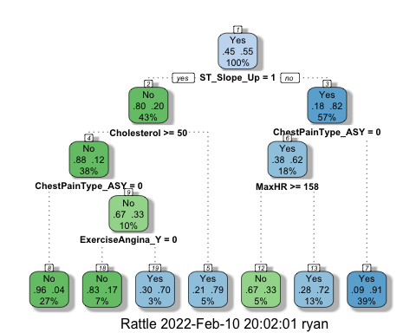

heart_fit$fit$fit$fit$cptable

## CP nsplit rel error xerror xstd  
## 1 0.57491289 0 1.0000000 1.0000000 0.04389406  
## 2 0.06620209 1 0.4250871 0.4250871 0.03463635  
## 3 0.01742160 2 0.3588850 0.3588850 0.03240139  
## 4 0.01393728 4 0.3240418 0.3623693 0.03252808  
## 5 0.01000000 6 0.2961672 0.3379791 0.03161802

The optimal value is 0.0100 with 6 splits and xerror of .3379791.

set.seed(123)  
folds = vfold_cv(train, v = 5)

heart_recipe = recipe(HeartDisease ~., train) %>%  
 step_dummy(all_nominal(),-all_outcomes())  
  
tree_model = decision_tree(cost_complexity = tune()) %>%   
 set_engine("rpart", model = TRUE) %>% #don't forget the model = TRUE flag  
 set_mode("classification")  
  
tree_grid = grid_regular(cost_complexity(),  
 levels = 25) #try 25 sensible values for cp  
  
heart_wflow =   
 workflow() %>%   
 add_model(tree_model) %>%   
 add_recipe(heart_recipe)  
  
tree_res =   
 heart_wflow %>%   
 tune_grid(  
 resamples = folds,  
 grid = tree_grid  
 )  
  
tree_res

## # Tuning results  
## # 5-fold cross-validation   
## # A tibble: 5 × 4  
## splits id .metrics .notes   
## <list> <chr> <list> <list>   
## 1 <split [513/129]> Fold1 <tibble [50 × 5]> <tibble [0 × 1]>  
## 2 <split [513/129]> Fold2 <tibble [50 × 5]> <tibble [0 × 1]>  
## 3 <split [514/128]> Fold3 <tibble [50 × 5]> <tibble [0 × 1]>  
## 4 <split [514/128]> Fold4 <tibble [50 × 5]> <tibble [0 × 1]>  
## 5 <split [514/128]> Fold5 <tibble [50 × 5]> <tibble [0 × 1]>

tree_res %>%  
 collect_metrics() %>%  
 ggplot(aes(cost_complexity, mean)) +  
 geom_line(size = 1.5, alpha = 0.6) +  
 geom_point(size = 2) +  
 facet_wrap(~ .metric, scales = "free", nrow = 2)

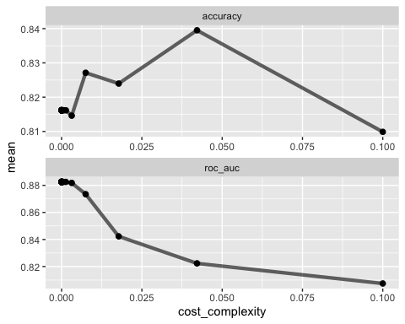

best_tree = tree_res %>%  
 select_best("accuracy")  
  
best_tree

## # A tibble: 1 × 2  
## cost_complexity .config   
## <dbl> <chr>   
## 1 0.0422 Preprocessor1_Model24

The best value is 0.0422.

final_wf =   
 heart_wflow %>%   
 finalize_workflow(best_tree)

final_fit = fit(final_wf, train)  
  
tree = final_fit %>%   
 pull_workflow_fit() %>%   
 pluck("fit")

## Warning: `pull_workflow_fit()` was deprecated in workflows 0.2.3.  
## Please use `extract_fit_parsnip()` instead.

fancyRpartPlot(tree)

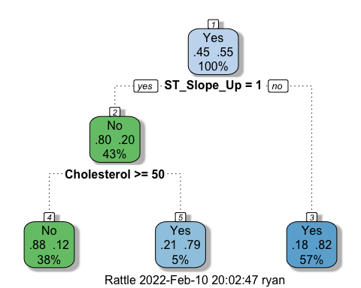

treepred = predict(final_fit, train, type = "class")  
head(treepred)

## # A tibble: 6 × 1  
## .pred_class  
## <fct>   
## 1 No   
## 2 No   
## 3 No   
## 4 No   
## 5 No   
## 6 No

confusionMatrix(treepred$.pred_class,train$HeartDisease,positive="Yes")

## Confusion Matrix and Statistics  
##   
## Reference  
## Prediction No Yes  
## No 213 29  
## Yes 74 326  
##   
## Accuracy : 0.8396   
## 95% CI : (0.8088, 0.8671)  
## No Information Rate : 0.553   
## P-Value [Acc > NIR] : < 2.2e-16   
##   
## Kappa : 0.6705   
##   
## Mcnemar's Test P-Value : 1.455e-05   
##   
## Sensitivity : 0.9183   
## Specificity : 0.7422   
## Pos Pred Value : 0.8150   
## Neg Pred Value : 0.8802   
## Prevalence : 0.5530   
## Detection Rate : 0.5078   
## Detection Prevalence : 0.6231   
## Balanced Accuracy : 0.8302   
##   
## 'Positive' Class : Yes   
##

We got an accuracy of 0.8396 on the training set for the heart data set.

treepred_test = predict(final_fit, test, type = "class")  
head(treepred_test)

## # A tibble: 6 × 1  
## .pred_class  
## <fct>   
## 1 No   
## 2 No   
## 3 Yes   
## 4 Yes   
## 5 No   
## 6 Yes

confusionMatrix(treepred_test$.pred_class,test$HeartDisease,positive="Yes") #predictions first then actual

## Confusion Matrix and Statistics  
##   
## Reference  
## Prediction No Yes  
## No 91 16  
## Yes 32 137  
##   
## Accuracy : 0.8261   
## 95% CI : (0.7761, 0.8689)  
## No Information Rate : 0.5543   
## P-Value [Acc > NIR] : < 2e-16   
##   
## Kappa : 0.6435   
##   
## Mcnemar's Test P-Value : 0.03038   
##   
## Sensitivity : 0.8954   
## Specificity : 0.7398   
## Pos Pred Value : 0.8107   
## Neg Pred Value : 0.8505   
## Prevalence : 0.5543   
## Detection Rate : 0.4964   
## Detection Prevalence : 0.6123   
## Balanced Accuracy : 0.8176   
##   
## 'Positive' Class : Yes   
##

We got an accuracy of 0.8261 on the testing set for the heart data set.

blood <- read_csv("Blood.csv")

## Rows: 748 Columns: 5

## ── Column specification ────────────────────────────────────────────────────────  
## Delimiter: ","  
## dbl (5): Mnths_Since_Last, TotalDonations, Total_Donated, Mnths_Since_First,...

##   
## ℹ Use `spec()` to retrieve the full column specification for this data.  
## ℹ Specify the column types or set `show_col_types = FALSE` to quiet this message.

blood = blood %>% mutate(DonatedMarch = as_factor(DonatedMarch)) %>%  
 mutate(DonatedMarch = fct_recode(DonatedMarch,"No" = "0", "Yes" = "1"))

set.seed(1234)   
blood_split = initial_split(blood, prop = 0.7, strata = DonatedMarch) #70% in training  
train2 = training(blood_split)   
test2 = testing(blood_split)

set.seed(1234)  
folds = vfold_cv(train2, v = 5)

blood_recipe = recipe(DonatedMarch ~., train2) %>%  
 step_dummy(all_nominal(),-all_outcomes())  
  
tree_model = decision_tree(cost_complexity = tune()) %>%   
 set_engine("rpart", model = TRUE) %>% #don't forget the model = TRUE flag  
 set_mode("classification")  
  
tree_grid = grid_regular(cost_complexity(),  
 levels = 25) #try 25 sensible values for cp  
blood_wflow =   
 workflow() %>%   
 add_model(tree_model) %>%   
 add_recipe(blood_recipe)  
  
tree_res =   
 blood_wflow %>%   
 tune_grid(  
 resamples = folds,  
 grid = tree_grid  
 )  
  
tree_res

## # Tuning results  
## # 5-fold cross-validation   
## # A tibble: 5 × 4  
## splits id .metrics .notes   
## <list> <chr> <list> <list>   
## 1 <split [418/105]> Fold1 <tibble [50 × 5]> <tibble [0 × 1]>  
## 2 <split [418/105]> Fold2 <tibble [50 × 5]> <tibble [0 × 1]>  
## 3 <split [418/105]> Fold3 <tibble [50 × 5]> <tibble [0 × 1]>  
## 4 <split [419/104]> Fold4 <tibble [50 × 5]> <tibble [0 × 1]>  
## 5 <split [419/104]> Fold5 <tibble [50 × 5]> <tibble [0 × 1]>

tree_res %>%  
 collect_metrics() %>%  
 ggplot(aes(cost_complexity, mean)) +  
 geom_line(size = 1.5, alpha = 0.6) +  
 geom_point(size = 2) +  
 facet_wrap(~ .metric, scales = "free", nrow = 2)

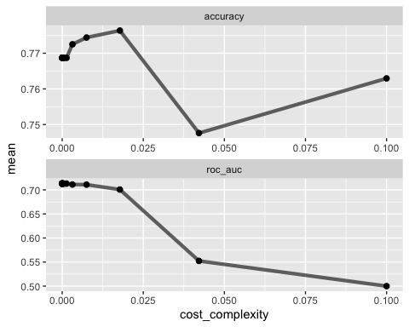

best_tree = tree_res %>%  
 select_best("accuracy")  
  
best_tree

## # A tibble: 1 × 2  
## cost_complexity .config   
## <dbl> <chr>   
## 1 0.0178 Preprocessor1_Model23

The optimal value appears to be 0.0178.

final_wf =   
 blood_wflow %>%   
 finalize_workflow(best_tree)

final_fit = fit(final_wf, train2)  
  
tree = final_fit %>%   
 pull_workflow_fit() %>%   
 pluck("fit")

## Warning: `pull_workflow_fit()` was deprecated in workflows 0.2.3.  
## Please use `extract_fit_parsnip()` instead.

fancyRpartPlot(tree)

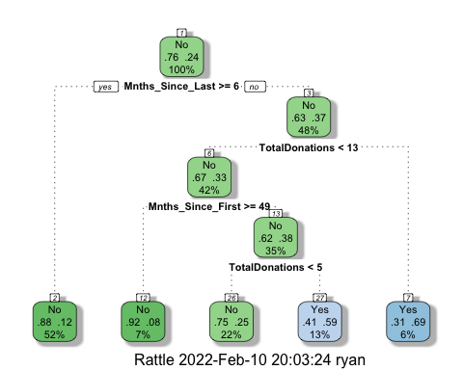

treepred = predict(final_fit, train2, type = "class")  
head(treepred)

## # A tibble: 6 × 1  
## .pred_class  
## <fct>   
## 1 Yes   
## 2 Yes   
## 3 Yes   
## 4 Yes   
## 5 Yes   
## 6 Yes

confusionMatrix(treepred$.pred_class,train2$DonatedMarch,positive="Yes") #predictions first then actual

## Confusion Matrix and Statistics  
##   
## Reference  
## Prediction No Yes  
## No 361 63  
## Yes 38 61  
##   
## Accuracy : 0.8069   
## 95% CI : (0.7704, 0.8399)  
## No Information Rate : 0.7629   
## P-Value [Acc > NIR] : 0.009214   
##   
## Kappa : 0.4263   
##   
## Mcnemar's Test P-Value : 0.016936   
##   
## Sensitivity : 0.4919   
## Specificity : 0.9048   
## Pos Pred Value : 0.6162   
## Neg Pred Value : 0.8514   
## Prevalence : 0.2371   
## Detection Rate : 0.1166   
## Detection Prevalence : 0.1893   
## Balanced Accuracy : 0.6983   
##   
## 'Positive' Class : Yes   
##

0.8069 is the accuracy on the train set for the blood data set.

treepred_test = predict(final_fit, test2, type = "class")  
head(treepred_test)

## # A tibble: 6 × 1  
## .pred_class  
## <fct>   
## 1 Yes   
## 2 No   
## 3 Yes   
## 4 Yes   
## 5 No   
## 6 Yes

confusionMatrix(treepred_test$.pred_class,test2$DonatedMarch,positive="Yes") #predictions first then actual

## Confusion Matrix and Statistics  
##   
## Reference  
## Prediction No Yes  
## No 150 28  
## Yes 21 26  
##   
## Accuracy : 0.7822   
## 95% CI : (0.7225, 0.8343)  
## No Information Rate : 0.76   
## P-Value [Acc > NIR] : 0.2434   
##   
## Kappa : 0.3753   
##   
## Mcnemar's Test P-Value : 0.3914   
##   
## Sensitivity : 0.4815   
## Specificity : 0.8772   
## Pos Pred Value : 0.5532   
## Neg Pred Value : 0.8427   
## Prevalence : 0.2400   
## Detection Rate : 0.1156   
## Detection Prevalence : 0.2089   
## Balanced Accuracy : 0.6793   
##   
## 'Positive' Class : Yes   
##

0.7822 is the accuracy on the test set for the blood data set.