Almond_ClusterAssign

Ryan Almond

2/28/2022

trucks <- read_csv("trucks.csv")

## Rows: 4000 Columns: 3

## ── Column specification ────────────────────────────────────────────────────────  
## Delimiter: ","  
## dbl (3): Driver_ID, Distance, Speeding

##   
## ℹ Use `spec()` to retrieve the full column specification for this data.  
## ℹ Specify the column types or set `show_col_types = FALSE` to quiet this message.

ggplot(trucks, aes(Distance, Speeding)) +  
 geom_point(alpha = 0.4) + theme_bw()

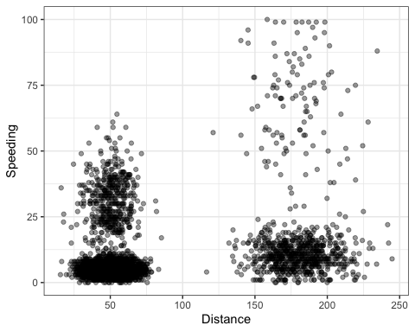

There appears to be some natural clustering of drivers. Big cluster around the 50 milage distance for drivers not speeding very often and another around the 150-200 mileage range and under 25% speeding. There is another potential cluster for that same distance but a fair amount of drivers speeding more then 50%. A lot more people drive a much shorter distance and typically speed less often.

kmeans_recipe = recipe(~ Speeding + Distance, trucks)   
  
trucks_dummy = kmeans_recipe %>%   
 step_scale(all_numeric()) %>%  
 step_center(all_numeric())   
  
trucks_dummy = prep(trucks_dummy, trucks) #prepares the recipe  
  
trucks_cleaned = bake(trucks_dummy, trucks) #applies the recipe and yields a data frame

set.seed(64)  
clusts =   
 tibble(k = 2) %>%  
 mutate(  
 kclust = map(k, ~kmeans(trucks_cleaned, .x)),  
 tidied = map(kclust, tidy),  
 glanced = map(kclust, glance),  
 augmented = map(kclust, augment, trucks_cleaned)  
 )  
  
clusts

## # A tibble: 1 × 5  
## k kclust tidied glanced augmented   
## <dbl> <list> <list> <list> <list>   
## 1 2 <kmeans> <tibble [2 × 5]> <tibble [1 × 4]> <tibble [4,000 × 3]>

clusters =   
 clusts %>%  
 unnest(cols = c(tidied))  
  
assignments =   
 clusts %>%   
 unnest(cols = c(augmented))  
  
clusterings =   
 clusts %>%  
 unnest(cols = c(glanced))

p1 =   
 ggplot(assignments, aes(x = Distance, y = Speeding)) +  
 geom_point(aes(color = .cluster), alpha = 0.8) +   
 facet_wrap(~ k)  
p1

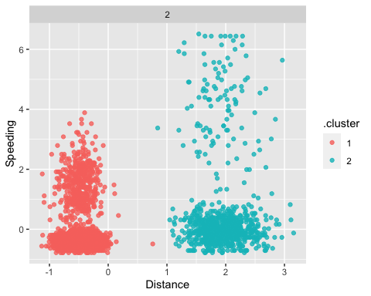

The clusters line up to people who either do not drive very far and people who drive much further. This lines up to what I would image two clusters would be.

set.seed(412)  
clusts =   
 tibble(k = 1:8) %>%  
 mutate(  
 kclust = map(k, ~kmeans(trucks_cleaned, .x)),  
 tidied = map(kclust, tidy),  
 glanced = map(kclust, glance),  
 augmented = map(kclust, augment, trucks_cleaned)  
 )  
  
clusts

## # A tibble: 8 × 5  
## k kclust tidied glanced augmented   
## <int> <list> <list> <list> <list>   
## 1 1 <kmeans> <tibble [1 × 5]> <tibble [1 × 4]> <tibble [4,000 × 3]>  
## 2 2 <kmeans> <tibble [2 × 5]> <tibble [1 × 4]> <tibble [4,000 × 3]>  
## 3 3 <kmeans> <tibble [3 × 5]> <tibble [1 × 4]> <tibble [4,000 × 3]>  
## 4 4 <kmeans> <tibble [4 × 5]> <tibble [1 × 4]> <tibble [4,000 × 3]>  
## 5 5 <kmeans> <tibble [5 × 5]> <tibble [1 × 4]> <tibble [4,000 × 3]>  
## 6 6 <kmeans> <tibble [6 × 5]> <tibble [1 × 4]> <tibble [4,000 × 3]>  
## 7 7 <kmeans> <tibble [7 × 5]> <tibble [1 × 4]> <tibble [4,000 × 3]>  
## 8 8 <kmeans> <tibble [8 × 5]> <tibble [1 × 4]> <tibble [4,000 × 3]>

clusters =   
 clusts %>%  
 unnest(cols = c(tidied))  
  
assignments =   
 clusts %>%   
 unnest(cols = c(augmented))  
  
clusterings =   
 clusts %>%  
 unnest(cols = c(glanced))

p1 =   
 ggplot(assignments, aes(x = Distance, y = Speeding)) +  
 geom_point(aes(color = .cluster), alpha = 0.8) +   
 facet_wrap(~ k)  
p1

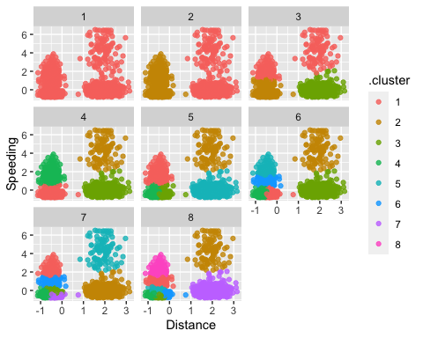

I think 4 clusters is the right number for what we want to see.

ggplot(clusterings, aes(k, tot.withinss)) +  
 geom_line() +  
 geom_point()

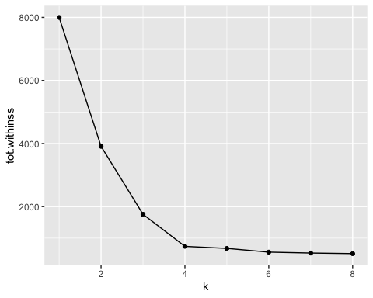

A k value of 3 or 4 seems to be the best for this data. I am going to continue with 4 though based on visualization earlier.

set.seed(64)  
clusts =   
 tibble(k = 4) %>%  
 mutate(  
 kclust = map(k, ~kmeans(trucks_cleaned, .x)),  
 tidied = map(kclust, tidy),  
 glanced = map(kclust, glance),  
 augmented = map(kclust, augment, trucks_cleaned)  
 )  
  
clusts

## # A tibble: 1 × 5  
## k kclust tidied glanced augmented   
## <dbl> <list> <list> <list> <list>   
## 1 4 <kmeans> <tibble [4 × 5]> <tibble [1 × 4]> <tibble [4,000 × 3]>

clusters =   
 clusts %>%  
 unnest(cols = c(tidied))  
  
assignments =   
 clusts %>%   
 unnest(cols = c(augmented))  
  
clusterings =   
 clusts %>%  
 unnest(cols = c(glanced))

p2 =   
 ggplot(assignments, aes(x = Distance, y = Speeding)) +  
 geom_point(aes(color = .cluster), alpha = 0.8) +   
 facet_wrap(~ k)  
p2

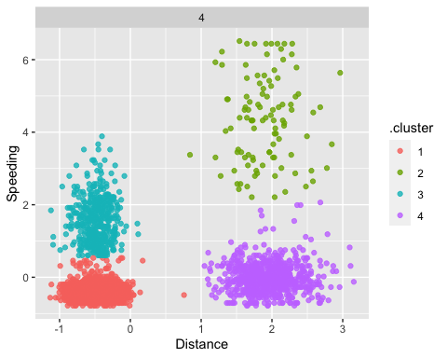

The clusters that result here are about what I thought when I visualized the relationship early on without clusters present.