Stock It v1.0.0
Introduction
Stock It is a custom software specially designed for an enterprise specialized in buying and selling animal feed.

Techonologies Used:
Environment : .NET, Winforms.
Languages : C#, SQL.
Frameworks : SQLite, QuestPDF.

Module 1: Achats
Use Cases
- Manage Suppliers
  - Add new suppliers
  - Remove existing suppliers
- Manage Truck Drivers
  - Add truck drivers
  - Remove truck drivers
- Invoice Handling
  - Automatically generate invoice details
  - Print and store invoices

Architecture Overview
The application architecture is derived from the MVC pattern, extended into an MVSC structure (Models, Views, Services, Controllers). The components are organized as follows:
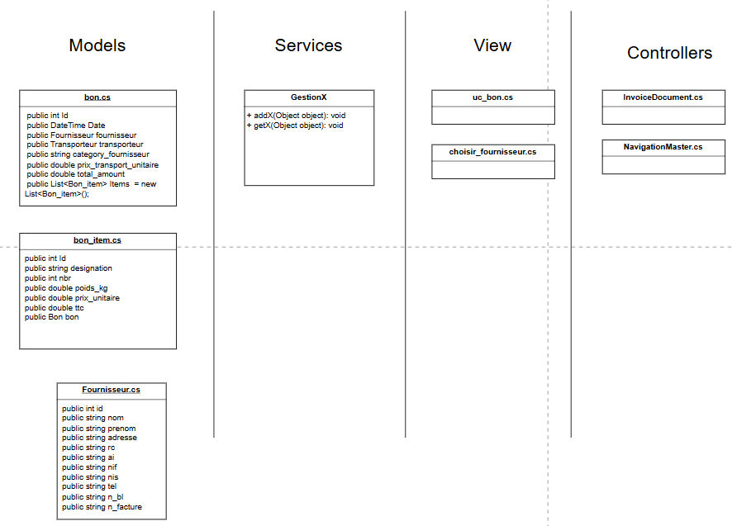
- Models
Represent temporary objects that map to database tables. These are used to transfer data between different architecture layers.
- Services
Example: GestionX.cs files.
Services handle CRUD operations, such as inserting a model instance into a database table.
Method format example:
addFournisseur(Fournisseur fournisseur)
- Controllers
Coordinate the interaction between Views, Models, and Services. They manage application logic and user input.
- Views
Represent the frontend interface of the application, where user interaction occurs.

NavigationMaster.cs
Responsible for user navigation. Loads forms and user controls and keeps history of forms and user controls loaded.

Database Overview
Db.cs Initializes a connection to the SQLite database.
Database Diagram
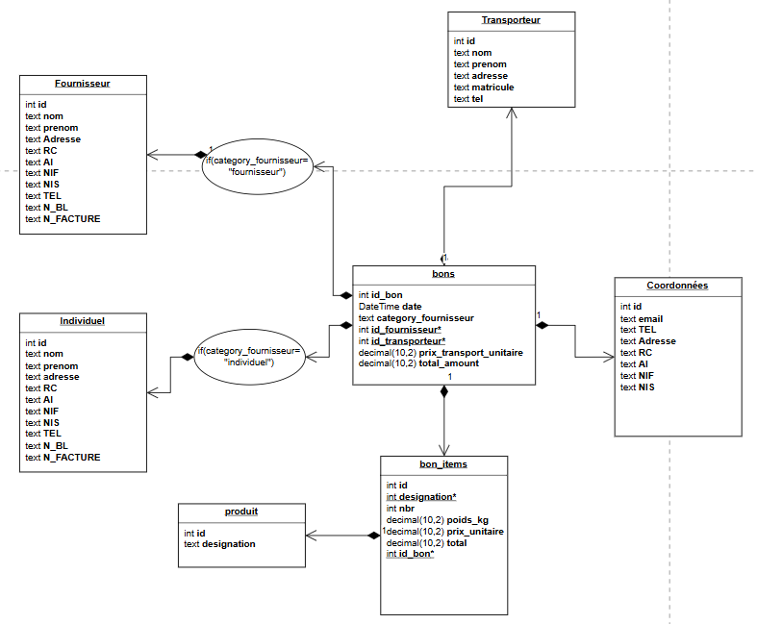
Category_fournisseur: “Entreprise” or “Particulier” ?
When filling invoices the supplier can be a registered enterprise which automatically fills out the invoice by fetching the enterprise’s data from the database. However, the supplier can also be an unregistered individual, in this case the user will manually fill the invoice.
The application will check the database, if this individual’s data does not exists in the registered enterprises databases then he will be added to the “Particuliers” Table.
Sample get request:
public List<Produit> GetProduits()
{
var produits = new List<Produit>();
using (var conn = Db.GetConnection())
{
conn.Open();
string query = "SELECT * FROM produit";
try
{
using (var cmd = new SqliteCommand(query, conn))
using (SqliteDataReader reader = cmd.ExecuteReader())
{
while (reader.Read())
{
var produit = new Produit
{
Id = reader.GetInt32(0), // Column index 0: id
Designation = reader.GetString(1) // Column index 1: des
};
produits.Add(produit);
}
}
}
catch (Exception e)
{
MessageBox.Show("Error: " + e.Message);
}
}
return produits;
}

Sample insert request:
public static void ajouterProduit(Product product)
{
using (var conn = Db.GetConnection())
{
string query = "INSERT INTO produit (designation)" +
" VALUES (@designation)";
try
{
using (var cmd = new SqliteCommand(query, conn))
{
cmd.Parameters.AddWithValue("@designation", product.designation);
int rows = cmd.ExecuteNonQuery();
MessageBox.Show($"{rows} produit(s) ajouté(s).");
}
}
catch (Exception e)
{
MessageBox.Show("Error: " + e.Message);
}
}
}

