Assignment 1 Deliverables

Burkhardt, Ryan

UMGC CMSC 315

Author Note

This Program will encapsulate a file from the user and run it through a class called DelimiterCheck to see if it is missing any parenthesis, brackets, or braces.

UML Class Diagram

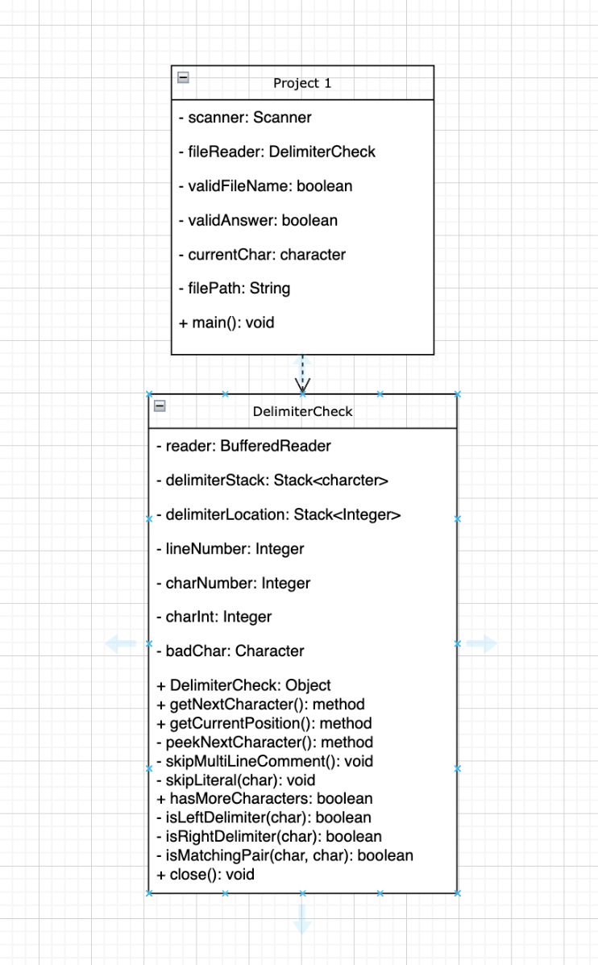

**Assignment 1 Deliverables**

Assignment 1 was quite a challenge. I started by creating a layout of what variables I was going to need on an empty whiteboard. After looking at the requirements from the rubric I went into creating the two classes. I quickly became overwhelmed with which variable I was going to put where and how I was going to call the character repetitively. I then went to draw.io to attempt to make sense of it in a class diagram and furthermore got overwhelmed. It became a code and diagram as you go for me. This is something I have been trying to get better with and am currently working on. I finally concluded the assignment after rigorous testing and calling in many resources such as geeksforgeeks and stackoverflow. While I did not use the code that was found on these sites, I did come back with great references on which direction to go with my while try loops.

During this assignment I learned the power of the stack class and how to use remove, append, and peek from the class. It will prove helpful in the lessons and programming future to come. I also learned about the IOException class and had to take my time reading through the different exceptions so I could catch the right exception. I also learned that when calling the exceptions, you could get the error messages from the throwable class. It also taught me while I was in the throwable class about the getCause method and the getLocalizedMessage(). These will prove crucial in my future when I build more advanced programs to handle exceptions.

**Test Table**

|  |  |  |  |  |
| --- | --- | --- | --- | --- |
| **Test Case** | **Input** | **What to Test** | **Actual Output** | **Pass/Fail** |
| 1 | Open Project 1  run test1.txt  end | Running the delimiter check for missing parenthesis | Missing Delimiter on line 6 & 9 | Pass |
| 2 | Open Project 1  run test1.txt  continue  runt test1.txt  end | Running the delimiter check for missing parenthesis. Change parenthesis between left and right to see if they catch changes in same file and continue function | Missing delimiter on line 25 char 38 and line 28 char 22  Missing Delimiter on line 25 char 35 and line 27 char 22  Continue Function works | Pass |
| 3 | Improper file name  Improper string name  no | Test to see if it continuously asks for a file | Worked and asked for a file repetitively  Successfully closed application | Pass |
| 4 | Enter wrong answer for yes or no | Continuously prompt to user for a valid input if they want to check a file and enter invalid input | Successfully re-prompts the user for a valid input | Pass |
| 5 | RunTest.txt  End | Alter test with open brackets, braces, and parenthesis to see if it can catch multiple errors and types | Successfully caught all errors | Pass |

**Screenshots**

**Test Case 1**

**Test Case 2**

**Test Case 3**

**Test Case 4**

