Written Assignment Unit 3
System Architecture and Version Control

Ryan Bains-Jordan
University of the People
MSIT-5910: Capstone
Dr. Shabia Shabir
April 29, 2026

Written Assignment Unit 3

System Architecture and Module Design
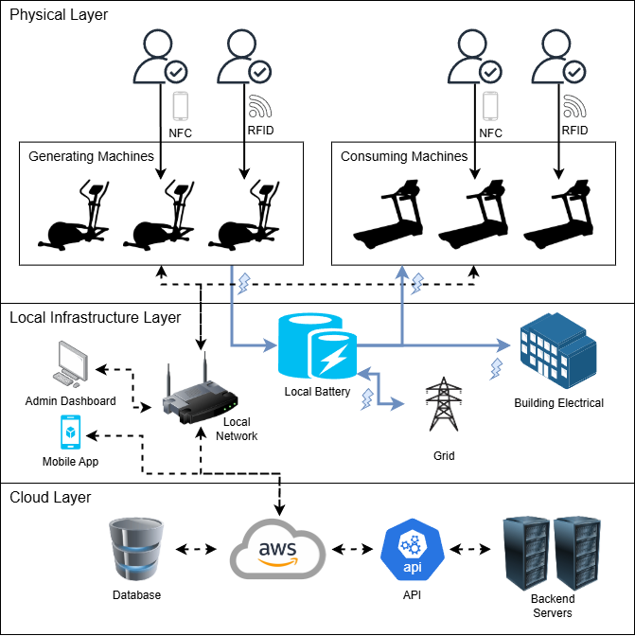
Figure 1. Visual representation of the System Architecture

System Components
The Power Plant Fitness infrastructure comprises a mix of energy-generating and energy-consuming equipment, touchless authentication mechanisms, a local battery system, administrative and consumer apps, and a centralized cloud-based backend to manage it all. Below is a list of inputs, outputs, and functional and non-functional requirements for each component to prioritize which functionality is important to implement, thereby enabling the project to be more successful and helping developers stay on track (Letaw, 2024).

Exercise Machines
The most critical components of the gym are the smart exercise machines that use resistive motors to generate electricity. This includes machines like stationary bikes, ellipticals, rowing machines, and cable-based strength machines. Each machine captures mechanical energy based on the user-configured resistance setting during a workout and converts it into usable electricity. In addition to energy-generating equipment, the gym will also be equipped with non-energy-generating machines that will not contribute to wattage for redeemable rewards. These include machines like treadmills and stair climbers that draw power from the gym’s local batteries instead of contributing to them. These machines will still use RFID authentication to track telemetry statistics and connect to the central server to track energy use, but will not contribute to the user's wattage balance.
Inputs | Outputs | Methodology | FR | NFR
Physical Effort – torque applied to resistive motor; RFID/NFC session token | Electricity – routed to local grid; session telemetry (like resistance level, RPM, time, etc.) | Energy meters measure real-time wattage output and telemetry statistics and transmit them to the centralized backend. | The machines must accurately measure and transmit wattage during every active session. | Telemetry transmission must occur with a latency under two seconds to ensure accuracy and maintain progress if the connection fails.

RFID Wearables and Smartphone NFC
At the time of enrollment at the gym, the user will receive an RFID tag and a silicon wristband with a tab insert. Lanyards would be available at the gym shop. The tag is loaded with an encrypted token associated with the user’s identity, which is then read by a reader embedded in each gym machine. The encryption ensures spoofing is mitigated between the tag and reader (Twingate Team, 2024). This will serve as a touchless identification layer that syncs each session to a specific member account before any telemetry statistics are recorded. As an alternative, members can download the Power Plant Fitness mobile app and use their smartphone’s NFC chip to connect to the same readers once logged in.
Inputs | Outputs | Methodology | FR | NFR
Tag RFID signal or smartphone NFC broadcast. | Authenticated session token transmitted to the machine interface and the backend | Mutual authentication ensures that both parties are verified before a session is established. | Authentication must be established before the machine becomes usable | Authentication must be completed within three seconds to avoid lengthy delays

Machine-Level Touchscreen Interface
Every machine is equipped with an interactive touchscreen display that provides real-time session feedback. This includes workout telemetry like elapsed time, selected goal, RPM, resistance level, generated wattage, and cumulative wattage credit. After signing in by tapping their wearable or smartphone to the embedded reader, the screen welcomes them by name and then offers options to configure their workout session and track their progress.
Inputs | Outputs | FR | NFR
RFID/NFC session token; real-time telemetry from onboard energy meter | Visual session data – workout telemetry and wattage generation | Authentication must be established before the machine becomes usable | The interface must be intuitive enough for a first-time user to start a session without assistance (usability)

Local Battery and Energy Management System
Power Plant Fitness is so named because, in theory, it can generate more energy than it consumes and sell excess power to the grid. A facility-level battery system receives electricity from resistance machines and charges local batteries stored in a secure location within the gym. The gym’s local power then discharges the local battery power to enable energy-consuming equipment to operate. A local energy management controller meters both inflow and outflow and logs net energy data to the backend.
Inputs | Outputs | FR | NFR
Electricity – Generated from resistance machines and the outside power grid | Electricity – Required by energy-consuming machines | The system must track net energy generation and consumption in real time, drawing power from the external grid when battery levels are too low | The battery system must maintain stable power delivery to the gym operations regardless of fluctuations in member activity (reliability)

Administrative Dashboard
A browser-based portal accessible to gym staff provides real-time visibility into machine usage, member activity, energy generation metrics, and reward transactions. Role-based access control ensures only authorized individuals can access data relevant to their function.
Inputs | Outputs | FR | NFR
Backend data feeds; staff authentication credentials | Operational reports; manual wattage adjustments | The dashboard must display real-time energy generation totals and member session activity. | The dashboard must be accessible via standard web browsers without requiring additional software installation (usability)

Power Plant Fitness Mobile App
The consumer-facing mobile application allows members to sign in to their accounts remotely, view their session history, monitor their Watt Wallet balance, redeem rewards, participate in personal and group challenges, check leaderboards, and manage their accounts. The app also enables NFC-based machine authentication for members who prefer not to use their RFID tag.
Inputs | Outputs | FR | NFR
Member login credentials; User input for changing configurations, setting goals, and redeeming rewards | Previous session data, Watt Wallet, reward redemption history, leaderboards, challenge updates | The app must allow members to view their data in real-time | The app must be available on both iOS and Android platforms (compatibility)

Centralized Cloud Backend
For operational simplicity and flexibility, the backend for the gym's system components will be served and managed on AWS. This will serve as the system’s core business-logic layer, managing user accounts, processing wattage-credit calculations, maintaining the reward ledger, and coordinating data flow among all components. Integrating with AWS allows the gym to scale up or down with ease, enabling it to pay only for what it needs without the need for infrastructure specialists (GeeksforGeeks, 2025). The backend will also be responsible for normalizing efforts to ensure wattage credits are distributed fairly. Over-rewarding or under-rewarding both affect motivation and purpose, so applying an algorithm to normalize the effort will improve morale and continued participation (Dwivedi, 2024).
Inputs | Outputs | Methodology | FR | NFR
Session telemetry from machines, authentication events, staff, and member app requests | Wattage credit updates; reward transaction records; database feeds; app responses | The reward calculation engine applies a normalized score to ensure equitable credit distribution. | The backend must calculate and apply wattage credits to member accounts within 60 seconds of session completion. | The system must support concurrent sessions across all gym machines without degradation in performance (scalability)

Version Control and Collaboration
This capstone project uses a Git-based version control system to maintain consistent documentation, track design decisions, and ensure traceability across all phases of the project. Git makes file changes more organized by managing them through commits and pull requests, ensuring every change is intentional and reviewed. It also makes it significantly easier to manage a project with multiple contributors as it supports merging and conflict resolution (Davies, 2024).
The repository follows a two-branch model labeled main and development. The main branch represents the project's stable, submission-ready state and is generally updated only after the project files have been reviewed and finalized. The development branch, however, serves as the active working branch where new diagrams, drafts, and source files are added and refined before being merged into main. This workflow mirrors industry-standard Git workflows to better prepare for real-world version control solutions.
The following root directories organize the directory structure:
- /docs: contains all written assignment submissions
  - /assignments: holds the written assignments that make up the report
  - /report: contains the final capstone report
- /diagrams: contain the architecture and schema diagrams
- /mockups: stores high-fidelity images of interfaces
- /src: contains the Python implementation of the wattage credit normalization algorithm
This approach ensures that every change that is made to the project files is both recoverable and documented, providing a transparent record of how the project was developed. This fulfills the traceability and accountability goals that version control is designed to provide.

References
Davies, S. (2024). Blueprints: Creating, describing, and implementing designs for larger-scale software projects (Version 2.5). University of Mary Washington. https://open.umn.edu/opentextbooks/textbooks/blueprints-creating-describing-and-implementing-designs-for-larger-scale-software-projects-davis Licensed under CC BY-SA
Dwivedi, K. (2024, January 10). What are the most effective ways to balance rewards and incentives? LinkedIn. https://www.linkedin.com/advice/1/what-most-effective-ways-balance-rewards-incentives-ggufe
GeeksforGeeks. (2025, August 6). AWS vs OnPremise Servers: Why Cloud is the Future. GeeksforGeeks. https://www.geeksforgeeks.org/blogs/aws-vs-on-premise-servers-why-cloud-is-the-future/
Letaw, L. (2024). Handbook of software engineering methods [Open textbook]. Oregon State University. https://open.oregonstate.education/setextbook/ Licensed under CC BY-NC-SA 4.0
Twingate Team. (2024, August 7). What is RFID spoofing? How it works & examples. Twingate. https://www.twingate.com/blog/glossary/rfid%20spoofing

