Homework Problem Set 7: Database Programming

# Overview

In this lab, we will explore database programming of procedures, views, triggers, and functions.

## Learning Objectives

Upon completion of the lab, you should be able to:

* Write your own data logic as user-defined functions.
* Write your own data logic as triggers.
* Write your own data logic as stored procedures.
* Use built-in functions to solve data-logic-type problems.

## What You Will Need

To complete this lab, you will need the learn-databases environment up and running, specifically:

* Microsoft SQL Server DBMS.
* Provision the **TinyU** database using the database provisioner application <https://localhost:5000>.
* Azure Data Studio connected to SQL Server with an open query window.
* Please review the first lab if you require assistance with these tools.

# Questions

Answer these questions using the problem set submission tem For any screen shots provided, please follow the guidelines for submitting a screen shot.

Write the following as SQL programs. For each, include the SQL as a screen shot with the output of the query.

1. In the **TinyU** database:
   1. Write an SQL Stored procedure called **p_upsert_major**, which, given a major_code (business key) and a major_name, does an Upsert, which is the following:
      1. Checks if the major_code exists in the table already.
      2. If yes, updates the table and makes the major_name match the new major name.
      3. If no, inserts the new major_name and major_code into the table. HINT: major_id is not a surrogate key, so you will need to determine the next ID yourself in code!

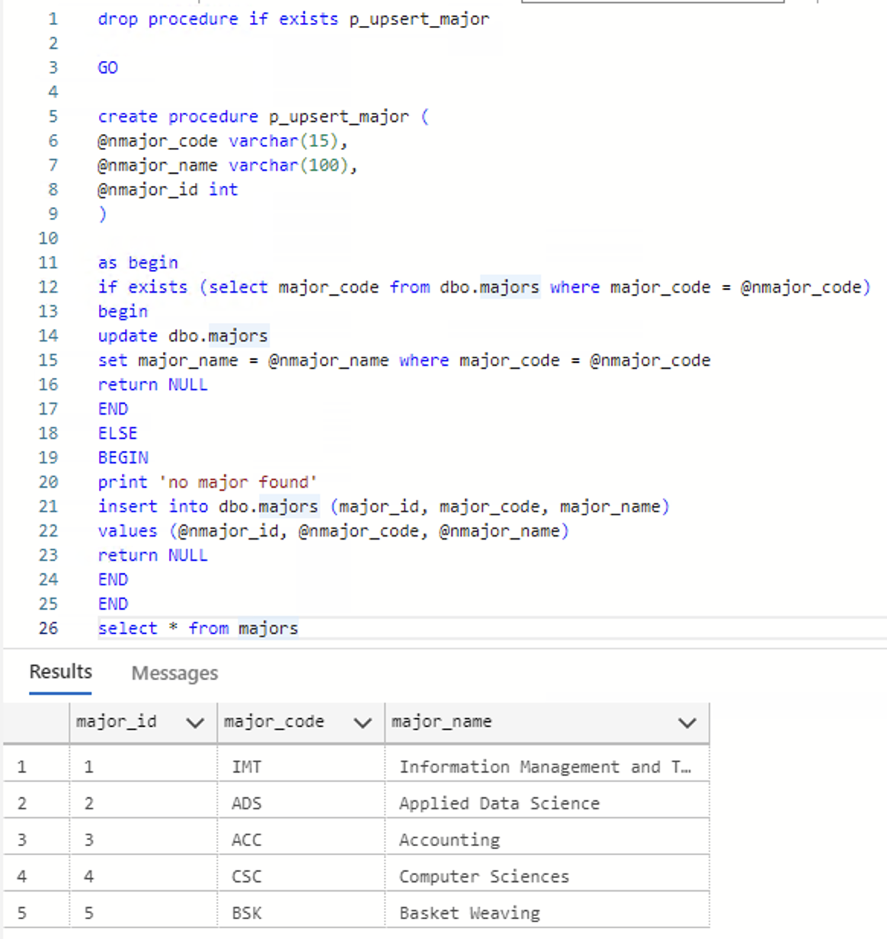

* 1. Test your stored procedure by executing it to make these changes:
     1. Change : CSC—Computer Sciences to CSC—Computer Science
     2. Add: FIN—Finance

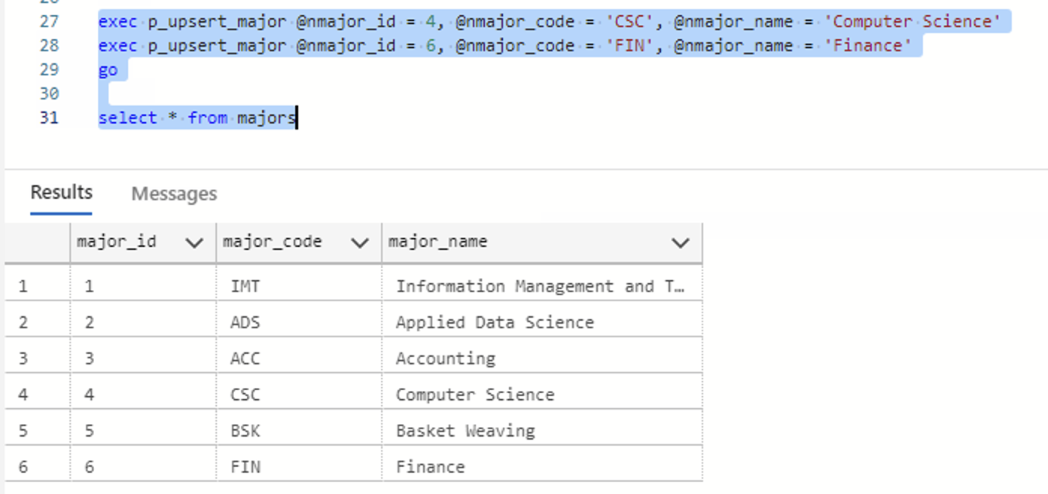

1. In the **TinyU** database:
   1. Write a user-defined function called **f_concat** that combines the any two varchars @a and @b together with a one-character @sep in between.   
      A screenshot of a computer program

      Description automatically generated with low confidence
   2. Now create a view called **v_students** that displays the student_id, student name (first last), student name (last, first), GPA, and name of major. You should call the function you created in 2.a. After you create the view, execute it with a SELECT statement.

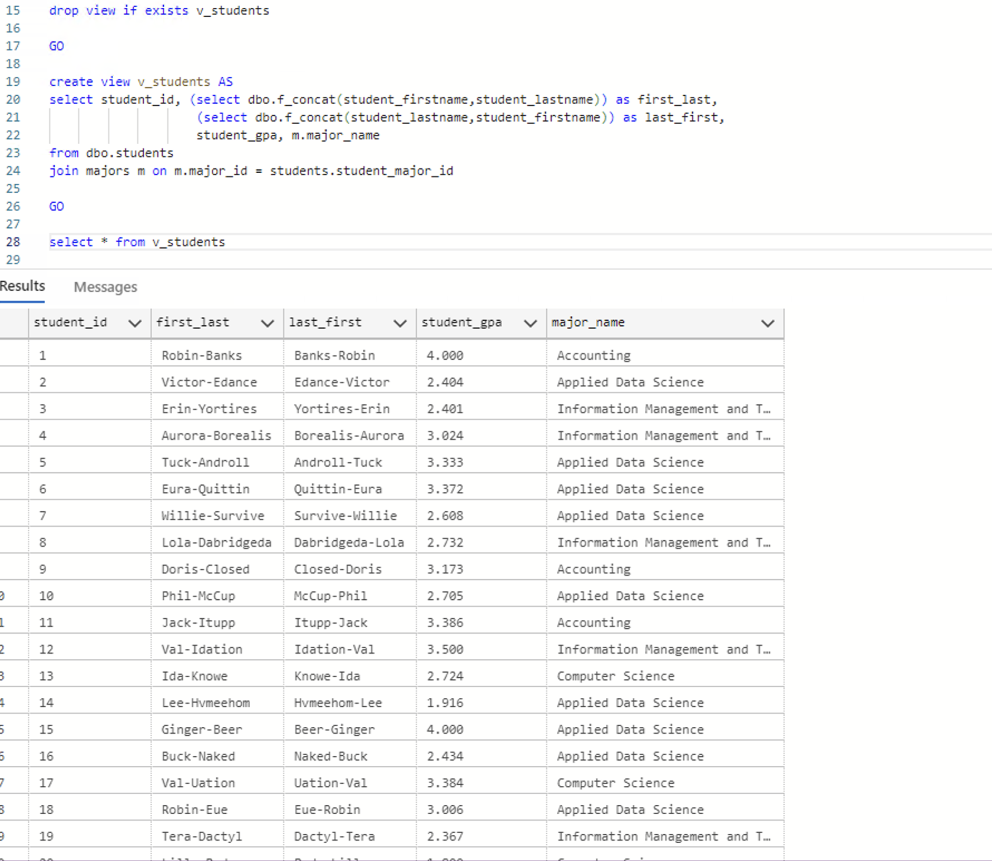

1. In the **TinyU** database:
   1. Write a query on the **majors** table so that the major_name is broken up into keywords, one per row. HINT: You must use string_split() with cross-apply.   
      A screenshot of a computer

      Description automatically generated
   2. Then use the query in 3.a to create a table-valued function **f_search_majors** that allows you to search the majors by keyword. Demonstrate calling the TVF by querying all majors with the “Science” keyword.

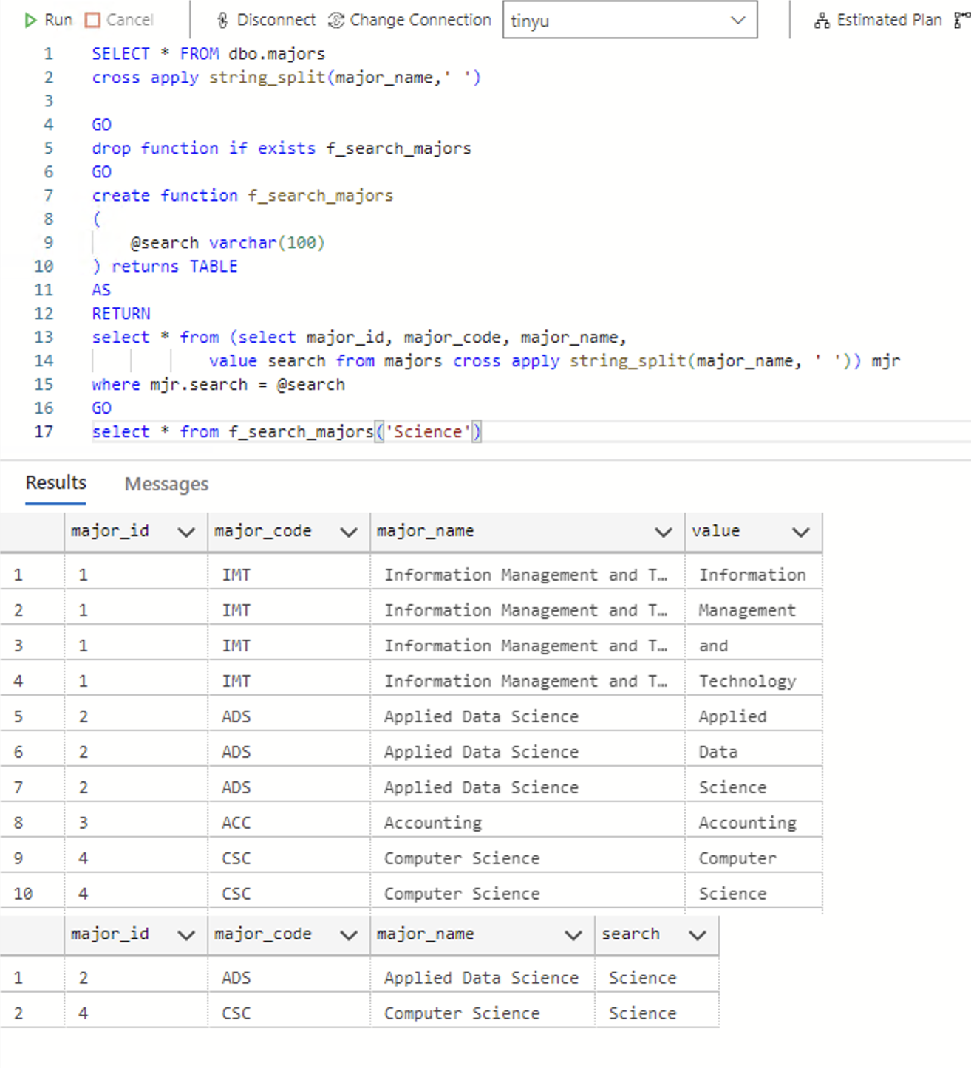

1. In the **TinyU** database:
   1. Alter the **students** table and add the following columns:
      1. student_active char(1) default (‘Y’) not null
      2. student_inactive_date date null

* 1. Create a trigger on the **students** table: when there is an student_inactive_date set, set student_active to ‘N’, and whenever there is not a student_inactive_date, then student_active is set to ‘Y’.
  2. Write SQL code to deactivate all the ‘Graduate’ students with a date of ‘2020-08-01’.
  3. Write SQL code to reactivate all the ‘Graduate’ students.

Provide a screen shot of your code from 4.a. and 4.b working. Provide another screen shot demonstrating 4.c worked. Then, provide a final screen shot of code and demonstration of 4.d working.