Instructions: Must be a text file in the same folder as Functions.cpp, Functions.h, and Source.cpp. The name does not matter (specified by user during runtime). The text file must have integers spaced out with a new line in order for the code to be able create a vector with them. Source.cpp includes code that gives a test run of all of the functions included in Functions.cpp.

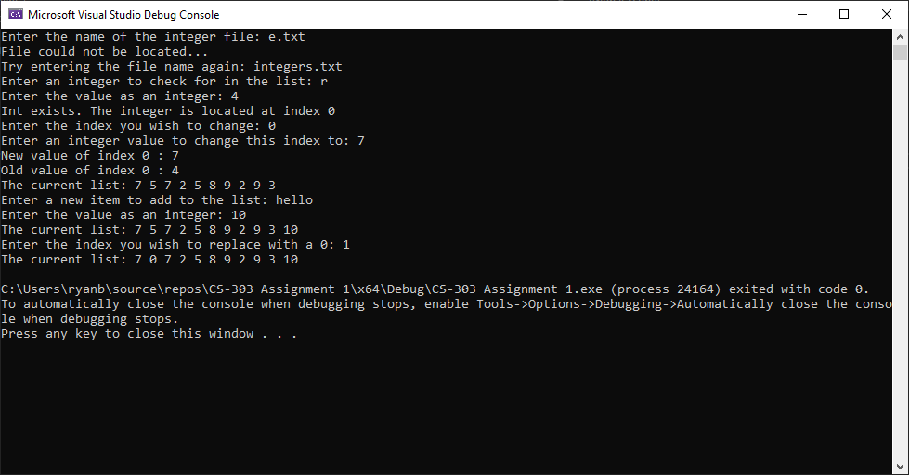Output of Source.cpp: