LOGOCLOTHZ.COM  155 N.E. 37th Road  Homestead, FL. 33033  Call / Fax / Text: 833-5646  https://logoclothz.com  CUT, SEWN, & PRINTED IN THE USA | Customer Name: {{CUSTOMER_NAME}}  Email Address: {{CUSTOMER_EMAIL}}  Company: {{CUSTOMER_COMPANY}}  Phone: {{CUSTOMER_PHONE}}  Shipping Address:  {{SHIPPING_ADDRESS}}

QUOTE: {{ORDER_ID}} - {{PO_DATE}}
To Supply: 6FT - FULL-DYE SUBLIMATED TABLE THROW: 4-Sided / Closed Back
Item: Full-dye Sublimated Round Table Throw  Fabric: 100% 6 oz Polyester  Wrinkle & Fire-resistant (machine washable)  Fabric Color: BLACK  Size: 6FT - Table Size: 30” W x 72” L x 29” H  Imprint: Full-color, Dye-Sublimation  Style: 4-Sided / Closed Back  Price for (6) @ $ (176.69) each  7% Discount Applied (Reg. Price @ 189.99)  No Set-up Fees, No Hidden Charges, No Tax | IMAGE: Full-dye Sublimated Table Throw  4-Sided / Closed Back  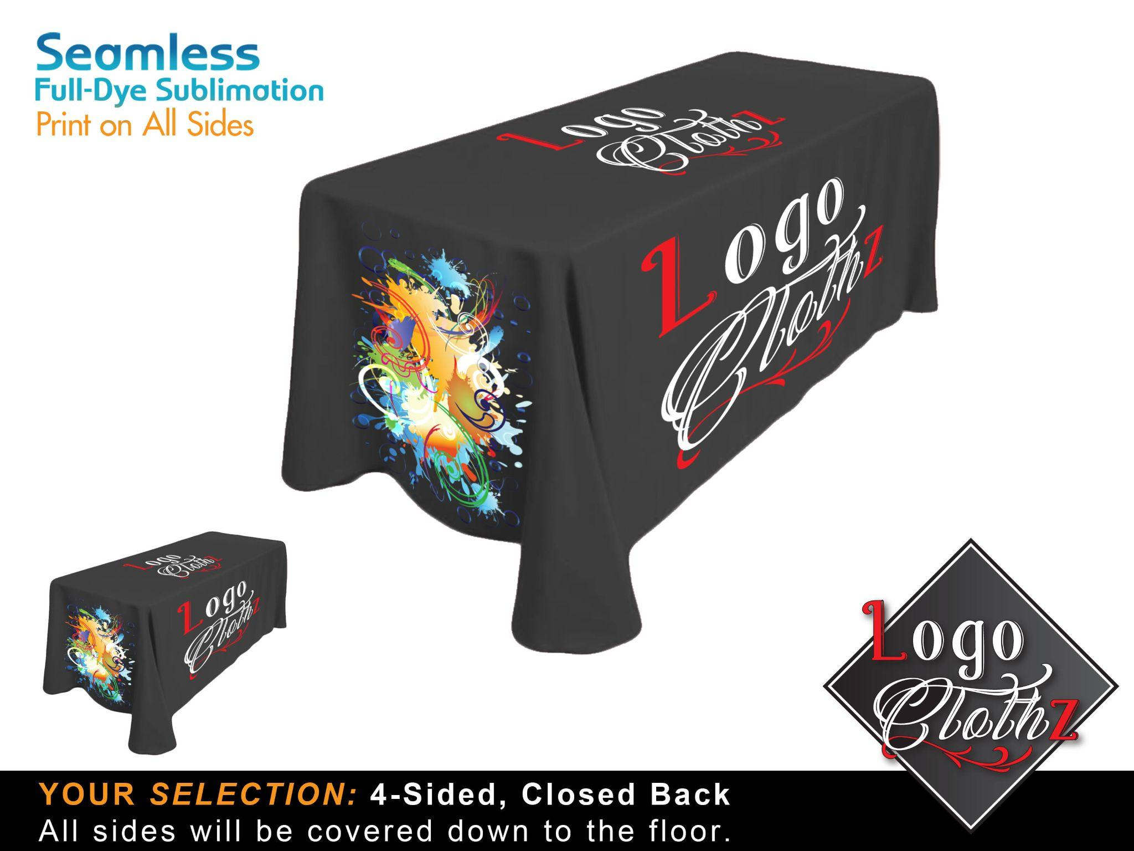
Product Total: {{SUBTOTAL}} | Tax: {{TOTAL_TAX}} | UPS GROUND SHIPPING: {{SHIPPING_COST}}
Total Order: {{ORDER_TOTAL}} - Notes: Notes: {{NOTES}}

*The tablecloths are machine washable using cool water and a low-heat setting. The imprint will not be damaged if the covers are washed as mentioned above. We do not recommend taking them to the dry cleaners as they tend to use harsh chemicals and detergents.

PRODUCTION TIME: Production will require 3-business days and begins the following business day after the order is paid and the proofs are approved. There is a cutoff time of 1:00 p.m. (EST) for orders to go into production the next business day.
UPS GROUND SHIPPING: UPS Ground shipping is included in the pricing above.
Shipping to Torrance, CA 90501 will require 4 business days; we ship from Patterson, NJ. 07501
We are not responsible for UPS delays beyond our control.
PRODUCT INFO: All of our products are made and printed here in the USA. We print on 100% polyester, which is wrinkle-resistant, fire-resistant, and machine-washable.
PRINT METHOD: We print using a dye-sublimation print method where ink is fused into the fabric. This makes for a long-lasting and durable product.

FRONT PANEL PRINTS: The front panel starts out completely white and is printed in full color, including the background color. The front panel is then sewn together with the other panels, which are pre-dyed. This may result in a very slight color variation between the printed and non-printed panels.
*The color variation is very subtle and hardly noticeable - it is the industry standard of printing.
FULLY-DYE SUBLIMATED PRINTS: With our fully-dye sublimated tablecloths, the entire cover is printed at the same time, including all panels. This results in a uniform fabric color on the entire table cover.
WASHING INSTRUCTIONS: Machine wash using cool water and a low-heat setting.
We do not suggest taking them to a dry cleaner as they tend to use harsh detergents and chemicals.

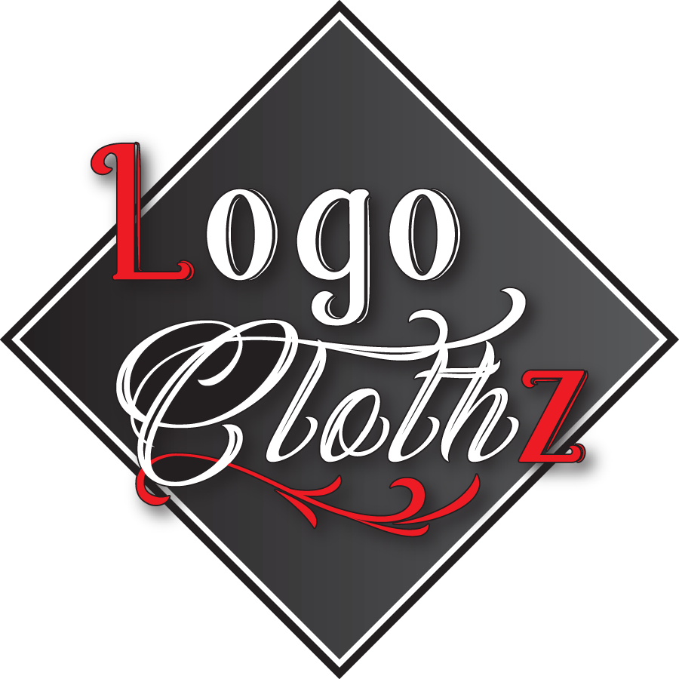We Put the "Pro" in Promotional Table Covers
Purchase from Logoclothz & you will be helping people, the environment & the Planet
Logoclothz as a company has a strong & dedicated philanthropic outlook. We take corporate responsibility very seriously and feel that we all need to step up to the plate for future generations and also do things that can make an impact today. So how do we achieve this?
Logoclothz is the company that will print your logo onto a tablecloth and then plant trees. We are a company that fights against hunger, cares, and gives back to our men and women of the military. Logoclothz proudly cares for our staff and feel they are an integral part of our vision; they are our greatest asset and are regarded as individuals. We at Logoclothz are passionate about helping to make a difference and are dedicated to giving a portion of our time, money, and assistance to our local, state, and worldwide concerns."
When you place an order with Logoclothz online, no matter the size, you will be presented with an option asking which one of the charities we are supporting you would like a portion of your sales to go to. There is no need for you to put your hand in your pocket as we will donate from the sale that you generated. Logoclothz.com is committed to making the world a more beautiful, sustainable, and healthier place through selling our products. We Partner With;
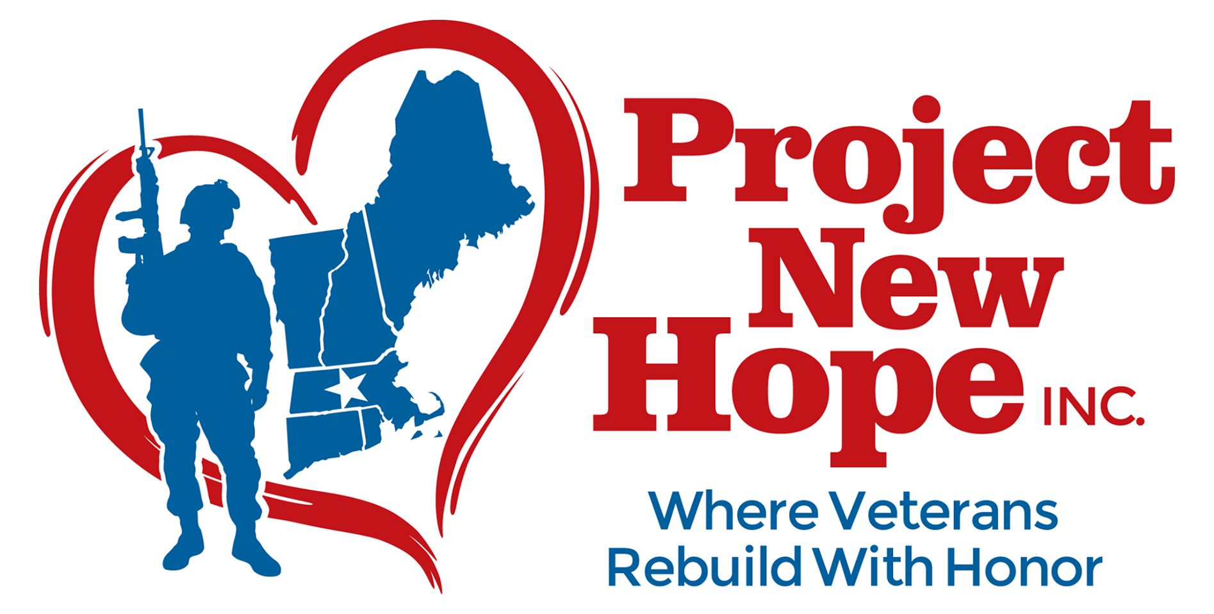 | 