*The deliverables for this assessment will be a single pdf document containing a 2000-word report. It is not academic in style, and you should use markdown to create the document. I consider 2000 words to be a rough estimate, and your report may be anything from between 1000 to 2000 words in length. The document should, roughly, be structure as follows:*

**Title and Cover Page**

* Link to your hosted web application.
* Link to your hosted Git Repository (ensure it is public, or if on GitHub you can add me - joeappleton18), which should include a:
  + Professional README.md file. This file should contain information on how to run the project in development and production.
  + Your project's, version-controlled, source files

**Introduction**

This should pull together, and summarise, the entire project. You should also include the background and inspiration that lead you to undertake this project. You may, at this point, want to pull in statistics to underpin your argument as to why this project was required

From week 5:

The problem statement:

* The problem statement should form part of your introduction.
* The problem statement should:
* Identify an issue
* How your project will address the issue

Example: Currently, at Solent University, there is no central database containing key features (e.g. capacity, equipment) regarding teaching space. Rather, this information is stored in a spread sheet which needs to be manually inspected; this is a time consuming process. This project proposes to construct a, proof of concept, web application that moves this process online.

**System Overview**

A high-level overview of how the system functions, you can use screen shots if it helps. You should consider aspects such as: Briefly describing all datastores including databases, file systems and media data stores Key views and interfaces Including a diagram of the key system components and how they are linked

From week 5:

The System Overview

The system overview is going to be a high level overview of your, completed, application. You will want to include screen shots, a system diagram (we will look at this later).

**Key Design Decisions**

You should rationalise the choices you made in designing your application.

From week 5:

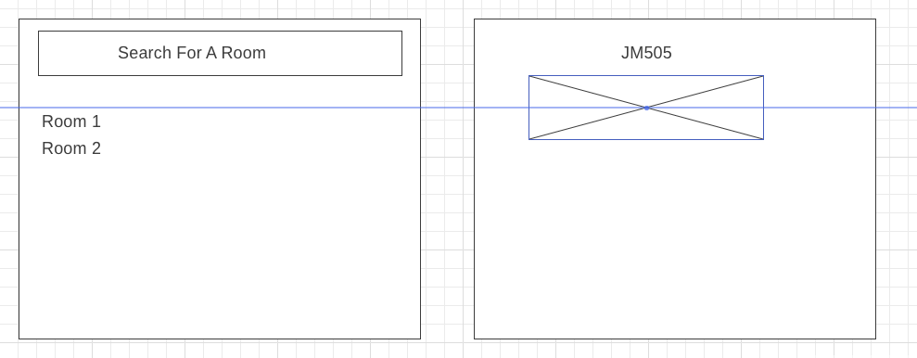

If you are using a non-relational database, I suggest you present a wire frame of the views in your application. Continuing with the above idea of a room exploration system. Above, is a very simplified version of what some basic layouts could look like. Wire frames like this are fine; however, you will want to be more detailed.

**Database Design**

This section will document the different database entities and how they are related. If you are using a relational database you may want to include an entity relationship diagram.

**Security and Scalability**

Identify in what ways your application is secure and scalable.

**Conclusion and Reflection**

Bring the document to a close by tying together the process, and provide me with a brief reflective account of the entire project.