CSS 422: Hardware and Computer Organization

Homework: Intro to Logisim

Instructor Rob Nash

Student Name: Ryan Peters

Number Conversions

Convert the following hex number to base 7; consider conversion first to decimal, and show all work. (1 pt) 0x9D7A4₁₆
N = ∑p_i*b^i
Decimal = 9*16^4 + 13*16^3 + 7*16^2 + 10*16 + 4
- 9*65,536 + 13*4096 + 7*256 + 10*16 + 4
- 589,824 + 53,248 + 1792 + 160 + 4 => 645,018
- 645018/7 = 92,145, r = 3
- 92145/7 = 13,163, r = 4
- 13163/7 = 1180, r = 3
- 1880/7 = 168, r = 4
- 268/7 = 24, r = 2
- 38/7 = 3, r = 3
- 5/7 = 0, r = 5

- Complete a truth table for the positive logic implementation of AND, OR, and NAND with two inputs A and B using true and false voltage signals. (2pt)
A | B | A*B | A+B | A NAND B
L | L | L | L | H
L | H | L | H | L
H | L | L | H | L
H | H | H | H | L

- Complete the truth table for the negative logic implementation of AND, OR, and NOR with two inputs A and B using true and false voltage signals. (2pt)
A | B | A*B | A+B | A NOR B
H | H | H | H | L
L | H | H | L | H
H | L | H | L | H
L | L | L | L | H

- Draw conclusions about: (1pt)
  - AND in positive logic and OR in negative logic. What can we conclude here?

- The two gates are not equivalent, nor are they opposites.

  - AND in positive logic and NOR in negative logic. What can we conclude here?

  - OR in negative logic and NAND in positive logic. What can we conclude here?

Given the following logic circuit, answer the questions below.
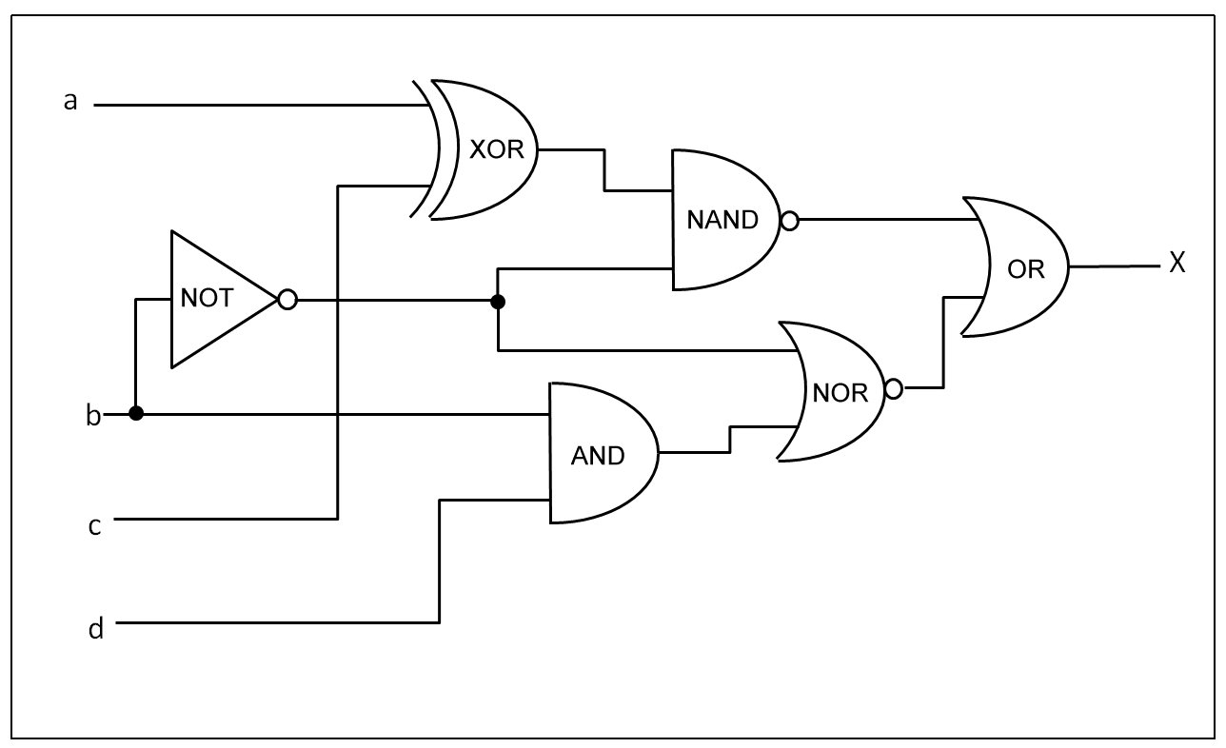
- What is the equivalent logical Boolean equation for this circuit?
- ~((a^c)*~b)+~(~b+(b*d)) = x

- Draw a Truth table for the four inputs {A,B,C,D} and the one output X.
a | b | c | d | x
0 | 0 | 0 | 0 | 1
0 | 0 | 0 | 1 | 1
0 | 0 | 1 | 0 | 0
0 | 0 | 1 | 1 | 0
0 | 1 | 0 | 0 | 1
0 | 1 | 0 | 1 | 1
0 | 1 | 1 | 0 | 1
0 | 1 | 1 | 1 | 1
1 | 0 | 0 | 0 | 0
1 | 0 | 0 | 1 | 0
1 | 0 | 1 | 0 | 1
1 | 0 | 1 | 1 | 1
1 | 1 | 0 | 0 | 1
1 | 1 | 0 | 1 | 1
1 | 1 | 1 | 0 | 1

- For the Boolean equation derived in (5), simplify this using the Boolean logic laws.
- (~(a^c)+b)+(b*(~b+~d)) => ((~a XNOR ~c)+b)+(b~d) => (~a XNOR ~c)+b+b~d
- (~a XNOR ~c)+b+b~d

Introduction to Logisim
In this section, we’ll introduce a graphical tool for designing and simulating logic circuits and systems. We’ll start by installing the software, and then we’ll walk through each tutorial.
- Download the Logisim Simulator at http://www.cburch.com/logisim/
- Find the beginners tutorial under the Documentation page and start at Step 0

  - Read step 0: Orienting yourself, and summarize what you learned in this step. What did you do?
    - I learned where to find the “explorer pane, the attribute table, and the canvas. Above these parts are the menu bar and the toolbar”

  - Read step 1: Adding Gates. Explain what you did here.
    - I added not, and, and or gates to create an XOR blackbox.

  - Read step 2: Adding wires. What did you learn to do in this section?
    - Add wire, read word, type answer.

  - Read step 3: Adding text. What did you accomplish in this section?
    - I learned how to add labeling text to the circuit canvas. The tutorial suggested writing something informative and useful… So I followed in the footsteps of the smartest man on television and named it ‘poopaids_copy’

  - Read step 4: Testing your circuit. What output did you create here?
    - The most exclusive or this side of my living room.

  - After completing the above exercises answering the above questions, save your circuit and submit the file along with your answers. (2 pts)
    - File name is poopaids_copy.circ

- Simulate the following ALU with Logisim; save and submit the file. (1.5 pts)
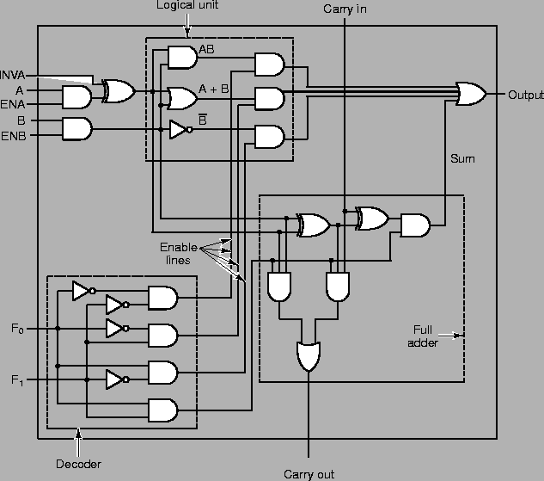

- Change the signals on the inputs F0 and F1, and observe how the output changes based on the A and B signals. Make a truth table for A,B, F0, F1, and output here. (1.5 pts)
A | B | F0 | F1 | Output
0 | 0 | 0 | 0 | 0
0 | 0 | 0 | 1 | x
0 | 0 | 1 | 0 | 1
0 | 0 | 1 | 1 | x
0 | 1 | 0 | 0 | x
0 | 1 | 0 | 1 | x
0 | 1 | 1 | 0 | x
0 | 1 | 1 | 1 | x
1 | 0 | 0 | 0 | 0
1 | 0 | 0 | 1 | x
1 | 0 | 1 | 0 | 1
1 | 0 | 1 | 1 | x
1 | 1 | 0 | 0 | x
1 | 1 | 0 | 1 | x
1 | 1 | 1 | 0 | x

- Describe the four operations that correspond to the four different values for F0 and F1. (1 pt)
  - F0 and F1 allow the circuit to determine which condition of A and B we need in order to produce the adder’s output. That covers the first 3 operations, (A*B, A+B, or ~B). The fourth operation indicates that the adder has exceeded it’s nybble, and needs to carry over to the next adder.

- A majority function is a combinational circuit that outputs a 1 if the input lines have more 1’s than 0’s. If there are an equal number of 1s and 0s, or more 0s than 1s, a 0 is outputted. Complete the truth table below for such a circuit that has 4 inputs {A,B,C,D} and one output X.
A | B | C | D | X
0 | 0 | 0 | 0 | 0
0 | 0 | 0 | 1 | 0
0 | 0 | 1 | 0 | 0
0 | 0 | 1 | 1 | 0
0 | 1 | 0 | 0 | 0
0 | 1 | 0 | 1 | 0
0 | 1 | 1 | 0 | 0
0 | 1 | 1 | 1 | 1
1 | 0 | 0 | 0 | 0
1 | 0 | 0 | 1 | 0
1 | 0 | 1 | 0 | 0
1 | 0 | 1 | 1 | 1
1 | 1 | 0 | 0 | 0
1 | 1 | 0 | 1 | 1
1 | 1 | 1 | 0 | 1
1 | 1 | 1 | 1 | 1

X | ~A~B | ~AB | AB | A~B
~C~D
~CD |  |  | 1
CD |  | 1 | 1 | 1
C~D |  |  | 1

- Derive a reduced Boolean equation for X using the Karnaugh map above. Start by indicating the borders of the empty K-Map as A/~A, B/~B, C/~C, D/~D. (2 pts)
CD(A+B)+AB(C+D)

- Design this circuit using just AND, OR, and NOT gates in Logisim. Take a screenshot and attach the image to the document you submit. (6pts)
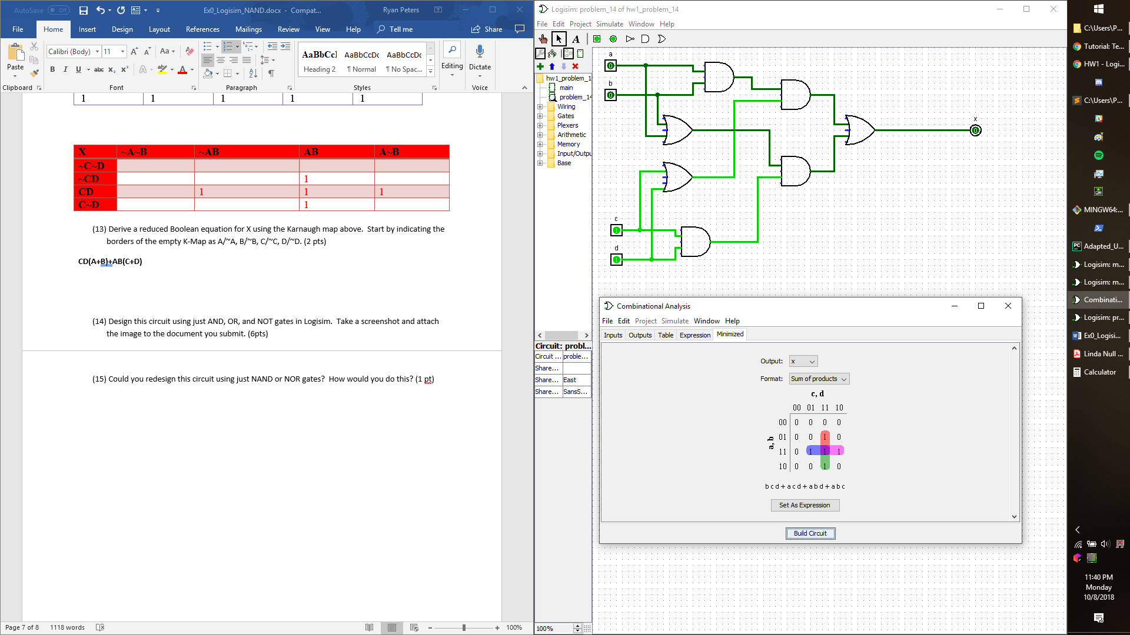

- Could you redesign this circuit using just NAND or NOR gates? How would you do this? (1 pt)
  - You could achieve this by creating a blackbox NOT gate from 3 NAND gates, then you could feed… lunch to starving children in Africa, because I just ran out of time to finish answering this question, sorry.
Thank you for being as gentle as possible with my very, very fragile ego when you graded this… 😉

