RLab5 report
Ryan Peters
Table of Contents

Exercises

# pkgload is a custom script that's defined inside of the shared_lab_utils folder
pkgload(c("devtools","crayon","utils"))
## Loading required package: devtools
## Loading required package: crayon
# Instead of forcing the script to reload the dataframe every time we run it,
# lets do a quick check to see if it's already been instantiated from a
# previsou run first
df_name <- 'ames'
if (exists(df_name)) is.data.frame(get(df_name)) else{
download.file('http://www.openintro.org/stat/data/ames.RData', destfile = 'ames.RData')
load('ames.RData')
}
area <- ames$Gr.Liv.Area
price <- ames$SalePrice
# getmode(vector) is a custom function defined in prep_script
area_mode <- area[which.max(tabulate(match(unique(area),area)))]
price_mode <- price[which.max(tabulate(match(unique(price),price)))]
sumry <- summary(area)
sumry["mode"] <- area_mode
for(name in names(sumry)){
cat("\n",name,":",sumry[name],"\n")
}
Min. : 334
1st Qu. : 1126
Median : 1442
Mean : 1499.69
3rd Qu. : 1742.75
Max. : 5642
mode : 1656
hist_with_labels(area, border="yellow", col="dodgerblue", las=1, xlab="area")
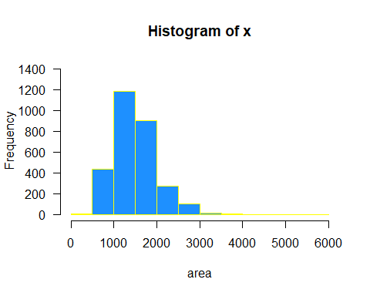

Exercise 1:
Describe this population distribution.
This is a right-skewed (aka right-tailed) distribution, with a mean of 1500 ft² and a median of 1442 ft².
Jump to Table of Contents

samp1 <- sample(area, 50)
hist_with_labels(samp1, border="dodgerblue", col="yellow", las=1, xlab="area for sample population of 50")
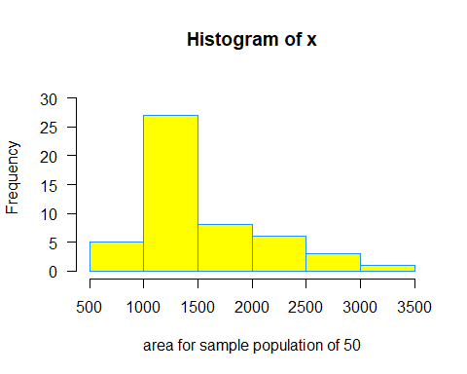

Exercise 2:
Describe the distribution of this sample. How does it compare to the distribution of the population?
It still appears to be right skewed, but it is definitly closer to a normal distribution than the total population
Jump to Table of Contents

mean(samp1)
[1] 1524.64
samp2 <- sample(area, 50)
mean(samp2)
[1] 1509.42

Exercise 3:
Take a second sample, also of size 50, and call it samp2.
How does the mean of samp2 compare with the mean of samp1?
It is definetly different, but it’s hard to say if that’s purely due to chance or the distribution of the population.
Suppose we took two more samples, one of size 100 and one of size 1000. Which would you think would provide a more accurate estimate of the population mean?
I believe that as the sample size gets larger, the accuracy of its sample statistics in approximating the population parameters directly improves. So I believe the 1000 sample would be better at approximating the total population’s mean.
Jump to Table of Contents

sample_means50 <- rep(NA, 5000)
for(i in 1:5000){
samp <- sample(area, 50)
sample_means50[i] <- mean(samp)
}
hist_with_labels(sample_means50, text_col = "black", border="orange", col="magenta3", las=1, xlab="example means5 for sample populations of 50")
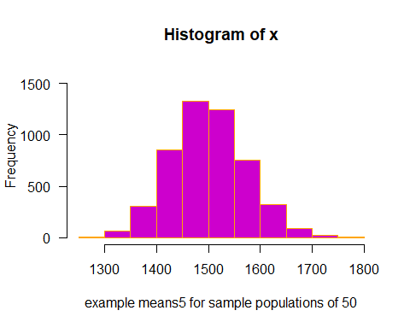
hist_with_labels(sample_means50, text_col = "black", border="orange3", col="magenta3", las=1,breaks = 25)
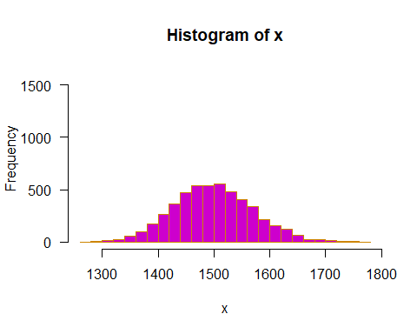

Exercise 4:
How many elements are there in sample_means50?
length(sample_means50)
[1] 5000
Describe the sampling distribution, and be sure to specifically note its center.
It’s an approximately normal distribution, with a mean around 1500.
Would you expect the distribution to change if we instead collected 50,000 sample means?
I would expect the distribution to continue to further conform to that of a normal distribution.
Jump to Table of Contents

sample_means50 <- rep(NA, 5000)
samp <- sample(area, 50)
sample_means50[1] <- mean(samp)
samp <- sample(area, 50)
sample_means50[2] <- mean(samp)
samp <- sample(area, 50)
sample_means50[3] <- mean(samp)
samp <- sample(area, 50)
sample_means50[4] <- mean(samp)
sample_means50 <- rep(NA, 5000)
for(i in 1:5000){
samp <- sample(area, 50)
sample_means50[i] <- mean(samp)
# print(i)
}

Exercise 5:
To make sure you understand what you’ve done in this loop, try running a smaller version. Initialize a vector of 100 zeros called sample_means_small. Run a loop that takes a sample of size 50 from area and stores the sample mean in sample_means_small, but only iterate from 1 to 100. Print the output to your screen (type sample_means_small into the console and press enter). How many elements are there in this object called sample_means_small? What does each element represent?
Nope, no answers here…
Jump to Table of Contents

hist_with_labels(sample_means50, text_col = "black", border="red2", col="cyan", las=1)
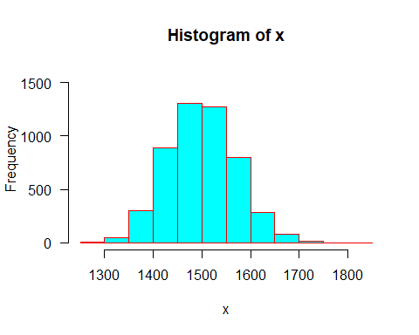
sample_means10 <- rep(NA, 5000)
sample_means100 <- rep(NA, 5000)
for(i in 1:5000){
samp <- sample(area, 10)
sample_means10[i] <- mean(samp)
samp <- sample(area, 100)
sample_means100[i] <- mean(samp)
}
par(mfrow = c(3, 1),
oma = c(0,0,0,0) + 1,
mar = c(0,1,2,1) + 1)
xlimits <- range(sample_means10)
# hist(sample_means10, breaks = 20, xlim = xlimits)
hist_with_labels(sample_means10, text_col = "yellow", breaks = 20, xlim = xlimits, border="gray", col="dodgerblue", las=1)
# hist(sample_means50, breaks = 20, xlim = xlimits)
hist_with_labels(sample_means50, text_col = "yellow", border="gray", col="dodgerblue", las=1)
# hist(sample_means100, breaks = 20, xlim = xlimits)
hist_with_labels(sample_means100, text_col = "yellow", breaks = 20, xlim = xlimits, border="gray", col="dodgerblue", las=1)
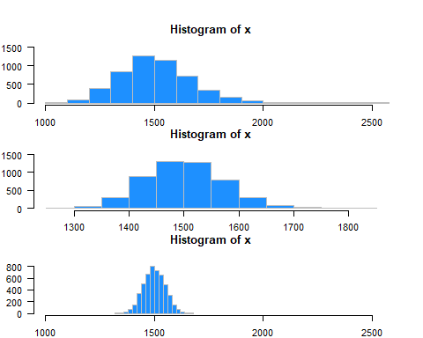

Exercise 6:
When the sample size is larger, what happens to the center? What about the spread?
Jump to Table of Contents
=====

On your own
So far, we have only focused on estimating the mean living area in homes in Ames. Now you’ll try to estimate the mean home price.

On Your Own 1:
Take a random sample of size 50 from price. Using this sample, what is your best point estimate of the population mean?
price_sample <- sample(price, 50)
hist_with_labels(price_sample,
border="white",
col="blue1",
las=1,
xlab="property prices for sample population of size = 50",
main="Histogram for\nsingle sample population of 50 samples")
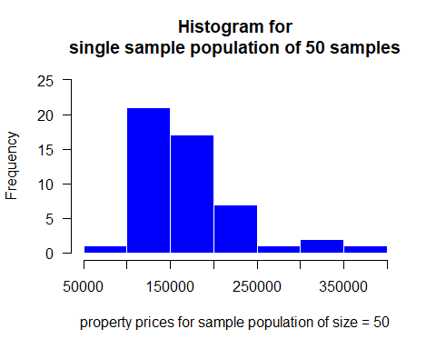
smry <- summary(price_sample)
cat("My best point estimate for the population mean is the sample mean: ***",smry[[4]],"***\n",sep="")
My best point estimate for the population mean is the sample mean: 172156.1
Jump to Table of Contents

On Your Own 2:
Since you have access to the population, simulate the sampling distribution for x-bar for price data by taking 5000 samples from the population of size 50 and computing 5000 sample means. Store these means in a vector called sample_means50.
sample_means50 <- range(5000)
for(i in 0:5000){
sample_means50[i] <- mean(sample(price,50))
}
Plot the data, then describe the shape of this sampling distribution.
hist_with_labels( sample_means50,
border="white",
col="blue1",
las=1,
xlab= "property value averages from sample populations of size = 50",
main="Histogram of means for\n50k sample populations of 50 samples a pieace")
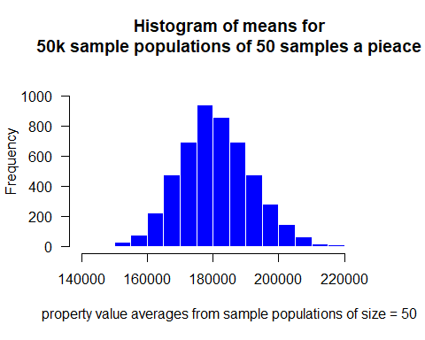
smry_50k <- summary( sample_means50)
Based on this sampling distribution, what would you guess the mean home price of the population to be?
The distribution is approximately normal, maybe slightly skewed to the rigt still From the histogram, I would estimate the mean home price to be approximately $180k
Finally, calculate and report the population mean.
cat("The calculated mean of 50k means on sample populations of 50... is: ***",smry_50k[[4]],"***\n",sep="")
The calculated mean of 50k means on sample populations of 50… is: 180895.7
Jump to Table of Contents

On Your Own 3:
Change your sample size from 50 to 150, then compute the sampling distribution using the same method as above, and store these means in a new vector called sample_means150.
Describe the shape of this sampling distribution, and compare it to the sampling distribution for a sample size of 50.
Based on this sampling distribution, what would you guess to be the meansale price of homes in Ames?
sample_means150 <- range(5000)
for(i in 0:5000){
sample_means150[i] <- mean(sample(price,150))
}
hist_with_labels( sample_means150,
border="white",
col="blue1",
las=1,
xlab= "property value averages from sample populations of size = 150",
main="Histogram of means for\n50k sample populations of 150 samples a pieace")
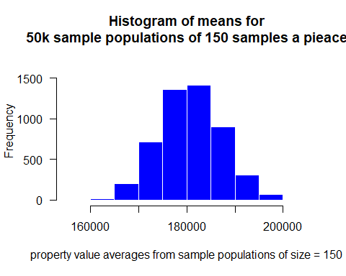
smry_150k <- summary( sample_means150)
cat("The distribution is approximately normal, though it is much less skewed than the sample size of only 50\nFrom the histogram, I would estimate the mean home price to be approximately $182k\nThe calculated mean of 50k means on sample populations of 150... is: ***",smry_150k[[4]],"***\n",sep="")
The distribution is approximately normal, though it is much less skewed than the sample size of only 50 From the histogram, I would estimate the mean home price to be approximately $182k The calculated mean of 50k means on sample populations of 150… is: 180809.8
Jump to Table of Contents

On Your Own 4:
Of the sampling distributions from 2 and 3, which has a smaller spread?
cat("The larger sample population has the smaller spread")
The larger sample population has the smaller spread If we’re concerned with making estimates that are more often close to the true value, would we prefer a distribution with a large or small spread?
price_summary <- summary(price)
true_mean <- price_summary[[4]]
winner_winner_chicken_dinner = "Neither sample size has a clear advantage"
if(abs(smry_50k[[4]]-true_mean) < abs(smry_150k[[4]]-true_mean)){
# the smaller sample size is closer to the true mean
winner_winner_chicken_dinner = "The smaller sample size appears to yield results closer to the population parameter mean"
} else if(abs(smry_50k[[4]]-true_mean) < abs(smry_150k[[4]]-true_mean)){
# the larger sample size is closer to the true mean
winner_winner_chicken_dinner = "The larger sample size appears to yield results closer to the population parameter mean"
}
I believe we would want a distribution with a narrower spread as it will more consistently provide an approximation that is reliably close to the true mean.
After comparing samples against the true mean, it appears that the results are: Neither sample size has a clear advantage
Jump to Table of Contents

Disclaimers and such
This is a product of OpenIntro that is released under a Creative Commons Attribution-ShareAlike 3.0 Unported.
This lab was written for OpenIntro by Andrew Bray and Mine Çetinkaya-Rundel.

