#### Steam Stream - In a Nutshell

Steam Stream is a service that provides seamless integration of games in a player's steam library with the biggest names in streaming outlets. Be it live streaming on *Twitch*, recorded game sessions on *YouTube Gaming*, or both on Microsoft's *Mixer*.

#### Say Hello to your first, and last stop for video game streaming entertainment

Steam Stream offers users an all-inclusive service for finding, following and tracking all kinds of video streams for their favorite games.

#### No longer do you need to hunt down a decent streaming feed for your favorite games

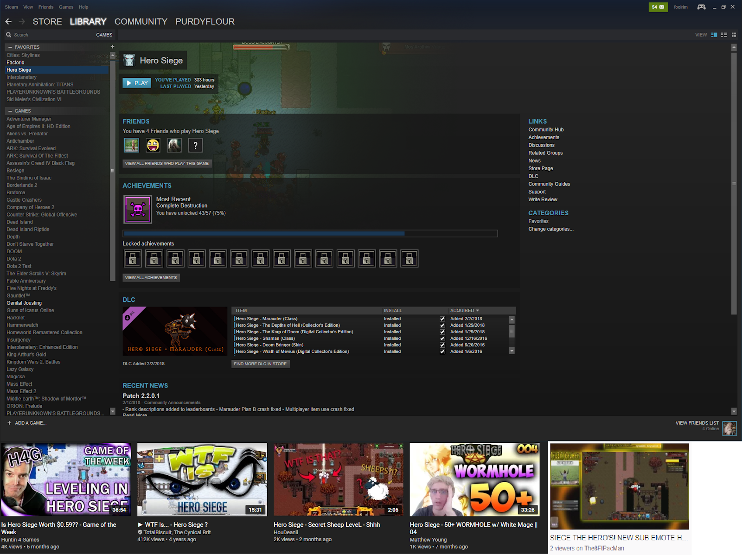Steam Stream integrates your Steam library, wish-list, and the Steam Store with an active feed of top streamer footage relevant to the titles visible in your Steam app's view portal.

#### There's something for everybody when you use Steam Stream

Steam Stream isn't just for stream viewers. In fact, the core set of features for this service are centered around improving the quality of life for stream producers!

In the world of video game streaming, it takes more than just being good at playing a game to make for an entertaining streaming session. It also requires the streamer to be entertaining, or to at least provide a visually appealing layout of information and style; however, where there is opportunity for people to make a very comfortable living while doing the things they love, you will inevitably attract the attention of many diverse people. This can result in all kinds of crazy design ideas, most of which simply clutter the field of options.

#### Get your brand on!

First and foremost, the streamer needs to be able to effectively manage their feed and presentation as a unique brand; key to this effort is being able to acquire and manage a quality

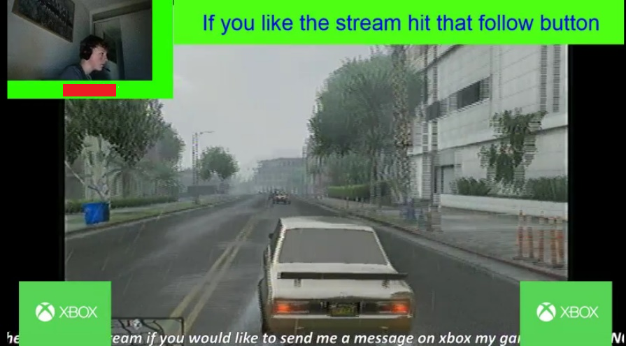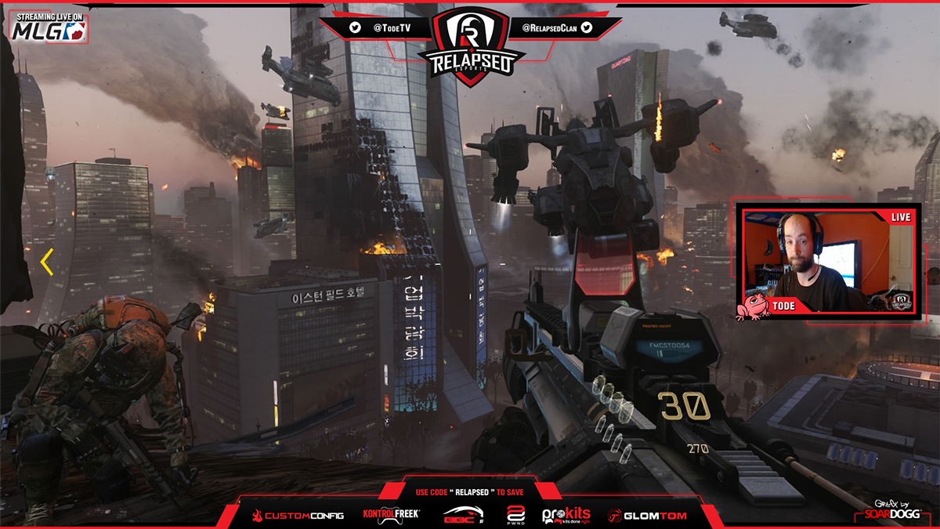stream overlay.

Unfortunately, creating an effective overlay is not something just anybody can do. That is why one of the core features of the new Steam Streamservice will be a **full suite of overlay templates with a complementary base package of skins** for those templates.

