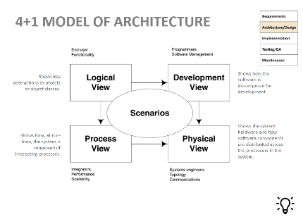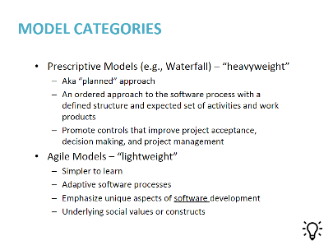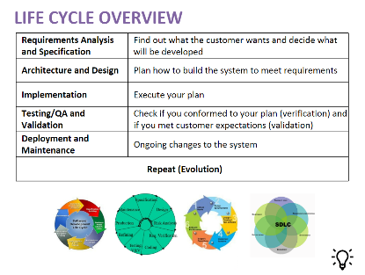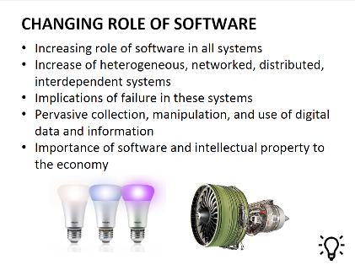

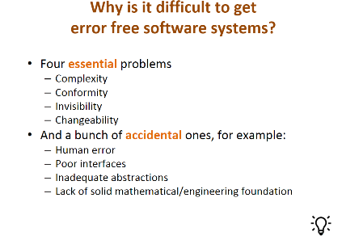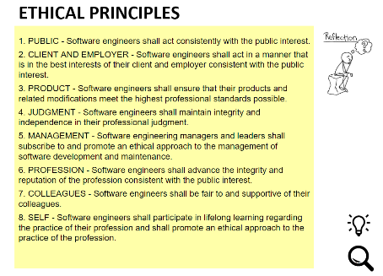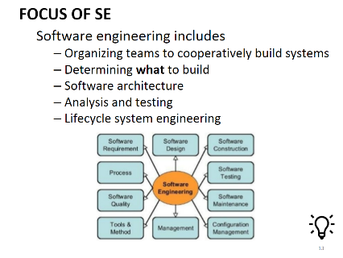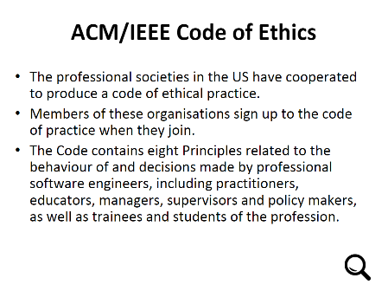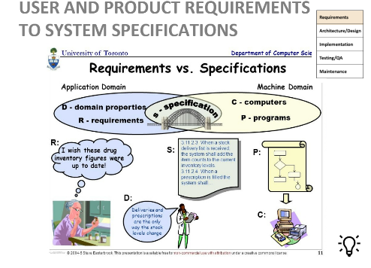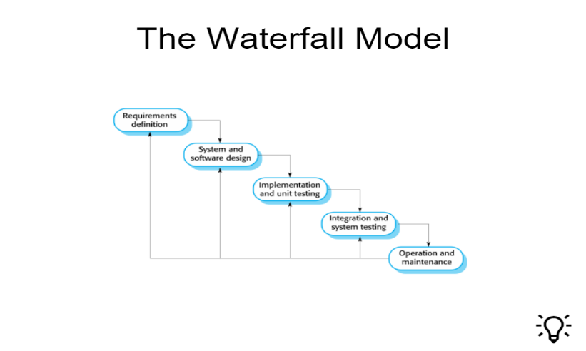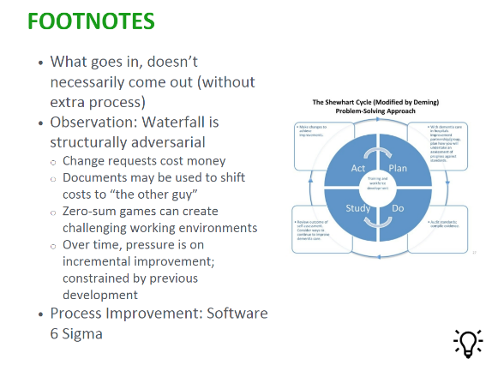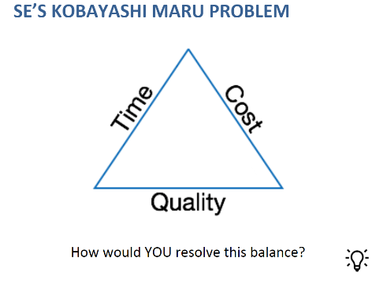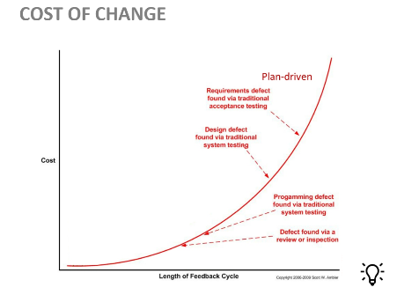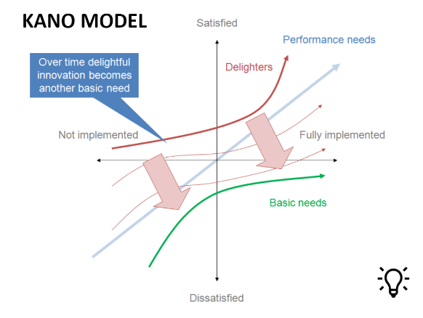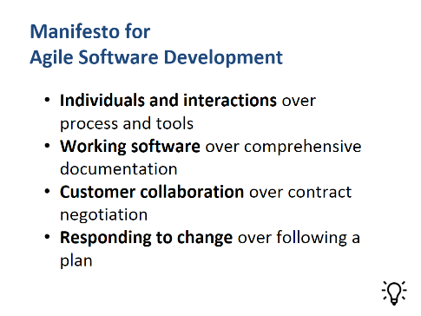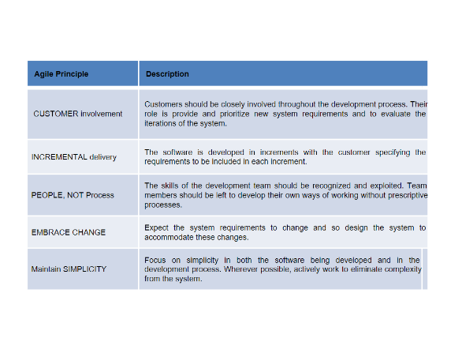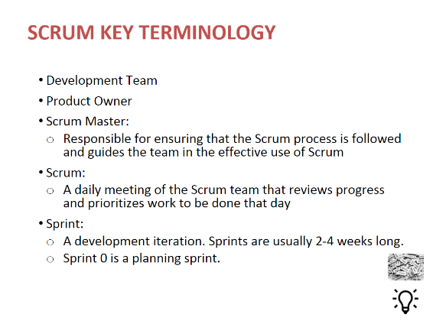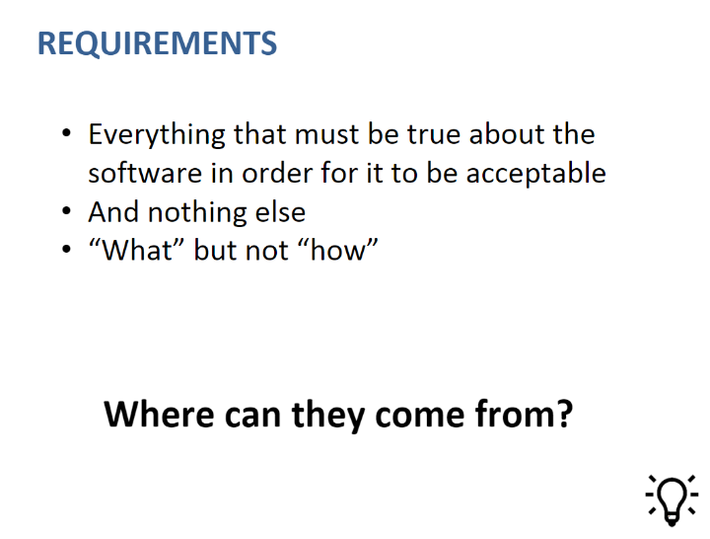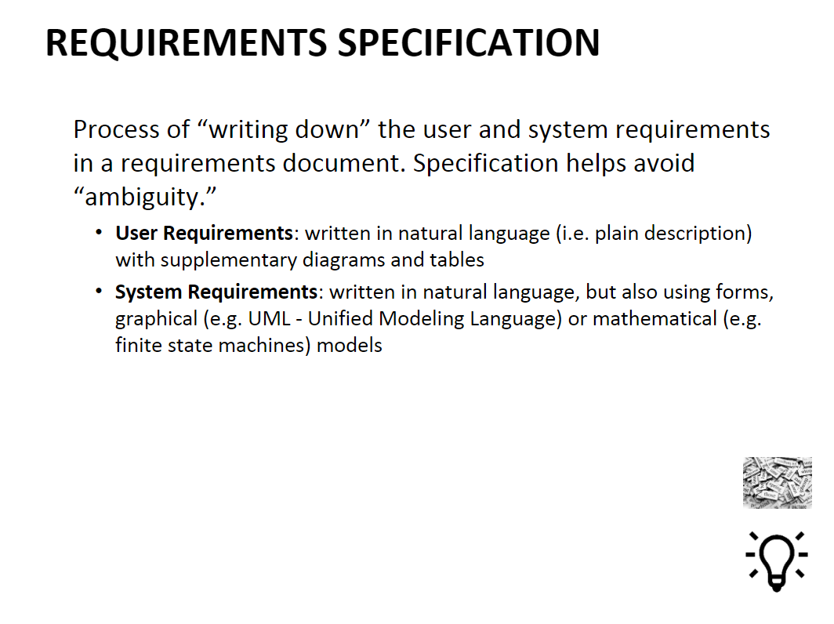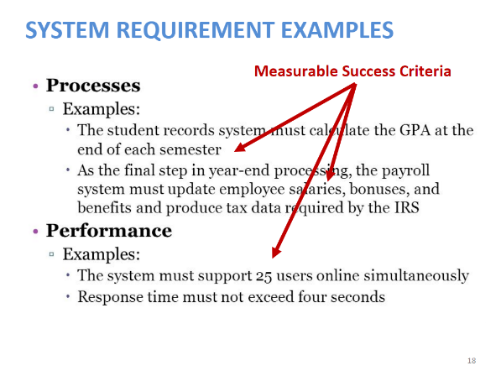

1. What is software engineering?  Write a short definition [4 points] Draw from these points…
   * “A discipline that deals with the building of software systems that are so large or so complex  that  they  are  built  by  a  team  or  teams  of  engineers”  [Ghezzi,  Jazayeri, Mandrioli]
   * “Multi-person construction of multi-version software” [Parnas]
   * “Software engineering is an engineering discipline that is concerned with all aspects of software production from the early stages of system specification through to maintaining the system after it has gone into use.”—Sommerville Ch.12.
2. What are four essential problems making it hard to get error-free software? [4 pts]
   * Complexity
   * Conformity
   * Changeability
   * Invisibility
3. Name and briefly define 4 key stages of software development life cycle. [4 pts] [4 of the following will work]
   * Requirements and/or Specification:  Find out what the customer wants and/or what the system should do
   * Architecture/Design:  Plan how to build the system to meet requirements
   * Implementation:  Execute your plan
   * Validation/Testing/QA:  Check if you conformed to your plan (verification) and if you met customer expectations (validation)
   * Deployment and/or Maintenance:  Ongoing changes to the system
   * Could potentially insert Repeat as a stage
4. List the 4 key principles of Agile Manifesto [4 pts]
   * Individuals and interactions over process and tools
   * Working software over comprehensive documentation
   * Customer collaboration over contract negotiation
   * Responding to change over following a plan
5. The incremental model of software development is [2 pts]
   * A good approach when a working core product is required quickly.
6. The linear sequential model of software development is also known as the [2 pts]
   * Both Classical life cycle model and Waterfall model

4 +1 view model of software architecture:   
- Development view -- illustrates a system from a programmer's perspective and is concerned with software management.  
- Logical view -- concerned with the functionality that the system provides to end-users  
- Physical view -- depicts the system from a system engineer's point of view.  
- Process view -- deals with the dynamic aspects of the system, explains the system processes  
- Scenarios -- The description of an architecture is illustrated using a small set of use cases,