[Look here](https://ryancpeters.github.io/Winter_UWB_2017/360_software_eng/Individual-Research-Project-Proposal/) for the rendered markdown formatting on this document!

Is the open source approach to systems of systems design viable?

By: Ryan Peters —

**Elevator Pitch**

I’ve heard a lot of people talking about open source code bases as being the way of the future. But I can’t say that I see how that’s going to work; I understand the altruistic goals of such endeavors, but I also understand that without an organized, funded, and adaptive govorning board of stakeholders in a project, there’s no amount of certainty that open source projects will be able to survive the eb and sway of popular culture.

**Rationale:**

Currently, there are a stagaring number of “citizen scientists” in the world that are capable of stepping up to the plate and making significant individual contributions towards solving major obsticals to both industry and society. But when everybody is independently racing to the next big solution, we run the risk of missing the mark and instead of creating a common solution we can all support, we get a situation similar to what’s seen in the xkcd comic’s “Standards” skit.

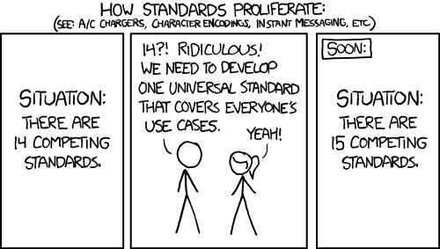

In researching this subject, I hope to be able to determine, for myself at least, if I will choose to a part of the open source movement, or if I will try to mitigate its percieved damages.

**Research Approach (1 short paragraph)**

I already have multiple scholarly articles from multiple academic databases, So I think I will review those and use them as my primary source of research.

**Conclusion: (1 paragraph or set of bullet points)**

An understanding of the possible risks and advantages that come from open sourced, publicly developed tools and platforms.

**Potential references/sources you are considering: (min. 2, be specific even if you change your mind later)**

References

Balamurugan, Chithralekha, and Shourya Roy. *“Human Computer Interaction Paradigm for Business Process Task Crowdsourcing.”* Proceedings of the 11th Asia Pacific Conference on Computer Human Interaction, ACM, 2013, pp. 264–273. ACM Digital Library, doi:10.1145/2525194.2525294. Accessed 8 Nov. 2017.

Dubey, Alpana, et al. *“Personas and Redundancies in Crowdsourced Testing.”* Proceedings of the 12th International Conference on Global Software Engineering, IEEE Press, 2017, pp. 76–80. ACM Digital Library, doi:10.1109/ICGSE.2017.7. Accessed 8 Nov. 2017.

Washington State, Office of Financial Management. Interactive State Budget (2017–19 Enacted). www.ofm.wa.gov/budget/state-budgets/2017-19-enacted-budgets/interactive-state-budget-2017-19-enacted. Accessed 8 Dec. 2017.

Lee, Preston V., and Valentin Dinu. “BitTorious Volunteer: Server-Side Extensions for Centrally-Managed Volunteer Storage in BitTorrent Swarms.” BMC Bioinformatics, vol. 16, Nov. 2015, EBSCOhost, doi:10.1186/s12859-015-0779-6. Accessed 8 Nov. 2017.

Levine, Sheen, and Michael Prietula. “Open Collaboration for Innovation: Principles and Performance.” Organization Science, vol. 25, no. 5, Sept. 2013. papers.ssrn.com, doi:10.1287/orsc.2013.0872. Accessed 8 Nov. 2017.

Mattauch, Thomas. “Innovate Through Crowd Sourcing.” Proceedings of the 41st Annual ACM SIGUCCS Conference on User Services, ACM, 2013, pp. 39–42. ACM Digital Library, doi:10.1145/2504776.2504796. Accessed 8 Nov. 2017.

Glassdoor.com, “Salary.” Glassdoor, 1 Nov. 2017, www.glassdoor.com/Salaries/software-engineer-salary,17.htm.

Tran-Thanh, Long, et al. “Efficient Crowdsourcing of Unknown Experts Using Bounded Multi-Armed Bandits.” Artificial Intelligence, vol. 214, no. Supplement C, Sept. 2014, pp. 89–111. ScienceDirect, doi:10.1016/j.artint.2014.04.005. Accessed 8 Nov. 2017.

Urban, Tim. “The Artificial Intelligence Revolution.” Wait But Why, 22 Jan. 2015, www.waitbutwhy.com/2015/01/artificial-intelligence-revolution-1.html. Accessed 8 Nov. 2017.