## Overview/Goals

* **Provide a video-recording suite that can integrate with all Steam games**
* **Provide streaming services that can integrate with all Steam games**
* **Be able to process stream data from the three major streaming websites: YouTube, Mixer, and Twitch to add streams to store and game pages**
* **Make these services easy to use directly from the Steam interface**
* **Integrate these services into the Steam ecosystem with minimal overhead**

## SDLC

**We chose Scrum as our SDLC.**

* **With Valve’s trend towards collaborative efforts and this project’s scope, we decided on an Agile Scrum process** 
  + **Steam Stream will be used by a large variety of users on a variety of different systems** 
    - **Change needs to be fast**
    - **Adaptation and evolution needs to be fast**
  + **Scrum will allow us to adjust agile principles to the growing scope of the project**
  + **The collaborative nature and unique organizational structure of Valve fits nicely into the agile principle of product ownership and responsibility**

## Requirements

* **As a Steam Stream user, I want to be able to have options for different kinds of stream overlays - Non-functional**
* **As a Steam Stream user, I want to be able to record video clips of gameplay highlights - Non-functional**
* **As a game developer I want to see a feed of popular streams on my game’s Steam page - Functional**

## Conclusion

* **This is a huge undertaking that we have no where near the technical experience to deal with.**
* **Streaming is a difficult technical problem**
* **In designing the Steam Stream we have a high level understanding of what it takes to actually implement a streaming system**
* **The technical challenge of designing a streaming system has helped us absorb what we have learned about the software engineering process this quarter**

## Technology Used

## Architectural Model

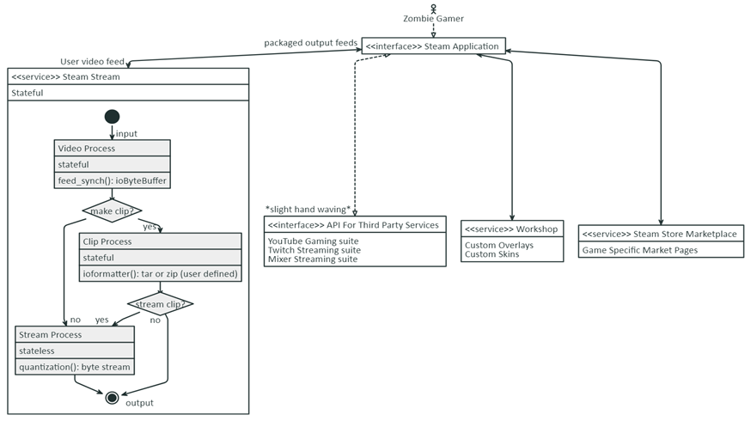

## Storyboard

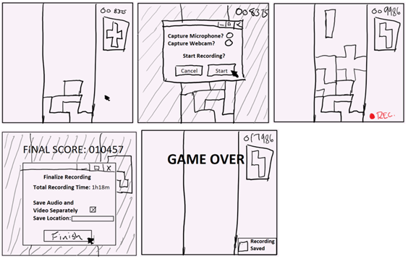

## Contextual Model

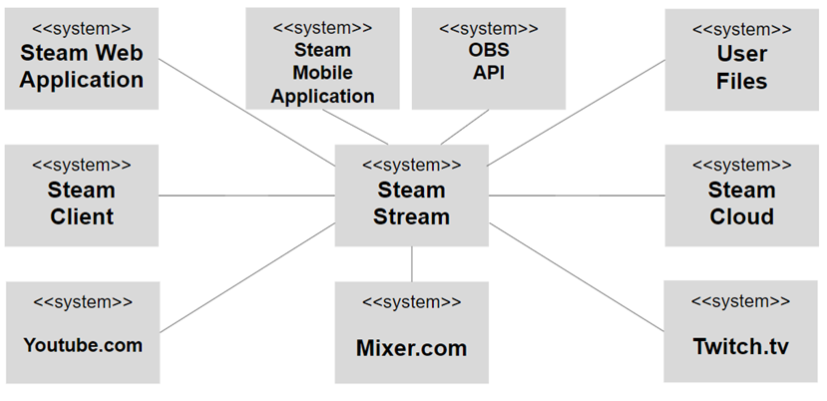

#### Figure 1: Steam Store mockup with on-click game-specific stream feed

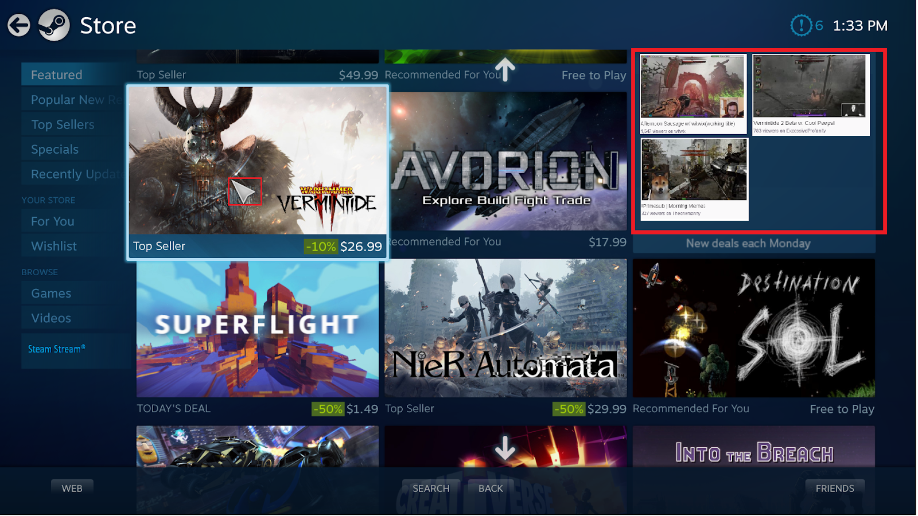

#### Figure 2: Steam Library mockup with on-click game-specific stream feed



