# Memo

**To:** Min Chen

**CC:** Fellow CSS 343 Students

**From:** Team 7 (Brady Pascoe, Daniel Bragaru, Mitchell Nye, Sean Chen)

**Date:** February 28, 2018

**Subject:** Assignment 4

# Overview

Using a minimalistic main() design, the Inventory class will be able to run every valid command (known as “Actions”, in the context of our design) and provide output wherever necessary. The setup is also minimalistic, with a constructor that only requires the customer file and the movie file as parameters. Once the setup is complete (Inventory object is initialized), the executeCommands() function is called and given the commands text file, and that’s it. The Inventory object should now handle everything it’s supposed to handle. The Inventory is essentially going to give the appropriate text files to three separate objects. The Movies text file will be given to “Movie Manager” and the customer text file will be given to “Customer Manager”. The third text file will be handled by Inventory itself with the aid of Action Dictionary. The inventory will essentially “feed” the Action Dictionary the third text file line by line. This is because each Action should be parsed individually and ran one at a time. Once the string is parsed and the Action Dictionary constructs the Action, it will return it to Inventory. Inventory will then call the newly constructed Action’s “doAction” function and perform whatever it needs to perform on the Inventory object.

# Diagrams

# All Classes

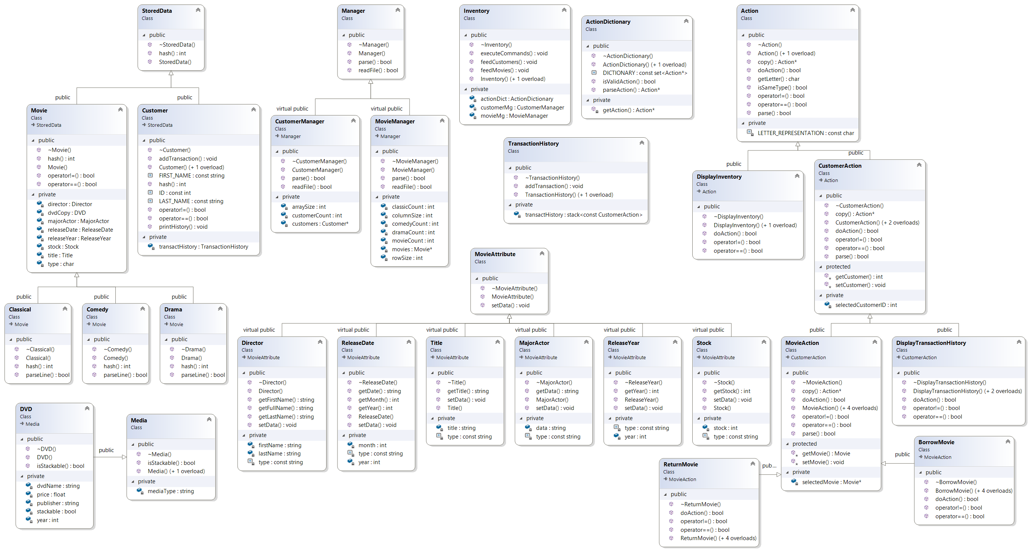

# Stored Data

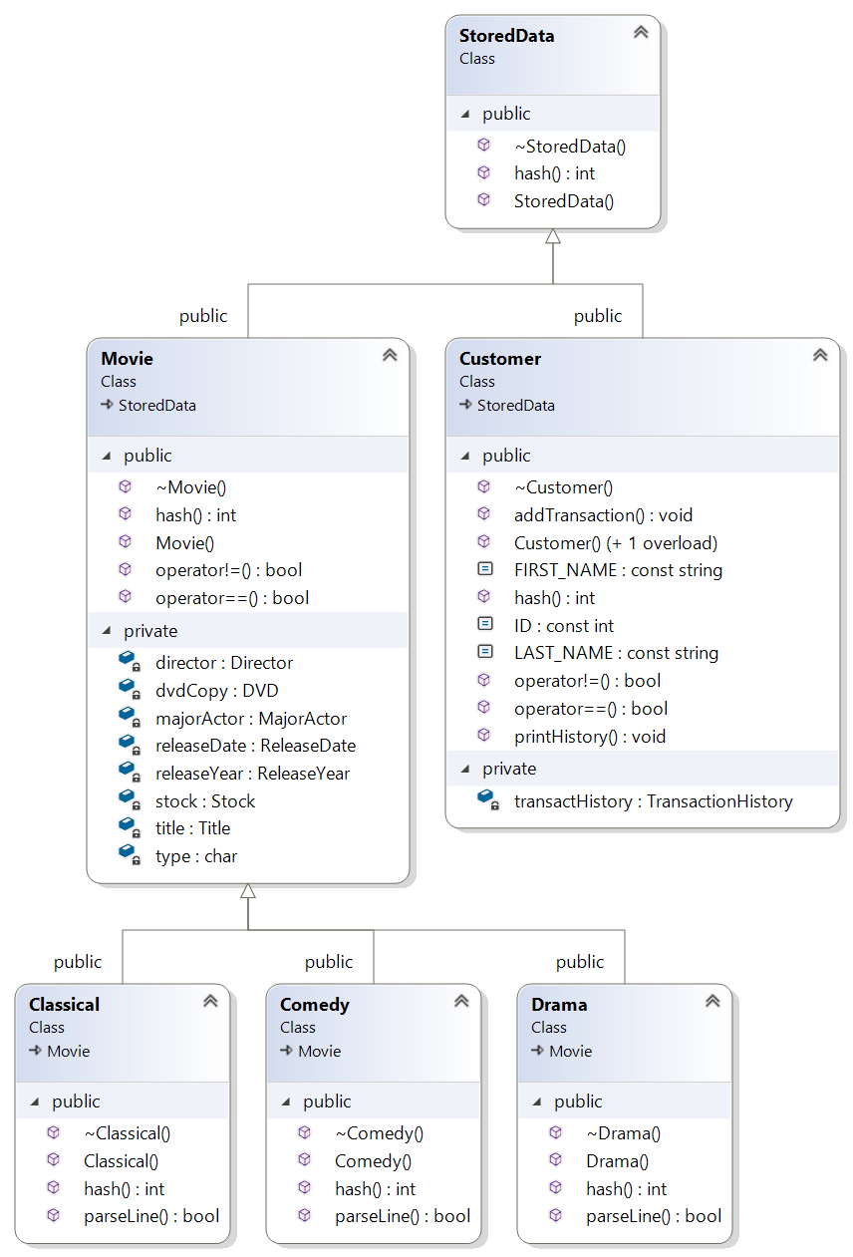

# Managers

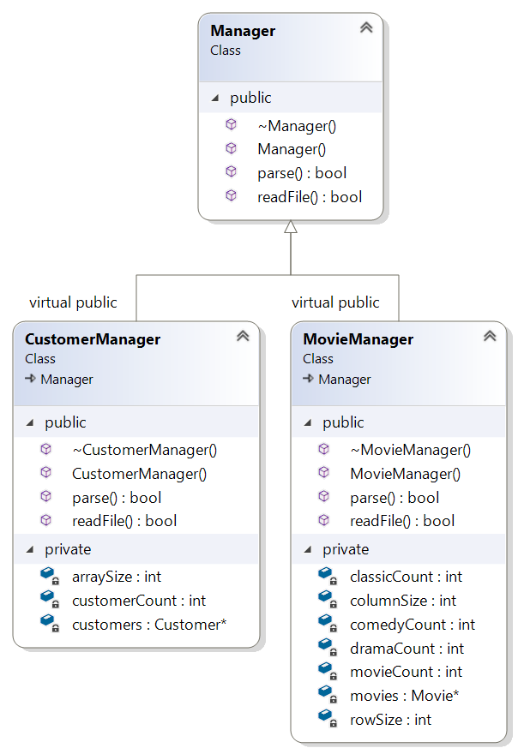

# Attributes

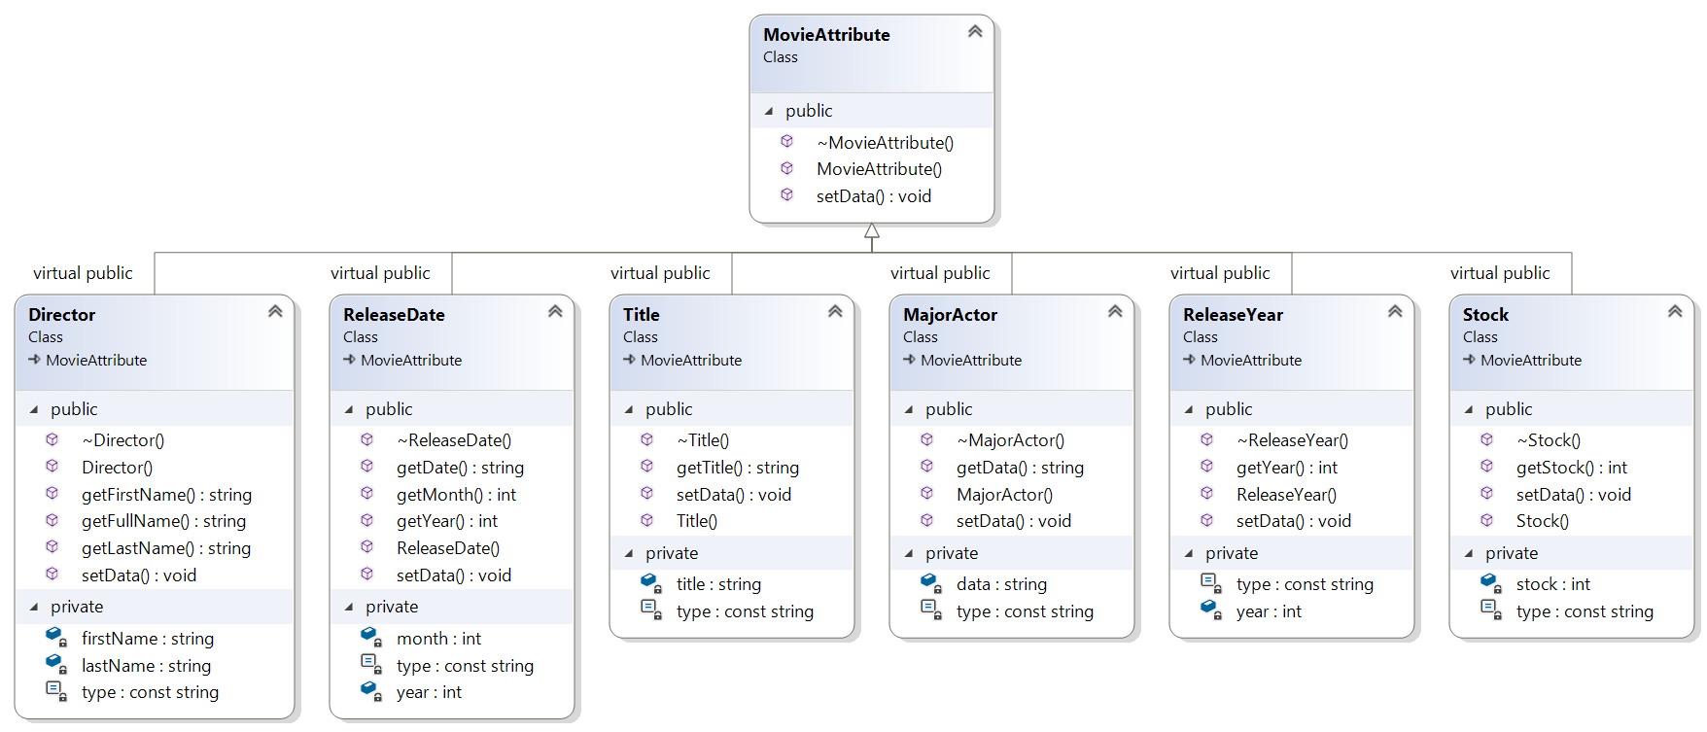

# Actions

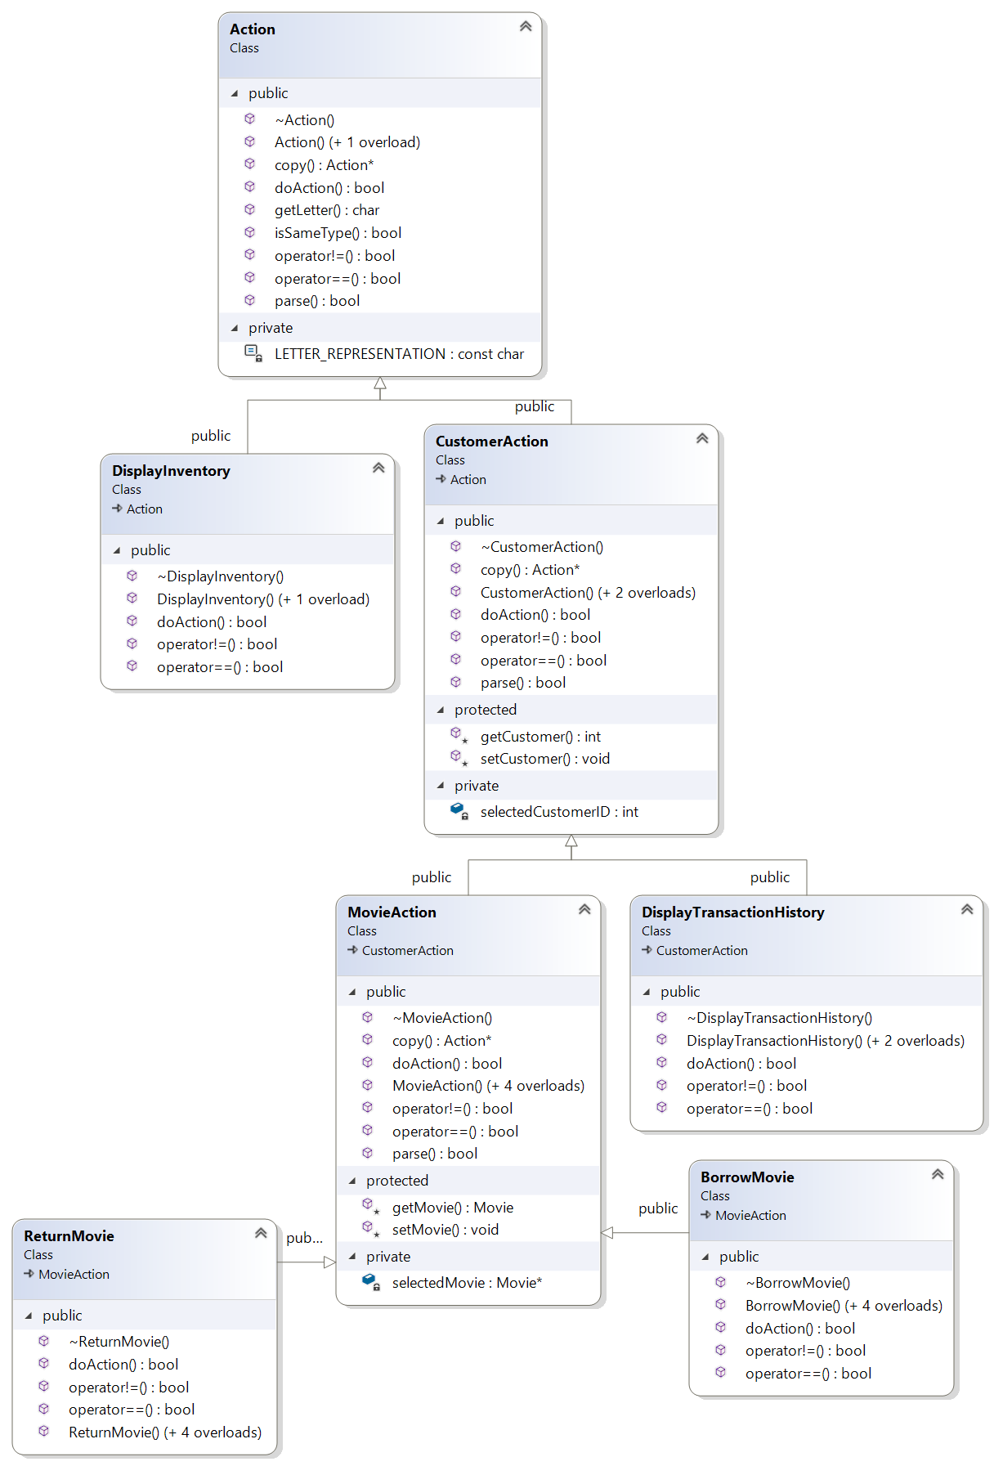

# Media

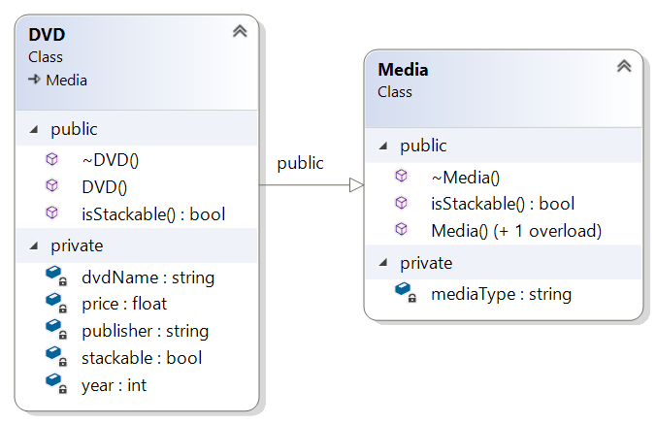

# Non-Inherited Classes

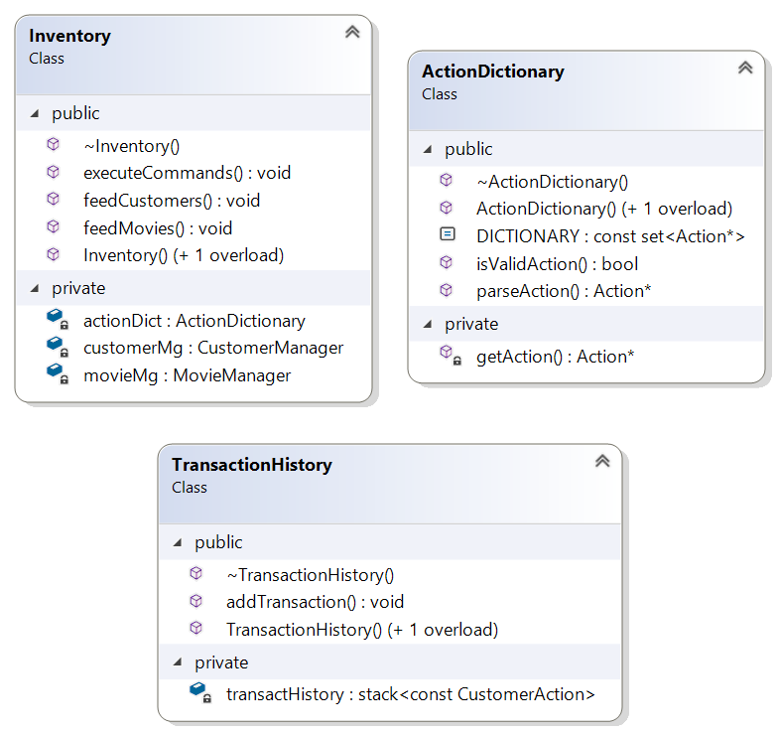

# Movie

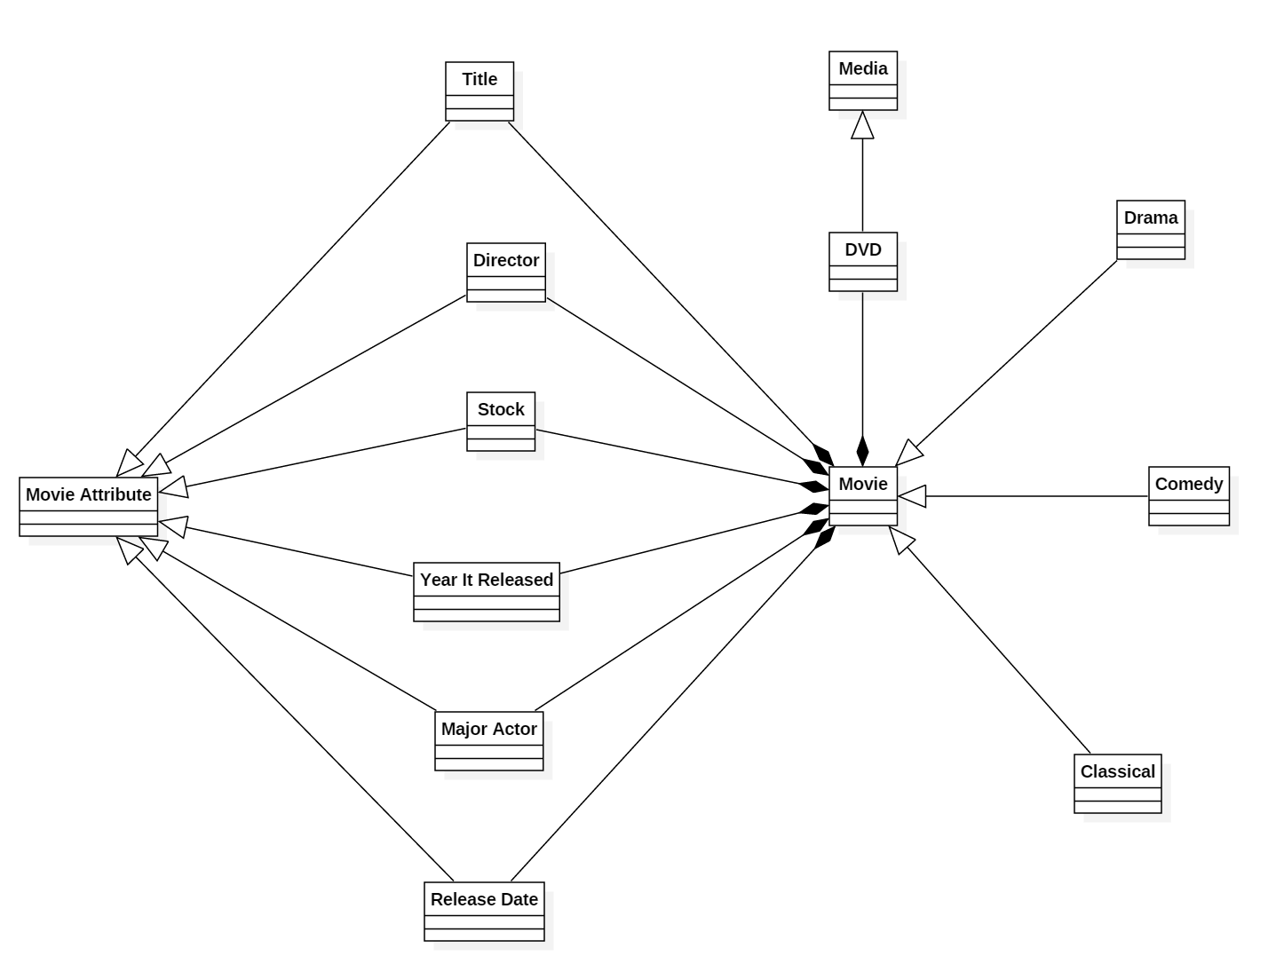

# Inventory

